**CITY OF GRAND JUNCTION, COLORADO**

**ORDINANCE NO. 4622**

**AN ORDINANCE AMENDING THE ZONING AND DEVELOPMENT CODE,**

**GRAND JUNCTION MUNICIPAL CODE SECTION 21.03.090, FORM DISTRICTS**

Recitals:

On April 5, 2010 the Grand Junction City Council adopted the updated 2010 Zoning and Development Code, codified as Title 21 of the Grand Junction Municipal Code of Ordinances.

It has been found that current standards relating to Form Districts do not encourage development of mixed use projects in Mixed Use Opportunity Corridors.

In order to implement the Comprehensive Plan goals of creating opportunities to encourage the development of mixed use projects that can reduce the amount of trips generated for shopping and commuting and create a broader range of housing types, Section 21.03.090, Form Districts, of the Zoning and Development Code (Code) needs to be amended.

The proposed amendments to Section 21.03.090 are intended to remove current restrictions that discourage mixed use developments within Mixed Use Opportunity Corridors.

The amendments are consistent with the goals and policies of the Comprehensive Plan and implement the vision, goals and policies of the Comprehensive Plan.

After public notice and a public hearing as required by the Charter and Ordinances of the City, the Grand Junction Planning Commission recommended approval of the proposed amendments, finding that:

1. The proposed amendments are consistent with the goals and policies of the Comprehensive Plan.

2. The proposed amendments will help implement the vision, goals and policies of the Comprehensive Plan.

After public notice and a public hearing before the Grand Junction City Council, the City Council hereby finds and determines that the proposed amendments will implement the vision, goals and policies of the Comprehensive Plan and promote the health, safety and welfare of the community, and should be adopted.

NOW THEREFORE BE IT ORDAINED BY THE CITY COUNCIL OF THE CITY OF GRAND JUNCTION THAT:

**21.03.090 Form districts.**

(a)    **Intent.** The form districts are intended to implement the Neighborhood Center, Village Center, Downtown Mixed Use future land use designations and Mixed Use Opportunity Corridors of the Comprehensive Plan. The form districts are intended to create pedestrian-friendly urban areas where higher density mixed uses and mixed building types promote less dependence on the automobile. The form districts are intended to be used in combination to create mixed use centers. The centers are intended to transition in scale to existing neighborhoods. The Comprehensive Plan Neighborhood Center designation is implemented with the three-story districts, the Village Center designation is implemented with the three- and five-story districts, and the Downtown Mixed Use designation is implemented with the three-, five- and eight-story districts. The Mixed Use Opportunity Corridor designation is implemented with the three-story districts.

(b)    **Mixed Use Residential (MXR-3, -5, -8).** The mixed use residential (MXR) districts are:

(1)    Intended to create residential neighborhoods with a mix of housing options in a pedestrian-friendly environment.

(2)    Divided into three intensities: low (MXR-3), medium (MXR-5), and high (MXR-8).

(3)    Intended as a transition from a mixed use center or corridor to the surrounding neighborhoods.

(4)    Comprised of the apartment, townhouse and civic building types.

(c)    **Mixed Use General (MXG-3, -5, -8).** The mixed use general (MXG) districts are:

(1)    Intended to create a mix of compatible uses in close proximity to one another in a pedestrian-friendly environment.

(2)    Divided into three intensities: low (MXG-3), medium (MXG-5), and high (MXG-8).

(3)    Comprised of the general, apartment, townhouse and civic building types.

(d)    **Mixed Use Shopfront (MXS-3, -5, -8).** The mixed use shopfront (MXS) districts are:

(1)    Intended to create the commercial core of a mixed use pedestrian-friendly area.

(2)    Divided into three intensities: low (MXS-3), medium (MXS-5), and high (MXS-8).

(3)    Comprised of the shopfront building type.

(e)    **District Standards.**

(1)    Building Type by District.

| **District** | **Building Type** | | | | |
| --- | --- | --- | --- | --- | --- |
|  | **Shopfront** | **General** | **Apartment** | **Townhouse** | **Civic** |
| Mixed Use Residential (MXR-) |  |  | **•** | **•** | **•** |
| Mixed Use General  (MXG-) |  | **•** | **•** | **•** | **•** |
| Mixed Use Shopfront  (MXS-) | **•** |  |  |  |  |

(2)    Height.

| **Intensity** | **District** | **Height Stories (min.)** | **Height Stories (max.)** | **Height Feet (max.)** |
| --- | --- | --- | --- | --- |
| Low | MXR-3, MXG-3, MXS-3 | 1 | 3 | 50 |
| Medium | MXR-5, MXG-5, MXS-5 | 2 | 5 | 65 |
| High | MXR-8, MXG-8, MXS-8 | 2 | 8 | 100 |

(3)    Building Entrances. The following building entrance requirements apply to shopfront, general and apartment building types:

(i)    An entrance providing both ingress and egress, operable during normal business hours, is required to meet the street-facing entrance requirements. Additional entrances off another street, pedestrian area or internal parking area are permitted.

(ii)    The entrance separation requirements provided for the building type must be met for each building, but are not applicable to adjacent buildings.

(iii)    An angled entrance may be provided at either corner of a building along the street to meet the street entrance requirements, provided any applicable entrance spacing requirements can still be met.

(iv)    A minimum of 50 percent of a required entrance must be transparent.

(v)    A required fire exit door with no transparency may front on a primary, side, or service street.

(4)    Parking.

(i)    On-site surface parking must be located behind the parking setback line.

(ii)    Structured parking must contain active uses on the ground story along any primary street for the first 30 feet of the building measured from the street-facing facade.

(iii)    The required street frontage may be interrupted to allow for a maximum 30-foot-wide vehicular entrance to a parking structure or area.

(5)    Service Entrances. Business service entrances, service yards and loading areas shall be located only in the rear or side yard, behind the parking setback line.

(6)    Open Space.

(i)    Public Parks and Open Space Fee. The owner of any multifamily or mixed use project in a form district shall be subject to the required parks impact fee.

(ii)    Open Space Requirement. Multifamily or mixed use developments in a form district shall be required to pay 10 percent of the value of the raw land of the property as determined in GJMC [21.06.020(b)](http://www.codepublishing.com/co/grandjunction/html2/GrandJunction21/GrandJunction2106.html#21.06.020(b)).

(7)    Outdoor Storage and Display. Outdoor storage and permanent displays are prohibited. Portable display of retail merchandise may be permitted as provided in GJMC [21.04.040(h)](http://www.codepublishing.com/co/grandjunction/html2/GrandJunction21/GrandJunction2104.html#21.04.040(h)).

(8) Awning Standards. Awnings and other façade enhancements are encouraged. One or more awnings extending from the building may be erected. Awnings shall be at least 8 feet above the sidewalk and shall be at least 4 feet wide, along the building frontage, and shall not overhang into the right-of-way more than 6 feet. Awnings shall otherwise meet with the requirements of the Grand Junction Municipal Code and Colorado Department of Transportation (CDOT) regulations.

(9) Landscaping and Buffering.

(i) No landscaping / screening buffer is required between adjacent properties zoned Mixed Use.

(ii) No street frontage landscaping is required when the setback for a building is ten (10) feet or less.

(iii) Street trees are required at a rate of one tree per eighty (80) feet. Street trees may be planted in the right-of-way with City approval.

(iv) All other landscaping regulations of the Grand Junction Municipal Code shall apply.

(f)    **Building Types.** See the building types on the following pages.

(1)    Shopfront. A building form intended for ground floor retail sales and service uses with upper-story residential or office uses. Lodging and indoor recreation and entertainment uses would also be allowed. High transparency (in the form of windows and doors) is required on the ground floor to encourage interaction between the pedestrian and the ground story space. Primary entrances are prominent and street facing.

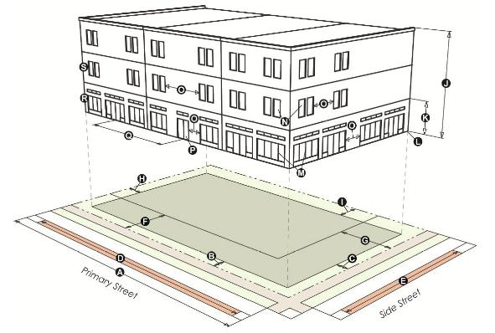

|  |  | **MXS-3** | **MXS-5** | **MXS-8** |  |  |  | **MXS-3** | **MXS-5** | **MXS-8** |
| --- | --- | --- | --- | --- | --- | --- | --- | --- | --- | --- |
|  | **LOT** | | | |  |  | **HEIGHT** | | | |
|  | Area (min. ft.2) | 4,000 | 5,000 | n/a |  | http://www.codepublishing.com/co/grandjunction/html2/images/grandj21.23.04.06.jpg | Stories (max.) | 3 | 5 | 8 |
| http://www.codepublishing.com/co/grandjunction/html2/images/grandj21.23.04.07.jpg | Width (min. ft.) | 40 | 50 | n/a |  | http://www.codepublishing.com/co/grandjunction/html2/images/grandj21.23.04.08.jpg | Feet (max.) | 50 | 65 | 100 |
|  | Lot coverage (max.) | 75% | 75% | n/a |  | http://www.codepublishing.com/co/grandjunction/html2/images/grandj21.23.04.09.jpg | Ground story height (min. ft.) | 15 | 15 | 15 |
|  | **FRONT SETBACK AREA** | | | |  | http://www.codepublishing.com/co/grandjunction/html2/images/grandj21.23.04.10.jpg | Ground story elevation (min. ft.) | 0 | 0 | 0 |
| http://www.codepublishing.com/co/grandjunction/html2/images/grandj21.23.04.11.jpg | Primary street (min./max. ft.) | 0/10 | 0/10 | 0/10 |  |  | **BUILDING FACADE** | | | |
| http://www.codepublishing.com/co/grandjunction/html2/images/grandj21.23.04.12.jpg | Side street (min./max. ft.) | 0/10 | 0/10 | 0/10 |  | http://www.codepublishing.com/co/grandjunction/html2/images/grandj21.23.04.13.jpg | Ground story transparency (min.) | 60% | 60% | 60% |
|  | **REQUIRED STREET FACADE** | | | |  | http://www.codepublishing.com/co/grandjunction/html2/images/grandj21.23.04.14.jpg | Upper story transparency (min.) | 20% | 20% | 20% |
| http://www.codepublishing.com/co/grandjunction/html2/images/grandj21.23.04.15.jpg | Primary street (min.) | 85% | 85% | 85% |  | http://www.codepublishing.com/co/grandjunction/html2/images/grandj21.23.04.16.jpg | Blank wall area (max. ft.) | 30 | 30 | 30 |
| http://www.codepublishing.com/co/grandjunction/html2/images/grandj21.23.04.17.jpg | Side street (min.) | 40% | 40% | 40% |  | http://www.codepublishing.com/co/grandjunction/html2/images/grandj21.23.04.18.jpg | Street-facing entrance required | yes | yes | yes |
|  | **PARKING SETBACK** | | | |  | http://www.codepublishing.com/co/grandjunction/html2/images/grandj21.23.04.19.jpg | Street entrance spacing | n/a | n/a | 50 |
| http://www.codepublishing.com/co/grandjunction/html2/images/grandj21.23.04.20.jpg | Primary street (min. ft.) | 30 | 30 | 30 |  |  | **ALLOWED USE** | | | |
| http://www.codepublishing.com/co/grandjunction/html2/images/grandj21.23.04.21.jpg | Side street (min. ft.) | 10 | 10 | 10 |  | http://www.codepublishing.com/co/grandjunction/html2/images/grandj21.23.04.22.jpg | Ground story | Commercial, Institutional and Civic | | |
|  | **SIDE/REAR SETBACKS** | | | |  |  |
| http://www.codepublishing.com/co/grandjunction/html2/images/grandj21.23.04.23.jpg | Side, interior (min. ft.) | 5 | 5 | 5 |  | http://www.codepublishing.com/co/grandjunction/html2/images/grandj21.23.04.24.jpg | Upper story | Commercial, Institutional and Civic, Residential | | |
| http://www.codepublishing.com/co/grandjunction/html2/images/grandj21.23.04.25.jpg | Rear (min. ft.) | 15 | 10 | 0 |  |

(2)    General. A building form intended for ground floor office and personal services uses (but does not include sales, repair or entertainment oriented uses) with upper-story residential or office. Transparency (in the form of windows and doors) is required on the ground floor to encourage interaction between the pedestrian and the ground story space; however, required transparency is lower than that for a shopfront building form. Primary entrances are prominent and street facing.

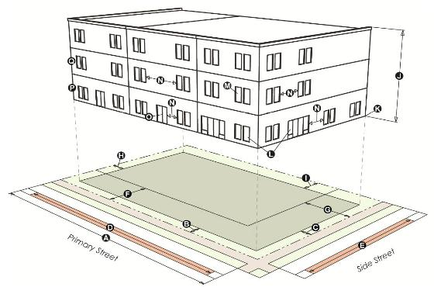

|  |  | **MXG-3** | **MXG-5** | **MXG-8** |  |  |  | **MXG-3** | **MXG-5** | **MXG-8** |
| --- | --- | --- | --- | --- | --- | --- | --- | --- | --- | --- |
|  | **LOT** | | | |  |  | **HEIGHT** | | | |
|  | Area (min. ft.2) | 4,000 | 5,000 | n/a |  | http://www.codepublishing.com/co/grandjunction/html2/images/grandj21.23.04.27.jpg | Stories (max.) | 3 | 5 | 8 |
| http://www.codepublishing.com/co/grandjunction/html2/images/grandj21.23.04.28.jpg | Width (min. ft.) | 40 | 50 | n/a |  | http://www.codepublishing.com/co/grandjunction/html2/images/grandj21.23.04.29.jpg | Feet (max.) | 50 | 65 | 100 |
|  | Lot coverage (max.) | 75% | 75% | n/a |  | http://www.codepublishing.com/co/grandjunction/html2/images/grandj21.23.04.30.jpg | Ground story elevation (min. ft.) | 0 | 0 | 0 |
|  | **FRONT SETBACK AREA** | | | |  |  | **BUILDING FACADE** | | | |
| http://www.codepublishing.com/co/grandjunction/html2/images/grandj21.23.04.31.jpg | Primary street (min./max. ft.) | 0/10 | 0/10 | 0/10 |  | http://www.codepublishing.com/co/grandjunction/html2/images/grandj21.23.04.32.jpg | Ground story transparency (min.) | 40% | 40% | 40% |
| http://www.codepublishing.com/co/grandjunction/html2/images/grandj21.23.04.33.jpg | Side street (min./max. ft.) | 0/10 | 0/10 | 0/10 |  | http://www.codepublishing.com/co/grandjunction/html2/images/grandj21.23.04.34.jpg | Upper story transparency (min.) | 20% | 20% | 20% |
|  | **REQUIRED STREET FACADE** | | | |  | http://www.codepublishing.com/co/grandjunction/html2/images/grandj21.23.04.35.jpg | Blank wall area (max. ft.) | 30 | 30 | 30 |
| http://www.codepublishing.com/co/grandjunction/html2/images/grandj21.23.04.36.jpg | Primary street (min.) | 80% | 80% | 80% |  | http://www.codepublishing.com/co/grandjunction/html2/images/grandj21.23.04.37.jpg | Street-facing entrance required | yes | yes | yes |
| http://www.codepublishing.com/co/grandjunction/html2/images/grandj21.23.04.38.jpg | Side street (min.) | 40% | 40% | 40% |  |  | **ALLOWED USE** | | | |
|  | **PARKING SETBACK** | | | |  | http://www.codepublishing.com/co/grandjunction/html2/images/grandj21.23.04.39.jpg | Ground story | Commercial, Institutional and Civic | | |
| http://www.codepublishing.com/co/grandjunction/html2/images/grandj21.23.04.40.jpg | Primary street (min. ft.) | 30 | 30 | 30 |  |  |
| http://www.codepublishing.com/co/grandjunction/html2/images/grandj21.23.04.41.jpg | Side street (min. ft.) | 10 | 10 | 10 |  | http://www.codepublishing.com/co/grandjunction/html2/images/grandj21.23.04.42.jpg | Upper story | Commercial, Institutional and Civic, Residential | | |
|  | **SIDE/REAR SETBACKS** | | | |  |
| http://www.codepublishing.com/co/grandjunction/html2/images/grandj21.23.04.43.jpg | Side, interior (min. ft.) | 5 | 5 | 5 |  |  |  |  |  |  |
| http://www.codepublishing.com/co/grandjunction/html2/images/grandj21.23.04.44.jpg | Rear (min. ft.) | 15 | 10 | 5 |  |  |  |  |  |  |

(3)    Apartment. A building form containing three or more dwelling units consolidated into a single structure. An apartment contains internal common walls. Dwelling units within a building may be situated either wholly or partially over or under other dwelling units. The building often shares a common entrance. Primary building entrance is generally through a street-facing lobby.

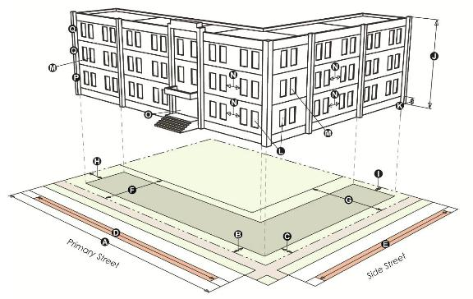

|  |  | **MXG-3**  **MXR-3** | **MXG-5**  **MXR-5** | **MXG-8**  **MXR-8** |  |  |  | **MXG-3**  **MXR-3** | **MXG-5**  **MXR-5** | **MXG-8**  **MXR-8** |
| --- | --- | --- | --- | --- | --- | --- | --- | --- | --- | --- |
|  | **LOT** | | | |  |  | **HEIGHT** | | | |
|  | Area (min. ft.2) | 6,000 | 6,000 | 6,000 |  | http://www.codepublishing.com/co/grandjunction/html2/images/grandj21.23.04.46.jpg | Stories (max.) | 3 | 5 | 8 |
| http://www.codepublishing.com/co/grandjunction/html2/images/grandj21.23.04.47.jpg | Width (min. ft.) | 60 | 60 | 60 |  | http://www.codepublishing.com/co/grandjunction/html2/images/grandj21.23.04.48.jpg | Feet (max.) | 50 | 65 | 100 |
|  | Lot coverage (max.) | 75% | 75% | 75% |  | http://www.codepublishing.com/co/grandjunction/html2/images/grandj21.23.04.49.jpg | Ground story elevation (min. ft.) | 0 | 0 | 0 |
|  | **FRONT SETBACK AREA** | | | |  |  | **BUILDING FACADE** | | | |
| http://www.codepublishing.com/co/grandjunction/html2/images/grandj21.23.04.50.jpg | Primary street (min./max. ft.) | 0/15 | 0/15 | 0/15 |  | http://www.codepublishing.com/co/grandjunction/html2/images/grandj21.23.04.51.jpg | Ground story transparency (min.) | 20% | 20% | 20% |
| http://www.codepublishing.com/co/grandjunction/html2/images/grandj21.23.04.52.jpg | Side street (min./max. ft.) | 0/15 | 0/15 | 0/15 |  | http://www.codepublishing.com/co/grandjunction/html2/images/grandj21.23.04.53.jpg | Upper story transparency (min.) | 20% | 20% | 20% |
|  | **REQUIRED STREET FACADE** | | | |  | http://www.codepublishing.com/co/grandjunction/html2/images/grandj21.23.04.54.jpg | Blank wall area (max. ft.) | 30 | 30 | 30 |
| http://www.codepublishing.com/co/grandjunction/html2/images/grandj21.23.04.55.jpg | Primary street (min.) | 75% | 75% | 75% |  | http://www.codepublishing.com/co/grandjunction/html2/images/grandj21.23.04.56.jpg | Street-facing entrance required | yes | yes | yes |
| http://www.codepublishing.com/co/grandjunction/html2/images/grandj21.23.04.57.jpg | Side street (min.) | 35% | 35% | 35% |  |  | **ALLOWED USE** | | | |
|  | **PARKING SETBACK** | | | |  | http://www.codepublishing.com/co/grandjunction/html2/images/grandj21.23.04.58.jpg | Ground story | Residential | | |
| http://www.codepublishing.com/co/grandjunction/html2/images/grandj21.23.04.59.jpg | Primary street (min. ft.) | 30 | 30 | 30 |  | http://www.codepublishing.com/co/grandjunction/html2/images/grandj21.23.04.60.jpg | Upper story | Residential | | |
| http://www.codepublishing.com/co/grandjunction/html2/images/grandj21.23.04.61.jpg | Side street (min. ft.) | 10 | 10 | 10 |  |  |  |  | | |
|  | **SIDE/REAR SETBACKS** | | | |  |  |  |  | | |
| http://www.codepublishing.com/co/grandjunction/html2/images/grandj21.23.04.62.jpg | Side, interior (min. ft.) | 5 | 5 | 5 |  |
| http://www.codepublishing.com/co/grandjunction/html2/images/grandj21.23.04.63.jpg | Rear (min. ft.) | 15 | 10 | 5 |  |  |  |  |  |  |

(4)    Townhouse. A building form with multiple dwelling units located side-by-side on a single zone lot and consolidated into a single structure that relates to the scale of surrounding houses. Each unit is separated by a common side wall. Units are not vertically mixed. Each unit has its own external entrance.

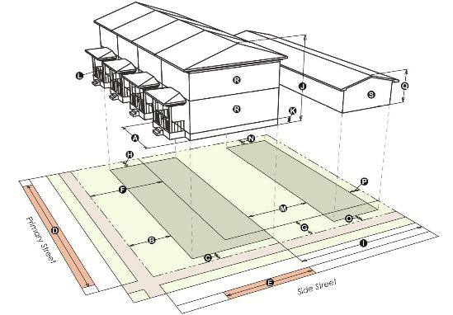

|  |  | **MXG-3, MXR-3** |  |  |  | **MXG-3, MXR-3** |
| --- | --- | --- | --- | --- | --- | --- |
|  | **LOT** |  |  |  | **HEIGHT** |  |
|  | Area (min. ft.2) | 1,200 |  | http://www.codepublishing.com/co/grandjunction/html2/images/grandj21.23.04.65.jpg | Stories (max.) | 3 |
| http://www.codepublishing.com/co/grandjunction/html2/images/grandj21.23.04.66.jpg | Unit width (min. ft.) | 16 |  | http://www.codepublishing.com/co/grandjunction/html2/images/grandj21.23.04.67.jpg | Feet (max.) | 50 |
|  | Lot coverage (max.) | 75% |  | http://www.codepublishing.com/co/grandjunction/html2/images/grandj21.23.04.68.jpg | Ground story elevation (min. ft.) | 1.5 |
|  | **FRONT SETBACK AREA** |  |  |  | **BUILDING FACADE** |  |
| http://www.codepublishing.com/co/grandjunction/html2/images/grandj21.23.04.69.jpg | Primary street (min./max. ft.) | 0/15 |  | http://www.codepublishing.com/co/grandjunction/html2/images/grandj21.23.04.70.jpg | Street-facing entrance required | yes |
| http://www.codepublishing.com/co/grandjunction/html2/images/grandj21.23.04.71.jpg | Side street (min./max. ft.) | 0/15 |  |  | **ACCESSORY STRUCTURE SETBACKS** |  |
|  | **REQUIRED STREET FACADE** |  |  | http://www.codepublishing.com/co/grandjunction/html2/images/grandj21.23.04.72.jpg | Separation from primary structure (min. ft.) | 10 |
| http://www.codepublishing.com/co/grandjunction/html2/images/grandj21.23.04.73.jpg | Primary street (min.) | 75% |  | http://www.codepublishing.com/co/grandjunction/html2/images/grandj21.23.04.74.jpg | Side, interior (min. ft.) | 5 |
| http://www.codepublishing.com/co/grandjunction/html2/images/grandj21.23.04.75.jpg | Side street (min.) | 35% |  | http://www.codepublishing.com/co/grandjunction/html2/images/grandj21.23.04.76.jpg | Side, street (min. ft.) | 10 |
|  | **PARKING SETBACK** |  |  | http://www.codepublishing.com/co/grandjunction/html2/images/grandj21.23.04.77.jpg | Rear (min. ft.) | 5 |
| http://www.codepublishing.com/co/grandjunction/html2/images/grandj21.23.04.78.jpg | Primary street (min. ft.) | 30 |  |  | **ACCESSORY STRUCTURE HEIGHT** |  |
| http://www.codepublishing.com/co/grandjunction/html2/images/grandj21.23.04.79.jpg | Side street (min. ft.) | 10 |  | http://www.codepublishing.com/co/grandjunction/html2/images/grandj21.23.04.80.jpg | Stories (max.) | 2 |
|  | **SIDE/REAR SETBACKS** |  |  | http://www.codepublishing.com/co/grandjunction/html2/images/grandj21.23.04.81.jpg | Feet (max.) | 30 |
| http://www.codepublishing.com/co/grandjunction/html2/images/grandj21.23.04.82.jpg | Side, interior (min. ft.) | 5 |  |  | **ALLOWED USE** |  |
| http://www.codepublishing.com/co/grandjunction/html2/images/grandj21.23.04.83.jpg | Rear (min. ft.) | 10 |  | http://www.codepublishing.com/co/grandjunction/html2/images/grandj21.23.04.84.jpg | All stories | Residential |
|  |  |  |  | http://www.codepublishing.com/co/grandjunction/html2/images/grandj21.23.04.85.jpg | Accessory structure | Accessory uses, Accessory dwellings |

(5)    Civic. A building form containing civic, religious, institutional or public uses. In order to provide a visual landmark, the civic building form is permitted to be set back further than other building forms. Civic buildings are commonly placed on prominent sites.

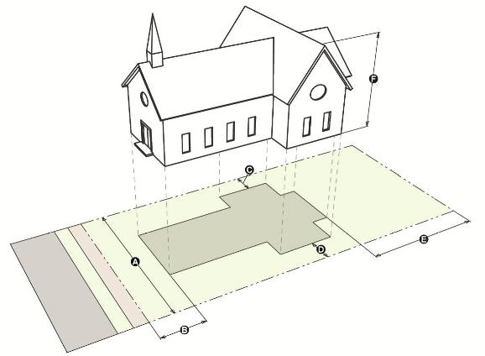

|  |  | **MXG-3**  **MXR-3** | **MXG-5**  **MXR-5** | **MXG-8**  **MXR-8** |
| --- | --- | --- | --- | --- |
|  | **LOT** |  |  |  |
|  | Area (min. ft.2) | 10,000 | 10,000 | 10,000 |
| http://www.codepublishing.com/co/grandjunction/html2/images/grandj21.23.04.87.jpg | Width (min. ft.) | 100 | 100 | 100 |
|  | Lot coverage (max.) | 80% | 80% | 80% |
|  | **SETBACKS** |  |  |  |
| http://www.codepublishing.com/co/grandjunction/html2/images/grandj21.23.04.88.jpg | Front (min. ft.) | 15 | 15 | 15 |
| http://www.codepublishing.com/co/grandjunction/html2/images/grandj21.23.04.89.jpg | Side, interior (min. ft.) | 5 | 5 | 5 |
| http://www.codepublishing.com/co/grandjunction/html2/images/grandj21.23.04.90.jpg | Side, street (min. ft.) | 10 | 10 | 10 |
| http://www.codepublishing.com/co/grandjunction/html2/images/grandj21.23.04.91.jpg | Rear (min. ft.) | 15 | 15 | 15 |
|  | **HEIGHT** |  |  |  |
| http://www.codepublishing.com/co/grandjunction/html2/images/grandj21.23.04.92.jpg | Stories (max.) | 3 | 5 | 8 |
| http://www.codepublishing.com/co/grandjunction/html2/images/grandj21.23.04.93.jpg | Feet (max.) | 50 | 65 | 100 |
|  | **ALLOWED USE** |  |  |  |
|  | All stories | Institutional and Civic | | |

(g)    **Mixed Use Opportunity Corridors.** See GJMC [21.02.140(c)(2)](http://www.codepublishing.com/co/grandjunction/html2/GrandJunction21/GrandJunction2102.html#21.02.140(c)(2)).

(h)    **Additions and New Buildings on Nonconforming Sites.**

(1)    Applicability. Any development in a form district where a maximum setback applies.

(2)    Permitted Additions. Where an existing building is being expanded, the setback area and required building frontage standards apply to the ground level, street-facing facade of the entire addition as set forth below.

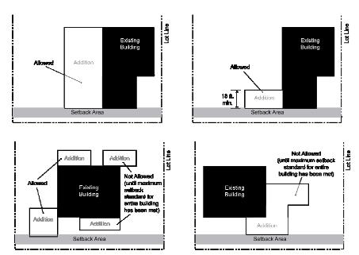

(3)    Permitted New Buildings. Where a new building is being constructed on a site with a nonconforming existing building, the setback area and required building frontage standards apply to the ground level, street-facing facade of the entire new building as set forth below.

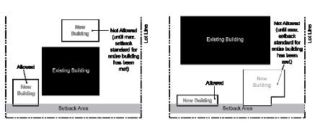

(i)    **Use Categories Allowed in Form Districts.** For the purposes of the form districts, the following use restrictions specific to the form districts are established. The references are to the use categories included in the use table in GJMC [21.04.010](http://www.codepublishing.com/co/grandjunction/html2/GrandJunction21/GrandJunction2104.html#21.04.010).

(1)    Residential. Allows household living; home occupation; and group living use categories.

(2)    Institutional and Civic. Includes colleges and vocational schools; community service; cultural; day care; hospital/clinic; parks and open space; religious assembly; funeral homes/mortuaries/crematories; safety services; schools; utility, basic; utility, corridors use categories, but not detention facilities use category.

(3)    Commercial. Includes entertainment event, major; lodging; office; recreation and entertainment, outdoor; recreation and entertainment, indoor; and retail sales and service (except adult entertainment) use categories. Does not include self-service storage; vehicle repair; vehicle service, limited; parking, commercial; or entertainment event, outdoor use categories.

(4)    Industrial. Includes only the telecommunications facilities use category, but not manufacturing and production, industrial services, contractors and trade shops, oil and gas support operations, junk yard, impound lot, heavy equipment storage/pipe storage, warehouse and freight movement, waste-related use, wholesale sales, agricultural, aviation or surface passenger terminal, mining use categories.

INTRODUCED on first reading the 15th day of January, 2014 and ordered published in pamphlet form.

PASSED and ADOPTED on second reading the 19th day of February, 2014 and ordered published in pamphlet form.

ATTEST:

/s/: Sam Susuras

President of the Council

/s/: Stephanie Tuin

City Clerk