CITY OF GRAND JUNCTION, COLORADO

RESOLUTION NO. 12-02

A RESOLUTION APPROVING THE MASTER PLAN
FOR THE MESA COUNTY PUBLIC LIBRARY DISTRICT
CENTRAL LIBRARY,
LOCATED AT 530 GRAND AVENUE

WHEREAS, on the 22nd day of January, 2002, a public hearing was held by the City of Grand Junction Planning Commission, Grand Junction, Colorado, for recommendation to the City Council for approval of the Mesa County Public Library District, Central Library, and

WHEREAS, on the 6th day of February, 2002, the Grand Junction City Council reviewed the Planning Commission’s recommendation and determined that the master plan for the Mesa County Public Library District complies substantially with the provisions of the Growth Plan, Section 2.20 of the Zoning and Development Code, and the Major Street Plan as well as the Grand Avenue Corridor Plan;

NOW, THEREFORE, BE IT RESOLVED BY THE CITY COUNCIL OF THE CITY OF GRAND JUNCTION:

- That the Master Plan is hereby approved for the Mesa County Public Library District, Central Library, located at 530 Grand Avenue. This site encompasses the 500 block from 5th Street to 6th Street, and from Grand Avenue to Chipeta Avenue, as depicted in Exhibit A.
- The Master Plan’s building zone area encompasses approximately 45,000 square feet with and expansion zone of approximately 26,400 square feet.
- The approved Master Plan shall be valid for a minimum of five years unless otherwise established and all phases of the project shall be developed in conformance with the approved plan.
- An amended Master Plan is required if significant changes are proposed.

ADOPTED this 6th day of February, 2002.

Attest:

/s/: Cindy Enos-Martinez
President of the Council

/s/: Stephanie Tuin
City Clerk

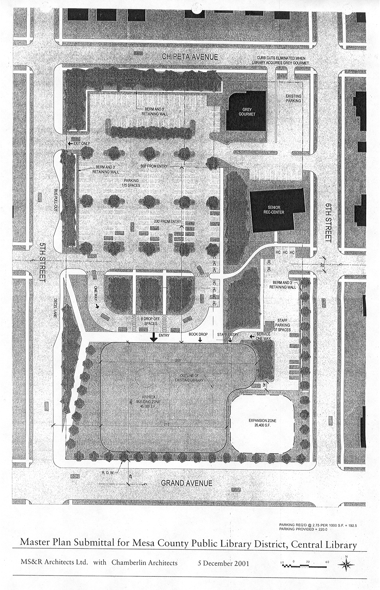
EXHIBIT A

