RESOLUTION NO. 132-02

CONCERNING THE ISSUANCE OF A REVOCABLE PERMIT TO
OUTDOOR PROMOTIONS, INC.

Recitals.

1. Outdoor Promotions, Inc., a Colorado corporation, hereinafter referred to as the Petitioner, represents that it is a legally created entity authorized to conduct business in the State of Colorado. Petitioner represents that it has entered into agreements with the City and the County of Mesa, respectively, which authorizes the Petitioner to provide transit shelters and transit benches at various transit stops in the City’s limits and in Mesa County.

2. The Petitioner has requested that the City Council issue a Revocable Permit to allow the Petitioner to install transit shelters, with advertising where allowed, in the public right-of-way at 40 locations in the City limits and second, to allow for 89 benches, with advertising where allowed, in the public right-of-way. The Petitioner warrants and represents that the transit shelters and benches the Petitioner proposes to install at the locations described below, the locations of which were provided by the Petitioner and described by the Petitioner shall be situated entirely within the limits of the City’s public right-of-way:

3. Based on representations made by the Petitioner, and the fact that Mesa County has entered into an agreement with the Petitioner, the City Council has determined that the request would not at this time be detrimental to the inhabitants of the City of Grand Junction.

NOW, THEREFORE, BE IT RESOLVED BY THE CITY COUNCIL OF THE CITY OF GRAND JUNCTION, COLORADO:

- That the City Manager is hereby authorized and directed to issue the attached Revocable Permit to the above-named Petitioner for the stated purposes, within the City’s public right-of-way in the specific locations shown, subject to each and every term and condition contained herein and in the attached Revocable Permit.

- The City’s existing prohibitions against advertising and signs in residential areas shall apply to each transit shelter and transit bench located adjacent to a residentially zoned area of the City (“residential shelter” and “residential bench”).

- Permittee shall not use or construct any transit shelter in the City’s limits unless it also uses and maintains the ratio of six to one residential shelters (6 to 1) without any signs or advertising on them or within or a part of the residential shelters.

- Permittee shall not use or construct any transit bench in the City’s limits unless it also uses and maintains the ratio of five to one residential benches (5 to 1) without any signs or advertising on them or within or a part of the residential benches.

- The Permittee shall provide a more descriptive street placement of the location of each proposed transit bench or transit shelter, along with the zoning of the adjacent property. The Community Development Department shall then verify the adjacent zoning and locations.

- The Community Development Director shall be authorized to approve changes in location of transit benches and transit shelters and to allow changes from a transit bench to a transit shelter. The Director shall also be allowed to approve the existing locations in newly annexed areas, provided the Permittee brings each transit bench and/or transit shelter into compliance with the City’s standards within 30 days of the effective date of the annexation.

PASSED and ADOPTED this 18th day of December, 2002

Attest:

/s/ Cindy Enos-Martinez
President of the City Council

/s/ Stephanie Tuin
City Clerk
To Outdoor Promotions, Inc.
For Transit Benches and Transit Shelters

Recitals.

1. Outdoor Promotions, Inc., a Colorado corporation, hereinafter referred to as the Petitioner, represents that it is a legally created entity authorized to conduct business in the City and the State of Colorado. Petitioner represents that it has entered into an agreement with the County of Mesa, Colorado pursuant to which the Petitioner will provide Transit benches and Transit shelters at various transit stops in Mesa County.

- The Petitioner has requested that the City Council issue a Revocable
Permit to allow the Petitioner to install 89 Transit benches in the public right-of-way in the City limits, twenty (20) of which shall have no advertising. The Petitioner has also requested that the City Council allow the Petitioner to install forty (40) Transit shelters, four (4) of which shall have no advertising. The Petitioner warrants and represents that the Transit benches and shelters shall be located only at the locations described, which locations were provided by the Petitioner and described by the Petitioner, and shall be situated entirely within the limits of public right-of-way. Exhibit A, attached, is the record of locations, zoning, adjacent property address if available and if advertising is allowed or not.

3. Based on representations made by the Petitioner, the City Council has determined that such action would not at this time be detrimental to the inhabitants of the City of Grand Junction.

NOW, THEREFORE, IN ACCORDANCE WITH THE ACTION OF THE CITY COUNCIL OF THE CITY OF GRAND JUNCTION, COLORADO:

There is hereby issued to the above-named Petitioner a Revocable Permit for the purposes described and within the limits of the public right-of-way described; provided, however, that Petitioner warrants and promises to abide by the following conditions and terms:

- The Petitioner warrants and represents that the Transit benches and Transit shelters are to be installed or maintained by the Petitioner at the above stated locations:
- will be situated entirely within the limits of public right-of-way except as otherwise approved by the Director of Public Works and Utilities in writing upon his receipt of evidence that each affected landowner has consented in writing;
- will not encroach over or across, or be located above, any buried utility or if so, is done at the risk of Petitioners; and
- No transit bench or transit shelter in the City shall be lawful or authorized unless each transit bench or transit shelter adjacent to a residentially zoned area has no advertising or signs, consistent with the City’s Zoning and Development Code.

- The Petitioner shall at all times maintain in effect suitable comprehensive general liability and hazard insurance which will protect the City, its officers, employees, agents and assets from liability in the event of loss of life, personal injury or property damage suffered by any person or persons arising from the facilities of the Petitioner authorized pursuant to this Permit. Such insurance policy shall have terms and amounts approved by the Risk Manager of the City. Such insurance shall not be cancelable without thirty (30) days prior written notice to the City and shall be written for at least a minimum of One Million Dollars ($1,000,000), combined single limit. A current certificate of insurance shall at all times while this Permit is effective be on deposit with the City’s Risk Manager. Such certificate shall designate “the City of Grand Junction, its officers, employees and agents” as additional insureds.

- The installation, operation, maintenance, repair and replacement of transit benches and transit shelters by the Petitioner within the public right-of-way as authorized pursuant to this Permit shall be performed with due care or any other higher standard of care as may be required to avoid creating hazardous or dangerous situations to persons and/or property, and to avoid damaging public or private property and assets, including roadways, sidewalks, utilities, or any other facilities presently existing or which may in the future exist in said right-of-way.

- Petitioner’s use hereunder is subject to the City’s, and its assignees and designees, right and privilege to use all or any portion of a City right of way for any purpose whatsoever. As provided in the City’s charter, Petitioner acknowledges the risk that the City may, without reason being stated, revoke this Permit at any time and in such event Petitioner shall remove all such transit benches and/or transit shelters appurtenances and shall restore the right of way, or private property as the case may be, to the original or better condition prior to Petitioner’s use and installation of such transit bench(s) and or shelter(s). The City Council may revoke particular locations and/or uses under this Permit without revoking the entire permit.

5. The Petitioner, for itself, its officers, share holders, successors and assigns, agrees and covenants that by acceptance of this Permit it releases and waives and covenants that it shall not hold, nor attempt to hold, the City of Grand Junction (and the City’s officers, employees and agents, collectively herein “City”), liable for damages caused to the facilities, personnel, assets, and property to be installed by the Petitioner within the limits of said public right-of-way (including the removal thereof), or any other property of the Petitioner or any other party, as a result of the Petitioner’s occupancy, possession or use of said public right-of-way or as a result of any City activity or use thereof or as a result of the installation, operation, maintenance, repair and replacement of public improvements or City authorized public service providers including utilities.

6. The Petitioner agrees that it shall at all times keep the above described public right-of-way and the facilities authorized pursuant to this Permit in good condition and repair.

- This Revocable Permit shall not be effective except upon concurrent execution by the Petitioner of an agreement that the Petitioner and the Petitioner’s successors and assigns shall save and hold the City of Grand Junction, its officers, employees and agents harmless from, and indemnify the City, its officers, employees and agents, with respect to any claim or cause of action however stated arising out of, or in any way related to, the encroachment or use permitted, and that upon revocation of this Permit by the City the Petitioner shall, at the sole expense and cost of the Petitioner, within thirty (30) days of notice of revocation (which may occur by mailing a first class letter to the last known address), peaceably surrender said public right-of-way and, at its own expense, remove any encroachment so as to make the described public right-of-way available for use by the City or the general public.

- The provisions concerning release, waiver, holding harmless and indemnity shall survive the expiration, revocation, termination or other ending of this Permit .

9. The Petitioner, for itself and for its successors and assigns, agrees that it shall be solely responsible for maintaining and repairing the condition of facilities authorized pursuant to this Permit. The schedule and standards provided for in the City Council’s hearing and/or in the approving resolution, which ever is the most strict and beneficial to the City and its citizens, shall govern.

10. This Revocable Permit, the foregoing Resolution and the following Agreement shall be recorded by the Petitioner, at the Petitioner’s expense, in the office of the Mesa County Clerk and Recorder.

11.The Petitioner shall not assign this Permit or any right or privilege connected
therewith, or allow any other person to install any other facility within the described right-of-way or any part thereof without first obtaining the written consent of the City, which consent must be approved and ratified by the City Council of the City. Any attempt to sublet, assign or transfer without the prior written consent of the City shall be void ab initio. Any consent by the City shall not be a consent to a subsequent assignment or occupation by any other party. Any unauthorized assignment or permission to occupy by the Petitioner shall be void and shall, at the option of the City, provide reasonable cause for the City to revoke this Permit. This Permit shall not be assignable by operation of law without the formal approval and ratification by the City Council of the City.

12. By signing this Permit, Gary Young affirmatively represents that he has
authority to bind Outdoor Promotions, Inc., to the terms and conditions of this Permit.

Dated this ________ day of ______________________, 2002.

The City of Grand Junction,
Attest: a Colorado home rule municipality

City Clerk City Manager

Attest: Outdoor Promotions, Inc.

___________________________
Secretary of Outdoor Promotions Gary D. Young, President

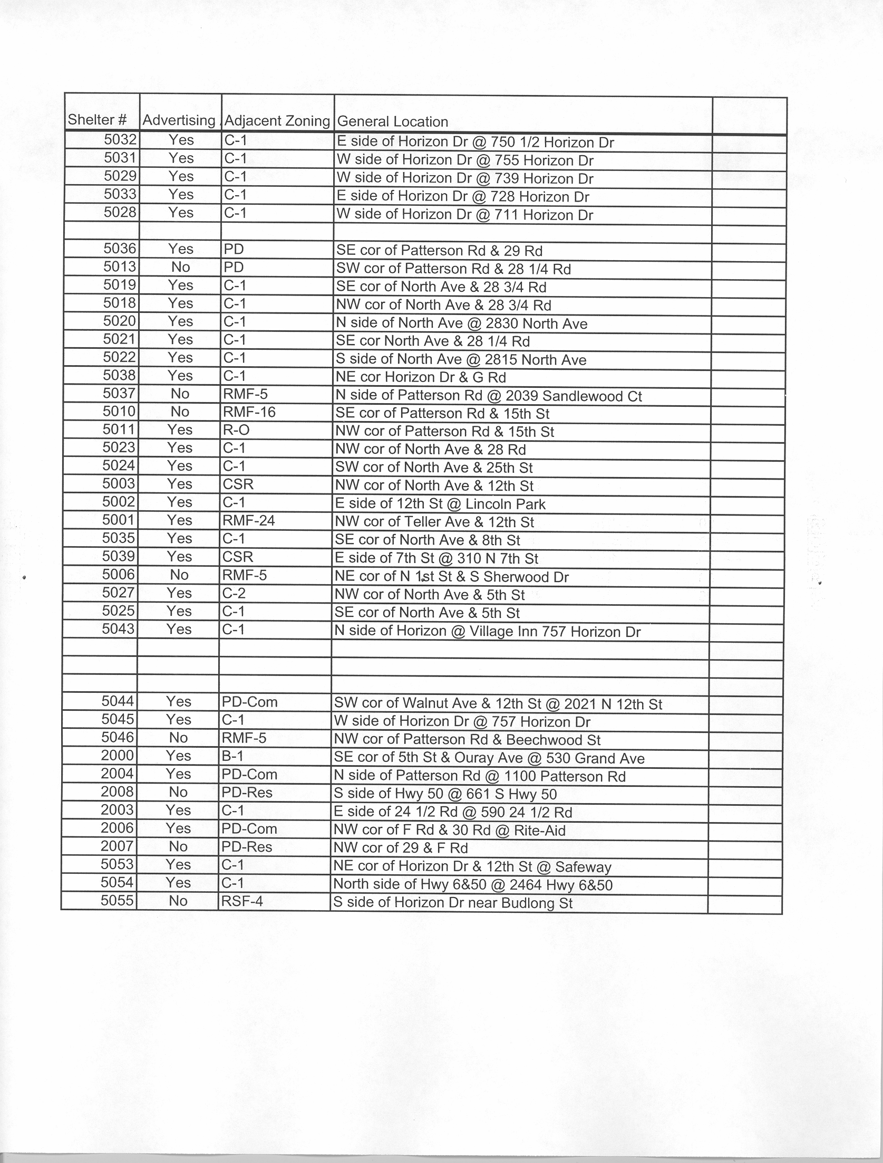
EXHIBIT “A”
