RESOLUTION NO. 97-02
Recorded October 29, 2002
Mesa County Clerk & Recorder, Recept. # 2084237 at Book 3189, Page 321

A RESOLUTION APPROVING A SPECIAL IMPROVEMENT DISTRICT AGREEMENT BETWEEN THE CITY OF GRAND JUNCTION RIMROCK MARKETPLACE GENERAL IMPROVEMENT DISTRICT AND THF BELLEVILLE DEVELOPMENT, L.P.; AND PROVIDING OTHER DETAILS RELATING THERETO.

WHEREAS, the City of Grand Junction Rimrock Marketplace General Improvement District (the "District"), located in the City of Grand Junction, Mesa County, Colorado, is a quasi-municipal corporation duly organized and existing under the Constitution and laws of the State of Colorado; and
WHEREAS, the members of the City Council of the City of Grand Junction (the "Council") have been duly elected and qualified and serve ex officio as the Board of Directors of the District (the "Board"); and
WHEREAS, the Board intends to form a special improvement district within the District (the "Assessment District") the boundaries of which will be coterminous with those of the District; and
WHEREAS, pursuant to Section 31-25-503(10), C.R.S., the Board may enter into a written agreement with the owners of all assessable property within the Assessment District waiving all the requirements for notice, publication and a hearing for the levy of the assessments in the Assessment District and the issuance of the bonds for financing improvements in the Assessment District ; and
WHEREAS, THF Belleville Development, L.P., a Missouri Limited Partnership, (the "Owner") has represented and warranted that it is the sole legal owner of all property to be assessed within the Assessment District; and
WHEREAS, the District and the Owner intend to enter into the Special Improvement District Agreement (the "Agreement") in substantially the form on file with the City Clerk as ex officio Secretary of the District.
NOW THEREFORE, BE IT RESOLVED BY THE CITY COUNCIL OF THE CITY OF GRAND JUNCTION, COLORADO, AS THE EX OFFICIO BOARD OF DIRECTORS OF THE CITY OF GRAND JUNCTION RIMROCK MARKETPLACE GENERAL IMPROVEMENT DISTRICT:

Section All action heretofore taken (consistent with the provisions of this resolution) by the District and the officers thereof, directed toward the election and the objects and purposes herein stated is hereby ratified, approved and confirmed.
Section The form, terms and provisions of the Agreement are approved, and the District shall enter into and perform its obligations under the Agreement in substantially the form of such document presented to the Board in this meeting, with only such changes therein as are required by the circumstances and are not inconsistent herewith; and the officers of the District are hereby authorized and directed to execute and deliver such document as required hereby.
Section The officers of the District are hereby authorized and directed to take all action necessary or appropriate to effectuate the provisions of this resolution.
Section If any section, subsection, paragraph, clause, or provision of this resolution shall for any reason be held to be invalid or unenforceable, the invalidity or unenforceability of such section, subsection, paragraph, clause, or provision shall in no manner affect any remaining provisions of this resolution, the intent being that the same are severable.
Section All orders, resolutions, bylaws, ordinances or regulations of the City, or parts thereof, inconsistent with this resolution are hereby repealed to the extent only of such inconsistency.
ADOPTED AND APPROVED this October 16th, 2002.

/s/: Cindy Enos-Martinez
Mayor ex officio
President of the District
(SEAL)

ATTESTED:

/s/: Stephanie Tuin
City Clerk ex officio
Secretary of the District

STATE OF COLORADO )
)
COUNTY OF MESA )
) SS.
CITY OF GRAND JUNCTION )
RIMROCK MARKETPLACE )
GENERAL IMPROVEMENT DISTRICT )

I, Stephanie Tuin, City Clerk of the City of Grand Junction, Colorado, and ex officio as Secretary of the City of Grand Junction Rimrock Marketplace General Improvement District (the "District") do hereby certify that:

The foregoing is a true and correct copy of a resolution (the "Resolution") passed and adopted at the regular meeting of the City Council serving ex officio as the Board of Directors of the District (the "Board") on October 16, 2002. A quorum of the Board was in attendance at the meeting.

The members of the Board voted on passage and adoption of the Resolution on October 16, 2002, as follows:

Those Voting Aye: Cindy Enos-Martinez
Dennis Kirtland
Harry Butler
William McCurry
James Spehar
Reford C. Theobold

Those Voting Nay: None

Those Absent: Janet Terry

Those Abstaining: None

The Resolution was approved and authenticated by the signature of the Mayor, ex officio President of the Board, sealed with the City seal, attested by the City Clerk, ex officio Secretary of the Board, and recorded in the minutes of the Board.

Attached hereto as Exhibit A is a copy of the notice of the meeting of October 16, 2002, which was posted at Grand Junction City Hall not less then 24 hours in advance of the meeting.

IN WITNESS WHEREOF, I have hereto set my hand and the seal of the City this 16th day of October, 2002.

/s/ Stephanie Tuin
City Clerk ex officio
Secretary of the District

(SEAL)

(Attach Notice of Meeting on October 16, 2002)
EXHIBIT A

GRAND JUNCTION CITY COUNCIL
CITY HALL AUDITORIUM, 250 NORTH 5TH STREET
AGENDA

WEDNESDAY, OCTOBER 16, 2002, 7:30 P.M.

CALL TO ORDER Pledge of Allegiance
Invocation - Pastor Rob Storey, River of Life Alliance Church

PRESENTATION OF CERTIFICATE OF APPOINTMENT

TO THE URBAN TRAILS COMMITTEE MEMBER

TO PARKS AND RECREATION ADVISORY BOARD MEMBER

SCHEDULED CITIZEN COMMENTS

* * * CONSENT CALENDAR * * *

1. Minutes of Previous Meetings Attach 1

Action: Approve the Summary of the September 30, 2002 Workshop, Minutes of the September 30, 2002 Special Meeting, Minutes of the October 2, 2002 Regular Meeting, and Minutes of the October 8, 2002 Special Meeting

2. Setting a Hearing on 430 30 Road Annexations No. 1 and No. 2 Located at 430 30 Road [File #ANX-2002-182] Attach 2

The 430 30 Road Annexation area consists of one parcel of land, approximately 11.18 acres in size. A petition for annexation has been presented as part of a Preliminary Plan, in accordance with the 1998 Persigo Agreement with Mesa County. The physical address for the property is 430 30 Road. This is a serial annexation.

- Referral of Petition, Setting a Hearing and Exercising Land Use Jurisdiction

Resolution No. 91- 02 – A Resolution Referring a Petition to the City Council for the Annexation of Lands to the City of Grand Junction, Colorado, Setting a Hearing on Such Annexation, and Exercising Land Use Control, the 430 30 Road Annexation, Located at 430 30 Road

*Action: Adopt Resolution No. 91-02

- Set a Hearing on Proposed Ordinances

Proposed Ordinance Annexing Territory to the City of Grand Junction, Colorado, 430 30 Road Annexation No. 1, Approximately 5.1706 Acres in Size, Located at 430 30 Road

Proposed Ordinance Annexing Territory to the City of Grand Junction, Colorado, 430 30 Road Annexation No. 2, Approximately 6.2599 Acres in Size, Located at 430 30 Road

Action: Adopt Proposed Ordinances on First Reading and Set a Hearing for November 20, 2002

Staff presentation: Lori V. Bowers, Senior Planner

3. Setting a Hearing on Crista Lee Annexation Located at 2933 B ½ Road [File #ANX-2002-180] Attach 3

The Crista Lee Annexation is an annexation comprised of one parcel of land located at 2933 B ½ Road, comprising a total of 6.1157 acres. The petitioner is seeking annexation as part of a request for Preliminary Plan approval pursuant to the 1998 Persigo Agreement with Mesa County.

  - Referral of Petition, Setting a Hearing and Exercising Land Use Jurisdiction

Resolution No. 92-02 – A Resolution Referring a Petition to the City Council for the Annexation of Lands to the City of Grand Junction, Colorado, Setting a Hearing on Such Annexation, and Exercising Land Use Control, the Crista Lee Annexation Located at 2933 B ½ Road

*Action: Adopt Resolution No. 92-02

b. Set a Hearing on Proposed Ordinance

Proposed Ordinance Annexing Territory to the City of Grand Junction, Colorado, Crista Lee Annexation, Approximately 6.1157 Acres, Located at 2933 B ½ Road

Action: Adopt Proposed Ordinance on First Reading and Set a Hearing for November 20, 2002

Staff presentation: Pat Cecil, Development Services Supervisor

4. Setting a Hearing on Lucas Annexations No. 1 and No. 2 Located at 2220 Broadway [File #ANX-2002-184] Attach 4

The Lucas Annexation is an annexation comprised of two parcels of land located at 2220 Broadway including a portion of the Broadway right-of-way, comprising a total of 3.9221 acres. The petitioner is seeking annexation as part of a request for Preliminary Plan approval pursuant to the 1998 Persigo Agreement with Mesa County.

- Referral of Petition, Setting a Hearing and Exercising Land Use Jurisdiction

Resolution No. 93-02 – A Resolution Referring a Petition to the City Council for the Annexation of Lands to the City of Grand Junction, Colorado, Setting a Hearing on Such Annexation and Exercising Land Use Control, Lucas Annexation No. 1 & 2, a Serial Annexation, Located at 2220 Broadway

*Action: Adopt Resolution No. 93-02

b. Set a Hearing on Proposed Ordinance

Proposed Ordinance Annexing Territory to the City of Grand Junction, Colorado, Lucas Annexation No. 1, Approximately 0.0883 Acres in Size, Located at 2220 Broadway

Proposed Ordinance Annexing Territory to the City of Grand Junction, Colorado, Lucas Annexation No. 2, Approximately 3.8338 Acres in Size, Located at 2220 Broadway

Action: Adopt Proposed Ordinances on First Reading and Set a Hearing for November 20, 2002

Staff Presentation: Pat Cecil, Development Services Supervisor

* * * END OF CONSENT CALENDAR * * *
_____________________________________________________________________

* * * ITEMS NEEDING INDIVIDUAL CONSIDERATION * * *

5. Public Hearing – DM South Annexations #1 & #2 Located at 511 30 Road [File #ANX-2002-138] Attach 5

Resolution for Acceptance of Petition to Annex/Second Reading of the Annexation Ordinance. The 1.7327-acre DM South Annexation is a serial annexation consisting of two parcels of land and a portion of the 30 Road right-of-way.

a. Accepting Petition

Resolution No. 94-02 – A Resolution Accepting Petitions for Annexation, Making Certain Findings, Determining that Property Known as DM South Annexation, a Serial Annexation Comprising DM South Annexation #1 and DM South Annexation #2 is Eligible for Annexation Located at 511 30 Rd

*Action: Adopt Resolution No. 94-02

b. Annexation Ordinances

Ordinance No. 3455 – An Ordinance Annexing Territory to the City of Grand Junction, Colorado DM South Annexation #1 Approximately 0.0207 Acres Located near 511 30 Road within the 30 Road R.O.W.

Ordinance No. 3456 – An Ordinance Annexing Territory to the City of Grand Junction, Colorado, DM South Annexation #2 Approximately 1.712 Acres Located at 511 30 Road and Includes a Portion of 30 Road R.O.W.

*Action: Adopt Ordinance No. 3455 and Ordinance No. 3456 on Second Reading

Staff presentation: Senta Costello, Associate Planner

6. Public Hearing – Zoning DM South Annexation Located at 511 30 Road [File #ANX-2002-138] Attach 6

Second Reading of the Zoning Ordinance for the DM South Annexations #1 & 2 located at 511 30 Rd. The 1.7327-acre DM South Annexation is a serial annexation consisting of one parcel of land and a portion of the 30 Road right-of-way. The Planning Commission reviewed the requested zoning on September 24, 2002 and recommended approval.

Ordinance No. 3457 – An Ordinance Zoning the DM South Annexation to B-1 (Neighborhood Business) Located at 511 30 Road

*Action: Adopt Ordinance No. 3457 on Second Reading

Staff presentation: Senta Costello, Associate Planner

7. Public Hearing – Summit View Meadows Annexations No. 1, No. 2 and No. 3 Located at 3146 D ½ Road [File #ANX-2002-153] Attach 7

A Resolution for acceptance of petition to Annex/Second Reading of the Annexation Ordinance for the Summit View Meadows Annexation, Located at 3146 D ½ Road.

a. Accepting Petition

Resolution No. 95-02 – A Resolution Accepting a Petition for Annexation, Making Certain Findings, Determining that Property Known as the Summit View Meadows Annexation area is Eligible for Annexation, Located at 3146 D ½ Road

*Action: Adopt Resolution No. 95-02

b. Annexation Ordinances

Ordinance No. 3458 – An Ordinance Annexing Territory to the City of Grand Junction, Colorado Summit View Meadows Annexation No. 1 Approximately 0.1699 Acres Right-Of-Way Located along D ½ Road

Ordinance No. 3459 – An Ordinance Annexing Territory to the City of Grand Junction, Colorado Summit View Meadows Annexation No. 2 Approximately 0.5770 Acres Right-Of-Way Located along D ½ Road

Ordinance No. 3460 – An Ordinance Annexing Territory to the City of Grand Junction, Colorado Summit View Meadows Annexation No. 3 Approximately 11.8211 Acres Located at 3146 D ½ Road

*Action: Adopt Ordinance No. 3458, Ordinance No. 3459 and Ordinance No. 3460 on Second Reading

Staff presentation: Lisa Gerstenberger, Senior Planner

8. Public Hearing – Iles Annexation Located at 3080 D ½ Road [File #ANX-2002-171] Attach 8

Resolution for Acceptance of Petition to Annex and Second Reading of the Annexation Ordinance for the Iles Annexation located at 3080 D ½ Road.

a. Accepting Petition

Resolution No. 96-02 – A Resolution Accepting a Petition for Annexation, Making Certain Findings, Determining that Property Known as Iles Annexation Area is Eligible for Annexation Located at 3080 D ½ Road

*Action: Adopt Resolution No. 96-02

b. Annexation Ordinance

Ordinance No. 3461 – An Ordinance Annexing Territory to the City of Grand Junction, Colorado, Iles Annexation Approximately 5.854 Acres Located at 3080 D ½ Road

*Action: Adopt Ordinance No. 3461 on Second Reading

Staff presentation: Lisa Gerstenberger, Senior Planner

9. Public Hearing – Zoning Iles Annexation Located at 3080 D ½ Road [File #ANX-2002-171] Attach 9

Second Reading of the Zoning Ordinance to Zone the Iles Annexation Residential Multi-Family-5 (RMF-5), Located at 3080 D ½ Road.

Ordinance No. 3462 – An Ordinance Zoning the Iles Annexation to Residential Multi-Family-5 (RMF-5), Located at 3080 D 1/2 Road
*Action: Adopt Ordinance No. 3462 on Second Reading

Staff presentation: Lisa Gerstenberger, Senior Planner

10. Public Hearing – Assessments for Alley Improvement District 2002
Attach 10

Improvements to the following alleys have been completed as petitioned by a majority of the adjoining property owners:

- East/West Alley from 2nd to 3rd, between Hill Avenue and Gunnison Avenue
- East/West Alley from 3rd to 4th, between Hill Avenue and Teller Avenue
- East/West Alley from 4th to 5th, between Colorado Avenue and Ute Avenue
- East/West Alley from 11th to 12th, between Grand Avenue and Ouray Avenue
- East/West Alley from 12th to 13th, between Kennedy Avenue and Bunting Avenue
- East/West Alley from 15th to 16th, between Hall Avenue and Texas Avenue
- “T” shaped Alley from 7th to Cannell, between Kennedy Avenue and Bunting Avenue

Ordinance No. 3463 – An Ordinance Approving the Assessable Cost of the Improvements Made in and for Alley Improvement District No. ST-02 in the City of Grand Junction, Colorado, Pursuant to Ordinance No. 178, Adopted and Approved the 11th Day of June, 1910, as Amended; Approving the Apportionment of said Cost to Each Lot or Tract of Land or Other Real Estate in Said District; Assessing the Share of Said Cost Against Each Lot or Tract of Land or Other Real Estate in Said District; Approving the Apportionment of Said Cost and Prescribing the Manner for the Collection and Payment of said Assessment

*Action: Adopt Ordinance No. 3463 on Second Reading

Staff presentation: Rick Marcus, Real Estate Technician

11. Agreement between G.J. Rimrock General Improvement District and the Developer Attach 11

This resolution authorizes an agreement between the City Council (acting as the Board of Directors for the Rimrock Marketplace General Improvement District) and THF Belleville, the owner and developer of Rimrock.

Resolution No. 97-02 – A Resolution Approving a Special Improvement District Agreement Between the City of Grand Junction Rimrock Marketplace General Improvement District and THF Belleville Development, L.P.; and Providing Other Details Relating Thereto

*Action: Adopt Resolution No. 97-02

Staff presentation: Ron Lappi, Administrative Services Director

12. Intergovernmental Agreement with Rural Fire Protection District Attach 12

At an August work session, the City Council directed staff to pursue an Intergovernmental Agreement with the Rural Fire District for the purposes of defining how the relationship for providing fire/EMS services, including a new Fire Station #5, and funding for those services to the subdistrict area (unincorporated Redlands) will be allocated.

Resolution No. 98-02 – A Resolution Authorizing the Mayor to Sign an Intergovernmental Agreement between the City of Grand Junction and the Rural Fire Protection District Regarding the Redlands Subdistrict

*Action: Adopt Resolution No. 98-02

Staff presentation: Kelly Arnold, City Manager
Dan Wilson, City Attorney

13. NON-SCHEDULED CITIZENS & VISITORS

14. OTHER BUSINESS

15. ADJOURNMENT

When Recorded, Return To:
Dee P. Wisor
Sherman & Howard L.L.C.
633 Seventeenth St., Suite 3000
Denver, CO 80202

SPECIAL IMPROVEMENT DISTRICT AGREEMENT

BETWEEN

CITY OF GRAND JUNCTION
RIMROCK MARKETPLACE GENERAL IMPROVEMENT DISTRICT

AND

THF BELLEVILLE DEVELOPMENT, L.P.
A MISSOURI LIMITED PARTNERSHIP

TABLE OF CONTENTS PAGE NO.

ARTICLE 1. CONSTRUCTION 4
1.1. Construction and Acquisition of Project 4
1.2. Excess Bond Proceeds. 9
1.3. Incidental Expenses. 9
1.4 Method of Payment. 10
2.1 Procedure 11
2.2 Financing 11
2.3 Assessed Property, Assessment Roll 11
2.4 Assessment Installments 11
2.5 Waiver 12

ARTICLE 3. MISCELLANEOUS 13
3.1 Agreement of Owner to Provide Letter of Credit 13
3.2 No Third-Party Beneficiaries 13
3.3 Continuing Disclosure 14
3.4 Successors; Assignments 14
3.5 Further Assurances 14
3.6 Severability 14
3.7 Governing Law 14
3.8 No District Obligation 15
3.9 Termination Date 15
3.10 Counterparts 15
3.11 Recordation 15
3.12 Conveyance Restriction 15

EXHIBITS
Property Description A
Title Exceptions B
List of Improvements C
Project Plans With Estimated Commerce and Completion Dates and Costs D
Owner Payment Request Form E
Assessment Roll F
This Special Improvement District Agreement (the "Agreement") for the of financing, construction, installation, completion, and acquisition of certain improvements in the City of Grand Junction Rimrock Marketplace General Improvement District (the "District") between the District, a political subdivision of the State of Colorado (the "State"), and THF Belleville Development, L.P., a Missouri Limited Partnership, as the owner of the property within the District (the "Owner") is made and entered into as of October 29, 2002.

RECITALS
The City of Grand Junction (the "City") has previously formed the District and the District has held an election on November 6, 2001 (the "Election") on the question of authorizing the issuance of bonds or other forms of indebtedness payable from property taxes or special assessments levied against the property in the District.
The Owner has indicated its preference that the indebtedness authorized at the Election be payable from special assessments.
Pursuant to Section 31-25-611.5, C.R.S., the City Council of the City, acting as the ex-officio Board of Directors of the District (the "Board") may establish special improvement districts within the boundaries of the District and levy special assessments within said special improvement districts.
The Board intends to form a special improvement district within the District (the "Assessment District") the boundaries of which will be coterminous with those of the District.
Pursuant to Section 31-25-503(10), C.R.S., the Board may enter into a written agreement with the owners of all assessable property within the Assessment District containing the provisions stated herein.
The Owner represents and warrants that it is the sole legal owner of all property to be assessed within the District, a legal description of the boundaries of which is attached hereto as Exhibit A which boundaries include both the property to be assessed and property owned or to be owned by governmental entities which will not be assessed, and that there are no liens or encumbrances on such property except as shown on Exhibit B.

The Owner has requested that the Board waive all the requirements for notice, publication and a hearing for the levy of the assessments in the Assessment District and the issuance of the Bonds (defined below).
In reliance on this Agreement, the District intends to form the Assessment District, levy the assessments and issue the Bonds.
The Owner proposes to construct certain improvements within the District which the District shall acquire (if the improvements are properly constructed pursuant to the standards in this Agreement) a brief description of which improvements is attached hereto as Exhibit C, including a list of the plans and specifications therefor (such improvements are referred to herein as the "Project").
The Owner proposes that the District finance the Project and the Board is willing to finance the Project by the sale of bonds (the "Bonds") payable from the levy of special assessment pursuant to Title 31, Article 25, Parts 5 and 6, C.R.S. (collectively, the "Act").

NOW, THEREFORE, IN CONSIDERATION OF THE MUTUAL COVENANTS AND CONDITIONS CONTAINED HEREIN, THE PARTIES HERETO AGREE AS FOLLOWS:

ARTICLE 1. CONSTRUCTION .
1.1. Construction and Acquisition of Project .
A. The Owner agrees to construct the Project in accordance with the full and detailed plans and specifications therefor, as approved by the City on October 3, 2002, or as later changed with the approval of the City, and listed on Exhibit C hereto. The original approved set of such plans and specifications are on file with the City Clerk of the City. The Owner has constructed certain portions of the Project and agrees to construct the remainder of the Project within the eighteen months after the date hereof in phases as shown on Exhibit D hereto, which sets forth the estimated cost of the respective phases. The District shall not be required to accept or pay for any phase of the Project unless that phase is constructed in accordance with such full and detailed plans and specifications and any amendments and addenda thereto approved by the City provided that the Owner shall deliver to the District "as built" plans and specifications prior to acceptance by the District. Within 10 days of the final inspection of and agreement to accept each phase of the Project by the District, the Owner shall transfer to the City fee title or an easement as determined by the City, in a form reasonably acceptable to the City to that phase of the Project, except for phases of the Project which are located on real property which is owned in fee by the District or the City.
B. Title. The Owner has provided the District with acceptable evidence of title for the property listed on Exhibit A. At the time of transfer of fee title or easement to any phase of the Project, the Owner will warrant that it has title thereto and that such phase of the Project is free of all mortgages, security interests, mechanics liens or any other encumbrances, except as shown on an updated title report specific to the phase in question which shall be delivered to the City for its review and approval at least 10 days prior to the transfer of fee title or easement to the City. In the event the City does not approve the title report, the City shall not be obligated to accept fee title or easement from the Owner and the District shall not be obligated to pay the Owner for such phase of the Project until the Owner has cured all objections to title to that phase of the Project to the satisfaction of the City. The District approves the title exceptions listed on Exhibit B. At the time of transfer of fee title or easement, the Owner shall provide written lien releases from any contractor, subcontractor or materialman, or any other person who might have the right to file a mechanics lien on the property being transferred. The Owner agrees to warrant and defend the City's fee title or easement to the property being transferred against any claim of encumbrance whatsoever or howsoever and shall pay all of the attorneys fees, costs and related expenses of the District and the City.

C. Warranty of Workmanship and Materials. The Owner at the time of transfer shall warrant to the City that the improvements have been constructed in accordance with the plans and specifications therefor which are listed on Exhibit C hereof, and all amendments and addenda thereto which have been approved by the City and the specifications described in Section 1.1.D. below. The Owner agrees to remedy any defects in any phase of the Project and pay for any damage to other work resulting therefrom, which shall appear within 1 year from the acceptance of that phase of the Project by the City or one year from any replacement or corrective work, whichever is later.
D. Construction Specifications. The construction work performed pursuant to this Agreement is subject to the specifications shown on the plans listed on Exhibit C, as well as standard City permitting, oversight and acceptance processes.
E. Cost Estimates. The Owner has furnished the District with current estimates of the cost of constructing each phase of the Project, in a form and with substance satisfactory to the District. In addition, at the time any contract or change order is executed in connection with the construction of any phase of the Project, if as a result thereof, the estimate of the cost of the phase of the Project previously furnished increases, the Owner shall furnish the District with another updated estimate of such cost, in a form and with substance satisfactory to the District. If the updated estimated cost of that phase exceeds the smaller of (i) the price of that phase as shown on Exhibit D plus any allocation of Bond proceeds available therefor because of a cost underrun on another phase or (ii) the amount of the proceeds of the Bonds available to pay the cost of that phase of the Project, as reasonably determined by the District taking into account any allocation of such Bond proceeds to the Project and to other phases of the Project, the Owner shall furnish to the District a performance bond and payment bond, in a form acceptable to the District, in an amount equal to the amount of such excess at the time of commencement of construction on that phase of the Project. That bond shall remain in effect until acceptance of that phase of the Project by the City. Cost overruns, plus any costs of warranty work (for example, during the one year period following acceptance) may be added to the cost of the project.
F. Payments for Project. At the time of transfer of title to that phase of the Project to the City, the District shall pay to the Owner the actual costs for each phase of the Project but not in excess of the greater of (i) the purchase price of that phase as listed in Exhibit D or (ii) such higher amount as may be available pursuant to the last sentence of this paragraph; provided that the District shall be obligated to pay such purchase price solely from the available proceeds of the Bonds to be hereafter issued by the District. The District agrees that the Finance Director of the City shall timely review each request for payment submitted by the Owner and shall within 7 working days advise the Owner of any deficiency therein or approve the request for payment. Within 14 working days following receipt of the approval of the payment request from the Finance Director of the City, the District shall make or direct to be made the full payment thereon to the Owner. At no time shall the aggregate amount paid by the District to the Owner pursuant to this Agreement exceed the reasonable actual costs to the Owner of the portions of the Project theretofore acquired and then being acquired, as reasonably determined by the District with reference to current market conditions and its prior experience with similar types of construction or otherwise. No payment shall be made for interest on construction loans which the Owner may incur. If the reasonable actual costs of a phase of the Project as reasonably approved by the District exceeds the price therefor as listed in Exhibit D, the District shall not be obligated to pay such difference unless and only to the extent that Bond proceeds are available to pay such excess because the aggregate District and Owner Incidental Expenses are less than the aggregate stated in Section 1.4, or the price paid for another phase of the Project that has already been completed and accepted by the District is less than the price listed for that phase of the Project as listed on Exhibit D or any combination of such factors.
G. Failure to Construct. In the event the Owner does not build a phase of the Project in accordance with the approved final construction drawings and specifications and any amendments and addenda thereto mentioned in paragraph B above, or is late in completing a phase of the Project, the District may, at its option, proceed to build, complete, or rebuild as necessary that phase of the Project so that when completed that phase will be constructed in accordance with the approved final construction drawings and specifications and any amendments or addenda thereto. (If not then prepared, the District may proceed to prepare such final construction drawings and specifications in accordance with the plans and specifications listed on Exhibit C hereto.) The District shall deliver to the Owner notice of its intention to commence to build, complete or rebuild as necessary that phase of the Project. If the Owner does not commence to build, complete or rebuild as necessary that phase of the Project specified in the notice from the District within 30 calendar days after receipt of the notice or if it commences such action within the 30 day period and thereafter ceases to prosecute such action to completion with all due diligence, then the District may, at its option, proceed to commence to build, complete or rebuild as necessary that phase of the Project. The District may apply the proceeds of the Bonds and amounts derived from any payment, performance or guarantee bond applicable to that phase of the Project to the costs of such building, completing or rebuilding (and of preparing construction drawings and specifications, if necessary) and any such costs shall be paid before any pending or later payments pursuant to paragraph F. The price to be paid to the Owner as listed on Exhibit D for any phase of the Project which is built, completed or rebuilt, or for which construction drawings and specifications are prepared, under this subsection shall be reduced by the amount applied by the District to that phase of the Project pursuant to this subsection. If these amounts are insufficient, the District shall make demand on the Owner to pay the amount of the insufficiency and the Owner shall immediately pay the District the amount of the insufficiency. The Owner will be treated as being late in completing any phase of the Project if either (i) that phase of the Project has not been completed within the earlier of (a) eighteen months after title to a lot in the District is transferred to a person or (b) eighteen months (or such longer period to which the parties hereto agree in writing) after a final subdivision plat is recorded for any property in the District which requires the installation of any of the improvements which are contemplated to be installed in that phase of the Project, or (ii) that phase of the Project or any portion thereof has not been completed by the date on which completion thereof was required in any permit issued by any governmental agency (including the District) to the Owner or any other owner or Owner of property in the District. Notwithstanding the foregoing, the Owner shall not be deemed late in completing any phase of the Project to the extent that construction thereof is delayed as a result of occurrences beyond the reasonable control and without the fault or negligence of Owner, including without limitation, fire, earthquake, floods and other out of the ordinary actions of the elements, enemy invasion, war, insurrection, sabotage, laws or orders of governmental, civil or military authorities, governmental restrictions and moratoria, riot, civil commotion and reasonably unavoidable casualty. In the event the Owner is delayed by such occurrences, the time within which the Owner must complete such phase of the Project shall be extended by a reasonable period of time not less than the actual number of days that Owner was delayed as a result of such occurrences, provided that the Owner recommences the construction of such phase at the earliest possible date following the cessation of such occurrence and proceeds with due diligence toward the completion thereof.
H. Cost Overruns. The Owner is responsible for the payment of and agrees to pay all costs of construction (including any costs required to repair and/or replace warranty work required by the City after acceptance of any phase of the Project). which exceed the amount available for that purpose from the proceeds of Bonds.
1.2. Excess Bond Proceeds.
In the event all of the construction of the Project is complete, accepted and payment therefor has been made in full by the District pursuant to Section 1.1 hereof, and all of the District's and Owner's Incidental Costs have been paid pursuant to Section 1.3 hereof, and there remain unexpended proceeds of the Bonds (including interest earned on such proceeds) which are not needed for any purpose related to the Project (with reasonable amounts being retained to pay for warranty work), the assessments or the Bonds, as determined by the District, the District and the Owner may, by agreement, amend the Project to include any other subprojects eligible for financing under the Act, that benefit the property assessed in the District and such unexpended Bond proceeds may be expended on such additional subprojects. If no such amendment is made or if after such an amendment, there still remains unexpended Bond proceeds, these unexpended proceeds shall be applied as soon as is reasonably possible to call bonds, and to the extent of proceeds remaining that are insufficient to call bonds, to pay debt service on the Bonds and to reduce, pro rata, the next assessment installment payments on each parcel of property in the District with an appropriate cash payment to the owner of any assessed parcel whose assessment has been paid in full.
1.3. Incidental Expenses.
The Owner and the District shall be entitled to be reimbursed for their incidental expenses ("Incidental Expense") as follows:
A. Owner Incidental Expenses. The Owner shall be entitled to be reimbursed from Bond proceeds for the actual costs of the following estimated Incidental Expenses incurred and paid by the Owner in connection with the District, up to an amount not exceeding $775,000 (unless additional amounts are available from cost underruns on the Project or the District's Incidental Expenses): engineering, architect and survey expenses (estimated at $310,000); legal expenses (estimated at $40,000); right of way acquisition costs (estimated at $415,000); other non-construction costs associated with the District (CDOT fee at $10,000). The District will, upon presentation of evidence of payment of the foregoing expenses by the Owner and approval thereof by the District, pay to the Owner the cost incurred, but only from the available proceeds of the Bonds.
B. District Incidental Expenses. The District shall be entitled to pay the following Incidental Expenses directly from the proceeds of the Bonds and any other monies provided to the District by the Owner for that purpose: (1) the District's cost of issuing the Bonds, which is estimated to be $167,500 and which includes the estimated fees and expenses of bond counsel ($45,000), the estimated cost of official statement printing and mailing ($2,500), the other costs listed in the purchase contract for the Bonds to be paid by the District including the estimated underwriter's discount ($30,000), the estimated costs of the Letter of Credit ($90,000), and the District's other estimated expenses in connection with the issuance of the Bonds ($1,000); (2) the estimated cost of publications and notices ($1,000); (3) the estimated amount of the District's other costs of creating the District and the Assessment District and administrating the acquisition and construction of the Project, including legal expenses ($1000) and (4) the estimated amount of the District's administrative expenses related to the District and the Project (including without limitation the costs for consultants and District staff in connection with submittal reviews and approvals) for two years ($2000). If the deposit made by the Owner for District costs and the available Bond proceeds are not sufficient to pay the District's Incidental Expenses, the Owner shall, at the request of the District, pay the amounts needed.
1.4 Method of Payment. Payments made to the Owner, whether for the cost of a phase of the project or for reimbursement of Incidental Expenses (as described in Section 1.3.A.), shall be made only on execution of a request for such payment signed by the Owner in the form attached as Exhibit E, by check or draft made out to the party designated in and mailed as provided in the form found at Exhibit E. The Owner agrees to not request a payment in an amount of less than $100,000, except for the final payment.
1.5 District Authorized to Pay. The District is authorized to directly pay all expenses listed in Section 1.3.B., without further authorization from the Owner, and shall provide to the Owner, each quarter beginning three months after the date of issuance of the Bonds, with a copy of any invoice received with respect to those costs, or in the case of internal costs, other evidence of those costs.
ARTICLE 2. ASSESSMENTS.
2.1 Procedure . The Owner agrees that the District may proceed to order that the Project be acquired and improved, form the Assessment District, issue the Bonds and otherwise finance the cost of the Project and levy the assessments without complying with the notice and hearing provisions of the Act. The Owner agrees that the District may create the Assessment District, levy assessments, issue the Bonds and for all other purposes relating to the District proceed pursuant to the provisions of the Act.
2.2 Financing . The District agrees to proceed with the financing of the Project by levying assessments against the property in the District and issuing the Bonds in the manner described herein.
2.3 Assessed Property, Assessment Roll . The District will levy assessments against that property in the District described on Exhibit F, as provided in the assessment ordinance to be adopted by the Board, and the amount of the assessments against each parcel of property in the District will not exceed that listed in the assessment roll attached hereto as Exhibit F. The final amount of the assessment against each parcel shall be determined in the sole discretion of the District based upon the information provided by the Owner.
2.4 Assessment Installments . Pursuant to Section 31-25-527 of the Act, the Owner hereby elects to pay the assessments in installments of principal and interest as may hereafter be fixed by the assessment ordinance. There will be not more than 15 substantially equal annual installments of principal and interest. The Owner hereby waives the right to pay the whole assessment within 30 days after final publication of the assessment ordinance. The assessments will bear interest at a rate not to exceed 1% above the highest interest rate on the Bonds.
2.5 Waiver . The Owner agrees: (i) that all of the property owned by it in the District is benefitted by the improvements proposed to be acquired and constructed in the District by an amount at least equal to the amount proposed to be assessed against those properties listed in the assessment roll attached as Exhibit F; and (ii) that the District may assess those properties in the amounts listed in the assessment roll. The Owner hereby waives: (a) any and all formalities required by the laws of the United States and the State of Colorado in order to impose such assessments, including, but not limited to, the notice and hearing provisions of Sections 31-25-520 and 521 of the Act; and (b) the Owner's right to bring a legal or equitable action challenging the creation or existence of the Assessment District or the District, the assessments, the assessment ordinance, or the Bonds pursuant to Section 31-25-538 of the Act, or any other law. The Owner consents and agrees to the assessments listed in the assessment roll for the property and agrees that those assessments must be paid regardless of whether any or all of the improvements proposed to be constructed as described herein are in fact constructed and agrees that the District may proceed to collect and enforce the assessments in the manner described herein regardless of whether it completes the acquisition or construction of the improvements. The Owner waives all powers, privileges, immunities and rights as against the District arising from or following from irregularities or defects, if any, occurring in connection with or ensuing from the actions, proceedings, matters and things heretofore taken or hereafter to be taken had and done by the District, the Board and the officers of the District (including, without limitation, the proper description of all property which the Owner owns within the District and the giving of proper notice of the proceedings relating to the District) concerning the creation of the District and the Assessment District, the levying of special assessments to meet the cost and expenses of the Project, and the issuance of the Bonds. The Owner consents and agrees to be bound and consents and agrees that all property in the District owned by the Owner be bound and be subject to the assessment lien as thoroughly and effectively as if all actions, proceedings, notices, matters and things had been taken and done free from irregularities. The Owner also represents and warrants that the market value of each parcel owned by it in the District on the date of execution hereof and the date the assessments are levied exceeds the amount of the assessment proposed to be made against each such parcel.
ARTICLE 3. MISCELLANEOUS.
3.1 Agreement of Owner to Provide Letter of Credit . The Owner hereby agrees that it shall provide a letter of credit in form and substance satisfactory to the District (the "Letter of Credit"). The Letter of Credit shall: a) be executed in favor of the District; b) shall be dated on or before the date of delivery of the Bonds; c) allow draws by the District in an amount at least equal to the principal of the assessments described herein and 365 days of interest on said principal at a rate not to exceed 1.00% above the highest interest rate on the Bonds; d) allow for draws by the District if the assessments are not paid when due or when the Letter of Credit is not extended and set to expire according to its terms; e) be noncancellable prior to issuance of final Certificates of Occupancy by the City to Lowe's and Wal-Mart (the expected anchor tenants of the property in the District); and f) be provided by LaSalle Bank or such other financial institution acceptable to the District.
3.2 Third-Party Beneficiaries . The City shall be a third party beneficiary of this Agreement. Except for the City, none of the provisions of this Agreement is intended to make any person who is not a party to this Agreement, including, without limitation, the subsequent owners of property assessed, the general public or any member thereof, a third party beneficiary hereunder or to authorize anyone who is not a party to this Agreement to maintain any suit pursuant to this Agreement for any reason, including, without limitation, any suit for personal injuries or property damage.

3.3 Continuing Disclosure . The District and the Owner agree to execute a continuing disclosure agreement or certificate in a mutually acceptable form prior to the issuance of the Bonds obligating each party to make certain disclosures on an ongoing basis as required under Rule 15c2-12 of the United States Securities Exchange Commission. If the parties are unable to agree on a form of agreement or certificate, the Bonds will not be issued unless they qualify for an exemption from Rule 15c2-12.
3.4 Successors; Assignments . This Agreement shall be binding upon and inure to the benefit of the District, the Owner, and their respective successors and assigns. No assignment of this Agreement or any right or obligation hereunder by the Owner shall be valid unless the District consents to such assignment in writing.
3.5 Further Assurances . The Owner and the District agree to do such further acts and things and to execute and deliver to the other such additional certificates, documents and instruments as the other may reasonably require or deem advisable to carry into effect the purposes of this Agreement or to better assure and confirm unto the other party its rights, powers, and remedies hereunder. The Owner shall execute all consents, certificates and other documents which the District or bond underwriter reasonably request in connection with the sale of the Bonds.
3.6 Severability . If any provision of this Agreement is deemed to be invalid or unenforceable, such invalidity or unenforceability shall not affect the remaining provisions hereof that can be given effect without the invalid or unenforceable provision and the District and Owner agree to replace such invalid or unenforceable provision with a valid provision which has, as nearly as possible, the same effect.
3.7 Governing Law . This Agreement shall be governed by and construed in accordance with the laws of the State of Colorado. The parties agree that exclusive venue for any litigation arising out of or relating to the Project, the Bonds, the District or the assessments shall be in the district court located in Mesa County.
3.8 No District Obligation . Nothing herein obligates the District to expend any money other than funds derived from the sale of the Bonds, amounts received from the investment thereof, and receipts from the assessments made against the property in the District.
3.9 Termination Date . Except as otherwise provided herein, this Agreement shall be in effect from the date and year first mentioned above until the later of: (i) the date all of the Bonds and all bonds issued to refund any of the Bonds (including through a series of refundings) have been retired; or (ii) the date on which all of the assessments against property in the District have been paid in full. In addition the City may at its exclusive option terminate this Agreement if the Bonds are not issued by July 1, 2003.
3.10 Counterparts . This Agreement may be executed on one or more counterparts, each of which shall be regarded as an original and all of which shall constitute the same Agreement.
3.11 Recordation . After this Agreement is executed in full, the District shall, within ten working days, record this Agreement in the office the Clerk and Recorder of Mesa County, Colorado (the "Clerk"), after which this Agreement is a binding obligation on all subsequent owners of the Owner's property in the District pursuant to the terms hereof;
3.12 Conveyance Restriction . The Owner agrees not to convey any parcel, lot or real property interest in any land described in Exhibit A to any party until after this Agreement or the final plat for the property has been recorded in the office of the Clerk, whichever is later.

[Remainder of page left blank intentionally]

IN WITNESS WHEREOF the District and the Owner have caused this Agreement to be executed as of the day and year first mentioned above.

CITY OF GRAND JUNCTION, COLORADO, RIMROCK MARKETPLACE GENERAL IMPROVEMENT DISTRICT

___________________________________
President
(SEAL)

Secretary

Approved as to Form:

City Attorney

THF BELLEVILLE DEVELOPMENT, L.P.
A MISSOURI LIMITED PARTNERSHIP

___________________________________ By: THF Belleville Inc.,
a Missouri Corporation, General Partner
By: Michael Staenberg
Title: President
STATE OF COLORADO )
) ss.
CITY OF GRAND JUNCTION )

This instrument was acknowledged before me on October __, 2002, by __________, as President of the City of Grand Junction Rimrock Marketplace General Improvement District.

Witness my hand and official seal.

________________________________
Notary Public for the State of Colorado

(NOTARY SEAL)

STATE OF COLORADO )
) ss.
CITY OF GRAND JUNCTION )

This instrument was acknowledged before me on October __, 2002, by ________, as Secretary of the City of Grand Junction Rimrock Marketplace General Improvement District.

Witness my hand and official seal.

________________________________
Notary Public for the State of Colorado

(NOTARY SEAL)

STATE OF COLORADO )
) ss.
CITY OF GRAND JUNCTION )

This instrument was acknowledged before me on October __, 2002 by Michael Staenberg as President of THF Belleville Inc., a Missouri Corporation, as General Partner of THF Belleville Development, L.P., a Missouri Limited Partnership.

Witness my hand and official seal.

________________________________
Notary Public for the State of Colorado
(NOTARY SEAL)

Exhibit A
Description of Property
LOT 1, RIMROCK MARKET PLACE
MESA COUNTY, COLORADO

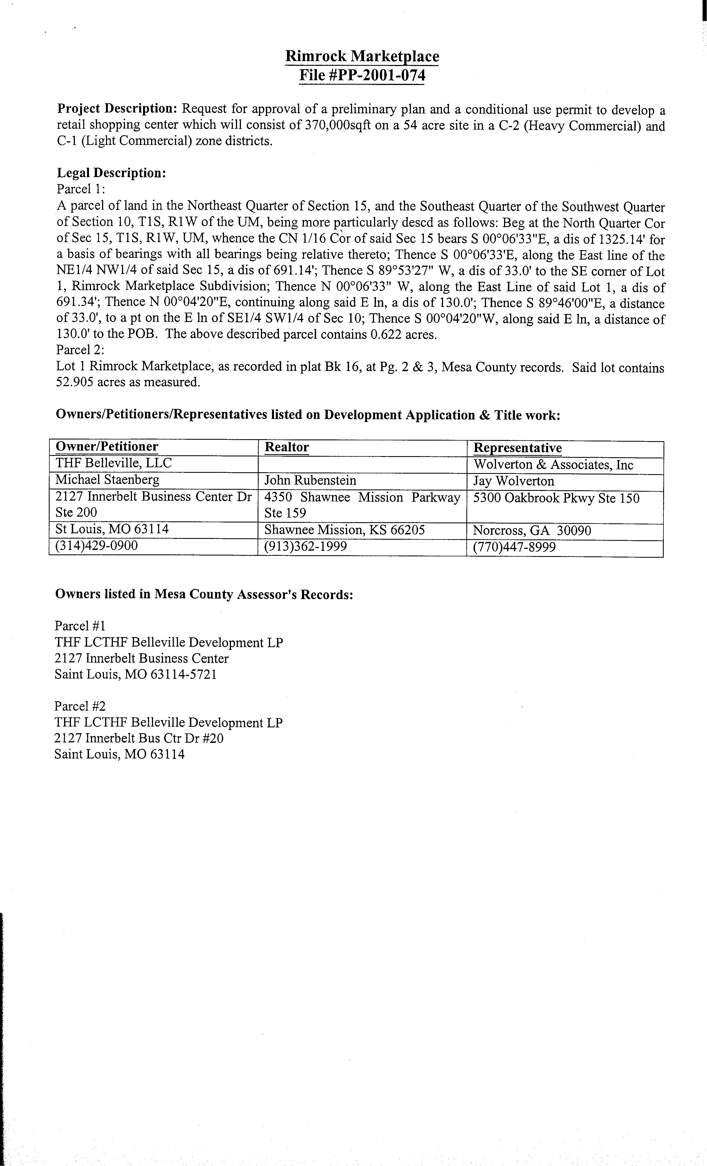

l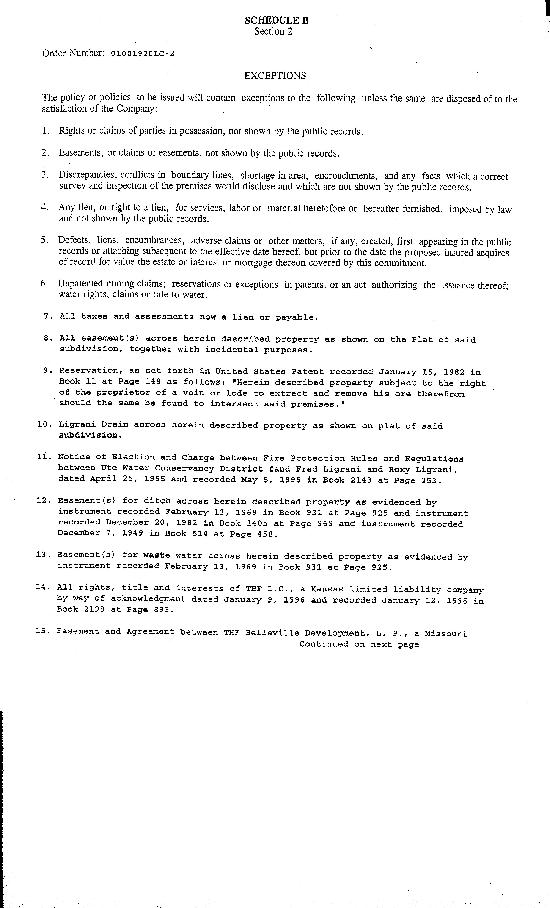
Exhibit B
Title
Exceptions
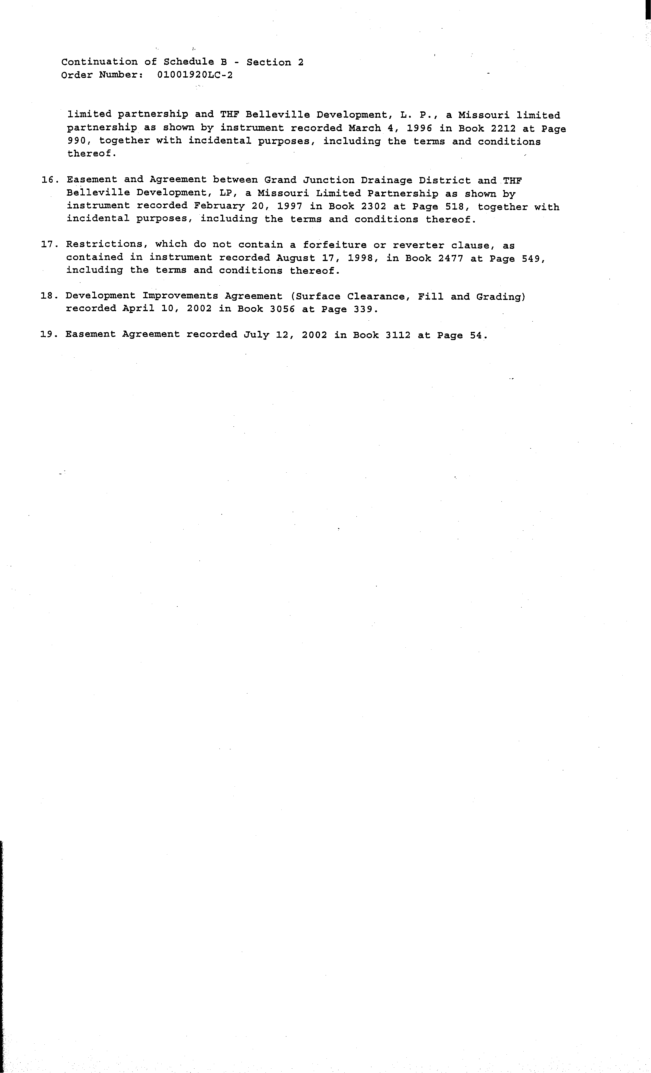
Exhibit C
List of Plans for Improvements

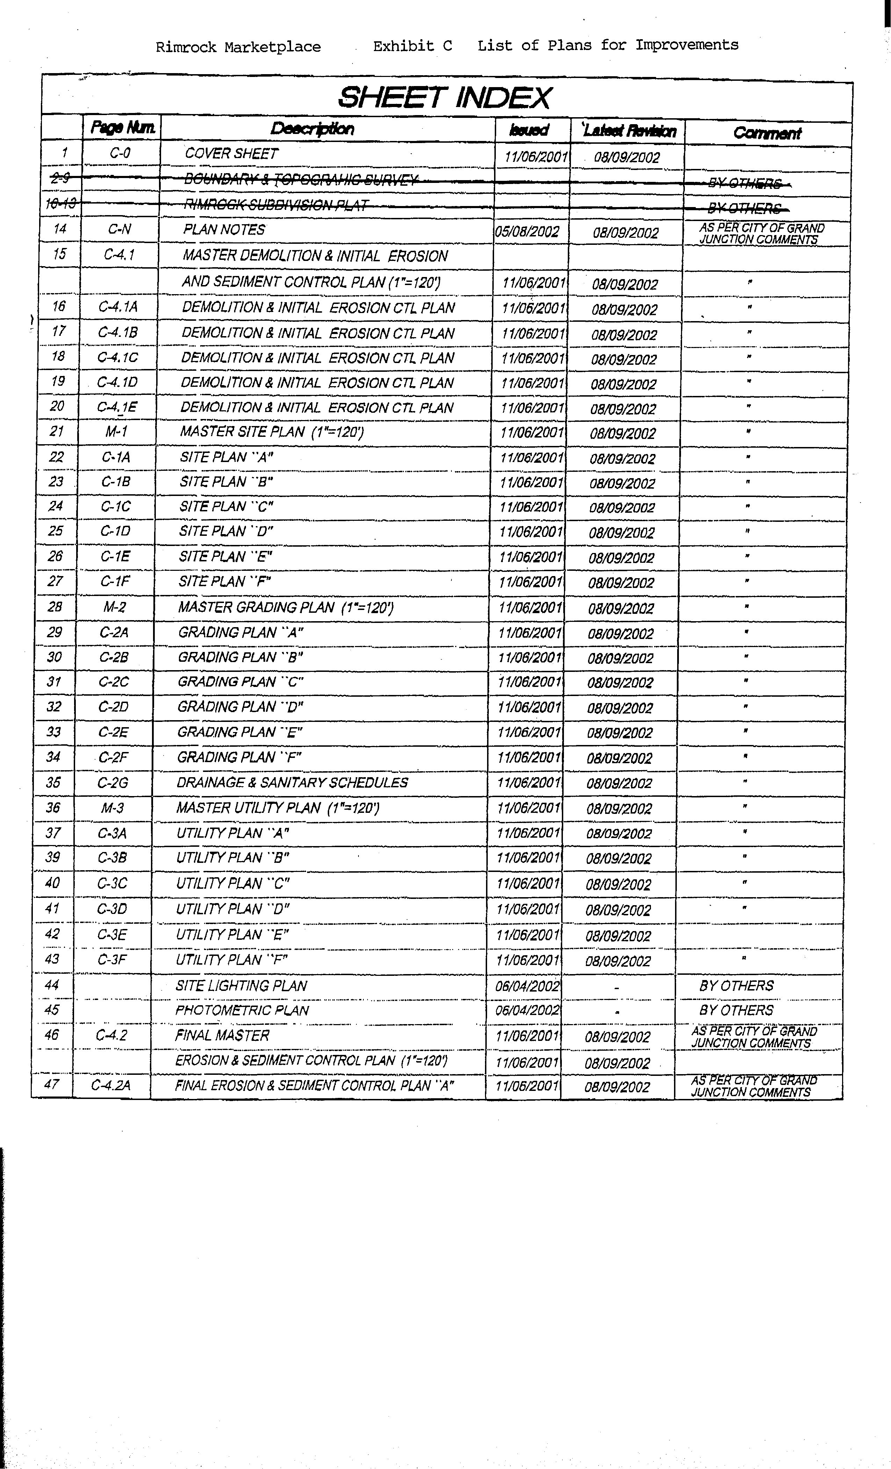
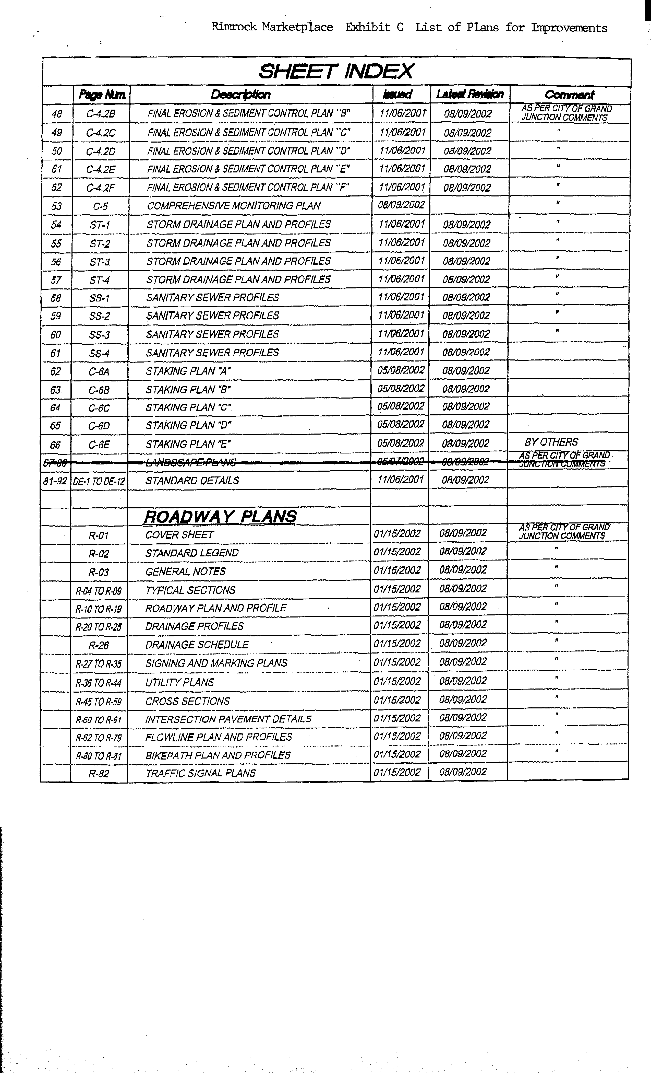
Exhibit D
Project Phases with Estimated Costs

Improvement Estimated Estimated
Draw Date Draw

1. Grand Junction Drainage Ditch Complete $ 450,000

2. Rimrock Avenue / 25-1/2 Road
(a) Payment #1 15-Dec-02 $ 612,850
(b) Payment #2 15-Jan-03 $ 524,968

3. Highway 6 & 50
(a) Payment #1 15-Apr-03 $ 91,080
(b) Payment #2 15-May-03 $ 141,915
(c) Payment #3 15-Jun-03 $ 423,330

4. Signalization of Highway 6 & 50 15-May-03 $ 275,000

5. Sam's Club ROW Construction*
(a) Payment #1 15-Nov-02 $ 46,785
(b) Payment #2 15-Dec-02 $ 48,215

6. Roundabout
(a) Payment #1 15-Apr-03 $ 41,410
(b) Payment #2 15-Jun-03 $ 55,105
(c) Payment #3 15-Jul-03 $ 254,332

7. Golden Corral ROW Construction* 15-Jun-03 $ 38,785
15-Jul-03 $ 26,215

8. Contingency, General Conditions & Fees Paid as incurred $ 112,500

Total $ 3,142,490

*These estimated costs are in Section 1.3(A)

Exhibit E

Owner Payment Request Form

To: City of Grand Junction Date: __________
Rimrock Marketplace General Improvement District
Attention: Mr. Ron Lappi
250 North 5th Street
Grand Junction, CO 81501-2668

Dear Mr. Lappi:

Attached please find documentation [including lien releases] evidencing a payment request in the total amount of $ _________________. The payment request is as contemplated by described in the Financing Agreement for the expenses and costs heretofore paid by the Owner and listed in the attached itemized statement, as contemplated by the Financing Agreement between us and the City of Grand Junction Rimrock Marketplace General Improvement District dated October __, 2002: (itemize and detail expenses or costs on an attached sheet (s))

Please remit payment to the following party and address:
____________________________________________
____________________________________________
____________________________________________
____________________________________________

Thank you.
___________________________________

By:________________________________
Title: ______________________________

Approved for payment:

______________________________________
Ron Lappi, Finance Director
Date: _________________________________

Exhibit F
Assessment Roll

Lot 1, Rimrock Market Place
Mesa County, Colorado
100%
Maximum Bond Issue
$3,980,000

[Note: As of October 24, 2002, the City has approved a replat of the following parcels. The Developer is working on completing the final “punch list” before the replat will be recorded.]

Acres %

Lot 1 Blk 1 14.985 31.62%
Lot 2 Blk 1 3.914 8.26%
Lot 3 Blk 1 20.402 43.05%
Lot 1 Blk 2 1.929 4.07%
Lot 1 Blk 3 4.700 9.92%
Lot 1 Blk 4 1.460 3.08%
47.390 100.00%

