CITY COUNCIL, CITY OF GRAND JUNCTION
RESOLUTION NO. 82-03

A RESOLUTION AMENDING THE GRAND VALLEY CIRCULATION PLAN BY CHANGING THE CLASSIFICATION OF B ¾ ROAD (FROM 28 ½ ROAD TO 29 ROAD) FROM RESIDENTIAL COLLECTOR TO LOCAL ROAD

Recitals:

The Grand Valley Circulation Plan, formerly known as the Major Street Plan, (referred to as “the Plan” hereinafter) identifies both major and minor transportation, circulation and connectivity routes and opportunities. The Plan is made and adopted pursuant to and in accordance with the Colorado Revised Statutes and the Grand Junction Zoning and Development Code.

On July 8, 2003, the Grand Junction Planning Commission recommended approval of an amendment to the Plan. That amendment created a district map for the area described herein. A copy of the map is attached hereto and incorporated by this reference. On July 31, 2003, the Mesa County Planning Commission approved the amendment.

The Plan assists owners and developers to be better able to plan and provide the needed connectivity within and through the area and outlines the needs and the goals of the developers and others in the community in contributing to that effort.

The Plan will facilitate development of both large and small parcels and if successfully implemented will help minimize congestion at major intersections by providing primary and secondary routes and other alternatives for circulation, connectivity and access.

In accordance with section 1.11B.3 of the Zoning and Development Code, the City Council shall, as it deems appropriate, decide, adopt and/or amend the City’s street plans and components of it. For the reasons stated in the foregoing recitals, the Grand Junction Planning Commission and the staff recommend that the City Council adopt the amendment to the Grand Valley Circulation Plan as proposed in the attached map marked “Grand Valley Circulation Plan - District Map “B ¾ Road (from 28 ½ Road to 29 Road) from Residential Collector to Local Road” dated July, 2003.

NOW THEREFORE, BE IT RESOLVED BY THE CITY COUNCIL OF THE CITY OF GRAND JUNCTION THAT:

The Grand Valley Circulation Plan is hereby amended to include the above described district map.

PASSED AND ADOPTED this 3rd day of September 2003 by the City Council of the City of Grand Junction.

ATTEST:

/s/ Jim Spehar /s/ Stephanie Tuin
Jim Spehar Stephanie Tuin
President of the City Council City Clerk
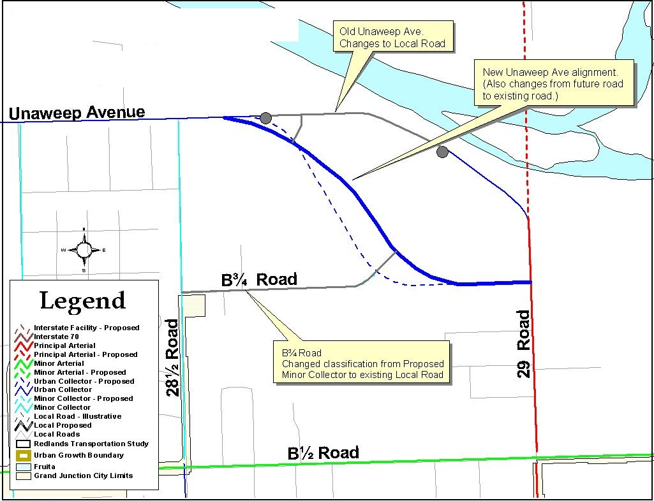

B ¾ Road District Map
Grand Valley Circulation Plan Amendment
July 2003

