RESOLUTION NO. 124-04

A RESOLUTION OF THE CITY OF GRAND JUNCTION CONCERNING ADOPTION OF A MEMORANDUM OF UNDERSTANDING BETWEEN THE CITY OF GRAND JUNCTION AND MESA COUNTY (WATERSHED MOU)

WHEREAS, The City and County wish to cooperate in land use decision making and planning by consulting about land use decisions for areas that are located in the City’s watershed areas; and,

WHEREAS, the City and County have reached an agreement to effect this cooperation effort;

NOW, THEREFORE, BE IT RESOLVED BY THE CITY COUNCIL OF THE CITY OF GRAND JUNCTION, COLORADO:

That the Memorandum of Understanding between the City of Grand Junction and Mesa County, Colorado, hereto attached, is adopted by the City Council of the City of Grand Junction, Colorado on December 1, 2004.

CITY OF GRAND JUNCTION

/s/: Gregg Palmer
Gregg Palmer, Mayor Pro Tem
Grand Junction City Council

Attest:

/s/: Stephanie Tuin
Stephanie Tuin
City Clerk

Memorandum of Understanding
Between The City of Grand Junction
And
Mesa County Colorado

This MEMORANDUM OF UNDERSTANDING (MOU) is made and entered into by and between the City of Grand Junction, hereinafter referred to as the City and Mesa County, hereinafter referred to as the County, as political subdivisions of the State of Colorado.

RECITALS:

The purpose of this MOU is to establish a mechanism for effective consultation in the processes and practices of making and implementing land use decisions by the County in the Grand Junction Watershed Area outlined on the Map (“City of Grand Junction Watershed Area,”) dated November 22, 2004 – Map Labeled Exhibit A attached hereto and made a part hereof by this reference, by providing for appropriate involvement by the City in the review of development applications in the Watershed Area.

This MOU is entered into under the authority of 29-4-101 C.R.S. et. seq. Article XIV, Section 18 of the Colorado Constitution and legislation pursuant thereto; namely, C.R.S., §29-1-201, et seq. Article XX, Section 10 of the Colorado Constitution to providing for Home Rule and the City’s Charter. Local Government Land Use Enabling Act, C.R.S., §29-20-105, et seq. Title 31 of the Colorado Revised Statutes.

IT IS MUTUALLY UNDERSTOOD AND AGREED BY AND BETWEEN THE PARTIES THAT THE CITY AND THE COUNTY WILL:

1. Cooperate in land-use decision making and planning by consulting about land use decisions and preparation of land-use plans for areas under County jurisdiction that are located in the City's Watershed Area.

2. Consultation includes providing advance notice, an opportunity to review and meaningfully comment on proposed plans and activities, and the incorporation of appropriate protective stipulations and agreements into plans, decisions and programs. Examples of actions when consultation will be required include, but are not limited to, road construction, a determination of existing and future land uses, and development, as defined by the County code, which includes but is not limited to energy and mineral development and planning and construction of rights-of-ways and facilities to support or in service of extractive uses or other development.

The County will:

Amend, revise and enforce its plan(s) and to the extent necessary to protect the City’s watersheds and water resources in the Watershed Area.

Prepare and maintain a current list of existing Codes, plans, agreements, licenses, permits and projects with respect to the land area that is the subject of this agreement.

Prepare and maintain a current list of future projects of mutual interest to the City and County.

Annually review with the City the preceding year’s development activities and share information collected as part of the development review process (monitoring data and analysis, site inspection reports, traffic counts and other data); and meet as required to discuss upcoming projects related to or that may impact the watershed.

Discussion topics include, but are not limited to:
Kannah Creek Water System Capacity
Septic tanks
Stormwater Authority/BMP’s
Watershed Health Assessment

Discuss in advance any changes in the development information/application to be collected and/or changes to the County Code or review techniques to be utilized.

Participate with the City in strengthening the definition and implementation of best management practices (BMP) and the prescriptions of the same in the Watershed Area.

Allow the City to collect additional information about the impact of development on/within the watersheds as required by the City.

Prioritize road construction and identify maintenance practices/road improvement(s) within the watershed area based on a project’s potential risk of adverse impacts to water quality.

Allow the City to post “Municipal Watershed Boundary” and other advisory or regulatory signs along roads as necessary to assist in the management of the watershed and to help protect water and land quality. The location of all signs will be approved by the County prior to installation.

Provide the City with advance notice of all project activities or proposals within the Watershed Area.

Unless an applicant establishes from verifiable data that the risks to water quality in the Watershed Area are speculative or insubstantial, the County shall deny requests for surface occupancy for mineral and/or oil/gas exploration and/or production.

Stipulate in development approvals that approved uses shall comply with all requirements of the County's codes.

The City will:

Provide for meaningful involvement of the County in designation of the City’s Watershed Area and any City effort to require best management practices of those operating or acting within the City’s watersheds.

Discussion topics:
Stormwater BMP’s
Grazing BMP’s
Kannah Creek-Whitewater Creek management BMP’s (cooperative use/reuse i.e., Massey, Lumbardy et. al.)
Oil and gas development

The County’s involvement in activities that may affect the City watershed includes:

- coordination and sharing of land and related inventories, studies and data;

- working with the County to resolve misunderstandings between City and County plans.

Make available to the County, City data that may be necessary to County operations, plans or activities in or upon the Watershed Area.

Make City expertise and/or personnel available for data gathering, environmental studies and land-use planning which would be mutually beneficial, subject to the City’s financial and personnel constraints.

Other:

Any information furnished to the County or the City under this agreement is subject to the Colorado Open Records Act, 24-72-101 et. seq. C.R.S. (2004).

This agreement in no way restricts the County or the City from participating in similar activities with other public or private agencies, organizations and individuals.

The County and the City will budget and expend their own funds in pursuing the objectives of this agreement. The City and the County may by separate agreement agree to a joint project/expenditure of funds to further the purposes of the agreement.

The following named people represent the principal contacts for this agreement and they and their designees have the authority to speak for their respective agencies for the purposes of this agreement.

County City
c/o County Administrator c/o City Manager
Telephone: (970)244-1800 Telephone: (970)244-1503
Fax: (970)244-1639 Fax: (970)244-1456
E-mail: mcadmin@co.mesa.co.us E-mail: kellya@gjcity.org

In general, the designees or appropriate staff of the City and the County may contact one another, as necessary, subject to this agreement to fulfill the purposes of the agreement.

Amendments or supplements to this agreement or the map may be proposed by either party and shall become effective only upon written approval of both parties.

Nothing in this agreement will be construed as limiting or affecting in any way the authority or legal responsibility of either party or as binding either the City or the County Service to perform beyond the respective authority of each or as requiring either party to assume liability for or to expend any sum in the excess of annual appropriations authorized by law and made available for this work.

This agreement shall become effective when signed by the parties hereto. Either the County or the City may terminate this MOU with a 180 day written notice to the other. Each and every provision of this Memorandum of Understanding is subject to the laws of the Mesa County, the City of Grand Junction and the State of Colorado.

This MOU is not intended to and does not create specific rights or benefits that are enforceable in law or in equity by one party against the other.

In Witness Whereof, the parties herein have caused this document to be executed, as of the date of the last signature shown below.
Mesa County

/s/: Doralyn B. Genova November 22, 2004
Doralyn B. Genova Date
Chair, Mesa County Board of County Commissioners
Attest:

/s/: Janice Ward
Janice Ward
Mesa County Clerk and Recorder

CITY OF GRAND JUNCTION

/s/: Gregg Palmer December 1, 2004
Gregg Palmer Date
Mayor Pro Tem, Grand Junction City Council
Attest:

/s/: Stephanie Tuin
Stephanie Tuin
City Clerk
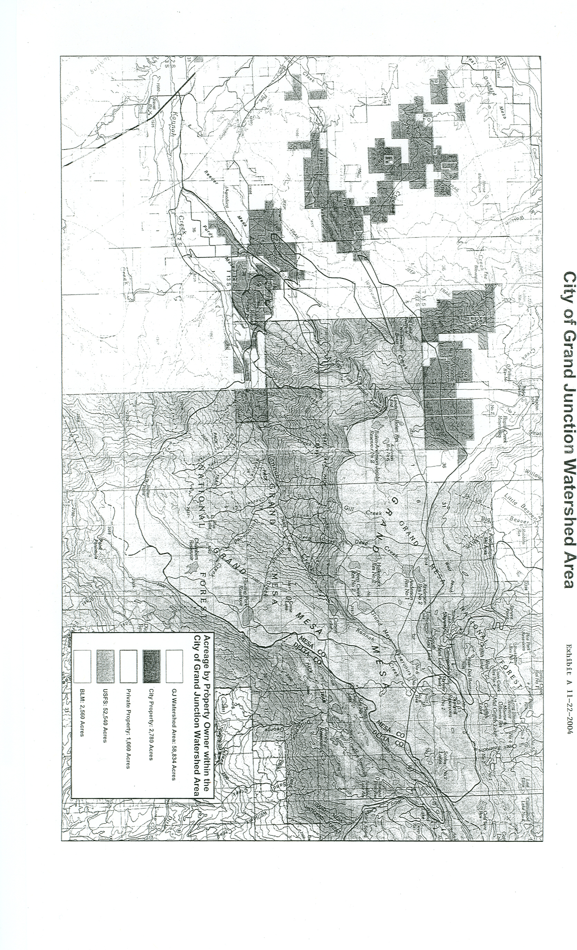
Exhibit A

