**CITY OF GRAND JUNCTION**

## RESOLUTION NO. 06-14

#### AN RESOLUTION VACATING A 10’ UTILITY EASEMENT

#### LOCATED AT 531 MALDONADO STREET

RECITALS:

A vacation of the dedicated easement for has been requested by the adjoining property owners.

The City Council finds that the request is consistent with the Comprehensive Plan, the Grand Valley Circulation Plan and Section 21.02.100 of the Grand Junction Municipal Code.

The Planning Commission, having heard and considered the request, found the criteria of the Code to have been met, and recommends that the vacation be approved.

NOW, THEREFORE BE IT ORDAINED BY THE CITY COUNCIL OF THE CITY OF GRAND JUNCTION THAT:

The following described dedicated easement for utilities is hereby vacated subject to the listed conditions:

1. Applicants shall pay all recording/documentary fees for the Vacation Resolution.

The following right-of-way is shown on “Exhibit A” as part of this vacation of description.

Dedicated easement to be vacated:

A parcel of land located in the Southwest Quarter of the Northeast Quarter (SW¼ NE¼) of Section 15, Township 1 South, Range 1 West of the Ute Meridian, Grand Junction, Mesa County, Colorado and being more particularly described as follows:

That ten foot (10.0') utility easement lying North of the South line of Lot 10, Block Six, Six and Fifty West Subdivision, Filing No. Two, as shown on the plat recorded in Plat Book 12, Page 101, Mesa County records, beginning at the West side of the ten foot (10.0') utility easement along the East lot line of said Lot 10 and terminating at the East line of the fifteen foot (15.0) Utility and Irrigation Easement lying along the West lot line of said Lot 10.

PASSED and ADOPTED this 19th day of March, 2014.

ATTEST:

______________________________

President of City Council

______________________________

City Clerk

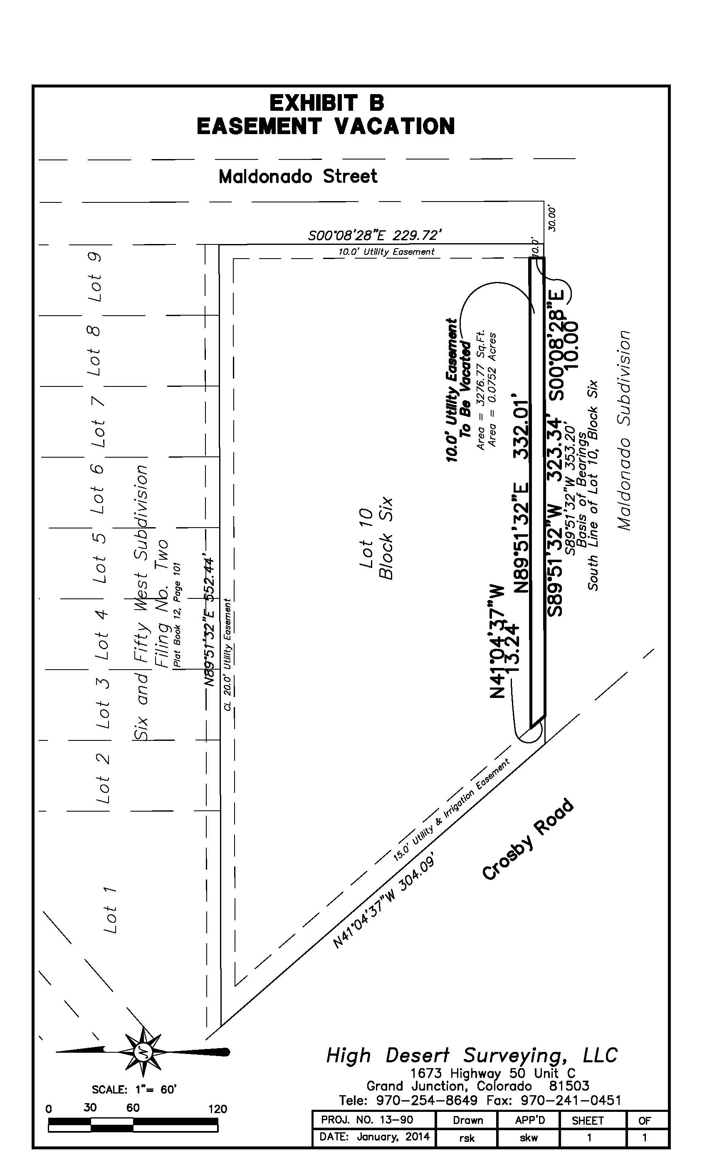

**A**