CITY COUNCIL, CITY OF GRAND JUNCTION
RESOLUTION NO. 65-04

A RESOLUTION AMENDING THE GRAND VALLEY CIRCULATION PLAN BY CHANGING THE CLASSIFICATION OF VARIOUS ROADS IN THE URBAN AREA

Recitals:

The Grand Valley Circulation Plan, formerly known as the Major Street Plan (referred to as “the Plan” hereinafter) identifies both major and minor transportation, circulation and connectivity routes and opportunities. The Plan is made and adopted pursuant to and in accordance with the Colorado Revised Statues and the Grand Junction Zoning and Development Code.

This modification to the Grand Valley Circulation Plan was adopted by the Mesa County Board of County Commissioners on June 21, 2004 and recommended for approval by the City of Grand Junction Planning Commission on June 22, 2004.

This update amendment to the Grand Valley Circulation Plan reflects changes in the following categories:

a. Updating “Proposed” roadways to “Existing” reflecting actual construction progress.

b. Modifying roadway classifications based on changing development patterns, updates to transportation models, and the better technical information.

c. Drafting errors.

d. Reflecting changes in previous district maps/amendments.

e. Changes proposed by Mesa County Staff outside of the 201 boundary.

A complete list of these changes is available upon request.

In accordance with section 1.11B.3 of the Zoning and Development Code, the City Council shall, as it deems appropriate, decide, adopt and/or amend the City’s street plans and components to it. For the reasons stated in the foregoing recitals, the Grand Junction Planning Commission and the staff recommend that the City Council adopt the amendment to the Grand Valley Circulation Plan as proposed in the attached maps marked “Grand Valley Circulation Plan – Grand Junction/Mesa County Urban Area Functional Classification Map” [Exhibit A] and “District Map 2004-01: Access Management Plan 24 Road/F Road” [Exhibit B].

NOW THEREFORE, BE IT RESOLVED BY THE CITY COUNCIL OF THE CITY OF GRAND JUNCTION THAT:

The Grand Valley Circulation Plan is hereby amended to include the above described map and district map.

PASSED AND ADOPTED this 21st day of July, 2004 by the City Council of the City of Grand Junction.

ATTEST:

/s/ Bruce Hill /s/ Stephanie Tuin
Bruce Hill Stephanie Tuin
President of the City Council City Clerk
Exhibit A
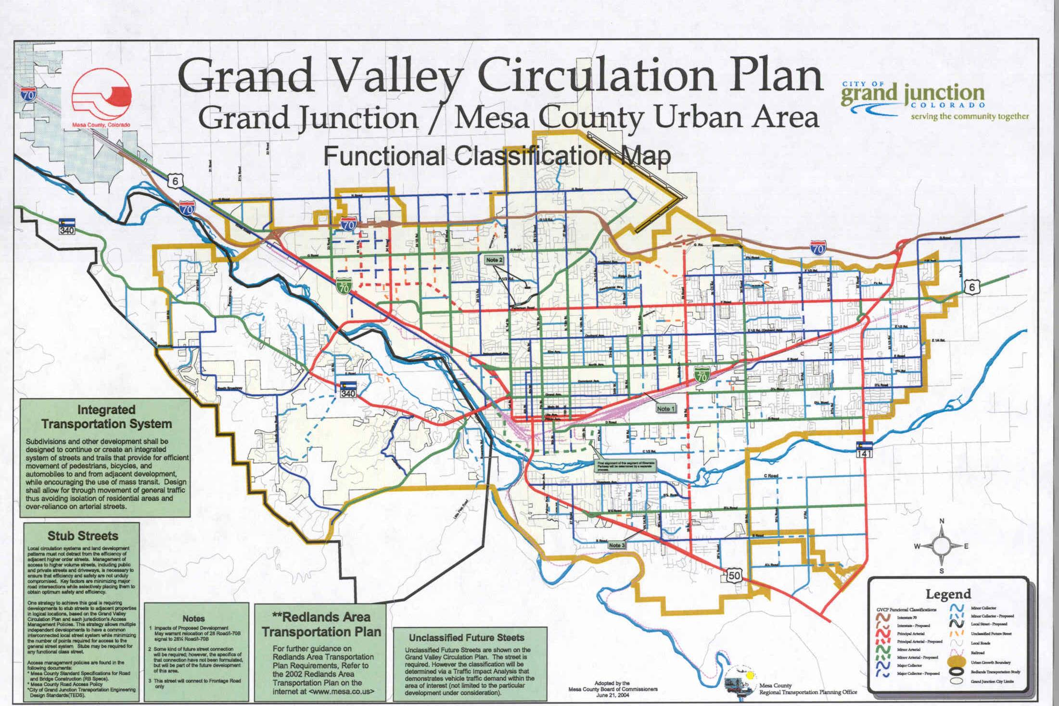

Exhibit A

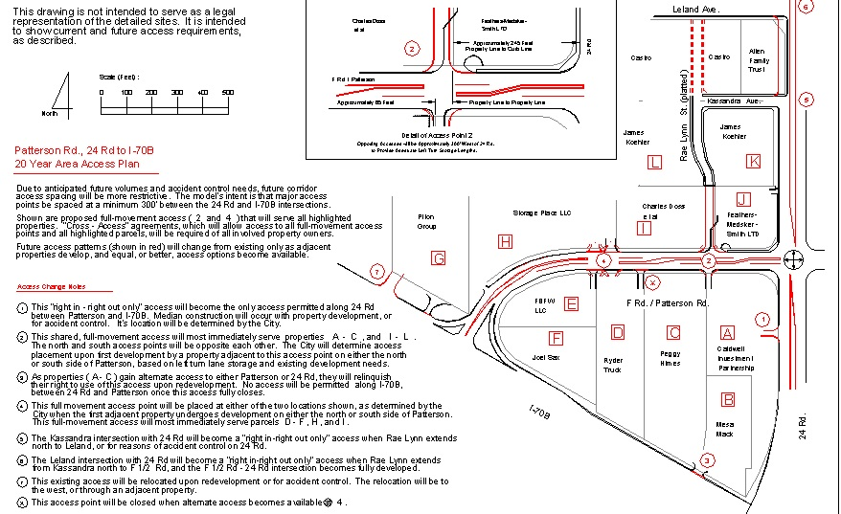

Exhibit B

