CITY OF GRAND JUNCTION

RESOLUTION NO. 89-04

A RESOLUTION VACATING A PORTION OF THE PARADISE HILLS INTERCEPTOR SEWER EASEMENT NO. 4, LOCATED IN THE PROPOSED BLUE HERON MEADOWS SUBDIVISION, LOCATED AT 2587 G ½ ROAD

Recitals.

As a part of the development of the proposed Blue Heron Meadow Subdivision, the existing twenty foot (20') wide sewer easement located on the property at 2587 G ½ Road will need be relocated. The Planning Commission, having heard and considered the request and found the criteria of the Code to have been met, recommends that the vacation be approved.

NOW, THEREFORE BE IT RESOLVED BY THE CITY COUNCIL OF THE CITY OF GRAND JUNCTION THAT:

1. The following described easement is vacated, subject to three conditions: (a) the Applicant shall pay all recording/documentary fees and costs for this Resolution; (b) this resolution and easement vacation is not effective until a replacement sewer line and related facilities needed to serve the property and other properties, as determined by the City Utility Director, are accepted following construction; and (c) the existing sewer line located within the easement being vacated hereby is taken out of service and appropriately removed or filled with concrete, as determined by the City Engineer and a new the easement is provided on the Final Plat.

2. The easement description is as shown on the attached Exhibit "A," to wit:

That certain easement recorded in Book 1094, pages 478 – 479, beginning at a point on the North boundary of said property, whence a Mesa County Survey Marker, marked ¼ Sec. 34 and 35 Township 1 North, Range 1 West of the Ute Meridian bears N89°52’26”E, 949.44 feet, thence S59°31’13”W, 53.99 feet, thence S17°11’48”W, 711.55 feet, thence S13°41’01”W, 348.87 feet, thence S31°11’02”W, 207.03 feet, to a point on the South boundary of said property.

PASSED and ADOPTED this 6th day of October, 2004.

ATTEST:

/s/ Stephanie Tuin /s/ Bruce Hill City Clerk President of City Council
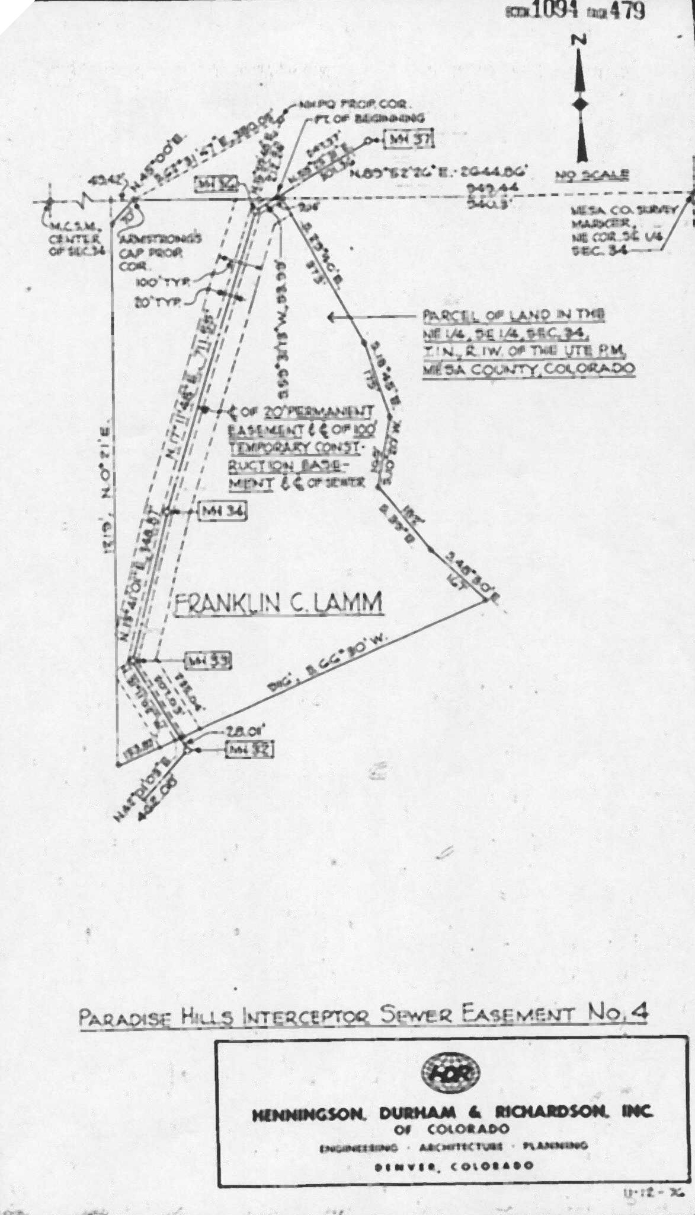
Exhibit A

