CITY OF GRAND JUNCTION, COLORADO

RESOLUTION NO. 162-05

A RESOLUTION VACATING A UTILITY EASEMENT ON LOT 1, OF THE JUNCTION EAST SUBDIVISION, LOCATED AT 3060 D ROAD, IN ORDER TO ACCOMMODATE THE PROPOSED RIVER RUN SUBDIVISION

Recitals:

A request for the vacation of a utility easement has been submitted in accordance with the Zoning and Development Code. The applicant has requested that the 20’ utility easement located along the westerly boundary of Lot 1, Junction East Subdivision, be vacated and replace it with a 10 foot multi-purpose easement, except along the westerly boundary of proposed Lot 9, of the proposed River Run Subdivision. This area will be replaced with a 15 foot multi-purpose easement. The 20-foot utility easement was dedicated via the Plat for Junction East Subdivision, recorded May 20, 1980, in Book 12, Page 263. The vacation request required to proceed with the River Run Subdivision.

In a public hearing, the Planning Commission reviewed the request for the vacation request and determined that it satisfied the criteria as set forth and established in Section 2.11.C of the Zoning and Development Code. The proposed vacation is also consistent with the purpose and intent of the Growth Plan.

NOW, THEREFORE, BE IT RESOLVED BY THE CITY COUNCIL OF THE CITY OF GRAND JUNCTION THAT THE AREA DESCRIBED BELOW IS HEREBY VACATED.

THE EASTERN MOST 10-FEET OF THE 20-FOOT UTILITY EASEMENT LOCATED ALONG THE WESTERN PORTION OF LOT 1, JUNCTION EAST SUBDIVISION, RECORDED ON MAY 20, 1980, BOOK 12, PAGE 263 AND AS SHOWN ON EXHIBIT A. THIS VACATION IS EFFECTIVE UPON THE RECORDING OF THE RIVER RUN SUBDIVISION PLAT WHICH SHALL CONTAIN THE NEW EASEMENTS AS DESCRIBED IN THIS RESOLUTION.

PASSED on this 19th day of October, 2005.

ATTEST:

/s/ Stephanie Tuin /s/ Bruce Hill
City Clerk President of Council
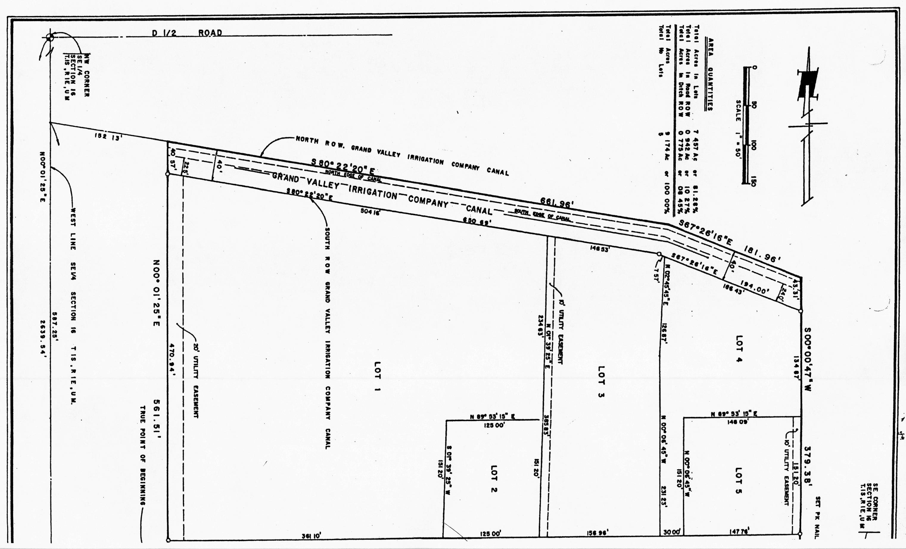
Exhibit A
Easement
To
Vacate

