RESOLUTION NO. 162-06

A RESOLUTION AUTHORIZING A MAIL BALLOT ELECTION IN THE GRAND JUNCTION DOWNTOWN DEVELOPMENT AUTHORITY FOR THE APRIL 3, 2007 SPECIAL ELECTION, AUTHORIZING THE CITY CLERK TO SIGN THE INTERGOVERNMENTAL AGREEMENT WITH MESA COUNTY CLERK AND RECORDER AND APPROVING THE WRITTEN PLAN FOR THE CONDUCT OF A MAIL BALLOT ELECTION

RECITALS.

The City Council for the City of Grand Junction has scheduled a special election within the Downtown Development Authority for April 3, 2007.

The City Council finds that conducting that election by mail ballot is the most efficient method for that election.

The City Council has designated the City Clerk as the Designated Election Official (DEO) for the special election.

The Mail Ballot Election Code, 1-7.5-101 et seq, C.R.S., specifically section 105, requires that the designated election official “shall notify the secretary of state no later than fifty-five days prior to the election. The notification shall include a proposed plan for the conducting the mail ballot election, . . .”

The Secretary of State has promulgated rules as to what is to be included in the plan.

NOW, THEREFORE, BE IT RESOLVED BY THE CITY COUNCIL OF THE CITY OF GRAND JUNCTION THAT:

1. The Special Election for the Downtown Development Authority is scheduled for April 3, 2007 and will be conducted by mail ballot.

2. That the City Clerk is hereby authorized to enter into an Intergovernmental Agreement with the Mesa County Clerk and Recorder for the printing and distribution of the required TABOR notice.

3. The attached “Written Plan for the Conduct of a Mail Ballot Election” is approved for the April 3, 2007 Special Election and that the City Clerk as the Designated Election Official be directed to submit such plan to the Secretary of State.

Approved this 20th day of December, 2006.

/s/ James J. Doody President of the Council

ATTEST:

/s/ Stephanie Tuin
City Clerk

WRITTEN PLAN FOR THE CONDUCT OF A
MAIL BALLOT ELECTION

SUBMITTED BY: Stephanie Tuin, City Clerk

ELECTION ADMINISTRATOR FOR: Downtown Development Authority, a Part of the City of Grand Junction, Colorado

- LEGAL NAME OF JURISDICTION: Grand Junction Downtown Development Authority, a part of the City of Grand Junction, Colorado

- TYPE OF JURISDICTION: An Authority as defined in 31-25-802, C.R.S.

- DESCRIPTION OF ELECTION TO BE HELD: Special Election on a Ballot Issue to be held on Tuesday, April 3, 2007
- AUTHORITY TO HOLD THIS ELECTION: 31-10-108 C.R.S. and 31-25-807(1)(b), C.R.S.

- ESTIMATED NUMBER OF ELECTORS: 800 qualified electors as defined in 31-25-802 C.R.S., Exhibit “F” may be used to designate a qualified voter under 31-25-802 (9) C.R.S.

- NAME OF CHIEF ELECTION ADMINISTRATOR: Stephanie Tuin, City Clerk, Acting Secretary for the Authority and Designated Election Official (hereinafter "D.E.O.")

- COUNTY CLERK AND RECORDER WILL: provide registration lists, assist as requested and print and distribute the required TABOR notice. An intergovernmental agreement has been executed for that purpose.

- NUMBER OF PLACES OF DEPOSIT: One - City Clerk's Office at City Hall at 250 North 5th Street, Grand Junction, Co. 81501

- IF BALLOT PACKETS ARE RETURNED AS UNDELIVERABLE: Undeliverable ballots will be tallied/recorded on the DAILY RECONCILIATION OF MAIL BALLOTS (see Exhibit “A”), entered as “U” on the ballot distribution database, alphabetically slotted into trays marked “Undeliverable”, and secured in a locked box accessible only by clerks/election judges/deputy clerks. These ballots will not be remailed, but may be reissued to any addressee appearing in person at the City Clerk's Office, upon presentation of proper identification of qualified elector and address.

- HOW POSTAGE WILL BE HANDLED FOR BALLOT PACKETS RETURNED AS UNDELIVERABLE: Ballots will be mailed in accordance with both USPS and state statutory requirements, each envelope bearing “RETURN SERVICE REQUESTED” as per the Domestic Mail Manual, Section F, 010.5.3. This will guarantee return of “undeliverable” envelopes to the City Clerk's Office. If a new address is identified by the yellow USPS label, the D.E.O. will comply with 1-2-605(5) C.R.S.

- PROCEDURES TO BE FOLLOWED TO ENSURE COMPLIANCE WITH STATUTES AND RULES INCLUDING NAMES OF THOSE RESPONSIBLE:

- Planning and procedural meetings will be held involving the D.E.O. and D.E.O. staff. Title 1, Article 7.5 C.R.S. and the Secretary of State's Rules and Regulations will be reviewed and explained for implementation and administration of the state’s mail ballot process. The State Statutes and the rules and regulations will be administered under the direct supervision of Stephanie Tuin, the D.E.O. Additional staff may be required for this mail ballot election and hired as judges for the final tally of the ballots. The County Elections Director and/or the County Clerk may be consulted as needed.

- Printing and mailing of the TABOR NOTICE will be coordinated with Mesa County as required by law. County Elections Director Sheila Reiner will supervise this in accordance with Article X, Section 20(3)(b), with a mailing date no later than March 2, 2007.

- Absentee mail ballot applications will be processed for mail distribution on the date required by law and in accordance with the appropriate regulations.

- Mail ballot packages, including absentee ballots, will be prepared in accordance with the mail ballot election law and under the supervision of D.E.O. Stephanie Tuin.

- Mail ballot packages for each eligible voter will be prepared and mailed no later than March 19, 2007 to all “active voters” that did not request absentee ballots. The ballot distribution system for this election will be manual and D.E.O. Stephanie Tuin will oversee this process. There are 800 eligible electors.

- Each business day, ballot envelopes received or returned to the Elections Office (City Clerks Office) will be date-stamped and tallied for recordkeeping. Each envelope will then be preliminarily verified (first verification) for completion of necessary information (including name, address, and signature) and voter eligibility. The pollbook will be updated daily for each ballot received, indicating by code either accepted, rejected or undeliverable. Accepted ballot envelopes will be deposited into a “dated” and sealed ballot box. Rejected or undeliverable ballot envelopes will be filed alphabetically in trays in a locked box in a secured facility. Daily receipt, coding and securing of ballots will include those received at the one drop off location or via mail. D.E.O. Stephanie Tuin and her designated assistants will be responsible for this process.

- The official verification of ballots will begin on Monday, March 24, 2007. Boxes representing each day’s receipt of accepted ballots shall be opened, the return envelopes slit, and the ballot stub number in each envelope checked against the ballot number issued. If acceptable, the ballot stub shall be removed, then the secrecy envelope removed and the ballot shall be placed in a transfer envelope. In the event a ballot is returned without a secrecy envelope (see Exhibit “G”), secrecies will be readily available for the election judge to enclose the ballot before removing it from the envelope. All envelopes will be sealed, numbers recorded and stored in a secured facility. D.E.O. Stephanie Tuin will oversee this aspect of the election.

- The City Clerk's Office, 250 N. 5th Street, will be open for issue of ballots to “inactive voters” or the reissue of ballots to those who have spoiled, lost, moved, or for some reason did not receive a ballot for the period of Tuesday, March 27, 2007 to Monday, April 2, 2007, from 7:30 a.m. to 5:30 p.m. each business day and Tuesday, April 3, 2007 7:00 a.m. to 7:00 p.m. In the event that all ballots have not been issued and an elector needs a ballot reissued on Saturday, March 31, 2007, the D.E.O. will be available to reissue that ballot. Prior to March 27, 2007 these requests will be handled in the regular City Clerk's Office area by D.E.O. staff.

Anytime that a replacement ballot is issued, or a ballot is issued to an “inactive voter”, a REQUEST FOR BALLOT/REPLACEMENT BALLOT (see Exhibit “B”) sworn statement must be completed, with signatures gathered either in person at the City Clerk's Office or through the mail. Reissued ballots, or ballots issued to “inactive voters” through the mail will have a mark on their return envelope (next to their signature affirmation) that will immediately alert the election judge that a completed sworn statement must be included with the voted ballot.

- DESCRIBE PROCEDURES TO ENSURE BALLOT SECURITY:

a) Ballot packages are prepared and stored in secured facilities by D.E.O. staff. Ballot packages will be sealed and delivered to the United States Post Office at 241 N. 4TH Street. The packages are then processed in accordance with USPS regulations and state statutory provisions.
b) Ballots, including pre-distribution and non-issued, will be kept in a locked box on secured premises at all times. All election materials, ballots, and ballot boxes will be monitored during utilization by D.E.O. staff and placed under locked security each night. The area used for ballot processing is in the City Clerk's Office. Only three keys to the critical ballot and materials areas exist, and those are held by the D.E.O. and her two assistants. All empty ballot boxes and envelopes will be witnessed before and during both sealings (first and second verifications), including the recording of seal numbers.
c) Ballots will be paper ballots. There is only a single ballot type for this election so no color-coding is necessary for the ballot. The ballots will be colored to distinguish them from the regular municipal election that is taking place at the same time.

d) At the single drop off site, the City Clerk's Office, there will be a locked ballot box.

e) All employees (D.E.O. staff) will be sworn in, affirming their adherence to the election statutes, rules and procedures. Observers (or watchers) will need to present completed forms, and the secured area is not accessible to the cleaning staff during the period of March 9th through April 4th. Ballots will be tabulated by hand at the City Clerk's Office and then stored in the vault.

- DESCRIBE THE PROCEDURES FOR SIGNATURE VERIFICATION: The very day each ballot envelope is received (initial verification), it will be verified for name, address and the presence of a signature. If any of the foregoing information does not correspond to the ballot issue record or if all information is not provided, the ballot will be rejected for discrepancies. The rejection will be coded on the pollbook and the envelope placed in alphabetical order in the “REJECTED” tray, which will be stored in the secured facility. Periodic checks of signatures on record will be performed to ensure the integrity of the mail ballot election in the Grand Junction Downtown Development Authority, City of Grand Junction. Pursuant to 31-25-802 (9) C.R.S., “any landowner or lessee which is not a natural person may vote only if it designates by some official action a representative thereof to cast its ballot.” A qualified landowner or lessee may use the “Voter Designation Form”, Exhibit “F”, if they show choose. Failure to provide such form does not disqualify the ballot.

- DESCRIBE THE PROCEDURES TO ENSURE SECRECY OF BALLOTS: A secrecy envelope will be enclosed with each ballot mailed to all active eligible voters on or before March 19, 2007. Voter instructions will specifically ask voters to place the voted ballot in a secrecy envelope (Exhibit “G”) when returning the ballot. Ballots initially received are left in sealed envelopes until the final verification. At the time of final verification, when ballot stubs are removed, each election judge will have secrecy envelopes to slip around any ballot (while it’s still in the envelope) in the event the voter did not place his/her voted ballot in the secrecy envelope. Ballots rejected with the stub still attached will be alphabetized and locked away nightly. Every D.E.O. staff member will be thoroughly trained on the vital importance and necessity of ballot security.

- DESCRIBE THE PROCEDURE TO RECONCILE BALLOTS ISSUED, BALLOTS RECEIVED, DEFECTIVE BALLOTS AND SUBSTITUTE BALLOTS: Reconciliation will occur daily for every ballot issued and every ballot received using the DAILY RECONCILIATION FORM (see Exhibit “A”) and the DAILY RUNNING TALLY (see Exhibit “C”). Reconciliation will be manual, and each day’s current status will be available by 9 am the following morning. FINAL DISPOSITION OF BALLOT RECONCILIATION (see Exhibit “D”) will reflect the number of ballots issued and reissued, less the number of ballots accepted, less the number rejected, less the number undeliverable, less the number of ballots returned after the deadline and/or never returned, which will equal the total number of ballots issued. Additionally, a STATEMENT OF BALLOTS (see Exhibit “E”) will be placed in each sealed envelope to assure verification with tabulation and the canvass board. Many safeguards have been built into the procedures; and yet the ability to immediately explain and /or access any ballot discrepancy will exist. Double checking by different staff members will occur daily to ensure tracking accuracy.

DATE OF SUBMISSION:

ELECTION OFFICIAL SIGNATURE:

TITLE: City Clerk/Acting Secretary of the
Authority/DEO

TIMETABLE ENCLOSED
TIMETABLE
For the conduct of a Mail Ballot Election
(Rule 12.3.3.b)

Please indicate dates by which each item will be completed

12/20/06 Written Plan submitted to governing body. Rule 12.3.2
12/20/06 Election approved by governing body. Rule 12.3.3b

no later than
02/07/07 Submission of written plan to Secretary of 1-7.5-105(1)
State (55 days prior to election) Rule 12.3.2

02/22/07 Last date for approval by Secretary of 1-7.5-105(2)
State (15 days after receipt in Secretary
of State’s office)

02/22/07 Registration records ordered by designated 1-5-303(1)
election official from County Clerk and Recorder
(at least 40 days prior to election)

03/02/07 List of electors submitted to election official 1-7.5-107(2)(a)
(at least 30 days prior to election)

03/05/07 Close of registration (29 days prior) 1-2-201(3)

03/09/07
through
03/19/07 Ballots mailed (not sooner than 25 days and 1-7.5-107(3)(a)
no later than 15 days prior)

03/09/07 Ballots available at election official’s office 1-7.5-107(3)(c)
(no sooner than 25 days prior)

03/14/07 Notice of election to electorate (at least 1-5-205(2)
20 days prior) with copy to County Clerk 1-7.5-107(2.5)

03/14/07 Notice of election to County Clerk & Recorder Rule 12.3.1a

03/14/07 Notice of election to County Assessor 1-5-304
03/14/07 Publish Notice of Election 1-7.5-107(2.5)(a)

03/14/07 Supplemental list of electors submitted 1-7.5-107(2)(b)
(at least 20 days prior)

03/24/07 Verification of ballot numbers to pollbook 1-7.5-107.5
(may begin at any time during the 10 days before)

04/03/07 Election day 31-10-108
City Charter, §3

04/05/07 Canvass dates/certification issued City Charter, §25
(canvass no later than 2 days after the election) Rule 12.12

Exhibit “A”

DAILY RECONCILIATION OF MAIL BALLOTS

DOWNTOWN DEVELOPMENT AUTHORITY
CITY OF GRAND JUNCTION
JUDGES DAILY RECONCILIATION OF MAIL BALLOTS
APRIL 3, 2007 SPECIAL ELECTION

(Date)

1. Total number of ballots received ___________
Information on return envelope verified Yes _____ No ____ _
2. Less number ballots rejected in first verification
-insufficient information on return verification envelope ___________
3. Less number ballots rejected in second verification ___________
-ballot number does not match poll book
4. Equals total number ballots approved for final count ___________
1-2-3 = 4
Spoiled _____ Undeliverable _____ Rejected Ballots: Incomplete _____ 2nd Rejected:
Signature _____ No Stub ______
Damaged _____ Unmatched ___
Total rejected ballots _______ Total 2nd Rej: ____
Hand count ______ Judge's Int ______
Electronic count ______ Judge's Int ______
Seal Number ______ Judges Signature

____________________________

____________________________

Seal Number ______ Judge's Signature

______________________________
Date of reseal ______ ______________________________
EXHIBIT “B"

Request for Ballot Original ballot number

April 3, 2007 Replacement number

Date

I , eligible elector of the Downtown Development

Authority, City of Grand Junction at
Residence Address

City/Town Zip

Request a ballot for the April 3, 2007 Special Election for the following reason(s):

I was not issued a ballot due to eligibility .

I have not as of this date received the ballot packet mailed to me.

The ballot I received was destroyed or marked incorrectly.

I have not voted a ballot issued for this election and I do not intend to vote except by voting this replacement ballot.

The original ballot issued me will not be cast and if the original and the replacement ballot are cast, neither will be counted in this election.

I understand that this sworn statement must be included in the return verification envelope with the marked ballot and must be received by 7:00 p.m. on Election Day for this replacement ballot to be counted.

SIGN Date of Birth
HERE

STATE OF COLORADO, COUNTY OF MESA, SS:

SUBSCRIBED AND SWORN BEFORE ME THIS DAY OF , 2007.

Clerk/Deputy/Notary
(Seal) My Commission expires :

EXHIBIT “C"

DAILY RUNNING TALLY

DOWNTOWN DEVELOPMENT AUTHORITY
CITY OF GRAND JUNCTION
DAILY RUNNING TOTAL
April 3, 2007 SPECIAL ELECTION

Received Date
Daily:
Number of Original Mailings _______
Number of spoiled Ballots _______
Number of ballots reissued / issued late _______
Number of ballots received _______
Number of ballots approved for final count _______
Total:
1. Number of Original Mailings _______
2. Number of ballots reissued / issued late _______
3. Number of ballots spoiled _______
Total ballots issued 1+2-3= _______
Total of ballots received _______
Total rejected ballots _______
Total Spoiled: _______
Total Undeliverable: _______
Total of ballots approved for final count _______

EXHIBIT “D"

DOWNTOWN DEVELOPMENT AUTHORITY
CITY OF GRAND JUNCTION
FINAL DISPOSITION OF MAIL BALLOT ELECTION

APRIL 3, 2007 SPECIAL ELECTION

ISSUED: _________
REISSUED: _________

ACCEPTED: __________
REJECTED: __________
SPOILED __________
INCOMPLETE __________
DAMAGED __________
SIGNATURE __________
UNMATCHED __________
NO STUB __________
UNDELIVERABLE __________
RETURNED AFTER DEADLINE __________
NEVER RETURNED __________
EXHIBIT “E"

SPECIAL MAIL BALLOT ELECTION
April 3, 2007

DOWNTOWN DEVELOPMENT AUTHORITY

CITY OF GRAND JUNCTION, MESA COUNTY, COLORADO

DATE OF BALLOT RECEIPT

NUMBER OF BALLOTS RECEIVED

NUMBER OF BALLOTS IN THIS TRANSFER CASE

TRANSFER CASE FOR THIS DAY’S RECEIPTS OF

SEAL #

JUDGES SIGNATURES

TEAMWORK COUNT

EXHIBIT “F”

VOTER DESIGNATION FORM

STATE OF COLORADO )
COUNTY OF MESA )
CITY OF GRAND JUNCTION ) ss
DOWNTOWN DEVELOPMENT AUTHORITY )

Pursuant to the Downtown Development Authority law, Title 31, Article 25, Part 8, C.R.S., _______________________, as the owner or lessee of real or personal property located within the boundaries of the Downtown Development Authority, hereby designate _______________________ as its representative for purposes of voting on its behalf in the election scheduled for April 3, 2007 in the City of Grand Junction Downtown Development Authority.

The address and phone number for the designated elector are:
_________________________________________
_________________________________________

_________________________________________
(Property owner/lessee)

By: ______________________________________
(Name)

Its: ______________________________________
(Title)

Exhibit “G”
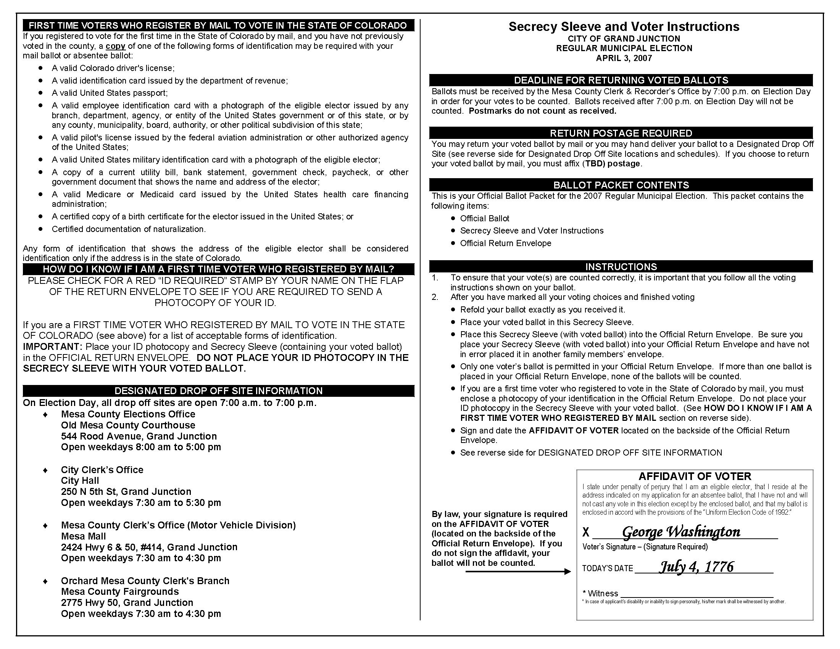
Draft Secrecy Sleeve

