CITY OF GRAND JUNCTION

RESOLUTION NO. 54-06

A RESOLUTION VACATING A ROADWAY SLOPE AND BORROW PIT EASEMENT
LOCATED AT 585 28 ¼ ROAD

RECITALS:

A resolution vacating a roadway slope and borrow pit easement, described in documents recorded in Book 1245 at Page 845 and in Book 1412 at Page 917 of the Mesa County records, located on the west side of 28 ¼ Road at 585 28 ¼ Road. The easement was created to facilitate street improvements to 28 ¼ Road and is no longer required at this time, therefore the applicant has requested that the easement be vacated.

The Planning Commission, having heard and considered the request and found the criteria of Section 2.11.C of the Zoning Code to have been met, recommend that the vacation be approved.

NOW, THEREFORE BE IT ORDAINED BY THE CITY COUNCIL OF THE CITY OF GRAND JUNCTION THAT:

The following described easement is hereby vacated subject to the listed conditions:

1. Applicant shall pay all recording/documentation fees for the Vacation Resolution, and/or related easement and dedication documents.
2. The recording of a final plat for the proposed development known as Ridgewood Heights, located at 585 28 ¼ Road.

EASEMENT VACATION DESCRIPTION:

All that part of a Roadway Slope and Borrow Pit Easement described in Book 1245 at Page 845 crossing Lot 1 of Laurel Subdivision; in the City of Grand Junction, County of Mesa, State of Colorado.

That part of a Roadway Slope and Borrow Pit Easement crossing Lot 1 of Laurel Subdivision; said easement being described in Book 1245 at Page 845, in the City of Grand Junction, County of Mesa, State of Colorado, said vacation being more particularly described as follows:

Beginning at the Northeast corner of said Lot 1;
Thence along the East line of said Lot 1, South 00°03'37" East, a distance of 46.78 feet;
Thence along the East line of said Lot 1, 62.76 feet along the arc of a 916.50 foot radius non-tangent curve to the right, through a central angle of 3°55'25", with a chord bearing South 21°54'32" West, a distance of 62.75 feet; to a point of reverse curvature;
Thence along the East line of said Lot 1, 437.58 feet along the arc of a curve to the left, having a radius of 611.50 feet and a central angle of 40°59'59" to a point of reverse curvature;
Thence along the East line of said Lot 1, 309.27 feet along the arc of a 1107.50 foot radius curve to the right, through a central angle of 16°00'00", with a chord bearing South 09°07'51" East, a distance of 308.27 feet;
Thence along the East line of said Lot 1, South 01°07'51" East tangent to said curve, a distance of 27.35 feet;
Thence North 89°57'21" West, a distance of 62.52 feet
Thence North 01°07'51" West, a distance of 26.06 feet;
Thence 145.91 feet along the arc of a 1045.00 foot radius tangent curve to the left, through a central angle of 8°00'00", with a chord bearing North 05°07'52" West, a distance of 145.79 feet;
Thence South 88°52'09" West, a distance of 79.33 feet;
Thence 123.92 feet along the arc of a 966.50 foot radius non-tangent curve to the left, through a central angle of 7°20'46", with a chord bearing North 13°27'29" West, a distance of 123.83 feet; to a point of reverse curvature;
Thence 161.72 feet along the arc of a 752.50 foot radius curve to the right, through a central angle of 12°18'47", with a chord bearing North 10°58'28" West, a distance of 161.40 feet;
Thence radial to said curve, South 85°10'56" West, a distance of 0.39 feet;
Thence North 84°22'00" East, a distance of 87.40 feet;
Thence 331.96 feet along the arc of a 665.50 foot radius non-tangent curve to the right, through a central angle of 28°34'46", with a chord bearing North 09°34'44" East, a distance of 328.52 feet;
Thence radial to said curve, South 66°07'53" East, a distance of 9.51 feet to the beginning of a 872.01 foot radius curve concave to the west radial to said line;
Thence 93.08 feet along the arc of said curve, through a central angle of 6°06'58", with a chord bearing North 20°48'38" East, a distance of 93.04 feet to the North line of said Lot 1;
Thence North 89°57'23" East, a distance of 31.00 feet to the Point of Beginning.

Containing 1.681 acres, more or less. Said Easement being delineated on the attached Easement Vacation Description, Exhibit A.

And,

All of that part of a Roadway Slope and Borrow Pit Easement described in Book 1412 at Page 917 crossing Lot 1 of Laurel Subdivision; in the City of Grand Junction, County of Mesa, State of Colorado.

That part of a Roadway Slope and Borrow Pit Easement crossing Lot 1 of Laurel Subdivision; said easement being described in Book 1412 at Page 917, in the City of Grand Junction, County of Mesa, State of Colorado, said vacation being more particularly described as follows:

Beginning at an angle point on the East line of said Lot 1, whence the NW1/16 corner of Section 7, Township 1 South, Range 1 East of the Ute Meridian bears South 89º57’21” East, a distance of 58.64 feet;
Thence along the East line of said Lot 1, South 01°39'13" East, a distance of 135.99 feet;
Thence along the South line of said Lot 1, South 88°20'47" West, a distance of 38.50 feet;
Thence along the South line of said Lot 1, South 01°39'13" East, a distance of 5.53 feet;
Thence along the South line of said Lot 1, South 86°05'03" West, a distance of 46.01 feet;
Thence North 01°39'13" West, a distance of 145.85 feet
Thence South 89°57'21" East, a distance of 84.51 feet to the Point of Beginning.

Containing 0.273 acres, more or less. Said Easement being delineated on the attached Easement Vacation Description, Exhibit B.

PASSED and ADOPTED this 7th day of June, 2006.

ATTEST:

/s/ James J. Doody
President of City Council

/s/ Stephanie Tuin
City Clerk

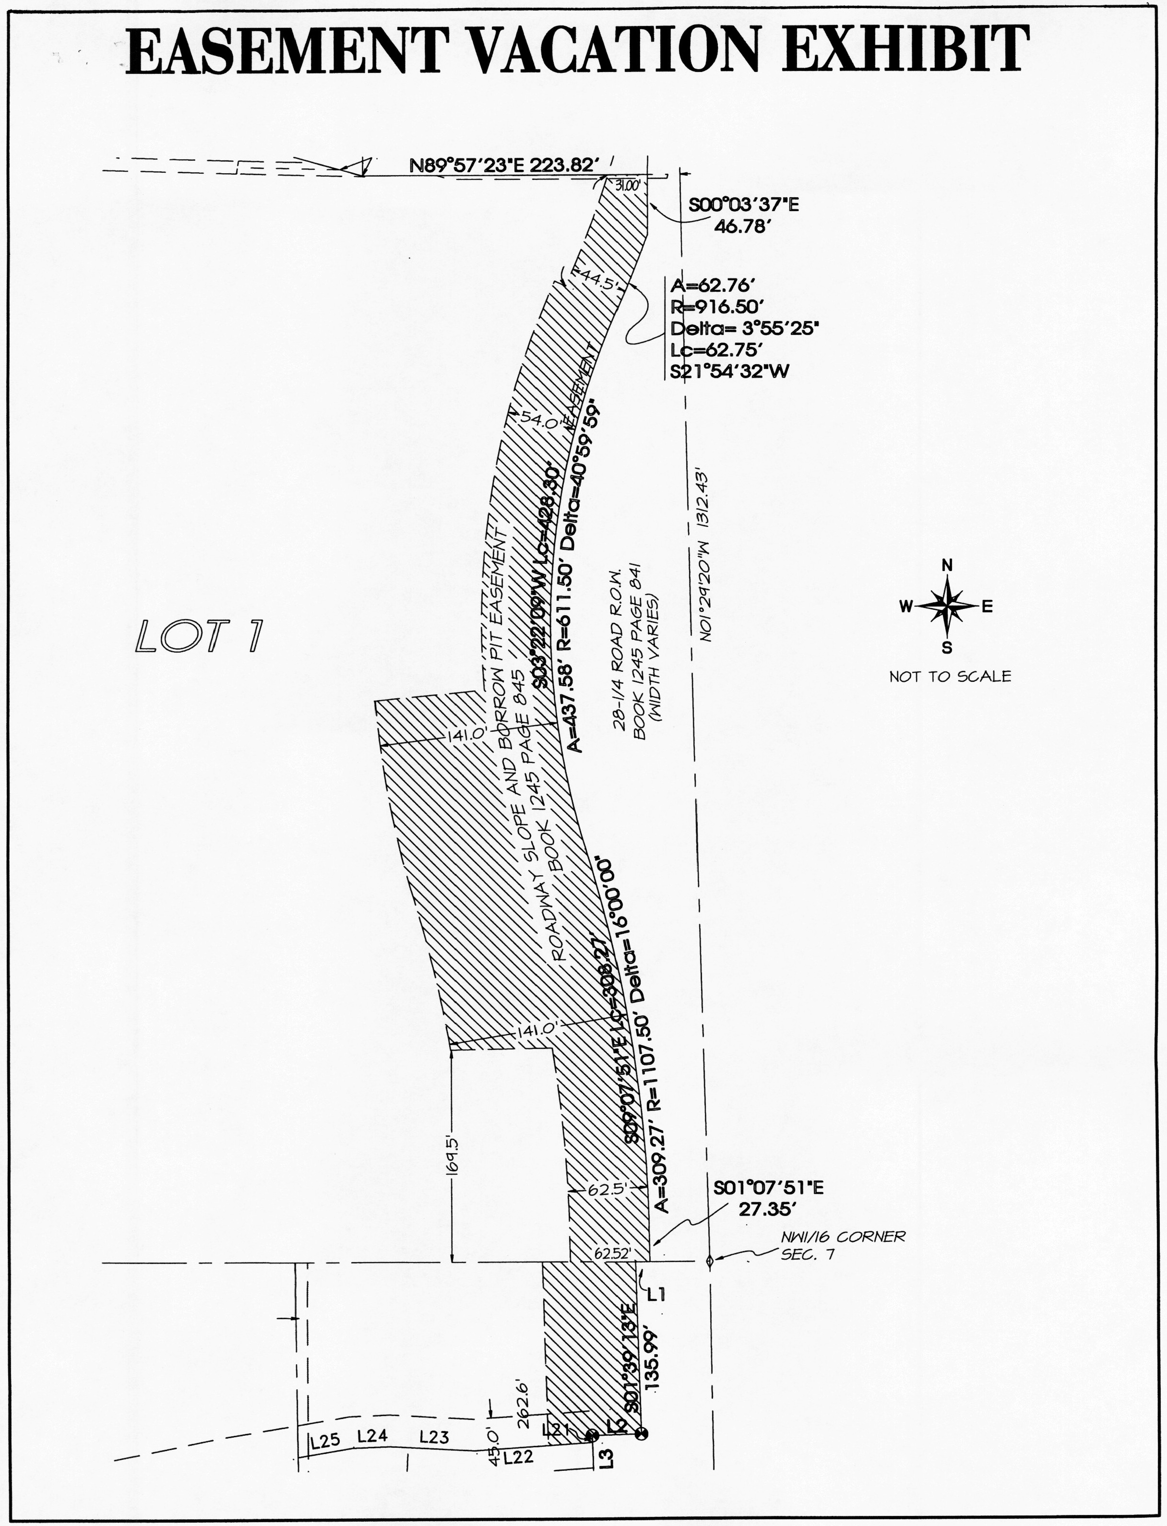

EXHIBIT A

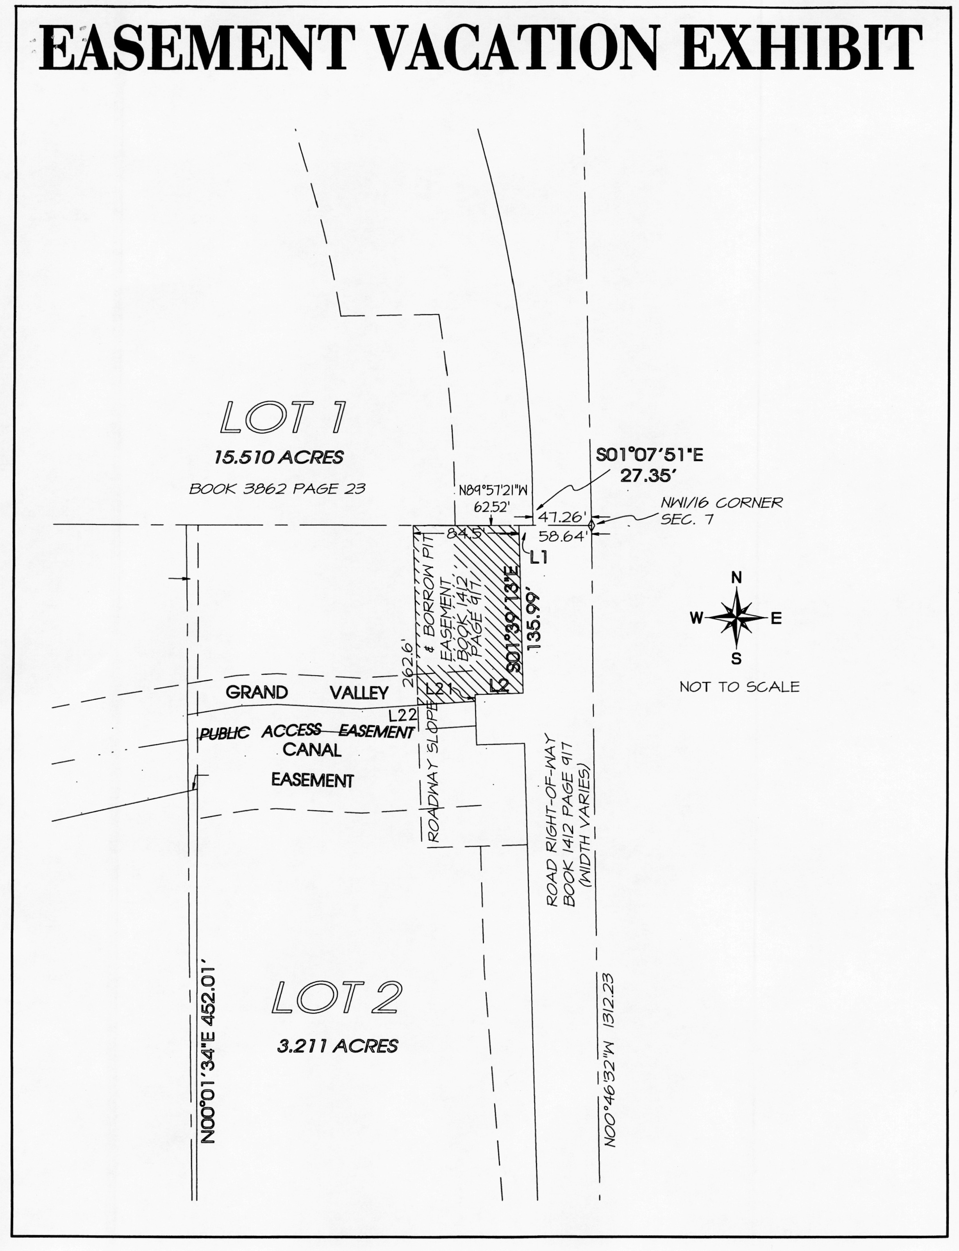

EXHIBIT B

