CITY OF GRAND JUNCTION, COLORADO

RESOLUTION NO. 149-07

A RESOLUTION CONCERNING THE ISSUANCE OF A REVOCABLE PERMIT TO
MESA COUNTY GOVERNMENT

Recitals
A. Mesa County - Sue A. Gormley hereinafter referred to as the Petitioner, represents it is the owner of the following described real property in the City of Grand Junction, County of Mesa, State of Colorado, to wit:

Lots 11 thru 26 incl & that ptn of Lot 27 lyg E of RR spur Blk 149 City of Grand Junction Sec 14 1S 1W inc vac n/s alley per B-2482 P-563 & inc vac alley on S & E as desc B-4294 P-139 Ord No 3960 Mesa Co Recds - 1.39a and identified by Mesa County Tax Schedule Number 2945-144-41-931.

B. The Petitioner has requested that the City Council of the City of Grand Junction issue a Revocable Permit to allow the Petitioner to maintain and repair the building sign, the 4 bike racks, and screening within the following described public right-of-way:

See attached Exhibits A and B

C. Relying on the information supplied by the Petitioner and contained in File No. RVP-2007-182 in the office of the City’s Public Works & Planning Department, the City Council has determined that such action would not at this time be detrimental to the inhabitants of the City of Grand Junction.

NOW, THEREFORE, BE IT RESOLVED BY THE CITY COUNCIL OF THE CITY OF GRAND JUNCTION, COLORADO:

1. That the City Manager is hereby authorized and directed to issue the attached Revocable Permit to the above-named Petitioner for the purpose aforedescribed and within the limits of the public right-of-way aforedescribed, subject to each and every term and condition contained in the attached Revocable Permit.

PASSED and ADOPTED this 5th day of November, 2007.

Attest:

/s/ Stephanie Tuin /s/ James J. Doody
City Clerk President of the City Council

REVOCABLE PERMIT

Recitals

A. Mesa County - Sue A. Gormley hereinafter referred to as the Petitioner, represents it is the owner of the following described real property in the City of Grand Junction, County of Mesa, State of Colorado, to wit:

Lots 11 thru 26 incl & that ptn of Lot 27 lyg E of RR spur Blk 149 City of Grand Junction Sec 14 1S 1W inc vac n/s alley per B-2482 P-563 & inc vac alley on S & E as desc B-4294 P-139 Ord No 3960 Mesa Co Recds - 1.39a and identified by Mesa County Tax Schedule Number 2945-144-41-931.

B. The Petitioner has requested that the City Council of the City of Grand Junction issue a Revocable Permit to allow the Petitioner to maintain and repair the building sign, the 4 bike racks, and screening within the following described public right-of-way:

See attached Exhibits A and B

C. Relying on the information supplied by the Petitioner and contained in File No. RVP-2007-182 in the office of the City’s Public Works & Planning Department, the City Council has determined that such action would not at this time be detrimental to the inhabitants of the City of Grand Junction.

NOW, THEREFORE, IN ACCORDANCE WITH THE ACTION OF THE CITY COUNCIL OF THE CITY OF GRAND JUNCTION, COLORADO:

There is hereby issued to the above-named Petitioner a Revocable Permit for the purpose aforedescribed and within the limits of the public right-of-way aforedescribed; provided, however, that the issuance of this Revocable Permit shall be conditioned upon the following terms and conditions:

1. The Petitioner’s use and occupancy of the public right-of-way as authorized pursuant to this Permit shall be performed with due care or any other higher standard of care as may be required to avoid creating hazardous or dangerous situations and to avoid damaging public improvements and public utilities or any other facilities presently existing or which may in the future exist in said right-of-way.

2. The City hereby reserves and retains a perpetual right to utilize all or any portion of the aforedescribed public right-of-way for any purpose whatsoever. The City further reserves and retains the right to revoke this Permit at any time and for any reason.

3. The Petitioner, for itself and for its successors, assigns and for all persons claiming through the Petitioner, agrees that it shall defend all efforts and claims to hold, or attempt to hold, the City of Grand Junction, its officers, employees and agents, liable for damages caused to any property of the Petitioner or any other party, as a result of the Petitioner’s occupancy, possession or use of said public right-of-way or as a result of any City activity or use thereof or as a result of the installation, operation, maintenance, repair and replacement of public improvements.

4. The Petitioner agrees that it shall at all times keep the above described public right-of-way in good condition and repair.

5. This Revocable Permit shall be issued only upon the concurrent execution by the Petitioner of an agreement that the Petitioner and the Petitioner’s successors and assigns shall save and hold the City of Grand Junction, its officers, employees and agents harmless from, and indemnify the City, its officers, employees and agents, with respect to any claim or cause of action however stated arising out of, or in any way related to, the encroachment or use permitted, and that upon revocation of this Permit by the City the Petitioner shall, at the sole cost and expense of the Petitioner, within thirty (30) days of notice of revocation (which may occur by mailing a first class letter to the last known address), peaceably surrender said public right-of-way and, at its own expense, remove any encroachment so as to make the aforedescribed public right-of-way available for use by the City or the general public. The provisions concerning holding harmless and indemnity shall survive the expiration, revocation, termination or other ending of this Permit.

6. This Revocable Permit, the foregoing Resolution and the following Agreement shall be recorded by the Petitioner, at the Petitioner’s expense, in the office of the Mesa County Clerk and Recorder.

Dated this day of , 2007.

The City of Grand Junction,
Attest: a Colorado home rule municipality

City Clerk City Manager

Acceptance by the Petitioner:

Mesa County - Sue A. Gormley
AGREEMENT

Mesa County - Sue A. Gormley, for itself and for its successors and assigns, does hereby agree to:

(a) Abide by each and every term and condition contained in the foregoing Revocable Permit;

(b) Indemnify and hold harmless the City of Grand Junction, its officers, employees and agents with respect to all claims and causes of action, as provided for in the approving Resolution and Revocable Permit;

(c) Within thirty (30) days of revocation of said Permit by the City Council, peaceably surrender said public right-of-way to the City of Grand Junction;

(d) At the sole cost and expense of the Petitioner, remove any encroachment so as to make said public right-of-way fully available for use by the City of Grand Junction or the general public.

Dated this day of , 2007.

Mesa County

By:
Sue A. Gormley
State of Colorado )
)ss.
County of Mesa )

The foregoing Agreement was acknowledged before me this day of ________________, 2007, by Sue A. Gormley – Mesa County.

My Commission expires:
Witness my hand and official seal.

Notary Public
EXHIBIT “A”

A parcel of land situated in the right-of-way of South Avenue adjoining Block 149, City of Grand Junction, County of Mesa, State of Colorado, being more particularly described as follows:

Beginning at a point on the south line of said Block 149, whence the southeast corner of said Block 149 bears South 89°51'34" East, a distance of 142.56 feet;
Thence South 00°08'26" West, a distance of 4.00 feet;
Thence North 89°51'34" West, a distance of 55.00 feet;
Thence North 00°08'26" East, a distance of 4.00 feet to the south line of said Block 149;
Thence South 89°51'34" East, a distance of 55.00 feet to the Point of Beginning.

Containing 220 square feet, more or less.
EXHIBIT “B”
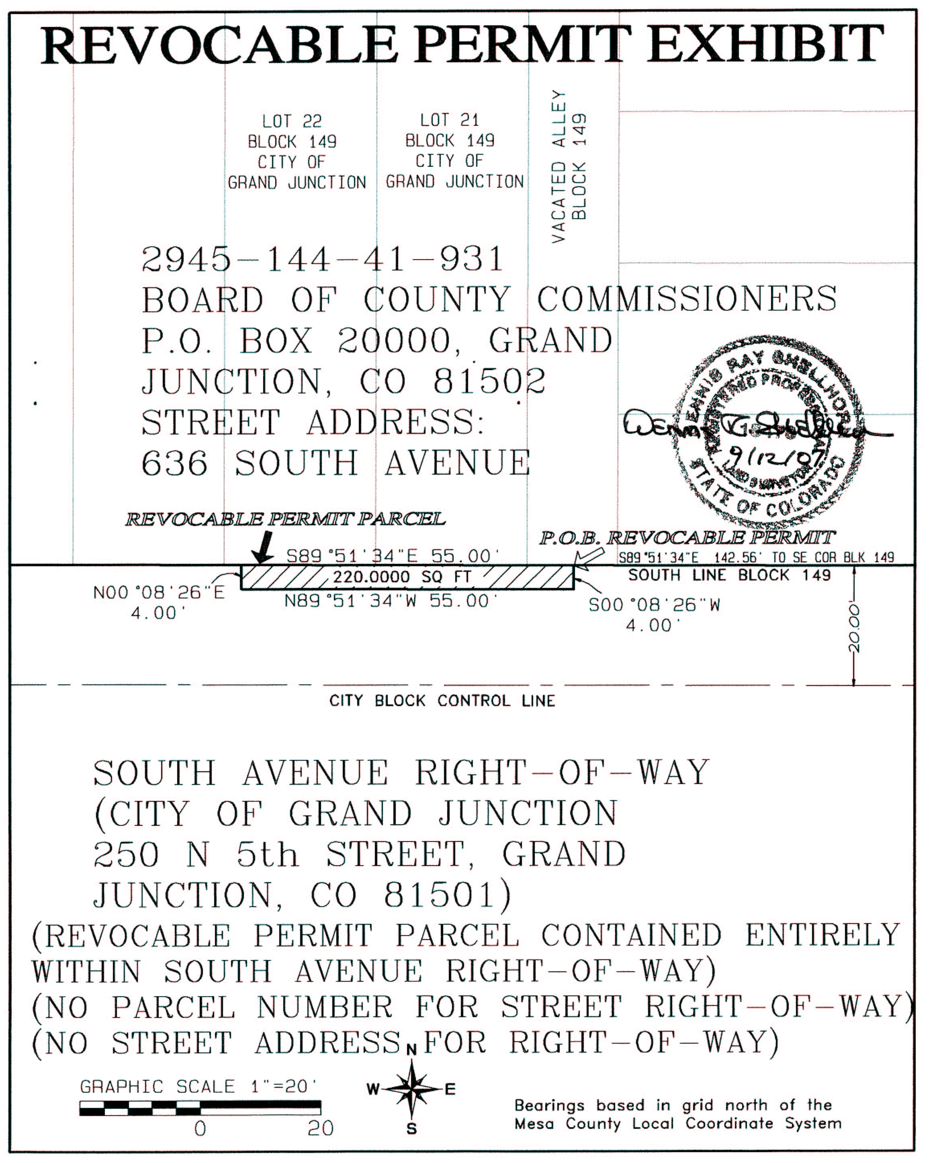
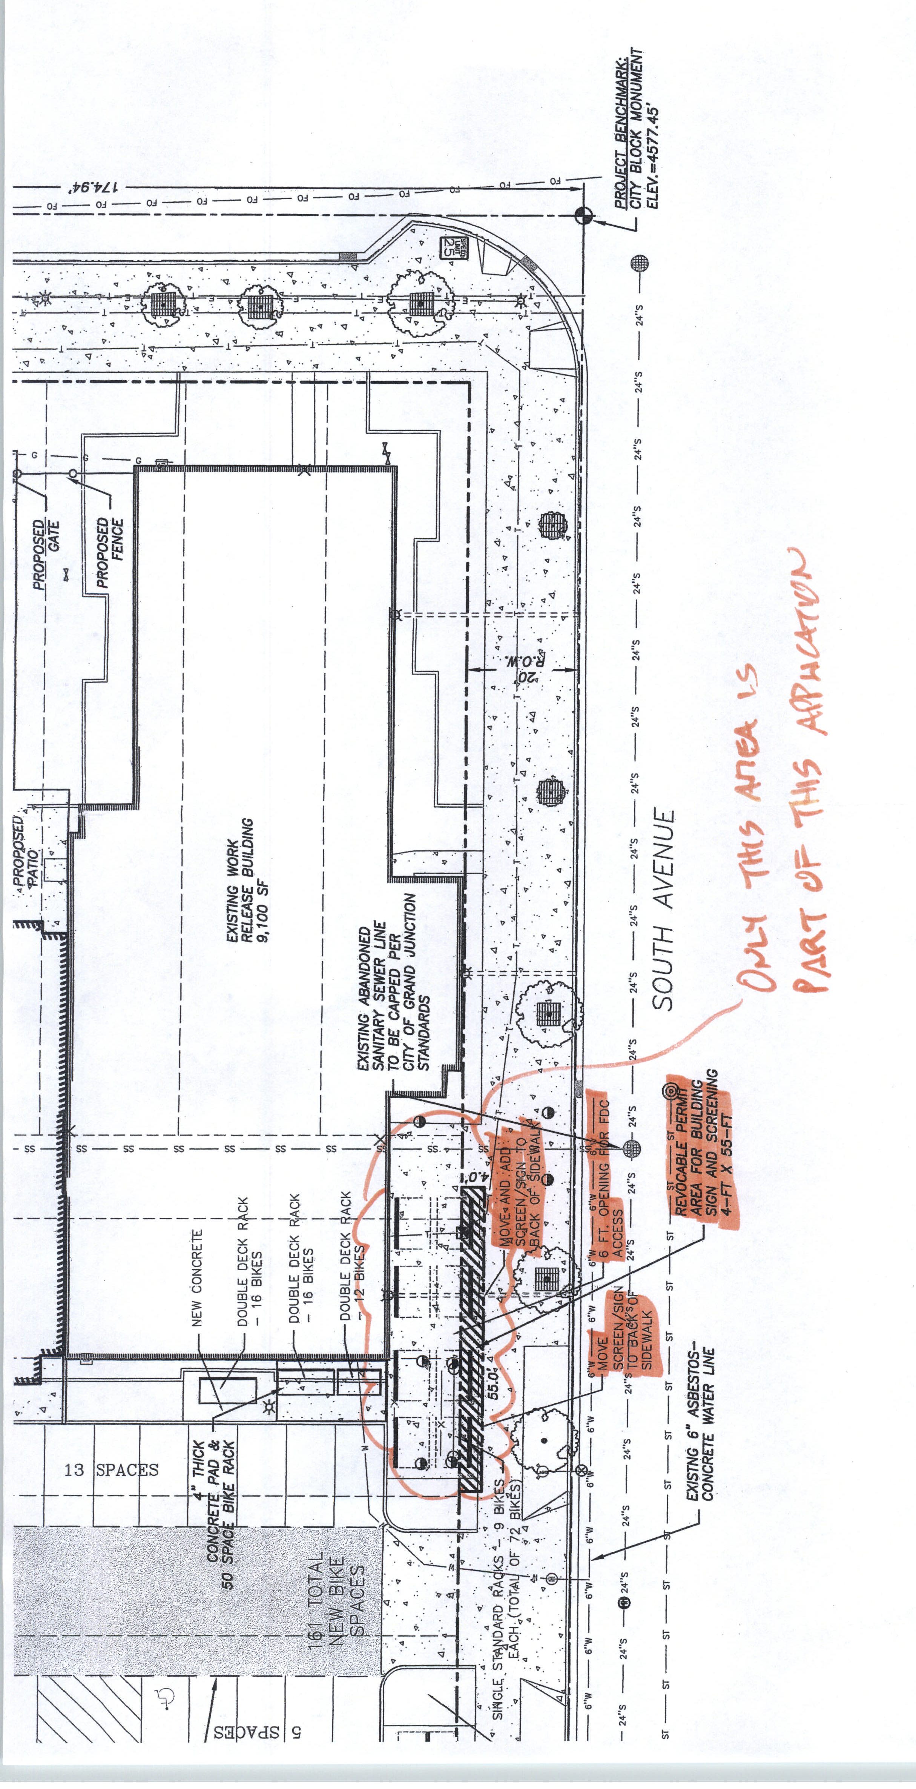
South Avenue
N
7th Street

