CITY OF GRAND JUNCTION

RESOLUTION NO. 19-07

A RESOLUTION VACATING A TEMPORARY TURN-AROUND EASEMENT ON LOT 1, BLOCK 1, INTERSTATE COMMERCIAL PARK FOUR SUBDIVISION

LOCATED AT 2314 LOGOS DRIVE

RECITALS:

A vacation of the temporary turn-around easement for Interstate Commercial Park Four has been requested by the property owners and per the plat note as provided on Interstate Commercial Park Two, recorded in Plat Book 18, Page 288 through 289, Mesa County Clerk and Recorder.

The City Council finds that the request is consistent with the Growth Plan, the Grand Valley Circulation Plan and Section 2.11 of the Zoning and Development Code.

The Planning Commission, having heard and considered the request, found the criteria of the Code to have been met, and recommends that the vacation be approved.

NOW, THEREFORE BE IT ORDAINED BY THE CITY COUNCIL OF THE CITY OF GRAND JUNCTION THAT:

The following described dedicated temporary turn-around easement for is hereby vacated subject to the listed conditions:

- Applicants shall pay all recording/documentary fees for the Resolution, any easement documents and dedication documents.

The following temporary turn-around easement is shown on “Exhibit A” as part of this vacation of description:

That certain turn-around easement as shown on the plat of Interstate Commercial Park Two, recorded in Plat Book 18 at page 288 in the Office of the Mesa County Clerk and Recorder, being more particularly described as follows:

Commencing at a 5/8-inch rebar and alloy cap (PLS 16413) for the SW1/16 Corner of Section 32, Township 1 North, Range 1 West of the Ute Meridian from whence a Mesa County Survey Marker for the S.E. Corner of the SW1/4 SW1/4 of said Section 32 bears S00º01’19”W for a distance of 1319.13 feet; thence N00º00’44”E, along the easterly line of the NW1/4 SW1/4 of said Section 32, for a distance of 381.38 feet to a 5/8-inch rebar and alloy cap (PLS 18469) for the S.E. Corner of Lot 1 Block 1 of Interstate Commercial Park Four as recorded in Book 4283 at Page 691, Reception Number 2346558, in the Office of the Mesa County Clerk and Recorder; thence, S89º58’41”W, along the southerly line of said Lot 1, for a distance of 6.61 feet to the Point of Beginning; thence, S89º58’41”W, continuing on said southerly line of Lot 1, for a distance of 101.84 feet; thence, leaving said southerly line, N49º50’59”E for a distance of 16.47 feet to a point of curvature; thence on the arc of a non-tangent 45.00 foot radius curve to the right (the central angle of which is 174º04’46” and the chord of which bears S83º14’ 21”E a distance of 89.88 feet) for a distance of 136.72 feet to the Point of Beginning.

(contains 3512.4 sq. ft. more or less)

PASSED on this 7th day of February, 2007.

/s/ James J. Doody
President of City Council
ATTEST:

/s/ Stephanie Tuin
City Clerk

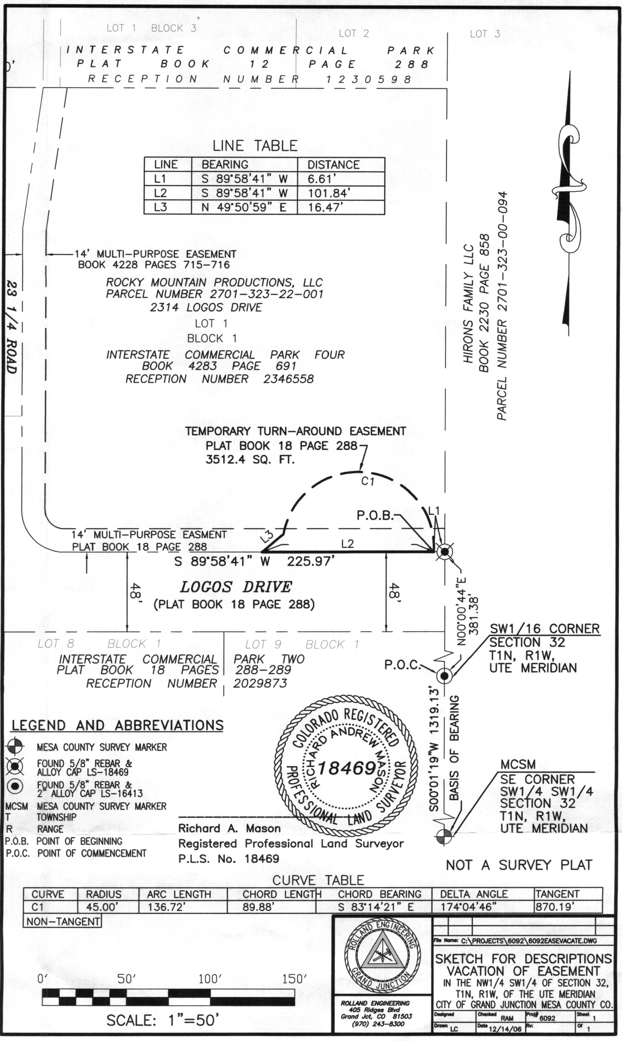
EXHIBIT A

