RESOLUTION NO. 42-07
A RESOLUTION CONCERNING THE ISSUANCE OF A REVOCABLE PERMIT TO
DONALD AND JOYCE ANDERSON

Recitals.

Donald Anderson and Joyce Anderson, hereinafter referred to as the Petitioners, represent that they are the owners, as joint tenants, of the following described real property in the City of Grand Junction, County of Mesa, State of Colorado, to wit:

Lot 2 Fair Minor Subdivision Section 33 1N 1W containing 0.53 acres.

and have requested that the City Council of the City of Grand Junction issue a Revocable Permit to allow the Petitioners to install, operate, maintain and repair fence and landscape improvements within the limits of the following described public right-of-way for G Road, to wit:

A parcel of land situated in the southwest 1/4 of the southeast 1/4 of Section 33, Township 1 North, Range 1 West of the Ute Meridian, Mesa County, Colorado, being more particularly described as follows:
Commencing at the east 1/16th corner on the south line of said Section 33, the basis of bearing being N89º57’57”W to the south 1/4 of said Section 33;
thence N17º52’12”W a distance of 82.03 feet to the Point of Beginning;
thence S00º07’32”E a distance of 8.00 feet;
thence along the arc of a non-tangent curve to the right 38.74 feet having a central angle of 73º59’49” and a radius of 30.00 feet and a chord bearing S33º40’37”W a distance of 36.11 feet;
thence N89º57’57”W a distance of 147.65 feet;
thence N00º06’55”W a distance of 20.00 feet;
thence S89º57’57”E a distance of 147.68 feet;
thence along the arc of a curve to the left 28.32 feet having a central angle of 90º09’29” and a radius of 18.00 feet and a chord bearing N44º57’16”E a distance of 25.49 feet;
thence N89º52’28”E a distance of 2.00 feet to the Point of Beginning.
Said parcel contains 3308 square feet more or less.

2. Based on the foregoing, the City Council has determined that such action would not at this time be detrimental to the inhabitants of the City of Grand Junction.

NOW, THEREFORE, BE IT RESOLVED BY THE CITY COUNCIL OF THE CITY OF GRAND JUNCTION, COLORADO:

That the City Manager, on behalf of the City and as the act of the City, is hereby authorized and directed to issue the attached Revocable Permit to the above-named Petitioners for the purposes aforedescribed and within the limits of the public right-of-way aforedescribed, subject to each and every term and condition contained in the attached Revocable Permit.

PASSED and ADOPTED this 21st day of March, 2007.

Attest:
/s/ James J. Doody
President of the City Council

/s/ Stephanie Tuin
City Clerk

REVOCABLE PERMIT

Recitals.

1. Donald and Joyce Anderson, hereinafter referred to as the Petitioners, have requested that the City of Grand Junction issue a Revocable Permit to allow the Petitioners to install, operate, maintain, repair and replace landscape improvements including an irrigation system and fencing, as approved by the City, within the limits of the public right-of-way as described in Exhibits A, B and C attached.

2. Based on the authority of the Charter and § 2.17B of the Grand Junction Zoning and Development Code applying the same, the City, by and through the Public Works and Planning Director, has determined that such action would not at this time be detrimental to the inhabitants of the City.

NOW, THEREFORE, IN ACCORDANCE WITH HIS LAWFUL AUTHORITY, TIM MOORE, AS PUBLIC WORKS AND PLANNING DIRECTOR, DOES HEREBY ISSUE:

To the above-named Petitioners a Revocable Permit for the purposes of, Fencing, landscaping and irrigation within the limits of the public right-of-way described; provided, however, that this Permit is conditioned upon the following:

1. The installation, operation, maintenance, repair and replacement of landscape improvements including an irrigation system and fencing by the Petitioners within the public right-of-way as authorized pursuant to this Permit shall be performed with due care or any other higher standard of care as may be required by the City to avoid creating hazardous or dangerous situations and to avoid damaging public roadways, sidewalks, utilities, or any other facilities presently existing or which may in the future exist in said right-of-way.

2. The City, on its behalf and on behalf of the County of Mesa, the State of Colorado and the Public Utilities, hereby reserves and retains a perpetual right to utilize all or any portion of the public right-of-way for any purpose whatsoever. The City further reserves and retains the right to revoke this Permit at any time and for any or no reason.

3. The Petitioners, for themselves and for their successors and assigns, agree that they shall not hold, nor attempt to hold, the City of Grand Junction, its officers, employees and agents, liable for damages caused to any improvements and/or facilities to be installed by the Petitioners within the limits of the public right-of-way (including the removal thereof), or any other property of the Petitioners or any other party, as a result of the Petitioners’ occupancy, possession or use of said public right-of-way or as a result of any City, County, State or Public Utility activity or use thereof or as a result of the installation, operation, maintenance, repair and replacement of public improvements.

4. The Petitioners agree that they shall at all times keep the above described public right-of-way and the facilities authorized pursuant to this Permit in good condition and repair.

5. This Revocable Permit for fencing, landscaping and irrigation shall be issued only upon concurrent execution by the Petitioners of an agreement that the Petitioners and the Petitioners’ successors and assigns shall save and hold the City of Grand Junction, its officers, employees and agents harmless from, and indemnify the City, its officers, employees and agents, with respect to any claim or cause of action however stated arising out of, or in any way related to, the encroachment or use permitted, and that upon revocation of this Permit by the City the Petitioners shall, at the sole expense and cost of the Petitioners, within thirty (30) days of notice of revocation (which may occur by mailing a first class letter to Petitioners’ last known address), peaceably surrender said public right-of-way and, at their own expense, remove any encroachment so as to make the described public right-of-way available for use by the City, the County of Mesa, the State of Colorado, the Public Utilities or the general public. The provisions concerning holding harmless and indemnity shall survive the expiration, revocation, termination or other ending of this Permit.

6. The Petitioners, for themselves and for their successors and assigns, agree that they shall be solely responsible for maintaining and repairing the condition of any and all fencing, plantings and irrigation systems and improvements and/or facilities authorized pursuant to this Permit. The Petitioners shall not install any fencing, trees, vegetation or other improvements that create sight distance problems.

7. This Revocable Permit and the following Agreement shall be recorded by the Petitioners, at the Petitioner’s expense, in the office of the Mesa County Clerk and Recorder.

Dated this ________ day of ______________________, 2007.

The City of Grand Junction,
Written and Recommended by: a Colorado home rule municipality

______________________________
Project Manager/Planner Director of Public Works and Planning

Acceptance by the Petitioner:

____________________________________
Donald Anderson Joyce Anderson

AGREEMENT

Donald and Joyce Anderson, for themselves and for their successors and assigns, do hereby agree to abide by each and every term and condition contained in the foregoing Revocable Permit for landscaping and an irrigation system. Furthermore, they shall indemnify the City of Grand Junction, its officers, employees and agents and hold the City of Grand Junction, its officers, employees and agents harmless from all claims and causes of action as recited in said Permit.

Within thirty (30) days of revocation of said Permit, peaceably surrender said public right-of-way to the City of Grand Junction and, at their sole cost and expense, remove any encroachment so as to make said public right-of-way fully available for use by the City of Grand Junction, the County of Mesa, the State of Colorado, the Public Utilities or the general public.

The Permittee acknowledges the existence of good and sufficient consideration for this Agreement.

Dated this _______ day of _______________, 2007.

By signing, the Signatories represent that they have full authority to bind the Permittee to each and every term and condition hereof and/or in the Permit.

Donald Anderson

Joyce Anderson

State of Colorado )
)ss.
County of Mesa )

The foregoing Agreement was acknowledged before me this _____ day of _____________, 2007, by __________________________________________.

My Commission expires: __________________
Witness my hand and official seal.

Notary Public
EXHIBIT A – Permit Area Legal Description

A parcel of land situated in the southwest 1/4 of the southeast 1/4 of Section 33, Township 1 North, Range 1 West of the Ute Meridian, Mesa County, Colorado, being more particularly described as follows:
Commencing at the east 1/16th corner on the south line of said Section 33, the basis of bearing being N89º57’57”W to the south 1/4 of said Section 33;
thence N17º52’12”W a distance of 82.03 feet to the Point of Beginning;
thence S00º07’32”E a distance of 8.00 feet;
thence along the arc of a non-tangent curve to the right 38.74 feet having a central angle of 73º59’49” and a radius of 30.00 feet and a chord bearing S33º40’37”W a distance of 36.11 feet;
thence N89º57’57”W a distance of 147.65 feet;
thence N00º06’55”W a distance of 20.00 feet;
thence S89º57’57”E a distance of 147.68 feet;
thence along the arc of a curve to the left 28.32 feet having a central angle of 90º09’29” and a radius of 18.00 feet and a chord bearing N44º57’16”E a distance of 25.49 feet;
thence N89º52’28”E a distance of 2.00 feet to the Point of Beginning.
Said parcel contains 3308 square feet more or less.

This description was prepared by:
Steven L Hagedorn
Colorado P.L.S. 24306
118 Ouray Ave.
Grand Junction, CO 81501

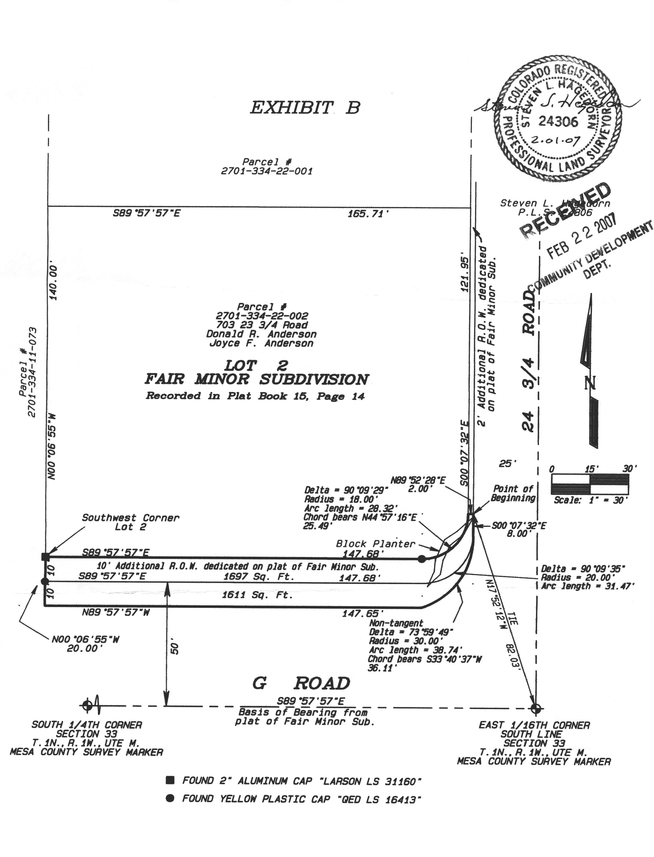

EXHIBIT C – SITE PLAN IMPROVEMENTS IN RIGHT-OF-WAY

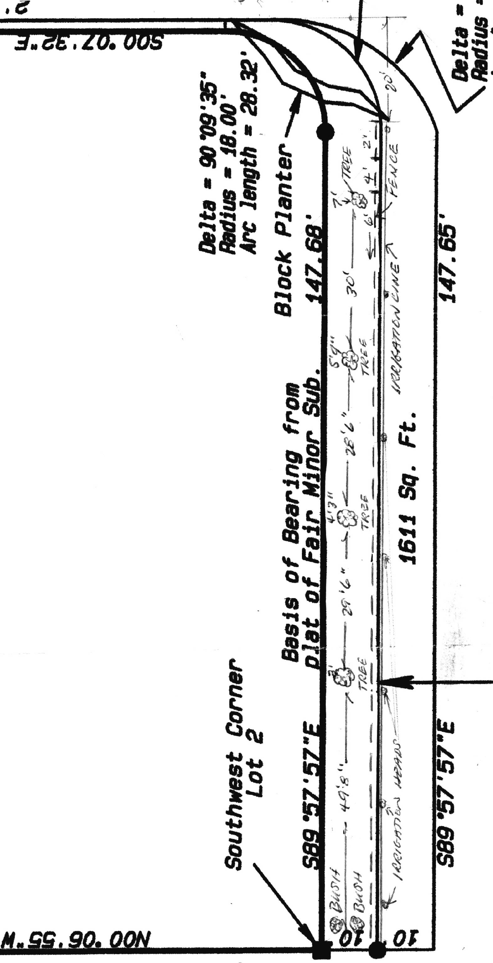
6-foot Privacy Fence
Front of house to rear property line
30-inch height solid fence or 4-foot height, 2/3 open fence from planter wall to front of house

