RESOLUTION NO. 144-08

A RESOLUTION AUTHORIZING THE SALES CONTRACT FOR A VACANT PARCEL OF CITY RIGHT-OF-WAY PROPERTY LOCATED ALONG THE REDLANDS PARKWAY, GRAND JUNCTION

Recitals.

Daniel and Joellen McIntyre approached the City regarding a possible purchase of a vacant parcel located along the Redlands Parkway bordering their property. The parcel is a vacant City right-of-way parcel. The City Council Property Committee approved the sale of the property and requested Staff to put the property out for bid. The McIntyres were the only party to respond with a bid of $3,000.00, which the Committee accepted.

NOW, THEREFORE, BE IT RESOLVED BY THE CITY COUNCIL OF THE CITY OF GRAND JUNCTION, COLORADO, THAT:

- The property described in the attached Exhibit B shall be conveyed to Daniel and Joellen McIntyre for the sale price of $3,000.00.
- All actions heretofore taken by the officers, employees and agents of the City relating to the sale of the property which are consistent with the provisions of the Sales Contract and this Resolution are hereby ratified, approved and confirmed.
- The officers, employees and agents of the City are hereby authorized and directed to take all actions necessary or appropriate to complete the sale of the described property. Specifically, City staff is directed to effectuate this Resolution and the Sales Contract, including the execution and delivery of the deed and such documents as are necessary to complete the sale.

DATED this 19th day of November, 2008.

/s/: Gregg Palmer
President of the Council
Attest:

/s/: Stephanie Tuin
City Clerk

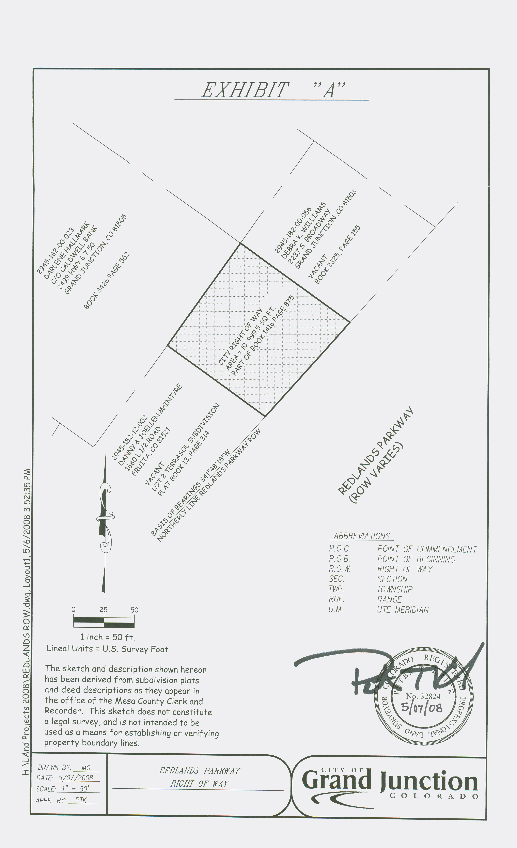
DESCRIPTION

A certain parcel of land, being a portion of Redlands Parkway right of way, located in the Northwest Quarter(NW1/4) of Section 18, Township 1 South, Range 1 West of the Ute Meridian, City of Grand Junction, Mesa County, State of Colorado, being more particularly described as follows:

All that portion of Redlands Parkway right of way as described in Book 1416, Page 875 and recorded in the office of the Mesa County Clerk lying Northwesterly of the northwesterly line of Redlands Parkway right of way, as said northwesterly right of way is extended northeasterly from the southeasterly line of Lot 2 Terrasol Subdivision, as recorded in Plat Book 13, Page 314 in said office.

Containing 10,999.50 square feet, more or less, as described.

Prepared by: Michael Grizenko
Real Estate Technician
Date: May 7, 2008

