CITY OF GRAND JUNCTION, COLORADO

ORDINANCE NO. 4629

AN ORDINANCE ADOPTING THE ORCHARD MESA NEIGHBORHOOD PLAN
AS AN ELEMENT OF THE GRAND JUNCTION COMPREHENSIVE PLAN FOR THE AREA GENERALLY LOCATED SOUTH OF THE COLORADO RIVER TO WHITEWATER HILL AND EAST OF THE GUNNISON RIVER TO 34 ½ ROAD

Recitals.

The Orchard Mesa Neighborhood Plan (Plan) is the result of a joint planning effort by the City of Grand Junction and Mesa County. It builds upon the 2010 Grand Junction Comprehensive Plan adopted by Mesa County and the City of Grand Junction.

The Plan has been developed based on input from meetings with property owners, residents and business owners. Input was received through six open houses, eleven focus group meetings attended by various representatives from area utility and service providers and Mesa County Fairground staff, staff representatives from Mesa County and City of Grand Junction; and thee joint City/County Planning Commission workshops. The Plan was developed during a year of extensive public involvement and deliberation. The Plan complements the Comprehensive Plan addresses the specific needs of the Orchard Mesa area.

The Plan area encompasses about 13,000 acres, or just over 20 square miles; of that about 3 square miles is in the current City limits. Over half of the Plan area is located within the Urban Development Boundary.

The Plan does the following:

  - Like the 2010 Grand Junction Comprehensive Plan, the Orchard Mesa Neighborhood Plan will serve as a guide to public and private development decisions through the year 2035. It supports the community vision for its own future set forth in the Comprehensive Plan and provides a road map to achieve that vision in Orchard Mesa. It identifies and recommends specific strategies that will help Orchard Mesa realize its place in the vision of Comprehensive Plan to become to be the most livable community west of the Rockies.

  - The Plan focuses on twelve planning topics in its twelve chapters: Community Image; Future Land Use & Zoning; Rural Resources; Housing Trends; Economic Development; Transportation; Public Services; Stormwater; Parks, Recreation, Open Space & Trails; Mesa County Fairgrounds; Natural Resources; and Historic Preservation. Each chapter begins with a “Background” discussion, describing existing conditions and known issues. Relevant sections of the 2010 Comprehensive Plan are included, with an emphasis on the Guiding Principles. The Goals and Actions for each subject are preceded by the related 2010 Comprehensive Plan Goals and Policies.

  - The Plan recommends changes to the Future Land Use Map for that area within and surrounding the Neighborhood Center at 27 ¾ Road and Hwy 50.

  - The Plan respects individual property rights.

The Planning Commission is charged with reviewing the Plan and making a recommendation to City Council.

The 2000 Orchard Mesa Neighborhood Plan was sunset when the Grand Junction Comprehensive Plan was adopted in February 17, 2010 (Ordinance No. 4406).

The Orchard Mesa Neighborhood Plan was heard by the Grand Junction Planning Commission in a public hearing jointly with Mesa County Planning Commission on February 20, 2014 and subsequently approved by the Mesa County Planning Commission. The Grand Junction Planning Commission forwarded a recommendation to City Council to adopt the Plan and the Future Land Use Map amendment recommended thereby.

NOW THEREFORE, BE IT ORDAINED BY THE CITY COUNCIL OF THE CITY OF GRAND JUNCTION:

That the Orchard Mesa Neighborhood Plan, in the form of the document attached hereto, and as recommended for adoption by the Grand Junction Planning Commission, is hereby adopted.

The full text of this Ordinance, including the text of the Orchard Mesa Neighborhood Plan, in accordance with paragraph 51 of the Charter of the City of Grand Junction, shall be published in pamphlet form with notice published in accordance with the Charter.

INTRODUCED on first reading the 16th day of April, 2014 and ordered published in pamphlet form.

PASSED and ADOPTED on second reading the 7th day of May, 2014 and ordered published in pamphlet form.

/s/ Phyllis Norris
President of City Council
ATTEST:

/s/ Stephanie Tuin
City Clerk
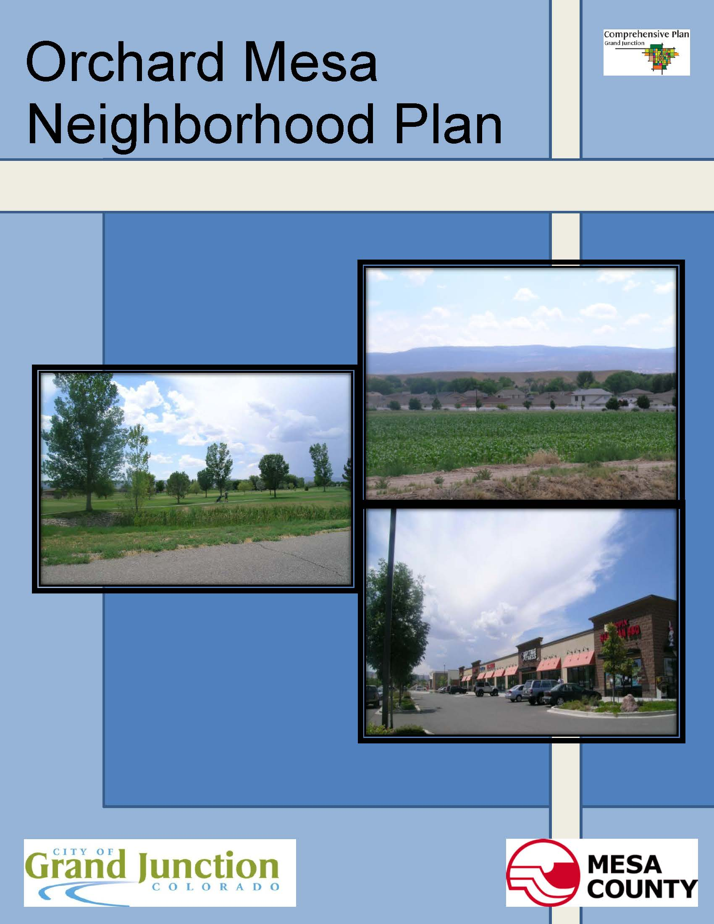
Orchard Mesa Neighborhood Plan
Table of Contents
PAGE
Introduction

1. Community Image 8

2. Future Land Use & Zoning 13

3. Rural Resources 21

4. Housing Trends 27

5. Economic Development 33

6. Transportation 38

7. Public Services 44
- Public Utilities and Infrastructure
- Community and Public Facilities
- Public Safety

8. Stormwater 54

9. Parks, Recreation, Open Space & Trails 57

10. Mesa County Fair Grounds 63

11. Natural Resources 66

12. Historic Preservation 71

Appendix: Maps 75
- Orchard Mesa Plan Area
- Plan Area Air Photo
- Commercial Industrial Property
- 2010 Future Land Use (as amended, February 2013)
- Zoning - City and County
- Neighborhood Center Future Land Use Changes
- Current Land Use
- Open Lands Overlay District
- Vacant Residential Property Inventory
Maps Continued
- Whitewater Hill Recreation and Training Facilities
- Enterprise Zones
- Grand Valley Circulation Plan
- Existing Trails (Sidewalks, Trails, Bike Lanes, Bike Routes)
- Neighborhood Center Circulation Concept Plan
- Highway 50 Corridor Circulation Concept Plan
- Utilities – Sewer Service
- Utilities – Water Service
- Orchard Mesa Irrigation District
- Utilities – Electric
- School attendance areas
- Fire Districts
- Flood Inundation Study – 100 Year area
- Floodplain
- Historic Resource Map

Figures PAGE
1. Orchard Mesa Neighborhood Plan Area 1
2. B ½ Road Interchange Beautification Concept 10
3. 2010 Comprehensive Plan Future Land Use Map 13
4. Neighborhood Center Future Land Use Changes 16
5. Priority Areas for Development 18
6. Residences by Year Built 30
7. Blended Residential Map 31
8. Neighborhood Center Circulation Concept Plan 39
9. Orchard Mesa Flood Inundation Study 55
10. Park Service Areas 58
11. Fairgrounds Master Plan 64

Tables
1. 2010 Census Data 2
2. Population Projections, 2010-2040 2
3. Owner Occupancy Rates 28
4. Dwelling Units by Type 29
5. Single Family Residential Valuation 30
6. Orchard Mesa Commercial & Industrial Uses by Zoning 34
7. Orchard Mesa Employment by Sector 34
8. School Enrollment 49
9. Fire Station No. 4 Call Volume 51
10. Park Inventory 59

Introduction

The 2010 Grand Junction Comprehensive Plan Vision for the area is to “become the most livable community west of the Rockies.”

The Orchard Mesa planning area is one of ten planning areas identified within the boundaries of the Comprehensive Plan. The joint Plan between the City of Grand Junction and Mesa County established six guiding principles that will shape growth and help the community achieve its vision:
- Concentrating growth in “Centers”.
- Developing and growing using sustainable growth patterns.
- Encouraging more variety in housing choice.
- Creating a grand green system of connected recreational opportunities.
- Establishing a balanced transportation system accommodating all modes of travel.
- Preserving Grand Junction as a regional center providing diverse goods and services.

Goal 1 of the 2010 Comprehensive Plan is to implement the Comprehensive Plan in a consistent manner between the City, Mesa County and other service providers.

Figure 1: Orchard Mesa Neighborhood Plan Area
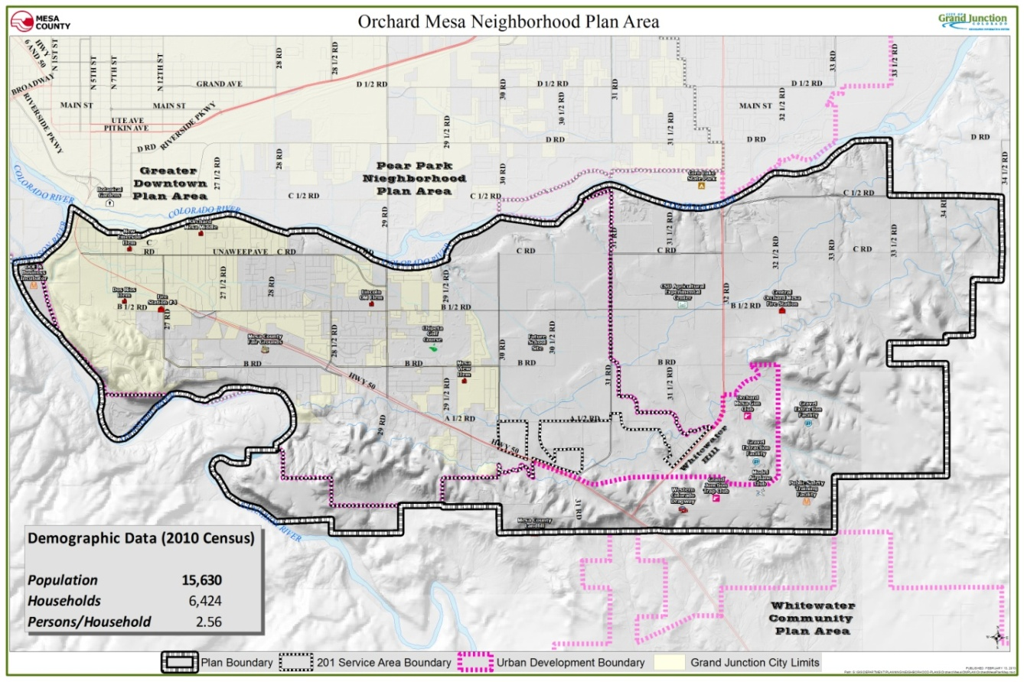

Pg 1

Location
The Orchard Mesa Neighborhood Plan area is bounded by the Gunnison and Colorado Rivers, Whitewater Hill and 34 ½ Road. (Figure 1; Appendix Map 1 and 2) The Plan area is generally urban or urbanizing west of 31 Road. East of 31 Road, the land uses are rural, and are designated as such in the 2010 Grand Junction Comprehensive Plan. There is an area in and around the Valle Vista subdivision and Springfield estates, along Highway 141, that is urban but surrounded by rural land uses. The Urban Development Boundary further delineates the areas that are intended for urban development.

Purpose of Plan
Developing a plan for Orchard Mesa allows residents, business owners and others to focus on neighborhood growth issues and helps create a livable community now and in the future. The Orchard Mesa Neighborhood Plan complements the Comprehensive Plan and focuses on specific quality of life issues that were identified during the planning process. At the time of the adoption of the 2010 Comprehensive Plan, the 1995 Orchard Mesa Neighborhood Plan (revised in 2000) was sunset, so it is no longer in effect. This is a new 25-year plan for Orchard Mesa.

The Plan develops the long range vision for Orchard Mesa by building upon the 2010 Comprehensive Plan. Specific Orchard Mesa Goals and Actions have been established in the Plan to implement the vision of the Comprehensive Plan and address Orchard Mesa’s particular issues.

Demographics

Orchard Mesa Plan Area Population
Table 1: 2010 Census Data
2010 CENSUS | Orchard Mesa | Grand Junction | Mesa County
Population | 15,630 | 58,566 | 146,723
Total Households | 6,424 | 26,170 | 62,644
Occupied Households | 6,105 | 24,311 | 58,095
% Occupied | 95% | 92.9% | 92.7%
Persons/Household | 2.56 | 2.29 | 2.46
% Owner Occupied | 83.3% | 62.4% | 71.4%
% Renter Occupied | 16.7% | 37.6% | 28.6%
Source: 2010 US Census data; Colorado State Demographer; Mesa County Assessor Records

Table 2: Population Projections, 2010-2040
 | 2010 | 2020 | 2030 | 2040 | % Change,  30-year | Average Annual Growth Rate
Urban | 14,377 | 17,782 | 19,990 | 23,360 | 62.5% | 1.63%
Rural | 920 | 1,012 | 1,108 | 1,194 | 29.8% | 0.87%
Total | 15,297 | 18,805 | 21,096 | 24,575 | 60.6% | 1.59%
Source: Mesa County Regional Transportation Planning Office
Note: 2010 base population difference from 2010 Census is due to minor boundary differences.
Housing Vacancy
Pg 2

The 2010 Census shows 95% of the housing units on Orchard Mesa were occupied. This is higher than both the City and County rates of just under 93%. About 75% of the homes in the Orchard Mesa Plan area were owner-occupied. Again, this is a higher percentage than in the City of Grand Junction (62%) and Mesa County (71%). The rate of owner occupancy in the unincorporated areas was even higher, at over 83%.
Translating the Vision
(2010 Grand Junction Comprehensive Plan)

“What does “livable” mean for Land Use?
- A broad range and balance of uses.
- Quality employment opportunities with a mix of job types.
- Provision of housing, jobs, services, health and safety for all its residents.
- Value of our agricultural background.
- Services and shopping are close to where we live to cut down the amount of cross-town traffic, decrease commuting times and reduced air pollution.

Commercial Vacancy

In June, 2013 Orchard Mesa led the City of Grand Junction in the percentage of vacant commercial buildings at 15.5%. That vacancy rate increased to 16.9% in August, 2013.

Housing Type vs. Population Needs

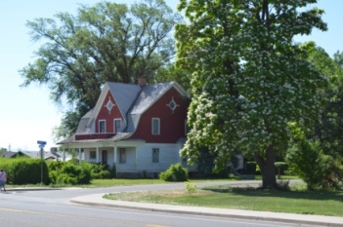A Guiding Principle of the 2010 Comprehensive Plan is the need to provide housing variety for our population. The majority of housing on Orchard Mesa is detached single family homes. More variety in housing types is needed that will better serve the needs of a diverse population made up of singles, couples, households with children, those just starting out, and retirees. The most significant population increase in the next 30 years will be in the 65 and older age group. The percentage of the population age 17 and younger is expected to stay steady, meaning the number of people age 18-64, as a percentage of the overall population, will decline. This will have a significant impact on the type of housing that will be in demand.

Low Income/At Risk Population

There is a misperception that a significant number of low-income or at-risk families and individuals reside in the Orchard Mesa area. While there are clusters of poverty, the Orchard Mesa community as a whole is much like any other part of the Grand Junction area. One indicator to identify this population is those served by Mesa County Department of Human Services (DHS). In reality, recipients of DHS services are spread over most of the county. The majority resides in the urbanized areas in the valley, which is the most populous area of the county, but as a proportion of the overall population, the number of lower income residents is no greater than in other parts of the county. Orchard Mesa’s younger median age relative to the rest of Grand Junction is another factor; young singles and families who are just starting out generally earn less than older people who have become more established in their jobs. There are middle and upper income homes and stable living environments throughout Orchard Mesa.

Pg 3
Growth and Development of Centers
The 2010 Comprehensive Plan established the future land uses for the Orchard Mesa Neighborhood Plan area, providing for the future growth anticipated for the Grand Junction area. The Comprehensive Plan contemplates growth over the next 25 years or longer, envisioning a doubling of the population. It identifies the need to grow in a more compact way, but in a manner that is predictable and doesn’t adversely affect existing neighborhoods. To achieve this goal, mixed-use centers were envisioned at key locations. Orchard Mesa has two areas where such centers are identified. Below is a brief description of these two Centers, with additional information found in the Land Use & Zoning chapter.

Existing Neighborhood Center at B ½ Road and Highway 50
This Neighborhood Center already exists with a major grocery store, public library, restaurants, and other services. There is vacant property available for growth in the center, with zoning in place for residential housing and additional commercial and public services. The County Fairgrounds and parks are immediately south across Highway 50.

A typical neighborhood center is pedestrian-oriented and can expect to have several buildings one to three stories in height encompassing an area less than 20 acres in size. They are developed to be compatible with surrounding neighborhoods while providing many of the services those neighborhoods need. The land uses are a mix of uses including convenience-oriented commercial (gas stations, grocers, dry cleaner, bakery, coffee shop, etc.), and may include service providers and facilities such as a fire station, post office, and library. Medium-density residential uses including townhomes and small apartments/condominiums are integrated within or immediately adjacent to the center. Walk-to neighborhood parks, public squares, and similar amenities may be located in or near the center.

Future Village Center at 30 Road and Highway 50
This future Village Center is not anticipated to be developed until Orchard Mesa has seen sufficient growth to support it and services have been extended to the area. It most likely will be many years before development in the area can support a Village Center at this location.

A Village Center is larger than a neighborhood center. It is a mixed-use center that is pedestrian-oriented with more buildings and additional heights up to five stories. It allows for a broader range of density and intensity with an inclusion of community service providers and facilities like libraries, fire stations, police stations, recreation centers, parks, post offices, etc. A mix of uses is expected including large to medium-sized stores and convenience-oriented retail. Residential densities taper downward (“transition”) gradually to match or compliment surrounding neighborhoods. Establishing a unique character through architecture and/or urban design for a village is desirable.

Pg 4

The Planning Process
The purpose of a neighborhood plan is to establish the means for existing and future residents and businesses to achieve a desired quality of life and help their community thrive. The Plan defines the vision and identifies specific issues; it establishes goals, policies and action steps that will improve existing conditions and shapes future growth. Based on the 2010 Comprehensive Plan’s vision, the Orchard Mesa Neighborhood Plan provides greater detail on how to address specific concerns and issues Orchard Mesa will face as the area grows and develops.

Public participation is very important in identifying the issues and concerns of the citizens, business owners and service providers. The City and County began the planning process for the Orchard Mesa Neighborhood Plan in early 2013 as a joint planning effort. Much of the planning area lies outside of the city limits, underlying the importance and on-going partnership between Mesa County and Grand Junction.

The process included eleven focus groups/ stakeholder meetings, six open houses and three joint City/County Planning Commission workshops. The Board of County Commissioners and City Council were also briefed through the process. Over 320 people participated in the initial six open houses with approximately 93 written comments received. In addition staff received information and issues identified by Orchard Mesa service and utility providers, homeowner associations and the business community at eleven focus group meetings.

How the Plan is Organized
The issues and topics that garnered the most interest during the planning process included the following twelve topic areas separated into twelve chapters in the plan. Each chapter includes one topic area that describes existing conditions/background, community wide goals and policies from the 2010 Comprehensive Plan, and specific Orchard Mesa goals and actions:

  - Existing Conditions/Background: A description of Orchard Mesa as it exists, plus any known issues or needs.
  - Goals: General Statements of an achievable future condition or end; broad public purposes toward which policies and programs are directed.
  - Policies: A set of guidelines for enacting goals. Policies are intended to bring predictability to decision-making.
  - Actions: A specific step or strategy to implement a policy and reach a goal.

Plan Topics
Community Image – The current condition and look of the US Highway 50 corridor is a concern for many that have participated in this planning process. Dilapidated buildings, vacant businesses, junk and weeds are also issues identified.

Future Land Use & Zoning – Growth of Orchard Mesa over the next 30+ years will be shaped by the 2010 Comprehensive Plan’s Future Land Use map. Major changes to that map are not part of this planning effort, except the Plan does include a change to the Neighborhood Center. The 2011/12 construction of a major sewer line along Hwy 141 (32 Road) that runs between Clifton and Whitewater is a major concern and issue identified.
Pg 5

Rural Resources- In addition to keeping the 32 Road corridor rural, the protection of agricultural businesses including agritourism has been paramount for the majority of those participating.

Transportation – One of the most significant issues for citizens is making the Highway 50 corridor multi-modal with bike, transit and pedestrian facilities. “Complete Streets” that provide access to users of all ages, abilities and modes is a priority for Orchard Mesa. Providing safe access across Highway 50 from the neighborhoods located on both sides of the corridor, and providing safe walking routes for school children is especially important. Linking neighborhoods to the Colorado Riverfront trail system and the Old Spanish Trail northern branch that enters Orchard Mesa from the south has also been identified.

Economic Development – Current business vacancy on Orchard Mesa has risen recently to almost 17%, emphasizing the need to help find ways for business to be successful on Orchard Mesa. Residents have stated their desire for more neighborhood services and businesses to be available on Orchard Mesa. The anticipated growth of activities at the Mesa County fairgrounds and the further development of Whitewater Hill including the Public Safety Training Facility will be regional attractions that should spur economic development on Orchard Mesa.

Parks, Recreation, Open Space & Trails – The underserved areas without nearby parks, the future of Confluence Point above the Colorado and Gunnison Rivers, the Old Spanish Trail (Sisters Trail network), private homeowner association parks, and access to public lands and trail systems are all of interest to the citizens of Orchard Mesa.

Storm Water – Performing pre-disaster mitigation and improving and maintaining drainage facilities collectively among drainage partners is important for 400 acres and 700 structures inside an identified 100 year floodplain located in the center of the urban area of Orchard Mesa,.

Mesa County Fairgrounds – The Mesa County Board of Commissioners adopted a master plan for the fairgrounds on December 20, 2012. The master plan includes additional facilities that will attract more events and people to the facility, reinforcing its presence as an economic driver on Orchard Mesa.

Public Utilities & Services – Services provided to our citizens are an important part of our quality of life and for Orchard Mesa what helps it be a great place to live and do business. These include utilities, community facilities (schools, libraries, etc.) and public health and safety including, fire, law enforcement, and medical services.

Housing Trends – The 2010 Comprehensive Plan identified deficiencies and lack of diversity in housing choice housing throughout the Grand Junction area. This Orchard Mesa Plan looks at how Orchard Mesa is doing in achieving the Comprehensive Plan’s Guiding Principle of providing housing variety in our community.
Pg 6
Natural Resources – Orchard Mesa is rich in gravel deposits and has abundant wildlife in an environment where urban development now interfaces. How the growing community deals with these issues is important.

Historic Preservation – Orchard Mesa has a national historic trail that has been identified and recognized. Additionally, there are locally significant historic homes, structures and sites.

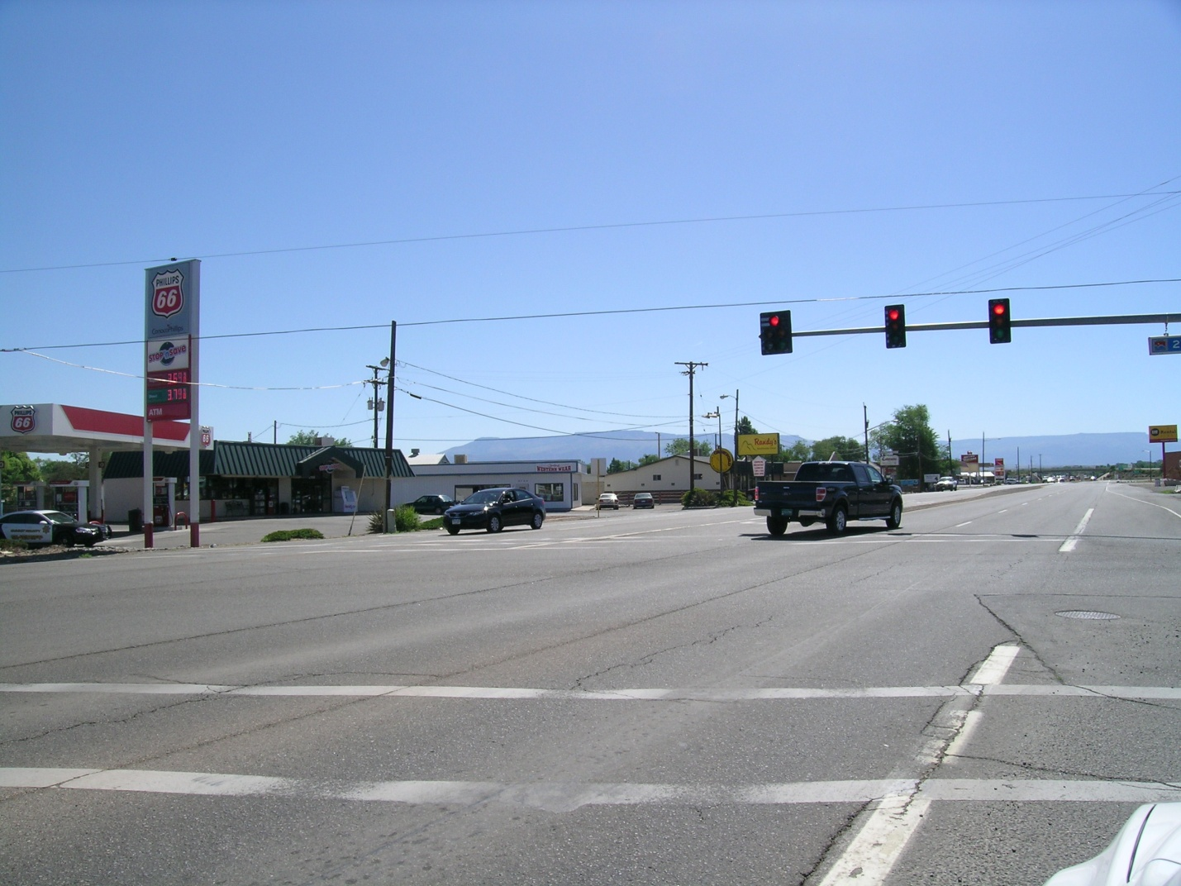1. Community Image
Pg 7

Background

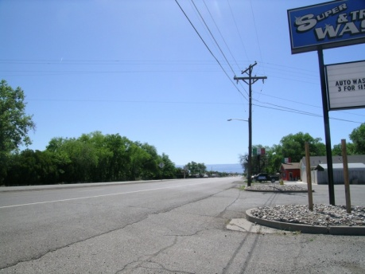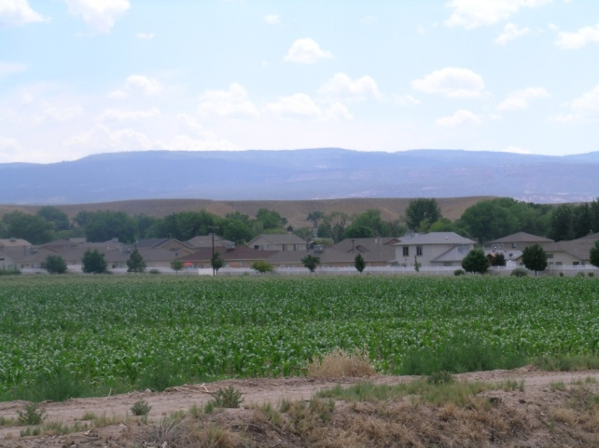How the community is portrayed affects many things including business climate, housing values and general quality of life aspirations. The first thing most people see when entering Orchard Mesa is the US Highway 50 corridor. It divides residential neighborhoods, creates a barrier for kids to get to school, and has no pedestrian and bicycle facilities. Some commercial properties along the corridor have struggled with vacancy rates running higher than other areas of Grand Junction; 16.9% of commercial buildings on Orchard Mesa were vacant according to a September 2013 Grand Junction vacancy survey (Appendix Map 3). Poorly maintained commercial and residential properties, weeds and junk further diminishes the image of the community.
Pg 8
Community Aesthetics
(2010 Grand Junction Comprehensive Plan)

“Area residents take pride in their community and have shown an interest in preserving and reinforcing the aesthetics of areas visible to the public. The Comprehensive plan preserves past objectives to enhance the community’s appearance. These include dressing up gateways and improving development standards for commercial and industrial areas. The plan recommends stronger design guidelines, especially in the highly visual areas of the community.”

The 2010 Comprehensive Plan’s vision is “To become the most livable community west of the Rockies.”

The Comprehensive Plan envisions a community that:
- Provides housing, jobs, services, health and safety for all its residents.
- Values our agricultural background; enjoys open spaces and a small-town feel.
- Has services and shopping close to where we live to cut down the amount of cross-town traffic and commute times to our jobs and to reduce air pollution.
- Wants neighborhoods and parks to be connected and close so our children have a safe place to play.
- Is willing to increase density in core areas, if that can prevent sprawl and encourage preservation of agricultural lands.
- Wants a broader mix of housing for all.
- Wants a community with a healthy economy and opportunities to raise families in a supportive, safe environment with good schools.
- Wants a transportation system that balances possibilities for cars, trucks, transit, bicycles and pedestrians.
- Wants opportunities for growth without sacrificing the quality of life that we have come to expect.
- 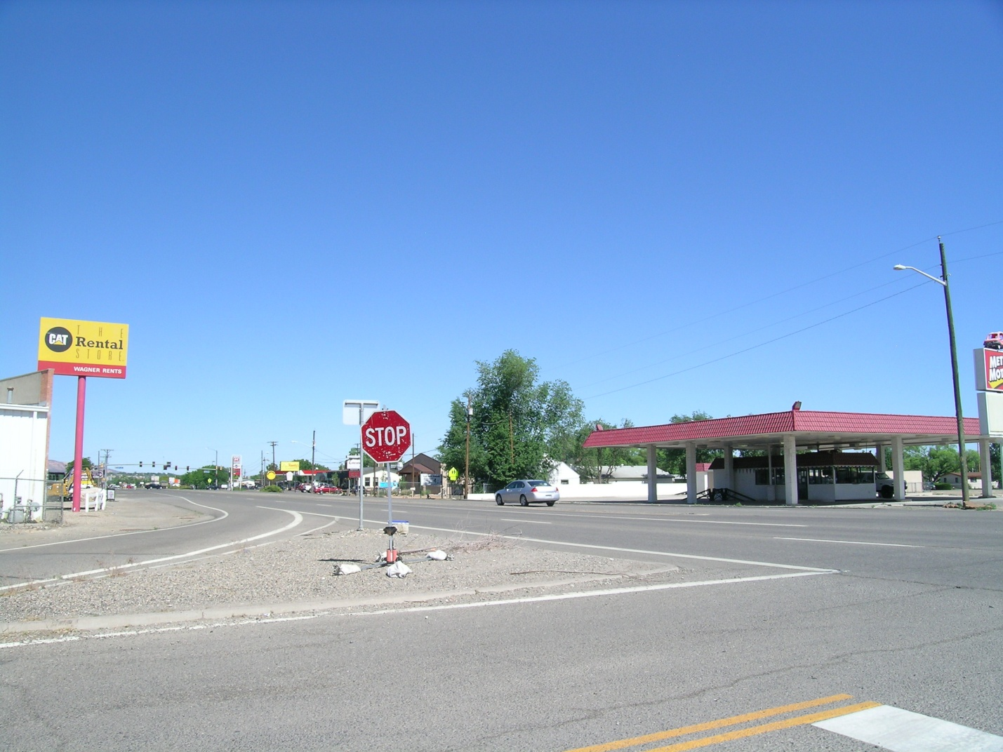Recognizes tourism and agri-tourism as a significant part of the economy. Without careful planning, agriculture and the lifestyles surrounding it will disappear under the weight of urban sprawl.

Community gateways and aesthetics has been a topic of discussion for years in Grand Junction and US Highway 50 that enters Orchard Mesa from the south and runs through the community is a very important gateway to Grand Junction. Beautifying the corridor continues to be a priority. A conceptual design has been done for the beautification of the interchange on the highway at B ½ Road (Figure 2). This section of the highway is a distinct visual cue that you have arrived for travelers entering Grand Junction from the south.

Pg 9
Figure 2: B ½ Road Interchange Beautification Concept
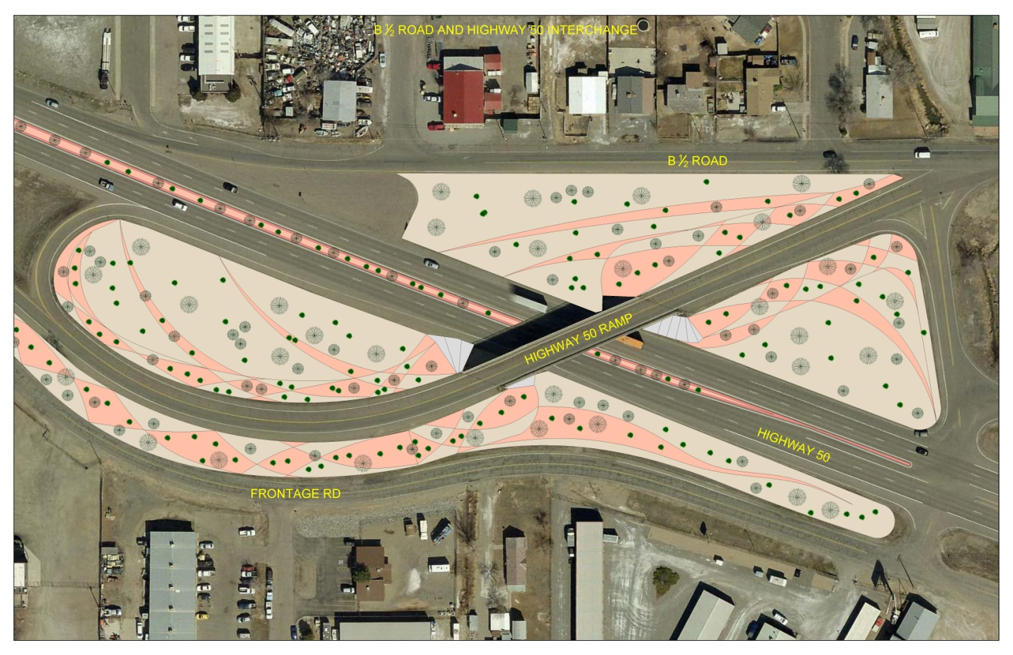
Neighborhoods play an important role in improving the livability and image of the community. A neighborhood can be as small as a block of houses and as big as the Orchard Mesa plan area. There are numerous neighborhoods throughout the City of Grand Junction that have registered with the City. On Orchard Mesa that number includes 17 registered neighborhoods or homeowner associations representing 1,203 dwelling units/lots. Mesa County does not track homeowner associations (HOAs) in the unincorporated area. However, state law requires all HOAs to register with the Department of Regulatory Agencies, or DORA, which maintains a searchable database; as of 2013, there were 3 HOAs in the unincorporated area, representing 450 dwelling units/lots, in the database.

The City of Grand Junction has a program in place to help neighbors get involved in their community. Administered through the Economic Development and Sustainability Division, the City of Grand Junction Neighborhood Program is a way of building a stronger sense of community, beginning with small groups of motivated people. The program evolved from a goal stated in City Council’s 2002-2012 Strategic Plan: “A vital, organized network of neighborhoods will exist throughout the City, linked with parks and schools and supported by City resources and active citizen volunteers.”
Often problems within a neighborhood raise residents’ interest and concern. The Neighborhood Program seeks to build a sense of community to promote pro-active pride, safety, volunteering and fun within neighborhoods rather than merely a group that deals with controversy as it arises.
Pg 10

2010 Comprehensive Plan Goals and Policies

Goal 8: Create attractive public spaces and enhance the visual appeal of the community through quality development.

Policies:
- Design streets and walkways as attractive public spaces.
- Construct streets in the City Center, Village Centers, and Neighborhood Centers to include enhanced pedestrian amenities.
- Enhance and accentuate the City “gateways” including interstate interchanges, and other major arterial streets leading into the City.
- Use outdoor lighting that reduces glare and light spillage, without compromising safety.
- Encourage the use of xeriscape landscaping.
- Encourage the revitalization of existing commercial and industrial areas.

Orchard Mesa Community Image

Goal 1: The Orchard Mesa community has safe and attractive entrances.

ACTIONS
- Identify key locations and create entry features and signage that identifies arrival to Grand Junction.
- Create wayfinding signage that guides visitors to area attractions.
- Create a streetscape plan for the Highway 50 corridor.
- Local governments, the Regional Transportation Planning Office and the Colorado Department of Transportation will work together to beautify the Highway 50 corridor.
- Develop funding sources for public beautification and improvement projects.

Goal 2: The quality of life on Orchard Mesa is preserved and enhanced.

ACTIONS
a. Establish and support Neighborhood Watch, Safe Routes to Schools, and other programs that will make neighborhoods safer.
b. Support neighborhood programs for existing neighborhoods
c. Identify view sheds/corridors that are important to the community.

Goal 3: Neighborhoods are attractive, cohesive and well maintained.

ACTIONS
Pg 11
a. Assist the public by providing information on existing codes and programs.
b. Work through neighborhood organizations to encourage property maintenance and junk and weed control.
c. Support the enforcement of codes for weeds, junk and rubbish.

Goal 4: The rural character outside the urbanizing area of Orchard Mesa is maintained.

ACTIONS
a. Support the growth of agricultural operations outside the urbanizing area.
b. Maintain and support zoning that provides for agricultural uses and a rural lifestyle outside the urbanizing area.

2. Future Land Use & Zoning
Pg 12

Background
Achieve an Appropriate Balance of Land Uses
(2010 Grand Junction Comprehensive Plan)

“Find an appropriate balance between the resident’s respect for the natural environment, the integrity of the community’s neighborhoods, the economic needs of the residents and business owners, the rights of private property owners and the needs of the urbanizing community as a whole.”

In 2010 the City of Grand Junction and Mesa County adopted the Grand Junction Comprehensive Plan, which identified a range of densities on Orchard Mesa (Figure 3; Appendix Map 4). The land within the Urban Development Boundary (UDB) allows urban densities to develop as the urban core moves outward. As development occurs within the Persigo sewer service boundary, annexation into the City of Grand Junction is required, and urban services are provided. The area that is within the UDB is transitional, with some rural properties intermixed within urban areas. It is expected that some of these rural land uses within the urbanizing area will continue for years to come. It is important to recognize the right of agricultural uses to continue until the property is developed.

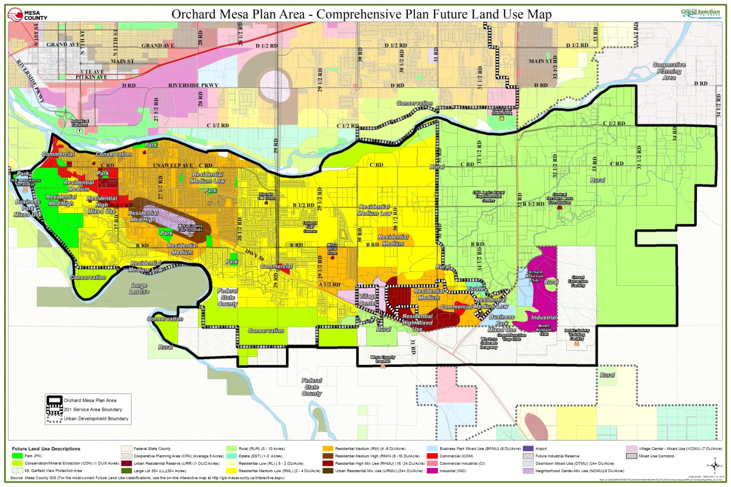Figure 3: 2010 Comprehensive Plan Future Land Use Map
Pg 13
During the 2010 Comprehensive Plan’s public process the public spoke about many priorities including:

- Locating future urban growth of high intensity/density adjacent to Highway 50;
- Preserving the river corridor as open land;
- Developing trails;
- Supporting cottage industries over other commercial and industrial land uses in the area;
- Preserving orchards and vineyards;
- Preserving agricultural land; and
- Limited industrial land on Orchard Mesa.

Zoning districts implement the future land use map and the goals and policies of the Comprehensive Plan (Appendix Map 5). One of the guiding principles of the Comprehensive Plan is to have sustainable growth patterns, in order to expand services efficiently and cost-effectively. The desired development pattern is to develop infill areas first, where it is most economical to extend and provide services, and then outward in a concentric pattern, rather than leapfrogging and developing beyond urban neighborhoods. Redevelopment of existing under-developed properties allows property owners to take full advantage of allowed land uses and densities as well as existing infrastructure (Appendix Map 7).
Infill
(2010 Grand Junction Comprehensive Plan)

“Much of future growth is focused inward, with an emphasis on infill and redevelopment of underutilized land, especially in the City Center which includes downtown. Growing inward (infill and redevelopment) allows us to take advantage of land with existing services, reduces sprawl, reinvests and revitalizes our City Center area. This includes maintaining and expanding a ‘strong downtown’.”

In 2011, a sewer line was installed along 32 Road (Highway 141) connecting the community of Whitewater to Clifton Sanitation District. Some urban development along this corridor with existing commercial and industrial zoning already in place can be served by this sewer line. However, the presence of the sewer service line is not intended to be used to urbanize the entire corridor area in the immediate future.

Neighborhood and Village Centers
The future land use map of the Comprehensive Plan identifies Village and Neighborhood centers, which will have commercial and residential land uses mixed within a more densely populated environment. Villages Centers are generally larger in area and intensity than neighborhood center. Two of these centers are identified on Orchard Mesa, a Neighborhood Center in the vicinity of the Fairgrounds and a Village Center near 30 Road (Appendix Map 4).

The Village Center development identified in the 2010 Comprehensive Plan would be directed to the southeast end of Orchard Mesa along Highway 50 between 30 Road and Highway 141. A mix of uses is allocated to the area: commercial, retail, office and residential uses. Densities are highest near the core of the village center and decrease as distance from the core increases.
Pg 14
Transitioning Density
(2010 Grand Junction Comprehensive Plan)

“The Comprehensive Plan coordinates future land uses so that compatible uses adjoin. When significantly different densities or uses are proposed near each other, they are shown to transition from high to low intensity by incorporating appropriate buffering.”

The Village Center is not expected to be developed until Orchard Mesa has seen sufficient growth and services have been extended to the area. Based on existing growth trends, this is not expected until well beyond the year 2020. The Comprehensive Plan looked at growth needs for the doubling of the 2010 population for the valley including a time when Whitewater has grown into an urban community with a Village Center. Doubling of the population is not expected to occur until after 2040.

The Neighborhood Center on Orchard Mesa is located at B ½ Road and Highway 50 where there is an existing City Market grocery store and other neighborhood businesses and services. The Comprehensive Plan envisions this area as having a mix of land uses, including higher-density residential development along with more services. The neighborhood center serves Orchard Mesa residents as well as those visiting the fairgrounds or just passing through.

Sometimes conflicts between existing zoning and the designated future land use need to be resolved before development occurs. For example, there have been inconsistencies between land use and zoning in the area of the Neighborhood Center on Highway 50 at B ½ Road, including some adjacent lands along the corridor as well as the Mesa County Fairgrounds. In Grand Junction, these conflicts are resolved prior to development, either by amending the future land use or by rezoning. Mesa County requires rezoning to be consistent with the future land use map and Mesa County Master Plan.
Compact Growth Concentrated in Village and Neighborhood Centers
(2010 Grand Junction Comprehensive Plan)

“Residents want to preserve the extensive agricultural and open space land surrounding the urban area. They also want the benefits of more efficient street and utility services. More compact development patterns will support both of these objectives. This Comprehensive Plan includes an emphasis on mixed- use ‘centers’ as a key growth pattern, accompanied by encouragement of infill and redevelopment more than external expansion. These concepts represent important new directions in the community’s efforts to balance the pressures for outward growth with the desire to promote infill.”

In 2010, the Fairgrounds was designated a mixture of Neighborhood Center, Residential Medium High, Residential Medium and Park in the Comprehensive Plan. Since 2010, a Master Plan for the Fairgrounds has been adopted. Designating the Fairgrounds as one future land use that best facilitates the implementation of the Fairground’s Master Plan is preferred. Planned Unit Development zoning governs the use of the Fairgrounds property in unincorporated Mesa County.
Pg 15
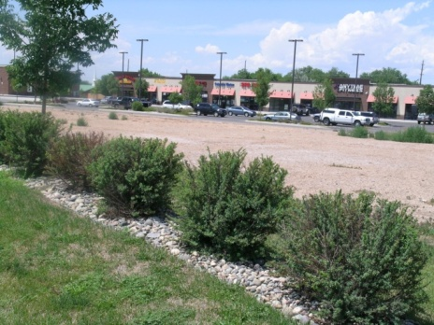Based on further analysis, the Neighborhood Center would be better delineated as the triangular-shaped area north of Highway 50, south of B ½ Road, east of 27 ½ Road and west of 28 Road. There are additional properties adjacent to or near this area that should be considered for inclusion in the neighborhood center and others best delineated as commercial for highway oriented land uses outside the center.

Changes to the Comprehensive Plan Future Land Use Map

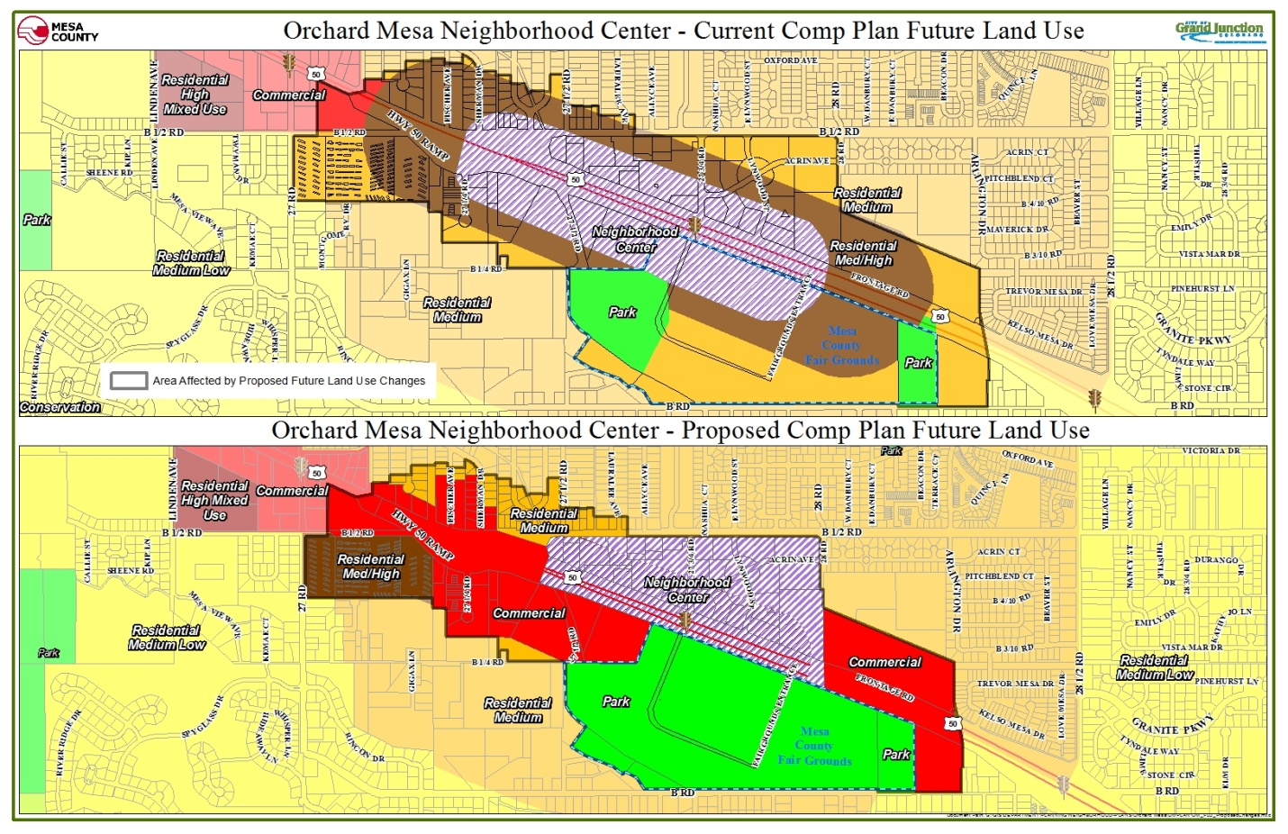Figure 4: Neighborhood Center Future Land Use Changes

The current configuration of the Neighborhood Center includes the fairgrounds as part of the center and there are existing conflicts between the Future Land Use Map and current zoning for some properties. The Orchard Mesa Neighborhood Plan seeks to remedy these by changing the Comprehensive Plan’s Future Land Use Map with the adoption of this Plan (Figure 4; Appendix Map 6).

The Future Land Use Map amendment:
Pg 16
- changes the land use designations for the County Fairgrounds to “Park,” which better facilitates the implementation of the Fairgrounds Master Plan and supports current zoning;
- adjusts the boundary of the Neighborhood Center to include the area north of Highway 50 only, between 27 ½ Road and 28 Road and south of B ½ Road;
- changes several properties located east and west of the Neighborhood Center to a “Commercial” designation supported by existing zoning; and
- establishes one land use designation on properties that currently are shown having more than one land use designation.
Mixed Uses
(2010 Grand Junction Comprehensive Plan)

“Residents recognize the value of mixing uses, that is, allowing development that contains appropriate non-residential and residential units of various types and price ranges. However, residents are also concerned that poorly designed projects can degrade a development or a neighborhood. This plan supports a broad mix of land uses, but calls for the establishment of appropriate standards to ensure neighborhood compatibility.”

Significant development and redevelopment opportunities exist along the Highway 50 corridor, which can also further the goals for Economic Development and Community Image. Future land use designations and existing zoning is in place that will support a sustainable growth pattern.

A Mixed-Use Opportunity Corridor is also shown along 29 Road. This 29 Road corridor is intended to allow small neighborhood-serving commercial and mixed-use development, primarily around intersections but with an emphasis on blending with surrounding residential development.

A commercial corner and medium density residential area is designated adjacent to the future school site at 30 ½ Road and B Road. Additional schools and parks should be located in the Village Center vicinity. The Village Center could also be a prime location for a regional park in this quadrant of the Grand Junction community.

Annexation
The Comprehensive Plan set priorities for growth of the urban area and annexation into the City of Grand Junction. Specifically, “The extensive public input of this Comprehensive Plan indicated strong support for Grand Junction to grow in a sustainable, compact pattern. To accomplish this objective, rather than continuing to grow in a random fashion (that is inefficient to serve), the Comprehensive Plan identifies priority growth areas to focus the extension of new infrastructure and development.” (Comprehensive Plan, page 29) For Orchard Mesa, the prioritization is based on accessibility to existing infrastructure, adequate access, the existence of sub-area plans and proximity to existing commercial and employment areas. Areas of Orchard Mesa classified as infill or vacant and underutilized properties that may accommodate infill development including the creation and/or expansion of centers are part of the Comprehensive Plan’s Priority 1. The Priority 2 area includes Central Orchard Mesa within the 2008 Persigo Boundary (201 service area), which extends east to 30 Road (Figure 5; Appendix Map 1). Priority 3, which includes development east of 30 Road to 31 Road, discourages new urban development until 2020 or when appropriate circumstances exist.
Pg 17

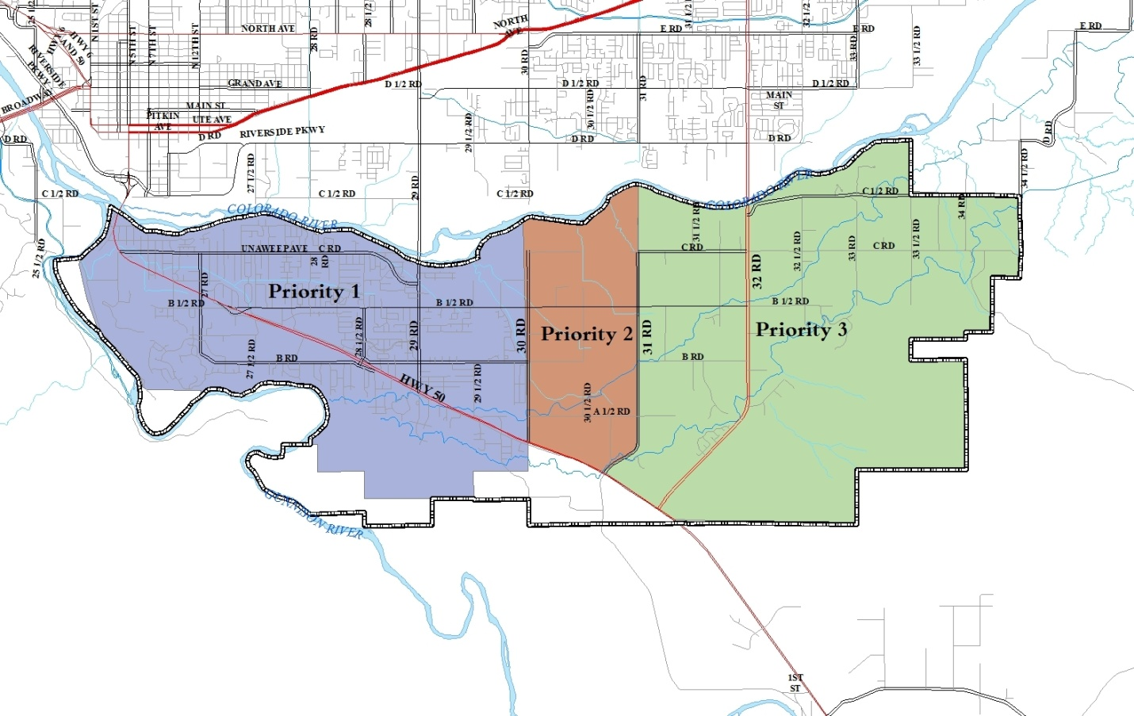Figure 5: Priority Areas for Development

Industrial Development
Orchard Mesa residents have voiced concern regarding increasing the amount of area for future industrial uses on Orchard Mesa. This sentiment was expressed during the 1995 Orchard Mesa Plan planning process and again during the 2010 Comprehensive Plan process. A large area in the Whitewater area was identified for future industrial businesses as part of the 2007 Whitewater Community Plan. With this industrial acreage in close proximity to Orchard Mesa, only a small area of industrial lands on Orchard Mesa was designated on the 2010 Comprehensive Plan’s Future Land Use Map. This small area includes land in and near the Springfield Estates subdivision located adjacent to Highway 141 (32 Road). The combinations of these lands should accommodate the industrial needs in the southern portion of the Grand Junction urban area. Adding more industrial uses than what has been established on the Future Land Use Map could trigger other issues affecting the industrial market and create additional neighborhood impacts.
Pg 18
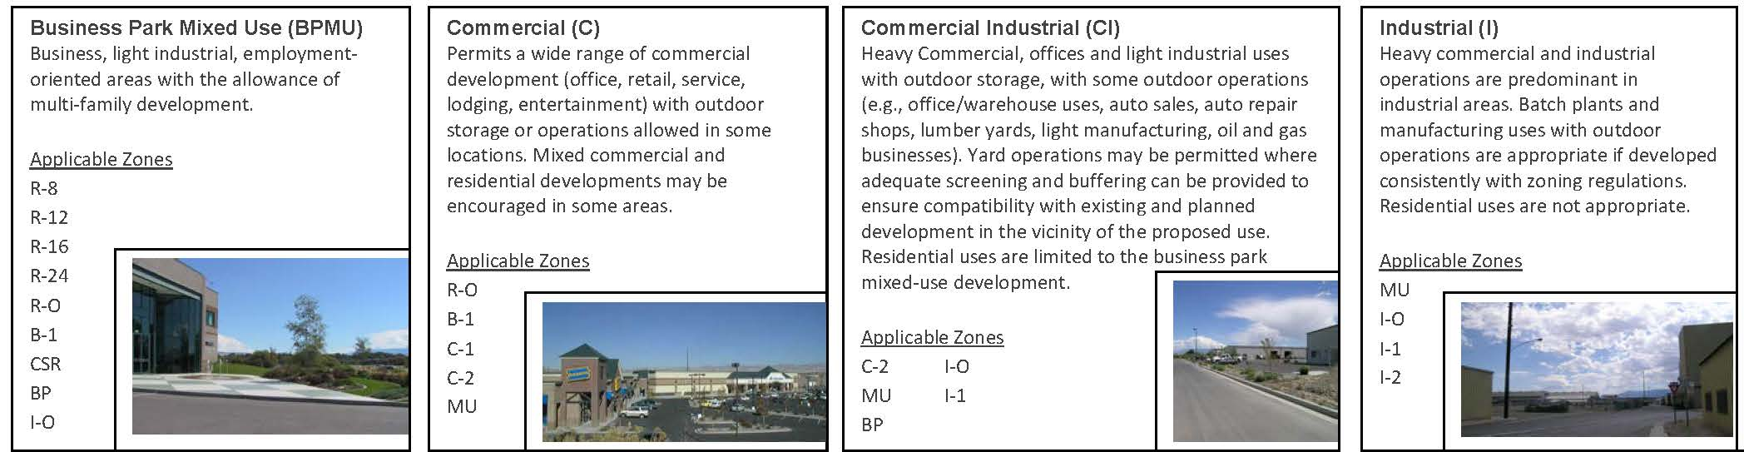The following graphic taken from the Comprehensive Plan depicts the differences between the different types of commercial and industrial land uses.
2010 Comprehensive Plan Goals and Policies

Goal 3: The Comprehensive Plan will create ordered and balanced growth and spread future growth throughout the community.

Policies:
- To create large and small “centers” throughout the community that provides services and commercial areas.
- Create opportunities to reduce the amount of trips generated for shopping and commuting and decrease vehicle miles traveled thus increasing air quality.

Goal 7: New development adjacent to existing development (of a different density/unit type/land use type) should transition itself by incorporating appropriate buffering.

Policies:
- In making land use and development decisions, the City and County will balance the needs of the community.

Orchard Mesa Future Land Use & Zoning

Goal 1: Development is consistent with the land uses identified on the Future Land Use Map. Infill areas are developed first and then development occurs concentrically out toward rural areas, limiting sprawl.

ACTIONS
a. Create and implement an infill and redevelopment boundary, with incentives encouraging infill development and concentric growth. Possible programs may include:
1) Charging development impact fees based on location;
Pg 19
2) Offering density bonuses.
b. Continue to allow existing agricultural operations within the Urban Development Boundary.

Goal 2: Outside of the Urban Development Boundary, agricultural uses are valued and protected as an important part of the Orchard Mesa economy and community character.

ACTIONS
a. Help maintain viable agricultural uses.
b. Implement incentive programs such as the existing Orchard Mesa Open Lands Overlay District that preserve open space, sensitive natural areas, irrigated agricultural lands, and the rural character.
c. Minimize conflicts between residential and agricultural uses. Require sufficient buffering for new development adjacent to agricultural land uses.
d. Encourage residential development on land that is unsuitable for agriculture and where services are available consistent with the Future Land Use Map.
Pg 20
3. Rural Resources

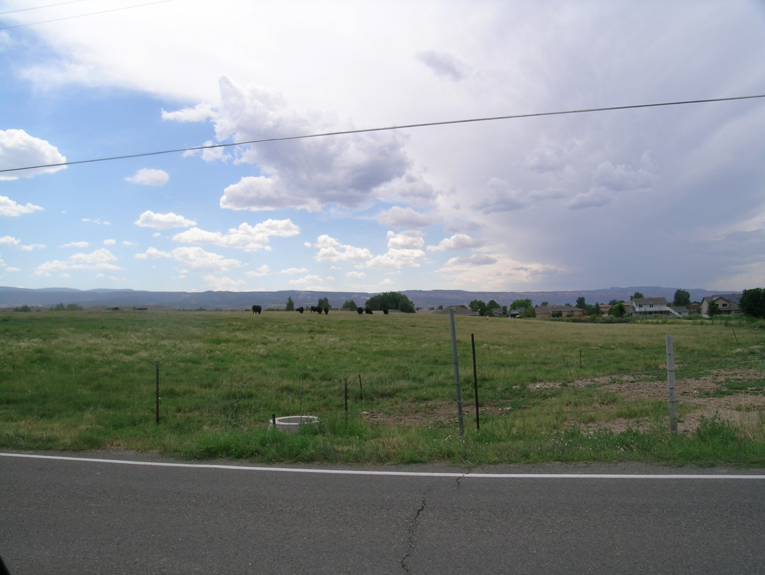Background

Orchard Mesa’s agricultural businesses contribute significantly to the local economy and provide a food source for the citizens of the Grand Valley and beyond. A local food supply improves health and reduces costs for the general population. Agricultural uses on Orchard Mesa include on-farm residences, orchards, row crops, and pasture. The topography and soils of this area lend themselves well to irrigation and are considered among the best soils in the Grand Valley for crop production. Nearly all the irrigable lands below the Orchard Mesa Irrigation Canals are or have been cultivated for a variety of crops, most notably peaches, apples, cherries, grapes, other fruits, and vegetables. Nearly all undeveloped irrigated land in Orchard Mesa is considered prime irrigated farmland and other areas are considered unique by the U.S. Soil Conservation Service.
Orchard Mesa Research Center
(CSU website)

“The research conducted at this site includes tree fruits, wine grape production, dry bean variety increases, and ornamental horticulture. This site has separate climate controlled greenhouse, as well as office and laboratory facilities. The site also houses Ram’s Point Winery. The winery is designed as the primary vehicle for training students and interns in best winemaking and winery business practices, as well as providing a location for enology research and outreach. It is also visible public recognition for the CSU partnership with Colorado Association for Viticulture and Enology (CAVE), representing the Colorado wine industry.”

The Colorado State University’s Agricultural Experiment Station includes the Western Colorado Research Center, part of a network of 7 research centers (9 sites) throughout the state. The Orchard Mesa site is located at 3168 B 1/2 Road on about 76 acres.

Mesa County’s “Right to Farm and Ranch Policy,” and Agricultural Forestry Transitional (AFT) zoning provides for agricultural operations. AFT zoning also allows subdivisions up to an average of one dwelling per 5 acres and generally permits lot sizes to be as small as one acre. Several voluntary land conservation tools are available to landowners who are interested in protecting agricultural properties and open space, including the Orchard Mesa Open Lands Overlay district (an incentive-based option for subdivision of land east of 31 Road; Appendix Map 8).
Pg 21
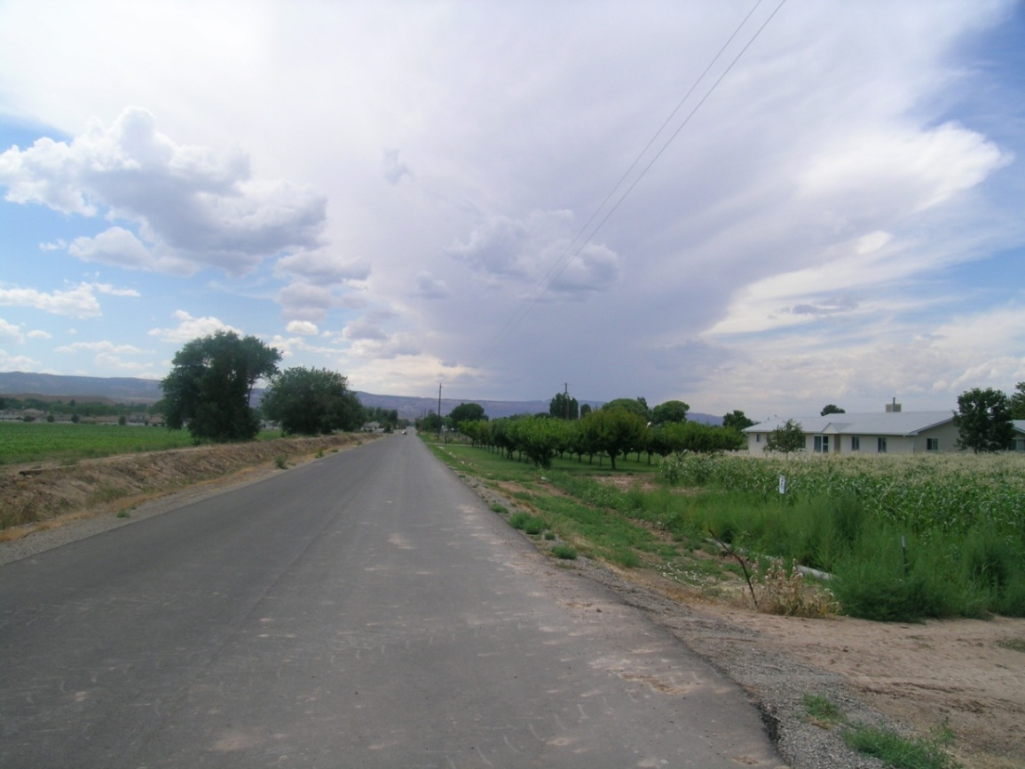
Becoming the Most Livable Community West of the Rockies
(2010 Grand Junction Comprehensive Plan)

“Tourism and agritourism are a significant part of our economy. Without careful planning agriculture and the lifestyles surrounding it will disappear under the weight of urban sprawl.”

In 2011, the Palisade Wine and Fruit Byway was established to encourage agritourism. The Byway includes signage and kiosks directing bicyclists and motorists touring the orchards and wineries of Orchard Mesa along a 25-mile loop route starting at 32 and C Roads.

Future Urban Growth in Rural Areas
Future Land Use Designations
(2010 Grand Junction Comprehensive Plan)

Rural 1 du/5-10 acre lots
Private land that will remain in parcels of 5 to 10 acres on average. The uses will vary among low density residential lots, low intensity agricultural operations, orchards and other small scale farm operations. Rural land use areas serve as a transition between urban and agricultural uses. Clustering techniques are required to achieve maximum density. No urban level services are supplied.

In 2008, the Persigo 201 sewer service boundary was expanded from 30 Road to 31 Road for the area north of A ½ Road by the Persigo Board (Mesa County Board of County Commissioners and the Grand Junction City Council). This decision reduced the area designated as “Rural” future land use on Orchard Mesa by one and one half square miles. While there are many properties within the Urban Development Boundary that continue to have rural uses and densities, the area will gradually transition to urban development. (Appendix Map 4)
Priorities for Growth and Annexation
(2010 Grand Junction Comprehensive Plan)

Priority 3: Development is not encouraged until after 2020 or appropriate circumstances exist for Central Orchard Mesa outside the 2008 Persigo 201 Boundary

Interim land uses in Priority 3 Areas
… Proposed for urban development only after the other priority areas are significantly developed and only after water and sewer infrastructure is in place. In the interim, landowners may develop at densities that do not require urban services. However, in doing so they must demonstrate the ability to take advantage of urban densities in the future. It is acknowledged that growth will continue to occur beyond 2035. As time passes, some of the areas identified as Agriculture and Rural Land Uses in this Plan may become more appropriate for urban development. These will be considered in future updates to the Comprehensive Plan.
Pg 22
Orchard Mesa includes two Centers in the Comprehensive Plan. An existing Neighborhood Center is located in the vicinity of B ½ Road at Highway 50, in the urbanized area. A future Village Center is envisioned sometime after the year 2020 along Highway 50 between 30 Road and the intersection with Highway 141. While currently rural, the area is expected to become more urban as the area grows and services are extended. A mix of uses is planned for the Village Center including commercial, retail, office and residences. Development densities are highest near the village center mixed-use area and decrease with distance from the center.

Although a sewer trunk line was installed along 32 Road (Highway 141) in 2011 connecting the community of Whitewater to the Clifton Sanitation District’s treatment plant, the 2010 Comprehensive Plan designates the majority of the corridor as Rural. Some urban development is appropriate along this corridor consistent with the Comprehensive Plan and existing zoning, i.e. in Springfield Estates and Valle Vista subdivision.

Upper Grand Valley Pest Control District
Mandatory Controlled Insects

Codling moth (Laspeyresia pomonella)
Peach twig borer (Anarsia lineatella)
Greater peach tree borer (crown borer) (Synathadon rugilosus)
San Jose scale (Aspidiotus lineatella)
Pear psylla (Psylla pyricola)
Shot hole borer (Scolytus rugulosus)
Oriental fruit moth (Grapholita molesta)
Western cherry fruit fly (Rhagoletis indifferens)
Japanese beetle (Popillia japonica)
Backyard fruit trees are often the source of insect and disease pests. Landowners within the Upper Grand Valley Pest Control District (UGVPCD) are required by State Law to control pests on fruit trees (C.R.S. 35-5). The UGVPCD includes portions of Orchard Mesa generally east of 30 Road. The purpose of the District is to protect commercial growers from pest and weed infestations. The Mesa County Weed and Pest Coordinator enforces the law, inspects nursery stock, educates the public, and identifies and manages weed infestations.

Weed Management
Weed management is a concern at the local, county, regional and state level. By law (the Colorado Weed Management Act), noxious weeds require control. As of 2013, there are nineteen weeds on the Mesa County Noxious Weed list that are being controlled or managed by policies set forth in the Mesa County Weed Management Plan. Weed species on List A must be eradicated wherever found in order to protect neighboring communities and the state as a whole.
“List A” Noxious Weeds
Found on Orchard Mesa

Japanese, Bohemian and Giant Knotweed
Myrtle and Cypress spurge
Giant reed grass
Potential to Spread to Orchard Mesa
Purple loosestrife - Yellow starthistle

Pg 23
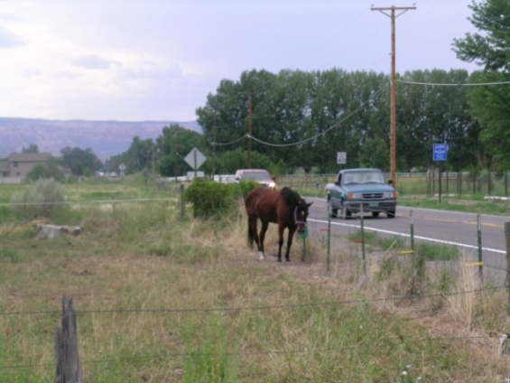Mesa County conducts roadside spraying. Some common weeds that are not listed as noxious are commonly controlled during roadside weed spraying. Residents can opt out of roadside spraying but must notify the Weed & Pest Coordinator, mark their property, and control the weeds themselves. Mesa County does not control overgrown weeds in residential areas; mow weeds on private property; or offer cost share.
Grand Junction Weed Management
- Requires owners of land within the City limits to manage all weeds on their property and on adjacent rights-of-way between the property line and curb and to the center of the alley. Vacant land, including agricultural use, is required to have weeds removed within twenty feet of adjacent developed land and within forty feet of any right-of-way.
- Manages weeds from curb to curb on right-of-ways within the City limits including those adjacent to properties within Mesa County.
- Will provide guidance to landowners developing a management plan for the control/eradication of the weeds on their property.
- Provides annual public outreach efforts reminding owners of their responsibility to control/eradicate all weeds and nonnative, undesirable plants.
- Has technical expertise on weed management techniques and implementation methods (mechanical, chemical, biological, and cultural) are available.
- Coordinates with other land management agencies for control of the undesirable noxious weeds as identified by the County.

Pg 24
Orchard Mesa Sub-Area Concept Plan – 2008
(A Sub-area study conducted as part of the 2010 Comprehensive Plan)

The desire to preserve prime agriculture was the prominent sentiment expressed by residents of Central Orchard Mesa. In addition, future urban growth of high intensity/density is to be located adjacent to Highway 50. Other priorities included:
- Preserve the river corridor as open land.
- Develop trails.
- Support cottage industries over other commercial and industrial land uses in the area.
- Preserve orchards and vineyards.

Mesa County Rural Master Plan Goals and Policies - Agriculture (AG)

AG Goal 1: Conservation of agricultural and range lands capable of productive use.

Policies:
AG1.1 Locate new development on land least suitable for productive agricultural use.

AG1.2 Clustering of dwellings is encouraged on a portion of the site where the remainder is reserved for open space or agricultural land.

AG1.3 Buffering of new development is required adjacent to agricultural operations.

AG1.4 Enhance methods of communicating the right-to-farm/ranch policy and provisions to educate non-farm/non-ranch users on the characteristics of an agricultural economy (e.g., noise, spraying, dust, traffic, etc.).

AG1.5 Require consultation with the appropriate land and resource manager and area residents to minimize and mitigate conflicts new development proposals may create between wildlife and agricultural uses.

AG1.6 Agricultural production practices will be honored and protected when development is allowed adjacent to or near productive agricultural lands.

AG1.7 Development will not be allowed to interfere with irrigation water used for agricultural production. Delivery of full water rights to farmland using irrigation water shall be guaranteed by the developers and/or subsequent Homeowners Association through a proper delivery system. Historic irrigation easements shall be respected and formalized or conserved.

AG1.8 Support farmers' markets and promote the purchase of local goods.

AG1.9 Support and promote voluntary techniques to preserve agricultural lands.

AG1.10 Promote multiple/compatible uses of agricultural lands.

AG1.11 Provide a streamlined process that allows limited creation of small parcels from larger bona fide lands in agricultural production to assist agricultural operations to remain viable.

Pg 25
Orchard Mesa Rural Resources

Goal 1: Rural land uses east of 31 Road are maintained, consistent with the Comprehensive Plan Future Land Use Map.

ACTIONS
- Maintain the Comprehensive Plan’s Future Land Use designations and support zoning that implements it.
- Support and sponsor community forums to identify and implement ways to incentivize local food production.
- Support voluntary land conservation techniques for agricultural properties.

Goal 2: The 32 Road corridor (Highway 141) retains its rural character.

ACTIONS
- Allow development on non-residentially zoned land and permitted non-residential uses in a manner consistent with the rural character of surrounding properties.
- Identify and protect important view sheds along the corridor.

Goal 3: Agricultural businesses are viable and an important part of Orchard Mesa’s economy.

ACTIONS
- Help promote the Fruit & Wine Byway.
- Support the CSU Research Center to improve agricultural production and sustainability for local farmers.
- Identify and permit appropriate areas for farmers markets throughout the growing season.
- Coordinate public outreach on noxious weed control, e.g. public forums with Mesa County Weed and Pest Control staff and the Mesa County Weed Board.
Pg 26
4. Housing Trends
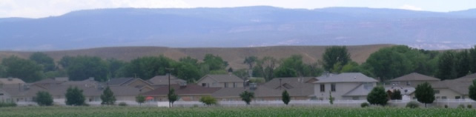

Background
A Variety of Price Points for the Full Spectrum of Incomes in a Diverse Economy
(2010 Grand Junction Comprehensive Plan)

“As Grand Junction moves into the future, we must remember to provide housing for the entire workforce to ensure these job positions that support our economy can be filled.… We expect that job growth will occur throughout all income categories, and housing demand will grow not just in the high income categories but also for service workers, retirees and students.”

According to the 2010 U.S. Census, the Orchard Mesa Plan area had about 6,424 housing units, with an occupancy rate of 95%. (Mesa County Assessor’s records show about 6,580 dwelling units as of 2013.) The average household size for the plan area was 2.56 people per household, above the Mesa County average of 2.46 and the City of Grand Junction average of 2.19. In the Orchard Mesa Census Designated Place (CDP), the average household size for renters is 3.54, while the average household size for owners is 2.46 (US Census Bureau American Community Survey, 2011).

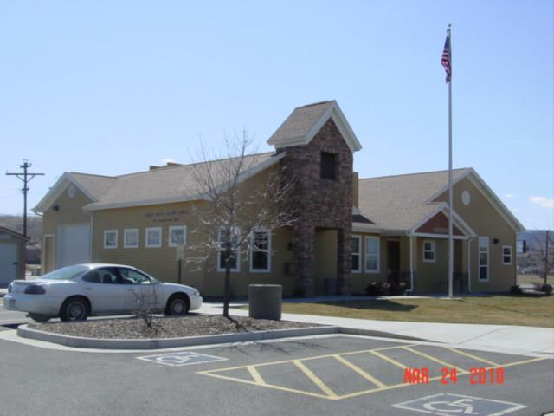Home ownership rates for the Orchard Mesa Plan area are higher than Grand Junction and Mesa County, at about 75%. (Table 3) The Census Bureau tabulates data for the Orchard Mesa Census Designated Place (CDP), which is the unincorporated area west of about 30 Road. The Orchard Mesa CDP is the more densely populated portion of the unincorporated area, but it includes most of the newer single-family developments, of which 83.3% are owner-occupied. The rural agricultural area has an even higher owner occupancy rate, at 85.3%. The westernmost portion of the Plan area is in the City of Grand Junction and represents 47% of all households in the area. The older, more-dense area has a lower proportion of owners, with 65% of homes owner-occupied, but it is still above the owner occupancy rate for the City as a whole.
Table 3: Owner Occupancy Rates
Pg 27
 | Occupied Households | Owner Occupied | Renter Occupied
Orchard Mesa Plan Area | 6,105 | 74.7% | 25.3%
- Orchard Mesa, incorporated | 2,959 | 64.5% | 35.5%
- Orchard Mesa CDP | 2,494 | 83.3% | 16.7%
- Orchard Mesa, rural | 652 | 85.3% | 14.7%
City of Grand Junction | 24,311 | 62.4% | 37.6%
Mesa County, all unincorporated | 27,502 | 79.2% | 20.8%
Mesa County, all | 58,095 | 71.4% | 28.6%
Source: 2010 Census

Data for the Orchard Mesa CDP includes information that can give a general view of Orchard Mesa households, reflecting the average conditions and demographics of the overall Plan area (US Census Bureau American Community Survey, 2011). In 2011:

- About 44% of the residents in the Orchard Mesa Plan area lived in the CDP. (48% of residents lived in the incorporated area and the remaining 8% lived in the rural area.)
- Nearly half of the residents moved in after 2005.
- About 75% of owner-occupied households had a mortgage; the median mortgage payment was $1,375.
- Median rent was $1,008. About 37% of renters paid more than 35% of their household toward rent. Typically, a household paying more than 30% of its income towards housing costs, including utilities, is considered to be at a high risk of being economically insecure.
- About 14% of the population was age 65 or older, while 25% was under age 18. These numbers closely match Mesa County as a whole.
- As with all of Grand Junction and Mesa County, the percentage of the population age 65 and older on Orchard Mesa will increase over the next 20 years; about 25% of the current population in the CDP is between the ages of 45 and 64.
Lack of Housing Choices
(2010 Grand Junction Comprehensive Plan)

“The affordable housing problem in Grand Junction is compounded by the lack of diversity in the local housing stock. The vast majority of the housing units in Grand Junction today are detached single family homes. This low density development pattern increases the cost of housing. . . . The Comprehensive Plan encourages a broader range of housing in locations dispersed throughout the community. ”

- The median age was 34.6 years. This is significantly younger than Grand Junction’s median age of 36.7 and Mesa County’s median age of 38.1 years. The lower median age indicates the presence of young families.

In the Orchard Mesa Plan area, single-family residences account for 91% of all dwelling units (Table 4). The preponderance of single family homes suggests the housing needs of many people may not be met, including seniors, lower income families, disabled persons and students. Townhomes, condominiums, duplexes and triplexes reflect 7% of the housing stock, while the remaining 2% of the dwelling units are in multi-family developments of 4 units or more. The average floor area for a single family residence is about 1,559 square feet. Houses on agricultural properties tend to be much larger, averaging 2,220 square feet. The average size for dwellings in townhome and multi-family development ranges from 829 to 1,129 square feet.
Pg 28

Table 4: Dwelling Units by Type
Type | Total Dwelling Units | Average Floor Area
Single Family Residence | 5,181 | 1,559 s.f.
Single Family, Ag Residence* | 829 | 2,220 s.f.
Townhome | 283 | 1,192 s.f.
Condominium | 31 | 829 s.f.
Duplex/Triplex | 165 | 1,058 s.f.
Multi-Family, 4-8 units | 82 | 823 s.f.
Multi-Family, 9 + units | 298 | 1,090 s.f.
Source: 2013 Mesa County Assessor’s Records and GIS
*Ag residence denotes a single family residence on a property classified by the Mesa County Assessor as an Agriculture land use.

The largest multi-family development is Monument Ridge Townhomes located at 2680 B ½ Road; it has 166 units totaling 190,095 square feet. It is a privately-owned rental complex but as a housing tax credit project, residents for some of the units must meet income qualifications. Other large multi-family developments include Linden Pointe located at 1975 Barcelona Way, with 92 units, and Crystal Brook Townhomes located at 1760 LaVeta Street, with 40 units. These two properties are owned and operated by the Grand Junction Housing Authority. Both have income requirements for tenants. The affordable housing stock on Orchard Mesa is rounded out by 12 duplexes on Linden Avenue, owned by Housing Resources of Western Colorado. The western Plan area includes several privately-owned mobile home parks, which may include older pre-HUD (1976) homes. (There are approximately 250 pre-HUD homes in the Plan area.) While not officially classified as affordable housing, these older, often obsolete structures fill a need for lower-income housing.

During periods of economic challenges, housing foreclosures increase and residents find themselves with a lack of affordable housing. Resulting impacts include limited availability of rental properties, higher rents, and overcrowding. The Grand Junction Housing Authority and other entities assist homeowners with foreclosure prevention counseling and workout options.

The average year built for single family residences is 1978, while the median year built is 1979. The oldest residences date back to 1890. Only a quarter of the housing stock is more than 50 years old. Orchard Mesa saw significant construction booms in the 1950s, 1970s, and 2000s; the decades following boom periods are all marked by significant declines in the number of new houses built (Figure 6). The average value in 2013 of a single-family residence was $170,545 (Table 5). Since the last housing boom there are a number of residentially zoned properties that are still vacant (Appendix Map 9).
Pg 29

Figure 6: Residences by Year Built

Table 5: Single Family Residential Valuation
 | Average | Total | Minimum* | Maximum*
Land | $55,795 | $289,073,380 | $3,690 | $288,750
Improvements | $114,750 | $594,520,700 | $760 | $664,910
Total | $170,545 | $883,594,080 | $760 | $844,910
Source: 2013 Mesa County Assessor’s Records and GIS
*Minimum and maximum are by each valuation category and do not reflect two single properties

The Grand Junction Comprehensive Plan’s Blended Residential Land Use Categories Map (Figure 7) allows for a broader range of density within the same land use classification, allowing for the development of varied housing types (single family, duplex, multi-family), thereby giving the community more housing choice. Providing housing for families and singles for all life stages is important in creating a community that is livable and vibrant.

Figure 7: Blended Residential Map
Pg 30
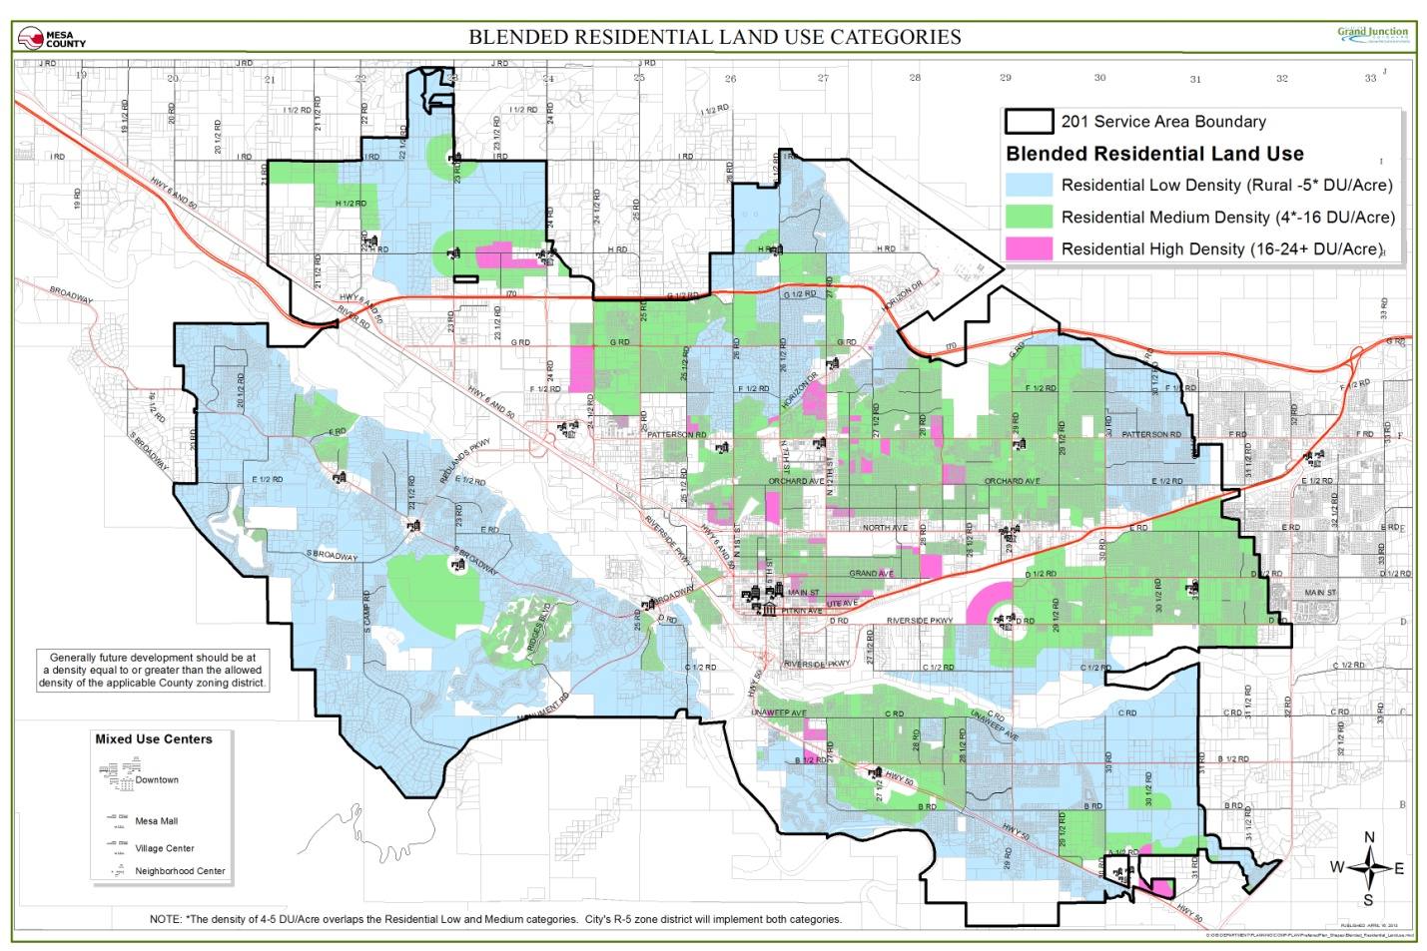
OM Plan Area
2010 Comprehensive Plan Goals and Policies

Goal 5: To provide a broader mix of housing types in the community to meet the needs of a variety of incomes, family types and life stages.

Policies:
A. In making lands use decisions, the City and County will balance the needs of the community.
B. Encourage mixed-use development and identification of locations for increased density.
C. Increasing the capacity of housing developers to meet housing demand.

Goal 1: A broad mix of housing types is available on Orchard Mesa to meet the needs of a variety of incomes, family types, and life stages.

ACTIONS
a. Identify and maintain an inventory of vacant parcels suited for housing and determine infrastructure needs for future development of those parcels. Coordinate improvements that will facilitate construction of more diverse types of housing with Capital Improvements Plans.
Pg 31
b. Implement through zoning the opportunity for housing alternatives where appropriate, such as multi-family within commercial zones, accessory dwelling units, and HUD-approved manufactured housing.
c. Implement the Blended Residential Land Use Categories Map to provide additional housing opportunities within the Orchard Mesa Plan area.
d. Continue to work with housing partners in the Grand Valley to develop and implement housing strategies, referencing the 2009 Grand Valley Housing Strategy report as background and guidance.

Goal 2: Housing on Orchard Mesa is safe and attainable for residents of all income levels.

ACTIONS
a. Work with housing partners such as Housing Resources of Western Colorado to provide information to residents on the availability of income-qualified housing rehabilitation and weatherization programs. Utilize public and private funding available for such improvements.
b. Work with neighborhood groups to educate residential property owners about programs that are available for foreclosure prevention, in order to preserve and stabilize neighborhoods during periods of economic challenges.
c. Work with housing partners and the development community to identify unmet needs in the housing market, and resolve regulatory barriers that would otherwise prevent such housing from being built.
d. Work with owners of mobile home parks to replace non-HUD mobile homes with HUD-approved manufactured homes, and to improve the overall appearance of the parks.

Goal 3: Neighborhoods on Orchard Mesa are safe and attractive.

ACTIONS
a. Maintain a neighborhood association database and provide sources for technical assistance to forming such associations.
b. Offer neighborhood services (block parties, etc.) to neighborhoods within and outside the City in partnership with Mesa County.
c. Coordinate the work of City and County code enforcement in areas where jurisdiction may abut or overlap.
d. Provide information to homeowners on resources available to those unable to maintain their properties.
e. Work with landlords to address property management and maintenance concerns.
Pg 32
5. Economic Development
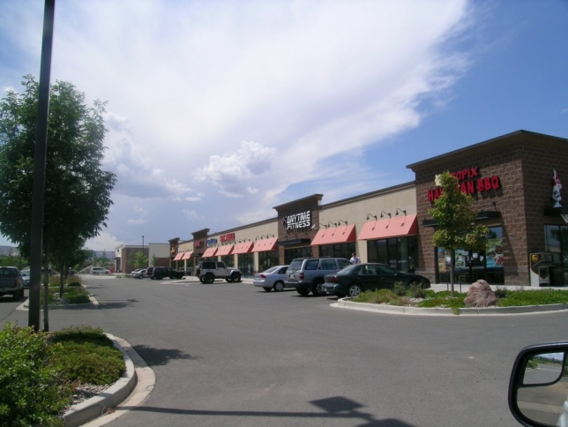Background

A key entryway to the Grand Valley, Orchard Mesa is often considered a drive-through rather than drive-to destination. The Highway 50 corridor’s variety of highway oriented services and local businesses could serve residents and nonresidents alike.
32 Road

A guiding principle of the 2010 Comprehensive Plan identifies the Grand Junction area as a Regional Center, “a provider of diverse goods and services and residential neighborhoods… (and) a community that provides strong health, education and other regional services.”
What does livable mean for
Sustainable Growth Patterns?
(2010 Grand Junction Comprehensive Plan)

- Fiscally sustainable development
- A healthy economy
- Growing tourism & agritourism as part of our economy

“Having a multi-faceted economy and being a regional center, we have a spectrum of jobs: commercial, retail, hospital, education, agriculture, financial offices, etc. as well as tourism-related services.”

Orchard Mesa’s farms, the CSU Western Colorado Research Center, and a variety of agricultural businesses are important to the character and local economy. Agricultural uses on Orchard Mesa include on-farm residences, orchards, vineyards, row crops, pasture, vegetable/row crops, farmers markets, and roadside stands. The Palisade Fruit and Wine Byway has brought added attention to the area and has increased interest in a variety of agritourism opportunities. The Byway includes signage and kiosks directing bicyclists and motorists touring the orchards and wineries of Orchard Mesa along a 25-mile loop route starting at 32 and C Roads.
Pg 33
Orchard Mesa has experienced a high turn-over of businesses over the years. Recent examples include the closure of the Choice Hotels call center and relocation of Wheeling Corrugating. The turnover rate is reflected in Orchard Mesa’s higher commercial vacancy rate, as compared to other areas of Grand Junction (Appendix Map 3). Nearly half of Orchard Mesa’s non-residential structures were built in the 1970s and 1980s. Approximately a quarter are less than 25 years old. Orchard Mesa has about 405 acres and 760,687 square feet of commercial space, and about 109 acres and 153,182 square feet of industrial floor area (Table 6). The largest employment sector, both by number of employees and by number of businesses, is service, while medical is the smallest sector, an indicator of the lack of medical care on Orchard Mesa (Table 7).
Mesa County Economic Development Plan
(Economic Development Partners)
Goals:
1. Become an Epicenter for Energy Innovation
2. Elevate the Community Profile
3. Support the Growth of Existing Business

The Grand Junction Chamber of Commerce visited sixty-five Orchard Mesa businesses during the summer of 2013 and found the current businesses were generally stable and cautious about the future. The diverse businesses in the area provide a good core with the potential to expand. Many expressed a need for better marketing ideas for Orchard Mesa.

Table 6: Orchard Mesa Commercial & Industrial Uses by Zoning
Zone | Commercial Use |  | Vacant |  | Building |  | Industrial Use |  | Vacant |  | Building
 | # Lots | Acres | # Lots | Acres | Sq. Ft. |  | #Lots | Acres | # Lots | Acres | Sq. Ft.
AFT | 5 | 40.4 | 1 | 2.1 | 17,966 |  | 1 | 8.9 | 0 | 0 | 5,876
RSFR | 1 | 13.7 | 0 | 0 | 7,366 |  | 0 | 0 | 0 | 0 | 0
RSF4 | 4 | 10.6 | 0 | 0 | 5,516 |  | 1 | 13.7 | 0 | 0 | 7,366
R8 | 3 | 3.2 | 0 | 0 | 8,768 |  | 0 | 0 | 0 | 0 | 0
PUD | 6 | 147.0 | 0 | 0 | 48,758 |  | 2 | 5.0 | 0 | 0 | 103,238
B2 | 3 | 2.5 | 1 | 0.3 | 6,365 |  | 0 | 0 | 0 | 0 | 0
C-1 | 113 | 105.5 | 36 | 32.7 | 465,242 |  | 0 | 0 | 0 | 0 | 0
C-2 | 25 | 45.3 | 6 | 20.5 | 123,542 |  | 3 | 31.2 | 0 | 0 | 36,702
I-1 | 1 | 0.1 | 0 | 0 | 120 |  | 14 | 50.5 | 14 | 50.5 | 0
I-2 | 2 | 37.2 | 1 | 5.4 | 77,044 |  | 0 | 0 | 0 | 0 | 0
Total | 163 | 405.5 | 45 | 61.0 | 760,687 |  | 21 | 109.3 | 14 | 50.5 | 153,182
Source: Mesa County Assessor’s 2013 Records; GIS

Table 7: 2010 Orchard Mesa Employment by Sector
Sector | Employees | Employers
Base | 535 | 113
Service | 1,538 | 200
Retail | 604 | 70
Medical | 86 | 14
Total | 2,763 | 397
Source: Info USA; Colorado Department of Labor

The Mesa County Fairgrounds and Whitewater Hill recreation and training facilities have great potential to be catalysts for new and expanded businesses and services such as lodging, restaurants, and other support businesses. The Public Safety Training Facility will be one-of-a-kind on the Western Slope, and the drag-way, trap club and airplane modeleers club all host regional and even State-level events (Appendix Map 10).
Pg 34
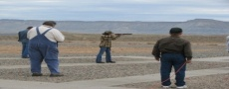
Orchard Mesa’s recreational facilities and surrounding public lands also attract visitors who can contribute to the local economy: e.g., Chipeta Golf Course, bowling lanes, Orchard Mesa Pool, Orchard Mesa Little League Park, Riverfront Trail, Colorado and Gunnison rivers, the Old Spanish Trail, and the BLM public lands.

Another important Orchard Mesa asset is the Business Incubator Center, ”The Grand Valley’s Center for Entrepreneurship,” located along the Gunnison River near the confluence with the Colorado River. According to their website:

“The Center offers comprehensive services to businesses through the collaborative efforts of four programs. The Business Incubator Center provides business coaching and workshops through the Small Business Development Center (SBDC), financial support through the Business Loan Fund of Mesa County, hands-on business development through the Incubator Program and tax credits for investment and job creation through the Enterprise Zone.”

Other potential opportunities for business development on Orchard Mesa include:
- Commercial and business pads and infrastructure in place for new and expanded businesses along Highway 50.
- Enterprise Zone - much of the Highway 50 corridor is eligible for tax credits for business investment/expansion. Most of the rural area is an Agricultural Enterprise Zone. (Appendix Map 11)
- Artesian Hotel site - good water source for bottling company or similar business.
- Confluence Point - proper zoning for a variety of commercial development with the best view of the confluence of the rivers.
Health Professional Shortage Area
(HPSA)
In 2012 Mesa County was classified as a whole county, primary medical care, low-income population HPSA. It was recognized that Mesa County has too few primary care physicians relative to the low-income population. Designation places the area and selected facilities in priority for grants and other funds, and offers incentives to health professionals practicing in a HPSA area.
- The eventual connection of 29 Road to I-70 will provide easier access to Orchard Mesa for travelers.
- The growing and diverse agritourism and outdoor and fairgrounds-oriented recreation industries.
- Promoting site development and marketing of health services and facilities on Orchard Mesa.
Pg 35
2010 Comprehensive Plan Goals and Policies

Goal 6: Land use decisions will encourage preservation of existing buildings and their appropriate reuse.

Policies:
A. In making land use and development decisions, the City and County will balance the needs of the community.

Goal 12: Being a regional provider of goods and services the City and County will sustain, develop and enhance a healthy, diverse economy.

Policies:
A. Through the Comprehensive Plan’s policies the City and County will improve as a regional center of commerce, culture and tourism.
Orchard Mesa Economic Development

Goal 1: Opportunities to shop, obtain personal and medical services, and dine out are convenient for Orchard Mesa residents.

ACTIONS

a. Assist economic development groups/partners in analysis of market needs suited to serving the local population of Orchard Mesa.
b. Support public/private partnerships and assist businesses with marketing Orchard Mesa.
c. Work with local health care providers and the Mesa County Health Department and the Mesa County Health Leadership Consortium to identify grants and other funding opportunities as incentives to health professionals to locate on Orchard Mesa.

Goal 2: Orchard Mesa includes businesses and facilities as a destination for area residents and visitors alike.

ACTIONS
a. Coordinate resources available from local economic development partners (Incubator, GJEP, Chamber of Commerce, Workforce Center, etc.) to create a commercial base that will serve the local population and visitors.
b. Improve infrastructure that will help local businesses thrive.
c. Support efforts to market the variety of opportunities on Orchard Mesa.

Pg 36
Goal 3: Orchard Mesa has an active and effective Orchard Mesa Business Association.

ACTIONS
a. Identify a business “champion” to be lead on organizing interested businesses and provide technical assistance to the “champion” and interested businesses on models used effectively elsewhere in Mesa County such as an improvement district (BID, URA, etc.) to provide funding for support services, infrastructure improvement, marketing, pedestrian/streetscape improvements and special events, for community revitalization and development (e.g., North Avenue, Horizon Drive).
b. Engage economic development groups/partners in an active program to periodically visit Orchard Mesa businesses to proactively identify issues and identify solutions.
c. Economic development groups/partners and area business will work together to evaluate and make recommendations on how to improve land use processes and regulations related to business retention, development, and maintenance.

Goal 4: Orchard Mesa’s agricultural industry thrives as an important part of the local economy and food source.

ACTIONS
a. Promote Orchard Mesa as a part of the Fruit and Wine Byway.
b. Support and encourage roadside markets and centralized events (e.g., farmers’ markets) to exhibit and sell locally produced agricultural products.
c. Actively support the Mesa County Right to Farm and Ranch Policy.
d. Make land use decisions consistent with the Future Land Use Map for Orchard Mesa.
e. Align with the Colorado Cultural, Heritage and Tourism Strategic Plan (2013) in an effort to maximize the Colorado Tourism Office’s promotion funding opportunities.

Goal 5: Sustainable businesses support the needs of regional attractions on Orchard Mesa. (e.g., Fairgrounds, Whitewater Hill - Public Safety and Recreational Facilities)

ACTIONS
a. Support appropriate improvements and maintenance of public infrastructure necessary to sustain local businesses and regional attractions at the Fairgrounds and Whitewater Hill.
b. Work with area economic development groups/partners to identify businesses that would support regional attractions on Orchard Mesa (e.g., extended-stay lodging, personal services, recreation facilities, etc.).
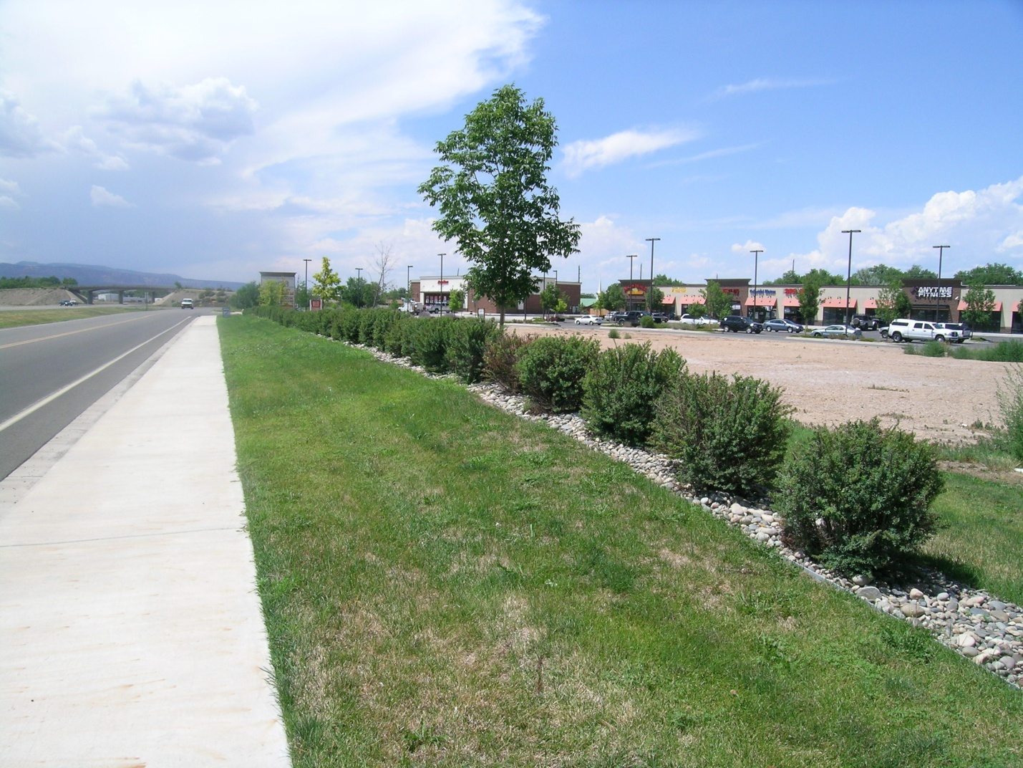
Pg 37
6. Transportation
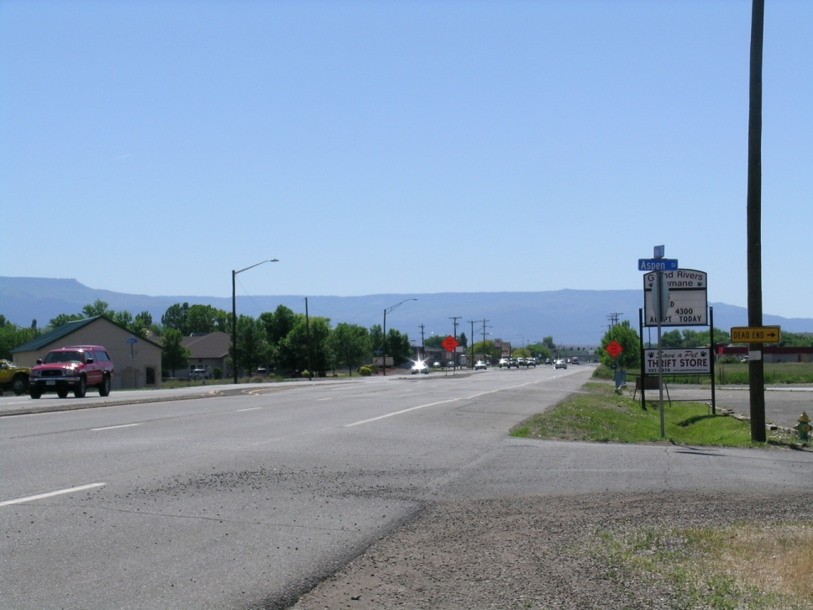Background

A well-designed and balanced transportation system will support access, circulation, and the safe movement of all modes of motorized and non-motorized transportation. Multiple travel routes provide greater options for driving, walking, and biking, and help reduce congestion by diffusing traffic. Well-connected street networks have been shown to reduce congestion, increase safety for drivers and pedestrians, and promote walking, biking, and transit use. The Grand Valley Circulation Plan (2010) shows existing and future roads that would serve the Plan area (Appendix Map 12).
Translating the Vision:
(2010 Grand Junction Comprehensive Plan)

What does livable mean for Balanced Transportation?
- Organized, functioning and orderly.
- Services and shopping are close to where we live to cut down the amount of cross-town traffic, commuting times and to reduce air pollution.
- A transportation system that balances possibilities for cars, trucks, transit, bicycles and pedestrians.
Connectivity
(2010 Grand Junction Comprehensive Plan)

“…[T]he region should identify and plan for additional crossings of the Colorado River and the Railroad. Doing so will help alleviate the choke points caused by the limited existing crossings, particularly as growth continues to the east and southeast. From a transportation perspective, potential river crossings should be evaluated on their ability to:
- Relieve traffic on existing crossings;
- Minimize impacts to neighborhoods and sensitive lands; and;
- Easily diffuse traffic onto multiple travel routes at each end.”
“Complete Streets” are ones in which the design addresses the needs of users of all ages and abilities, including safety, mobility and accessiblity. This means planning for everyone: pedestrians and bicyclists as well as the movement of vehicles and public transit. An important component of complete streets is providing for connectivity by creating small-scale, low-speed streets as part of a dense street grid with small block lengths. Such street networks maximize efficient traffic flow and roadway capacity while increasing safety by holding vehicles to slower speeds. Small block lengths encourage walking and increase pedestrian safety. Increasing connectivity is less costly, more cost-efficient, and less impactful than widening arterial roadways.
Pg 38

Multi-Modal System
There is a significant need for pedestrian and bicycle improvements throughout Orchard Mesa. Highway 50 has no pedestrian infrastructure and few crossings, limiting the ability of local residents to walk or bike safely. Notably, Mesa Valley School District #51 buses students who would have to cross Highway 50 to school, even though students may live within the designated walking area. A bike and pedestrian path along Highway 50, as well as improved crossings, are a high priority. A few bike and pedestrian facilities are located along streets, but Orchard Mesa has little in the way of dedicated bike routes and pedestrian paths within the neighborhoods and connecting to other areas (Appendix Map 13). The Urban Trails Master Plan (UTMP) identifies existing and future routes for bike facilities and trails.

Grade-separated pedestrian crossings (bridges) are the safest method to provide Highway 50 crossings for students and residents. While building new pedestrian bridges is very expensive, reconfiguring the B ½ Road overpass to include pedestrian and bicycle facilities would provide both an economical and functional solution that significantly improves connections between schools, neighborhoods, commercial areas and the fairgrounds. Further improvements along the Highway 50 corridor would complement the reconfigured B ½ Road interchange and improve mobility. (Figure 8; Appendix Maps 14 & 15)

Figure 8: Neighborhood Center Circulation Concept Plan
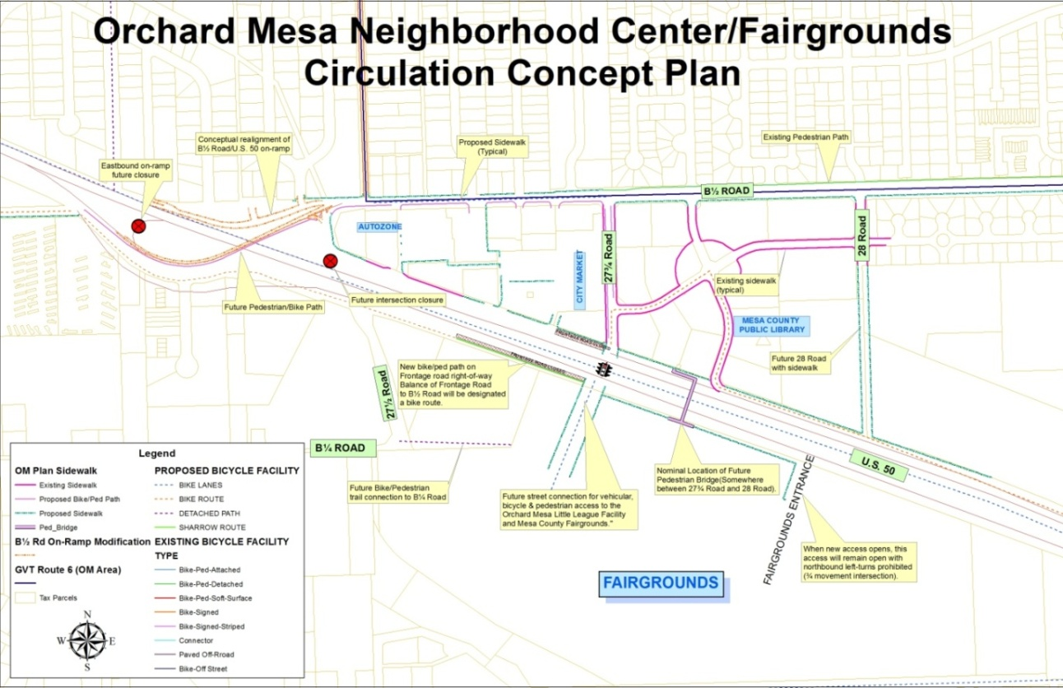
The nationally historic Old Spanish Trail travels through Orchard Mesa; the historical crossing of the Colorado River was near 28 ¾ Road. The Colorado Riverfront trail system runs along the north bank of the Colorado River and can be accessed from Orchard Mesa at four river crossings. Natural drainage ways traverse the planning area running north/northwest and can provide possible future trail connections to the trail facilities already in place. Linking neighborhoods with the Colorado River, downtown Grand Junction, Village Centers, Neighborhood Centers and other desired public attractions will provide a more complete transportation network for Orchard Mesa residents. The Parks, Recreation, Open Space & Trails section of this Plan provides more detail on trails, as well as additional Goals and Actions. (Appendix Maps 13 & 24)
Pg 39

Public Transit
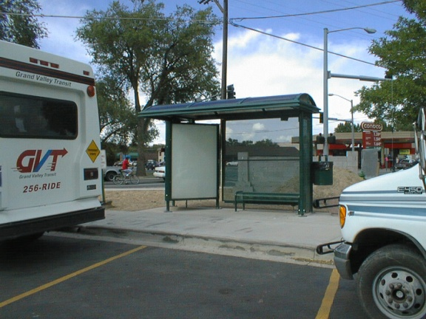Public transit is an important component of a multi-modal system. It provides transportation for people without reliable transportation, as well as the elderly and others with limited mobility. It can also help to relieve road congestion. Bus service is provided by Grand Valley Transit (GVT). The GVT system includes a route that travels from the transit center at 5th Street and South Avenue through Orchard Mesa and north along 29 Road to the Mesa County Workforce Center at North Avenue. This provides direct connections to a number of other routes serving Grand Junction and the Grand Valley. Buses run every half hour, Monday through Saturday; there is no service on Sundays or holidays. GVT buses are wheelchair accessible. Paratransit riders may also qualify for curb-to-curb service.

Access Control Plan
In 2009 Mesa County, the City of Grand Junction, and the Colorado Department of Transportation (CDOT) entered into an agreement to implement an Access Control Plan (ACP) for US Highway 50. The Plan establishes future access conditions on a property-by-property basis along the corridor. The purpose of the ACP is to provide reasonable access to adjacent properties while maintaining safe and efficient traffic flow. Key objectives include reducing traffic conflicts and improving traffic safety. Certain proposed actions in this Plan would implement the ACP, such as the addition of pedestrian and bicycle facilities on the B ½ Road overpass.

Potential Transportation Projects
For the past several years and during this planning process, the City and County have heard from businesses and residents about the many transportation needs on Orchard Mesa. The following is an unranked list of these projects:

- Highway 50 multi-modal improvements including non-motorized crossings
- B ½ Road multi-modal improvements
- 29 Road and Unaweep Avenue intersection control
- B Road multi-modal improvements
- 32 Road corridor improvements
- A connection between the Old Spanish Trail and the Colorado Riverfront trail system
Pg 40
- New Black Bridge (bike/pedestrian) connecting Orchard Mesa with the Redlands
- Bicycle improvements on the Fruit and Wine Byway
- 27 Road multi-modal improvements
- 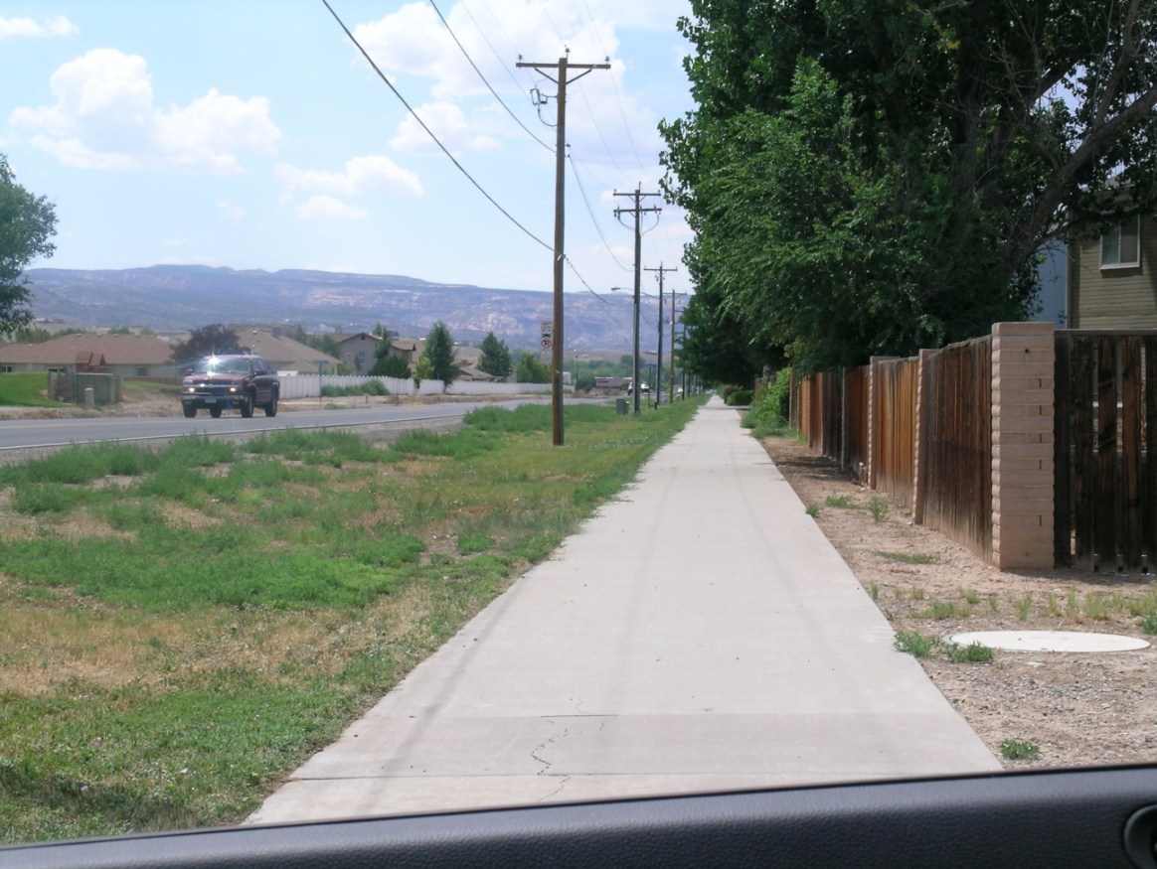Complete Streets traffic improvements and other measures at key locations such as commercial centers, schools, parks and other activity centers

2010 Comprehensive Plan Goals and Policies

Goal 9: Develop a well-balanced transportation system that supports automobile, local transit, pedestrian, bicycle, air, and freight movement while protecting air, water and natural resources.

Policies:
- The city and County will work with the Mesa County Regional Transportation Planning Office (RTPO) on maintaining and updating the Regional Transportation plan, which includes planning for all modes of transportation.
- Include in the Regional Transportation Plan detailed identification of future transit corridors to be reserved during development review and consider functional classification in terms of regional travel, area circulation, and local access.
- The Regional Transportation Plan will be used as a basis for development review and to help prioritize capital improvement programming. The City and County will maintain capital Improvement Plans (CIPs) which prioritize road and alley improvements based on needs for traffic flow, safety enhancements, maintenance and linkages.
- A trails master plan will identify trail corridors linking neighborhoods with the Colorado River, Downtown, Village Centers and Neighborhood Centers and other desired public attractions. The Plan will be integrated into the Regional Transportation Plan.
- When improving existing streets or constructing new streets in residential neighborhoods, the City and County will balance access and circulation in neighborhoods with the community’s needs to maintain a street system which safely and efficiently moves traffic throughout the community.

Orchard Mesa Transportation
Pg 41

Goal 1: Orchard Mesa’s multi-modal transportation network serves all users - vehicles, transit, bicycles and pedestrians – through the planning and design of “Complete Streets.”

ACTIONS
- Implement the Grand Valley Circulation Plan to improve the transportation network. Use a “Complete Streets” concept and policy for all transportation infrastructure, including planning, land use control, scoping, and design approvals.
b. Work with Grand Valley Regional Transportation Committee to include rebuilding the Highway 50 corridor as a Complete Street in the 2040 Regional Transportation Plan as a priority. Secure funding for CDOT to design and construct the corridor.
c. Future reconstruction or other major improvements to Highway 50 shall reflect the need to provide safe non-motorized crossing of the highway and multi-modal facilities.
d. Convert the eastbound lane of the B ½ Road overpass to a pedestrian/bicycle connection across Highway 50 (Figure 8).
e. Improve the westbound B ½ Road to westbound Highway 50 on-ramp to enhance safety (Figure 8).
f. As development/redevelopment occurs, ensure that the local road network supports the Highway 50 Access Control Plan.

Goal 2: Safe walking routes lead to all Orchard Mesa schools.

ACTIONS
a. Ensure that non-motorized access to schools is a key priority for new projects.
1) Include safe walking routes in applicable Capital Improvement Projects.
2) Seek grants and other funding, such as the federal Transportation Alternatives Program, for implementation.
b. Work with the school district, Colorado Department of Transportation and other partners to determine acceptable and effective Highway 50 school crossings and techniques at optimal locations.
c. Work with schools and community partners to ensure schools are connected to residential areas with walking paths and bicycle access, and secure bike parking is provided on school grounds.
d. Assist local partners such as Grand Valley Bikes and School District 51 with grant applications and other opportunities to map safe walking and biking routes to schools, conduct walking audits, create travel maps, and provide road safety information to parents and students.
e. Work with schools and community partners to improve transportation infrastructure to reduce conflicts between transportation modes during school drop-off and pick-up.
f. Incorporate pedestrian/street lighting into non-motorized facilities.

Goal 3: Orchard Mesa has a comprehensive system of bicycle and pedestrian facilities as part of a Complete Street network.
Pg 42

ACTIONS
a. Implement the Urban Trails Master Plan through land development proposals, planning activities, Capital Improvement Projects and other roadway improvements.
b. Require that all new streets and roads include sidewalks and/or bicycle facilities, including capital improvement street projects.
c. Identify and seek funding to build sidewalks and/or bike lanes and trails with school connectivity a top priority. Other key priority measures are connections to activity centers such as parks, commercial/retail areas and the Mesa County Fairgrounds.
d. Provide connectivity to existing and planned trails on public lands. Identify locations for and improve trailheads, including parking areas and other facilities.
e. Work with the Orchard Mesa Irrigation District, property owners and trails and bicycling organizations to identify corridors that will provide additional opportunities for non-motorized recreational and commuting opportunities.
1) Identify drainages and other corridors where trail linkages are possible based on location to existing or future trails, topographic constraints, and ownership agreements.
2) Develop and maintain a database containing easement agreements and other access agreements that cross private property for access to public lands.

Goal 4: Grand Valley Transit service and routes meet the needs of Orchard Mesa.

ACTIONS
a. Determine ridership demand through on-board surveys and collection and analysis of individual transit stop data and customer requests for service.
b. Add and/or adjust routes as justified by demand and budget allows.
c. Create new appropriate stops and “pull-outs” with proper signage.
d. Monitor land development activity to plan for future transit routes.
e. Construct safe non-motorized access to transit stops.

Pg 43
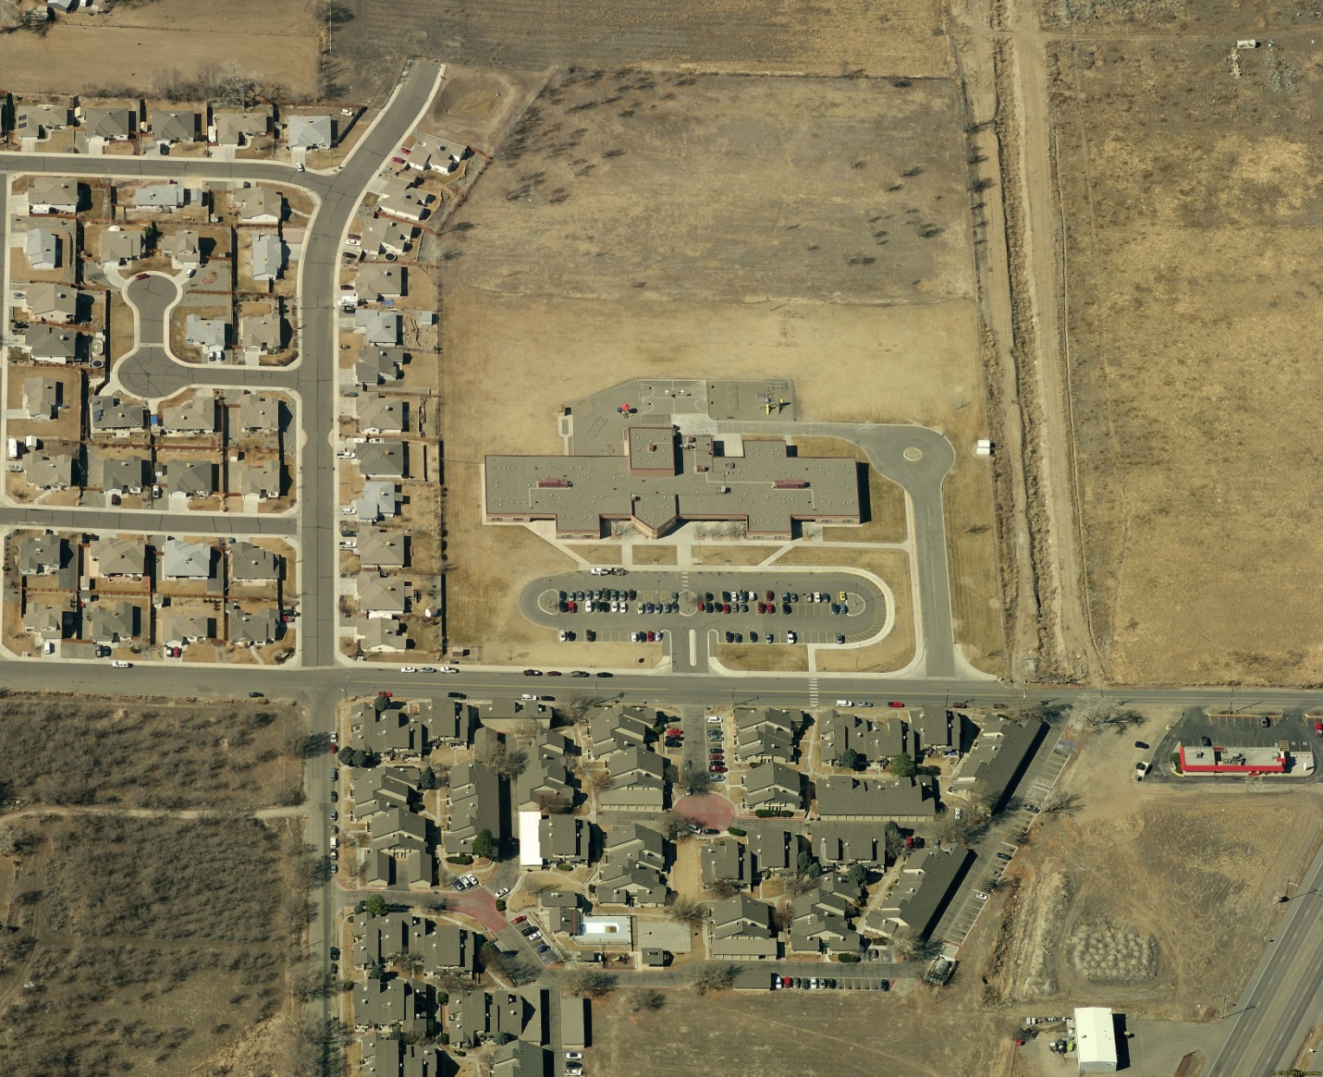7. Public Services

Public Utilities and Infrastructure
Cost of Infrastructure, Services
(2010 Grand Junction Comprehensive Plan)

“Although some City service costs are not closely tied to urban expansion (e.g. administration), there are many capital costs (utilities, street maintenance, public safety for example) that are sensitive to the type and location of growth. Generally, when growth occurs in lower densities, service providers incur disproportionate additional casts such as repairing and resurfacing roadways; cleaning and inspecting longer sewer lines; longer roads to plow snow and sweep; and longer trips for police, fire, building inspectors, schools buses and park maintenance crews, when compared to more compact urban land use patterns. These costs may not appear immediately (for example, it is usually several years before repaving is required), but they eventually add additional operating and capital replacement costs borne by the City, County and other service providers.”

Background

Sanitation & Sewer
Properties within the City of Grand Junction are served by the Persigo Wastewater Treatment Plant. The Orchard Mesa Sanitation District (OMSD) serves urban development between the City limits and 30 Road, but all sewage is treated at the Persigo Plant. Most of the development in the OMSD is infill. In accordance with the Persigo Agreement, the OMSD will dissolve in 2015 and the City of Grand Junction will serve the area.

Rural properties outside the Persigo Sewer District (201) boundaries are generally served by Individual Sewage Disposal Systems (ISDS). There are some individual properties within the Persigo boundaries that are served by ISDS; they would be served by public sewer if developed. A sewer main from the Clifton Sanitation District that serves Whitewater passes through the rural portion of the Plan area in the vicinity of 32 Road/Highway 141. This line can also serve urban development that is outside the Persigo District boundary, such as Springfield Estates. Rural development would only be permitted to connect to sewer service if located within 400 feet of the line, and if Clifton Sanitation District indicated a willingness to serve the property, consistent with the Mesa County Land Development Code Section 7.10.2. Development, uses and density must still conform to the adopted Future Land Use map. The location and design of the Clifton line limits the ability to serve most development west of 32 Road. Sewer service areas are shown in Appendix Map 16.
Pg 44

Domestic Water
The majority of the Orchard Mesa Plan area is served by Ute Water Conservancy District. Although nearly the entire planning area is within Ute’s district boundaries; some areas are served by either the City of Grand Junction or Clifton Water District (Appendix Map 17). Clifton Water has a large water tank on Whitewater Hill to service the Whitewater community.

There are several properties along the south edge of the Plan area, around Old Whitewater Road and near the junction of Highways 50 and 141, that are not in a water service district’s boundary. Future development of these properties would be dependent on inclusion in a water district and extension of service. One such area is Springfield Estates, off Highway 141; it is served by Ute Water. The County’s Whitewater Hill property (drag strip, trap club, modeleers club and Colorado Law Enforcement Training Center) is not in a water district but is served by Clifton Water. The existing 2-inch line is about 2.25 miles long; water pressure issues limit development. A 6-inch line would be needed to fully develop a firefighter training facility. Because of the elevation of the site, pumping is necessary. Clifton Water District has shown interest in developing the line, dependent on inclusion in their capital improvement plan. Grand Junction’s Kannah Creek raw water line is a potential source of non-potable water.

Solid Waste
The City of Grand Junction provides residential waste collection within the City limits. Large multi-family complexes (over 8 units) contract with private waste companies. Commercial properties within the City limits may have City trash service or may contract with a private hauler. Curbside Recycling Indefinitely, Inc. conducts curbside recycling collection within the City’s trash service area. It also maintains a drop-off site at the City shop property at 333 West Avenue. Commercial recycling collection may be available. Properties outside the City limits generally contract with private companies, although some individuals may choose to haul their own waste to the landfill. The Mesa County Landfill is located to the south of the Plan area. It provides a wide range of waste handling services, including the landfill, hazardous waste disposal, electronics recycling, recycling and composting.

Irrigation and Drainage
The Orchard Mesa Irrigation District (OMID) was organized in 1904 and became part of the Federal Grand Valley Project in 1922. Approximately 9,800 landowners and 4,300 acres are served by the district. (Appendix Map 18) OMID's water is diverted from the Colorado River at the Cameo Diversion Dam in DeBeque Canyon. Water rights within the District are allocated to the land and cannot be sold separately.
Pg 45
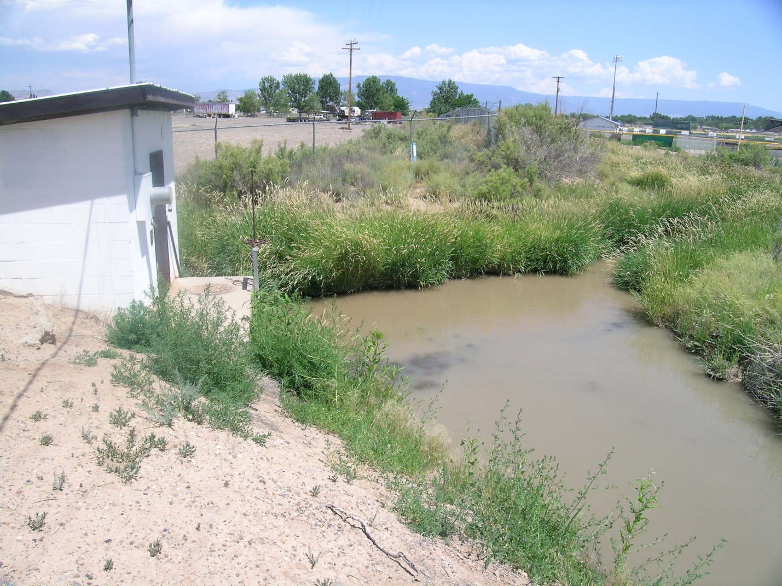The OMID is undertaking system improvements that will provide a more reliable water supply and will result in significant water savings. The most notable improvement will be a regulating reservoir, holding 80 to 100 acre-feet of water on a 15-acre site located north of A ½ Road and 29 ¾ Road and south of Mesa View Elementary School. The reservoir will improve the ability of OMID to deliver water at peak times. Check structures will be installed and improved, pump capacity will be increased, interties between canals will be constructed, and canal and lateral seepage will be reduced through lining and piping, further improving system efficiency.

Electrical & Gas Utilities
Xcel Energy provides electricity to the northwest portion of the Plan area. This includes the most-developed areas west of 27 ¼ Road and generally north of B ¼ Road, east across 30 Road. Xcel’s service area also includes the rural northeastern area, approximately along the C and C ½ Road corridors east of 32 Road. Grand Valley Power serves the remainder of the Plan area. Service areas are shown in Appendix Map 19. Natural gas service is provided by Xcel Energy to most of the Plan area. Infrastructure upgrades for both providers is driven by growth and development.
2010 Comprehensive Plan Goals and Policies

Goal 11: Public facilities and services for our citizens will be a priority in planning for growth.

Policies:
A. The City and County will plan for the locations and construct new public facilities to serve the public health, safety and welfare, and to meet the needs of existing and future growth.

Pg 46
Orchard Mesa Public Services – Public Facilities & Infrastructure

Goal 1: Services and infrastructure are cost-effective and meet the needs of residents and businesses in the Orchard Mesa Plan area.

ACTIONS
a. Future development levels shall be consistent with the adopted Future Land Use map and all requirements for infrastructure service connections. Sewer service shall not be extended to rural areas, except as permitted by the Mesa County Land Development Code.
b. Continue to submit development proposals to service providers for their review and comment.
c. Coordinate with water and sanitation providers to help ensure that water and sewer systems are designed and constructed with adequate capacity to serve existing and proposed development, and that their capital improvement plans are coordinated with implementation of this Plan.
d. Explore the creation of various types of Improvement Districts (local improvement districts, public improvement districts) for areas within the Urban Development Boundary where public infrastructure is needed and in areas that are already developed, for the purpose of providing sidewalks, street lighting, and storm water management or other urban services.
Public Improvement Districts in Centers
(2010 Grand Junction Comprehensive Plan)

“Mesa County requires creation of Public Improvement Districts (PID) for public urban service provisions in Centers located in unincorporated areas of Mesa County. These districts are formed to provide urban services, such as sewer (where a sanitation district does not exist), street lights, parks, additional public safety coverage’s, street sweeping and other urban services that are not offered by Mesa County. An urban services PID allows the identified district to establish a mill levy in the district and a sales tax upon approval of a ballot question in a general election by property owners in the proposed Public Improvement District. The monies raised through the levy and sales tax are used to pay for the urban services as the unincorporated Center grows.”

Pg 47
Community and Public Facilities

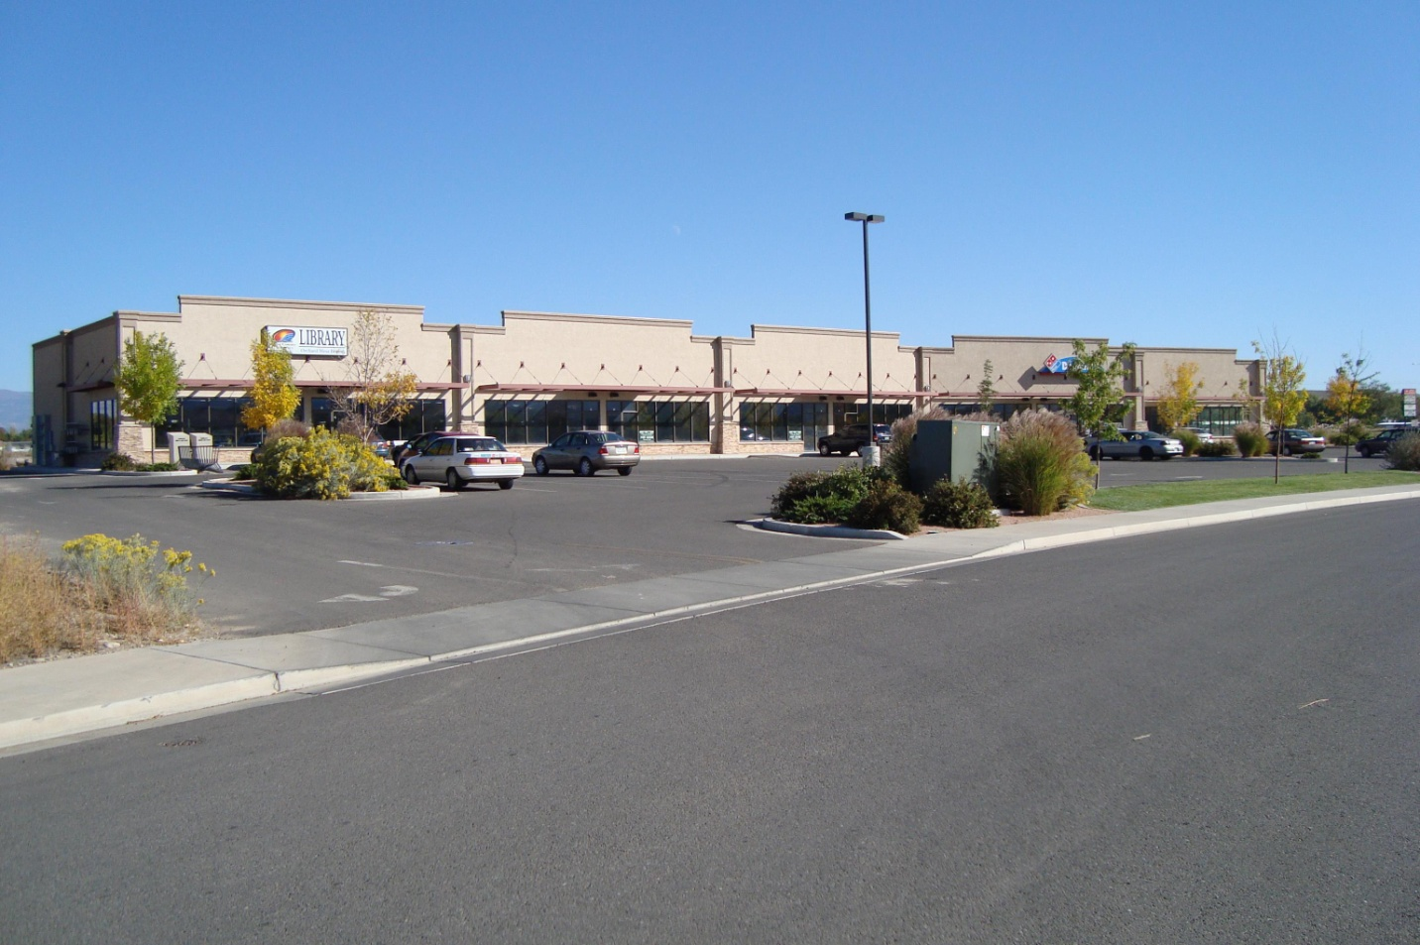Background

Public Facilities and Services
Public facilities on Orchard Mesa are limited. The Mesa County Library operates a branch at 230 East Lynwood Street. CSU Tri-River Extension offices are located at the Mesa County Fairgrounds. They provide information on agriculture and natural resources, consumer and family education and 4-H youth development. There are no other City or County administrative services or facilities located on Orchard Mesa.

Orchard Mesa does not have a post office. Depending on where one resides, the closest post office may be the main Grand Junction facility at 4th Street and White Avenue, Fruitvale, Clifton, or Whitewater. There are no commercial mail or shipping businesses in the area. Residents have noted that the lack of any facility with mail services is a significant issue.

Medical and behavioral health facilities are also limited on Orchard Mesa. There are some service providers such as a dentist, but no physicians’ offices, therapists’ offices or clinics. Residents requiring medical care must go to providers north of the river. This results in some hardships for low income residents and those with limited mobility. It may also contribute to the number of calls for emergency medical services.

Schools
Mesa County Valley School District #51 has 4 elementary schools and 1 middle school in the Plan area (Appendix Map 20). High school students from Orchard Mesa attend Central High School, Grand Junction High School or Palisade High School, depending on where they reside. A significant issue for the schools is the difficulty crossing Highway 50. Because of the lack of safe pedestrian crossings, students who live on the other side of the highway from their respective schools are bused, even when they reside within the District’s designated walking area. As shown in Table 8, enrollment in the Orchard Mesa schools has declined slightly in the past 5 years (about 2.8%). The largest decline has been at Lincoln Orchard Mesa Elementary, while enrollment at Mesa View Elementary has increased slightly.

The John McConnell Math and Science Center is located at New Emerson Elementary, a magnet school. A non-profit organization, it is dedicated to providing hands-on science education. It is open to the general public as well as to students.

The District owns approximately 34 acres at the northwest corner of B Road and 30 ½ Road. The site is for a potential future high school, and could also include a regional sports complex. Construction of a high school at this site will not occur until there is a need; District 51’s long range plan recommends a new high school in the Appleton area prior to building a school on Orchard Mesa. Therefore, development of the site is to be expected over the very long term. Additional sites for elementary and middle schools have not been identified.
Pg 48

Table 8: School Enrollment
School | Enrollment
 | 2009 | 2010 | 2011 | 2012 | 2013
Dos Rios Elementary | 439 | 430 | 374 | 382 | 404
Lincoln Orchard Mesa Elementary | 410 | 412 | 363 | 382 | 372
Mesa View Elementary | 421 | 441 | 454 | 448 | 434
New Emerson Elementary | 129 | 133 | 150 | 150 | 143
Orchard Mesa Middle School | 510 | 538 | 532 | 530 | 503
Totals | 1,909 | 1,954 | 1,873 | 1,892 | 1,856
Source: Mesa County Valley School District #51

CSU Western Colorado Research Center
Colorado State University’s Orchard Mesa research center is located at 3168 B ½ Road on 77 acres. The research center also includes a Fruita site. Research conducted at the Orchard Mesa site includes tree fruits, wine grape production, dry bean variety increases, and ornamental horticulture. The site includes Ram’s Point Winery, which trains students in winemaking and winery business practices.

Orchard Mesa Cemeteries
The Orchard Mesa Municipal Cemetery is located along 26 ¼ Road, and is maintained by the City of Grand Junction. There are several sections, including the Orchard Mesa, Masonic, Municipal, Odd Fellows (I.O.O.F.), and Veterans Cemeteries on the west and Calvary and St. Anthony’s Cemeteries on the east.

Goal 1: Community and public facilities meet the needs of area residents.

ACTIONS
a. Encourage the US Postal Service to provide a branch post office on Orchard Mesa.
b. Continue to maintain community facilities and services such as the Mesa County Library Branch.
c. Support the CSU Research Center and protect the surrounding area from urbanization.
d. Support assessment of health needs and encourage the location of medical offices and facilities within Orchard Mesa’s neighborhood centers.
e. Encourage and expand the Safe Routes to Schools program in Orchard Mesa neighborhoods.
Pg 49
Public Safety

Background
Police Services
(2010 Grand Junction Comprehensive Plan)

“The law enforcement staff has increased over recent years as concerns for safety and well-being have risen in Grand Junction. Cooperation between the City Police Department and Mesa County Sheriff’s Office improves coverage’s and response times. However, in some areas, jurisdictional responsibility is unclear, especially where city limits and County jurisdiction alternate. This results in inefficient, overlapping responses.”

Law Enforcement
Law enforcement within the City limits is provided by the Grand Junction Police Department (GJPD), while the Mesa County Sheriff’s Office (MCSO) covers the unincorporated areas. The patchwork of incorporated and unincorporated areas results in some uncertainty regarding jurisdictional responsibility; one side of the street or even individual parcels may be in the City, while the other side or immediately adjacent property is in the County. This results in inefficient and overlapping responses.

There are no police or sheriff substations on Orchard Mesa, and neither agency has patrol districts assigned exclusively to Orchard Mesa. The MCSO has one officer assigned to patrol the Old Spanish Trail/Gunnison River Bluffs Trail. The 911 call volume for Orchard Mesa tends to be low relative to its size, with the majority of the calls in the more dense western area. The 29 Road bridge has improved response times, allowing personnel to reach the area sooner.

Colorado State Patrol (CSP) is responsible for traffic patrol on the highways and investigates traffic accidents in unincorporated areas. All CSP offices have been consolidated at the Fruita Service Center.

Fire
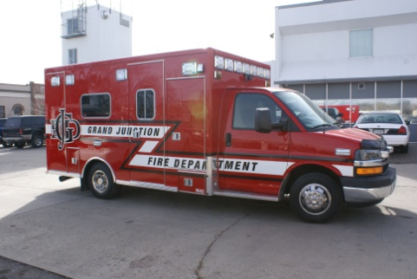The Orchard Mesa Plan area is served by the City of Grand Junction Fire Department (GJFD), the Grand Junction Rural Fire District, Central Orchard Mesa Fire District, and Land’s End Fire District (Appendix Map 21). A small area to the southeast of 31 Road and A 1/8 Road is not included in any fire district. Also, several properties in the southeast portion of the Plan area located south of Orchard Mesa Canal #2 are not within a fire district. Most of these properties are undeveloped, although a few have structures. Fire protection in areas outside Fire District boundaries is the responsibility of the MCSO. Fire protection on Bureau of Land Management property is the responsibility of the BLM.

GJFD Station 4 is located at 251 27 Road. Based on the City of Grand Junction Fire Facilities Plan 2013, there has been some discussion regarding moving the station east to the Unaweep Avenue and Alta Vista area. The Plan identifies all areas within 4 minutes estimated travel time from a station. The current location overlaps with the coverage area of the main station at 6th Street and Pitkin Avenue. Moving the station to the east would expand the area within the 4 minute response time, both on Orchard Mesa and in Pear Park. Data indicates a 17% increase in call volume from 2011 to 2012. However, the number of emergency medical service (EMS) calls decreased from about 80% of total calls in 2011 to about 75% in 2012. (Table 9)
Pg 50

Table 9: Fire Station No. 4 Call Volume
Station 4 | 2011 | 2012
Total Responses | 2625 | 3083
4 Minute Service Area
Total Incidents | 540 | 664
Total EMS | 431 | 496
Total Fire | 98 | 116
Population | 8894 | 8894
Population over 65 | 738 | 738
Source: City of Grand Junction Fire Facilities Plan 2013

Grand Junction Rural Fire District services are provided by the Grand Junction Fire Department through a contract with the City of Grand Junctions. Grand Junction Rural Fire District revenues are primarily derived from property taxes. The GJFD is operated as a general fund department of the City.

Central Orchard Mesa Fire Department is a separate fire district. It is a volunteer department managed by a 5-member board. The station is at 3253 B ½ Road. As of 2013, there were 13 volunteers. Most of the volunteers are certified as emergency medical technicians (EMTs). In 2012, the District had 108 calls, a decrease from prior years, with about 70% of the calls for EMS and 30% for fire. The majority of the fire calls are associated with field burning. The District’s service area covers about 8.1 square miles and includes approximately 800 households with an estimated 2,700 residents. The service area extends from approximately 30 ¼ Road and A ½ Road eastward to 35 Road and D ¼ Road, between Orchard Mesa Canal #2 and the Colorado River. Through the Mesa County EMS Resolution, the District covers an additional 17.9 square miles as a Rural Ambulance Service Area; that area extends east to the National Forest. The District is funded by taxes, grants and donations. Equipment includes three engines, a water tender, two brush trucks and two ambulances.

Ongoing issues for the Central Orchard Mesa Fire District include maintaining an adequate number of trained volunteers and water infrastructure issues, including lack of water pressure, no water lines or no hydrants. As a result, a water tender must be dispatched to all fire calls, requiring more department resources. Also, Central Orchard Mesa’s public protection classification (ISO rating) results in higher insurance costs for residents.

Land’s End Fire District is a volunteer department, with a station off Siminoe Road, south of Whitewater. The Colorado Law Enforcement Training Center, drag strip, trap club and model airplane club are within the Land’s End district. However, Grand Junction Rural Fire District may be more suited to respond to incidents, based on location, staffing and equipment. All areas of Orchard Mesa are covered by the County-wide mutual aid agreement for fire, EMS, and other emergency services provided by fire departments in the County.
Pg 51

The County continues to encourage fire-wise site design and construction in wildland-urban interface areas to keep homes safer from wildfires by providing informational materials to property owners and developers and through development review. The Mesa County Wildfire Protection Plan provides recommendations to abate catastrophic wildfire and minimize its impacts to communities. It includes a risk assessment of numerous areas, including Orchard Mesa, along with recommendations for fuel reduction and treatments, public education and actions for homeowners.

Emergency Management
The Mesa County Emergency Operations Plan (EOP) is an all-disciplines, all-hazards plan that establishes a single, comprehensive framework for incident management where resources from many agencies are involved. It provides the structure and mechanisms for coordination of local, state and federal agencies. The EOP is reviewed and updated every two years. Key components of the EOP are:
- Systematic and coordinated incident management;
- Organizing interagency efforts;
- Facilitating delivery of critical resources, assets and assistance; and
- Providing mechanisms for coordination, communication and information sharing in response to threats or incidents.

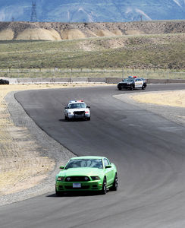Regional Public Safety Facility
The Colorado Law Enforcement Training Center at Whitewater Hill is the result of a partnership between Mesa County, the City of Grand Junction and Colorado Mesa University. Located on 78 acres, it is adjacent to the drag strip, trap club and model airplane club (Appendix Map 10). The largest training facility of its kind between Denver and Salt Lake City, it opened in 2013 with a pursuit driving track. It is expected to attract public safety personnel from throughout the region in addition to providing a venue to train local responders. Future plans for the site include an outdoor firing range, classrooms, fire training structures, and a simulated city block. One of the key challenges for development of the site is water. The water service will need to be improved to meet the fire code requirements for the planned classroom building and fire training needs.

Pg 52
Goal 1: Adequate public safety services are available to all residents.

ACTIONS
a. Work with all Fire Districts to determine the need for and location of stations on Orchard Mesa.
b. Work with the Fire Districts to determine how to provide appropriate services throughout Orchard Mesa.
c. The City and County shall encourage water providers, in coordination with the appropriate Fire District, to provide adequate fire flow for development planned or anticipated in all areas within their service area.
d. Provide outreach through the Sheriff’s Office, Grand Junction Police Department and Mesa County Health Department to area residents. Assist in the establishment of a Neighborhood Watch program. Work to address community concerns and health and safety issues, support consistent law enforcement presence and services, and address public safety on streets and roads.

Goal 2: The Colorado Law Enforcement Training Center serves as a regional training facility for law enforcement and emergency responders.

ACTIONS
a. Plan capital improvements that will enhance development and use of the training facility
b. Encourage economic development efforts that will support and enhance usage of the training facility.
Pg 53
8. Stormwater
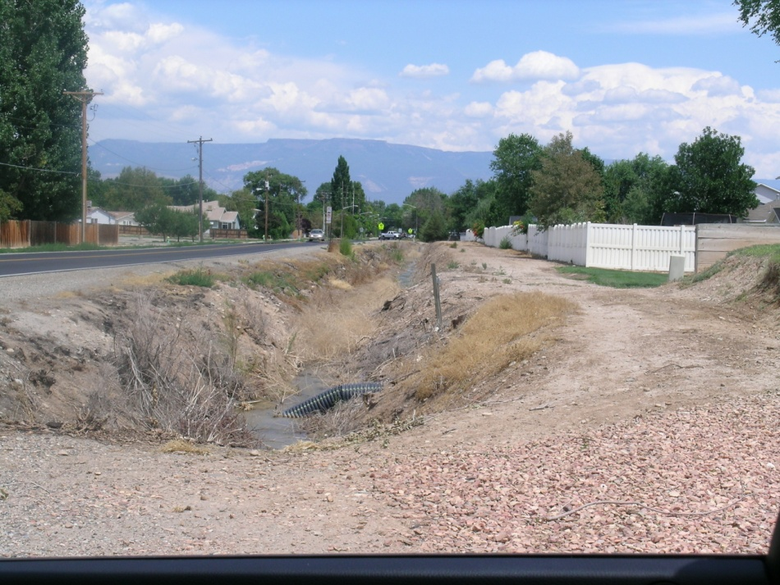Background

The 2010 Comprehensive Plan discusses Natural Hazards, which include drainage and stormwater management. Drainage for Orchard Mesa is managed by the City of Grand Junction, Mesa County, the Orchard Mesa Irrigation District, and the 5-2-1 Drainage Authority. Although the average annual precipitation for the Grand Junction vicinity is only about nine inches, flooding can and does occur. Because large storms are infrequent, drainage issues were overlooked in the past. Our native clay soils do not absorb water well. Vegetation is sparse in many areas and this encourages erosion. Finally, development increases the amount of impervious surfaces in the form of roofs, driveways, and parking lots, reducing the amount of open ground. These past practices and environmental conditions collectively promote little infiltration, rapid runoff, more debris in the runoff, and flash flooding.
Managing our Water Wisely
(2010 Grand Junction Comprehensive Plan)

“Grand Junction is an oasis in a desert landscape. While we have abundant water supplies, it makes sense to manage the use and quality of our water. Wise water management includes continuing the separate system of delivering irrigation water, making major efforts to prevent salt and other pollution of our rivers and streams and expanding the use of low-water landscapes (xeriscape).

In addition to flooding concerns, water quality is also important. There are many entities that are involved in stormwater quality in the Grand Valley, including Mesa County, City of Grand Junction, Town of Palisade, Grand Valley Drainage District, Orchard Mesa Irrigation District, Grand Valley Water Users’ Association, and School District #51. The Grand Valley Stormwater Unification Feasibility Study was conducted in 2003 and the 5-2-1 Drainage Authority was created to help monitor and manage the quality of water as it returns to local washes, creeks and rivers.
Pg 54

Storm Water Discharge
To aid in returning runoff to water sources safely, the U. S. Environmental Protection Agency (EPA) has developed a National Pollutant Discharge Elimination System (NPDES) stormwater permitting program. As part of the NPDES guidelines, employees in the Orchard Mesa Irrigation District (OMID) and the Grand Valley Water Users Association have the authority to monitor and report violations to the City of Grand Junction or Mesa County. (http://www.irrigationprovidersgv.org/stormwater_discharge.php) Generally, urban runoff will be treated as a pollutant, while agricultural drainage is exempt from NPDES regulation. Increased stormwater drainage in OMID’s system may add to the District’s permitting and treatment requirements.

Preparing for Disaster
The 5-2-1 Drainage Authority received a Pre-Disaster Mitigation Grant from the Federal Emergency Management Agency (FEMA) in 2009 to address several known problems on Orchard Mesa. A comprehensive drainage study, from 30 Road to the west, was completed as part of the grant project, resulting in the following map (Figure 9; Appendix Map 22). It identifies the area that would be inundated by a 1% chance (100-year) event, which is two inches of rainfall in a 24-hour timeframe. There are approximately 400 acres and 700 structures in the floodplain. The study found that spending over $4 Million (2009 dollars) to perform improvements would remove approximately 100 acres from the floodplain.

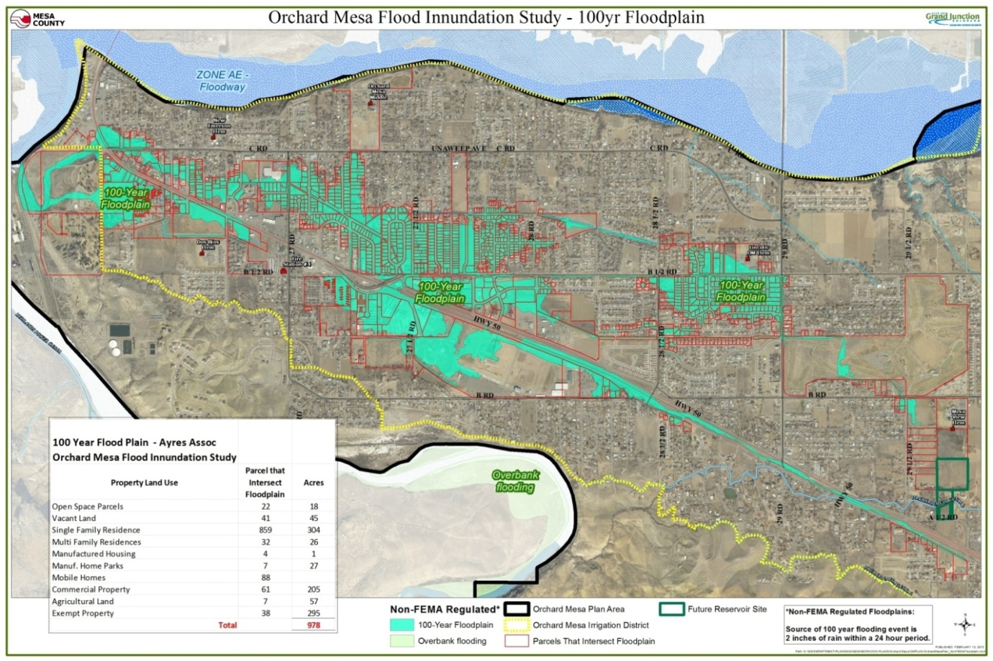Figure 9: Orchard Mesa Flood Inundation Study
Pg 55
Although FEMA has not created a Flood Insurance Rate Map (FIRM) from this study, the City is using it as the “best available information” to govern development in the area and to ensure all new structures are built high enough they will not flood in the 1% chance event. Because this is not yet a FIRM, lending agencies probably won’t require flood insurance to issue a loan. Affected land owners should consider obtaining flood insurance because basic homeowner’s policies do not cover flooding. A composite of the study area plus the FEMA-regulatory floodplain is shown in Appendix Map 23.
2010 Comprehensive Plan Goals and Policies

Goal 11: Public facilities and services for our citizens will be a priority in planning for growth.

Policies:
The city and county will plan for the locations and construct new public facilities to serve the public health, safety and welfare, and to meet the needs of existing and future growth.

Orchard Mesa Storm Water

Goal 1: Pre-disaster mitigation is performed to limit potential property damage.

ACTIONS
a. Support regional retention and detention facilities.
b. Assist in the study of regional drainage needs.
c. Create partnerships between local entities responsible for stormwater.

Goal 2: Improve and maintain drainage facilities collectively among drainage partners.

ACTIONS
a. Support the vision of the 5-2-1 Drainage Authority.
b. Create partnerships between local entities responsible for stormwater to establish regional drainage facilities.
Pg 56
9. Parks, Recreation,
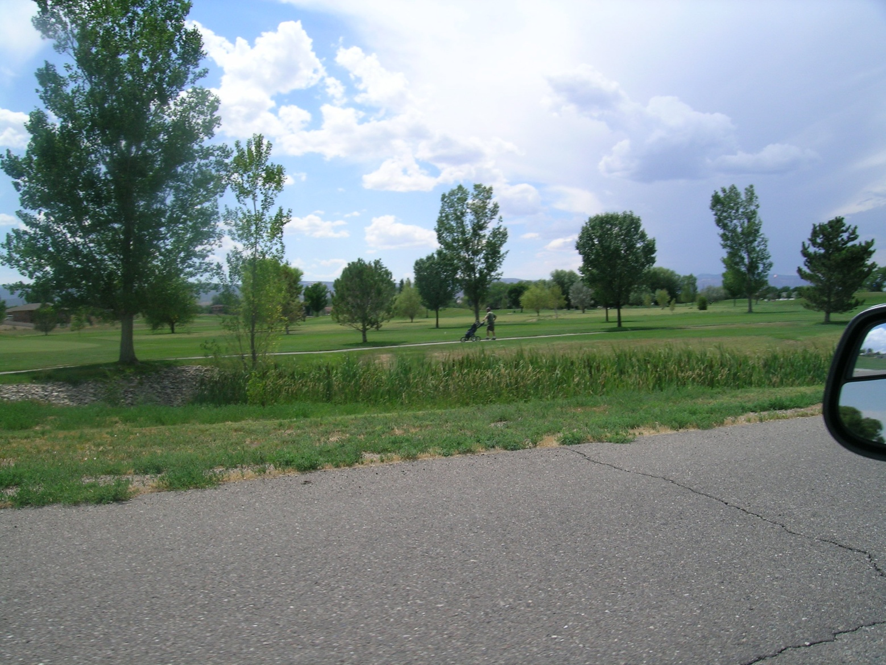Open Space & Trails
Background
A Grand Green System of Connected Recreational Opportunities
(2010 Grand Junction Comprehensive Plan - Guiding Principles)

“Take advantage of, and tie together the exceptional open space assets of Grand Junction, including the Colorado River, our excellent park system, trails and our surrounding open spaces.”

Existing Parks and Recreation Facilities
One of the Guiding Principles of the 2010 Comprehensive Plan is a “Grand Green System of Connected Recreational Opportunities.” Orchard Mesa has about 50 acres of park lands providing a variety of facilities (Table 10). City parks include Duck Pond Park, Eagle Rim Park and Dixson Park; Burkey Park South is undeveloped. Mesa County parks include Arlington/Oxford Park, Lynwood Park, Teardrop Park, Veterans/Lions Park and Village 9.

Other recreational facilities include the Orchard Mesa Community Pool, operated by the City of Grand Junction through a Memorandum of Understanding with Mesa County Valley School District 51 and Mesa County. The 95-acre Mesa County Fairgrounds at Veteran’s Memorial Park includes the Orchard Mesa Little League fields, BMX track, and equestrian facilities, as well as open space. Chipeta Golf Course is a privately owned 18-hole golf course. School playgrounds and sports fields provide additional facilities for local residents. However, availability is dependent on school schedules, policies, and funding. As of the writing of this plan, the Orchard Mesa Middle School tennis and volleyball courts are not available for use by the public due to fiscal constraints. Private parks are located in some subdivisions, for use by subdivision residents.
Pg 57
Park Needs
Additional Park Types: Mountain Park, Confluence Park, and Regional Parks
(2010 Grand Junction Comprehensive Plan)

“A large mountain park is suggested to take advantage of the City’s mountain side watershed lands on the Grand Mesa slopes. Large regional parks are suggested in various locations in the City. The Comprehensive plan resurrects the previous idea of a park of the confluence of the Colorado and Gunnison Rivers.”

One of the Guiding Principles of the Grand Junction Comprehensive Plan is to have a “Grand Green System” of connected parks, trails, and open space. The Comprehensive Plan summarizes parks by type – mini, neighborhood, community and regional, and their related service areas, with radii that range from ¼ mile to 10 miles. Many existing Orchard Mesa neighborhoods lie outside park service areas, indicating that there is a need for additional neighborhood and community parks. The Comprehensive Plan provides detail on levels of service (Figure 10).

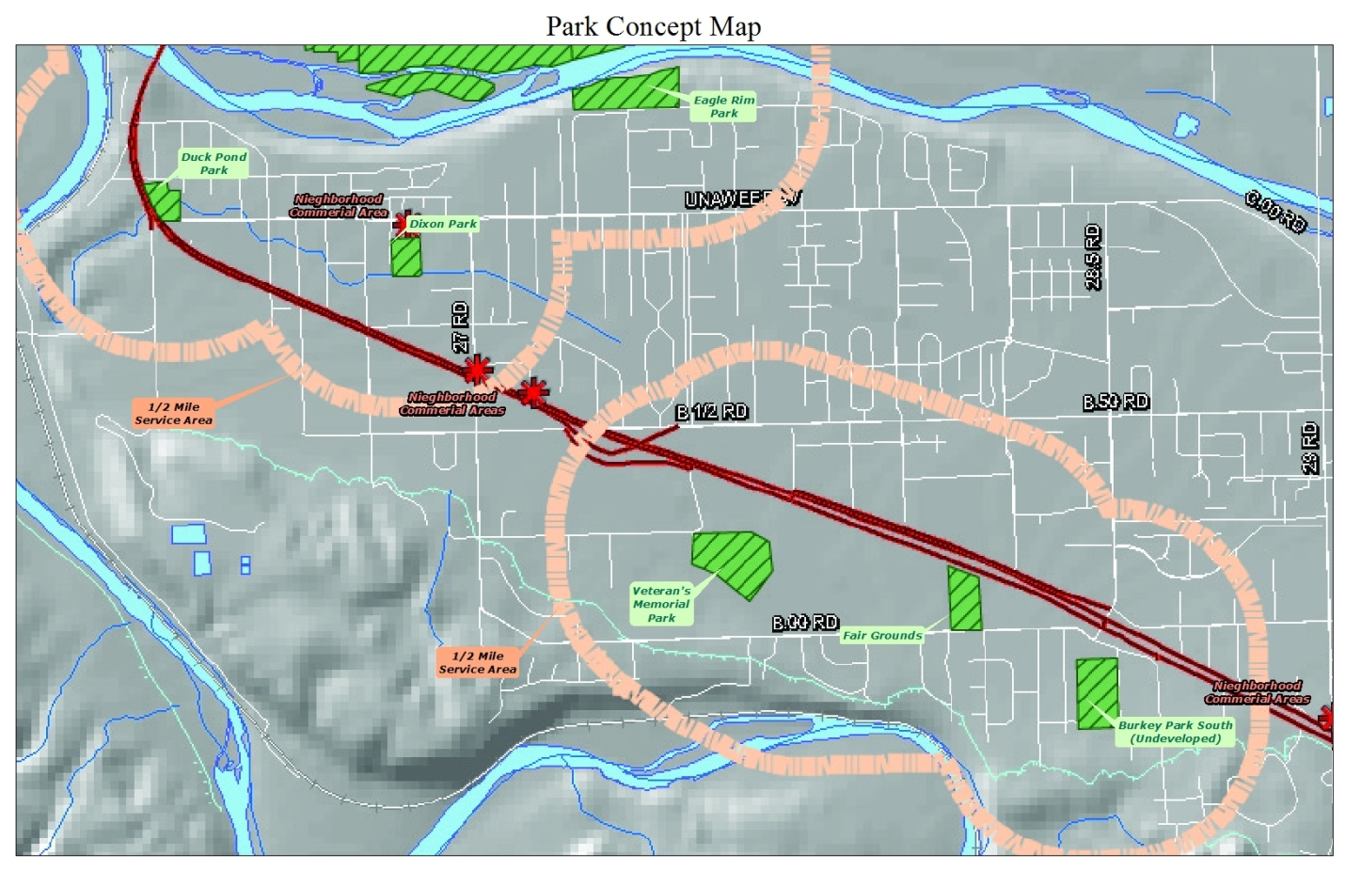Figure 10: Park Service Areas

The Comprehensive Plan specifically references the concept of Confluence Park, to be located at the junction of the Colorado and Gunnison Rivers. The future high school site, located at the northwest corner of B Road and 30 ½ Road, could include sports fields to serve regional recreation needs.

Pg 58
Table 10: Park Inventory
Name | Jurisdiction | Acres | Type
Arboreteum | Mesa County | 1.2 | Walking paths; amphitheater
Arlington/Oxford | Mesa County | 2 | Open Space
Burkey South | Grand Junction | 10 | Open Space/Future park; trailhead for Old Spanish Trail
Dixson | Grand Junction | 2 | Open space; picnic area; sports fields
Duck Pond | Grand Junction | 4.4 | Playground; picnic area
Eagle Rim Park | Grand Junction | 12 | Playground; picnic area; skate park; trails; access to Old Mill Bridge/Colorado Riverfront Trail
Lynwood | Mesa County | 2 | Playground; picnic area
Mesa County Fairgrounds | Mesa County | 85 | Picnic area; open space; equestrian activities; BMX course; ball fields
Orchard Mesa Pool | GJ/MC/Dist. 51 | n/a | Indoor swimming
Teardrop | Mesa County | 1 | Open space; picnic tables
Veterans/Lions Park | Mesa County | 7 | Green space; picnic tables; volleyball; Veteran’s Memorial
Village 9 East | Mesa County | 1.8 | Playground; picnic tables
Village 9 West | Mesa County | 7.5 | Open Space
Schools | Mesa County Valley School District #51 | n/a | Playgrounds and sports fields at schools
Chipeta Golf Course | Private | 124 | 18-hole golf course, driving range, tennis course
An Extensive Off-Street Trail System
(2010 Grand Junction Comprehensive Plan)

“The region is known for its great bicycling, but a complete trail system is lacking throughout the city. The plan expands on the great trail building efforts along the Colorado River and combines trails, bike paths, bike lanes and bike routes, envisioned in the Urban Trails Plan, to create an alternative system for getting around ….”

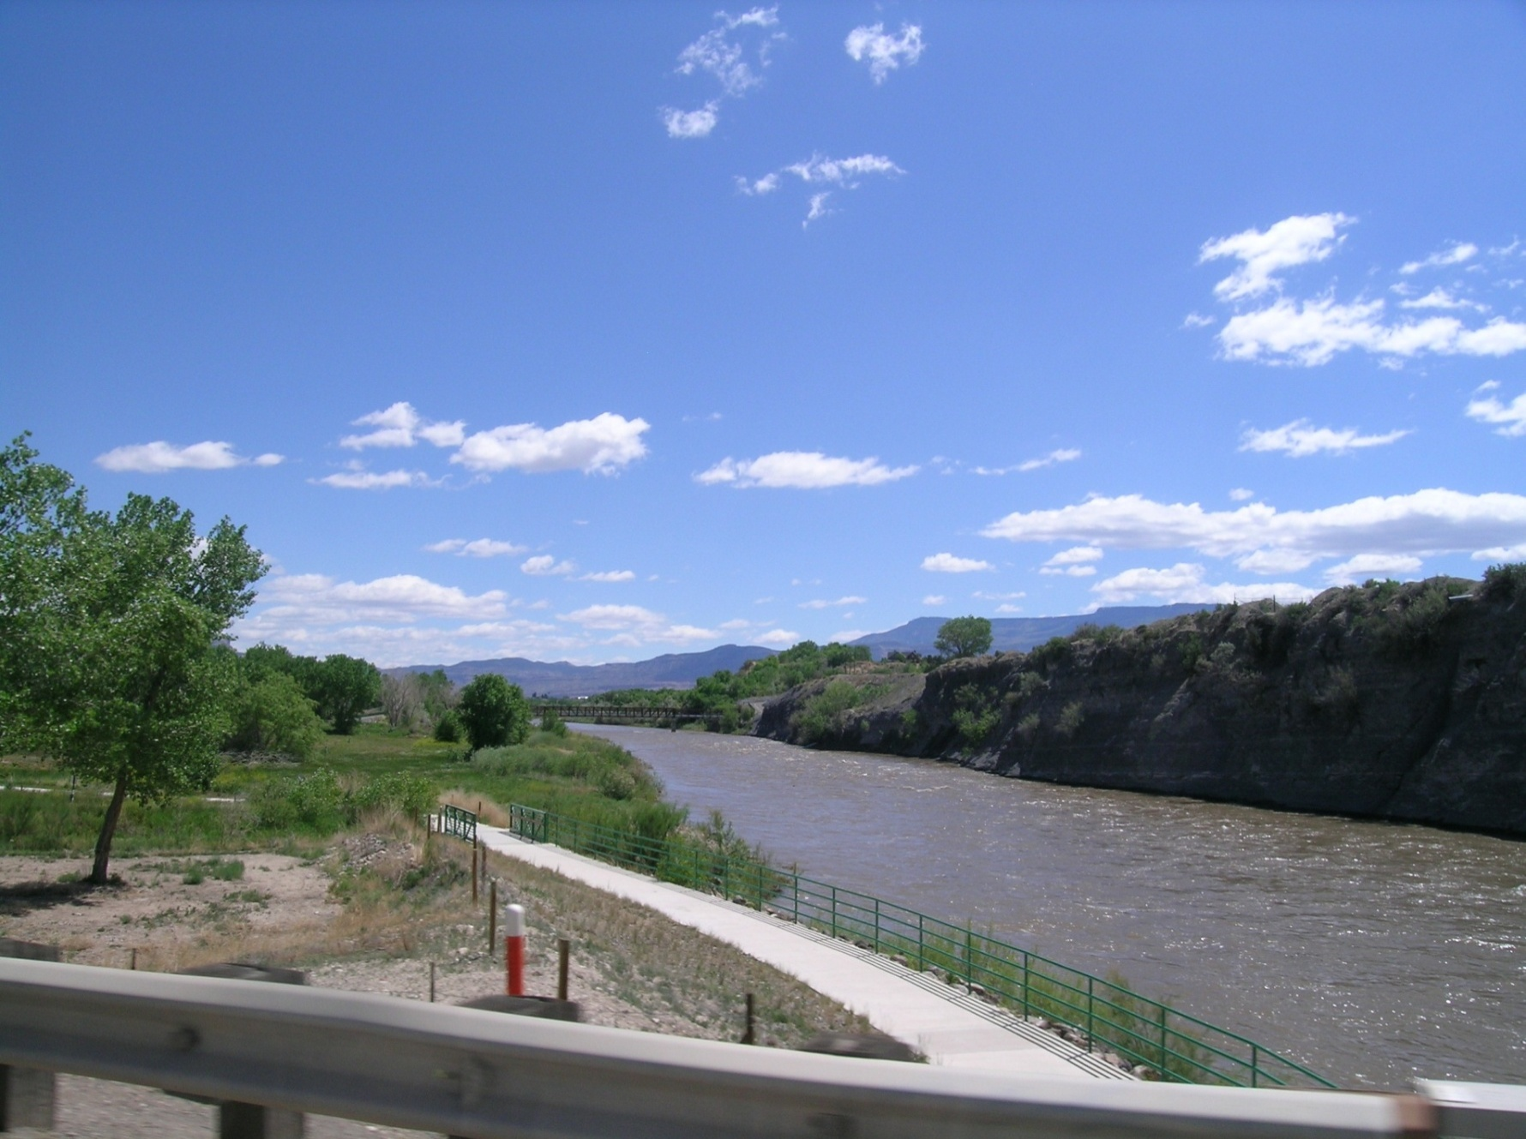Bike and Pedestrian Trails
Pg 59
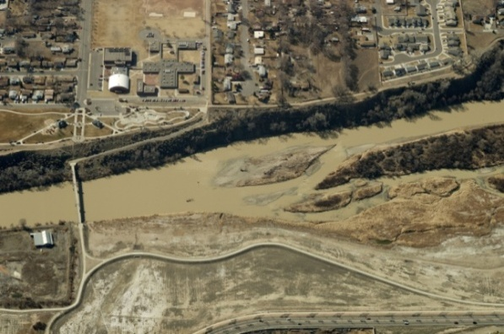Bridges connecting to the Colorado Riverfront Trail are located at Eagle Rim Park (Old Mill Bridge) and 32 ½ Road off C ½ Road. Other access points are across the river via the 5th Street Bridge and the 29 Road Bridge. The Orchard Mesa area includes a few bike and pedestrian facilities along streets, mostly in incorporated neighborhoods, but has little in the way of dedicated bike and pedestrian trails (Appendix Map 13). Trails connecting the Colorado Riverfront Trail and the Old Spanish Trail as well as connections across the Gunnison River at the Black Bridge site have been identified by residents as desirable routes. A bike and pedestrian path along Highway 50 is a high priority. The Urban Trails Master Plan identifies existing and future routes for bike facilities and trails.

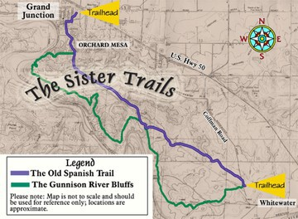One of the most significant assets of Orchard Mesa, both recreationally and culturally, is the Old Spanish Trail North Branch. Together with the Gunnison River Bluffs, they are known as the Sisters Trails. The area provides open space, hiking and biking, and opportunities to enjoy the natural setting. The north trailhead is a parking area located at the Burkey Park South property, which is undeveloped. Trail users must use Valley View Drive and Sunlight Drive, passing through a residential neighborhood to get to the trail. The southern trailhead is located in Whitewater, on Coffman Road. The trails pass through land owned by the BLM, Mesa County, City of Grand Junction, and private parties. The Old Spanish Trail is 7 miles long, while the Gunnison River Bluffs Trail runs for 8 miles. The draft Sisters Trail Plan has been prepared and will be considered for adoption in the near term. The plan identifies possible trailhead and interpretive improvements and emphasizes partnerships to implement the plan. The Old Spanish Trail Association is a national non-profit organization dedicated to promoting awareness of the Old Spanish Trail and its multicultural heritage. The local chapter serves as an advocate for the North Branch of the trail, partnering with government and other organizations to promote the trail as well as maintain and make improvements to the trail.
Pg 60

The Palisade Fruit & Wine Byway begins at 32 and C Roads and provides a 25-mile loop route for bicyclists and motorists touring the orchards and wineries of Orchard Mesa to Palisade. The majority of the Orchard Mesa portion of the Byway places the bike route within existing roadways.

2010 Comprehensive Plan Goals and Policies

Goal 10: Develop a system of regional, neighborhood and community parks protecting open space corridors for recreation, transportation and environmental purposes.

Policies:
A. A parks master plan that identifies regional, community and neighborhood parks and open space. The plan will be integrated into the Regional Transportation Plan and the trails master plan.
B. Preserve areas of scenic and/or natural beauty and, where possible, include these areas in a permanent open space system.
C. The City and County support the efforts to expand the riverfront trail system along the Colorado River from Palisade to Fruita.

Orchard Mesa Parks, Recreation, Open Space & Trails
Goal 1: Parks and recreational opportunities meet the needs of Orchard Mesa residents.

ACTIONS
a. Identify locations for new mini and neighborhood parks that will positively impact and enhance the Orchard Mesa community and meet the level of service standards for parks and recreation facilities in the Grand Junction Comprehensive Plan.
b. Include active, passive and natural areas, to provide a variety of experiences and activities for residents.
c. Preserve natural drainages, wildlife habitat and vegetation as open space.
d. Develop an historic park and/or viewpoint at Confluence Point.

Goal 2: The Old Spanish Trail and Gunnison River Bluffs Trail are a recreation destination.

ACTIONS
a. Adopt the Sisters Trail Plan and in coordination with the City of Grand Junction, Mesa County, Bureau of Land Management (BLM), National Park Service (NPS), Old Spanish Trail Association (OSTA), Colorado Plateau Mountain Bike Association (COPMOBA) and other interested parties, implement the Sister Trails Plan.
Pg 61
b. Work with OSTA, COPMOBA, BLM, NPS, City of Grand Junction, Mesa County, Museum of the West, Visitor’s Bureau, Interpretive Association of Western Colorado and other groups to make people aware of the Old Spanish Trail and Gunnison River Bluffs Trail and to promote the Old Spanish Trail as one of the reasons to visit Grand Junction.

Goal 3: A system of trails provides a network of connections throughout Orchard Mesa for pedestrians and bicyclists, with connections to the Riverfront Trail, the Redlands, and Whitewater.

ACTIONS
a. Continue to require new development to provide trails and connections as identified in adopted plans, either as easements or dedicated right-of-way, as links to existing trails and to the transportation system.
b. Work with property owners when planning routes for new trails, especially along drainages and other areas where easements from private property owners will be needed.
c. Work with the Regional Transportation Planning Office (RTPO) and Colorado Department of Transportation (CDOT) to plan for Highway 50 bike and pedestrian facilities.
d. Establish and develop Black Bridge Park with a pedestrian bridge over the Gunnison River that can also serve as an emergency access for businesses if the railroad blocks the current access, in coordination with the Riverfront Technology Corporation, the Riverfront Commission and the Department of Energy.

Goal 4: Parks and recreation facilities serving the residents of Orchard Mesa are developed, maintained and operated through effective partnerships between the City of Grand Junction, Mesa County and Mesa County Valley School District #51.

ACTIONS
a. Continue to utilize shared use agreements and intergovernmental agreements to develop, operate and maintain parks and recreational facilities.
b. Encourage new partnerships among government agencies, non-profit organizations, private sector businesses and area residents to assist with provision of park and recreational facilities and programs.
c. Enter into a partnership with Mesa County Valley School District #51 to develop a sports field complex at the high school site, redevelop the community sports facilities at the middle school site, and to locate neighborhood and community parks adjacent to school sites, to maximize resources.
d. Continue the partnership with the City of Grand Junction, Mesa County and School District #51 to operate the Orchard Mesa Community Center Pool.

Pg 62
10. Mesa County Fairgrounds
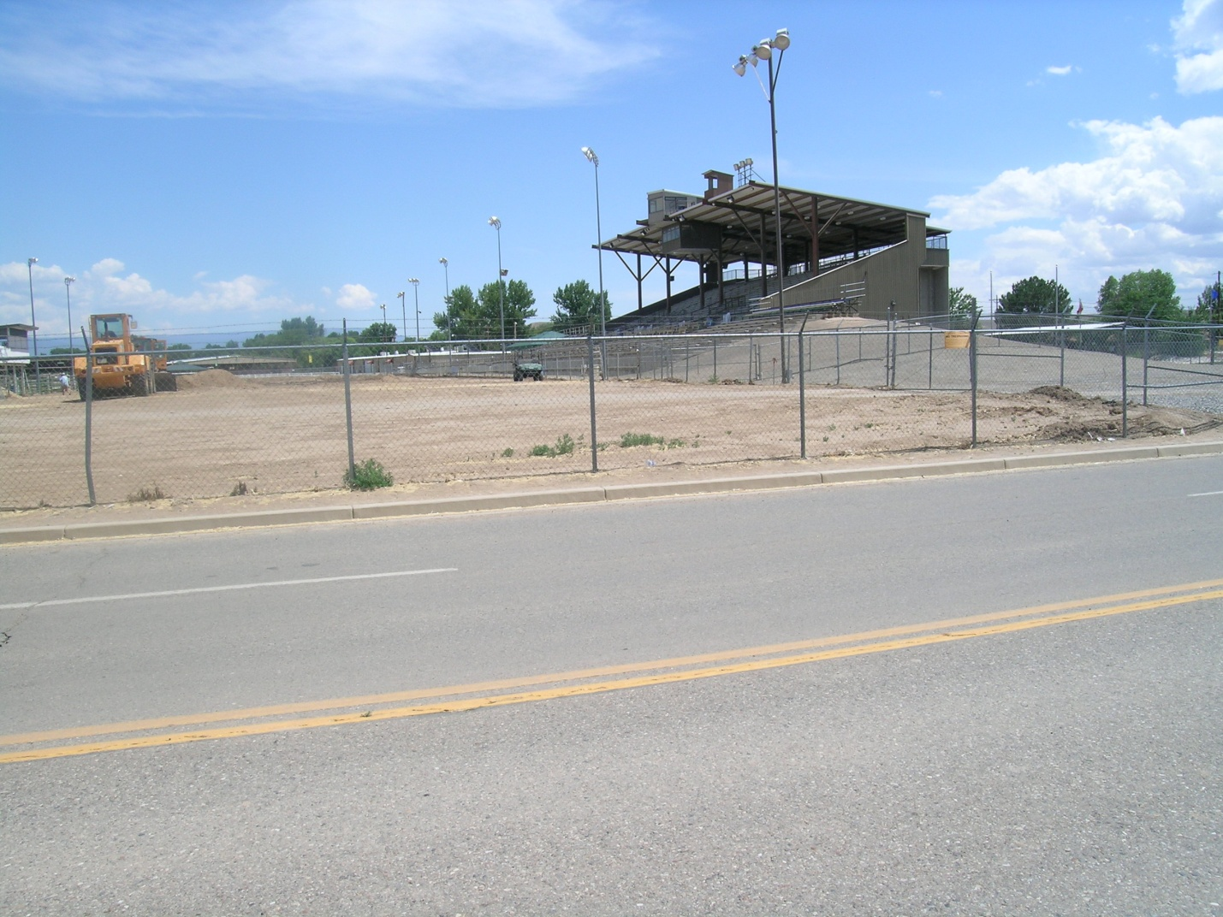
Background

The Mesa County Fairgrounds at Veteran’s Memorial Park is a 93-acre multi-purpose special event facility that was established in the 1940s. In addition to the annual county fair, it hosts numerous events and activities throughout the year and is the home campus for the Tri-River CSU Extension Office. The property includes the grandstand, equestrian center, buildings for indoor events, Little League ball fields, a BMX track, an arboretum and demonstration gardens. There are approximately 500 events each year, drawing more than 100,000 attendees.

Area residents also use the Fairgrounds as a neighborhood park; continued pedestrian access from B Road is important to the surrounding neighborhoods. In the future, as properties to the west develop, bike and pedestrian access B ¼ Road should be added, providing access to the Orchard Mesa Little League fields and Lions Park.
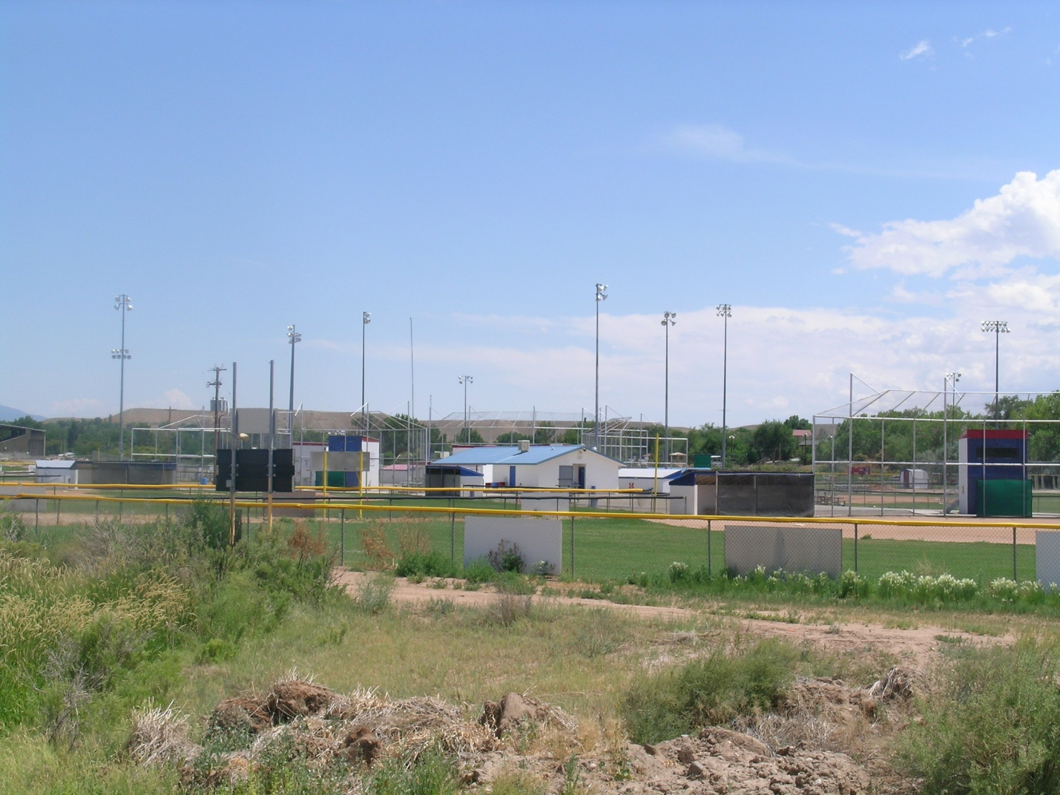
On December 10, 2012, the Mesa County Board of County Commissioners adopted the Mesa County Fairgrounds Master Plan. The Plan is a road map for future development of the property. The proposed Master Plan includes a new primary circulation road connecting the two Highway 50 Fairgrounds entries. Improvements at the west end of the site include upgrades to the Orchard Mesa Little League complex and parking area, relocation and expansion of the BMX venue to create a professional BMX course, relocated and enlarged Veteran’s Park, relocated Veteran’s Intermountain Memorial, and expanded paved parking. Improvements to the east end of the site include additional stall barns, a new covered arena, a permanent show office and restroom pavilion, and expanded RV sites. Improvements to the center of the site include a proposed 5,000 seat indoor event arena with attached 30,000 square foot divisible exhibition hall and expanded paved parking.
Pg 63

The Master Plan is proposed to be implemented in phases as funding becomes available (Figure 11). Work will occur first in the east and west sections, beginning in 2013. The more expensive event arena and exhibition hall will be the final phase of the project. The Master Plan includes an analysis of economic and fiscal impacts of fairground operations and development, as well as key benefits of the proposed improvements. The property is zoned Planned Unit Development (PUD); the development plan for the site will be updated in 2014 to reflect the new Master Plan.

With redevelopment of the Fairgrounds, the facility will continue to be an asset to the residents of Mesa County but will also become a regional attraction, providing a venue for expanded activities and events that will draw more visitors to the area. As such, it can serve as an anchor for the Orchard Mesa community and act as a catalyst for future development. The Future Land Use Map identifies the surrounding area as a Neighborhood Center. The Fairgrounds is an amenity to surrounding Orchard Mesa neighborhoods, but it can also have impacts, such as noise, traffic and dust. It will be important to address those impacts while continuing to provide neighborhood access.
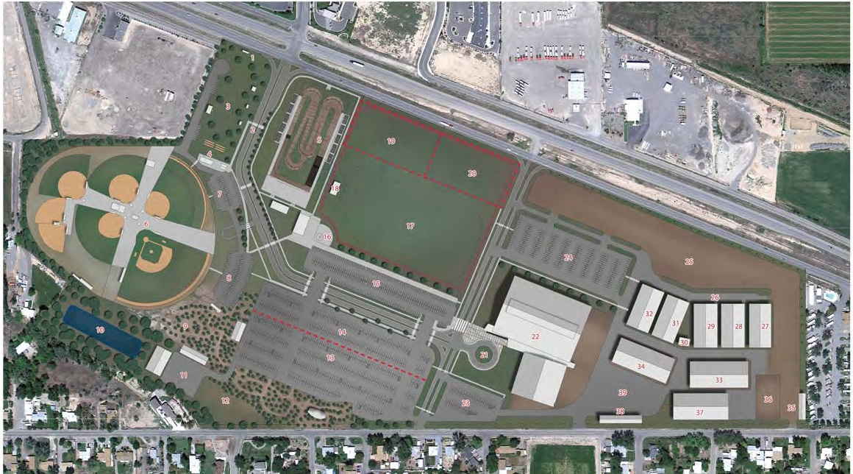Figure 11: Fairgrounds Master Plan
2010 Comprehensive Plan Goals and Policies

Goal 11: Public facilities and services for our citizens will be a priority in planning for growth.

Policies:
A. The City and County will plan for the locations and construct new public facilities to serve the public health, safety and welfare, and to meet the needs of existing and future growth.

Goal 12: Being a regional provider of goods and services the City and County will sustain, develop and enhance a healthy, diverse economy.

Policies:
A. Through the Comprehensive Plan’s policies the City and County will improve as a regional center of commerce, culture and tourism.

Mesa County Fairgrounds
Pg 64

Goal 1: The Mesa County Fairgrounds serves as a regional attraction and is an anchor for Orchard Mesa.

ACTIONS
a. Plan for and develop land uses and services that will support implementation of the Mesa County Fairgrounds Master Plan.
b. Encourage the formation of partnerships that will increase the quality and quantity of events, working with the Visitors and Convention Bureau and other local organizations.
c. Encourage economic development efforts that will support and enhance usage of the Fairgrounds.
d. Plan capital improvements that will enhance access to and use of the Fairgrounds. Include multi-modal transportation improvements.

Goal 2: Impacts of Fairgrounds activities on surrounding neighborhoods are reduced.
ACTIONS
a. Work with the Fairgrounds and surrounding neighborhoods to identify possible impacts and develop solutions that will minimize impacts from noise and dust associated with activities at the Fairgrounds through operations and site design.
b. Support efforts of the Fairgrounds to do neighborhood outreach and notification of events that may affect area residents.

Goal 3: The Fairgrounds and Orchard Mesa Little League complex connects to the surrounding neighborhoods.

ACTIONS
a. Maintain pedestrian access to the Fairgrounds from B Road.
b. Provide pedestrian improvements along B Road so residents can safely access the Fairgrounds.
c. As development occurs to the west, incorporate pedestrian access from B ¼ Road into site design.
d. Improve Highway 50 cross-access for pedestrians and bicycles.
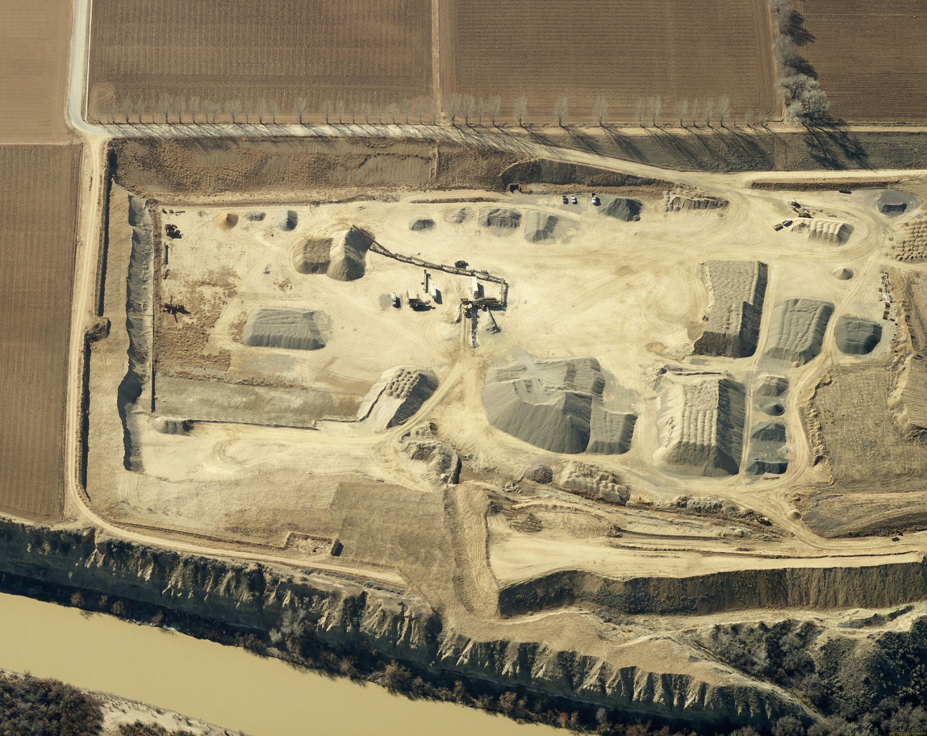11. Natural Resources
Pg 65
Background
The Orchard Mesa planning area contains a wealth of natural resources and amenity values. Most of the neighborhoods benefit from great views of the Grand Mesa, Bookcliffs, and the Colorado National Monument. The area also includes mineral resources, historic and existing drainage channels, wetlands, wildlife habitat, and the Colorado and Gunnison River floodplains.

Mineral Resources
Mineral resources are predominantly upland gravel deposits on both the Colorado River and Gunnison River bluffs as well as floodplain deposits along both rivers. The current, five gravel pits in the area are all outside of the City limits. Some coal deposits exist along the Gunnison River near the Department of Energy facility. These resources are all identified in the County's Mineral and Energy Resources Master Plan and mapped in the Mineral Resources Survey of Mesa County (1978).

As Orchard Mesa grows, the potential for land use conflicts increase between gravel operations and other development. Mineral extraction is regulated by local development codes and the State of Colorado.
Pg 66
MESA COUNTY MINERAL & ENERGY RESOURCES MASTER PLAN

GUIDING GOAL
Create and maintain a balance between present and future Resource development and use.
GOALS (excerpts):
G1. Mesa County will be a leader in the stewardship of natural, social, environmental, and economic assets of Mesa County, which will assure prosperity and quality of life into the future while minimizing impacts of development and use of Resources.
G3. Minimize potential impacts from all exploration, development, and use of Resources on lands, land uses, residents, and communities, recognizing the location of the Resources and current land use patterns.
G4. Protect Resources and existing Resource-related facilities from incompatible land uses.
G5. Minimize potential conflicting land uses that may adversely impair or prevent the exploration, development, and use of commercially valuable Resources, recognizing the location of the Resources and current land use patterns.
G6. Permit Resource development in a safe and environmentally sound fashion.
Geologic Hazards
Evidence of unstable slopes, soil creep and slumping is easily seen along the bluffs of Colorado River. Numerous locations along the Colorado and Gunnison River bluff lines show signs of soil movement and unstable slopes, including some areas where residential development has occurred. In the 1980’s several homes in the Lamplight Subdivision were damaged and ultimately removed due to earth movement sliding towards the Colorado River as shown below.
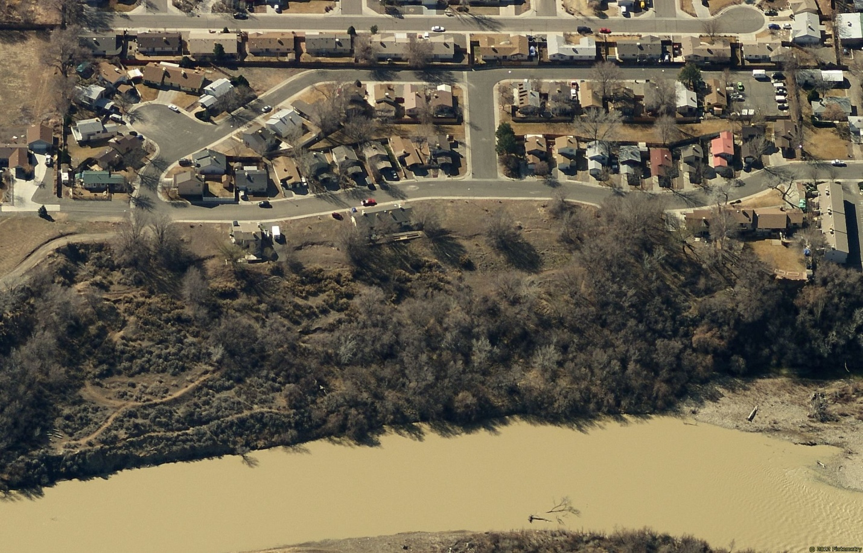
Pg 67
Steep Slopes
(2010 Grand Junction Comprehensive Plan)
… Steep slopes along the Colorado River have a demonstrated history of instability. Dramatic examples include the relocation of several houses on Orchard Mesa to avoid falling into the river…

City and County development codes set forth specific criteria for land use and development activities to avoid hazard areas or mitigate potential impacts. The codes also have standards for development along mapped ridgelines visible from major transportation corridors.
Visual Resources/Air Quality
The Highway 50 corridor is a major entryway to the Grand Junction area and offers visitors and residents their first view of the urban area. The image many people have of Orchard Mesa and the Grand Junction area is based on their experience along this corridor. Orchard Mesa is located above the majority of the urban area and boasts some of the best scenic views of the Grand Valley, the Uncompahgre Plateau, Colorado National Monument, the Bookcliffs and Grand Mesa.
Visual Resources
(2010 Grand Junction Comprehensive Plan)

Scenic resources can be defined as areas of high visual quality. The City of Grand Junction is surrounded by striking environmental features and uncommon scenic quality: from open valleys and irrigated fields to unique and memorable (mesa) landforms…”

Like much of Mesa County, the enjoyment of the night-sky is a high priority for residents of Orchard Mesa. Development codes include specific standards for outdoor lighting in and outside of the Grand Junction City limits.

The Mesa County Board of Health’s advisory body, the Grand Valley Air Quality Planning Committee, studies and addresses air quality issues such as: oil burning furnaces, illegal trash burning, legally permitted open burning, visibility, wood stove use during winter months, vehicle emissions, fugitive dust complaints, neighborhood odor complaints, etc.
Air Quality
(2010 Grand Junction Comprehensive Plan)

An increase in growth brings an increase in factors that impact air quality: motorized vehicle emissions, blowing dust from cleared land, smoke from chimneys, power plants. In the Grand Junction area thermal inversions trap air pollutants in the valley, to some degree, approximately 300 days per year and are most severe during winter months. Comprehensive Plan measures that will help mitigate the air quality impacts of growth include:
- Compact development patterns that reduce travel distances;
- Mixed-use centers that bring shopping closer to residential areas and encourage walking for some needs;
- Planning for transit;
- Expanding the trail system to encourage non-automobile travel; and
- Increasing connectivity to provide more efficient travel routes through the city.
Mesa County Resolution MCM 2002-066, Mesa County Air Pollution Resolution on Open Burning, sets forth direction for air quality protection consistent with Section 25-7-128 of the Colorado Revised Statutes. The County’s resolution provides specific direction for open burning in the designated air shed, prohibited materials, general practices, exemptions, permit requirements, local fire protection agency requirements, and season and timing of burning. Agricultural burning is generally exempt from regulation and the resolution prohibits open burning of residential household trash.

Pg 68
Wildlife
The 100-year floodplains of the Gunnison and Colorado Rivers are designated as critical wildlife habitat by the U.S. Fish and Wildlife Service for several endangered fish species: the Colorado pikeminnow, razorback sucker, bonytail chub, and humpback chub. The western yellow-billed cuckoo is proposed for threatened status. The Colorado hookless cactus, a listed threatened plant is also in the area. Local development codes require minimum setbacks from the Colorado and Gunnison Rivers and consultation with the Colorado Parks and Wildlife and the U.S. Fish and Wildlife Service for input on development near drainages and other wildlife habitat.
2010 Comprehensive Plan Goals and Policies

Goal 10: Develop a system of regional, neighborhood and community parks protecting open space corridors for recreation, transportation and environmental purposes.

Policies:
B. Preserve areas of scenic and/or natural beauty and, where possible, include these areas in a permanent open space system.

Orchard Mesa Natural Resources

Goal 1: Mineral resources are used efficiently while minimizing the impacts to related natural resources and adjacent neighborhoods.

ACTIONS
a. Use the Mesa County Mineral and Energy Resources Master Plan and local and state regulations to determine location of resources and manner of extraction and reclamation.
b. Continue to regulate gravel operations using the Conditional Use Permit process.
c. Collaborate with gravel mining interests to develop innovative approaches to reclamation that will provide wildlife habitat, restoration of native landscapes, recreational opportunities, limited development, and other public values.

Goal 2: The natural environment is preserved including: wetlands, natural drainages, wildlife habitat, river floodplains, steep slopes, geological hazard areas and water quality.

ACTIONS
a. Preserve creeks, floodplains, washes, and drainages through incentives and standards in the applicable development codes.
b. Require sufficient setbacks of all structures from natural and constructed drainages to ensure the preservation of the integrity and purpose(s) [aquifer and water course recharge, wildlife habitat, water quality enhancement, flood control, etc.] of the drainages.
c. Direct landowners of significant wetlands and drainages to seek assistance from the Natural Resource Conservation Service or USDA Farmland Protection Program for the purpose of formulating management plans. Direct landowners to the U.S. Army Corps of Engineers for determine permitting requirements prior to any construction activities.
Pg 69
d. Continue to use Colorado Parks and Wildlife and the U. S. Fish & Wildlife Service as review agencies for proposed development near potentially impacted riparian and other wildlife habitat.
e. Continue to enforce ridgeline and geologic hazard development standards

Goal 3: Visual resources and air quality are preserved.

ACTIONS
a. Develop/distribute Best Management Practices (BMP’s) for mineral extraction, agricultural, and construction operations.
b. Encourage landowners to work with Natural Resource Conservation Service, the County Air Quality staff and Planning Committee, and the Tri-River Extension Service on best management practices for agricultural operations including: alternatives to open burning, and dust minimization during high wind events, etc.
c. Enforce air emission permits (e.g., gravel operations, industrial uses).
d. Work with the County Air Quality Planning Committee on ways to maintain a healthy air quality.
e. Continue to require full cutoff light fixtures on all new development to minimize light spillage outward and upward.
f. Create and distribute informational materials for homeowners and businesses to minimize outdoor lighting while still maintaining needed security.
g. Explore revising development codes to include protection of key view sheds and corridors.
h. Continue to enforce ridgeline development standards.

Pg 70
12. Historic Preservation

Background

Orchard Mesa is rich in history. (Appendix Map 24) Like all of Mesa County, Orchard Mesa was a Ute Indian territory until 1881 when the area was opened for settlement. In that year, George Crawford, the founder of Grand Junction, first viewed the Grand Valley from a point above what is now the Fifth Street Bridge on Orchard Mesa. Before George Crawford and the many pioneers that came to settle the Grand Valley, early Spanish traders and explorers passed through on the way to search for gold, silver and other riches. They came across Orchard Mesa on the Old Spanish Trail Northern Branch from 1829 to 1848. This trail made its way through Mesa County from Santa Fe, New Mexico to Green River, Utah, where it rejoined the main branch of the trail. It was used by early traders, trappers and explorers to trade with the Ute Indians.

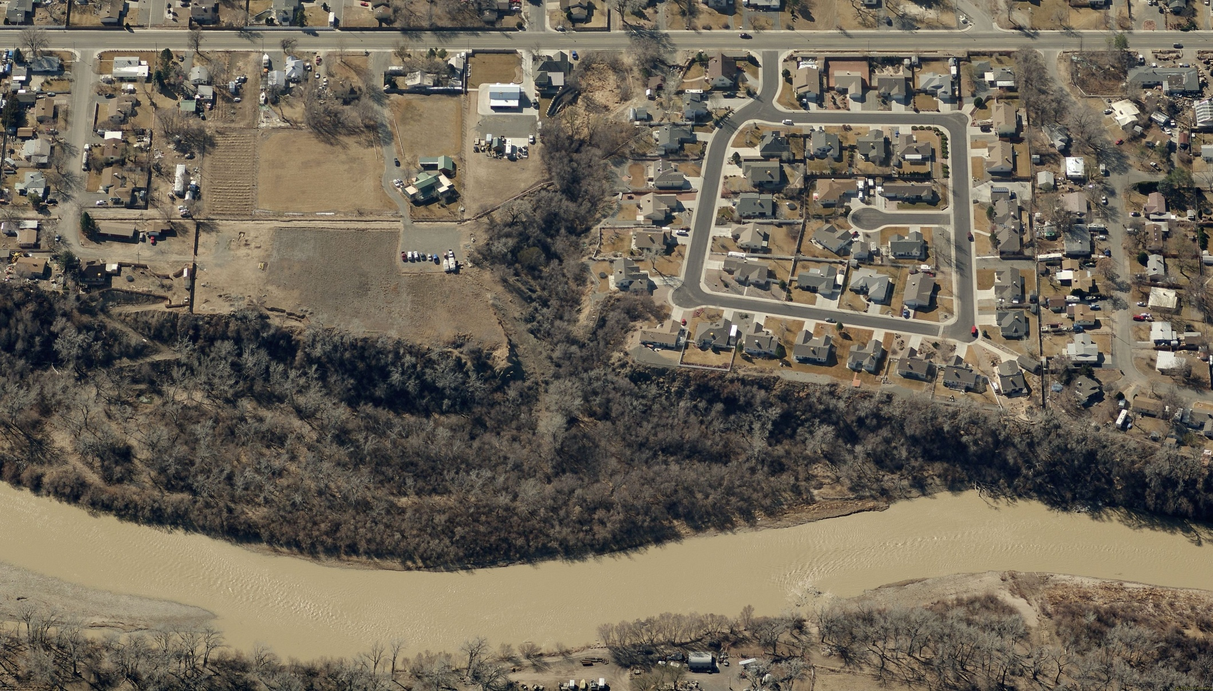The Old Spanish Trail crossed the Colorado River near the present day location of 28 ¾ Road. An historic marker is located along Unaweep Avenue. A seven-mile-long section of a public trail from Whitewater to Orchard Mesa has been designated as an official Retracement Route of the Old Spanish Trail by the National Park Service. The Old Spanish Trail was designated as a National Historic Trail by Congress in 2002.

The Sisters Trails (the Old Spanish Trail & Gunnison River Bluffs Trails) draft report was completed in 2012. Adoption and implementation of the Plan will help to recognize, promote and protect the Old Spanish Trail and Gunnison River Bluffs Trails area by:

- Developing a vision and goals for the area;
- Identifying, surveying and recording trail alignments through the area;
- Identifying trail standards to be used for construction and maintenance;
- 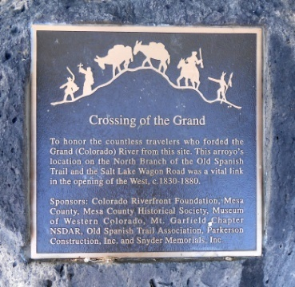Identifying signage standards;
- Identifying funding sources for trail and trailhead development and enhancements:
- Developing a Community Engagement Strategy; and
- Promoting long-term stewardship.
Pg 71
It was from the junction of the Gunnison River and the Grand River (now known as the Colorado River) that George Crawford stood and viewed the location of a new town site. This spot now referred to by locals as “Confluence Point” is under private ownership and has been mentioned for many years as a place that should be set aside with public access.

Orchard Mesa Heights, located at 26 ½ Road and C Road on 120 acres, was the earliest recorded subdivision on Orchard Mesa. It was recorded in 1890 and 1895 and created standard city lots (100 feet by 25 feet), organized on city blocks. There are several older houses remaining in the western portion of Orchard Mesa that characterize the architecture of the late 19th and early 20th centuries, with styles such as Queen Anne, Dutch Colonial, Gothic Revival and Craftsman, as well as simple vernacular farmhouses.
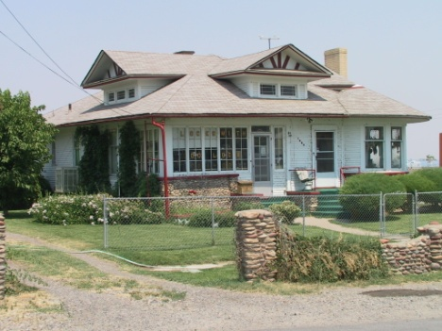
The first orchards were established during the late 1880s. The main crops in order of priority were apples, pears and peaches. The Orchard Mesa Land and Investment Company set out 240 acres with 50,000 fruit trees in 1891. Irrigation water was pumped from the rivers for private use and by the 1920s the US Bureau of Reclamation began a drainage project to solve alkali problems. In the 1920s the Rose Glen Dairy was established on the west end of the mesa by the Clymer family. It became known as Clymer’s Dairy and remained open into the 1990s. The Clymer Residence at 1865 Clymer Way is listed on the Grand Junction Register of Historic Sites, Structures and Districts. In the rural areas, several old barns and agricultural buildings from original farms can still be found.

Modern access to Orchard Mesa has included three bridges spanning the Colorado and Gunnison Rivers. The Fifth Street Bridge was constructed in 1886 and was replaced by a two-lane bridge in 1933. This bridge lasted until 1989 when it was replaced to match the existing two lane southbound bridge constructed years earlier when the volume of traffic warranted four lanes of traffic. The old Black Bridge crossed the Gunnison River, connecting Orchard Mesa with the Redlands area and Glade Park. It was closed to traffic in 1983 due to damage to its stone foundations caused by flood waters and although it was listed on the National Register of Historic Places, it was taken down in September of 1988 by Mesa County. The third bridge, a bridge at 32 Road (State Highway 141) replaced the old Clifton Bridge.

Orchard Mesa’s main road during the late 1800s and early 1900s followed Unaweep Avenue (C Road) through the Four Corners area (29 Road and B ½ Road) and then ran parallel to the Gunnison River to Whitewater along the old Whitewater Hill Road (commonly believed to be part of the Salt Lake Wagon Road/Old Spanish Trail). This route became State Highway 340 until US Highway 50 across Orchard Mesa was established in the 1940s. Along Highway 50, properties such as the Artesian Hotel are typical of the mid-century auto-oriented development that served the traveling public.
Pg 72
Lincoln Orchard Mesa Elementary School, located on B ½ Road near 29 Road, was established in 1895 as the first school built to serve Orchard Mesa. The original building no longer stands, but was utilized as part of the elementary school as recently as the late 1980s.

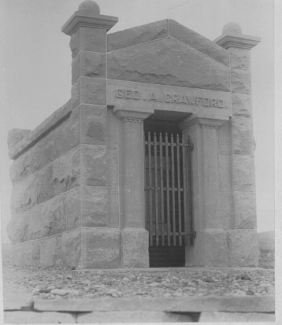The US Department of Energy’s (DOE) site along the Gunnison River was originally established in the 1940s as part of the Manhattan Project. At one time, the site housed two pilot uranium ore milling plants. It later became a leading office involved in restoration of properties contaminated with uranium mill tails. After the Uranium Mill Tailings Remediation Action (UMTRA) was completed in the 1990s, the DOE no longer needed the entire 54-acre site and most of it was transferred to the City and County for use as a business incubator. The DOE continues to house their Legacy properties offices on the site and monitors the site’s groundwater.

The Bannister Cemetery (now a part of the Orchard Mesa Cemetery) was the first cemetery on Orchard Mesa. Now Orchard Mesa is the site of several cemeteries, all of which are located adjacent to one another above the Gunnison River near the Fifth Street hill. They include Potter’s Field, Calvary, Municipal, Orchard Mesa, Veterans, Ohr Shalom, the Oddfellows (I.O.O.F), and Masonic Cemeteries. George Crawford is buried on a hill above the cemeteries; the City continues to work to preserve and enhance the site.
2010 Comprehensive Plan Goals and Policies

Goal 6: Land Use decisions will encourage preservation of existing buildings and their appropriate reuse.

Policies:
A. In making land use and development decisions, the City and County will balance the needs of the community.

Orchard Mesa Historic Preservation

Goal 1: Paleontological, historic and cultural resources that symbolize the area’s identity and uniqueness are retained and preserved.

ACTIONS
a. Efforts shall be made to preserve and protect significant historic, cultural and paleontological resources whenever possible and reasonable.
b. Conduct a comprehensive inventory of historic, cultural and paleontological resources in the planning area in conjunction with the Museum of Western Colorado and other partners.
Pg 73
c. Assist property owners in listing properties on the Grand Junction Register of Historic Sites, Structures and Districts and the Mesa County Register of Historic Landmarks. Provide guidance and technical assistance to help preserve or rehabilitate historic properties.
d. Working in partnership with the Museum of Western Colorado, the Old Spanish Trail Association and other organizations, encourage and support efforts to provide interpretive materials that recognize the history and culture of Orchard Mesa.
e. Include the Old Spanish Trail and other historic sites on Orchard Mesa when promoting the Grand Valley as a place to visit and recreate.
Pg 74
APPENDIX: MAPS

List Maps
- Orchard Mesa Plan Area
- Plan Area Air Photo
- Commercial Industrial Property
- 2010 Future Land Use (as amended, February 2013)
- Zoning – City and County
- Neighborhood Center Future Land Use Changes
- Current Land Use
- Open Lands Overlay District
- Vacant Residential Property Inventory
- Whitewater Hill Recreation and Training Facilities
- Enterprise Zones
- Grand Valley Circulation Plan
- Existing Trails (Sidewalks, Trails, Bike Lanes, Bike Routes)
- Neighborhood Center Circulation Concept Plan
- Highway 50 Corridor Circulation Concept Plan
- Utilities – Sewer Service
- Utilities – Water Service
- Orchard Mesa Irrigation District
- Utilities – Electric
- School attendance areas
- Fire Districts
- Flood Inundation Study – 100 Year area
- Floodplain
- Historic Resource Map

Pg 75
