RESOLUTION NO. 68-09

A RESOLUTION APPROVING THE SERVICE PLANS AND INTERGOVERNMENTAL AGREEMENTS FOR 29 AND D METROPOLITAN DISTRICT NO. 1 AND NO. 2

Recitals:
On July 27, 2009, a service plan was filed with the City of Grand Junction with a request to approve a service plan for 29 and D Metropolitan District No. 1 (“District No. 1”) and a service plan for 29 and D Metropolitan District No. 2 (“District No. 2”).
Upon review of the service plans and after public hearing, it appears that each meets the requirements of the Special District Act, Part 2 of Article 1 of Title 32, of the Colorado Revised Statutes (“Act”).
The service plans with the formation of the districts will provide for the financing of construction and installation of public improvements within the service plan areas (District No. 1 for residential uses and District No. 2 for commercial/industrial uses).
NOW, THEREFORE, BE IT ORDAINED BY THE CITY COUNCIL OF THE CITY OF GRAND JUNCTION, COLORADO:
Upon consideration of the service plans for 29 and D Metropolitan District No. 1 (“District No. 1”) and for 29 and D Metropolitan District No. 2 (“District No. 2”), the City Council finds:
(a) That the terms of each service plan contains the information required pursuant to the Act;
(b) That the City Council held a public hearing after proper notice was duly published and mailed in accordance with the Act;
(c) That there is sufficient existing and projected need for organized service in the area to be serviced under the service plans;
(d) The existing service in the area to be served is inadequate for present and projected needs;
(e) The special districts are capable of providing economical and sufficient service to the area within its proposed boundaries;
(f) The area included in the special districts has, or will have, the financial ability to discharge the proposed indebtedness on a reasonable basis;
(g) The Districts are wholly located within the boundaries of the City of Grand Junction and general descriptions of the boundaries of the areas are:

See the attached Exhibit “A” incorporated herein for District No. 1 and the attached Exhibit “B” incorporated herein for District No. 2.

The service plans and intergovernmental agreements for the District are hereby approved.

PASSED and ADOPTED this 17th day of August 2009.

/s/ Bruce Hill
Attest: President of the Council

/s/ Stephanie Tuin
City Clerk

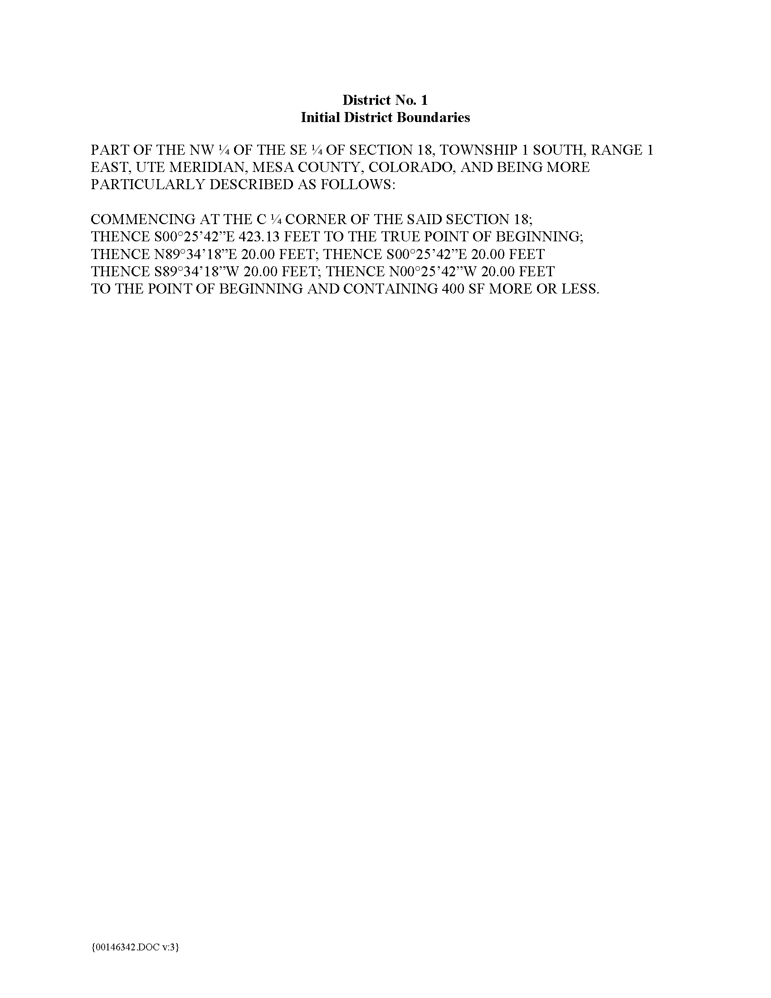
Exhibit A

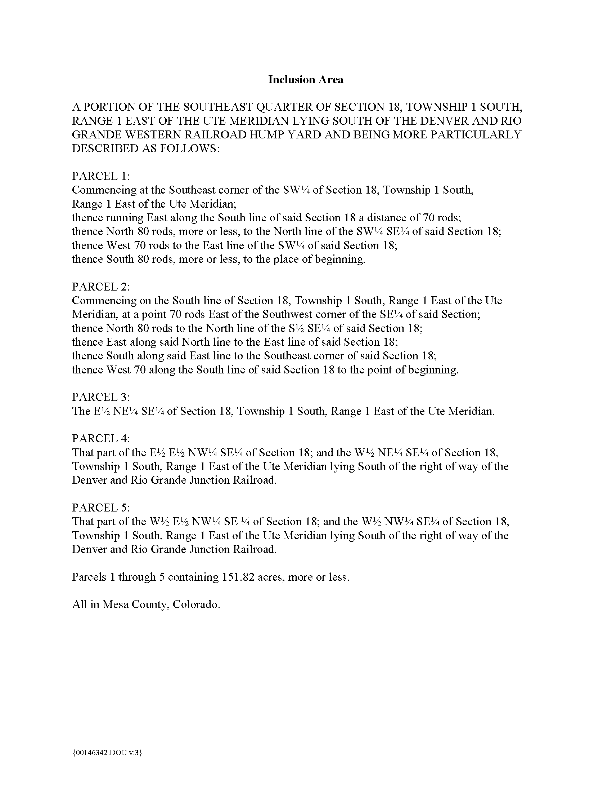

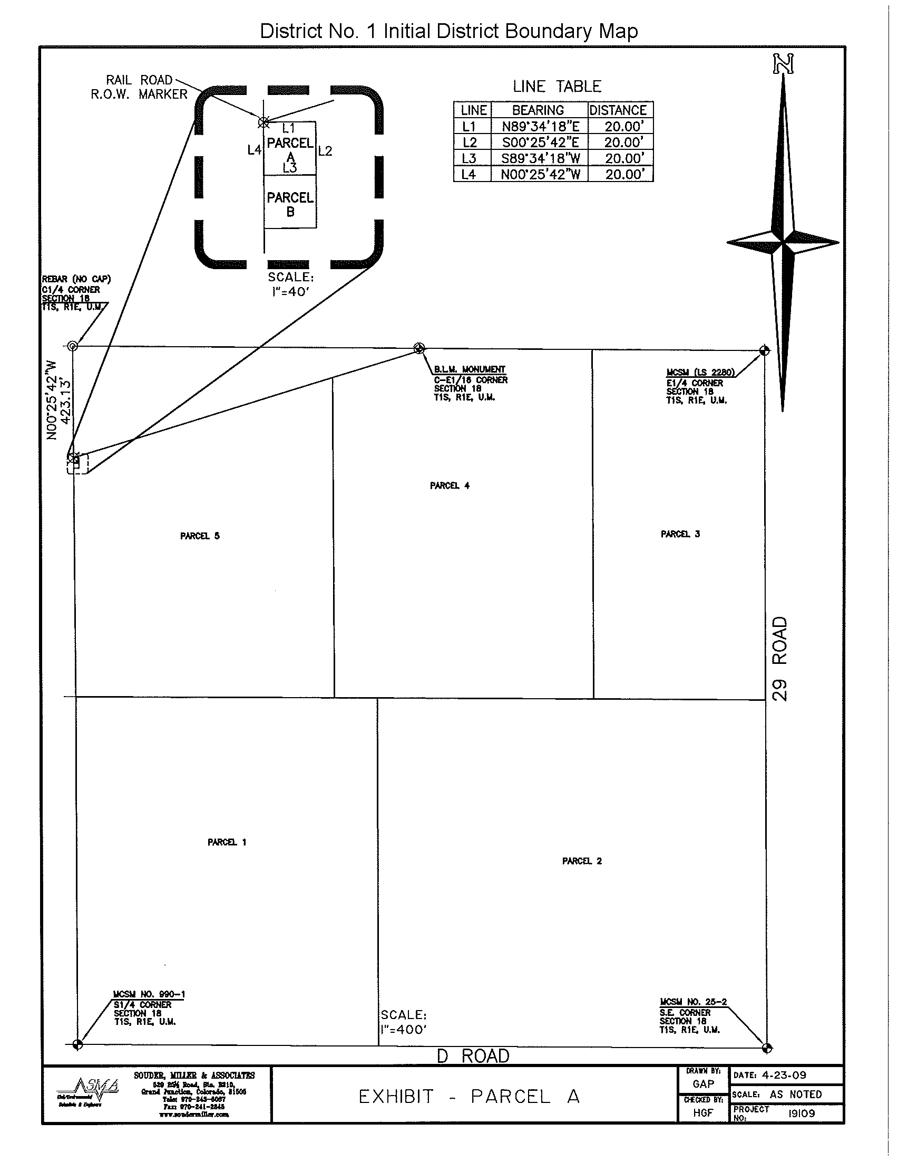

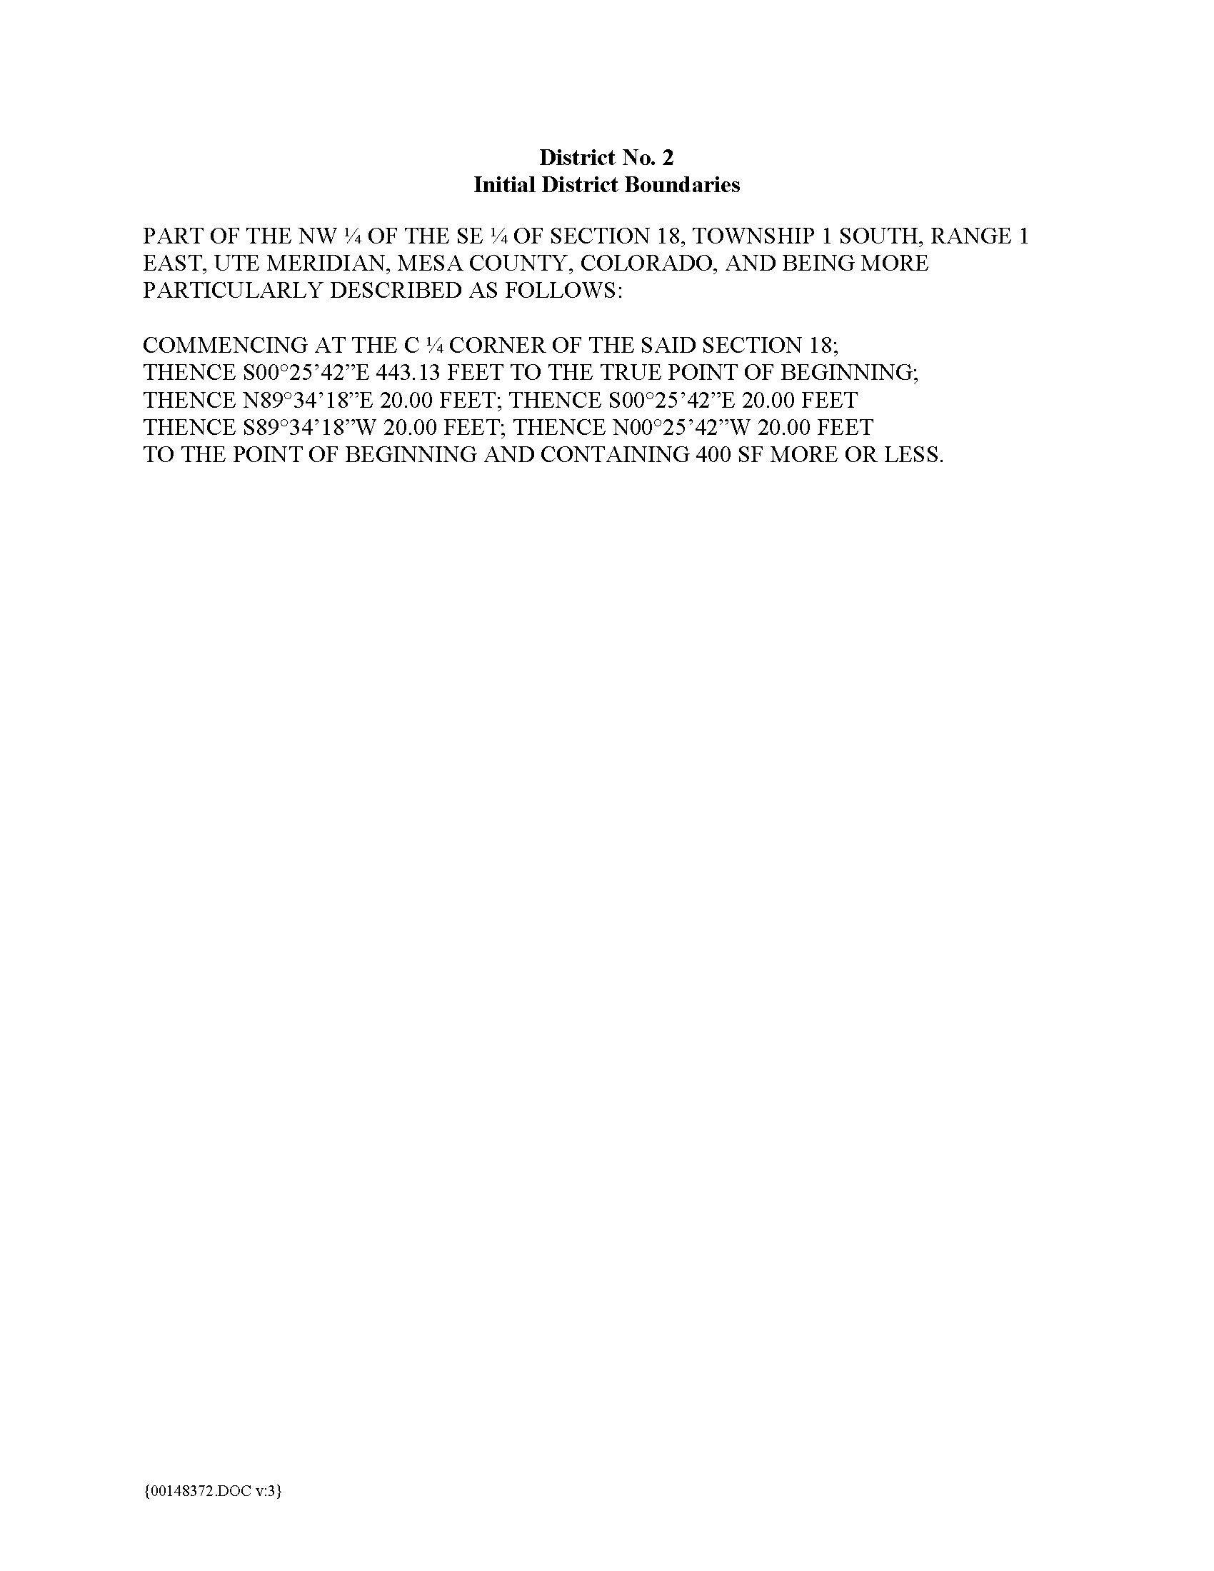
EXHIBIT B

