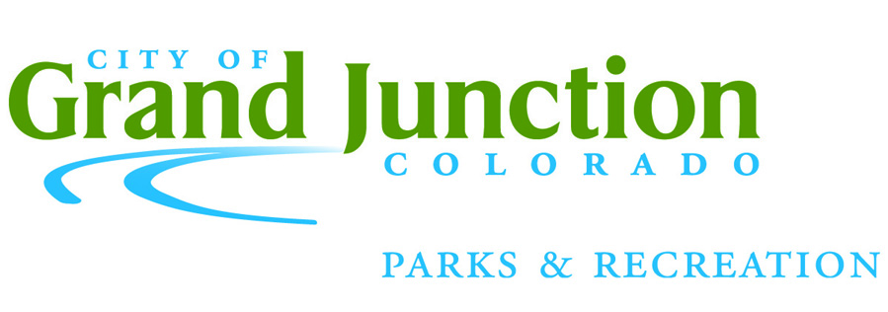 |  | Commercial Use Application  1340 Gunnison Ave., Grand Junction, CO 81501 • 970-254-3866 parksandrec@gjcity.org
Today’s Date |  | Organization/Business Name
Contact Name |  |  |  | Email
Mailing Address
Phone #1 |  |  | Phone #2 |  |  |  | Effective Date (permit will be valid 365 from this date)
What type of business will you be conducting, or service will you be providing?

In which park(s) would you like to conduct this business?
Blue Heron Boat Ramp  Canyon View  Columbine  Dos Rios  Dos Rios Bike Park  Duck Pond (OM)  Eagle Rim | Emerson (See Tier 3)  Hawthorne (See Tier 3)  Las Colonias  Las Colonias Boat Ramp  Lincoln Park  Lincoln Park Pool  Matchett |  |  |  | Orchard Mesa Pool  Pomona  Riverfront Trails  Riverside  Rocket  Sherwood |  |  | Tabeguache Trailhead  (Lunch Loops Parking)  Westlake  Whitman (See Tier 3)  Other___________________
How many hours per week will you use the park(s)?

Please describe your typical schedule?
How many clients per day or students per class do you expect?

Tier  Examples: Bike rentals, Personal Trainers, Photographers, Instructors, Yoga, Workshops |  |  |  |  |  | Daily Fee |  |  | Annual Fee  (365 days from issue date)
Tier 1: 5 or less participants annually. |  |  |  |  |  | $25 |  |  | $300
Tier 2: 6 or more participants annually. |  |  |  |  |  | $40 |  |  | $500
Tier 3: “Downtown” Permit for use of Emerson, Hawthorne and Whitman only |  |  |  |  |  | No charge |  |  | $25
By signing below, I verify that all the above information is true. I have also read and agree to comply with the following terms and conditions:

- Liability Insurance: Supply the City of Grand Junction with a proof of insurance certificate naming the City as an additional insured on the policy. Coverage must be Comprehensive General Liability insurance coverage with unimpaired combined single limits of at least $1,000,000 per person and $1,000,000 in the aggregate. The certificate must be received once the application is approved and before the permit is issued. The issuance of a proof of insurance certificate is a formal process on the part of the Lessee’s insurance company and must be sent directly from the insurer to the Grand Junction Parks and Recreation Department. Copies made by the Lessee are not valid.
- Payment: Once the application is approved the full fee is to be paid before the Commercial User Permit is issued.
- The Commercial Use Permit must be with you at all times.
- The Commercial Use Permit does not entitle you to exclusive use of any facility. If exclusive use is needed a separate facility use permit must be obtained from Grand Junction Parks and Recreation. Fees may apply.
- The Commercial Use Permit does not include any storage of equipment or supplies.

Signature: Date:

