CITY OF GRAND JUNCTION

RESOLUTION NO. 68-04

A RESOLUTION VACATING A SPECIFIC AREA OF A MULTI-PURPOSE EASEMENT
AND A UTILITY AND PEDESTRIAN ACCESS EASEMENT
EQUATING TO THE AREA OF A RESIDENTIAL ENCROACHMENT LOCATED AT 1914 PALMER STREET

RECITALS:

The applicant proposes to vacate a specific area of a 25’ multi-purpose easement dedicated by plat in Plat Book 18 Page 268 and a specific area of an 80’ utility & pedestrian access easement described in Book 2103 Page 771. The described easements cross Lot 1 of the Jordan Subdivision. There are no utilities in the area requested to be vacated.

At its July 13, 2004 hearing the Grand Junction Planning Commission found that the request satisfies the review criteria set forth in Section 2.11.C of the Zoning and Development Code and recommended approval conditioned upon the approval of the Utility Coordinating Committee (UCC) for that portion of the 80’ utility and pedestrian access easement. The UCC gave its approval on July 14, 2004.

NOW, THEREFORE BE IT RESOLVED BY THE CITY COUNCIL OF THE CITY OF GRAND JUNCTION THAT:

The City Council finds that the vacation request meets the criteria set forth in Section 2.11.C of the Grand Junction Zoning and Development Code and in accordance therewith the following described areas of the easements are hereby vacated:

Multi-Purpose Easement Vacation

Legal Description

The following described portion of that certain Multi-Purpose Easement, as depicted, located upon Lot 1 of Jordan Subdivision, situate in the Northwest ¼ of the Northeast ¼ (“NW ¼ NE ¼”) of Section 26, Township 1 South, Range 1 West of the Ute Meridian, City of Grand Junction, County of Mesa, State of Colorado, as recorded in Plat Book 18 at Page 268 in the office of the Mesa County Clerk and Recorder, being more particularly described as follows:

Commencing at the Southwest corner of Lot 1 of Jordan Subdivision, and considering the South boundary line of Lot 35, Block 21 of Orchard Mesa Heights, as recorded in Plat Book 1 at Page 16 in the office of the Mesa County Clerk and Recorder, to bear N 88º36’22” W as shown on that certain Boundary Survey prepared by DH Surveys Inc., and deposited with the office of the Mesa County Surveyor on March 28, 1995, in Book 1 at Page 32, Reception No. 1170-95, with all other bearings contained herein being relative thereto; thence N 00º38’00” E along the West boundary line of Lot 1 of said Jordan Subdivision a distance of 33.80 feet to the intersection of the West boundary line of said Lot 1 with the Southerly boundary line of an existing Multi-Purpose Easement as dedicated with the recorded Plat of said Jordan Subdivision; thence leaving the West boundary line of said Lot 1 and along the Southerly boundary line of said existing Multi-Purpose Easement, S 86º56’33” E a distance of 21.02 feet to the True Point of Beginning; thence leaving the Southerly boundary line of said existing Multi-Purpose Easement, N 00º00’38” E a distance of 2.60 feet; thence along a line which is parallel with and 11.20 feet South of the North boundary line of said Lot 1, S 88º35’24” E a distance of 40.30 feet; thence S 00º00’38” W a distance of 3.76 feet to a point on the Southerly boundary line of said existing Multi-Purpose Easement; thence N 86º56’33” W along the Southerly boundary line of said existing Multi Purpose Easement a distance of 40.33 feet to the Point of Beginning, containing 128.15 square feet, more or less, as described.

Utility Easement and Pedestrian Access Vacation

Legal Description

The following described portion of that certain Utility Easement and Pedestrian Access created by City of Grand Junction Ordinance No. 2775, as depicted on Exhibit B, recorded in Book 2103 at Page 771 in the office of the Mesa County Clerk and Recorder, located upon Lot 1 of Jordan Subdivision, situate in the Northwest ¼ of the Northeast ¼ (“NW ¼ NE ¼”) of Section 26, Township 1 South, Range 1 West of the Ute Meridian, City of Grand Junction, County of Mesa, State of Colorado, as recorded in Plat Book 18 at Page 268 in the office of the Mesa County Clerk and Recorder, being more particularly described as follows:

Commencing at the Southwest corner of Lot 1 of Jordan Subdivision, and considering the South boundary line of Lot 35, Block 21 of Orchard Mesa Heights, as recorded in Plat Book 1 at Page 16 in the office of the Mesa County Clerk and Recorder, to bear N 88º36’22” W as shown on that certain Boundary Survey prepared by DH Surveys Inc., and deposited with the office of the Mesa County Surveyor on March 28, 1995, in Book 1 at Page 32, Reception No. 1170-95, with all other bearings contained herein being relative thereto; thence N 00º38’00” E along the West boundary line of Lot 1 of said Jordan Subdivision a distance of 8.00 feet; thence leaving the West boundary line of said Lot 1 and along a line which is parallel with and 8.0 feet North of the South boundary line of said Lot 1, S 88º35’24” E a distance of 21.00 feet to the True Point of Beginning; thence along a line which is parallel with and 21.00 feet East of the West boundary line of said Lot 1, N 00º38’00” E a distance of 27.80 feet; thence along a line which is parallel with and 11.20 feet South of the North boundary line of said Lot 1, S 88º35’24” E a distance of 40.30 feet; thence leaving said line, S 00º38’00” W a distance of 27.80 feet; thence along a line which is parallel with and 8.0 feet North of the South boundary line of said Lot 1, N 88º35’24” W a distance of 40.3 feet to the Point of Beginning, containing 1,120.23 square feet, more or less, as described.

PASSED and ADOPTED this 4th day of August, 2004.

ATTEST:

/s/ Stephanie Tuin /s/ Bruce Hill
City Clerk President of City Council
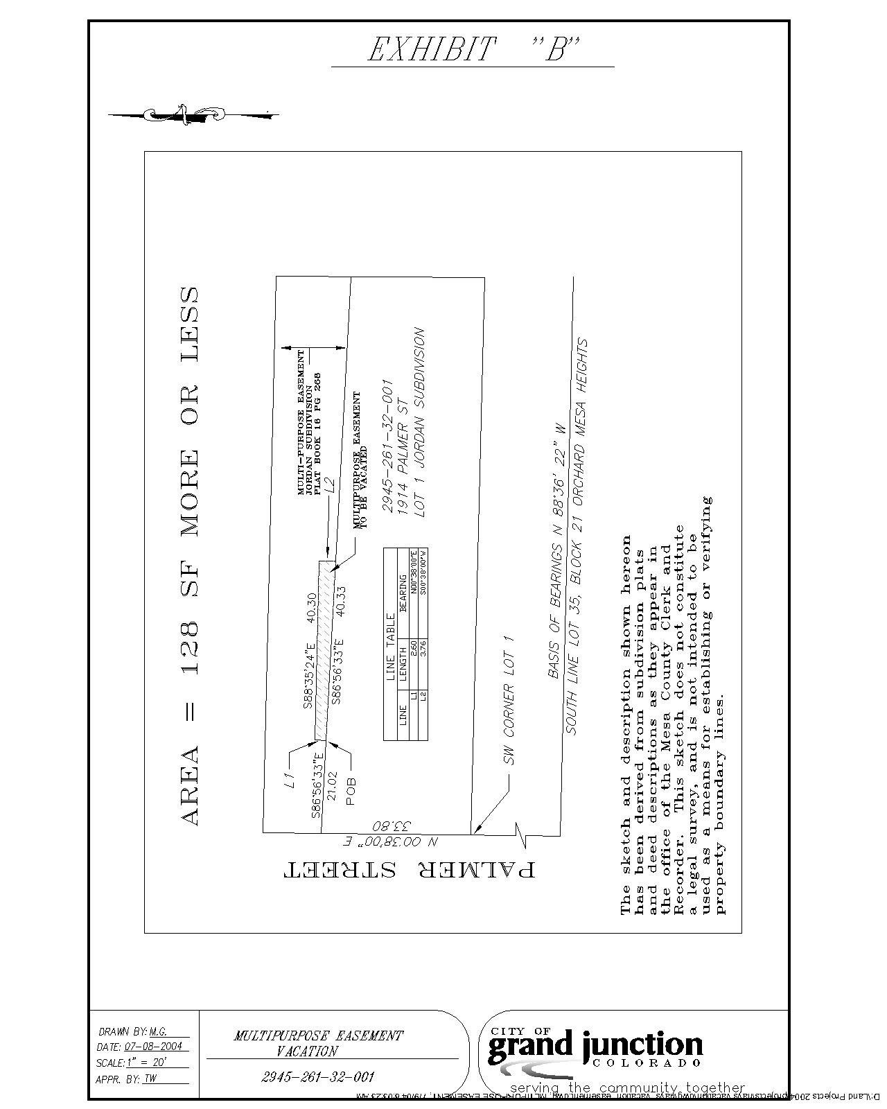
“A”
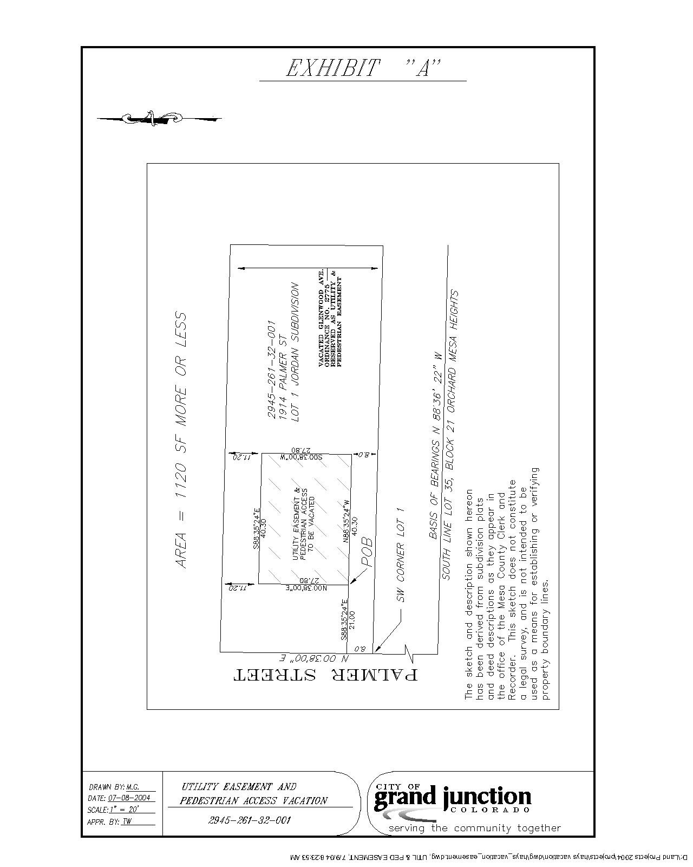

“B”

