MCC# 94-115 GJCC# 56-94
RESOLUTION

A JOINT RESOLUTION OF THE COUNTY OF MESA AND THE CITY OF GRAND JUNCTION CONCERNING ADOPTION OF THE FISCAL YEAR 1995 UNIFIED PLANNING WORK PROGRAM AND THE FISCAL YEARS 1995-2000 TRANSPORTATION IMPROVEMENT PLAN

WHEREAS, The City and County have been designated by the Governor as the Metropolitan Planning Organization for the Grand Junction/Mesa County Urbanized Area; and

WHEREAS, Part 2 of Article 1 of Title 29, Colorado Revised Statutes authorizes the parties to contract with one another to make the most efficient and effective use of their powers and responsibilities; and

WHEREAS, The City and County realize the importance of both short and long range planning in the development of an efficient transportation system, and are both aware that it is the responsibility of the Metropolitan Planning Organization to perform those planning functions; and

WHEREAS, The City and County, in their performance of those planning functions for the Urbanized Area, wish to use Federal Highway Administration transportation planning funds in coordination with the Colorado Department of Transportation;

NOW, THEREFORE, BE IT JOINTLY RESOLVED BY THE BOARD OF COUNTY COMMISSIONERS OF THE COUNTY OF MESA, COLORADO AND THE CITY COUNCIL OF THE CITY OF GRAND JUNCTION, COLORADO:

That the Fiscal Year 1995 Unified Planning Work Program, and the Fiscal Years 1995-2000 Transportation Improvement Plan, hereunto attached, were adopted by the Board of County Commissioners of the County of Mesa, Colorado on June 28, 1994, and by the City Council of the City of Grand Junction, Colorado on July 6, 1994.

CITY OF GRAND JUNCTION COUNTY OF MESA

/s/ R.T. Mantlo /s/ John Crouch
President of the Council Chairman of the Board
Grand Junction City Council Mesa County Board of Commissioners

6th day of July, 1994 28th day of June, 1994

Attest: Attest:
/s/ Stephanie Nye /s/ Monika Todd
City Clerk County Clerk

FY 1995

UNIFIED PLANNING WORK PROGRAM

FOR THE

GRAND JUNCTION/MESA COUNTY URBANIZED AREA

Prepared by the

Grand Junction/Mesa County Area Metropolitan Planning Organization

and the

Colorado Department of Transportation,
Program Management Branch

In cooperation with the
U.S. Department of Transportation,
Federal Highway Administration

June, 1994

TABLE OF CONTENTS

Introduction 2

Summary of the Budget 5

UPWP Work Tasks 8

Tables

Summary of the Budget - Table 1 5

UPWP Task Costs - Table 2 7

Figures

Transportation Planning Terminology - Figure 1 1

Urbanized Area Map - Figure 2 3

MPO Local Review Process - Figure 3 4

Task Schedule - Figure 4 16

Figure 1

TRANSPORTATION PLANNING TERMINOLOGY

Air Quality Control Commission AQCC

Annual Element AE

Colorado Department of Transportation CDOT

U.S. Department of Transportation DOT

Federal-Aid Highway Program Manual FHPM

Federal Highway Administration FHWA

Federal Transportation Administration FTA

Fiscal Year for the MPO FY

Highway Planning and Research Funds HPR

Intermodal Surface Transportation Act ISTEA

Metropolitan Planning Organization MPO

FHWA planning funds made available through CDOT to the MPO PL Funds

FTA funds made available through CDOT
to the MPO Section 8 Funds
Section 9 Funds
State Implementation Plan SIP

Title VI of the U.S., Civil Right Act of 1964,
as amended Title VI

Transit Development Plan TDP

Transportation Improvement Plan TIP

Transportation Policy Advisory Committee TPAC

Transportation Technical Advisory Committee TTAC

Unified Planning Work Program UPWP

Urban Transportation Planning Process UTPP

Vehicle Miles Traveled VMT
Introduction

INTRODUCTION

The Unified Planning Work Program describes planning tasks and personnel costs and budget funds for the Fiscal Year 1995 running from October 1, 1994 through September 30, 1995.

The Metropolitan Planning Organization (MPO), composed of Grand Junction and Mesa County elected officials and staff, coordinates this planning with state officials from the Colorado Department of Transportation (CDOT) and the Colorado Health Department who, through the Air Quality Control Commission, is charged with protecting air quality throughout Colorado. The ultimate goal of this planning process is an efficient, effective transportation system.

To further the continuing, comprehensive, and cooperative planning for the Grand Junction Urbanized Area (Fig. 2), the Federal Highway Administration provides PL funds to the MPO under the administration of the CDOT. The 1995 PL allocation is $59,784. PL funds are matched at a 17.21% ratio by the MPO members. Thus, for every $100 expended by the MPO on approved tasks, $82.79 will be reimbursed by PL funds up to the budgeted amount. The MPO plans to program $59,784 of the available PL funds in FY 1994. The MPO also plans to program $18,976 of Section 8 monies, and $20,000 of HPR monies. These funds are matched at a 20.0% ratio by the MPO members. The MPO proposes to spend a total of $120,932 including local match, on transportation related tasks contained in the FY 1995 Unified Planning Work Program.

The CDOT, as the Contract Administrator, monitors the timely accomplishment of tasks and the reimbursement process. In addition, the CDOT actively participates in the planning process through the provision of technical services. (See Figure 3 for the MPO structure.)

The current local operational structure allows for the maximum funding to be channeled to local City and County agencies, through the Transportation Technical Advisory Committee (TTAC) and Transportation Policy Advisory Committee (TPAC), to provide staff and resources for completion of the various tasks. The MPO continues to shift much of the administrative activity associated with each task (development, implementation and monitoring) into the task budget itself. This allows the MPO Administrator to focus on required documents, annual certification and overall policy development for the agency and direct more dollars to actual studies and activities.

The Supervisor of the Mesa County Public Works Department currently serves as the MPO Administrator. It is proposed, for FY 1995, to hire a full time MPO Administrator to perform administrative functions and perform work directly supporting the task elements of the FY 1995 UPWP. This office is the "single point-of-contact" between MPO agencies, state and federal officials. The technical operational agencies assume an active role in developing, implementing and monitoring the program tasks. The MPO Administrator provides technical support and performs the managerial tasks necessary for the MPO to comply with state and federal requirements. Program goals call for continued support of planning, monitoring and implementation tasks, and minimum administrative overhead. The local MPO's approach to this UPWP should accomplish those goals.

FIGURE 2

URBANIZED AREA MAP
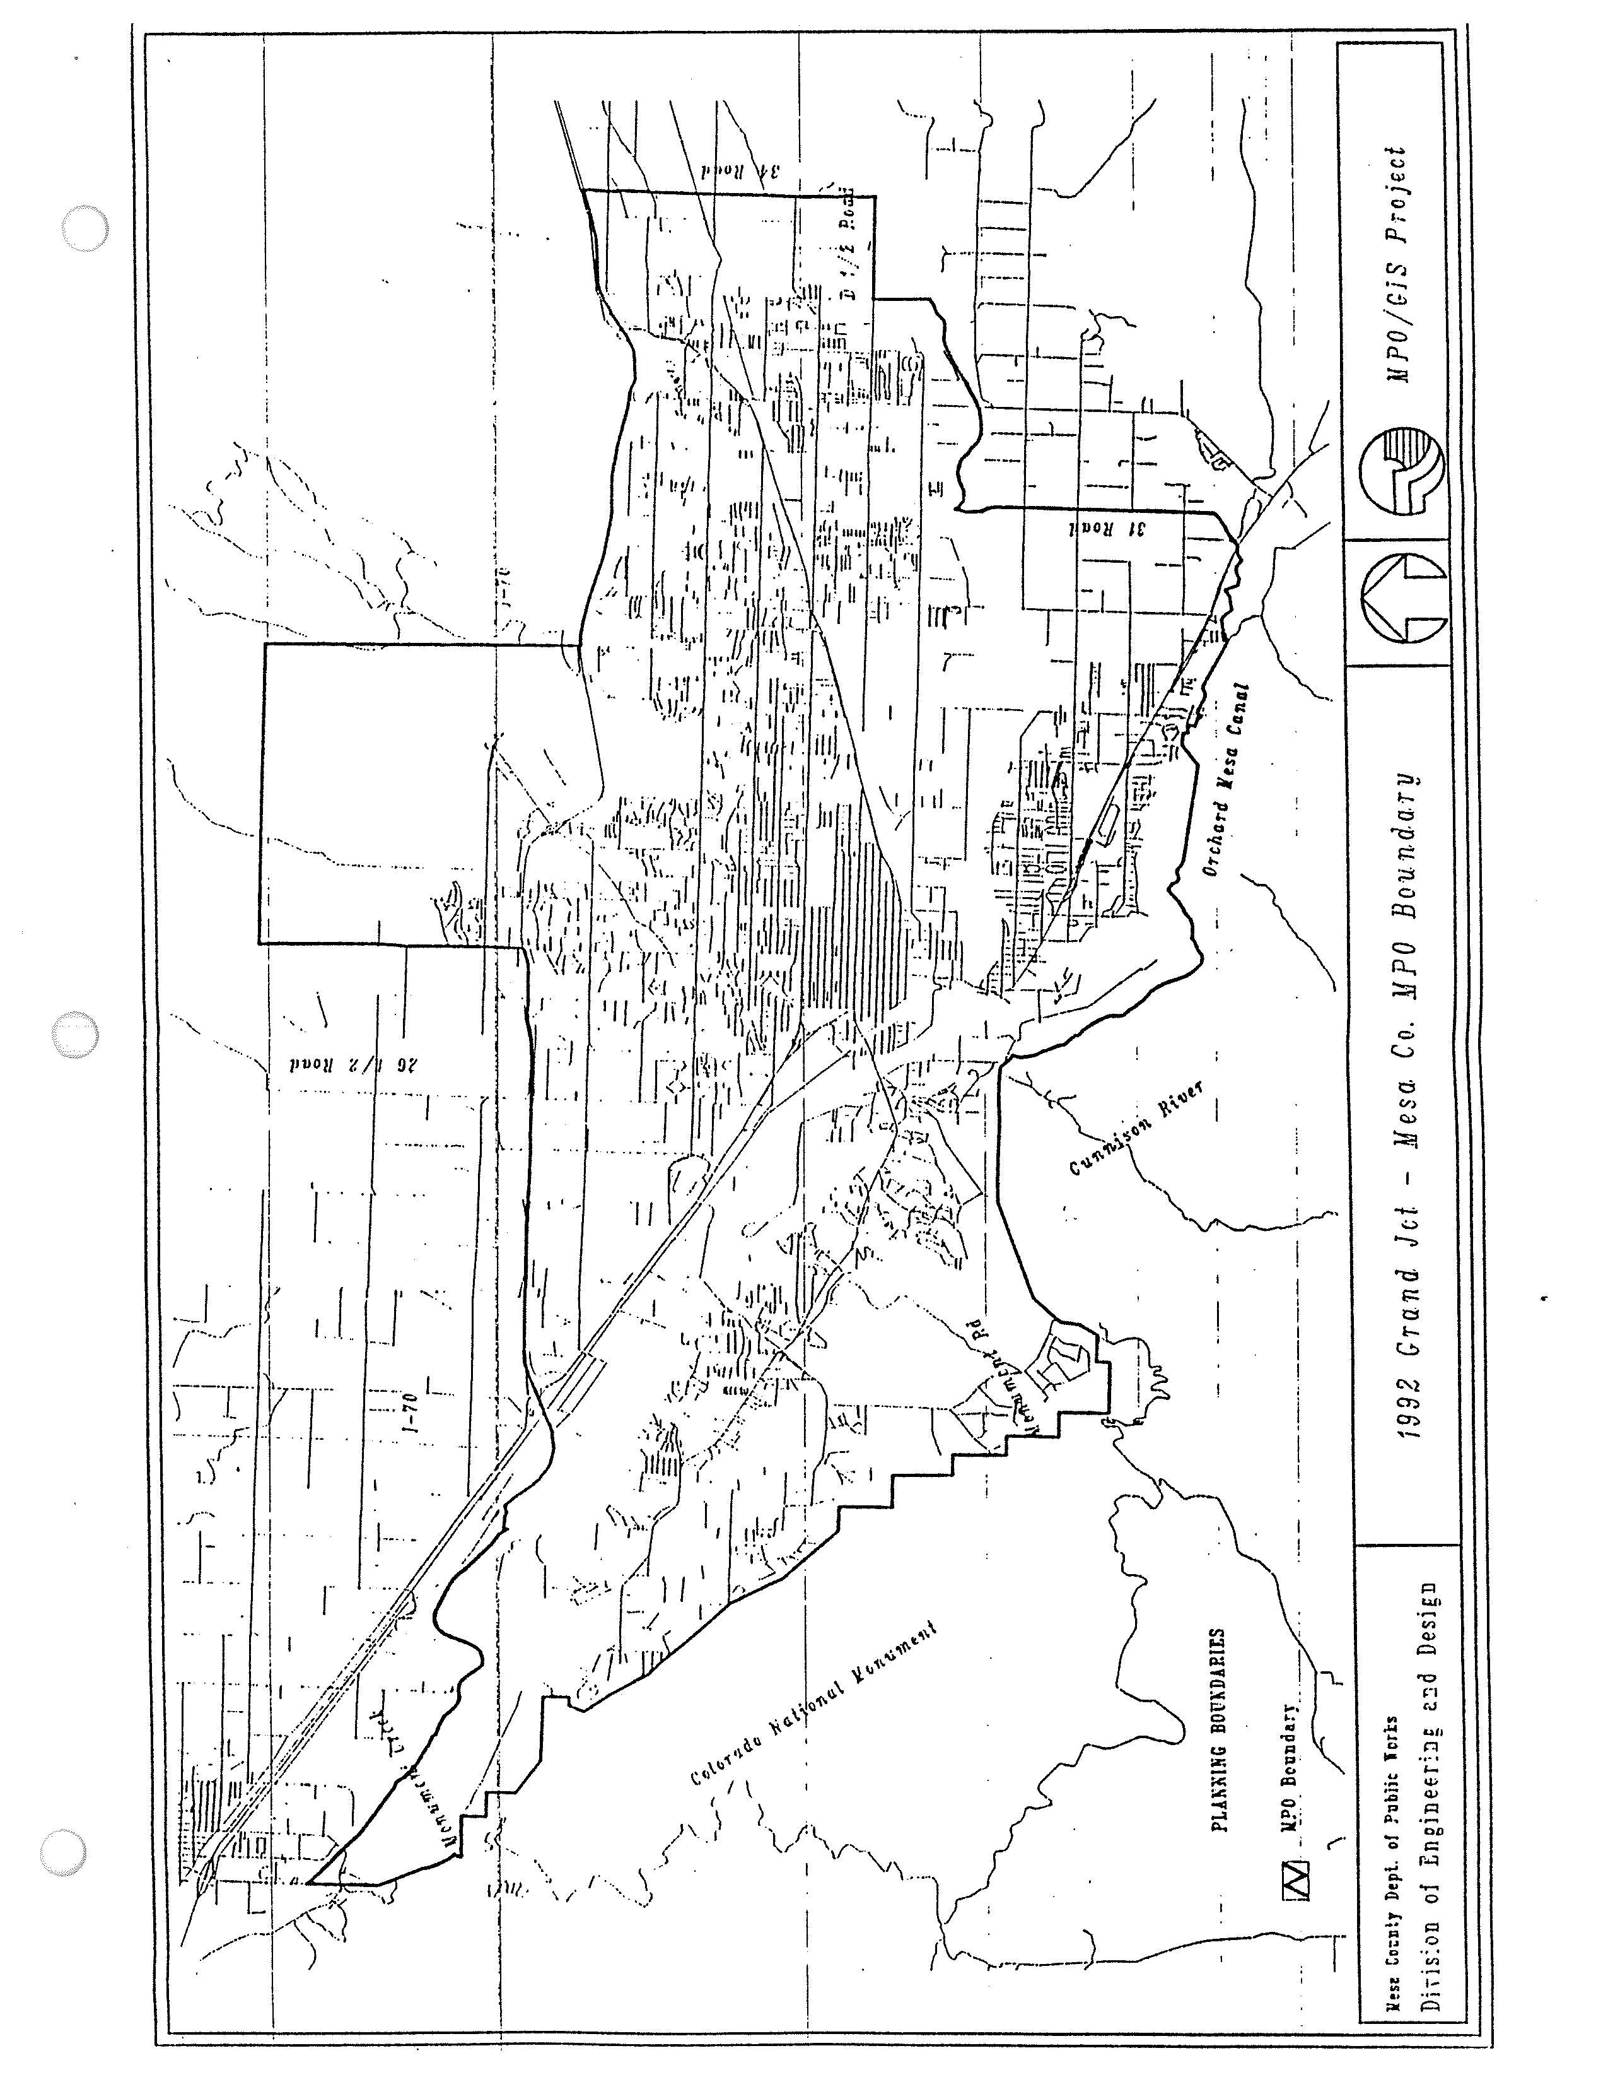

FIGURE 3 - ORGANIZATIONAL STRUCTURE 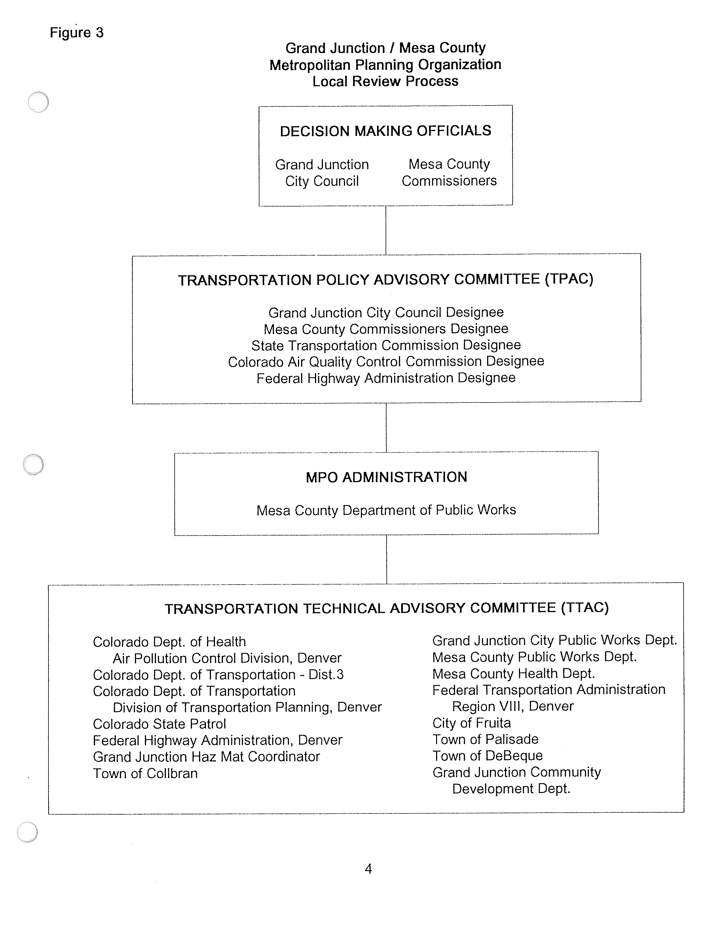
Summary of the Budget

For FY 1995 it is proposed that $120,932, be expended by the MPO on transportation planning. Of that amount $22,172 would be the required match from Grand Junction, Mesa County and other local sources. Federal Highway Administration funds and Federal Transportation Administration funds passed through the Colorado Department of Transportation, would provide $98,760. A breakdown of these funds by task group and agency is shown below.

Table 1

TASK | LOCAL MATCH | PL FUNDS | HPR FUNDS | SEC 8 FUNDS | SEC 9 FUNDS | TOTAL
Management | 4,449.00 | 21,401.00 |  |  |  | 25,850.00
Monitoring | 3,933.00 | 18,917.00 |  |  |  | 22,850.00
Planning | 13,080.00 | 16,051.00 | 20000.00 | 18,976.00 |  | 68,107.00
Implementation | 215.00 | 1,035.00 |  |  |  | 1,250.00
Services | 495.00 | 2,380.00 |  |  |  | 2,875.00
Totals | 22,172.00 | 59,784.00 | 20,000.00 | 18,976.00 |  | 120,932.00
Local Mach Summary
PL Local Match | 12,428.00
HPR Local Match | 5,000.00
Sec 8 Local | 4,744.00
FUNDING BREAKDOWN
PL / HPR / Section 8 Funds / Section 9 Funds  Mesa County Funds  City of Grand Junction Fund |  | $98,760.0011,086.0011,086.00
Total |  | $ 120,932.00
State

SOURCE OF FUNDS

FUNDING SOURCE |  |  |  | AMOUNT | PROGRAMMED FOR 1995
1993 PL Allocation: |  |  |  | $ 59,784.00 |  |  |  | $ 59,784.00
Local Match |  |  |  | 12,428.00 |  |  |  | 12,428.00
PL Funds Available |  |  |  | $ 72,212.00 |  |  |  | $ 72,212.00
HPR Funds:  Section 8 funds: |  |  | $20,000.00  18,976.00 |  |  |  | $20,000.00 18,976.00
Total Other Funds |  |  | $ 38,976.00 |  |  |  | $ 38,976.00
Local Match |  |  | 9,744.00 |  |  |  | 9,744.00
Other Funds Available |  |  | $ 48,720.00 |  |  |  | $ 48,720.00
TOTAL FUNDS AVAILABLE |  |  | $ 120,932.00 |  |  |  | $ 120,932.00

These amounts are further broken down in table 2 by task and agency.

Table 2 - UPWP TASK COSTS
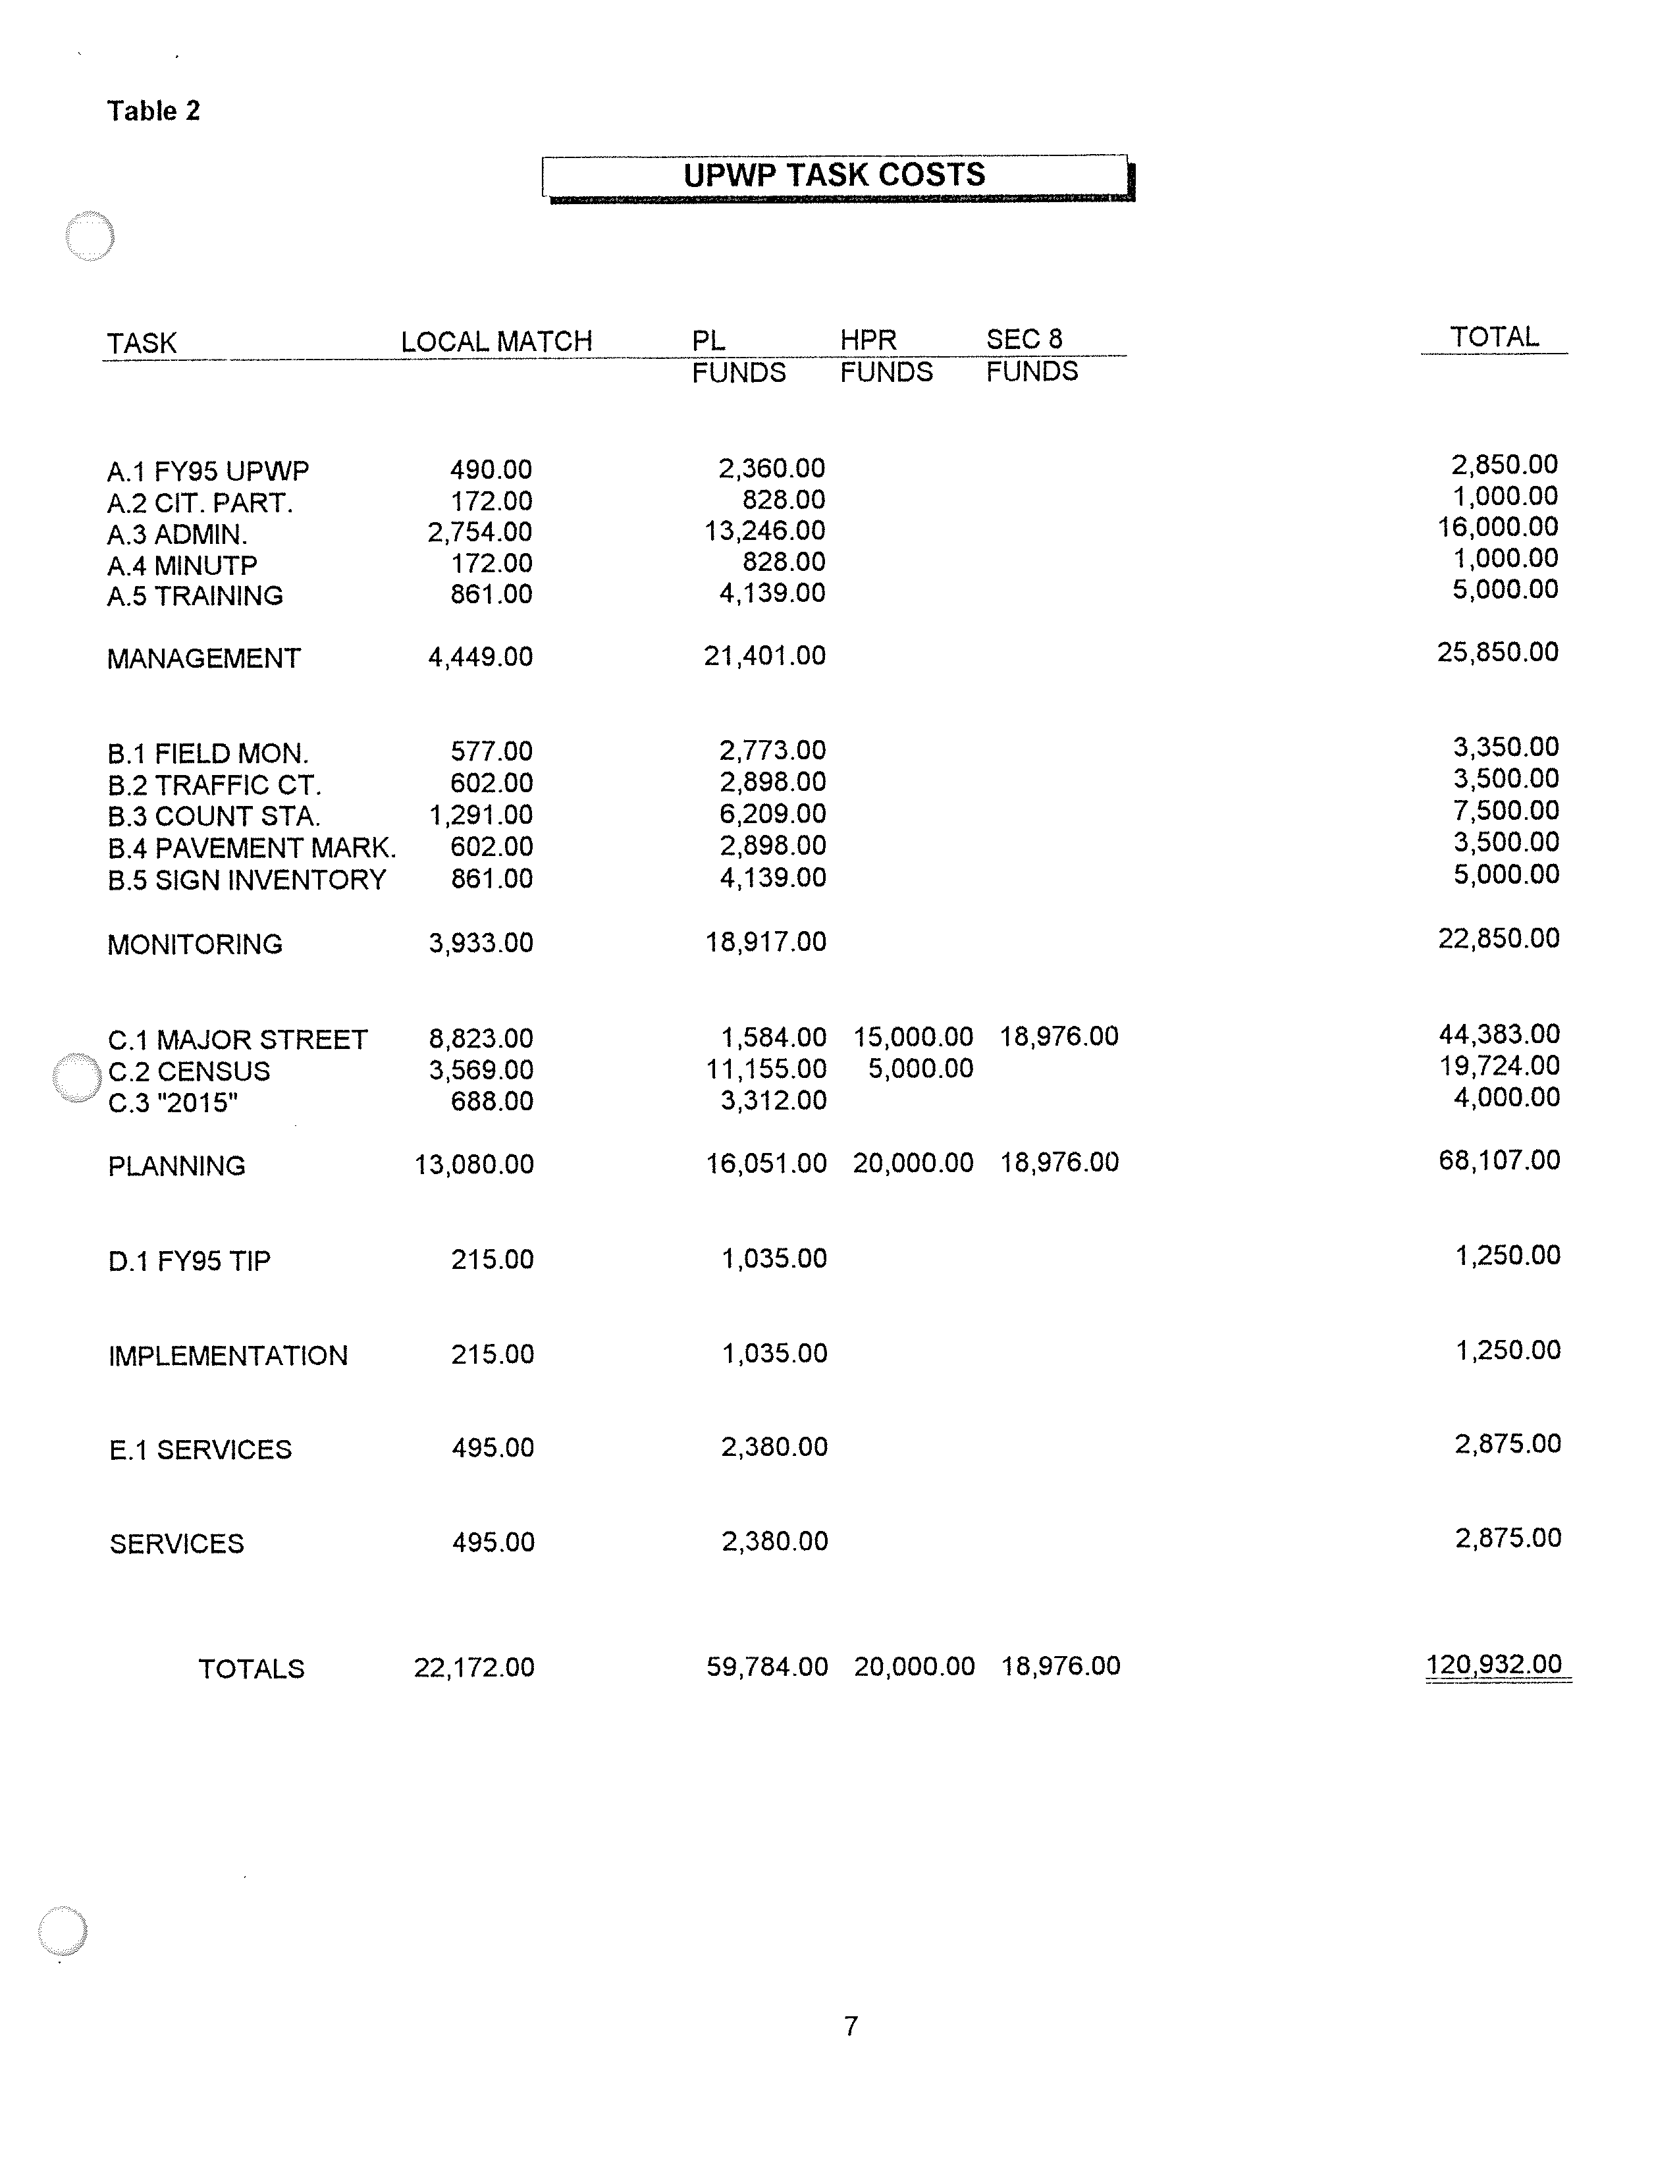

GRAND JUNCTION / MESA COUNTY MPO

UPWP Work Tasks

The major portion of this document consists of work tasks to be completed during Fiscal Year 1995 (October 1, 1994 to September 30, 1995). These work tasks are intended to monitor and implement the continuing, cooperative and comprehensive urban transportation planning process carried out by the MPO and CDOT in the Grand Junction urbanized area. The agencies with primary responsibility for completion of each task are listed in the UPWP. The UPWP is intentionally presented as an outline of primary funding sources and planning schedules. An overview of the entire planning process is contained in the Memorandum of Agreement establishing the MPO. (See Figure 3 for the MPO structure)

Figure 4 provides a summary of scheduling for all UPWP tasks. Work tasks of a continuing nature are differentiated from those with definable time frames. Modifications in task schedules are reflected in quarterly PL monitoring reports. Significant changes in schedules will be agreed to by CDOT and the MPO.

An accomplishment report for FY 1995 will be completed in October, 1995 and submitted to the CDOT.

A. MANAGEMENT ACTIVITIES

The primary objective of the UPWP management activities is to provide for the on-going management of the urban transportation planning program in the Grand Junction urbanized area. Secondary objectives include coordination of planning efforts between local, regional and state agencies, and monitoring and documentation of transportation planning efforts and technical studies through locally adopted planning documents. Since the MPO and CDOT share responsibility for compliance with Federal planning guidelines, both agencies are involved in program management activities.

A.1. Task Name: Fiscal Year 1996 (October 1, 1995 through September 30, 1996) Unified Planning Work Program (UPWP).

Objective: To perform the necessary management tasks to produce a FY96 UPWP that will include all transportation planning activities, regardless of Federal funding sources, which significantly impact the local Study Area, whether performed on a federal, state, or local level.

Methodology: The MPO staff, with input from the local government technical staff and the CDOT, will be responsible for preparing the FY96 UPWP. The UPWP will be prepared in accordance with applicable federal and state requirements. Each task in the UPWP will be described in terms of objective, methodology, product, schedule, agency responsibility, costs and CDOT.

Product: A Unified Planning Work Program for FY 1996.

Schedule: A meeting to discuss planning work needs will be held in May. UPWP first draft in June, with local adoption by July 15th. The MPO Contract will be signed by the Grand Junction City Council, Mesa County Commissioners, and State of Colorado by September 30th.

Agency: MPO Administrator.

Personnel: Local 15 days

Costs: Local $2,850 CDOT $1,200 (Includes non-salary costs)
A.2. Task Name: Citizen Participation.

Objective: To encourage public involvement in transportation planning and increase awareness of the Metropolitan Planning Organization Process.

Methodology: Citizens will actively participate in the development of policy for the MPO through the City and County Planning Commissions. Local staff will prepare information for the media and the public, hold open meetings of the TTAC, and advertise public hearing on items requiring public comment.

Products: Press releases concerning transportation issues and an annual report. The annual report will be a brief overview of work performed by the MPO during the fiscal year. The report will be in language understandable by the general public.

Schedule: Continuous throughout the year. Annual report in September 1995.

Agency: MPO Administrator.

Personnel: Local 5 days

Costs: Local $1,000 (Includes non-salary costs)

A.3. Task Name: Program Administration.

Objective: To effectively administer, manage, support, monitor, coordinate, control the continuing federally assisted transportation planning process for the Grand Junction urbanized area.

Methodology: The local staff will be responsible for carrying out the following activities:

(1) Maintain the commitments included in the Memorandum of Agreement and the contracts for planning funds (PL funds and Section 8 & HPR funds); (2) Submit monitoring reports on the FY95 UPWP tasks; (3) Maintain and document expenditures and submit financial reports; (4) Support members of the decision making bodies, Transportation Policy Advisory Committee, Transportation Technical Advisory Committee and the City and County Planning Commissions in their decisions on MPO related activities; (5) To monitor significant policy activities on the federal, state and local levels that could have potential impact on MPO activities. At the direction of the MPO, represent the MPO members in federal, state, and local decision making processes; (6) Represent the MPO in the Regional Planning Organization; (7) Monitor UPWP task activities; (8) Assist in development of RFP's for UPWP study and coordinate contract management.

The Colorado Department of Transportation staff will participate in the above listed activities and, in addition, perform necessary administrative functions to assure the effective coordination and participation of other branches of State government and appropriate federal agencies in the MPO Transportation Planning Process.

Schedule: Continuous through the year with quarterly monitoring reports (October, January, April, and July) and T.T.A.C. meetings as required.
Agency: MPO Administration.

Personnel: Local 80 days
Costs: Local $16,000.00*
CDOT $2,500 * Includes non-salary costs

A.4 Task Name: Minutp Maintenance

Objective: To purchase a maintenance contract to develop the capability to maintain and use the Minutp software package, and perform transportation analysis to facilitate local transportation planning.

Methodology: MPO member agencies will use the Minutp software to analyze development proposals and scenarios and develop transportation plans that effectively recognize the transportation requirements in an area.

Product: The product will be reports generated on an "as needed" basis to assist in transportation planning and development.

Schedule: Continuous throughout the year. Results included in quarterly reports to CDOT.

Agency: MPO Administration

Personnel: Local 0 days

Costs: Local $1,000 (Non-salary cost)

A.5 Task Name: Training and Travel

Objective: To provide training for MPO member agency personnel and increase their expertise in transportation planning and related issues. Pay for travel associated with ongoing programs.

Methodology: Member agency staff will participate in training courses that focus on the different aspects of transportation planning. The MPO will participate in costs incurred for providing Minutp training to staff members. The MPO will also participate in the Census Transportation Planning Package training.

Products: The product of this effort will be the successful completion of training courses by selected staff members.

Schedule: Continuous throughout the year. Progress reports furnished quarterly.

Agency: MPO Administration

Personnel: Local 5 days

Costs: Local $5,000 (Includes non-salary costs)

B. MONITORING ACTIVITIES

The primary objective of monitoring is to provide support to transportation planning, implementation, and service activities through the collection, maintenance and analysis of certain factors indicating the condition of land use development and the existing transportation system. Data normally maintained by participating agencies will be utilized to meet reporting requirements as much as possible. A compatible data base will be utilized to the maximum extent feasible.

B.1 Task Name: Field Traffic Monitoring Systems

Objective: Monitor data from permanent traffic count stations.

Methodology: Provide for automatic data retrieval via phone lines to existing count stations.

Product: A continuous data stream to fulfill traffic management system needs.

Schedule: Ongoing effort with results submitted annually.

Agency: Grand Junction City Public Works
Mesa County Public Works

Cost: County $2,000 * City $1,350 *

* Includes non-salary costs

B.2. Task Name: Traffic Counting

Objective: To monitor traffic conditions at a variety of intersections and other critical locations.

Methodology: Engineering staff will conduct traffic counts with no less than 1-hour intervals, with some specific intersection monitoring. Locations will be coordinated with the CDOT.

Product: An on-going traffic monitoring program with the ability to produce information on peak hour and directional flows.

Schedule: On-going, with results submitted annually.

Agency: Mesa County Public Works

Personnel: County 35 days

Costs: County $3,500
B.3 Task Name: Permanent Traffic Counting Stations

Objective: Install an additional permanent count stations to monitor traffic conditions at critical locations.

Methodology: Count stations providing data at up to 15 minute intervals, 365 days a year, at tow selected locations.

Product: Ability to extrapolate data to assign 30th highest hour information, factor for annual average daily traffic information for counts routinely collected at all locations, and fro transportation and regional planning efforts.

Schedule: On-going effort with results submitted annually.

Agency: Grand Junction City Public Works

Personnel: City 5 Days

Costs: City $7,500*

*Includes non-salary costs.

B.4 Task Name: Pavement Marking Inventory

Objective: To maintain a current data base with all pavement markings inventoried.

Methodology: Traffic staff will perform an ongoing inventory of pavement markings and serviceability status.

Product: Data base with inventory and status of all pavement markings.

Schedule: On-going with results reported annually.

Agency: Mesa County Public Works

Personnel: County 35 Days

Costs: Local $3,500

B.5 Task Name: Sign Inventory

Objective: To maintain a current data base with all traffic control signs inventoried.

Methodology: Traffic staff will perform an ongoing inventory of signs and serviceability status.

Product: Data base with inventory and status of all traffic control signs.

Schedule: On going, with results submitted annually.

Agency: Mesa County Public Works

Personnel: County 50 Days

Costs: Local $5,000
C. PLANNING ACTIVITIES

The primary objective of planning activities is to support the decision making process of the MPO through the development of studies and analyses concerning short and long-term transportation needs.

C.1. Task Name: Major Street Plan

Objective: To identify the existing and future arterial and collector street system, and the on-street and off-street pedestrian and bicycle path system in the urban area.

Methodology: Traffic and administrative staff will work with the land use consultants for the City and County during 1994-95, and agency staffs. New information and present information will be utilized to develop plan.

Product: The plan will develop maps to show existing and proposed street classifications for the urban area.

Schedule: Draft plan will be developed by May 1995, with final product due in September 1995.

Agency: Mesa County Public Works.

Personnel: Local 238 days

Costs: Local $44,383 (Includes non-salary costs)

C.2. Task Name: Census Coordination and Summary.

Objective: To continue to compile census data, and maintain Census/MPO GIS data base in a format usable by the public and local entities.

Methodology: MPO Administrator will coordinate local contact with Census officials. Staff will compile the census data by in a summary format. Graphic illustrations will be done for easy reference. Recommendations for annual updates and projections will be included.

Product: Required responses to the Census Bureau. Data will be contained in a summary document on diskette which can be easily updated and printed for publication. Also, the development of a computerized GIS data base capable of providing the following information for the MPO area: zoning, road classifications, traffic counts, bicycle system information and census data analysis for origin and destination studies. The system will have hard copy production capabilities. The focus of the product is to produce a usable analysis tool to provide transportation related information.

Schedule: Continuous throughout the year. Quarterly reports.

Agency: Mesa County Public Works

Personnel: Local 104 days

Costs: Local $19,724 ((Includes non-salary costs)

C.3 Task Name: Long Range Planning "2015"

Objective: To continue work on and complete the "2015" Plan for the Grand Junction Area MPO.

Methodology: Citizens and MPO member agency representatives will participate in the development of the "2015" Plan. Work will be done with the Grand Junction City Planning Commission and the Mesa County Planning Commission to coordinate needs and planning processes. Coordinate with CDOT. This phase of the plan will focus on refining implementation schedule.

Products: The product of this effort will be a document addressing the long term transportation needs of the MPO area.

Schedule: The final draft of the "2015" Plan is scheduled for completion in January 1995.

Agency: Mesa County Public Works Department

Personnel: Local 10 days

Costs: Local $4,000*

* Includes non-salary costs

D. IMPLEMENTATION TASKS

Implementation activities refer to lists of capital projects adopted by the MPO which establish policy guidance on the use of transportation funds in the urbanized area of Grand Junction.

D.1. Task Name: Fiscal Years 1996-2001 Transportation Improvement Plan (TIP).

Objective: The Fiscal Years 1996-2001 TIP will establish the capital projects in the urbanized area for which federal assistance is expected. It will contain an annual element showing specific projects to which funds have been committed.

Methodology: MPO, City Engineering, County Engineering and CDOT District 3 staff will develop a TIP using information from existing capital improvement programs, monitoring data concerning traffic volumes, accidents, and revenue projections.
Products: The FYs 1996-2001 Transportation Improvement Plan.

Schedule: First draft in June with local adoption by July 15th.

Agency: MPO Administrator.

Personnel: Local 5 days

Costs: Local $1250 (Includes non-salary costs)

E. SERVICE TASKS

Service activities refer to assistance to local and other governmental agencies concerning transportation issues.

E.1. Task Name: Services.

Objective: To provide technical data and general assistance to requesting agencies and the public.

Methodology: Published reports or data will be supplied when available. Local MPO staff will also provide planning assistance to local or state agencies. The MPO technical library will be maintained for use by the agencies. General assistance will be provided to the public, as requested.

Products: Inquiries answered, assistance provided.

Schedule: Continuous.

Agency: MPO Administration

Personnel: Local 12 days

Costs: Local $2,875 CDOT $2,300 (Includes non-salary costs)

FIGURE 4

TASK SCHEDULE

TASKS 1994 1995 1995
OCT NOV DEC JAN FEB MAR APR MAY JUN JUL AUG SEP

A.1 FY95 UPWP | | | | | | | | - - - - --D - - - R - - - - - - - - - - - |
A.2 CIT.PART. ** ** ** ** ** ** ** ** ** ** ** R
A.3 PROG ADMIN ** ** ** R ** ** R ** ** R ** R
A.4 MINUTP MAIN ** ** ** R ** ** R ** ** R ** R
A.5 TRAINING ** ** ** R ** ** R ** ** R ** R
B.1 FIELD MONT. ** ** ** ** ** ** ** ** ** ** ** R
B.2 TRAF. COUNT ** ** ** ** ** ** ** ** ** ** ** R
B.3 COUNT STA. ** ** ** ** ** ** ** ** ** ** ** R
B.4 PAV. MARK. ** ** ** ** ** ** ** ** ** ** ** R
B.5 SIGN INV. ** ** ** ** ** ** ** ** ** ** ** R
C.1 MAJOR ST. ** ** ** ** ** ** ** D ** ** ** R
C.2 CENSUS ** ** ** R ** ** R ** ** R ** R
C.3 "2015" ** ** ** R ** ** ** ** ** ** ** **
D.1 FY96 TIP ** ** ** ** ** ** ** ** D R ** **
E.1 SERVICES ** ** ** ** ** ** ** ** ** ** ** R

L E G E N D

- - - = TASK ACTIVITY TIME FRAME
** = CONTINUOUS TASK ACTIVITY
D = DRAFT REPORT DUE
R = REPORT DUE

TRANSPORTATION IMPROVEMENT PLAN

FISCAL YEARS 1995-2000

FOR THE

GRAND JUNCTION/MESA COUNTY URBANIZED AREA

OCTOBER 1, 1994 TO SEPTEMBER 30, 2000

PREPARED BY THE

GRAND JUNCTION/MESA COUNTY AREA METROPOLITAN PLANNING ORGANIZATION

IN COOPERATION WITH THE
COLORADO DEPARTMENT OF TRANSPORTATION
PROGRAM MANAGEMENT BRANCH

AND THE

U.S. DEPARTMENT OF TRANSPORTATION
FEDERAL HIGHWAY ADMINISTRATION

June 1994

TABLE OF CONTENTS

Figure 1 - Transportation Planning Terminology 1

Figure 2 - Urbanized Area Map 2

Introduction 3

Contents 3

Format 3

Process 4

Figure 3 - Local Review Process 5

Transportation Improvement Plan FY'S 1995-2000 6-8

Transportation Improvement Plan and Annual Element 9-17

Private Sector Documentation 18

Certification 19-21

FIGURE 1
TRANSPORTATION PLANNING TERMINOLOGY

Air Quality Control Commission AQCC

Annual Element AE

Colorado Department of Transportation CDOT

U.S. Department of Transportation DOT

Federal-Aid Highway Program Manual FHPM

Federal Highway Administration FHWA

Federal Transportation Administration FTA

Fiscal Year for the MPO FY

Highway Planning and Research Funds HPR

Intermodal Surface Transportation Efficiency Act ISTEA

Metropolitan Planning Organization MPO

FHWA planning funds made available through CDOT to the MPO PL Funds

FTA funds made available through CDOT to the MPO Section 8 Funds
Section 9 Funds

State Implementation Plan SIP

Surface Transportation Program STP

Title VI of the Civil Rights Act of 1964, as amended Title VI

Transit Development Plan TDP

Transportation Improvement Plan TIP

Transportation Policy Advisory Committee TPAC

Transportation Technical Advisory Committee TTAC

Unified Planning Work Program UPWP

Urban Transportation Planning Process UTPP

Vehicle Miles Traveled VMT

FIGURE 2 - URBANIZED AREA MAP

INTRODUCTION

The Transportation Improvement Plan (TIP) is a six-year capital improvement program for the urbanized area of Grand Junction and Mesa County (See Map). The plan's purpose is to carry out continuing, comprehensive and cooperative transportation planning by:

• Coordinating projects in the urbanized area initiated by individual City, County and State agencies.

• Defining the costs of these projects and the available financial resources.

• Prioritizing the projects to make the best use of available resources.

The TIP not only serves the needs of the people of the area for an efficient transportation system, but also satisfies regulations jointly issued by the Federal Transportation Administration (FTA) and Federal Highway Administration (FHWA), regarding the content and purpose of the program. An approved plan is necessary to maintain the federal funding for highways and streets within the planning area, and for federal assistance on transit programs. It is developed by the Grand Junction/Mesa County Metropolitan Planning Organization (MPO).

CONTENTS

The plan shall contain all federally funded transportation projects in the urbanized area initiated by Mesa County, Grand Junction or by the Colorado Department of Transportation (CDOT). It is necessary to include operating and/or capital grants from the U.S. Department of Transportation's (DOT) FTA to agencies (public or private) in the urbanized area.

Only projects within the Federal Aid Urban Boundary are eligible for Federal aid. The Federal Aid Urban Boundary is defined by the urban area boundary illustrated in Figure 1, and is made up of those streets which are not urban extensions of primary highways such as U.S. 50.

In 1985 the City and the County went to a two year cycle in the sharing of urban system funds. This allows the money to be used more effectively on larger projects. Annual adjustments of funds were made as required with input from the City, County and CDOT. Beginning in 1992, the City and County began to apply for these funds jointly and coordinate their planned improvements in such a way as to maximize the efficiency of the funds expended.

For informational purposes, projects locally funded and of regional significance may be included so that improvements to the total urbanized area transportation system can be considered.

FORMAT

Format for the TIP is specified by federal and state requirements. Projects are broken out by:

1. Funding Source - (STP, FTA, etc.)

2. Priority - The projects are listed by priority in the first year of the program. The first year is the only year in which commitments are made. This year is frequently called the annual element.

Each project must identify the location, description, responsible agency, general purpose, whether the project has received or will receive federal/state funding beyond the program period, and the breakdown of funding by year and source. This format is standardized by the CDOT for all urbanized areas.

Location, description, and responsible agency are self-explanatory. The general purpose relates to whether the project furthers goals of the long-range plan or the Transportation System Management Element, which emphasizes solution of short-term needs by relatively low capital intensive means (i.e. signal timing to increase traffic flow). Other purposes may be safety related. An example might be "for relief of traffic congestion and implementation of adopted plan".
PROCESS

The projects in the plan were proposed for inclusion by the implementing agencies. Projects will be considered by members of the Transportation Technical Advisory Committee (TTAC), composed of representatives from all public agencies involved in construction or operation of transportation systems in the Grand Junction Urbanized area. The first year, the portion of the plan to which financial commitments are made, is discussed with elected officials to assure that matching funds will be included in the local agency budgets.

After review of the plan, the TIP is forwarded to the Transportation Policy Advisory Committee (TPAC), composed of local representatives from the Grand Junction City Council, the Mesa County Board of Commissioners, the State Transportation Commission and the State Air Quality Control Commission. The TPAC may refer the plan back to the TTAC or endorse the program and place it before the Mesa County Commissioners and the Grand Junction City Council for their approval. The Council and the County Commission will approve the plan or refer it back to the TPAC for consideration. A copy of the final document is sent to the State Clearinghouse for review and approval.

The plan is sent to the Governor for his approval, and then forwarded to the Federal Highway Administration and the Environmental Protection Agency for concurrence and/or comments. The FTA Region VII office in Denver, Colorado is also copied with the approved document.

Amendments to the TIP involve major changes in the costs of projects or the addition or deletion of projects. These are approved in the same manner as the program. Flexibility is required to allow for construction cost changes or unforeseen difficulties. An "Urban Transportation Planning Process Certification" is part of the TIP. This document is a brief certification between the CDOT and the MPO that work is, or is not, being completed in a satisfactory manner.

Figure 3 - ORGANIZATIONAL STRUCTURE

STATE TRANSPORTATION IMPROVEMENT PROGRAM
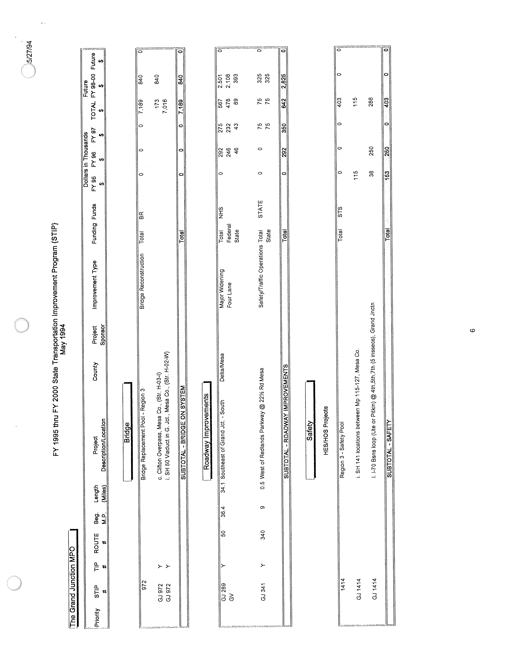
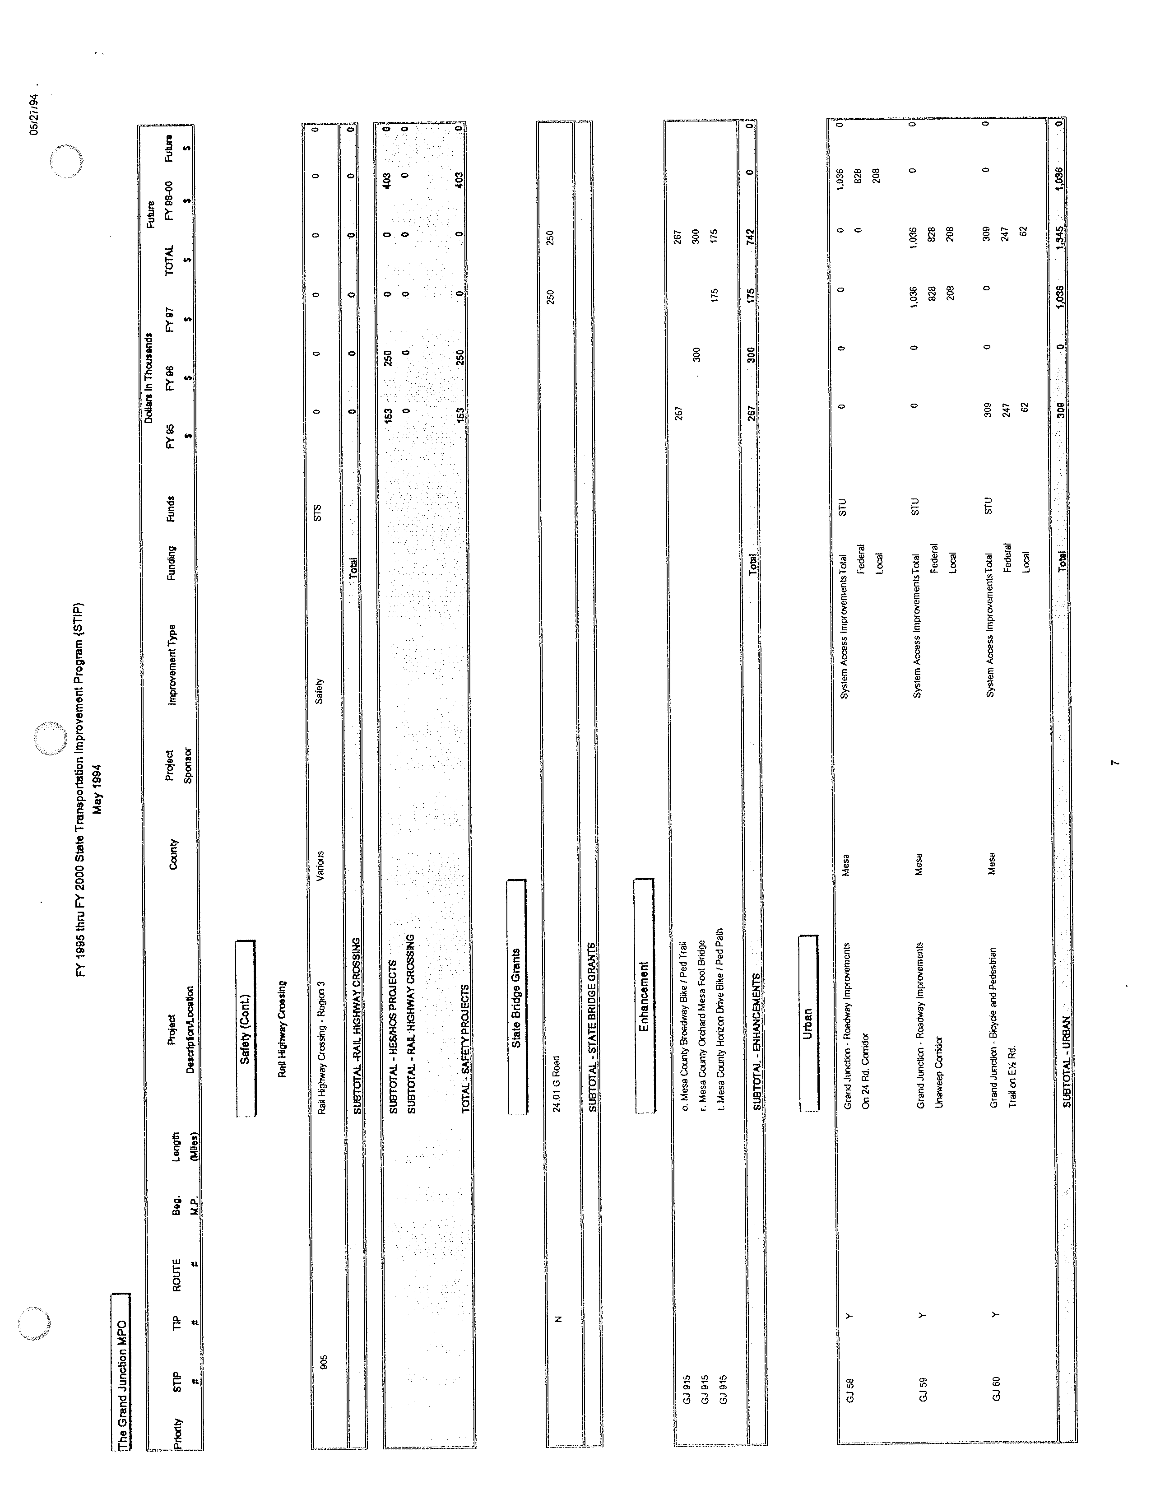
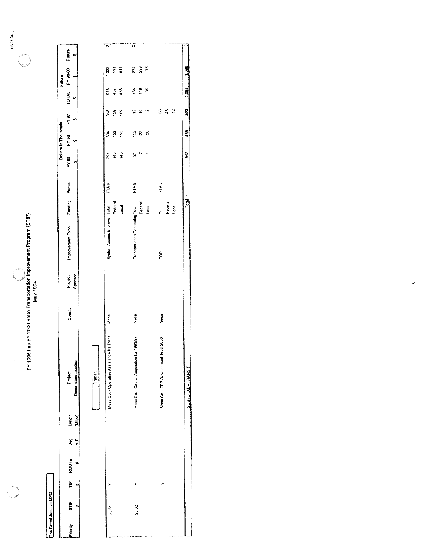
TRANSPORTATION IMPROVEMENT PLAN AND ANNUAL ELEMENT
FY'S 1995-2000

MPO STP ALLOCATION

Location: Mesa County, Colorado
Project Description: Construction of a pedestrian and bike trail adjacent to E½ Road

Responsible Government: Mesa County

Past Funding: N Future Funding: N Long Range: Y TSM:

Budget Year |  | 1995
Federal |  | 247,000.00
Local |  | 62,000.00
TOTAL |  | $309,000.00

Location: Grand Junction/Mesa County, Colorado
Project Description: Construction of corridor and safety improvements along Unaweep Avenue

Responsible Governments: City of Grand Junction
Mesa County

Past Funding: N Future Funding: N Long Range: Y TSM:

Budget Year |  | 1997
Federal |  | 828,000.00
Local |  | 208,000.00
TOTAL |  | $1,036,000.00

Location: Grand Junction/Mesa County, Colorado
Project Description: Construction of corridor and safety improvements along 24 Road

Responsible Governments: Mesa County
City of Grand Junction

Past Funding: N Future Funding: N Long Range: Y TSM:
Budget Year |  | 1999
Federal |  | 828,000.00
Local |  | 208,000.00
TOTAL |  | $1,036,000.00
ENHANCEMENT FUNDS

Location: Mesa County, Colorado
Project Description: Construction of an attached pathway along SH 340 on the Redlands

Responsible Government: Mesa County

Past Funding: N Future Funding: N Long Range: Y TSM:

Budget Year |  | 1995
Federal |  | 213,000.00
Local |  | 54,000.00
TOTAL |  | $267,000.00

Location: City of Grand Junction, Colorado
Project Description: Construction of a foot bridge across Colorado River adjacent to Orchard Mesa Middle School

Responsible Government: City of Grand Junction

Past Funding: N Future Funding: N Long Range: Y TSM:

Budget Year |  | 1996
Federal |  | 240,000.00
Local |  | 60,000.00
TOTAL |  | $300,000.00

Location: City of Grand Junction, Colorado
Project Description: Construction of a trail connecting the 7th Street Corridor to the Horizon Drive Corridor

Responsible Government: City of Grand Junction

Past Funding: N Future Funding: N Long Range: Y TSM:

Budget Year |  | 1997
Federal |  | 140,000.00
Local |  | 35,000.00
TOTAL |  | $175,000.00
STATE GRANT BRIDGES

Location: City of Grand Junction, Colorado
Project Description: Replacement of a functionally obsolete bridge along the 24 Road Corridor

Responsible Government: City of Grand Junction

Past Funding: N Future Funding: N Long Range: Y TSM:

Budget Year |  | 1997
State |  | 200,000.00
Local |  | 50,000.00
TOTAL |  | $250,000.00
SAFETY PROJECTS

Location: Mesa County, Colorado
Project Description: Installation of guard rail at several locations along SH 141

Responsible Government: State of Colorado

Past Funding: N Future Funding: N Long Range: TSM: Y

Budget Year |  | 1995
TOTAL |  | $115,000.00

Location: City of Grand Junction, Colorado
Project Description: Intersection improvements along I-70 business loop

Responsible Government: City of Grand Junction

Past Funding: N Future Funding: N Long Range: TSM: Y

Budget Year |  | 1995 |  |  | 1996
TOTAL |  | $38,000.00 |  |  |  | $250,000.00

NATIONAL HIGHWAY SYSTEM

Location: Mesa County, Colorado
Project Description: Major Widening of Highway 50 southeast of Grand Junction

Responsible Government: State of Colorado

Past Funding: Y Future Funding: Y Long Range: Y TSM:

Budget Year |  | 1996 |  |  |  | 1997 |  |  |  |  |  | 1998-2000
Federal |  | 246,000.00 |  |  |  |  | 232,000.00 |  |  |  |  |  | 2,108,000.00
State |  | 46,000.00 |  |  |  |  | 43,000.00 |  |  |  |  |  |  | 393,000.00
TOTAL |  | $292,000.00 |  |  |  |  |  | $275,000.00 |  |  |  |  |  |  | $2,501,000.00

NON-FEDERAL AID

Location: Mesa County, Colorado
Project Description: Intersection improvements at 22 ½ Road and SH 340

Responsible Government: State of Colorado

Past Funding: N Future Funding: N Long Range: TSM: Y

Budget Year |  | 1997 |  | 1998-2000
State |  | 75,000.00 |  | 325,000.00
TOTAL |  | $75,000.00 |  | $325,000.00

BRIDGE REPLACEMENT POOL

Location: City of Grand Junction, Colorado
Project Description: SH 50 Viaduct Replacement

Responsible Government: State of Colorado

Past Funding: Y Future Funding: N Long Range: Y TSM:

Budget Year |  | 1995-1997
TOTAL |  | $7,016,000.00

Location: Mesa County, Colorado
Project Description: Clifton overpass replacement

Responsible Government: State of Colorado

Past Funding: N Future Funding: N Long Range: Y TSM:

Budget Year |  | 1995-1997 |  | 1998-2000
TOTAL |  | $173,000.00 |  | $840,000.00

FEDERAL TRANSPORTATION ADMINISTRATION FUNDS

Location: Mesa County, Colorado
Project Description: Operating assistance for transit services.
Project utilizes FTA Section 9 funds.

Responsible Government: Mesa County

Past Funding: Y Future Funding: Y Long Range: Y TSM:

Budget Year | 1995 | 1996 | 1997 | 1998 | 1999 | 2000
Federal | 145,480.00 | 152,195.00 | 159,019.00 | 164,585.00 | 170,345.00 | 176,307.00
State
Local | 145,480.00 | 152,194.00 | 159,019.00 | 164,584.00 | 170,345.00 | 176,307.00
TOTAL | $290,960.00 | $304,389.00 | $318,038.00 | $329,169.00 | $340,690.00 | $352,614.00

Location: Mesa County, Colorado

Project Description: Capital acquisition for 1993/97 is taken from the amended 1993/97 TDP.
Project utilizes FTA Section 9.

Year | 1995 | 1996 | 1997 | 1998 | 1999 | 2000
Wheelchair Van | 0 | *3 | 0 | *3 | 0 | *3

(*Denotes replacement vehicle)
This plan includes replacement of existing transit vehicles, capital maintenance, and purchase of other capital items proposed in the amended 1993/97 TDP.

Responsible Government: Mesa County

Past Funding: Y Future Funding: Y Long Range: Y

Budget Year | 1995 | 1996 | 1997 | 1998 | 1999 | 2000
Federal | 16,800.00 | 121,920.00 | 9,600.00 | 133,280.00 | 21,600.00 | 144,000.00
State
Local | 4,200.00 | 30,480.00 | 2,400.00 | 33,320.00 | 5,400.00 | 36,000.00
TOTAL | $21,000.00 | $152,400.00 | $12,000.00 | $166,600.00 | $27,000.00 | $180,000.00
Location: Mesa County, Colorado

Project Description: Five year Transportation Development Plan (TDP) for years 1998-2002.
Project utilizes FTA Section 8 funds.

Responsible Government: Mesa County

Past Funding: Y Future Funding: Long Range : Y

Budget Year | 1995 | 1996 | 1997 | 1998 | 1999 | 2000
Federal |  |  | 48,000.00
State
Local |  |  | 12,000.00
TOTAL |  |  | $60,000.00
PRIVATE SECTOR DOCUMENTATION - UMTA CIRCULAR C 7005.1

The Grand Junction/Mesa County Urbanized Area has formally adopted policies for the involvement of the private transportation providers. A joint resolution and policy was adopted by the Mesa County Board of Commissioners on June 2, 1987, and by the Grand Junction City Council on June 3, 1987. The resolution is on file in the MPO Administrator's office.

Currently, Mesa County contracts for 100% of its transportation services with a private operator who has expressed an interest in providing transit service for the urbanized area. This operator is directly involved in the planning process through Mesa County and the local transportation coalition, of which Mesa County is a member.

The coalition meets monthly and is open to members and the public in general. Any private provider can use this forum to propose contracting opportunities, make suggestions for service, or make complaints.

Proposals on new or expanded service will be evaluated throughout the year. Opportunity for input, on this TIP, from private enterprise was provided. A legal notice was placed in the area newspaper soliciting input and/or comments. No comments were received during FY 1994 (or ALL input was considered and/or addressed in the approved TIP/AE document).

There are currently no known impediments to contracting services for Mesa County. Mesa County is committed to using the private sector to its fullest economic capability.

The private sector policy, as submitted to FTA, sets forth procedures to resolve complaints or conflicts with regard to proposals, contracting, or involvement of the private sector in transit services. There were no complaints submitted during FY 1993 and none to date during FY 1994.

Proposals and bids, from the private sector, are evaluated on a "true cost" basis when comparing them to the public sector. Currently, Mesa County contracts out 100% of its transit services to the private sector.
CERTIFICATION

URBAN TRANSPORTATION PLANNING PROCESS
GRAND JUNCTION/MESA COUNTY URBANIZED AREA
AUGUST, 1993

The Federal Highway Administration (FHWA) and the Urban Mass Transportation Administration (UMTA) have amended 23 CFR Part 450 and 49 CFR Part 613, relative to urban transportation planning. This revision, effective August 1, 1983, is intended to: (1) increase flexibility at the State and local level; (2) reduce red tape and simplify administration of the planning process; and (3) shift certain responsibilities from the Federal to the State and local level, while maintaining an appropriate Federal oversight role.

The most recent certification covering the "3C" Continuing, Cooperative, and Comprehensive Transportation Planning process in the Grand Junction/Mesa County Urbanized Area, the process was approved by the Metropolitan Planning Organization, the Colorado Department of Transportation, Federal Transit Administration and Federal Highway Administration. There were no conditions placed on the area.

This certification of the Grand Junction/Mesa County urban transportation planning process assures that activities support the development and implementation of a Transportation Development Plan (TDP), Transportation Improvement Plan/Annual Element (TIP/AE), and subsequent project development activities, including the environmental impact assessment process. These activities are included in the Unified Planning Work Program (UPWP) to the degree appropriate for the size of this urbanized area, and the complexity of its transportation problems. In addition, the planning process is consistent with the involvement of appropriate public and private transportation providers, Title VI of the Civil Rights Act, and special efforts to plan public mass transportation facilities and services that can effectively be utilized by elderly and handicapped persons. A Minority Business Enterprise Plan does not exist for the MPO. It is understood by the MPO it must follow MBE guidelines and provide for maximum opportunity for minority business participation on any contracting opportunities.

The State and the MPO certify that the planning process is being carried on in compliance with applicable requirements of 23 CFR Part 450, 49 CFR Part 613, and Section 174 and 176(c) and (d) of the Clean Air Act (42 U.S.C. 7504, 7506(c) and (d)).

The above certification statement is a preface to the following specific comments concerning:
A. FTA Transportation Development Plan
B. Transportation Improvement Plan/Annual Element (TIP/AE)
C. Unified Planning Work Program (UPWP)
D. Major Technical Activities since last Certification
E. Specific Recommendations for Improvements
F. Conditions on the Area
A. FTA TRANSPORTATION DEVELOPMENT PLAN

The County engaged a transportation consultant to perform a Transportation Development Plan detailing the existing transit program, projected growth, and current problems. The report prepared by the consultant detailed present and future alternatives for providing service, and cost projections. The report was amended in May, 1994 to address continuation of the local transit program. The TDP covers fiscal years 1993-1997.

B. TRANSPORTATION IMPROVEMENT PLAN/ANNUAL ELEMENT

The Transportation Improvement Plan (TIP) is a product of the continuing, cooperative and comprehensive (3C) transportation planning process, carried out in the Grand Junction/Mesa County, Colorado Urbanized Area. The time period for the current TIP is October 1, 1993 through September 30, 1998. The geographic area covered by this TIP is the Grand Junction/Mesa County Urbanized Area. All projects contained in this TIP have been found to be consistent with applicable portions of the current Colorado State Implementation Plan (SIP). Projects for Elderly and Handicapped Transportation will be taken from the Mesa County Transportation Development Plan: 1993-1997 and any updates.

C. UNIFIED PLANNING WORK PROGRAM

The City Council of Grand Junction and the Mesa County Board of Commissioners are the designated Metropolitan Planning Organization for the Grand Junction/Mesa County Urbanized Area. Responsibility for carrying out the "3C" transportation planning process rests jointly with the Colorado Department of Transportation and the MPO as described in the current Memorandum of Agreement. A contract was executed between the State of Colorado for the use and benefit of the State Department of Transportation, Division of Transportation Planning and the Grand Junction/ Mesa County MPO in October, 1993. The contract was based on the FY 1994 UPWP, which was approved through the 3C planning process and addresses the planning needs in the Grand Junction/Mesa County Urbanized Area.

D. MAJOR TECHNICAL ACTIVITIES SINCE LAST CERTIFICATION

The major technical activities of the Grand Junction/Mesa County MPO during FY 1994 included:

* Various traffic counting activities.
* Development of 1990 Census Product for public distribution.
* Preparation/distribution of materials for public information.
* Efforts to comply with Title VI requirements.
* Preparation of the FY 95 Unified Planning Work Program.
* Preparation of the FY's 1995-2000 Transportation Improvement Plan and Annual Element.
* Completed the "2015" planning process (SWIFT)
E. SPECIFIC RECOMMENDATIONS FOR IMPROVEMENTS

None.

F. CONDITIONS ON THE AREA

None.

The above certification and comments have been reviewed and jointly agreed to by the Colorado Department of Transportation and the Grand Junction/Mesa County MPO.

Approved as part of the FY's 1995-2000 Transportation Improvement Plan by the Mesa County Board of Commissioners on the ________day of _____________,1994, and by the Grand Junction City Council on the _______day of ____________,1994. (Joint resolution attached)

Approved as part of the FY's 1995-2000 Transportation Improvement Plan by the Colorado State Transportation Commission on the __________ day of ___________________, 1994.

Joe Crocker
MPO Administrator

Harvey Atchison, Director
Division of Transportation Planning
Colorado Department of Highways

