MCC# 95-75
GJCC# 55-95
RESOLUTION

A JOINT RESOLUTION OF THE COUNTY OF MESA AND THE CITY OF GRAND JUNCTION CONCERNING ADOPTION OF THE FISCAL YEAR 1996 UNIFIED PLANNING WORK PROGRAM

WHEREAS, The City and County have been designated by the Governor as the Metropolitan Planning Organization for the GrandJunction/Mesa County Urbanized Area; and

WHEREAS, Part 2 of Article 1 of Title 29, Colorado Revised Statutes authorizes the parties to contract with one another to make the most efficient and effective use of their powers and responsibilities; and

WHEREAS, The City and County realize the importance of both short and long range planning in the development of an efficient transportation system, and are both aware that it is the responsibility of the Metropolitan Planning Organization to perform those planning functions; and

WHEREAS, The City and County, in their performance of those planning functions for the Urbanized Area, wish to use Federal Highway Administration transportation planning funds in coordination with the Colorado Department of Transportation;

NOW, THEREFORE, BE IT JOINTLY RESOLVED BY THE BOARD OF COUNTY
COMMISSIONERS OF THE COUNTY OF MESA, COLORADO AND THE CITY COUNCIL
OF THE CITY OF GRAND JUNCTION, COLORADO:

That the Unified Planning Work Program for Fiscal Year 1996, hereunto attached, is adopted by the Board of County Commissioners of the County of Mesa, Colorado on May 15, 1995, and by the City Council of the City of Grand Junction, Colorado on May 17, 1995.

CITY OF GRAND JUNCTION COUNTY OF MESA

/s/ Ron Maupin /s/ Doralyn B. Genova
President of the Council Chairman of the Board
Grand Junction City Council Mesa County Board of Commissioners

17th day of May, 1995 15th day of May, 1995

Attest: Attest:

/s/ Stephanie Nye /s/ Monika Todd
City Clerk County Clerk

FY 1996

UNIFIED PLANNING WORK PROGRAM

FOR THE

GRAND JUNCTION/MESA COUNTY URBANIZED AREA

Prepared by the

Grand Junction/Mesa County Area
Metropolitan Planning Organization

and the

Colorado Department of Transportation,
Program Management Branch

In cooperation with the
U.S. Department of Transportation,
Federal Highway Administration

April, 1995

TABLE OF CONTENTS

Introduction 2

Summary of the Budget 5

UPWP Work Tasks 8

Tables

Summary of the Budget - Table 1 5

UPWP Task Costs - Table 2 7

Figures

Transportation Planning Terminology - Figure 1 1

Urbanized Area Map - Figure 2 3

MPO Local Review Process - Figure 3 4

Task Schedule - Figure 4 16

Figure 1
TRANSPORTATION PLANNING TERMINOLOGY

Air Quality Control Commission AQCC

Annual Element AE

Colorado Department of Transportation CDOT

U.S. Department of Transportation DOT

Federal-Aid Highway Program Manual FHPM

Federal Highway Administration FHWA

Federal Transportation Administration FTA

Fiscal Year for the MPO FY

Highway Planning and Research Funds HPR

Intermodal Surface Transportation Act ISTEA

Metropolitan Planning Organization MPO

FHWA planning funds made available through CDOT to the MPO PL Funds

FTA funds made available through CDOT
to the MPO Section 8 Funds
Section 9 Funds

State Implementation Plan SIP

Title VI of the U.S., Civil Right Act of 1964, as amended Title VI

Transit Development Plan TDP

Transportation Improvement Plan TIP

Transportation Policy Advisory Committee TPAC

Transportation Technical Advisory Committee TTAC

Unified Planning Work Program UPWP

Urban Transportation Planning Process UTPP

Vehicle Miles Traveled Introduction VMT
INTRODUCTION

The Unified Planning Work Program describes planning tasks and personnel costs and budget funds for the Fiscal Year 1996 running from October 1, 1995 through September 30, 1996.

The Metropolitan Planning Organization (MPO), composed of Grand Junction and Mesa County elected officials and staff, coordinates this planning with state officials from the Colorado Department of Transportation (CDOT) and the Colorado Health Department who, through the Air Quality Control Commission, is charged with protecting air quality throughout Colorado. The ultimate goal of this planning process is an efficient, effective transportation system.

To further the continuing, comprehensive, and cooperative planning for the Grand Junction Urbanized Area (Fig. 2), the Federal Highway Administration provides PL funds to the MPO under the administration of the CDOT. The 1996 PL allocation is $59,784. PL funds are matched at a 17.21% ratio by the MPO members. Thus, for every $100 expended by the MPO on approved tasks, $82.79 will be reimbursed by PL funds up to the budgeted amount. The MPO plans to program $59,784 of the available PL funds in FY 1995. The MPO also plans to program $20,000 of Section 8 monies. These funds are matched at a 20.0% ratio by the MPO members. The MPO proposes to spend a total of $97,212 including local match, on transportation related tasks contained in the FY 1996 Unified Planning Work Program.

The CDOT, as the Contract Administrator, monitors the timely accomplishment of tasks and the reimbursement process. In addition, the CDOT actively participates in the planning process through the provision of technical services. (See Figure 3 for the MPO structure.)

The current local operational structure allows for the maximum funding to be channeled to local City and County agencies, through the Transportation Technical Advisory Committee (TTAC) and Transportation Policy Advisory Committee (TPAC), to provide staff and resources for completion of the various tasks. The MPO continues to shift much of the administrative activity associated with each task (development, implementation and monitoring) into the task budget itself. This allows the MPO Administrator to focus on required documents, annual certification and overall policy development for the agency and direct more dollars to actual studies and activities.

The Supervisor of the Mesa County Land Use and Transportation Department currently serves as the MPO Administrator, but the duties will soon be transferred to a new MPO Administrator/Planner. This position will perform administrative functions and perform work directly supporting the task elements of the FY 1996 UPWP. This office is the "single point-of-contact" between MPO agencies, state and federal officials. The technical operational agencies assume an active role in developing, implementing and monitoring the program tasks. The MPO Administrator provides technical support and performs the managerial tasks necessary for the MPO to comply with state and federal requirements. Program goals call for continued support of planning, monitoring and implementation tasks, and minimum administrative overhead. The local MPO's approach to this UPWP should accomplish those goals.

FIGURE 2 - URBANIZED AREA MAP
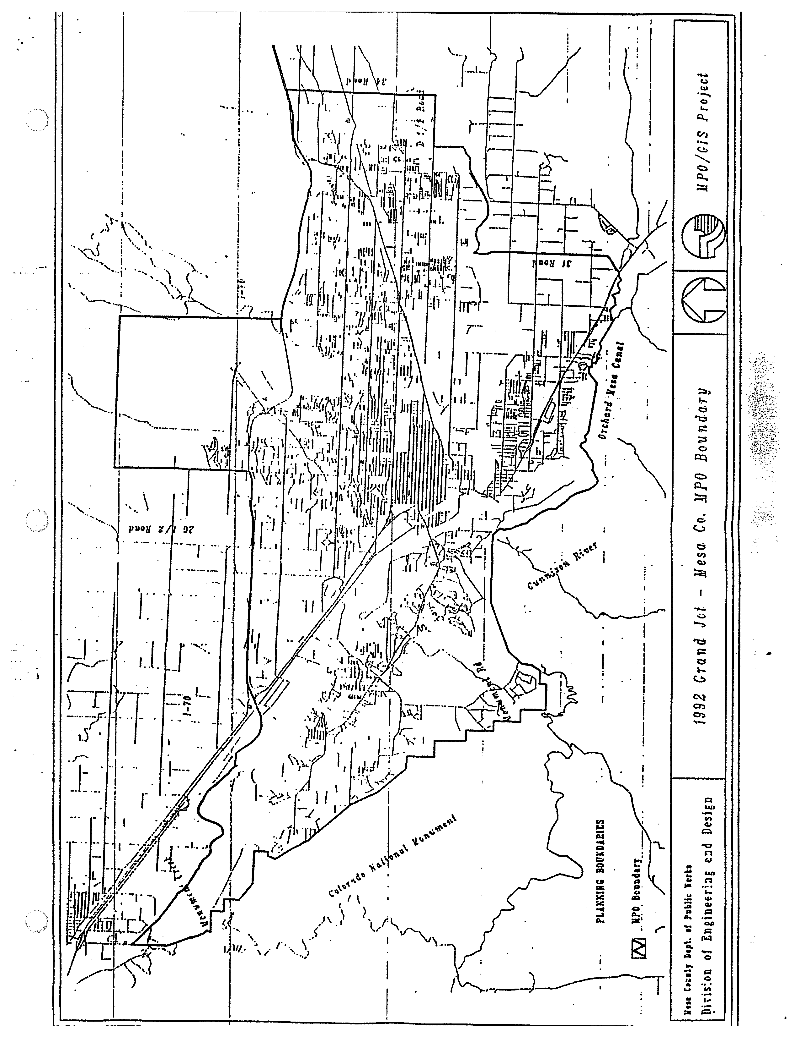

FIGURE 3

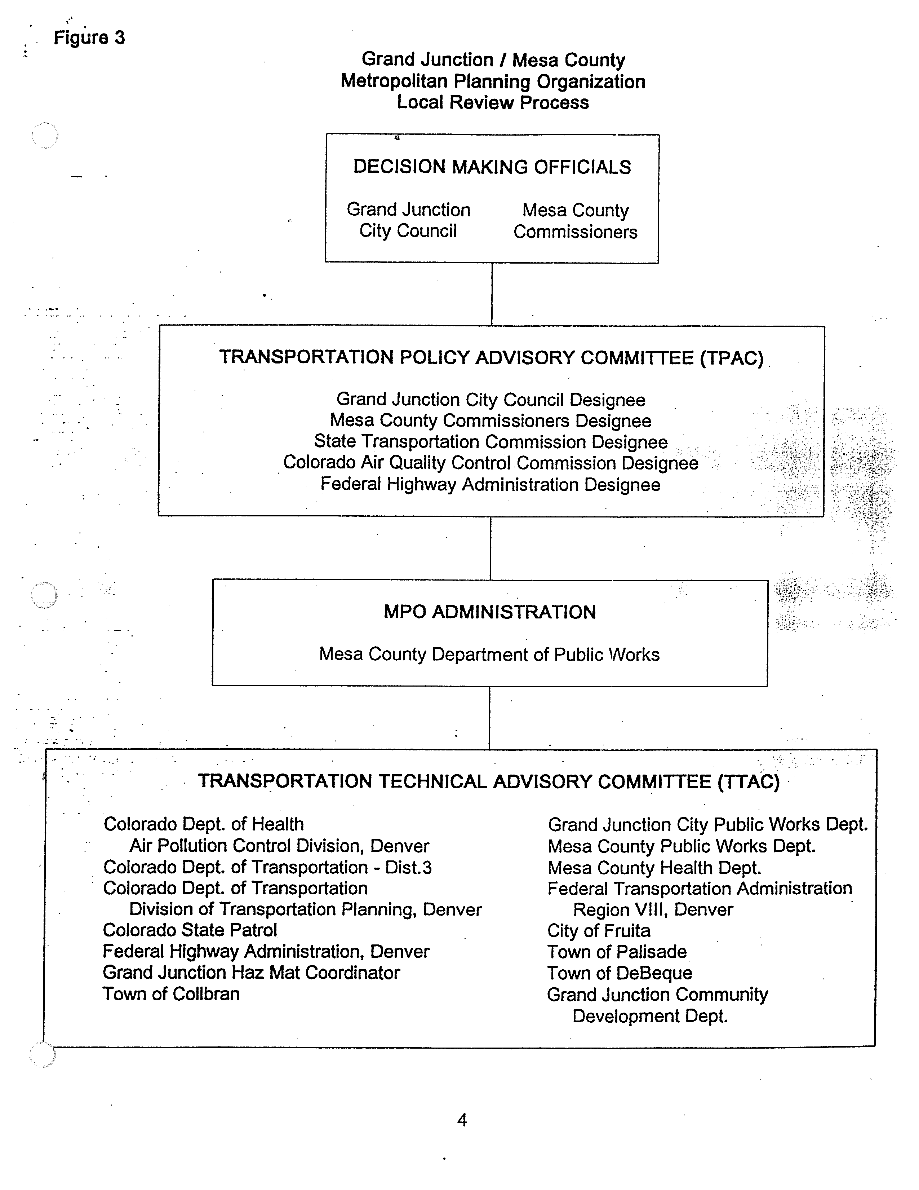

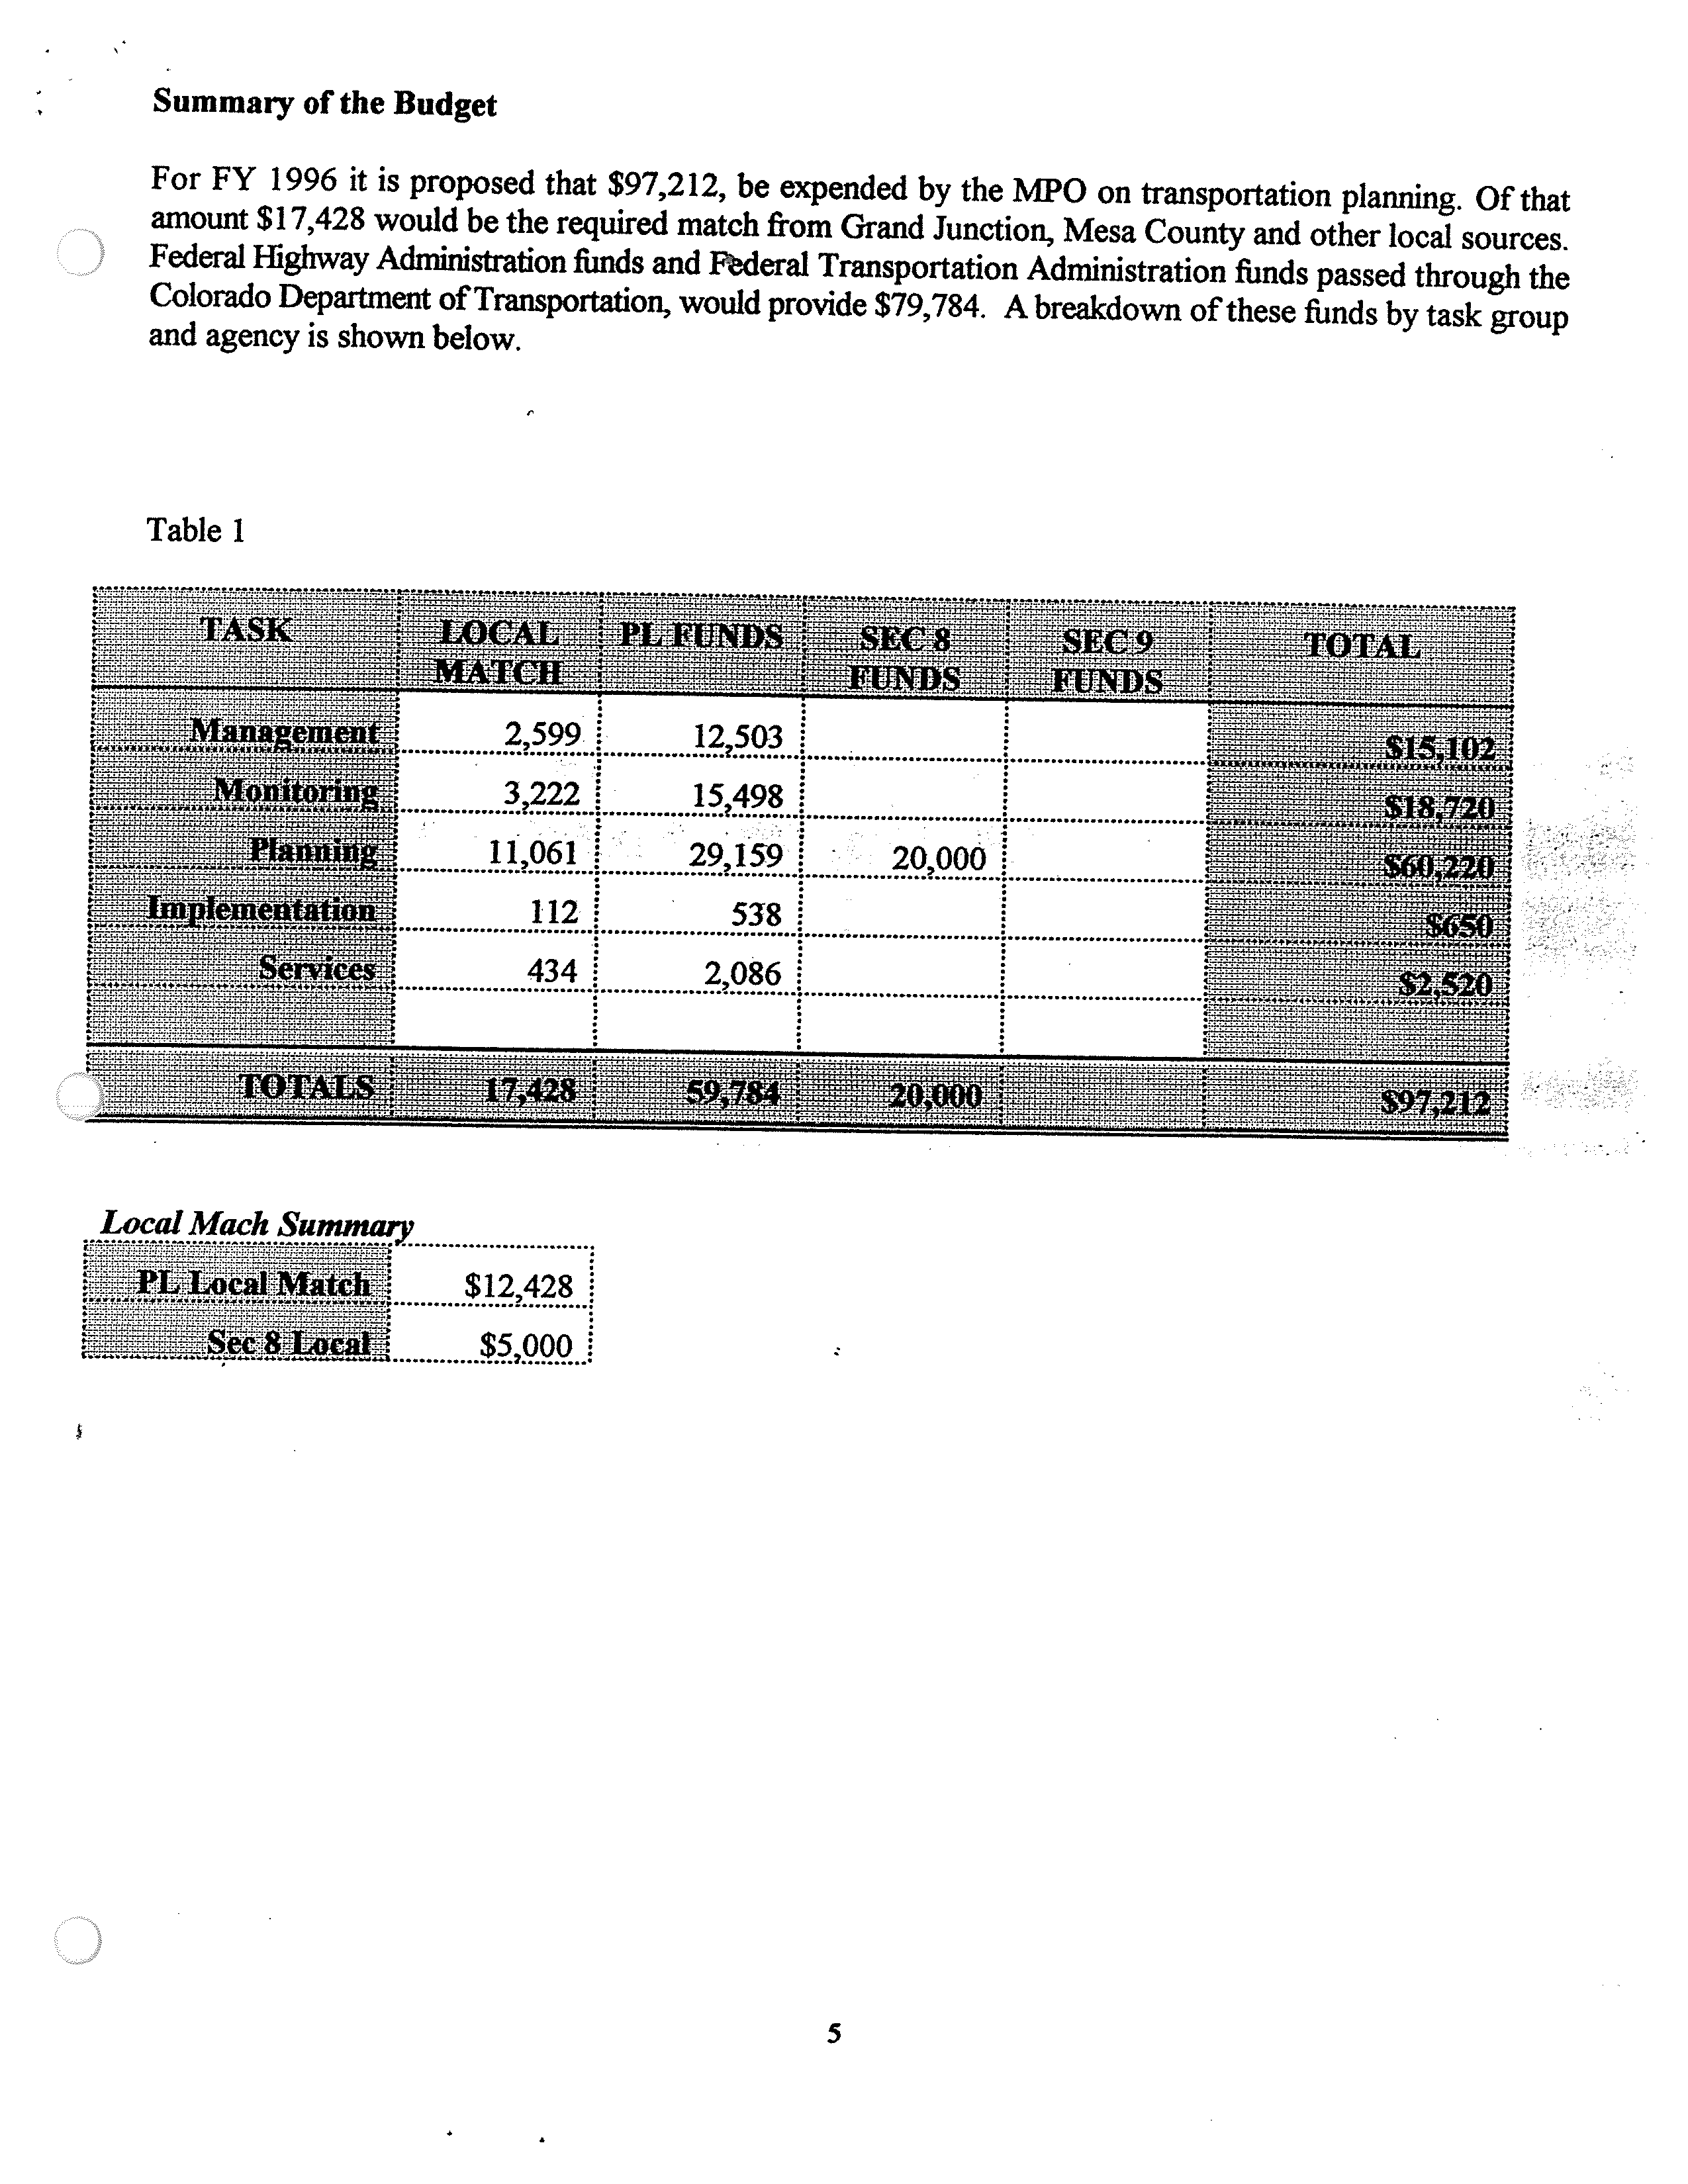
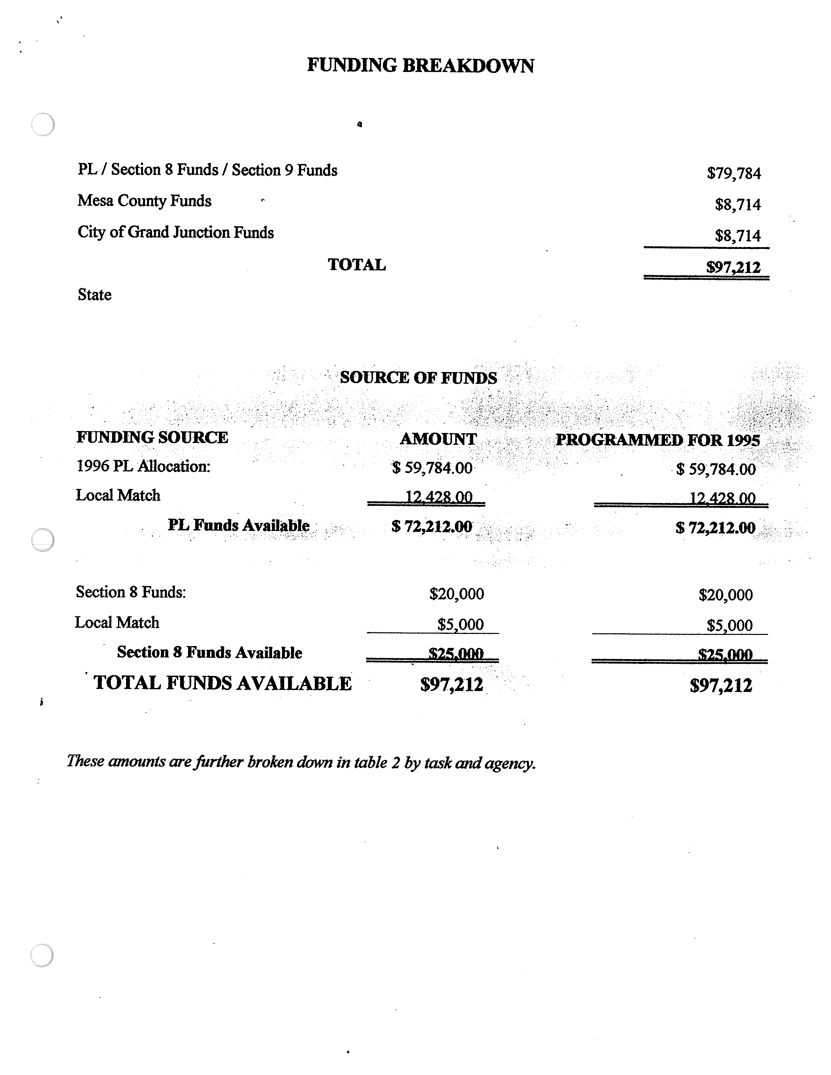
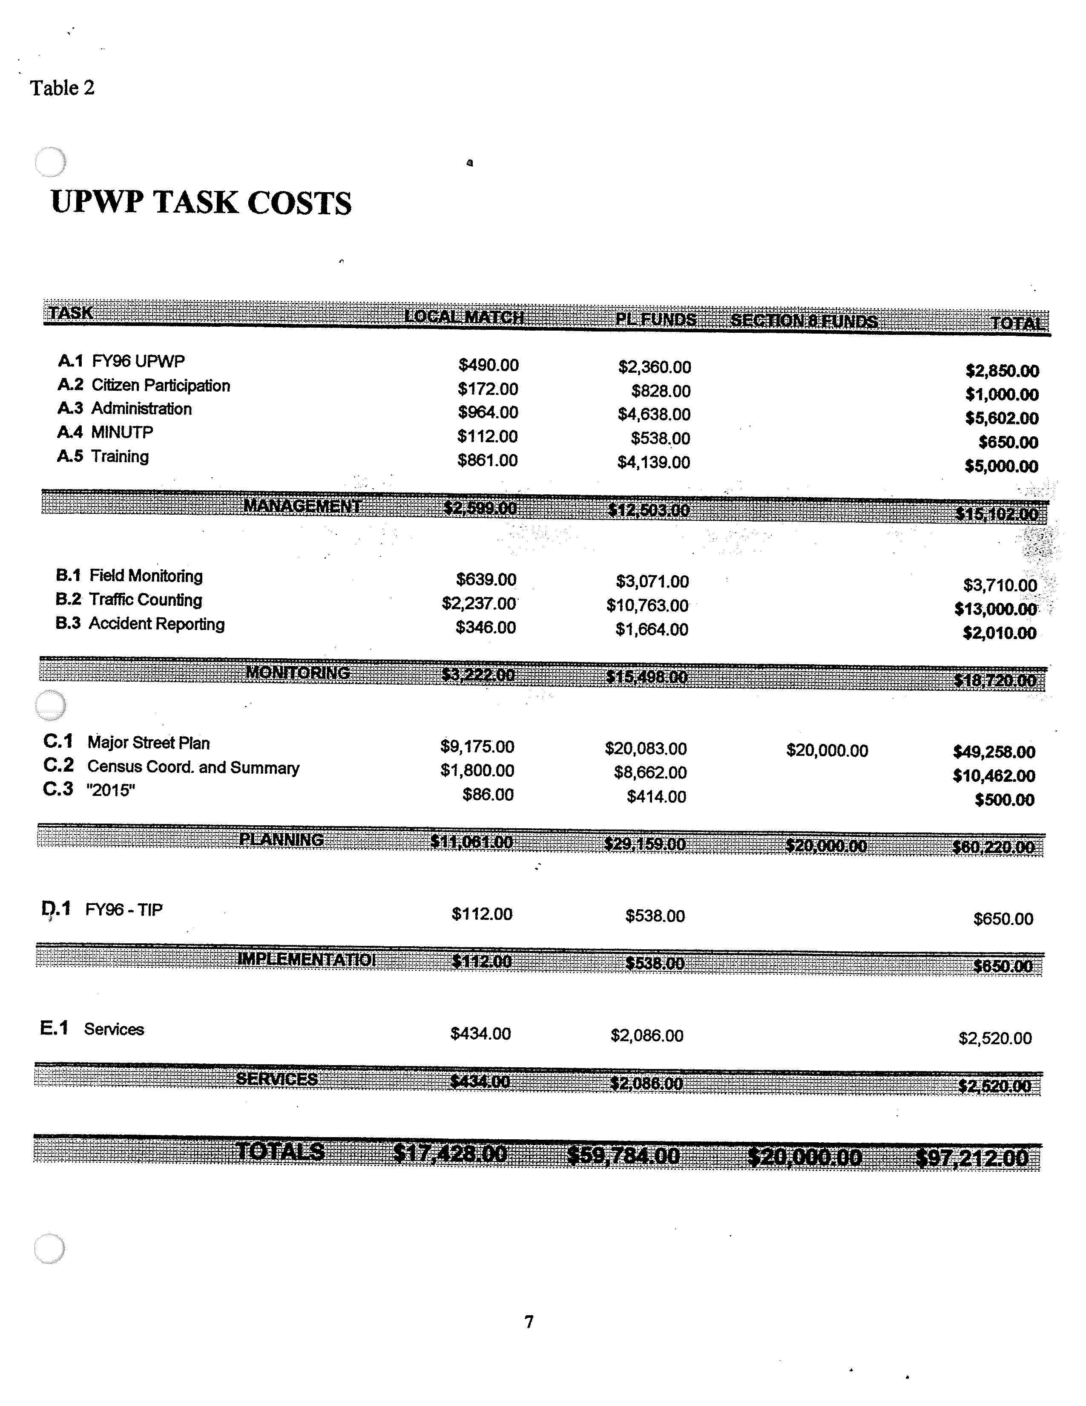
GRAND JUNCTION / MESA COUNTY MPO

UPWP Work Tasks

The major portion of this document consists of work tasks to be completed during Fiscal Year 1996 (October 1, 1995 to September 30, 1996). These work tasks are intended to monitor and implement the continuing, cooperative and comprehensive urban transportation planning process carried out by the MPO and CDOT in the Grand Junction urbanized area. The agencies with primary responsibility for completion of each task are listed in the UPWP. The UPWP is intentionally presented as an outline of primary funding sources and planning schedules. An overview of the entire planning process is contained in the Memorandum of Agreement establishing the MPO. (See Figure 3 for the MPO structure)

Figure 4 provides a summary of scheduling for all UPWP tasks. Work tasks of a continuing nature are differentiated from those with definable time frames. Modifications in task schedules are reflected in quarterly PL monitoring reports. Significant changes in schedules will be agreed to by CDOT and the MPO.

An accomplishment report for FY 1996 will be completed in October, 1996 and submitted to the CDOT.

A. MANAGEMENT ACTIVITIES

The primary objective of the UPWP management activities is to provide for the on-going management of the urban transportation planning program in the Grand Junction urbanized area. Secondary objectives include coordination of planning efforts between local, regional and state agencies, and monitoring and documentation of transportation planning efforts and technical studies through locally adopted planning documents. Since the MPO and CDOT share responsibility for compliance with Federal planning guidelines, both agencies are involved in program management activities.

A.1. Task Name: Fiscal Year 1997 (October 1, 1996 through September 30, 1997)
Unified Planning Work Program (UPWP).

Objective: To perform the necessary management tasks to produce a FY97 UPWP that will include all transportation planning activities, regardless of Federal funding sources, which significantly impact the local Study Area, whether performed on a federal, state, or local level.

Methodology: The MPO staff, with input from the local government technical staff and the CDOT, will be responsible for preparing the FY97 UPWP. The UPWP will be prepared in accordance with applicable federal and state requirements. Each task in the UPWP will be described in terms of objective, methodology, product, schedule, agency responsibility, costs and CDOT.

Product: A Unified Planning Work Program for FY 1997.

Schedule: A meeting to discuss planning work needs will be held in March. UPWP first draft in April, with local adoption by May 15th. The MPO Contract will be signed by the Grand Junction City Council, Mesa County Commissioners, and State of Colorado by September 30th.

Agency: MPO Administrator.

Personnel: Local 15 days

Costs: Local $2,850 CDOT $1,200 (Includes non-salary costs)

A.2. Task Name: Citizen Participation.

Objective: To encourage public involvement in transportation planning and increase awareness of the Metropolitan Planning Organization Process.

Methodology: Citizens will actively participate in the development of policy for the MPO through the City and County Planning Commissions. Local staff will prepare information for the media and the public, hold open meetings of the TTAC, and advertise public hearing on items requiring public comment.

Products: Press releases concerning transportation issues and an annual report. The annual report will be a brief overview of work performed by the MPO during the fiscal year. The report will be in language understandable by the general public.

Schedule: Continuous throughout the year. Annual report in September 1996.

Agency: MPO Administrator.

Personnel: Local 5 days

Costs: Local $1,000 (Includes non-salary costs)

A.3. Task Name: Program Administration.

Objective: To effectively administer, manage, support, monitor, coordinate, control the continuing federally assisted transportation planning process for the Grand Junction urbanized area.

Methodology: The local staff will be responsible for carrying out the following activities:

(1) Maintain the commitments included in the Memorandum of Agreement and the contracts for planning funds (PL funds and Section 8 funds); (2) Submit monitoring reports on the FY96 UPWP tasks; (3) Maintain and document expenditures and submit financial reports; (4) Support members of the decision making bodies, Transportation Policy Advisory Committee, Transportation Technical Advisory Committee and the City and County Planning Commissions in their decisions on MPO related activities; (5) To monitor significant policy activities on the federal, state and local levels that could have potential impact on MPO activities. At the direction of the MPO, represent the MPO members in federal, state, and local decision making processes; (6) Represent the MPO in the Regional Planning Organization; (7) Monitor UPWP task activities; (8) Assist in development of RFP's for UPWP study and coordinate contract management.

The Colorado Department of Transportation staff will participate in the above listed activities and, in addition, perform necessary administrative functions to assure the effective coordination and participation of other branches of State government and appropriate federal agencies in the MPO Transportation Planning Process.

Schedule: Continuous through the year with quarterly monitoring reports (October, January, April, and July) and TTAC meetings as required.

Agency: MPO Administration.

Personnel: Local 28 days

Costs: Local $5,602.00 (Includes non-salary costs)
CDOT $2,500

A.4 Task Name: Minutp Maintenance

Objective: To purchase a maintenance contract to develop the capability to maintain and use the Minutp software package, and perform transportation analysis to facilitate local transportation planning.

Methodology: MPO member agencies will use the Minutp software to analyze development proposals and scenarios and develop transportation plans that effectively recognize the transportation requirements in an area.

Product: The product will be reports generated on an "as needed" basis to assist in transportation planning and development.

Schedule: Continuous throughout the year. Results included in quarterly reports to CDOT.

Agency: MPO Administration

Personnel: Local 0 days

Costs: Local $650.00 (Non-salary cost)

A.5 Task Name: Training and Travel

Objective: To provide training for MPO member agency personnel and increase their expertise in transportation planning and related issues. Pay for travel associated with ongoing programs.

Methodology: Member agency staff will participate in training courses that focus on the different aspects of transportation planning. The MPO will participate in costs incurred for providing Minutp training to staff members. The MPO will also participate in the Census Transportation Planning Package training.

Products: The product of this effort will be the successful completion of training courses by selected staff members.

Schedule: Continuous throughout the year. Progress reports furnished quarterly.

Agency: MPO Administration

Personnel: Local 5 days

Costs: Local $5,000 (Includes non-salary costs)

B. MONITORING ACTIVITIES

The primary objective of monitoring is to provide support to transportation planning, implementation, and service activities through the collection, maintenance and analysis of certain factors indicating the condition of land use development and the existing transportation system. Data normally maintained by participating agencies will be utilized to meet reporting requirements as much as possible. A compatible data base will be utilized to the maximum extent feasible.

B. Task Name: Field Traffic Monitoring Systems

Objective: Funding for monthly telephone service charges for data retrieval from field monitoring stations.

Methodology: Provide for automatic data retrieval via phone lines from existing and proposed count stations.

Product: Continuous data stream to fulfill traffic management system needs.

Schedule: Monthly, October 1995 through October 1996.

Agency: Grand Junction City Public Works
Mesa County Land Use and Transportation

Cost: County $2,360.00 (Includes non-salary costs)
City $1,350 (Includes non-salary costs)

B.2. Task Name: Traffic Counting

Objective: To monitor traffic conditions at a variety of intersections and other critical locations.

Methodology: Engineering staff will conduct traffic counts at no less than 1-hour intervals, with some specific intersection monitoring. Locations will be coordinated with CDOT.

Product: An on-going traffic monitoring program with the ability to produce information on peak hour and directional flows, and developing ADT's.

Schedule: On-going effort, with results submitted annually.

Agency: Mesa County Land Use and Transportation
City of Grand Junction Public Works

Personnel: County 88 days City 56 days

Costs: County $8,000.00 City $5,000.00

B.3 Task Name: Traffic Accident Report Coordination

Objective: To obtain and file all traffic accident information in Mesa County within the MPO area.

Methodology: Obtain photocopies of itemized traffic accident reports from the Colorado State Patrol, enter data and scan collision diagrams to computer inventory.

Product: Computer inventory of accident information with the ability to produce location maps.

Schedule: October 1995 through October 1996.

Agency: Mesa County Land Use and Transportation

Personnel: Local 15 Days

Costs: Local $2,010.00

C. PLANNING ACTIVITIES

The primary objective of planning activities is to support the decision making process of the MPO through the development of studies and analyses concerning short and long-term transportation needs.

C.1. Task Name: Major Street Plan

Objective: To identify the existing and future arterial and collector street system, and the on- street and off-street pedestrian and bicycle path system in the urban area.

Methodology: Traffic and administrative staff will work with the land use consultants for the City and County during 1995-96, and agency staffs. New information and present information will be utilized to develop plan.

Product: The plan will develop maps to show existing and proposed street classifications for the urban area.

Schedule: Draft plan will be developed by May 1996, with final product due in September 1996.

Agency: Mesa County Land Use and Transportation.

Personnel: Local 200 days

Costs: Local $49,258.00 (Includes non-salary costs)

C.2. Task Name: Census Coordination and Summary.

Objective: To continue to compile census data, and maintain Census/MPO GIS data base in a format usable by the public and local entities.

Methodology: MPO Administrator will coordinate local contact with Census officials. Staff will compile the census data by in a summary format. Graphic illustrations will be done for easy reference. Recommendations for annual updates and projections will be included.

Product: Required responses to the Census Bureau. Data will be contained in a summary document on diskette which can be easily updated and printed for publication. Also, the development of a computerized GIS data base capable of providing the following information for the MPO area: zoning, road classifications, traffic counts, bicycle system information and census data analysis for origin and destination studies. The system will have hard copy production capabilities. The focus of the product is to produce a usable analysis tool to provide transportation related information.

Schedule: Continuous throughout the year. Quarterly reports.

Agency: Mesa County Land Use and Transportation

Personnel: Local 50 days

Costs: Local $10,462.00 (Includes non-salary costs)

C.3 Task Name: Long Range Planning "2015"

Objective: To continue work on and print the "2015" Plan for the Grand Junction Area MPO.

Methodology: Citizens and MPO member agency representatives will participate in the development of the "2015" Plan. Work will be done with the Grand Junction City Planning Commission and the Mesa County Planning Commission to coordinate needs and planning processes. Coordinate with CDOT. This phase of the plan will focus on refining implementation schedule.

Products: The product of this effort will be a document addressing the long term transportation needs of the MPO area.

Schedule: The final draft of the "2015" Plan is scheduled for completion and printing in October 1995.

Agency: Mesa County Land Use and Transportation Department

Personnel: Local 2 days

Costs: Local $500.00 (Includes non-salary costs)

D. IMPLEMENTATION TASKS

Implementation activities refer to lists of capital projects adopted by the MPO which establish policy guidance on the use of transportation funds in the urbanized area of Grand Junction.

D.1. Task Name: Fiscal Years 1997-2002 Transportation Improvement Plan (TIP).

Objective: The Fiscal Years 1997-2002 TIP will establish the capital projects in the urbanized area for which federal assistance is expected. It will contain an annual element showing specific projects to which funds have been committed.

Methodology: MPO, City Engineering, County Engineering and CDOT District 3 staff will develop a TIP using information from existing capital improvement programs, monitoring data concerning traffic volumes, accidents, and revenue projections.

Products: The FYs 1997-2002 Transportation Improvement Plan.

Schedule: First draft in June with local adoption by July 15th.

Agency: MPO Administrator.

Personnel: Local 3 days

Costs: Local $650.00 (Includes non-salary costs)

E. SERVICE TASKS

Service activities refer to assistance to local and other governmental agencies concerning transportation issues.

E.1. Task Name: Services.

Objective: To provide technical data and general assistance to requesting agencies and the public.

Methodology: Published reports or data will be supplied when available. Local MPO staff will also provide planning assistance to local or state agencies. The MPO technical library will be maintained for use by the agencies. General assistance will be provided to the public, as requested.

Products: Inquiries answered, assistance provided.

Schedule: Continuous.

Agency: MPO Administration

Personnel: Local 10 days

Costs: Local $2,520.00 CDOT $2,300 (Includes non-salary costs)

FIGURE 4

TASK SCHEDULE

TASKS 1995 1996 1996
OCT NOV DEC JAN FEB MAR APR MAY JUN JUL AUG SEP

A.1 FY96 UPWP | | | | | | D R | | | |
A.2 CIT.PART. ** ** ** ** ** ** ** ** ** ** ** R
A.3 PROG ADMIN ** ** ** R ** ** R ** ** R ** R
A.4 MINUTP MAIN ** ** ** R ** ** R ** ** R ** R
A.5 TRAINING ** ** ** R ** ** R ** ** R ** R
B.1 FIELD MONT. ** ** ** ** ** ** ** ** ** ** ** R
B.2 TRAF. COUNT ** ** ** ** ** ** ** ** ** ** ** R
B.3 ACCIDENT RPT. ** ** ** ** ** ** ** ** ** ** ** R
C.1 MAJOR ST. ** ** ** ** ** ** ** D ** ** ** R
C.2 CENSUS ** ** ** R ** ** R ** ** R ** R
C.3 "2015" R ** ** ** ** ** ** ** ** ** ** **
D.1 FY97 TIP ** ** ** ** ** ** ** ** D R ** **
E.1 SERVICES ** ** ** ** ** ** ** ** ** ** ** R

L E G E N D

- - - = TASK ACTIVITY TIME FRAME
** = CONTINUOUS TASK ACTIVITY
D = DRAFT REPORT DUE
R = REPORT DUE

