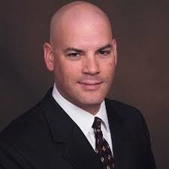

**Jesse Wilkins**

FOUNDING MEMBER of wcoARMA!

We are delighted to bring him to Western Colorado for a return speaking engagement!!

Jesse Wilkins, CIP, CRM, IGP, is the Director, Research & Development for AIIM International. He has worked in the information management industry for eighteen years as an end user, vendor, consultant, and trainer. His areas of expertise include enterprise content management, electronic records management, email management, document imaging, digital preservation, and social media technologies and governance processes.

Jesse is a frequent speaker and author on information management topics and has presented numerous sessions at AIIM, ARMA, ARMA Canada, MER, and other industry conferences since 2002. He has written a number of articles and white papers including:

* Social Business - 8 Steps to an Effective Strategy, AIIM 2012
* How to Conduct a Social Business Assessment, AIIM 2012
* The AIIM Social Business Roadmap, AIIM 2011
* Taking the Lead in the Information Race, Information Management Magazine, 2010
* A Walk in the Cloud, Information Management Magazine, 2009. This article, coauthored with Patrick Cunningham, won the 2009 ARMA International Britt Literary Award.

Jesse has also developed a number of training programs for AIIM, including:

* ERM Master Class
* Social Media Governance Practitioner Course
* Managing Records and eDiscovery in SharePoint 2013 Practitioner Course
* Automating Records Management Course
* Selling Content Management Course

He is an accredited instructor for every course AIIM offers. He was also the technical lead for the development of the Certified Information Professional certification. In 2006 he won the AIIM Education Award.

For additional detail on Jesse's background and expertise please see his LinkedIn profile at http:/www.linkedin.com/in/jessewilkins/