RESOLUTION NO. 06-11
A RESOLUTION OF THE COUNCIL OF THE CITY OF GRAND JUNCTION APPROVING THE DOWNTOWN DEVELOPMENT AUTHORITY'S CALL FOR AN ELECTION TO BE HELD FOR THE PURPOSE OF SUBMITTING A PROPOSED BALLOT MEASURE TO THE QUALIFIED ELECTORS OF THE DOWNTOWN DEVELOPMENT AUTHORITY DISTRICT, SETTING THE BALLOT TITLE, AUTHORIZING A MAIL BALLOT ELECTION AND APPROVING A MAIL BALLOT PLAN
WHEREAS, the City of Grand Junction, in the Colorado (the “City”), is a home rule municipal corporation duly organized and existing under laws of the State of Colorado and the City Charter (the “Charter”); and
WHEREAS, Article X, Section 20 of the Constitution (“TABOR”) requires voter approval for incurring debt, the creation of any tax, and for spending certain moneys above limits established by TABOR; and
WHEREAS, TABOR requires that ballot issue elections (as defined in TABOR) be held on certain specified election days; and
WHEREAS, April 5, 2011 is the City’s regular election and one of the election dates at which ballot issues may be submitted pursuant to TABOR; and
WHEREAS, it is the desire of the City to conduct an independent mail ballot election within the Grand Junction Downtown Development Authority (the “Authority”) district on the election date; and
WHEREAS, pursuant to Article II, Section 25 of the Charter, for the purposes of participating in a mail ballot election, the City shall be governed by all applicable provisions of the Municipal Election Code, being Article 10 of Title 31, C.R.S., and the Mail Ballot Election Act, being Article 7.5 of Title 1, C.R.S.; and
WHEREAS, at its regular meeting on January 13, 2011 the Board of Directors of the Authority, by resolution attached as Exhibit A, called for an election (“DDA Election”) of the qualified electors of the for the purpose of submitting to the electors a question regarding the issuance of debt by the City to finance development projects in furtherance of the Authority plan of development; and
WHEREAS, Section 31-25-807(3)(b), C.R.S. requires approval by the City Council for such DDA Election; and
WHEREAS, Section 31-25-807(3)(b), C.R.S., requires that the DDA Election be held and conducted in the manner prescribed by law for the holding and conducting of other regular or special elections in the municipality; and
WHEREAS, it is necessary to set forth certain procedures concerning the conduct of the election.
NOW THEREFORE BE IT RESOLVED BY THE COUNCIL OF THE CITY OF GRAND JUNCTION as follows:

All actions heretofore taken (not inconsistent with the provisions of this Ordinance) by the City and the officers thereof, directed towards the election and the objects and purposes herein stated are hereby ratified, approved and confirmed. Unless otherwise defined herein, all terms used herein shall have the meanings defined in Title 31, Article 25, Part 8, C.R.S. (the “DDA Act”), the Municipal Election Code, the Mail Ballot Election Act, and TABOR.

Pursuant to the applicable laws of the State of Colorado, the Council hereby determines that at the City’s regular election to be held on April 5, 2011, there shall be submitted to the qualified electors of the Authority the question set forth in Section 3 below.

The Council hereby authorizes and directs the designated election official to submit to the qualified electors of the Authority, at the election a question in the substantially the following form:
“SHALL CITY OF GRAND JUNCTION DEBT BE INCREASED NOT TO EXCEED $65,000,000 WITH A REPAYMENT COST OF $72,000,000, WITHOUT RAISING ADDITIONAL TAXES, TO FINANCE STREETS, PARKS, PLAZAS, PARKING FACILITIES, PLAYGROUNDS, CAPITAL FACILITIES, PEDESTRIAN MALLS, RIGHTS-OF-WAY, STRUCTURES, WATERWAYS, BRIDGES, ACCESS ROUTES TO ANY OF THE FOREGOING, DESIGNED FOR USE BY THE PUBLIC GENERALLY OR USED BY ANY PUBLIC AGENCY WITH OR WITHOUT CHARGE; SUCH DEBT TO BE EVIDENCED BY BONDS, LOANS, ADVANCES OR INDEBTEDNESS PROVIDED THAT THE SPECIFIC TERMS OF THE DEBT, INCLUDING A PROVISION FOR EARLY REPAYMENT WITH OR WITHOUT A PREMIUM, AND THE PRICE AT WHICH IT WILL BE SOLD SHALL BE DETERMINED BY THE CITY AS NECESSARY AND PRUDENT; SHALL THE PLEDGE OF THE TAX INCREMENT FUND TO SUCH DEBT BE AUTHORIZED FOR A PERIOD NOT TO EXCEED THE MAXIMUM TIME PERMITTED BY LAW?”

The City Clerk is hereby appointed as the Designated Election Official for the City for purposes of performing acts required or permitted by law in connection with the election.

The officers of the City are hereby authorized and directed to take all action necessary or appropriate to effectuate the provisions of this Resolution.

If any section, subsection, paragraph, clause, or provision of this Resolution shall for any reason be held to be invalid or unenforceable, the invalidity or unenforceability of such section, subsection, paragraph, clause, or provision shall in no manner affect any remaining provisions of this Resolution, the intent being that the same are severable.
All orders, resolutions, bylaws, ordinances or regulations of the City, or parts thereof, inconsistent with this resolution are hereby repealed to the extent only of such inconsistency.

ADOPTED AND APPROVED this 31st day of January, 2011.

(SEAL)
CITY OF GRAND JUNCTION

/s/ Teresa A. Coons
President of the City Council
Attest:

/s/ Stephanie Tuin
City Clerk
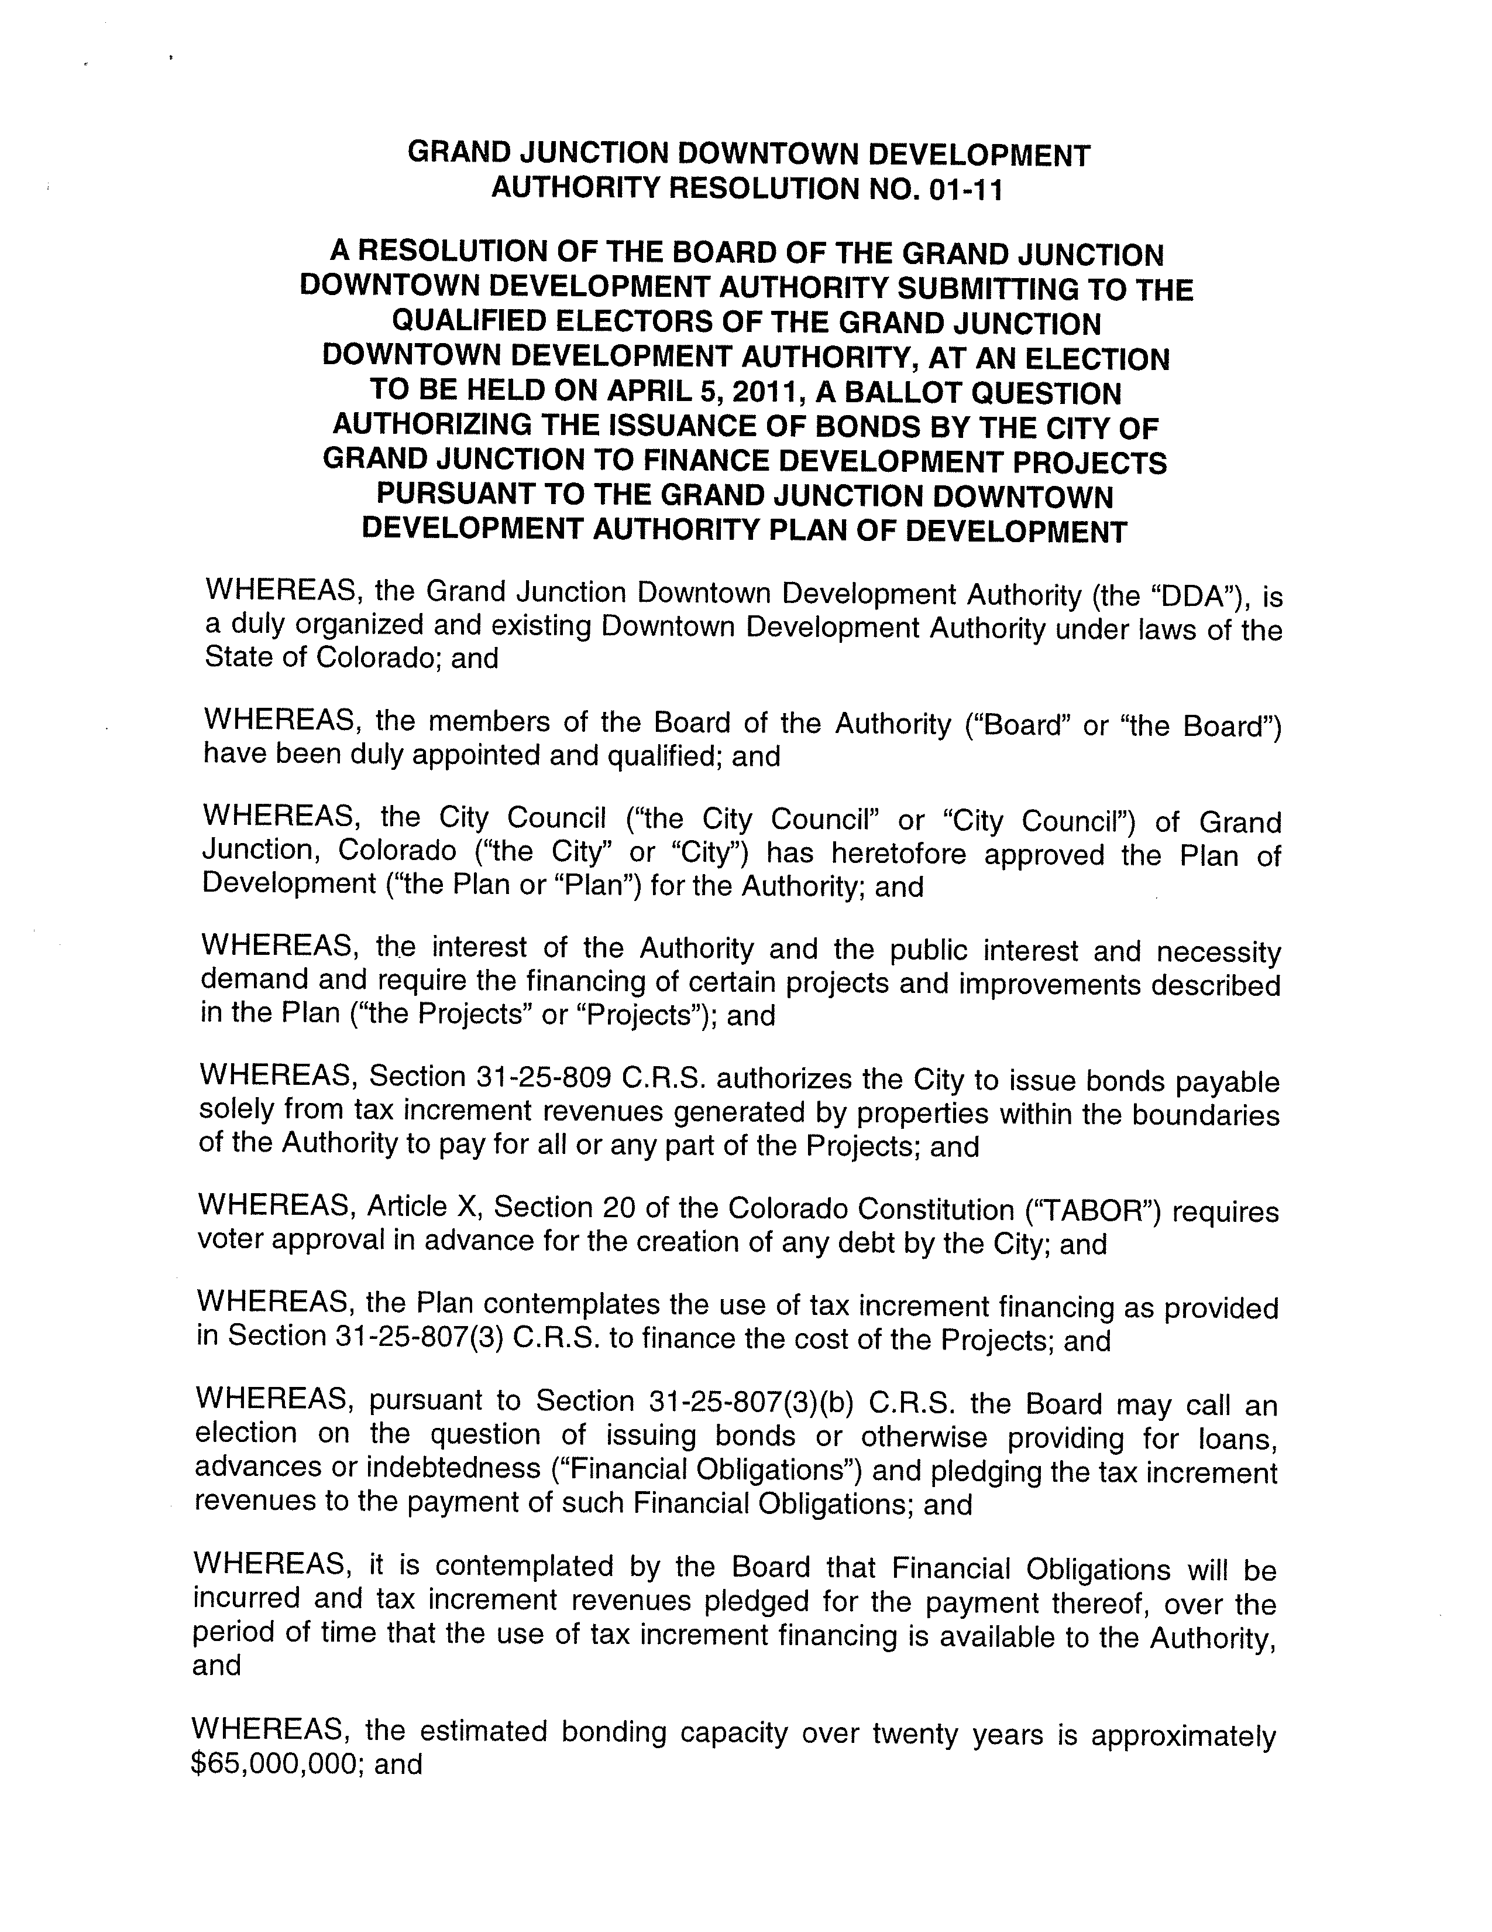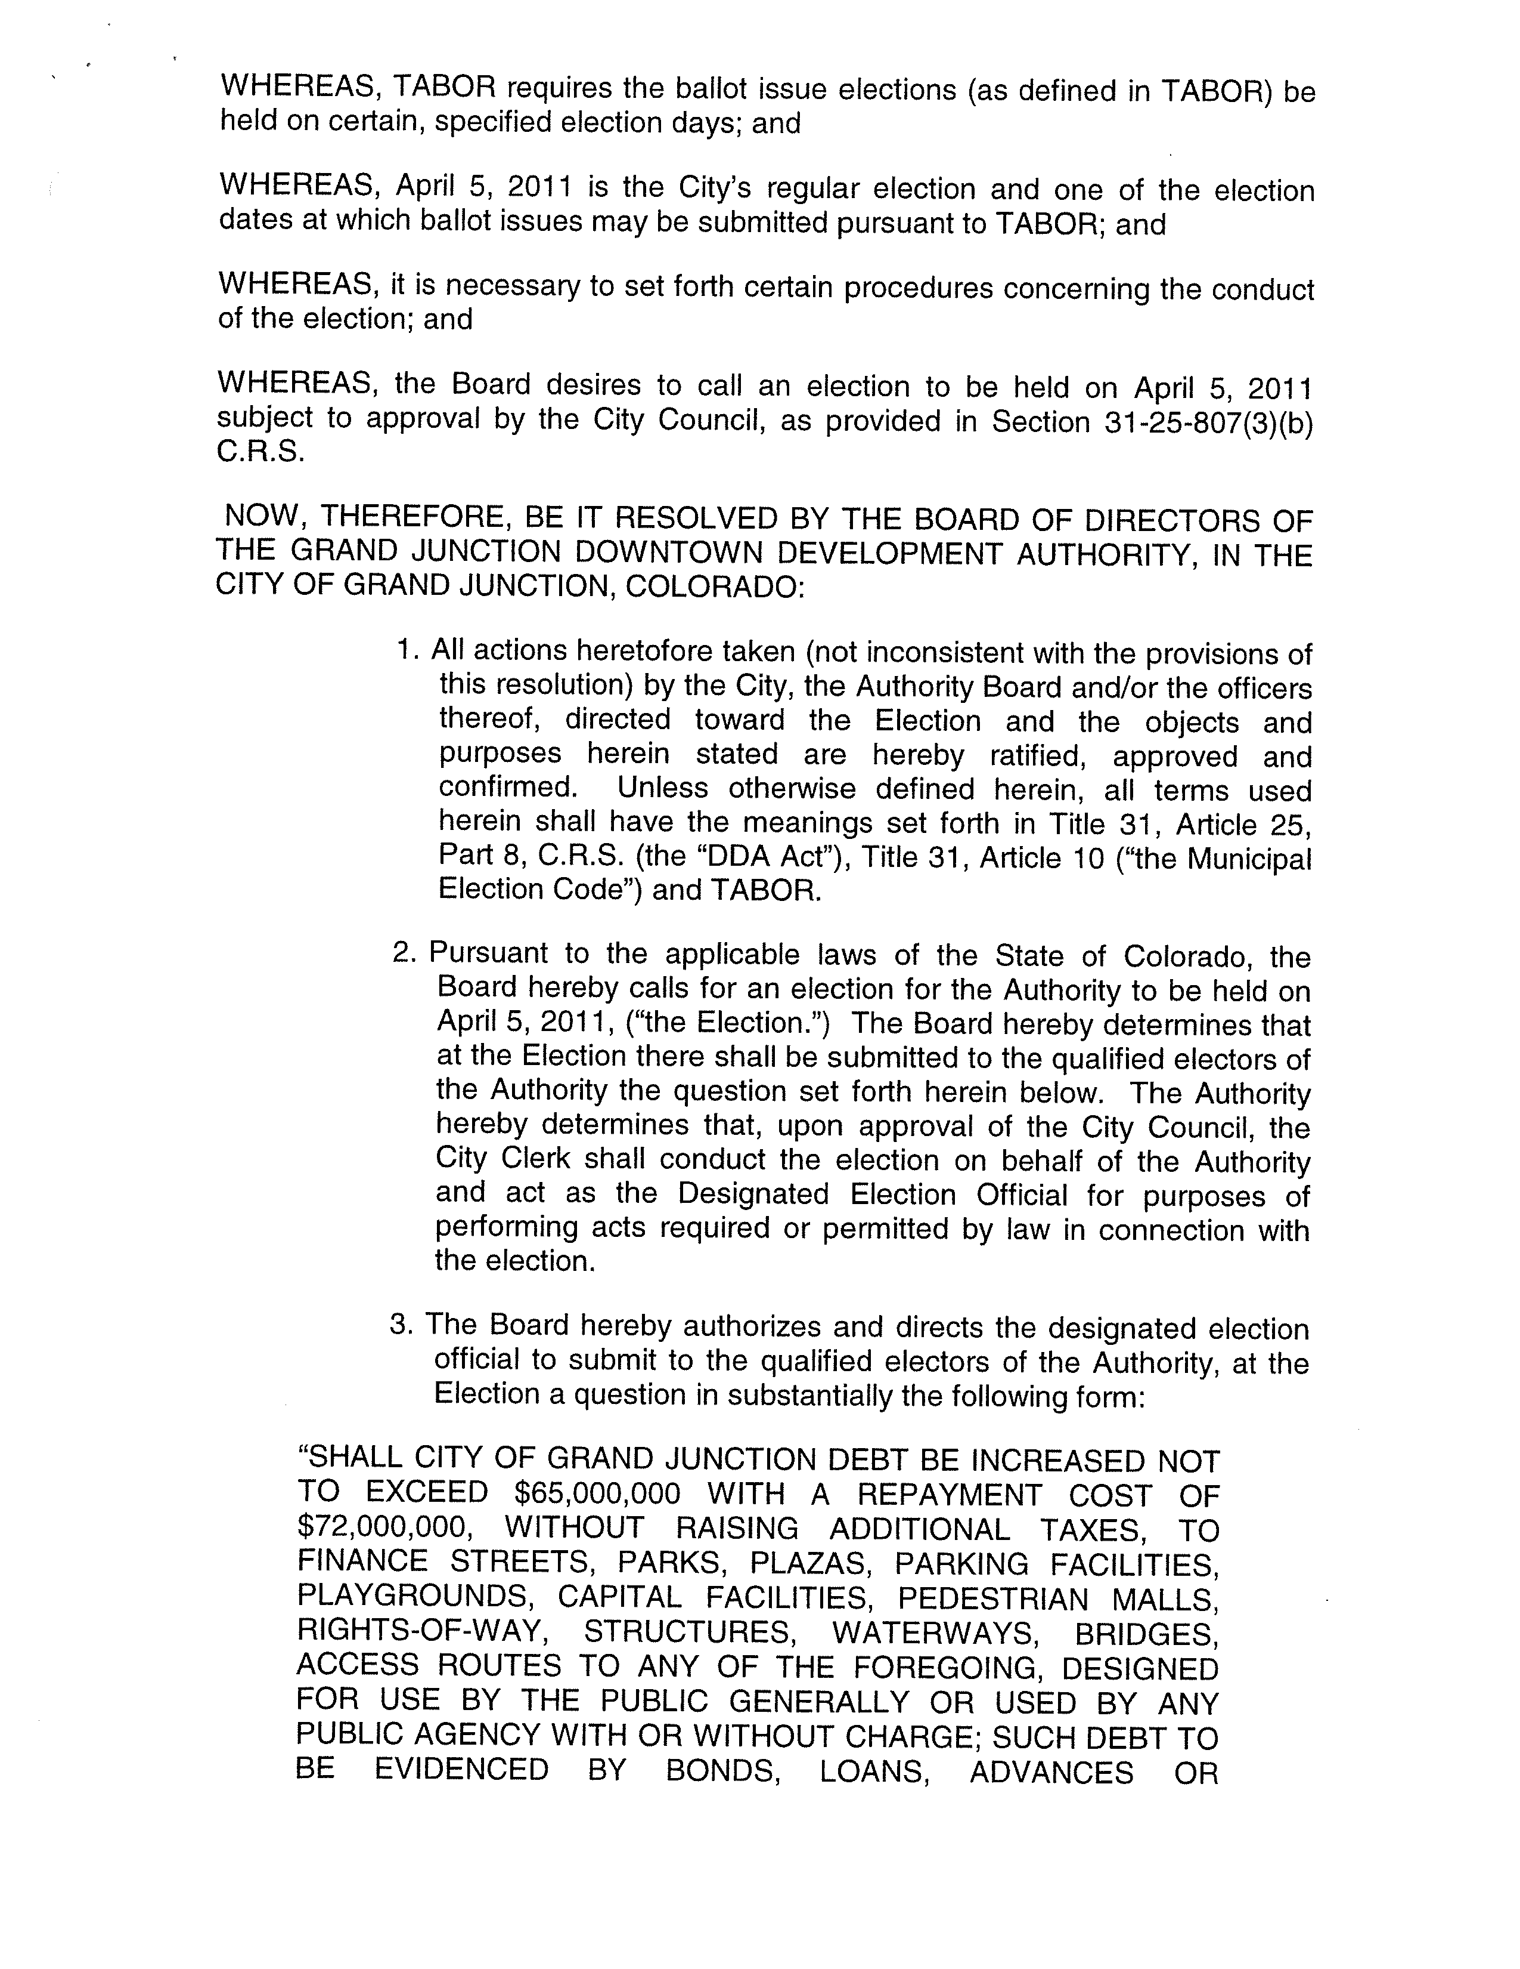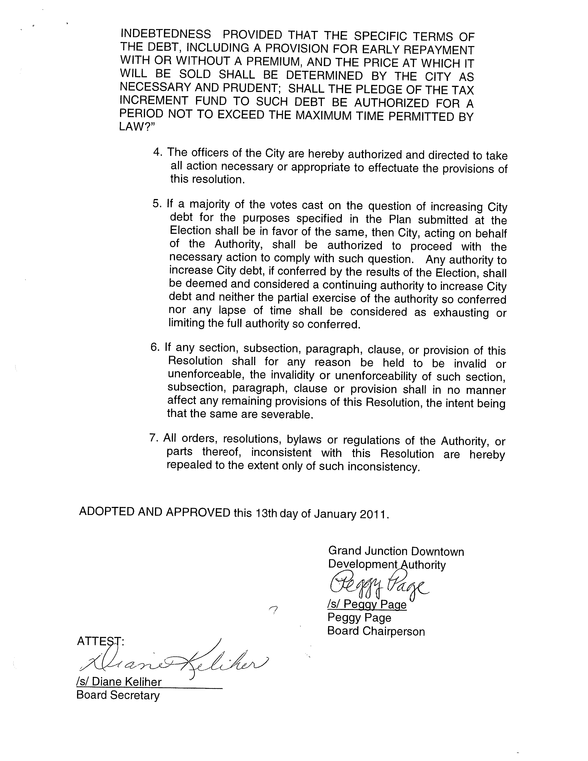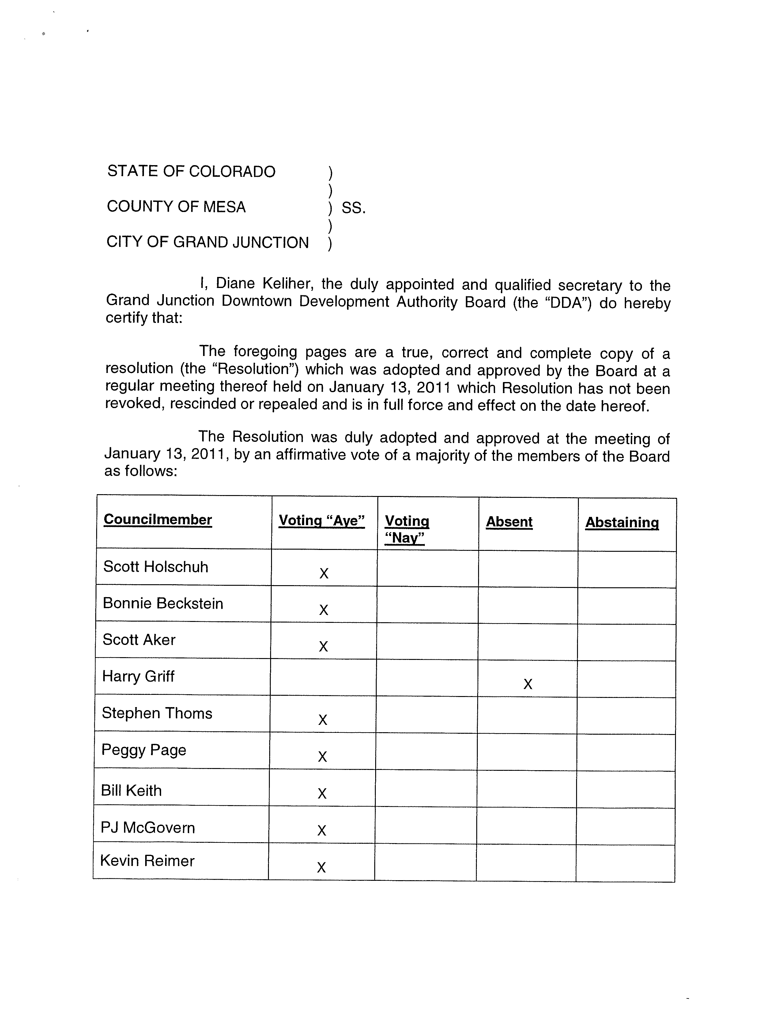

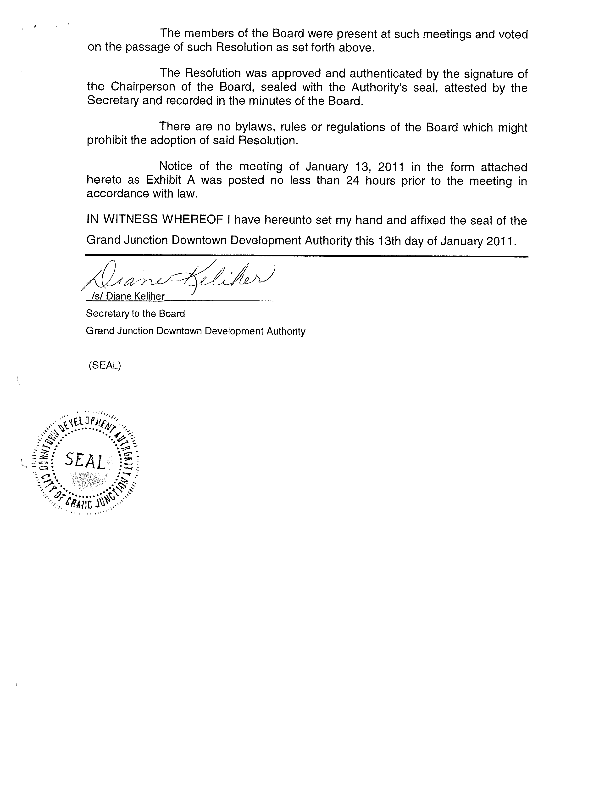


“EXHIBIT A”

Grand Junction Downtown
Development Authority (DDA)

BOARD MEETING AGENDA
Thursday, January 13, 2011, 7:30am
Whitman School, 248 South Fourth Street

7:30 am Call to Order / Roll Call

7:32 am Consent Agenda:
Approval of Agenda
Approval of Minutes – December 9, 2010

7:35 am Action Item: Ratification of Lease – Five60 Salon

7:40 am Action Item: April 2011Ballot Question

7:55 am Action Item: Reappointment of Steve Thoms to Real Estate Committee

8:00 am Action Item: Appointments to Avalon Foundation

8:10 am Executive Director’s Report

8:55 am Adjourn

Important Dates:

Next DDA meetings: January 27, February 10, February 24

Mail Ballot Plan
Coordinated or other Non-partisan Elections
Colorado Secretary of State
1700 Broadway, Suite 200
Denver, Colorado 80290
phone: 303-894-2200
Fax: 303-869-4861

Introduction

Pursuant to section 1-7.5-105 of the Colorado Revised Statutes and the Colorado Secretary of State’s Election Rule 12, the designated election official responsible for conducting a mail ballot election must submit a written mail ballot plan to the Secretary of State.

This mail ballot plan must be submitted at least sixty-five (65) days prior to a regular special district election and no later than fifty-five (55) days prior to any other coordinated or non-partisan election. Additionally, a special district may request a seven (7) day filing extension if the mail ballot plan is for a regular special district election that may be cancelled. Please see Election Rule 12.4.1 for more information.

The following standard fillable form is designed to aid you in your completion and submission of the required mail ballot plan. This form may be completed online and then saved to your computer. Once you have saved the form to your computer, you will be able to submit the entire plan to the Secretary of State’s office via email, regular mail, or fax. Please refer to the instruction section below for more complete guidance.

NOTE: Pursuant to section 1-7.5-104, C.R.S., a mail ballot election cannot be held for elections or recall elections that involve partisan candidates or elections held in conjunction with, or on the same day as, a congressional vacancy election.

Instructions
(Please read this section COMPLETELY. Failure to do so may result in undue delay in the approval of your plan.)

Spaces and check boxes are provided below for each required aspect of the mail ballot plan. Please fill out the form in its entirety, making sure to check all boxes where applicable. Additional pages may be attached to the end of the mail ballot plan if necessary.

Election Rule 12.4.1 requires the submission of a sample secrecy sleeve or envelope and a written timetable. A copy of the Secretary of State approved secrecy sleeve is included at the end of this form. Please review the secrecy sleeve and indicate your usage of the approved sleeve by checking the box associated with the secrecy sleeve (Item “21.” of the mail ballot plan). Additionally, a written timetable is provided at the end of this fillable form. Please fill in the date column of the timetable to indicate the date or range of dates for each required occurrence.

When you have checked each applicable box and supplied all required information, please save the form to your computer. Once the form is saved, you may choose your method of submittal (email, regular mail, or fax). The Secretary of State’s office requests that you email your plan as an attachment to state.electiondivision@sos.state.co.us.

Please feel free to contact Michael Hagihara via phone at 303-894-2200 ext. 6331 or via email at michael.hagihara@sos.state.co.us with any questions you may have.

Attention Home Rule Municipalities

The Secretary of State will not review the mail ballot plan of any home rule municipality that fails to read and affirm the following declaration. Please indicate your affirmation by checking the box.

x Although I am submitting this plan on behalf of a home rule municipality, this mail ballot election will be conducted in accordance with state law. As such, this plan does not contain any locally-adopted election procedures that differ from the state procedures set forth in the Colorado Mail Ballot Election Act (§§ 1-7.5-101 through 1-7.5-111, C.R.S.) or in Election Rule 12.
Name of person submitting plan: Stephanie Tuin

Address: 250 N. 5th Street, Grand Junction, CO 81501

Political Subdivision: City of Grand Junction, Downtown Development Authority

Email: stepht@gjcity.org

- Date of the election: April 5, 2011

- Type and name of the jurisdiction(s) involved in the election (Example: county, municipality, special district, school district, etc.): Municipality, City of Grand Junction; Downtown Development Authority, Grand Junction, Colorado, Downtown Development Authority; County, Mesa County

- Description of the type of election to be conducted (Example: coordinated election, recall election, special election, etc.): special election

- Citation of the statute or home rule charter provisions authorizing the election: [§1-7.5-105, C.R.S.] (please add any additional statutes authorizing the mail ballot election for the jurisdictions involved)
31-10-101 et seq., C.R.S. and Article II, Secs. 3 through 25, City of Grand Junction Charter and 31-25-801 et seq. C.R.S.

- Estimated number of eligible electors: 800

x Between twenty-two (22) and eighteen (18) days before the election, the designated election official will mail to each active registered elector a mail ballot packet.
[§1-7.5-107(3), C.R.S.]

x No later than 30 days prior to the election the designated election official will send a mail ballot packet to each active registered UOCAVA elector. [§1-8-103.5, C.R.S.]

- Name of the designated election official who will be responsible for all aspects of the election: [Rule 12.4.1] City Clerk Stephanie Tuin

- If the election is NOT being conducted by the County Clerk & Recorder, an indication of whether the County Clerk and Recorder will assist in the election for the entity other than by providing a list of registered electors and other information required by statute (Please check the appropriate box): [Rule 12.4.1]

x Yes, the County Clerk and Recorder will assist in the election for the entity other than by providing a list of registered electors and other information required by statute. (If yes, please read the following statement regarding use of county voting systems, check the corresponding box if applicable, and provide the requested information.)
x The County Clerk and Recorder will assist in the election for the entity by providing voting systems to be used by the entity during the election. The make and model number of the voting systems to be used is as follows:

Make(s): Elections System and Software Model 650, green light sensor, firmware version 2.1.0.0.

Model Number(s): 650

No, the County Clerk and Recorder will not assist in the Election for the entity other than by providing a list of registered electors and other information required by statute.

- The address and hours of operation for all “drop-off locations.” Note: For security reasons, unmonitored freestanding drop-off locations located out-of-doors are not allowed: [Rule 12.4.1]

Three # of drop-off locations

In the space below please provide the address and hours of operation for each drop-off location (attach additional pages if necessary):

City Clerk’s Office
City Hall
250 N. 5th Street
Grand Junction, Co. 81501
Hours: 7:30 a.m. – 5:30 p.m. Monday thru Friday

Mesa County Elections Office
Old Mesa County Courthouse
544 Rood Avenue Suite 301A
Grand Junction, Co. 81501
Hours: 8:00 a.m. – 5:00 p.m. Monday thru Friday

Mesa County Clerk’s Office (Motor Vehicle Division)
Mesa Mall
2424 Hwy 6 & 50, #414
Grand Junction, Co. 81505
Hours: 7:30 a.m. – 5:30 p.m. Monday thru Friday

Please check one of the boxes below:

All drop-off locations and any walk-in voting locations will be located within the political subdivision.

X At least one or all drop-off locations will be located outside of the county, municipality, or special district. Such drop-off locations are within reasonable proximity to the political subdivision or the majority of electors. The reasons for requesting permission from the Secretary of State for such drop-off locations are as follows:

The Mesa Mall location is outside the boundaries of the Downtown Development Authority. Electors in this political subdivision may receive more than one ballot. If the elector decides to drop off their ballot at the Mesa Mall location it would be inconvenient if they could not drop off both ballots. Allowing the use of the Mesa Mall drop off location is a convenience to the voter. All three drop off locations will be monitored in the same manner.

- For elections coordinated by the County Clerk and Recorder, the total number of walk-in voting locations, and the location and hours of operation for each walk-in voting location: [Rule 12.4.1]

# of walk-in voting locations

In the space below please provide the address for each walk-in location:

NA

All walk-in voting locations will be open during normal business hours from:
[§1-7.5-107(3)(c), C.R.S.]

Dates: to
Hours: to

Example:
Dates: April 12, 2010 to May 4, 2010
Hours: 8:00 a.m. to 5:00 p.m.

X Walk-in voting locations will not be utilized because this election is being conducted as an independent mail ballot election that is not coordinated with the County Clerk and Recorder.

- Number of accessible voting machines anticipated being used for walk-in voting locations in elections coordinated by the County Clerk and Recorder: [§1-5-705, C.R.S.]

# of accessible voting machines

X The use of accessible voting machines is not applicable because the election will not be coordinated by the County Clerk and Recorder.

- Length of time accessible voting machines will be available for walk-in voting in elections coordinated by the County Clerk and Recorder: (Please include the dates and hours of operation.)
Example: April 12, 2010 through May 3, 2010, 8:00 a.m. to 5:00 p.m., Monday through Friday; and 7:00 am to 7:00 pm. on May 4th.

X The use of accessible voting machines is not applicable because the election will not be coordinated by the County Clerk and Recorder.

- Please complete the written timetable near the end of this form. You must provide a date or a range of dates for each occurrence listed in the left-hand column of the timetable.

- Indication of how postage will be handled for ballot packets returned as undeliverable (Please read and indicate your compliance by checking the box):

X As the designated election official, I hereby affirm that ballot packets will be marked “DO NOT FORWARD. RETURN SERVICE REQUESTED,” “RETURN POSTAGE GUARANTEED,”,” or any other similar language that is in accordance with United States Postal Service regulations. [§1-7.5-107(3)(a), C.R.S.]

- Indication of procedures to be followed to ensure compliance with statutes and rules, including persons responsible for each stage (Please read and indicate your compliance by checking each box):

X As the designated election official, I hereby affirm that I have read and understand Article 7.5 of Title 1, C.R.S. and Secretary of State Election Rule 12 and that appropriate measures and procedures will be undertaken to ensure compliance with these statutes and rules.

If the designated election official is not the person responsible for such compliance, please check the box and indicate the person responsible:

Individual responsible for compliance:

The designated election official will supervise the distributing, handling, counting of ballots and the survey of returns in accordance with rules promulgated by the Secretary of State and will take the necessary steps to protect the confidentiality of the ballots cast and the integrity of the election. [§1-7.5-105(3), C.R.S.]

X If the designated election official is not the person responsible for such compliance, please check the box and indicate the person responsible:

Individual responsible for compliance: Mesa County Elections Director Catherine Lenhart

X The Postmaster or local postal representative has been notified of the election and provided with the design of the ballot packet to ensure that postal standards are met:

X A ballot packet has been subject to a “Tap Test” by a local postal representative to ensure that all relevant mailing information is visible through the envelope window.

X At least one ballot packet has been submitted to the local postal representative to ensure that the ballot packet has been printed correctly.

For elections where multiple ballots will be included in the same packet or will be sent in separate packets, the ballots and return envelopes shall include distinctive markings or colors to identify political subdivisions when the colors or distinctive markings will aid in the distribution and tabulation of the ballots. [Rule 12.5.2]

Not applicable for the following reason(s) (Please check all that apply):

X This election is being conducted as an independent mail ballot election that is not coordinated with the County Clerk and Recorder. However, there will be distinctive colors to distinguish between the two ballots and the outgoing envelope as well as the instructions or other notice shall have the following notice: “This may not be your only ballot. Other elections may be held by other political subdivisions by mail or by polling place.”

This election will be conducted with the use of one ballot containing all candidates and ballot issues for the coordinating jurisdictions.

For all coordinated elections where more than one mail ballot is being mailed or polling place elections are being held as well as the mail ballot election, the outgoing envelope as well as the instructions or other notice shall have the following notice: “This may not be your only ballot. Other elections may be held by other political subdivisions by mail or by polling place.” [Rule 12.5.5.] NA

X All deposited ballots will be counted as provided in Article 7.5 of Title 1, C.R.S. and by rules promulgated by the Secretary of State. A mail ballot will be valid and counted only if it is returned in the return envelope, the self-affirmation on the return envelope is signed and completed by the eligible elector to whom the ballot was issued, and the information on the return envelope is verified. [§1-7.5-107(6), C.R.S.]

X If the election official determines that an eligible elector to whom a replacement ballot has been issued has voted more than once, the first ballot returned by the elector will be considered the elector’s official ballot. [§1-7.5-107(6), C.R.S.]

- Description of procedures to be used to ensure ballot security at all stages of the process (Please read and indicate your compliance by checking each box):

X The ballot or ballot label will contain the following warning: [§1-7.5-107(3)(b), C.R.S.]

“WARNING:

Any person who, by use of force or other means, unduly influences an eligible elector to vote in any particular manner or to refrain from voting, or who falsely makes, alters, forges, or counterfeits any mail ballot before or after it has been cast, or who destroys, defaces, mutilates, or tampers with a ballot is subject, upon conviction, to imprisonment, or to a fine, or both.”

X The return envelope will have printed on it a self-affirmation substantially in the following form: [§1-7.5-107(3)(b.5)]

“I state under penalty of perjury that I am an eligible elector; that my signature and name are as shown on this envelope; that I have not and will not cast any vote in this election except by the enclosed ballot; and that my ballot is enclosed in accord with the provisions of the “Uniform Election Code of 1992.”

Date: Signature of Voter: .

X When not being processed, ballot packets will be placed in a safe, secure area under the supervision of the designated election official, election judge, or person designated by the designated election official.

X A replacement ballot may be requested if the ballot was destroyed, spoiled, lost, or not received by the elector. The elector requesting the replacement ballot must complete a sworn statement in compliance with section 1-7.5-107(3)(d)(I), C.R.S. The form may be mailed to an elector along with their mail ballot packet, however, it must be returned to the election official on or before Election Day. [§1-7.5-107(3)(d), C.R.S.]

X Ballots will not be left unattended while being processed. After processing is complete, ballots will be placed in a safe and secure area. Access to the secure area shall be determined by the County Clerk and Recorder or designated election official.

- Description of procedures for maintaining privacy and security of accessible voting machines to be used in an election coordinated by the County Clerk and Recorder (If this section does not apply to you, please check the box marked “Not applicable and then indicate the reason(s) why this section does not apply to you):

At the voter’s request, the election judge will instruct the voter on the use of the accessible machine. [Rule 9]

Each accessible voting device will be positioned as to protect each voter’s privacy while voting. [Rule 12.12.3]

For elections coordinated by the County Clerk and Recorder, a security plan will be submitted in accordance with Rule 43 in addition to the mail ballot plan, if such security plan has not already been received by the Secretary of State. [Rule 43]

In an election coordinated by the County Clerk and Recorder, if a voter surrenders a mail ballot to the designated election official and votes in-person on an accessible device provided for the election, the accessible device will be subject to the privacy, security and accuracy standards set forth in the Election Rules and Title 1, C.R.S. [Rule 12.12]

X Not applicable for the following reason(s) (Please check all that apply):

X This election is being conducted as an independent mail ballot election that is not coordinated with the County Clerk and Recorder.

X This election will be conducted with the use of paper ballots; no voting machines will be involved in this election.

- Description of procedures to be used for signature verification (Please read and indicate your compliance by checking each box. If this section does not apply to you, please check the box marked “Not applicable”.): [§1-7.5-107.3, C.R.S.]

X Not applicable as this election is being conducted as an independent mail ballot election that is not coordinated with or conducted by the County Clerk and Recorder.

An election judge will compare the signature on the self-affirmation on each return envelope with the signature of the eligible elector stored in the statewide voter registration system.

If, upon comparing the signature on the self-affirmation on the return envelope with the signature of the eligible elector stored in the statewide voter registration system, the election judge determines that the signatures do not match, two other election judges of different political party affiliations will simultaneously compare the signatures.

If both other election judges agree that the signatures do not match, the County Clerk and Recorder will, within three (3) days after the signature deficiency has been confirmed, but in no event later than two (2) days after the election day, send a letter to the eligible elector explaining the discrepancy in signatures and a form for the eligible elector to confirm that the elector returned a ballot to the County Clerk and Recorder.

If the County Clerk and Recorder receives the form within eight (8) days after the election confirming that the elector returned a ballot to the County Clerk and Recorder and enclosing a copy of the elector’s identification, and if the ballot is otherwise valid, the ballot will be counted.

If the eligible elector returns the form indicating that the elector did not return a ballot to the County Clerk and Recorder, or if the eligible elector does not return the form within eight (8) days after election day, the self-affirmation on the return envelope will be categorized as incorrect, the ballot will not be counted, and the County Clerk and Recorder will send copies of the eligible elector’s signature on the return envelope and the signature stored in the statewide voter registration system to the District Attorney for investigation.

An original return envelope with an enclosed secrecy envelope containing a voted ballot that is not counted due to a discrepancy in signatures in accordance with the above procedures will be stored under seal in the office of the County Clerk and Recorder in a secure location separate from valid return envelopes and may be removed only under the authority of the District Attorney or by order of a court having jurisdiction.

In the case of a disagreement among the election judges as to whether the signature of an eligible elector on the self-affirmation on the return envelope matches the signature of the eligible elector stored in the statewide voter registration system, the mail ballot will be counted in the same manner as ballots received in valid, verified return envelopes.

An election judge will not determine that the signature of an eligible elector on the self-affirmation does not match the signature of that eligible elector stored in the statewide voter registration system solely on the basis of substitution of initials or use of a common nickname.

- Description of Procedures to be used for ballots returned by electors who have not previously voted in Colorado and have failed to include proper proof of identification: [§ 1-7.5-107(3.5)(d), C.R.S.]

X Upon receipt of a mail ballot, from an elector who has not previously voted in Colorado, which does not contain a proper form of identification as required under section 1-7.5-107(3.5)(b), C.R.S., the designated election official will, within three (3) days after receipt of the mail ballot, but in no event later than two (2) days after election day, send to the eligible elector a letter explaining the lack of compliance with section 1-7.5-107(3.5)(b), C.R.S.

X If the designated election official receives a copy of identification in compliance with section 1-7.5-107(3.5)(b), C.R.S. within eight (8) days after election day, and if the mail ballot is otherwise valid, the mail ballot will be counted.

- Description of procedures to ensure privacy by use of a secrecy sleeve or secrecy envelope so receiving judges cannot tell how the elector voted (Please read and indicate your compliance by checking the box):

X To protect the voter’s privacy, a secrecy sleeve or envelope will be included in the mail ballot package. [§1-7.5-106(1), C.R.S.]

- Description of procedures to be used to reconcile ballots issued, ballots received, defective ballots and substitute ballots (Please read and indicate your compliance by checking each box):

X Ballots will be date stamped upon receipt. Each day when ballots come in, a judge will count the ballots, batch them, and record the number of ballots received including those that were returned as undeliverable. [Rule 12.7.3]

X The designated election official or the County Clerk and Recorder will maintain a daily reconciliation log containing the number of ballots issued, returned, and outstanding. [Rule 12.7.2]

- Please review the Secretary of State approved Secrecy Sleeve with Voter Instructions at the bottom of this fillable form. (Please read the following statement and indicate your compliance by checking the box):

X As the designated election official, I hereby affirm that the Secretary of State approved secrecy sleeve with voter instructions or voter instructions page as included at the end of this form will be used in the mail ballot election.

X As the designated election official, I hereby affirm that the political jurisdiction will be using the attached secrecy sleeve, which is in substantial compliance with the requirements set forth by the Secretary of State.

Date copy of written plan was submitted to the governing body [Rule 12.4.1] | 01/31/2011
Date of approval of election by governing body [Rule 12.4.1] | 01/31/2011
Date by which local jurisdictions must submit notice of election to the County Clerk  and Recorder if the County Clerk will assist with the election (no later than 40 days  before the election) [§1-5-303(1), C.R.S.; Rule 12.4.1] | 2/24/2011
Date by which local jurisdictions must submit notice of election to the county assessor,  if property owners are eligible to vote in the election (no later than 40 days before the  election) [§1-5-304(1), C.R.S.] | 2/24/2011
Date by which the County Clerk and Recorder must submit the list of eligible  electors to the local jurisdiction conducting the mail ballot election.  Also, for special district elections, the date by which the county assessor must submit  the list of property owners who are eligible to vote in the election to the jurisdiction.  (No later than 30 days before the election) [§1-7.5-107(2), C.R.S.] | 3/4/2011
Date of close of registration (29 days before the election) [§1-2-201(3), C.R.S.] | 3/7/2011
Date ballots will be mailed (no sooner than 22 days before the election and no later  than 18 days before the election) [§1-7.5-107(3), C.R.S.] | 3/14/2011 through  3/18/2011
Date ballots will be made available at the designated election official’s office,  or the office designated in the Mail Ballot Plan (no sooner than 22 days prior to the  election) [§1-7.5-107(3), C.R.S.] | 3/14/2011
Date by which the County Clerk and Recorder must submit a supplemental list of  eligible electors to the local jurisdiction conducting the mail ballot election.  Also, for special district elections, the date by which the county assessor must submit  a supplemental list of property owners who are eligible to vote in the election to the  jurisdiction. (No later than 20 days before the election) [§1-7.5-107(2), C.R.S.] | 3/16/2011
Date of publication of notice of election, including information regarding walk-in voting  and accessible voting options.(no later than 20 days before the election)  [§§1-5-705, 1-7.5-107(2.5), C.R.S.] | 3/16/2011
Date verification and counting of ballots will begin (counting may begin 15 days  before the election) [§1-7.5-107.5, C.R.S.] | 3/21/2011
Date of Election | 4/5/2011

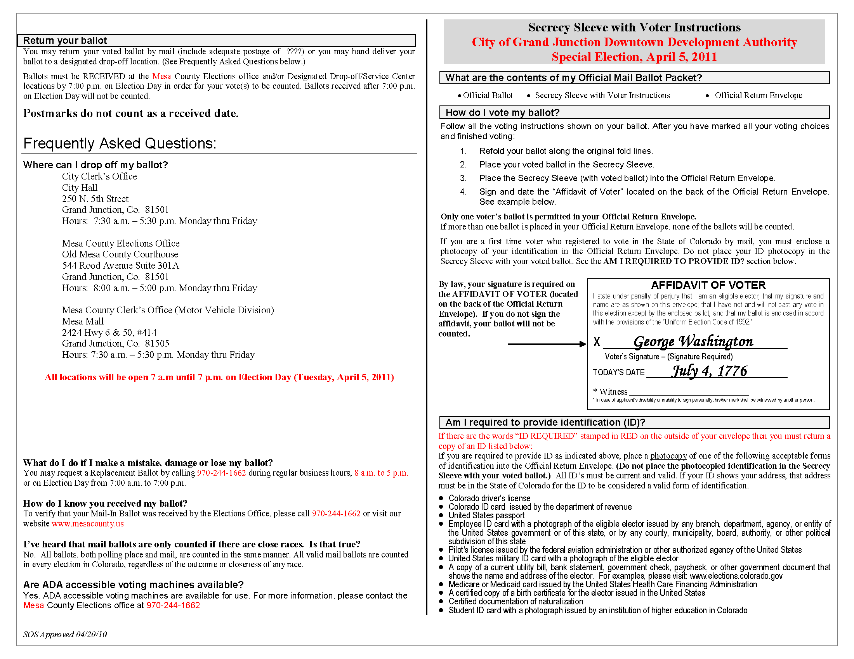

Thank you for accessing the mail ballot plan online form. Please save this form to your computer so that it may be submitted to our office upon completion. Forms should be submitted via email (state.electiondivision@sos.state.co.us).

Please feel free to contact Michael Hagihara via phone at 303-894-2200 ext. 6331 or via email at michael.hagihara@sos.state.co.us with any questions you may have.

