RESOLUTION NO. 14-11

A RESOLUTION CONCERNING
THE ISSUANCE OF A REVOCABLE PERMIT TO
JOHN O. SPENDRUP LLC

Recitals.

A. John O Spendrup LLC, hereinafter referred to as the Petitioner, represent it is the owner of the following described real property in the City of Grand Junction, County of Mesa, State of Colorado, to wit:

BEG N4 COR SEC 23 1S 1W S ALG W LI OF NE4 53.3FT E 132FT N 53.3FT W 132FT TO BEG

Identified by Mesa County Tax Schedule Number 2945-231-00-001

B. The Petitioner has requested that the City Council of the City of Grand Junction issue a Revocable Permit for an existing structure, originally designed for lumber storage, within the following described portion of public right-of-way:

A portion of 7th Street situate in the NE1/4 of Section 23, Township One South, Range one West of the Ute Meridian in the City of Grand Junction, Mesa County, Colorado, more particularly described as follows:

Commencing at a two-inch pipe monument for the S1/4 Corner of said Section 14, whence an alloy cap for the N1/16 Corner of Section 23, Township One South, Range One West of the Ute Meridian bears S0011’26”W a distance of 1315.10 feet, more or less, thence S8950’40”E for a distance of 128.97 feet to the west line of said 7th Street and the Point of Beginning; thence the following four courses and distances:
- S8950’40”E for a distance of 2.50 feet;
- S0028’16”E, parallel with the west line of said 7th Street, for a distance of 53.30 feet;
- N8950’40”W for a distance of 2.50 feet;
- N0028’16”W, on the west line of said 7th Street, for a distance of 53.30 feet to the beginning.

Containing approximately 133 square feet.

See also attached Exhibit A

C. Relying on the information supplied by the Petitioner and contained in File No. RVP-2011-536 in the office of the City’s Public Works and Planning Department, the City Council has determined that such action would not at this time be detrimental to the inhabitants of the City of Grand Junction.

D. The Petitioner is successor in interest to the following described real property in the City of Grand Junction, County of Mesa, State of Colorado, to wit:

LOTS 1 TO 15 INC BLK 160 GRAND JUNCTION

Identified by Mesa County Tax Schedule Number 2945-143-42-001

E. The Petitioner has demonstrated that revocable permit issued for structures on the above described property have been demolished and that said revocable permit, recorded February 4, 1965 in Book 879, Pages 128-129 of the records of the Mesa County Clerk and Recorder and attached herein as Exhibit B, is no longer necessary and request that it be revoked.

F. Relying on the information supplied by the Petitioner and contained in File No. RVP-2011-536 in the office of the City’s Public Works and Planning Department, the City Council has determined that such action would not at this time be detrimental to the inhabitants of the City of Grand Junction.

NOW, THEREFORE, BE IT RESOLVED BY THE CITY COUNCIL OF THE CITY OF GRAND JUNCTION, COLORADO:

1. That the City Manager is hereby authorized and directed to issue the attached Revocable Permit to the above-named Petitioner for the purpose aforedescribed and within the limits of the public right-of-way aforedescribed, subject to each and every term and condition contained in the attached Revocable Permit.

2. That the Revocable Permit recorded February 4, 1965 in Book 879, Pages 128-129 of the records of the Mesa County Clerk and Recorder and attached herein as Exhibit B, is no longer necessary and is hereby revoked.

PASSED and ADOPTED this 28th day of February, 2011.

Attest:
/s/ Teresa A. Coons
President of the City Council
/s/ Stephanie Tuin
City Clerk

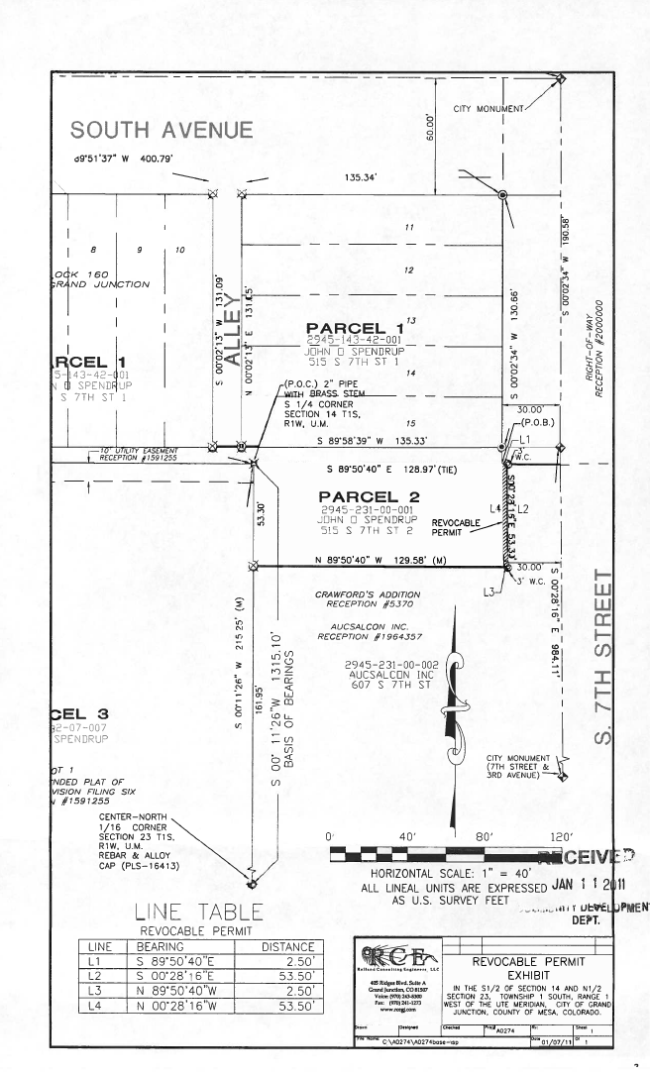
Exhibit A

REVOCABLE PERMIT

Recitals.

A. John O Spendrup LLC, hereinafter referred to as the Petitioner, represent it is the owner of the following described real property in the City of Grand Junction, County of Mesa, State of Colorado, to wit:

BEG N4 COR SEC 23 1S 1W S ALG W LI OF NE4 53.3FT E 132FT N 53.3FT W 132FT TO BEG

Identified by Mesa County Tax Schedule Number 2945-231-00-001

B. The Petitioner has requested that the City Council of the City of Grand Junction issue a Revocable Permit for an existing structure, originally designed for lumber storage, within the following described portion of public right-of-way:

A portion of 7th Street situate in the NE1/4 of Section 23, Township One South, Range one West of the Ute Meridian in the City of Grand Junction, Mesa County, Colorado, more particularly described as follows:

Commencing at a two-inch pipe monument for the S1/4 Corner of said Section 14, whence an alloy cap for the N1/16 Corner of Section 23, Township One South, Range One West of the Ute Meridian bears S0011’26”W a distance of 1315.10 feet, more or less, thence S8950’40”E for a distance of 128.97 feet to the west line of said 7th Street and the Point of Beginning; thence the following four courses and distances:
- S8950’40”E for a distance of 2.50 feet;
- S0028’16”E, parallel with the west line of said 7th Street, for a distance of 53.30 feet;
- N8950’40”W for a distance of 2.50 feet;
- N0028’16”W, on the west line of said 7th Street, for a distance of 53.30 feet to the beginning.

Containing approximately 133 square feet.

See also attached Exhibit

C. Relying on the information supplied by the Petitioner and contained in File No. RVP-2011-536 in the office of the City’s Public Works and Planning Department, the City Council has determined that such action would not at this time be detrimental to the inhabitants of the City of Grand Junction.

NOW, THEREFORE, IN ACCORDANCE WITH THE ACTION OF THE CITY COUNCIL OF THE CITY OF GRAND JUNCTION, COLORADO:

There is hereby issued to the above-named Petitioner a Revocable Permit for the purpose aforedescribed and within the limits of the public right-of-way aforedescribed; provided, however, that the issuance of this Revocable Permit shall be conditioned upon the following terms and conditions:

1. The Petitioner’s use and occupancy of the public right-of-way as authorized pursuant to this Permit shall be performed with due care or any other higher standard of care as may be required to avoid creating hazardous or dangerous situations and to avoid damaging public improvements and public utilities or any other facilities presently existing or which may in the future exist in said right-of-way.

2. The City hereby reserves and retains a perpetual right to utilize all or any portion of the aforedescribed public right-of-way for any purpose whatsoever. The City further reserves and retains the right to revoke this Permit at any time and for any reason.

3. The Petitioner, for itself and for its successors, assigns and for all persons claiming through the Petitioner, agrees that it shall defend all efforts and claims to hold, or attempt to hold, the City of Grand Junction, its officers, employees and agents, liable for damages caused to any property of the Petitioner or any other party, as a result of the Petitioner’s occupancy, possession or use of said public right-of-way or as a result of any City activity or use thereof or as a result of the installation, operation, maintenance, repair and replacement of public improvements.

4. The Petitioner agrees that it shall at all times keep the above described public right-of-way in good condition and repair.

5. This Revocable Permit shall be issued only upon the concurrent execution by the Petitioner of an agreement that the Petitioner and the Petitioner’s successors and assigns shall save and hold the City of Grand Junction, its officers, employees and agents harmless from, and indemnify the City, its officers, employees and agents, with respect to any claim or cause of action however stated arising out of, or in any way related to, the encroachment or use permitted, and that upon revocation of this Permit by the City the Petitioner shall, at the sole cost and expense of the Petitioner, within thirty (30) days of notice of revocation (which may occur by mailing a first class letter to the last known address), peaceably surrender said public right-of-way and, at its own expense, remove any encroachment so as to make the aforedescribed public right-of-way available for use by the City or the general public. The provisions concerning holding harmless and indemnity shall survive the expiration, revocation, termination or other ending of this Permit.

6. This Revocable Permit, the foregoing Resolution and the following Agreement shall be recorded by the Petitioner, at the Petitioner’s expense, in the office of the Mesa County Clerk and Recorder.

Dated this day of , 2010.

The City of Grand Junction,
a Colorado home rule municipality
Attest:

City Clerk City Manager

Acceptance by the Petitioner:

John O Spendrup LLC

AGREEMENT

John O Spendrup LLC, for themselves and for their successors and assigns, do hereby agree to:

(a) Abide by each and every term and condition contained in the foregoing Revocable Permit;

(b) Indemnify and hold harmless the City of Grand Junction, its officers, employees and agents with respect to all claims and causes of action, as provided for in the approving Resolution and Revocable Permit;

(c) Within thirty (30) days of revocation of said Permit by the City Council, peaceably surrender said public right-of-way to the City of Grand Junction;

(d) At the sole cost and expense of the Petitioner, remove any encroachment so as to make said public right-of-way fully available for use by the City of Grand Junction or the general public.

Dated this day of , 2011.

By:
John O Spendrup LLC

State of Colorado )
)ss.
County of Mesa )

The foregoing Agreement was acknowledged before me this___ day of ________________, 2011, by _______________________ for John O Spendrup LLC

My Commission expires:
Witness my hand and official seal.

Notary Public

