RESOLUTION NO. 36-11

A RESOLUTION AUTHORIZING THE LEASE OF SIDEWALK
RIGHT-OF-WAY TO SKIPPER’S ICE CREAM PARLOR DBA GELATO JUNCTION

Recitals:

The City has negotiated an agreement for Skipper’s Ice Cream Parlor DBA Gelato Junction to lease a portion of the sidewalk right-of-way located in front of 449 Main Street from the City for use as outdoor dining; and

The City Council deems it necessary and appropriate that the City lease said property to Skipper’s Ice Cream Parlor DBA Gelato Junction.

NOW, THEREFORE, BE IT RESOLVED BY THE CITY COUNCIL OF THE CITY OF GRAND JUNCTION, COLORADO:

The City Manager is hereby authorized and directed to sign the Lease Agreement leasing the city-owned sidewalk right-of-way for a period of four and a half months for $52.50 to Skipper’s Ice Cream Parlor DBA Gelato Junction.

PASSED and ADOPTED this 6th day of July, 2011.

/s/: Tom Kenyon President of the Council
Attest:

/s/: Stephanie Tuin
City Clerk

DOWNTOWN OUTDOOR DINING LEASE AGREEMENT

THIS LEASE AGREEMENT (“Agreement”) is made and entered into as of June 1, 2011, by and between THE CITY OF GRAND JUNCTION, COLORADO, a municipal corporation, as Lessor, hereinafter City and, Skipper’s Ice Cream Parlor DBA Gelato Junction as Lessee, hereinafter Lessee.

RECITALS:

The City by Ordinance No. 3650 and subsequently amended by Ordinance No. 4120 established a Sidewalk Restaurant commercial activity permit for restaurants in the Downtown Shopping Park (DSP) on Main Street, Seventh Street and Colorado Avenue.

In accordance with that authority the City Council and the Downtown Development Authority (DDA) desire to make certain areas of the sidewalk in the DSP available by lease to approximate land owners and/or lessees that want to make use of a portion of the sidewalk in the DSP for restaurant and/or alcohol service.

NOW THEREFORE, in consideration of the mutual covenants, terms and conditions contained herein, it is agreed as follows:

- The City does hereby lease to Lessee approximately 140 square feet of the sidewalk in the DSP located in front of 449 Main Street, hereinafter the Leased Area; specifically the Leased Area is that portion of the sidewalk immediately across the sidewalk from the Lessee’s business. The Leased Area is depicted on the attached Exhibit A. A brief description of the Lessee’s business is depicted on the attached Exhibit B.

- The term of this lease shall be for a period beginning on July 6, 2011, and terminating on November 15, 2011. Rent shall be calculated at $1.00 per square foot per year. As rent for the Leased Area, Lessee agrees to pay the City the total sum of $52.50 (140 SF x $1/SF/yr x 4.5 months), which sum shall be payable in advance on or before July 6, 2011, at the offices of the City Clerk, Grand Junction City Hall, 250 North 5th Street, Grand Junction, Colorado 81501.

If the rent payment is not paid in full when due, a Lease shall not issue.

4. Lessee agrees to use the Leased Area for the sole purpose of selling and dispensing food and/or beverages to the public. The Leased Area shall be open to the public, weather permitting, during the Lessee’s normal business hours but in no event shall food and/or beverage service be extended beyond 1:00 am. Food shall be available to be served in the Leased Area during all hours that it is open to the public and in accordance with the Lessee’s liquor license if lessee holds a valid liquor license.

5. Lessee further agrees to use the Leased Area for no purpose prohibited by the laws of the United States, the State of Colorado or ordinances of the City of Grand Junction. Further, Lessee agrees to comply with all reasonable recommendations by DDA relating to the use of the Leased Area. Prior to alcohol service in the leased area, the Lessee shall modify its liquor licensed premises as required by the laws of the State and City. Modification of the licensed premises, in accordance with Colorado law, is a precondition to the authority in this lease.

6. Pursuant to this Lease, Lessee understands and agrees that upon termination of the lease, Lessee shall remove any and all improvements, enclosures, furniture, fixtures, equipment or structures installed by it or at its direction in the Leased Area promptly upon expiration of this Lease. All modification shall be at the Lessee's sole expense. Failure to remove the same within ten (10) days of expiration shall result in ownership thereof transferring to the City and/or DDA.

7. Lessee agrees to keep the Leased Area in good repair and free from all litter, dirt and debris and in a clean and sanitary condition; to neither permit nor suffer any disorderly conduct or nuisance whatsoever, which would annoy or damage other persons or property by any alteration to the Leased Area or by any injury of accident occurring thereon. Further, Lessee does, by execution of this Lease, indemnify and hold harmless the City of Grand Junction and the DDA and its employees, elected and appointed officials, against any and all claims for damages or personal injuries arising from the use of the Leased Area. Lessee agrees to furnish certificates(s) of insurance as proof that it has secured and paid for a policy of public liability insurance covering all public risks related to the leasing, use, occupancy, maintenance and operation of the Leased Area. Insurance shall be procured from a company authorized to do business in the State of Colorado and be satisfactory to the City. The amount of insurance, without co-insurance clauses, shall not be less than the maximum liability that can be imposed upon the City under the laws of the State, as amended. Lessee shall name the City and the DDA as named insureds on all insurance policies and such policies shall include a provision that written notice of any non-renewal, cancellation or material change in a policy by the insurer shall be delivered to the City no less than ten (10) days in advance of the effective date.

8. All construction, improvements, furniture, fixtures and/or equipment on the Leased Area shall comply with the following:

a. Not be wider than the street frontage of the business nor extend to the extent that pedestrian traffic is impeded. Pedestrian passage must be a minimum of 8’ between any permanent fixtures, including fences, planters, art pedestals, and any other fixed object. Exceptions to this minimum (installed prior to June 13, 2011) may not be modified to decrease the pedestrian passage any further for any reason.

b. No portion of the Lessee’s furniture, fixtures or equipment shall extend beyond the boundaries of the Leased Area; this shall be construed to include perimeter enclosures, planters, signs, tables, chairs, shade structures, umbrellas while closed or open and any other fixtures, furniture or equipment placed or utilized by the Lessee.

c. A fence may be required for other Leased Areas if the Lessee has encroached outside of the perimeter during previous Lease periods.

e. No cooking shall be located on the Leased Area.

f. Lessee may place furniture, fixtures and equipment in the Leased Area so long as the same are not allowed to encroach into the public right of way or otherwise to endanger any passerby or patron and are secured to resist wind.

g. The Lessee shall allow its fixtures to remain in place at its own discretion and liability and shall accept and retain full responsibility and liability for any damage to such fixtures caused thereby.

h. Neither electric (alternating current) nor gaslights are allowed on the Leased Area. Candles and battery powered lights are allowed.

i. The Lessee shall store all fixtures, including but not limited to umbrellas, chairs, tables, and signs for the period of November 15 to March 30.

j. On and after March 1, 2012 the Lessee shall not allow signage, including but not limited to banners, on the Leased Area. Similarly signage shall be disallowed on furniture, which includes but is not limited to, chairs, benches, tables, umbrellas, planters and the perimeter fence of the Leased Area. Menu signs shall be allowed in accordance with provisions of the City of Grand Junction sign code and subject to review by the DDA.

k. The Lessee shall not utilize public trash or recycling receptacles for refuse generated within the leased area. The Lessee may provide a private trash and/or recycling receptacle within the leased area provided that it is emptied and maintained on a regular basis.

9. The leased premises and improvements, additions and fixtures, furniture and equipment thereon shall be maintained and managed by Lessee.

10 Lessee agrees to permit agents of the City and/or the DDA to enter upon the premises at any time to inspect the same and make any necessary repairs or alterations to the sidewalks, utilities, meters or other public facilities as the City may deem necessary or proper for the safety, improvement, maintenance or preservation thereof.

Lessee further agrees that if the City shall determine to make changes or improvements to the DSP, which may affect any improvements placed by the Lessee, that the Lessee, by execution of this Agreement, hereby waives any and all right to make any claim for damages to the improvements (or to its leasehold interest) and agrees to remove any structures necessary during such construction periods. The City agrees to rebate all rents in the event it undertakes major structural changes during a lease period.

11. The City by this demise hereby conveys no rights or interest in the public way except the right to the uses on such terms and conditions as are above described and retains all title thereto.

12. Lessee agrees not to sublet any portion of the Leased Area, not to assign this lease without the prior written consent of the City being first obtained.

13. Lessee hereby affirms that Lessee is the owner and/or lessee of the abutting property and agrees that on sale or other transfer of such ownership interest, Lessee will so notify the City of the transfer in interest and all right and interest under this Lease shall terminate.

14. Lessee agrees to surrender and deliver up the possession of the Leased Area promptly upon the expiration of this Lease or upon five (5) days’ written notice in the case of the termination of this Lease by City by reason of a breach in any provisions hereof.

15. If legal action is taken by either party hereto to enforce any of the provisions of this Lease, the prevailing party in any legal action shall be entitled to recover from the other party all of its cost, including reasonable attorney’s fees.

16. It is further agreed that no assent, expressed or implied, to any breach of any one or more of the covenants or agreements herein shall be deemed or taken to be a waiver of any succeeding or any other breach.

17. Lessee agrees to comply with all laws, ordinances, rules and regulations that may pertain or apply to the Leased Area and its use. In performing under the Lease, Lessee shall not discriminate against any worker, employee or job applicant, or any member of the public because of race, color, creed, religion, ancestry, national origin, sex, age, marital status, physical handicap, status or sexual orientation,
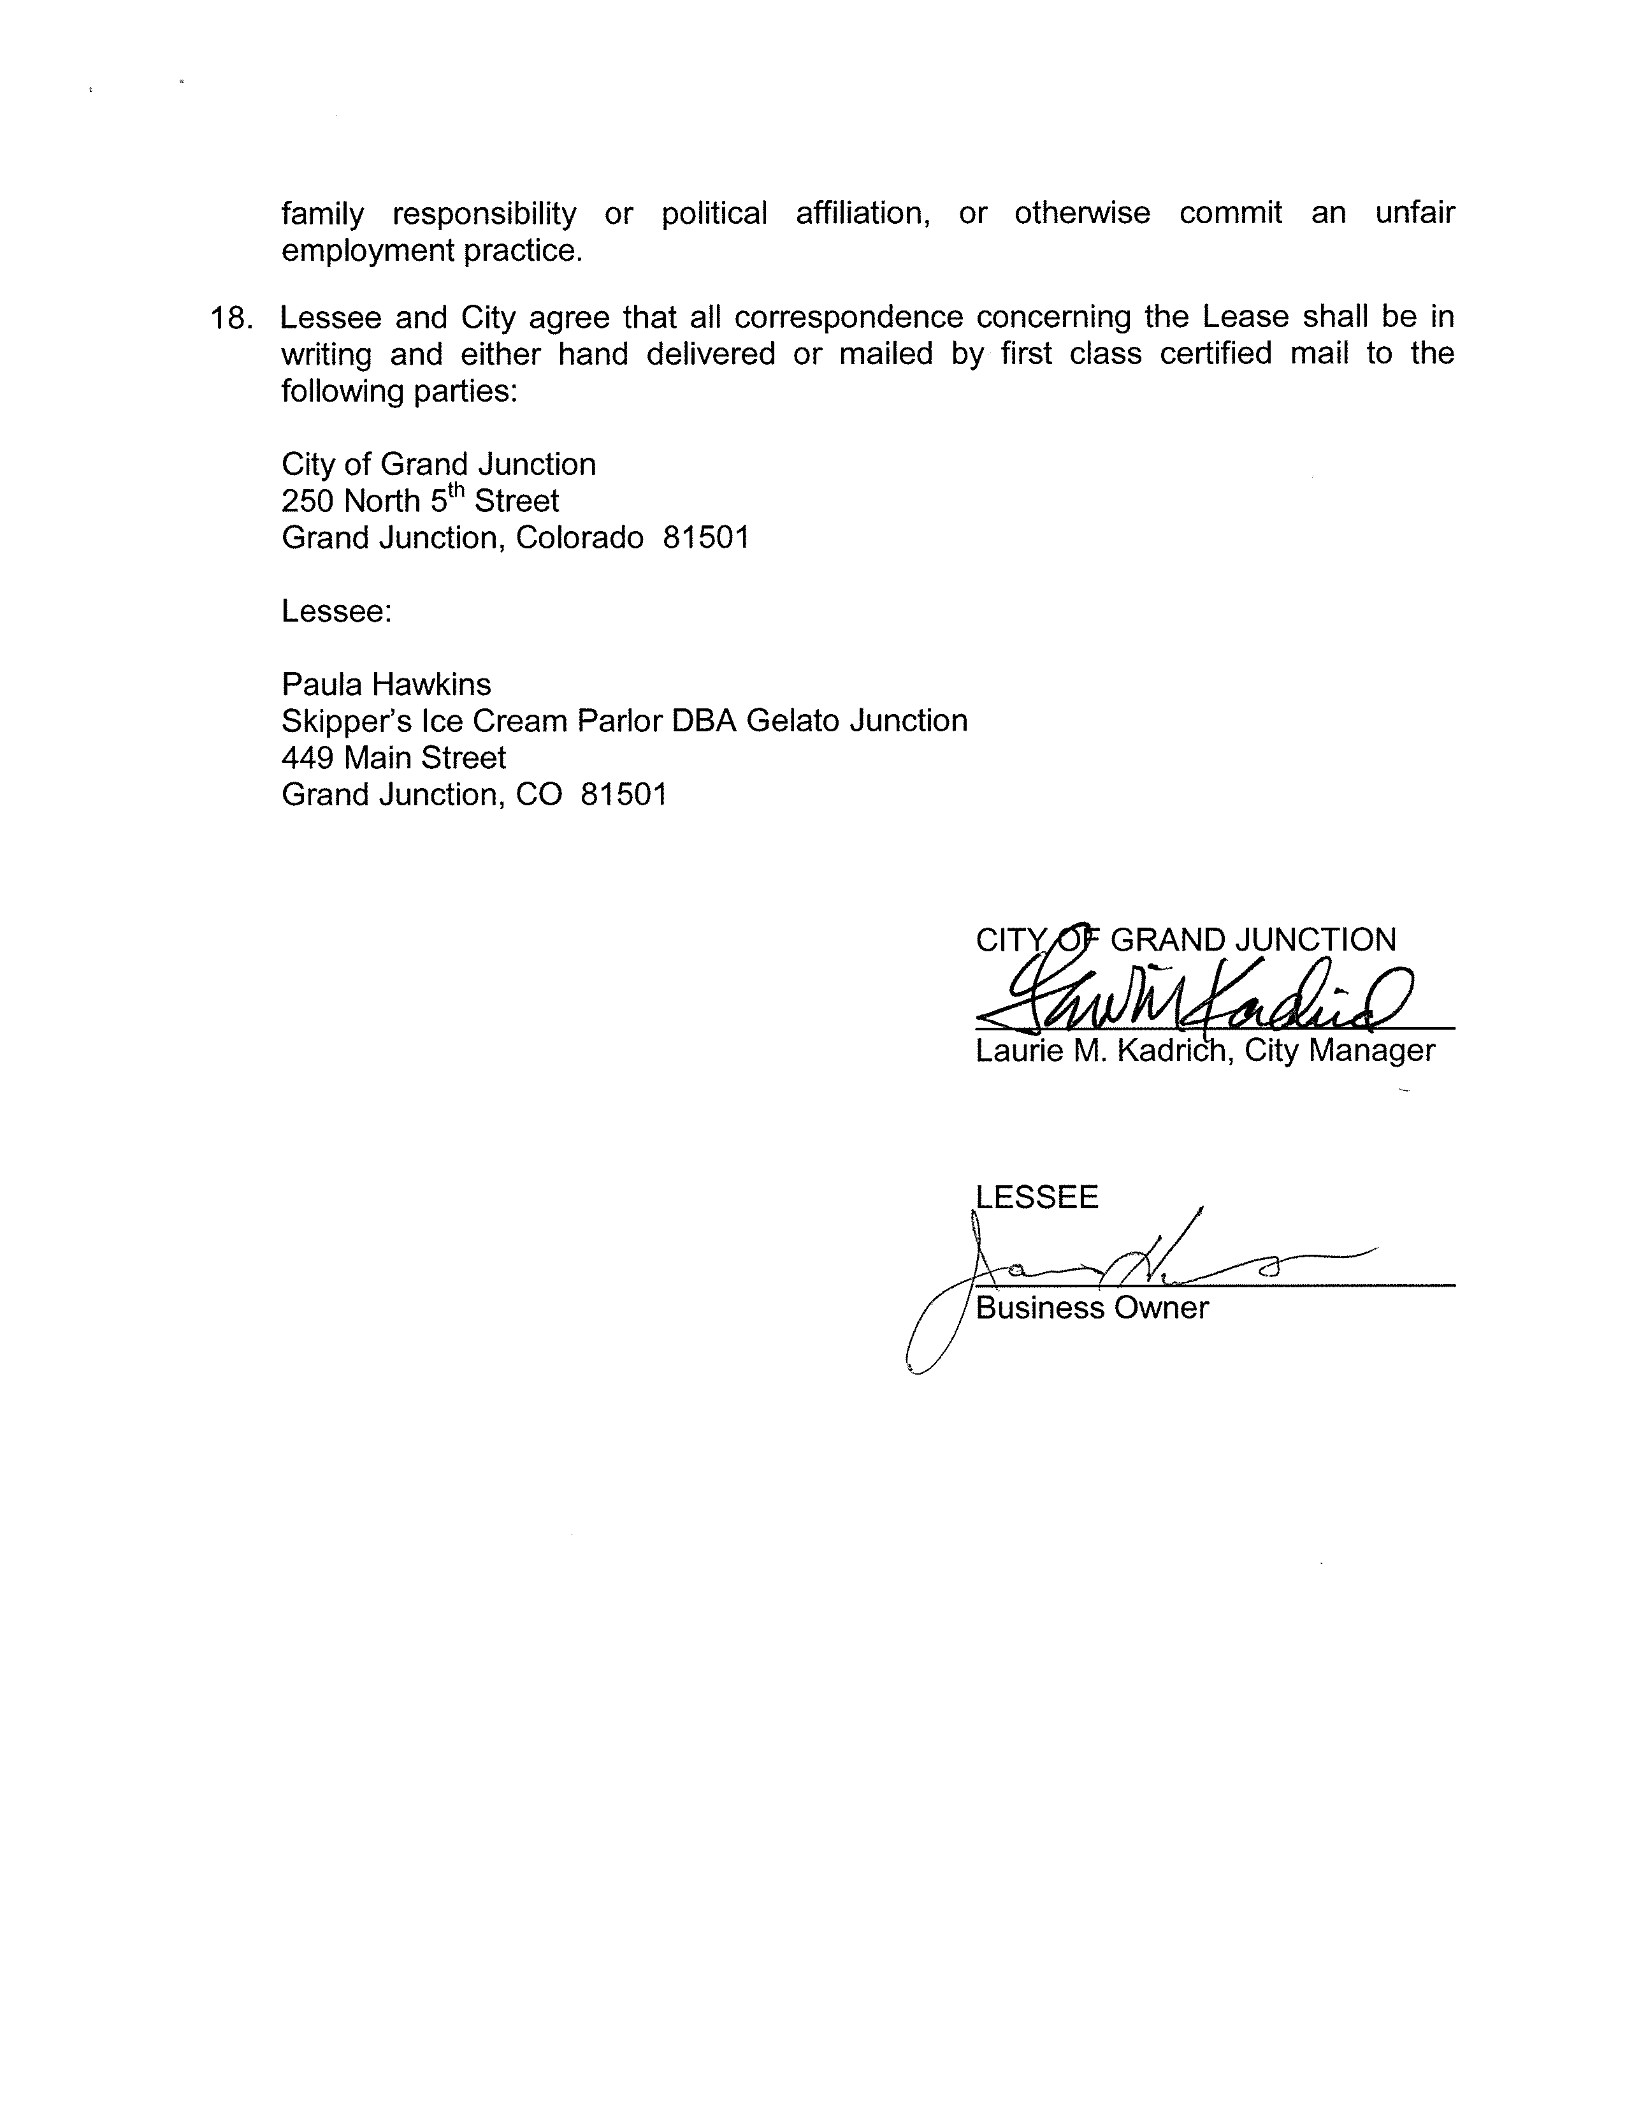

Exhibit A: Proposed Lease Area (Skipper’s Ice Cream Parlor DBA Gelato Junction):
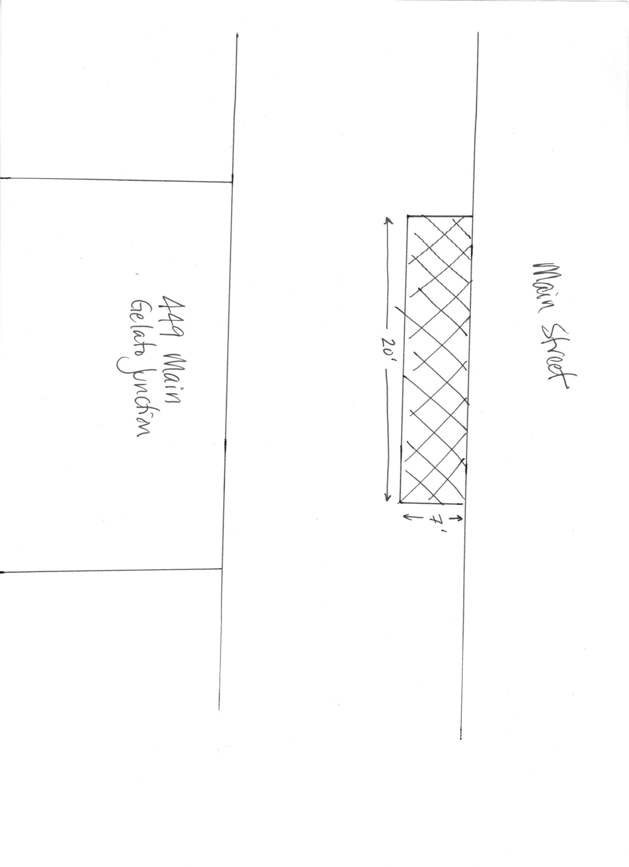

Exhibit B: Brief Description of Business / DDA Certification:

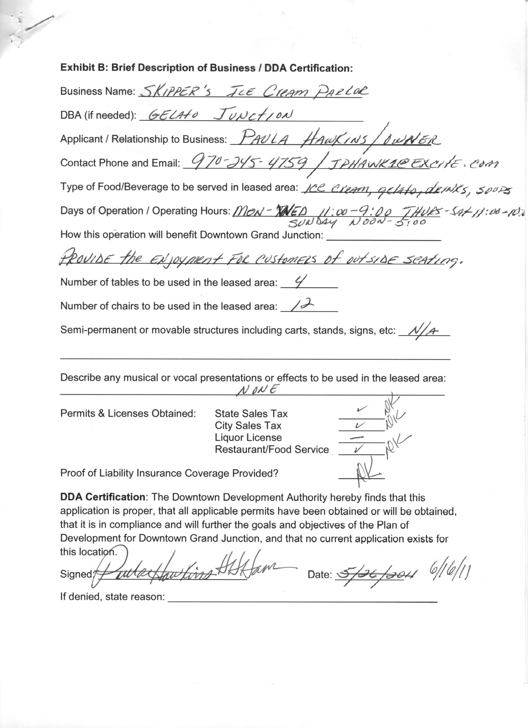
Exhibit C: Assurances, Hold Harmless and Indemnity Agreement

