RESOLUTION NO. 41-11

A RESOLUTION CONCERNING
THE ISSUANCE OF A REVOCABLE PERMIT TO
MESA MANAGEMENT LLC, LOCATED AT 602 26 1/2 ROAD

Recitals.

A. Mesa Management LLC, hereinafter referred to as the Petitioner, represent it is the owner of the following described real property in the City of Grand Junction, County of Mesa, State of Colorado, to wit:

A parcel of land situate in the SE 1/4 SW 1/4 of Section 2, Township 1 South, Range 1 West of the Ute Meridian, City of Grand Junction, Mesa County, Colorado, being more particularly described as follows:

Commencing at the S 1/4 corner of said Section 2, the basis of bearing being N00°01'19"E along the west line of said SE 1/4 SW 1/4 to the C-S 1/16 corner of said Section 2;
thence N00°01'19"E a distance of 160.00 feet;
thence S89°53'32"E a distance of 45.00 feet to the east right-of-way line of 26 1/2 Road and the point of beginning;
thence S89°53'32"E a distance of 144.88 feet;
thence S00º01'03"E a distance of 130.00 feet to the north right-of-way of F Road;
thence N89º53'32"W a distance of 125.00 feet along said right-of-way;
thence N44º54'00"W a distance of 28.28 feet along said right-of-way;
thence N00º01'19"E a distance of 110.00 feet along said right-of-way to the point of beginning.

Said parcel contains 0.43 acres more or less and identified by Mesa County Tax Schedule Number 2945-024-00-023.

B. The Petitioner has requested that the City Council of the City of Grand Junction issue a Revocable Permit to allow the Petitioner to install, maintain and repair an existing detached garage, stone BBQ, fencing and landscaping within the following described public right-of-way:

A strip of land for road right-of-way purposes, situate in the SW 1/4 SE 1/4 of Section 2, Township 1 South, Range 1 West of the Ute Meridian, City of Grand Junction, Mesa County, Colorado, being described as follows:

Commencing at the S 1/4 corner of said Section 2, the basis of bearing being
N00°01'19"E along the west line of said SW 1/4 SE 1/4 to the C-S 1/16 corner of said Section 2;
thence S89°53'32"E a distance of 190.00 feet along the south line of said SW 1/4 SE 1/4;
thence N00º01'03"W a distance of 30.00 feet to the north right-of-way of F Road as recorded in Book 1505 at Page 921 and the point of beginning;
thence N89º53'32"W a distance of 125.00 feet along said right-of-way;
thence N44º54'00"W a distance of 28.28 feet along said right-of-way;
thence N00º01'19"E a distance of 22.41 feet along said right-of-way;
thence S44°54'00"E a distance of 31.69 feet;
thence S89°53'32"E a distance of 122.58 feet to the west line of Lot 1, Walker Heights subdivision as recorded in Plat Book 11 at Page 55;
thence S00º01’03”E a distance of 20.00 feet to the point of beginning.

Said strip contains 2,950 square feet more or less.

C. Relying on the information supplied by the Petitioner and contained in File No. SPN-2011-783 in the office of the City’s Public Works and Planning Department, the City Council has determined that such action would not at this time be detrimental to the inhabitants of the City of Grand Junction.

NOW, THEREFORE, BE IT RESOLVED BY THE CITY COUNCIL OF THE CITY OF GRAND JUNCTION, COLORADO:

1. That the City Manager is hereby authorized and directed to issue the attached Revocable Permit to the above-named Petitioner for the purpose aforedescribed and within the limits of the public right-of-way aforedescribed, subject to each and every term and condition contained in the attached Revocable Permit.

PASSED and ADOPTED this 3rd day of August, 2011.

Attest:
/s/: Tom Kenyon
President of the City Council
/s/: Stephanie Tuin
City Clerk
REVOCABLE PERMIT

Recitals.

A. Mesa Management LLC hereinafter referred to as the Petitioner, represent it is the owner of the following described real property in the City of Grand Junction, County of Mesa, State of Colorado, to wit:

A parcel of land situate in the SE 1/4 SW 1/4 of Section 2, Township 1 South, Range 1 West of the Ute Meridian, City of Grand Junction, Mesa County, Colorado, being more particularly described as follows:

Commencing at the S 1/4 corner of said Section 2, the basis of bearing being N00°01'19"E along the west line of said SE 1/4 SW 1/4 to the C-S 1/16 corner of said Section 2;
thence N00°01'19"E a distance of 160.00 feet;
thence S89°53'32"E a distance of 45.00 feet to the east right-of-way line of 26 1/2 Road and the point of beginning;
thence S89°53'32"E a distance of 144.88 feet;
thence S00º01'03"E a distance of 130.00 feet to the north right-of-way of F Road;
thence N89º53'32"W a distance of 125.00 feet along said right-of-way;
thence N44º54'00"W a distance of 28.28 feet along said right-of-way;
thence N00º01'19"E a distance of 110.00 feet along said right-of-way to the point of beginning.

Said parcel contains 0.43 acres more or less and identified by Mesa County Tax Schedule Number 2945-024-00-023.

B. The Petitioner has requested that the City Council of the City of Grand Junction issue a Revocable Permit to allow the Petitioner to install, maintain and repair an existing detached garage, stone BBQ, fencing and landscaping within the following described public right-of-way as identified in Exhibit A:

A strip of land for road right-of-way purposes, situate in the SW 1/4 SE 1/4 of Section 2, Township 1 South, Range 1 West of the Ute Meridian, City of Grand Junction, Mesa County, Colorado, being described as follows:

Commencing at the S 1/4 corner of said Section 2, the basis of bearing being
N00°01'19"E along the west line of said SW 1/4 SE 1/4 to the C-S 1/16 corner of said Section 2;
thence S89°53'32"E a distance of 190.00 feet along the south line of said SW 1/4 SE 1/4;
thence N00º01'03"W a distance of 30.00 feet to the north right-of-way of F Road as recorded in Book 1505 at Page 921 and the point of beginning;
thence N89º53'32"W a distance of 125.00 feet along said right-of-way;
thence N44º54'00"W a distance of 28.28 feet along said right-of-way;
thence N00º01'19"E a distance of 22.41 feet along said right-of-way;
thence S44°54'00"E a distance of 31.69 feet;
thence S89°53'32"E a distance of 122.58 feet to the west line of Lot 1, Walker Heights subdivision as recorded in Plat Book 11 at Page 55;
thence S00º01’03”E a distance of 20.00 feet to the point of beginning.

Said strip contains 2,950 square feet more or less.

C. Relying on the information supplied by the Petitioner and contained in File No. SPN-2011-783 in the office of the City’s Public Works and Planning Department, the City Council has determined that such action would not at this time be detrimental to the inhabitants of the City of Grand Junction.

NOW, THEREFORE, IN ACCORDANCE WITH THE ACTION OF THE CITY COUNCIL OF THE CITY OF GRAND JUNCTION, COLORADO:

There is hereby issued to the above-named Petitioner a Revocable Permit for the purpose aforedescribed and within the limits of the public right-of-way aforedescribed; provided, however, that the issuance of this Revocable Permit shall be conditioned upon the following terms and conditions:

1. The Petitioner’s use and occupancy of the public right-of-way as authorized pursuant to this Permit shall be performed with due care or any other higher standard of care as may be required to avoid creating hazardous or dangerous situations and to avoid damaging public improvements and public utilities or any other facilities presently existing or which may in the future exist in said right-of-way.

2. The City hereby reserves and retains a perpetual right to utilize all or any portion of the aforedescribed public right-of-way for any purpose whatsoever. The City further reserves and retains the right to revoke this Permit at any time and for any reason.

3. The Petitioner, for itself and for its successors, assigns and for all persons claiming through the Petitioner, agrees that it shall defend all efforts and claims to hold, or attempt to hold, the City of Grand Junction, its officers, employees and agents, liable for damages caused to any property of the Petitioner or any other party, as a result of the Petitioner’s occupancy, possession or use of said public right-of-way or as a result of any City activity or use thereof or as a result of the installation, operation, maintenance, repair and replacement of public improvements.

4. The Petitioner agrees that it shall at all times keep the above described public right-of-way in good condition and repair.

5. This Revocable Permit shall be issued only upon the concurrent execution by the Petitioner of an agreement that the Petitioner and the Petitioner’s successors and assigns shall save and hold the City of Grand Junction, its officers, employees and agents harmless from, and indemnify the City, its officers, employees and agents, with respect to any claim or cause of action however stated arising out of, or in any way related to, the encroachment or use permitted, and that upon revocation of this Permit by the City the Petitioner shall, at the sole cost and expense of the Petitioner, within thirty (30) days of notice of revocation (which may occur by mailing a first class letter to the last known address), peaceably surrender said public right-of-way and, at its own expense, remove any encroachment so as to make the aforedescribed public right-of-way available for use by the City or the general public. The provisions concerning holding harmless and indemnity shall survive the expiration, revocation, termination or other ending of this Permit.

6. This Revocable Permit, the foregoing Resolution and the following Agreement shall be recorded by the Petitioner, at the Petitioner’s expense, in the office of the Mesa County Clerk and Recorder.

Dated this day of , 2011

The City of Grand Junction,
a Colorado home rule municipality
Attest:

City Clerk City Manager

Acceptance by the Petitioner:

Mesa Management LLC

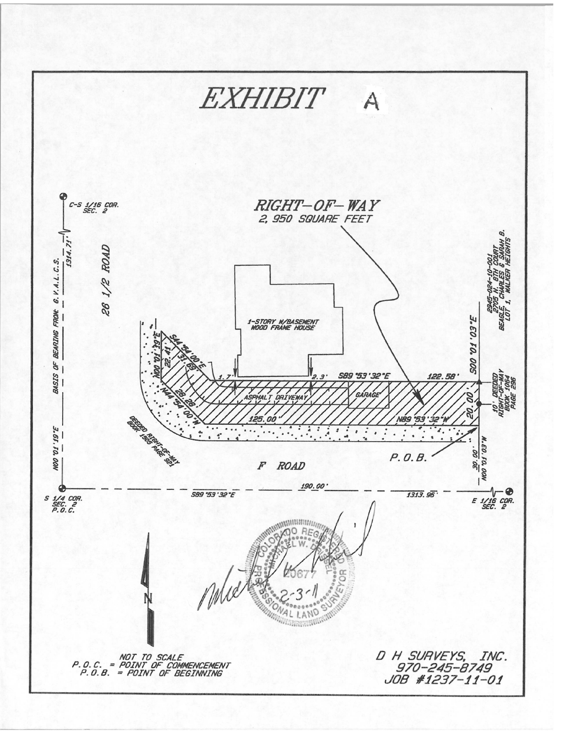

AGREEMENT

Mesa Management LLC, for itself and for its successors and assigns, does hereby agree to:

(a) Abide by each and every term and condition contained in the foregoing Revocable Permit;

(b) Indemnify and hold harmless the City of Grand Junction, its officers, employees and agents with respect to all claims and causes of action, as provided for in the approving Resolution and Revocable Permit;

(c) Within thirty (30) days of revocation of said Permit by the City Council, peaceably surrender said public right-of-way to the City of Grand Junction;

(d) At the sole cost and expense of the Petitioner, remove any encroachment so as to make said public right-of-way fully available for use by the City of Grand Junction or the general public.

Dated this day of , 2011

Mesa Management LLC

By:
Michael McCormick, General Manager
State of Colorado)
)ss
County of Mesa )

The foregoing Agreement was acknowledged before me this___ day of ________________, 2011, by Michael McCormick, General Manager of Mesa Management LLC.

My Commission expires:
Witness my hand and official seal.

Notary Public

