**CITY OF GRAND JUNCTION, COLORADO**

**ORDINANCE NO. 4646**

**AN ORDINANCE AMENDING SECTIONS OF THE ZONING AND DEVELOPMENT CODE (TITLE 21 OF THE GRAND JUNCTION MUNICIPAL CODE) TO CREATE A NEW FORM-BASED ZONING DISTRICT THAT WILL IMPLEMENT THE MIXED USE OPPORTUNITY CORRIDOR FUTURE LAND USE DESIGNATION OF THE COMPREHENSIVE PLAN AND TO AMEND DEVELOPMENT STANDARDS APPLICABLE TO THE FORM DISTRICTS**

**Recitals:**

The City Council desires to maintain effective zoning and development regulations that implement the vision and goals of the Comprehensive Plan while being flexible and responsive to the community’s desires and market conditions. The City Council has also recently developed an Economic Development Plan and desires that the zoning and development code be reviewed and amended where necessary and possible to facilitate economic development.

Form-based zoning districts, or form districts, are zoning districts which emphasize the character of the built environment more than separation of uses as the organizing principle for compatible development. The form districts provided in the Zoning and Development Code implement the Neighborhood Center, Village Center and Downtown Mixed Use future land use designations of the Comprehensive Plan. These areas are planned as pedestrian-friendly urban centers where higher density mixed uses and mixed but compatible building types promote less dependence on the automobile.

The Comprehensive Plan also designates Mixed Use Opportunity Corridors, which are areas designated for mixed use, but they are along major arterial streets, such that the existing form district standards do not quite fit the concept of the Mixed Use Opportunity Corridors, which are more automobile-centric than the neighborhood, village and downtown centers.

Therefore it is desirable to amend the Zoning and Development Code to create a new form district to implement the Mixed Use Opportunity Corridors which accommodate mixed uses but with a somewhat more automobile-centric concept and layout.

Due to significant interest in developing along these corridors, a committee of developers, two City Council members and City staff worked together to create the Mixed Use Opportunity Corridor (MXOC) form district and applicable standards for such development.

After public notice and a public hearing as required by the Charter and Ordinances of the City, the Grand Junction Planning Commission recommended adoption of the proposed amendments, finding the proposed amendments consistent with the vision, goals and policies of the Comprehensive Plan.

Following public notice and a public hearing as required by applicable law, the Grand Junction City Council finds and determines that the proposed amendments implement the vision, goals and policies of the Comprehensive Plan, and that they are in the best interest of the community and its citizens, and should be adopted.

**NOW THEREFORE BE IT ORDAINED BY THE CITY COUNCIL OF THE CITY OF GRAND JUNCTION THAT:**

**Subsection 21.02.140(c)(2) is amended to as follows (deletions struck through, additions underlined):**

(2)    Mixed Use Opportunity Corridors. Areas Residentially-zoned property within a Mixed Use Opportunity Corridor designated on the Future Land Use Map in the Comprehensive Plan that are currently zoned for residential purposes may be rezoned for more intense use (including nonresidential uses); provided, that to the Mixed Use Opportunity Corridor form district (MXOC) if the property is not also within a Village or Neighborhood Center, or to one of the other form districts of GJMC [21.03.090](http://www.codepublishing.com/co/grandjunction/html2/GrandJunction21/GrandJunction2103.html#21.03.090) if the property is also within a Village or Neighborhood Center, are utilized so long as and the depth of the lot measured perpendicular to the corridor is at least 150 feet. During consideration of the application of When considering a rezone to a form district, the City Council shall consider the following:

(i)    The extent to which the rezoning furthers the goals and policies of the Comprehensive Plan; and

(ii)    The extent to which the proposed rezoning would enhance the surrounding neighborhood by providing walkable commercial, entertainment and employment opportunities, as well as alternative housing choices.

**All other parts of Section 21.02.140(c) shall remain in full force and effect.**

**Subsection 21.03.020(c) (Table of Zoning Districts) and Subsection 21.03.020(d) (Table of Districts to Implement the Comprehensive Plan) are amended as follows (deletions struck through; additions underlined):**

(c) Districts.

|  |  |
| --- | --- |
| **Residential Districts** | |
| R-R | Residential - Rural |
| R-E | Residential - Estate |
| R-1 | Residential - 1 |
| R-2 | Residential - 2 |
| R-4 | Residential - 4 |
| R-5 | Residential - 5 |
| R-8 | Residential - 8 |
| R-12 | Residential - 12 |
| R-16 | Residential - 16 |
| R-24 | Residential - 24 |
| **Mixed Use Districts** | |
| R-O | Residential - Office |
| B-1 | Neighborhood Business |
| B-2 | Downtown Business |
| C-1 | Light Commercial |
| C-2 | General Commercial |
| CSR | Community Services and Recreation |
| M-U | Mixed Use |
| BP | Business Park Mixed Use |
| **Industrial Districts** | |
| I-O | Industrial/Office Park |
| I-1 | Light Industrial |
| I-2 | General Industrial |
| **Form Districts** | |
| MXR- | Mixed Use Residential |
| MXG- | Mixed Use General |
| MXS- | Mixed Use Shopfront |
| MXOC | Mixed Use Opportunity Corridor |

(d) Districts to Implement the Comprehensive Plan. The following table shows which zoning district(s) appropriately implement(s) a given future land use designation of the Comprehensive Plan. A dot indicates that the zone district implements the corresponding future land use designation and is therefore an appropriate option for zoning or rezoning of land within that designated area on the future land use map of the Comprehensive Plan; the absence of a dot indicates that the zone district is not an appropriate option for zoning or rezoning of land within the corresponding future land use designation.

|  |  |  |  |  |  |  |  |  |  |  |  |  |  |  |  |  |  |  |  |
| --- | --- | --- | --- | --- | --- | --- | --- | --- | --- | --- | --- | --- | --- | --- | --- | --- | --- | --- | --- |
| **Zoning**  **District** | |  | **Comprehensive Plan Land Use Designation** | | | | | | | | | | | | | | | | |
| **RESIDENTIAL** | | | | | | | |  | **NONRESIDENTIAL** | | | | | | | | |
| **Low** | | | | **Medium** | | **High** | |  |  | | | | | | | | |
| **Rural** | **Estate** | **RL** | **RML** | **RM** | **RMH** | **RH-MU** | **UR RH-MU** | **Commercial** | **NC-MU** | **VC-MU** | **DT-MU** | **MIXED USE OPPORTUNITY**  **CORRIDOR\*** | **Industrial** | **C/I** | **BP-MU** | **P & OS** | **Conservation/**  **Mineral Extraction** |
| **RR** | | **•** | **•** | **•** | **•** |  |  |  |  |  |  |  |  |  |  |  |  |  | **•** |
| **R-E** | | **•** | **•** | **•** | **•** |  |  |  |  |  |  |  |  |  |  |  |  |  |  |
| **R-1** | | **•** | **•** | **•** | **•** |  |  |  |  |  |  |  |  |  |  |  |  |  |  |
| **R-2** | | **•** | **•** | **•** | **•** |  |  |  |  |  |  |  |  |  |  |  |  |  |  |
| **R-4** | | **•** | **•** | **•** | **•** | **•** | **•** |  |  |  |  |  |  |  |  |  |  |  |  |
| **R-5** | | **•** | **•** | **•** | **•** | **•** | **•** |  |  |  |  |  |  |  |  |  |  |  |  |
| **R-8** | |  |  |  |  | **•** | **•** |  |  |  | **•** | **•** |  |  |  |  | **•** |  |  |
| **R-12** | |  |  |  |  | **•** | **•** |  |  |  | **•** | **•** |  |  |  |  | **•** |  |  |
| **R-16** | |  |  |  |  |  | **•** | **•** | **•** |  | **•** | **•** | **•** |  |  |  | **•** |  |  |
| **R-24+** | |  |  |  |  |  |  | **•** | **•** |  |  | **•** | **•** |  |  |  | **•** |  |  |
|  |  | | | | | | | | | | | | | | | | | | |
| **R-O** | |  |  |  |  | **•** | **•** | **•** | **•** | **•** | **•** | **•** | **•** |  |  |  | **•** |  |  |
| **B-1** | |  |  |  |  |  |  |  | **•** | **•** | **•** | **•** |  |  |  |  |  |  |  |
| **B-2** | |  |  |  |  |  |  |  |  |  |  |  | **•** |  |  |  |  |  |  |
| **C-1** | |  |  |  |  |  |  |  |  | **•** | **•** | **•** | **•** |  |  |  |  |  |  |
| **C-2** | |  |  |  |  |  |  |  |  | **•** |  |  |  |  |  | **•** |  |  |  |
| **CSR** | | **•** |  |  |  |  |  |  |  |  |  |  |  |  |  |  | **•** | **•** | **•** |
| **M-U** | |  |  |  |  |  |  |  |  | **•** |  |  |  |  | **•** | **•** |  |  |  |
| **BP** | |  |  |  |  |  |  |  |  |  |  |  |  |  |  | **•** | **•** |  |  |
|  |  | | | | | | | | | | | | | | | | | | |
| **I-O** | |  |  |  |  |  |  |  |  |  |  |  |  |  | **•** | **•** | **•** |  |  |
| **I-1** | |  |  |  |  |  |  |  |  |  |  |  |  |  | **•** | **•** |  |  |  |
| **I-2** | |  |  |  |  |  |  |  |  |  |  |  |  |  | **•** |  |  |  |  |
|  |  | | | | | | | | | | | | | | | | | | |
| **MXR-3**  **MXG-3**  **MXS-3** | |  |  |  |  |  |  |  |  |  | **•** | **•** | **•** |  |  |  |  |  |  |
| **MXR-5**  **MXG-5**  **MXS-5** | |  |  |  |  |  |  |  |  |  |  | **•** | **•** |  |  |  |  |  |  |
| **MXR-8**  **MXG-8**  **MXS-8** | |  |  |  |  |  |  |  |  |  |  |  | **•** |  |  |  |  |  |  |
| **MXOC** | |  |  |  |  |  |  |  |  |  |  |  |  | **•\*** |  |  |  |  |  |

*The Mixed Use Opportunity Corridor future land use designation of the Comprehensive Plan “overlays” other future land use designations, according to and as shown on the Comprehensive Plan Future Land Use Map. Therefore, in addition to the MXOC form district, other zone districts which implement the *underlying* future land use designation may also be appropriate in a given area of the Mixed Use Opportunity Corridor. Also, implementation of the Mixed Use Opportunity Corridor future land use designation is limited by Section 21.02.140(c)(2).

**All other parts of Section 21.03.020 shall remain in full force and effect.**

**Section 21.03.090(a) (Form Districts - Intent) is amended as follows (deletions struck through; additions underlined):**

**21.03.090 Form districts.**

(a)    **Intent.** The form districts are intended to implement the Neighborhood Center, Village Center, Downtown Mixed Use future land use designations and Mixed Use Opportunity Corridors of the Comprehensive Plan. The form districts are intended to create pedestrian-friendly urban areas where higher density mixed uses and mixed building types promote less dependence on the automobile. The form districts are intended to be used in combination to create mixed use centers. The centers are intended to transition in scale to existing neighborhoods. The Comprehensive Plan Neighborhood Center designation is implemented with the three-story districts, the Village Center designation is implemented with the three- and five-story districts, and the Downtown Mixed Use designation is implemented with the three-, five- and eight-story districts. The Mixed Use Opportunity Corridor designation is implemented with the MXOC, a three-story form district districts as limited by Section 21.02.140(c)(2); in addition, because the Mixed Use Opportunity Corridor overlays other future land use designations as shown on the Comprehensive Plan Future Land Use Map, other zone districts which implement the underlying future land use designation would also be appropriate zoning options in a given area of the Mixed Use Opportunity Corridor.

**Section 21.03.090 (e), (f), (g), (h) and (i) are amended to create a new subsection “(e)” generally describing the Mixed Use Opportunity Corridor (MXOC) form district and to add standards applicable to the form districts and particularly the MXOC form district; also, accordingly, subsection designations (e), (f), (g), (h) and (i) are changed to (f), (g), (h), (i) and (j) to accommodate the new subsection “(e),” as follows (deletions struck through, additions underlined):**

(e) Mixed Use Opportunity Corridors (MXOC) district is intended to:

(1) Create mixed use development(s) along the corridor in a pedestrian friendly environment while accommodating the more automobile-centric nature of the areas due to the fact that these corridors are primarily along arterial streets;

(2) Provide a transition from nonresidential to existing neighborhood residential uses, and respect the limitations set forth in Section 21.02.140(c)(2);

(3) Combine access between two or more sites whenever possible to restrict the number of access points along the arterial street; and

(4) Establish standards for access, parking, delivery and pickup areas, trash service, signage, building entry, and architecture that reflect the somewhat more automobile-centric nature compared to the other form districts.

(f) **District Standards.**

(1)    Building Type by District.

| **District** | **Building Type** | | | | |
| --- | --- | --- | --- | --- | --- |
|  | **Shopfront** | **General** | **Apartment** | **Townhouse** | **Civic** |
| Mixed Use Residential (MXR-) |  |  | **•** | **•** | **•** |
| Mixed Use General  (MXG-) |  | **•** | **•** | **•** | **•** |
| Mixed Use Shopfront  (MXS-) | **•** |  |  |  |  |
| Mixed Use Opportunity Corridor (MXOC) | **•** | **•** | **•** | **•** | **•** |

(2)    Height.

| **Intensity** | **District** | **Height Stories (min.)** | **Height Stories (max.)** | **Height Feet (max.)** |
| --- | --- | --- | --- | --- |
| Low | MXR-3, MXG-3, MXS-3, MXOC | 1 | 3 | 50 |
| Medium | MXR-5, MXG-5, MXS-5 | 2 | 5 | 65 |
| High | MXR-8, MXG-8, MXS-8 | 2 | 8 | 100 |

(3)    Building Entrances. The following building entrance requirements apply to shopfront, general and apartment building types:

(i)    An entrance providing both ingress and egress, operable during normal business hours, is required to meet the street-facing entrance requirements. Additional entrances off another street, pedestrian area or internal parking area are permitted.

(ii)    The entrance separation requirements provided for the building type must be met for each building, but are not applicable to adjacent buildings.

(iii)    An angled entrance may be provided at either corner of a building along the street to meet the street entrance requirements, provided any applicable entrance spacing requirements can still be met.

(iv)    A minimum of 50 percent of a required entrance must be transparent.

(v)    A required fire exit door with no transparency may front on a primary, side, or service street.

(vi) A street-facing entrance is not required in the MXOC.

(4)    Parking.

(i)    On-site surface parking must be located behind the parking setback line.

(ii)    Structured parking must contain active uses on the ground story along any primary street for the first 30 feet of the building measured from the street-facing facade.

(iii)    The required street frontage may be interrupted to allow for a maximum 30-foot-wide vehicular entrance to a parking structure or area.

(5)    Service Entrances. Business service entrances, service yards and loading areas shall be located only in the rear or side yard, behind the parking setback line.

(6)    Open Space.

(i)    Public Parks and Open Space Fee. The owner of any multifamily or mixed use project in a form district shall be subject to the required parks impact fee.

(ii)    Open Space Requirement. Multifamily or mixed use developments in a form district shall be required to pay 10 percent of the value of the raw land of the property as determined in GJMC [21.06.020(b)](http://www.codepublishing.com/co/grandjunction/html2/GrandJunction21/GrandJunction2106.html#21.06.020(b)).

(7)    Outdoor Storage and Display. Outdoor storage and permanent displays are prohibited. Portable display of retail merchandise may be permitted as provided in GJMC [21.04.040(h)](http://www.codepublishing.com/co/grandjunction/html2/GrandJunction21/GrandJunction2104.html#21.04.040(h)).

(8) Awning Standards. Awnings and other façade enhancements are encouraged. One or more awnings extending from the building may be erected. Awnings shall be at least 8 feet above the sidewalk and shall be at least 4 feet wide, along the building frontage, and shall not overhang into the right-of-way more than 6 feet. Awnings shall otherwise meet with the requirements of the Grand Junction Municipal Code and Colorado Department of Transportation (CDOT) regulations.

(9) Landscaping and Buffering.

(i) No landscaping / screening buffer is required between adjacent properties zoned Mixed Use.

(ii) No street frontage landscaping is required when the setback for a building is ten (10) feet or less.

(iii) Street trees are required at a rate of one tree per eighty (80) feet. Street trees may be planted in the right-of-way with City approval.

(iv) All other landscaping regulations of the Grand Junction Municipal Code shall apply.

(10) Mechanical Equipment. Screening of mechanical equipment either located on the roof or on the ground is required.

(g) **Building Types.** See the building types on the following pages.

(1)    Shopfront. A building form intended for ground floor retail sales and service uses with upper-story residential or office uses. Lodging and indoor recreation and entertainment uses would also be allowed. High transparency (in the form of windows and doors) is required on the ground floor to encourage interaction between the pedestrian and the ground story space. Primary entrances are prominent and street facing except that street-facing entrances are optional in MXOC.

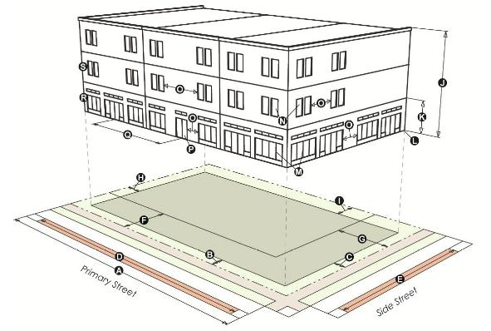

|  | |  | **MXS-3**  **MXOC** | **MXS-5** | **MXS-8** |  |  |  | **MXS-3**  **MXOC** | **MXS-5** | **MXS-8** |
| --- | --- | --- | --- | --- | --- | --- | --- | --- | --- | --- | --- |
|  | | **LOT** | | | |  |  | **HEIGHT** | | | |
|  | | Area (min. ft.2) | 4,000 | 5,000 | n/a |  |  | Stories (max.) | 3 | 5 | 8 |
|  | | Width (min. ft.) | 40 | 50 | n/a |  |  | Feet (max.) | 50 | 65 | 100 |
|  | | Lot coverage (max.) | 75% | 75% | n/a |  |  | Ground story height (min. ft.) | 15 | 15 | 15 |
|  | | **FRONT SETBACK AREA** | | | |  |  | Ground story elevation (min. ft.) | 0 | 0 | 0 |
|  | | Primary street (min./max. ft.) * | 0/10 | 0/10 | 0/10 |  |  | **BUILDING façade** | | | |
|  | | Side street (min./max. ft.) | 0/10 | 0/10 | 0/10 |  |  | Ground story transparency (min.) *** | 60% | 60% | 60% |
|  | | **REQUIRED STREET FAÇADE \*\*** | | | |  |  | Upper story transparency (min.) | 20% | 20% | 20% |
|  | | Primary street (min.) | 85% | 85% | 85% |  |  | Blank wall area (max. ft.) | 30 | 30 | 30 |
|  | | Side street (min.) | 40% | 40% | 40% |  |  | Street-facing entrance required *** | yes | yes | yes |
|  | | **PARKING SETBACK** | | | |  |  | Street entrance spacing | n/a | n/a | 50 |
|  | | Primary street (min. ft.) | 30 | 30 | 30 |  |  | **ALLOWED USE** | | | |
|  | | Side street (min. ft.) | 10 | 10 | 10 |  |  | Ground story | Commercial, Institutional and Civic | | |
|  | **SIDE/REAR SETBACKS** | | | |  |  |  | |
|  | | Side, interior (min. ft.) | 5 | 5 | 5 |  |  | Upper story | Commercial, Institutional and Civic, Residential | | |
|  | Rear (min. ft.) | 15 | 10 | 0 |  |  | |

* No maximum front setback in MXOC

** Excludes drainage facilities, waterways, and pedestrian areas

***Not required in MXOC

(2)    General. A building form intended for ground floor office and personal services uses (but does not include sales, repair or entertainment oriented uses) with upper-story residential or office. Transparency (in the form of windows and doors) is required on the ground floor to encourage interaction between the pedestrian and the ground story space; however, required transparency is lower than that for a shopfront building form. Primary entrances are prominent and street facing except that street-facing entrances are optional in MXOC.

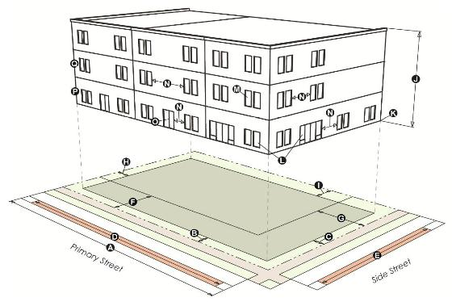

|  | |  | **MXG-3**  **MXOC** | **MXG-5** | **MXG-8** |  |  |  | **MXG-3**  **MXOC** | **MXG-5** | **MXG-8** |
| --- | --- | --- | --- | --- | --- | --- | --- | --- | --- | --- | --- |
|  | | **LOT** | | | |  |  | **HEIGHT** | | | |
|  | | Area (min. ft.2) | 4,000 | 5,000 | n/a |  |  | Stories (max.) | 3 | 5 | 8 |
|  | | Width (min. ft.) | 40 | 50 | n/a |  |  | Feet (max.) | 50 | 65 | 100 |
|  | | Lot coverage (max.) | 75% | 75% | n/a |  |  | Ground story elevation (min. ft.) | 0 | 0 | 0 |
|  | | **FRONT SETBACK AREA** | | | |  |  | **BUILDING façade** | | | |
|  | | Primary street (min./max. ft.)* | 0/10 | 0/10 | 0/10 |  |  | Ground story transparency *** (min.) | 40% | 40% | 40% |
|  | | Side street (min./max. ft.) | 0/10 | 0/10 | 0/10 |  |  | Upper story transparency (min.) | 20% | 20% | 20% |
|  | | **REQUIRED STREET FAÇADE \*\*** | | | |  |  | Blank wall area (max. ft.) | 30 | 30 | 30 |
|  | | Primary street (min.) | 80% | 80% | 80% |  |  | Street-facing entrance required *** | yes | yes | yes |
|  | | Side street (min.) | 40% | 40% | 40% |  |  | **ALLOWED USE** | | | |
|  | | **PARKING SETBACK** | | | |  |  | Ground story | Commercial, Institutional and Civic | | |
|  | Primary street (min. ft.) | 30 | 30 | 30 |  |  |
|  | | Side street (min. ft.) | 10 | 10 | 10 |  |  | Upper story | Commercial, Institutional and Civic, Residential | | |
|  | **SIDE/REAR SETBACKS** | | | |  |
|  | | Side, interior (min. ft.) | 5 | 5 | 5 |  |  |  |  |  |  |
|  | | Rear (min. ft.) | 15 | 10 | 5 |  |  |  |  |  |  |

* No maximum front setback in MXOC

** Excludes drainage facilities, waterways, and pedestrian areas

***Not required in MXOC

(3)    Apartment. A building form containing three or more dwelling units consolidated into a single structure. An apartment contains internal common walls. Dwelling units within a building may be situated either wholly or partially over or under other dwelling units. The building often shares a common entrance. Primary building entrance is generally through a street-facing lobby.

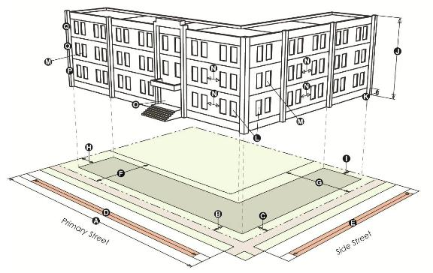

|  |  | **MXG-3**  **MXR-3**  **MXOC** | **MXG-5**  **MXR-5** | **MXG-8**  **MXR-8** |  |  |  | **MXG-3**  **MXR-3**  **MXOC** | **MXG-5**  **MXR-5** | **MXG-8**  **MXR-8** |
| --- | --- | --- | --- | --- | --- | --- | --- | --- | --- | --- |
|  | **LOT** | | | |  |  | **HEIGHT** | | | |
|  | Area (min. ft.2) | 6,000 | 6,000 | 6,000 |  |  | Stories (max.) | 3 | 5 | 8 |
|  | Width (min. ft.) | 60 | 60 | 60 |  |  | Feet (max.) | 50 | 65 | 100 |
|  | Lot coverage (max.) | 75% | 75% | 75% |  |  | Ground story elevation (min. ft.) | 0 | 0 | 0 |
|  | **FRONT SETBACK AREA** | | | |  |  | **BUILDING façade** | | | |
|  | Primary street (min./max. ft.)* | 0/15 | 0/15 | 0/15 |  |  | Ground story transparency (min.)*** | 20% | 20% | 20% |
|  | Side street (min./max. ft.) | 0/15 | 0/15 | 0/15 |  |  | Upper story transparency (min.) | 20% | 20% | 20% |
|  | **REQUIRED STREET FAÇADE \*\*** | | | |  |  | Blank wall area (max. ft.) | 30 | 30 | 30 |
|  | Primary street (min.) | 75% | 75% | 75% |  |  | Street-facing entrance required*** | yes | yes | yes |
|  | Side street (min.) | 35% | 35% | 35% |  |  | **ALLOWED USE** | | | |
|  | **PARKING SETBACK** | | | |  |  | Ground story | Residential | | |
|  | Primary street (min. ft.) | 30 | 30 | 30 |  |  | Upper story | Residential | | |
|  | Side street (min. ft.) | 10 | 10 | 10 |  |  |  |  | | |
|  | **SIDE/REAR SETBACKS** | | | |  |  |  |  | | |
|  | Side, interior (min. ft.) | 5 | 5 | 5 |  |
|  | Rear (min. ft.) | 15 | 10 | 5 |  |  |  |  |  |  |

* No maximum front setback in MXOC

** Excludes drainage facilities, waterways, and pedestrian areas

***Not required in MXOC

(4)    Townhouse. A building form with multiple dwelling units located side-by-side on a single zone lot and consolidated into a single structure that relates to the scale of surrounding houses. Each unit is separated by a common side wall. Units are not vertically mixed. Each unit has its own external entrance.

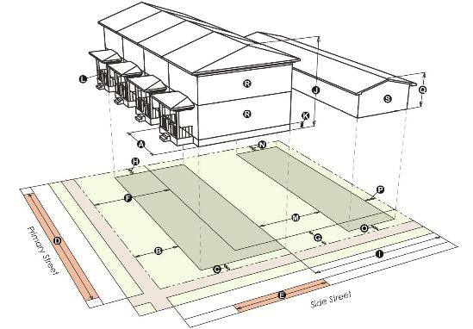

|  |  | **MXG-3, MXR-3, MXOC** |  |  |  | **MXG-3, MXR-3, MXOC** |
| --- | --- | --- | --- | --- | --- | --- |
|  | **LOT** |  |  |  | **HEIGHT** |  |
|  | Area (min. ft.2) | 1,200 |  |  | Stories (max.) | 3 |
|  | Unit width (min. ft.) | 16 |  |  | Feet (max.) | 50 |
|  | Lot coverage (max.) | 75% |  |  | Ground story elevation (min. ft.) | 1.5 |
|  | **FRONT SETBACK AREA** |  |  |  | **BUILDING FACADE** |  |
|  | Primary street (min./max. ft.) * | 0/15 |  |  | Street-facing entrance required *** | yes |
|  | Side street (min./max. ft.) | 0/15 |  |  | **ACCESSORY STRUCTURE SETBACKS** |  |
|  | **REQUIRED STREET FAÇADE \*\*** |  |  |  | Separation from primary structure (min. ft.) | 10 |
|  | Primary street (min.) | 75% |  |  | Side, interior (min. ft.) | 5 |
|  | Side street (min.) | 35% |  |  | Side, street (min. ft.) | 10 |
|  | **PARKING SETBACK** |  |  |  | Rear (min. ft.) | 5 |
|  | Primary street (min. ft.) | 30 |  |  | **ACCESSORY STRUCTURE HEIGHT** |  |
|  | Side street (min. ft.) | 10 |  |  | Stories (max.) | 2 |
|  | **SIDE/REAR SETBACKS** |  |  |  | Feet (max.) | 30 |
|  | Side, interior (min. ft.) | 5 |  |  | **ALLOWED USE** |  |
|  | Rear (min. ft.) | 10 |  |  | All stories | Residential |
|  |  |  |  |  | Accessory structure | Accessory uses, Accessory dwellings |

* No maximum front setback in MXOC

** Excludes drainage facilities, waterways, and pedestrian areas

***Not required in MXOC

(5)    Civic. A building form containing civic, religious, institutional or public uses. In order to provide a visual landmark, the civic building form is permitted to be set back further than other building forms. Civic buildings are commonly placed on prominent sites.

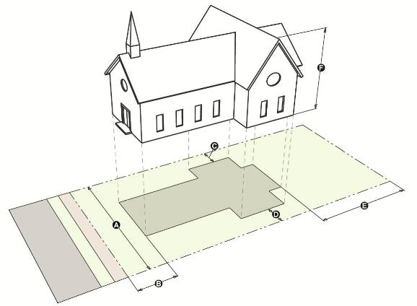

|  |  | **MXG-3**  **MXR-3**  **MXOC** | **MXG-5**  **MXR-5** | **MXG-8**  **MXR-8** |
| --- | --- | --- | --- | --- |
|  | **LOT** |  |  |  |
|  | Area (min. ft.2) | 10,000 | 10,000 | 10,000 |
|  | Width (min. ft.) | 100 | 100 | 100 |
|  | Lot coverage (max.) | 80% | 80% | 80% |
|  | **SETBACKS** |  |  |  |
|  | Front (min. ft.) | 15 | 15 | 15 |
|  | Side, interior (min. ft.) | 5 | 5 | 5 |
|  | Side, street (min. ft.) | 10 | 10 | 10 |
|  | Rear (min. ft.) | 15 | 15 | 15 |
|  | **HEIGHT** |  |  |  |
|  | Stories (max.) | 3 | 5 | 8 |
|  | Feet (max.) | 50 | 65 | 100 |
|  | **ALLOWED USE** |  |  |  |
|  | All stories | Institutional and Civic | | |

(h) Mixed Use Opportunity Corridors. See GJMC 21.02.140(c)(2). In addition to the standards established in subsections 21.03.090(f) and (g) above, except as specifically modified therein for the MXOC zone district, standards for the MXOC shall be as follows:

1. Access. When the site is adjacent to a local or collector street, the primary access shall be on the lower order street. Additional access points may be allowed based on traffic safety, as determined by the City’s development engineer. Whenever possible, access between two or more sites shall be combined and access points restricted on arterial streets.
2. Parking, delivery/pick-up areas, trash service. Parking, delivery and pick-up, and trash service areas are not permitted between the building and the primary street (corridor).
3. Signage. Signage shall conform to Section 21.06.070(g)(3) except that all freestanding signs shall be monument style signs with a maximum height of 15 feet.
4. Architectural standards.
5. Any façade of a new building along the corridor shall have visually interesting architectural features and patterns that are designed to reduce mass and scale and reflect the desired vision of construction; buildings at a human scale with urban design features attractive to the motoring public, the surrounding neighborhood, bicyclists and pedestrians.
6. The building façade shall exhibit a minimum of three of the following seven architectural design elements:
7. Variation in materials, material modules, expressed joints and details, surface relief and texture to break up building forms and wall surfaces. Such detailing may include sills, headers, belt courses, reveals, pilasters, window bays or similar features for all sides of the building.
8. Façade articulation/variation such as recessed or projecting bays or pilaster / column projections at a minimum of every 30 feet for all sides of the building.
9. Variation in roof lines / roof materials in order to add interest to and reduce the scale of buildings or expanses of blank wall. This can be accomplished through design elements such as overhangs, eaves, recesses, projections, raised cornice parapets over doors or bays and peaked roof forms.
10. Façade features on the primary street (corridor) that emphasize the primary building entrance through projecting or recessed forms, detail, color and/or material.
11. Outdoor patio in combination with or without outdoor seating located between the building and the primary street (corridor).
12. Ground story transparency of at least 50% in the form of windows and/or door(s) for facades facing all public street frontages.
13. Other architectural and landscaping features that achieve the goals of the overall form district vision or concept, as determined by the Director.

(i) **Additions and New Buildings on Nonconforming Sites**.

1. Applicability. This subsection (i) applies to any development in a form district where a maximum setback applies, except in MXOC.
2. Permitted Additions. Where an existing building is being expanded, the setback area and required building frontage standards apply to the ground level, street-facing facade of the entire addition as set forth below.

(1)    Applicability. Any development in a form district where a maximum setback applies.

(2)    Permitted Additions. Where an existing building is being expanded, the setback area and required building frontage standards apply to the ground level, street-facing facade of the entire addition as set forth below.

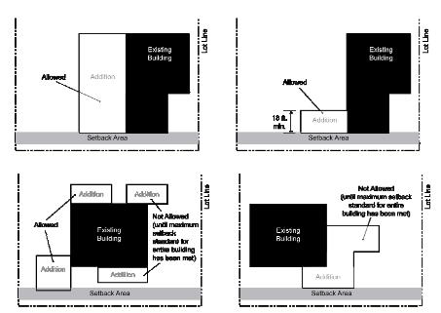

(3)    Permitted New Buildings. Where a new building is being constructed on a site with a nonconforming existing building, the setback area and required building frontage standards apply to the ground level, street-facing facade of the entire new building as set forth below.

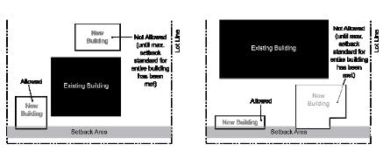

(i)    **Use Categories Allowed in Form Districts.** For the purposes of the form districts, the following use restrictions specific to the form districts are established. The references are to the use categories included in the use table in GJMC [21.04.010](http://www.codepublishing.com/co/grandjunction/html2/GrandJunction21/GrandJunction2104.html#21.04.010).

(1)    Residential. Allows household living; home occupation; and group living use categories.

(2)    Institutional and Civic. Includes colleges and vocational schools; community service; cultural; day care; hospital/clinic; parks and open space; religious assembly; funeral homes/mortuaries/crematories; safety services; schools; utility, basic; utility, corridors use categories, but not detention facilities use category.

(3)    Commercial. Includes entertainment event, major; lodging; office; recreation and entertainment, outdoor; recreation and entertainment, indoor; and retail sales and service (except adult entertainment) use categories. Does not include self-service storage; vehicle repair; vehicle service, limited; parking, commercial; or entertainment event, outdoor use categories.

(4)    Industrial. Includes only the telecommunications facilities use category, but not manufacturing and production, industrial services, contractors and trade shops, oil and gas support operations, junk yard, impound lot, heavy equipment storage/pipe storage, warehouse and freight movement, waste-related use, wholesale sales, agricultural, aviation or surface passenger terminal, mining use categories.

**All other parts of Section 21.03.090 shall remain in full force and effect.**

**Section 21.06.040(i), Landscaping Requirements (table) is amended to add MXOC, as follows (addition underlined):**

21.06.040(i) Landscaping Requirements.

|  |  |  |
| --- | --- | --- |
| **Zoning of Proposed**  **Development** | **Landscape Requirement** | **Location of Landscaping on Site** |
| Single-family residential  (R zones) | As required for uses other than single-  family residential; and as required in subsections (b)(16) and (g) of this section | As required for uses other than  single-family residential; and landscape buffer and public right- of-way |
| R-5, R-8, R-12, R-16,  R-24, R-0, B-1, C-1, C-2, I-O, CSR, MU | One tree per 2,500 square feet of  improved area, with no more than 20 percent of the total being ornamental trees or evergreens. One five-gallon shrub per 300 square feet of improved area | Buffer, parking lot, street frontage  perimeter, foundation plantings and public right-of-way |
| B-2 | One tree per 2,500 square feet of  improved area, with no more than 20 percent of the total being ornamental trees or evergreens. One five-gallon shrub per 300 square feet of improved area | Parking lot, park strip (in right-of-  way) |
| I-1, I-2 | As required in subsection (h) of this  section and in other subsections of this section where applicable | Street frontage, parking lots, buffers  and public right-of-way |
| MXR, MXG, MXS, MXOC | One tree per 3,000 square feet of  improved area, with no more than 20 percent of the total being ornamental trees or evergreens. One five-gallon shrub per 300 square feet of improved area. Plantings must be evenly distributed throughout the development | Buffer, parking lot, street frontage  perimeter, foundation plantings and public right-of-way |
| Facilities: mining, dairy,  vineyard, sand or gravel operations, confined animal feeding operation, feedlot, forestry commercial, aviation or surface passenger terminal, pasture | One tree per 5,000 square feet of  improved area. One five-gallon shrub per 600 square feet of improved area | Perimeter, buffer and public right-  of-way |

**All other parts of Section 21.06.040 shall remain in full force and effect.**

**Section 21.06.040(k) shall be amended to add MXOC, as follows (addition underlined):**

21.06.040(k) Buffering Between Zoning Districts.

| **Zoning of Proposed Development** | **Zoning of Adjacent Property** | | | | | | | | | | | | | | | | | |
| --- | --- | --- | --- | --- | --- | --- | --- | --- | --- | --- | --- | --- | --- | --- | --- | --- | --- | --- |
| **SF** | **R-5** | **R-8** | **R-12**  **R-16** | **R-24** | **R-O & MXOC** | **B-1** | **B-2** | **C-1** | **C-2**  **I-O** | **I-1** | **I-2** | **M-U** | **CSR** | **BP** | **MXR-** | **MXG-** | **MXS-** |
| **SF (Subdivisions)** | - | - | - | - | - | - | F | - | F | W | W | W | F | - | F | - | - | - |
| **R-5** | - | - | - | - | - | - | F | - | F | W | W | W | - | - | F | - | - | - |
| **R-8** | - | - | - | - | - | F | F | - | F | W | W | W | F | - | F | A | - | - |
| **R-12 & R-16** | - | - | - | - | - | - | F | - | W | W | W | W | F | - | F | A | - | - |
| **R-24** | - | - | - | - | - | - | F | - | W | W | W | W | F | - | F | A | - | - |
| **RO & MXOC** | A | A | A | A | A | - | A or F | - | A or F | W | W | W | A or F | - | A or F | A | - | - |
| **B-1** | F | F | F | A or F | A or F | A or F | A or F | - | A or F | A or F | A or F | A or F | A or F | - | A or F | A | - | - |
| **B-2** | - | - | - | - | - | - | - | - | - | - | - | - | - | - | - | - | - | - |
| **C-1** | A&W | W | W | W | W | W | - | - | - | - | - | - | - | - | - | - | - | - |
| **C-2 & I-O** | W | W | W | W | W | W | F | - | - | - | - | - | A or F | A or F | A or F | A&W | - | - |
| **I-1** | W | W | W | W | W | W | F | - | - | - | - | - | A or F | B&W | A or F | B&W | A or F | A or F |
| **I-2** | B&W | W | W | W | W | W | F | - | - | - | - | - | A or F | B&W | A or F | B&W | A or F | A or F |
| **M-U** | A or F | A or F | A or F | A or F | A or F | A or F | A or F | - | A or F | A or F | A or F | A or F | - | - | - | - | - | - |
| **CSR3 1** | - | - | - | - | - | - | - | - | - | - | - | - | - | - | - | - | - | - |
| **BP** | A or F | A or F | A or F | A or F | A or F | A or F | A or F | - | - | - | - | - | - | - | - | A or F | A or F | A or F |
| **MXR-** | - | - | - | - | - | - | F | - | - | W | W | W | F | - | F | - | - | - |
| **MXG-** | - | - | - | - | - | - | F | - | - | W | W | W | F | - | F | - | - | - |
| **MXS-** | - | - | - | - | - | - | F | - | - | W | W | W | F | - | F | - | - | - |
| Notes  •A berm with landscaping is an alternative for a required fence or wall if the total height is a minimum of six feet.  •Where alleys or streets separate different zone districts, the Director may approve increased landscaping rather than requiring a wall or fence.  •The Director may modify this table based on the uses proposed in any zone district.  1 Gravel operations subject to buffering adjacent to residential. | | | | | | | | | | | | | | | | | | |

**All other parts of Section 21.06.040 shall remain in full force and effect.**

INTRODUCED on first reading the 5th day of November, 2014 and ordered published in pamphlet form.

PASSED and ADOPTED on second reading the 19th day of November, 2014 and ordered published in pamphlet form.

ATTEST:

/s/: Phyllis Norris

President of the Council

/s/: Stephanie Tuin

City Clerk