RESOLUTION NO. 40-14
A RESOLUTION APPROVING THE INTERGOVERNMENTAL AGREEMENT
RESTATING AND AMENDING THE RELATIONSHIP BETWEEN THE CITY OF GRAND JUNCTION,
MESA COUNTY, AND MESA COUNTY VALLEY SCHOOL DISTRICT 51 CONCERNING THE ORCHARD MESA SWIMMING POOL AND APPOINTING AND ASSIGNING A CITY COUNCILMEMBER TO REPRESENT THE CITY ON THE ORCHARD MESA POOL ADVISORY BOARD
Recitals:
The City, Mesa County and School District 51 are currently parties to a 1982 agreement together with subsequent amendments concerning the operation and maintenance of the Orchard Mesa Pool. The old agreements have served well since their inception in 1982; however, a comprehensive restatement of the terms concerning the Pool would be beneficial.
The City, the County and the School District have negotiated and agreed to restate and amend their relationship concerning the Pool and with this new agreement the various roles and responsibilities of the City, the County are better defined. With the new agreement the County, the District and the City will clearly understand and agree on such important topics as ownership, continued operations and have a method for reviewing and recommending a budget for the continued operation and maintenance of the Orchard Mesa Pool.
Aquatic recreation is important to the public in general and specifically to those persons that utilize the Pool and with the agreement the City has stated its intention to support the continued success of the Pool.
The agreement calls for the creation of a “Pool Board” comprised of one elected official from the City, the School Board and the Mesa County Board of Commissioners. The Orchard Mesa Pool is within Council District E; Councilmember Duncan McArthur represents District E and has volunteered to serve on the Pool Board.
NOW, THEREFORE, BE IT RESOLVED BY THE CITY COUNCIL OF THE CITY OF GRAND JUNCTION COLORADO THAT:
The intergovernmental agreement restating and amending the relationship between the City of Grand Junction, Mesa County and Mesa County Valley School District 51 concerning the Orchard Mesa swimming pool is approved; and
FURTHERMORE THAT:
Duncan McArthur is appointed to the Orchard Mesa Pool Advisory Board to serve until replaced.

PASSED AND ADOPTED THIS 19th day of November, 2014.

/s/: Phyllis Norris
Phyllis Norris, President of the City Council
ATTEST:

/s/: Stephanie Tuin
City Clerk

INTERGOVERNMENTAL AGREEMENT RESTATING AND AMENDING THE RELATIONSHIP BETWEEN THE CITY OF GRAND JUNCTION, MESA COUNTY AND MESA COUNTY VALLEY SCHOOL DISTRICT 51 CONCERNING THE ORCHARD MESA SWIMMING POOL

THIS AGREEMENT (“Agreement”) is made and entered into by and between MESA COUNTY, hereinafter called “County,” MESA COUNTY VALLEY SCHOOL DISTRICT NO. 51 hereinafter called “District” and THE CITY OF GRAND JUNCTION, hereinafter called “City,” collectively the City, the County and the District may be referred to as the “Parties.” The Agreement shall be effective on the date that it is signed by all Parties.

RECITALS:
The City, County and District are currently parties to a 1982 agreement together with subsequent amendments (“Old Agreement(s)”) concerning the operation and maintenance of the Orchard Mesa Pool (“Pool” or “the Pool”), the floor plan of which is depicted in the attached Exhibit “A”, the northern edge of which abuts a common hallway shared with Orchard Mesa Middle School. The parties agree that this shared hallway and the Orchard Mesa Middle School are the District’s sole responsibility.
The Old Agreement(s) have served the Parties well since their inception in 1982; however, the arrangement(s) together with the amendments thereto that have been made over time, in totality, are not perfectly clear and a comprehensive restatement of the terms concerning the Pool would be beneficial to the Parties.
Beginning in 2010 the County determined that it would no longer participate in funding the Pool as it had for many years in accordance with the Old Agreement(s). Despite the County’s decision, the Old Agreement(s) were never terminated and recently the County re-considered its position and agreed that it would again fund the Pool on condition that the Old Agreement(s) be restated and amended by the Parties. It is the Parties’ intent that this new agreement supersedes and replaces the previous agreement between the Parties.
Each party, the City, the County and the District have certain obligations under the Old Agreement(s) that could be better defined. With better definition the Parties will clearly understand and agree on such important topics as 1) ownership, 2) continued operations and 3) a method for setting a budget and expending funds for the continued operation and maintenance of the Pool.
In the main the Parties agree that the provision of aquatic recreation is important to the public in general and specifically to those persons utilizing the Pool. With that understanding and for the general purposes of meeting the needs of the community, the Parties enter into this agreement as authorized by §18, Article XIV of the Colorado Constitution, §29-1-203, C.R.S., § 22-32-122(1), C.R.S. and other applicable law.
The Parties individually and collectively do hereby express their present and future intentions to support the continued success of the Pool on the terms and conditions stated herein.
NOW, THEREFORE, in consideration of the mutual covenants and conditions contained herein and other valuable consideration, the sufficiency of which is acknowledged for both the formation and enforcement of this Agreement, the Parties agree as follows:
1. The term of this Agreement will be for 5 years commencing on the date that it is signed by all parties and ending 5 years thereafter. On mutual agreement of the Parties this Agreement, together with amendments if any, may be renewed for 3 additional 5 year terms. The Agreement is subject to annual appropriation by the Parties of the funds necessary to defray the expenses arising out of or under the Agreement and/or operation of the Pool. In the event of non-appropriation the agreement shall terminate. The Parties agree that consideration paid and given is sufficient to support this Agreement and the enforcement of the same.
2. The Parties agree that because the Pool is located on District property that the District is and shall be the owner of the Pool. As the owner the District shall provide property loss coverage for the Pool/pool building. The City and/or the County may separately procure property coverage(s) insuring their own interests.
3. The City and County shall have no claim to the Pool and/or the real property on which it is located. The Parties may upon expiration or termination agree to a disposition of the Pool and/or equipment but absent an agreement, the District as owner shall have the sole right to use, sell or otherwise dispose of the Pool premises, including but not limited to the real property, as it determines in its sole and absolute discretion. Improvements made to the Pool including but not limited to fixtures as defined by Colorado law shall accrue to the District upon expiration or termination of the Agreement.
4. The Parties shall jointly establish a board or committee (“Pool Board”) to provide policy direction relating to the funding and management of the Pool during the term of this Agreement or any extension thereof. The Pool Board shall be comprised of one member of City Council, one member of the Board of Commissioners and one member of the District 51 School Board. The Parties shall each respectively designate and assign a member to the Pool Board. Appointment shall be by and in a manner customary to each appointing entity. City personnel, as the managers of the Pool shall serve as staff to the Pool Board. Bylaws and/or procedural rules deemed necessary or required for the conduct of the Pool Board shall be drafted and approved by it.
5. The Pool Board shall recommend an annual budget and capital improvement plan(s) to the City Council, the Board of County Commissioners and the School Board; in the event that all three do not agree on a budget the last approved budget shall control until a new budget is approved or this Agreement is terminated. The annual review and budget recommendation by the Pool Board may include but not necessarily be limited to recommending changes to programming, scheduling and/or alternative approach(es) to management such as privatization, creation of a district and/or other alternatives; however, no recommendation shall be effective until formally adopted by the City, the County and the District.
6. The City and the County shall equally share the cost, less the expenses paid by the District, of the operation and maintenance of the Pool. Expenses shall be reviewed by the Pool Board and a budget shall be recommended by the Pool Board for adoption by each member.
a) The Pool Board shall compare the expenses for operation and management services with the revenue derived from the operation of the Pool and the budgeted subsidies and shall recommend the subsequent years’ budget(s) such that expenses do not exceed revenue (including a subsidy from the City and County as recommended by the Pool Board and as the same is annually budgeted as provided in paragraphs 4 and 5.)
b) For purposes of this Agreement expenses is defined as and includes City inter-fund charges, which are the costs associated with the City’s overhead and management of the operations including, information technology, finance, legal, risk management and other , fees and costs of operation and maintenance of the Pool and all direct staff costs, indirect staff costs of the Recreation Supervisor and Recreation Coordinator assigned to manage and oversee the Pool operations and serve as staff to the Pool Board, hiring costs incurred by the City, lifeguard certification and training (currently Ellis and Associates) fees, mileage and uniform costs.
c) The Pool Board shall recommend the fees and charges for Pool usage to the governing bodies of the City, County and District. All fees and charges collected by the City above and beyond the expenses (except for fees charged by District 51 for its use as the same is further described in paragraph 17) shall be considered revenue for the use and benefit of the Pool Board’s recommendation of a budget for the operations and maintenance of the Pool.
7. The Parties acknowledge and agree that the City staff will occasionally recommend major capital expenditures related to the Pool facilities and/or necessary to provide the services referenced in this Agreement. The Pool Board shall consider capital expenditures as part of the annual budget process.
8. The Pool Board shall consider, and if a majority thereof deems it advisable, recommend the establishment of a capital maintenance fund for the Pool. Any and all supplemental budget requests shall first be presented to the Pool Board for its consideration. If and/or when budgeted the City and County shall contribute equally to the maintenance fund in order to maintain the Pool and pool building in a safe and useful condition. The City, as staff to the Pool Board, will make recommendations for improvements that:
a) are planned;
b) will keep the Pool in reasonable compliance with the Americans with Disabilities Act (“ADA”), 42 U.S.C. 1201 et seq. and the Virginia Graeme Baker Pool and Spa Safety Act, 15 U.S.C. 8001 et seq. and all other applicable legal and safety standards;
c) fund emergency repairs, pending the payment of insurance claim(s), if any; and,
d) fund necessary capital maintenance.
9. All supplies and equipment reasonably required by the City and the cost of the Ellis and Associates Comprehensive Aquatic Risk Management Program (“Ellis”) or a comparable program, which shall be purchased by the City and County and shall be accounted for as expenses. A list of supplies and equipment necessary or required to operate the Pool is provided in Exhibit “B” – OM Pool Maintenance – Supplies.
10. In its operation of the Pool the City shall apply the standards and customary practices it requires together with those required by the Ellis Program or a comparable successor to Ellis. , called for in the program. A description of the Ellis program is attached as Exhibit C and incorporated by this reference as if fully set forth herein.
11. The City shall promptly notify the Pool Board and the District’s Chief Operations Officer if the physical condition of the Pool is not conducive to the safe conduct of any programmed activity in the Pool and/or if maintenance practices may impact in any way, the scheduling of activities in the Pool.
12. With and through the budget process the Pool Board shall be responsible for reviewing and recommending changes to the funding and/or operations of the Pool. In the event that a budget is not approved by the Pool Board or one or more of the governing bodies (City, District or the Board of County Commissioners) then the Pool Board may recommend that the Pool be closed, [ or privatized; any recommendation that results in the permanent closure, or fundamental change to the operation of the Pool as contemplated by this Agreement shall a) require unanimity of the Pool Board and b) absent an emergency as defined herein occur no sooner than 12 months after the recommendation is made to the District, the City and the Board of County Commissioners.
13. For purposes of this Agreement an emergency is:
a) an Act of God or the declaration of a local, state or federal emergency that directly effects the continued ability to operate the Pool; and/or
b) an unforeseen event, such as contamination by bacteria, communicable disease or some other happening and/or order by an agency having authority following an event or happening to close the Pool and/or render it unusable;
c) lacking the occurrence of a) or b) above a failure of any Party to budget and/or fund the Pool is not an emergency.
14. The District agrees to allow the City and County to use the Pool during the term of this Agreement or any extension thereof without need or requirement of compensation to the District; during the term of this Agreement or any extension thereof the District’s sole financial obligations to the Pool’s operating expenses shall be the payment of premiums for property insurance covering the Pool, internet access in the Pool area (recurring charges and network connection(s) for use by the City for scheduling), and payment for all gas and electric utilities, water and trash service reasonably necessary for operation of the Pool.
15. The City agrees to provide all required labor for the operation of the Pool. Labor for purposes of this Agreement is lifeguards, janitorial staff, swim instructors, guest service representatives and pool managers. The City will pay as an expense of the operation of the Pool all wages, salaries, benefits and workers’ compensation insurance premiums and inter-fund charges for the required labor and operations of and for the Pool. Personnel who will work on District property are required to meet the same requirements for background checks, CBI criminal history and fingerprinting as District personnel.
16. The City will provide basic daily maintenance and janitorial services.
17. The City will manage the Pool for and schedule all open swim, swim lesson and special event participants, including for District sponsored uses. The City staff will collect the revenues generated by public swim, swim lessons, private parties and special events and concessions and the revenue shall be used to pay the expenses of the Pool. Fees and charges for District-sponsored users (i.e., physical education classes, swim team practice/meets and District-sponsored events) shall be determined by the District; the District shall not be required to pay the City and/or County for use of the Pool for District purposes. Fees, if any, collected by the City for the District shall be promptly paid to the District in the amount agreed and determined by the District and the City. District-sponsored uses shall have priority over use by the general public during normal school hours.

18. The City will pay as an expense of the operation of the Pool the liability insurance premiums, for coverage with limits and deductibles to be agreed-upon by the Parties but in any event in amounts no less than the most current limits established by the Colorado Governmental Immunity Act, 24-10-101 et seq., C.R.S., as from time to time amended. The County and the District shall be named as loss payees, with insurance declaration sheets provided to them.
19. As part of the budget the Pool Board shall budget for and create an insurance reserve account for the purposes of paying the property and casualty deductible(s) incurred in the event of a claim(s). The City shall maintain the account for the use and benefit to the parties.
20. The Parties understand and agree that each and every one of them may be protected by, and will rely on and do not waive or intend to waive by any provision of this Agreement, the limitations or any other rights, immunities and protections provided by the Colorado Governmental Immunity Act, 24-10-101 et seq., C.R.S., as from time to time amended.
21. To the extent authorized by law and/or insurance the City agrees to indemnify and hold harmless the County and the District and their officers and employees, from and against all liability, claims, demands and expenses, including court costs and attorney fees, on account of any injury, loss or damage, which arise out of or are in any manner connected with the operations and programming work to be performed by the City under this agreement, if such injury, loss or damage is caused by, or is claimed to be caused by, the act, omission, or other fault of the City or any officer or employee of the City.
22. Any person(s) employed by the City, the County or the District that performs work hereunder shall be and remain the employee(s) of the respective party and not agent(s) or employee(s) of another party.
23. No party may assign or delegate its obligations under this Agreement or any portion thereof without the prior written consent of the other Parties.
24. Each and every term and condition hereof shall be deemed to be a material element of this Agreement. In the event either Party should fail or refuse to perform according to the terms of this Agreement; such party may be declared in default.
25. This Agreement may, absent an emergency, only be terminated by giving the other parties written notice of no less than three hundred sixty-five (365) days advance notice of termination. In the event of an emergency the Pool Board shall recommend a means for termination or suspension of this Agreement. Termination shall not prevent any party from exercising any other legal remedies which may be available to it. Any party’s failure to appropriate the funds necessary to defray the expenses assumed by each through the adopted budget shall constitute a default and be cause for termination of the agreement.
26. The Parties shall reasonably comply with the applicable provisions of the ADA and any and all other applicable federal, state or local laws and regulations.
27. This Agreement represents the entire agreement between the Parties and there are no oral or collateral agreements or understandings. Only an instrument in writing signed by the parties may amend this Agreement.
28. The traditional rule that ambiguities shall be construed against the drafter is waived.
29. Venue for any action arising out of or occurring under this Agreement shall be in the District Court for Mesa County, Colorado. The agreement shall be controlled by, construed and interpreted in accordance with the law of the State of Colorado.
30. The Parties agree that any and all disputes, claims or controversies arising out of or relating to this Agreement shall be submitted for mediation, and if the matter is not resolved through mediation, then the parties may proceed to District Court.

This Agreement has been negotiated and agreed to by, with and through the common effort of the Parties and as such each waives and foregoes the customary rule that ambiguities are construed against the drafter.
In the event of any ambiguities the Parties agree to a liberal construction of the Agreement and to give meaning, purpose and effort to attempting to resolve the ambiguity(ies) in favor of continuing the Agreement for the benefit of the communities that they serve.
The Parties, individually and collectively, intending to be bound to the terms and conditions hereof do sign and bind the entity for which he/she/they sign.
______________________________________________
City of Grand Junction – date
__________ Title
______________________________________________
Mesa County Board of Commissioners - date
___________Title
______________________________________________
Mesa County Valley School District 51 – date

___________Title
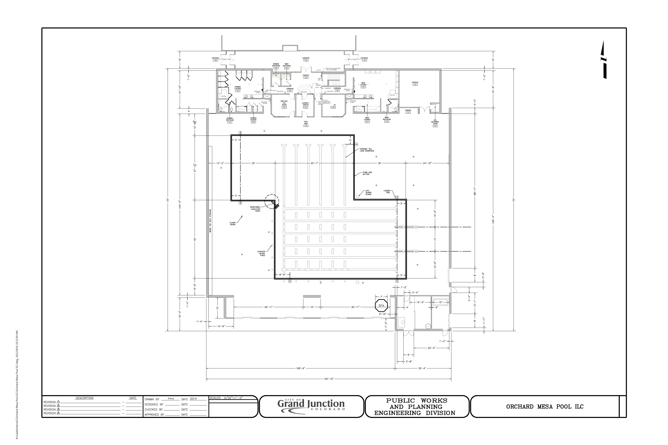
Exhibit A
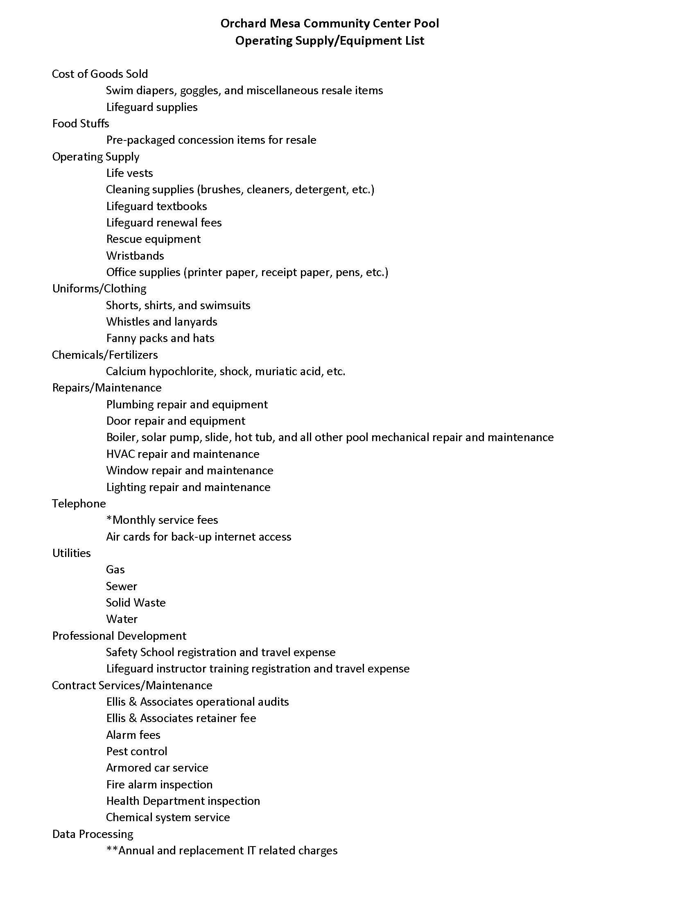
Exhibit B
Exhibit B cont.

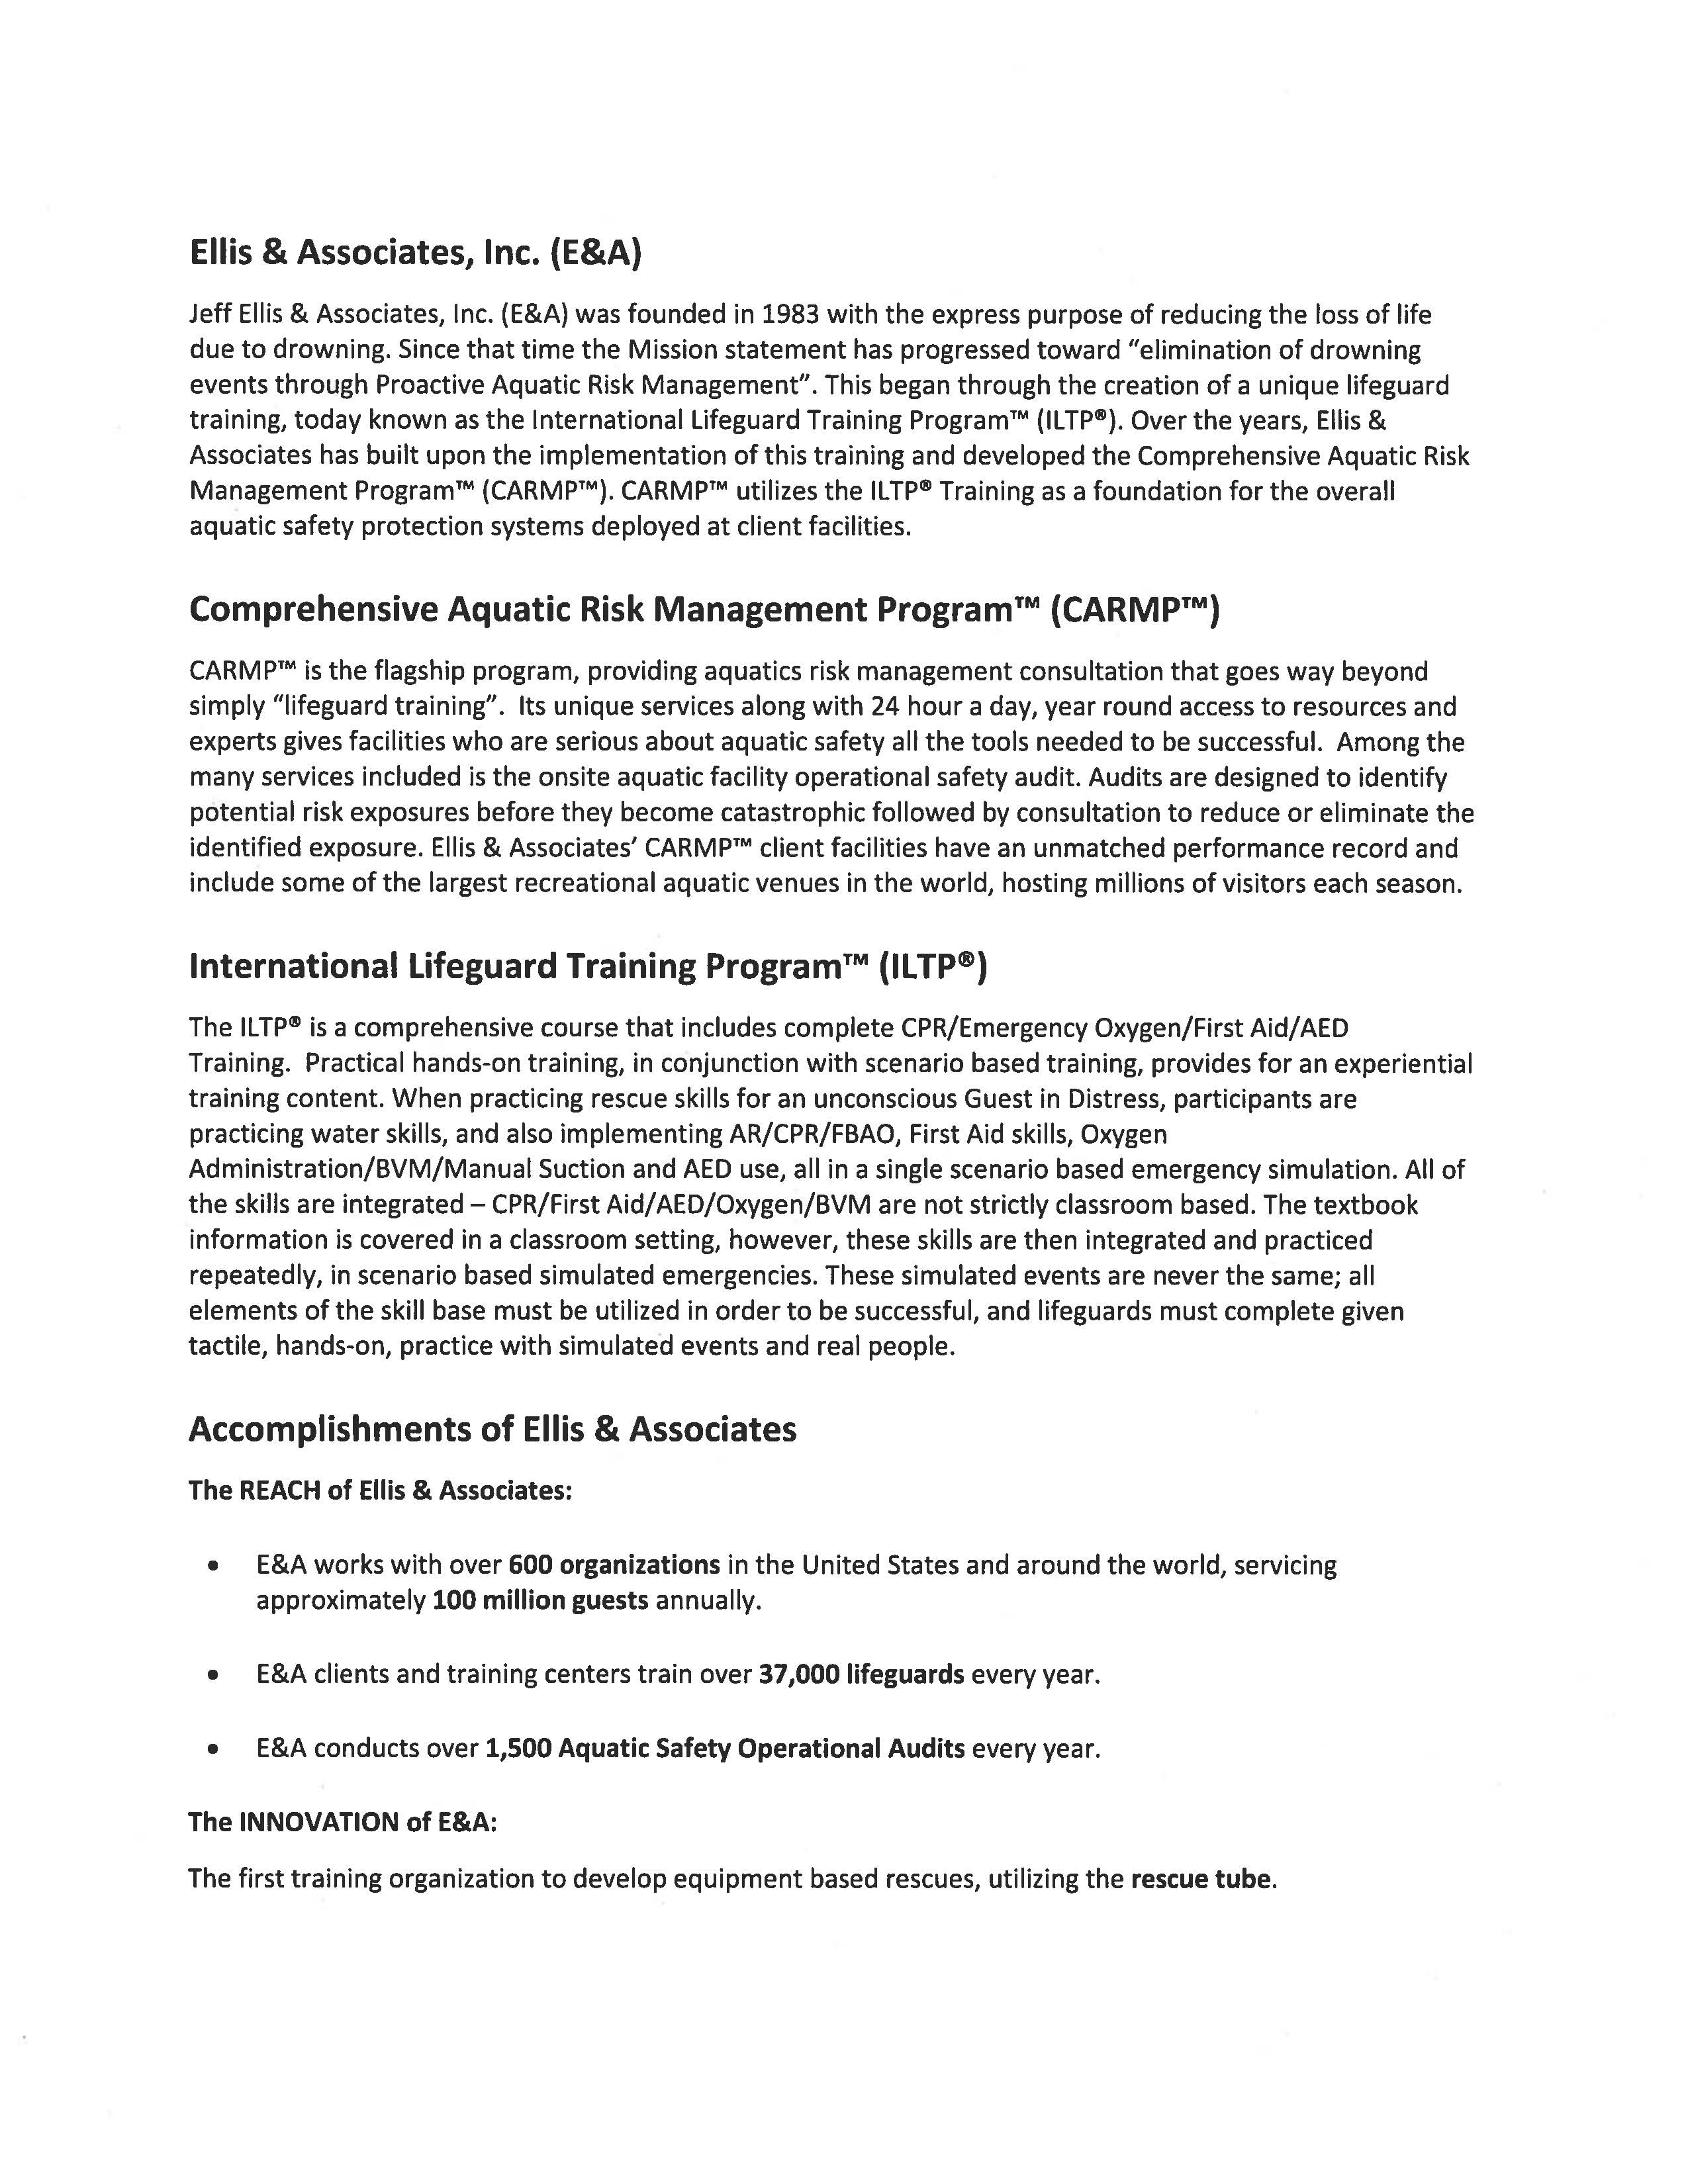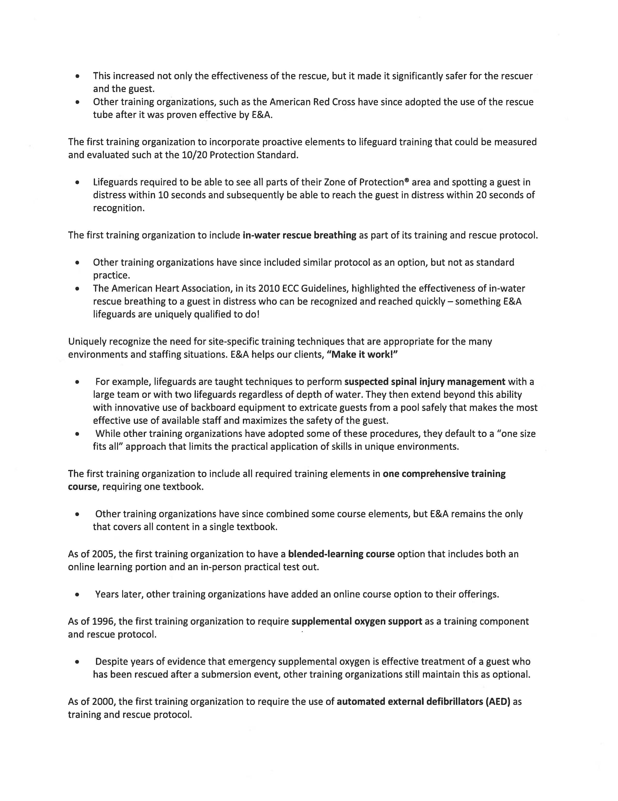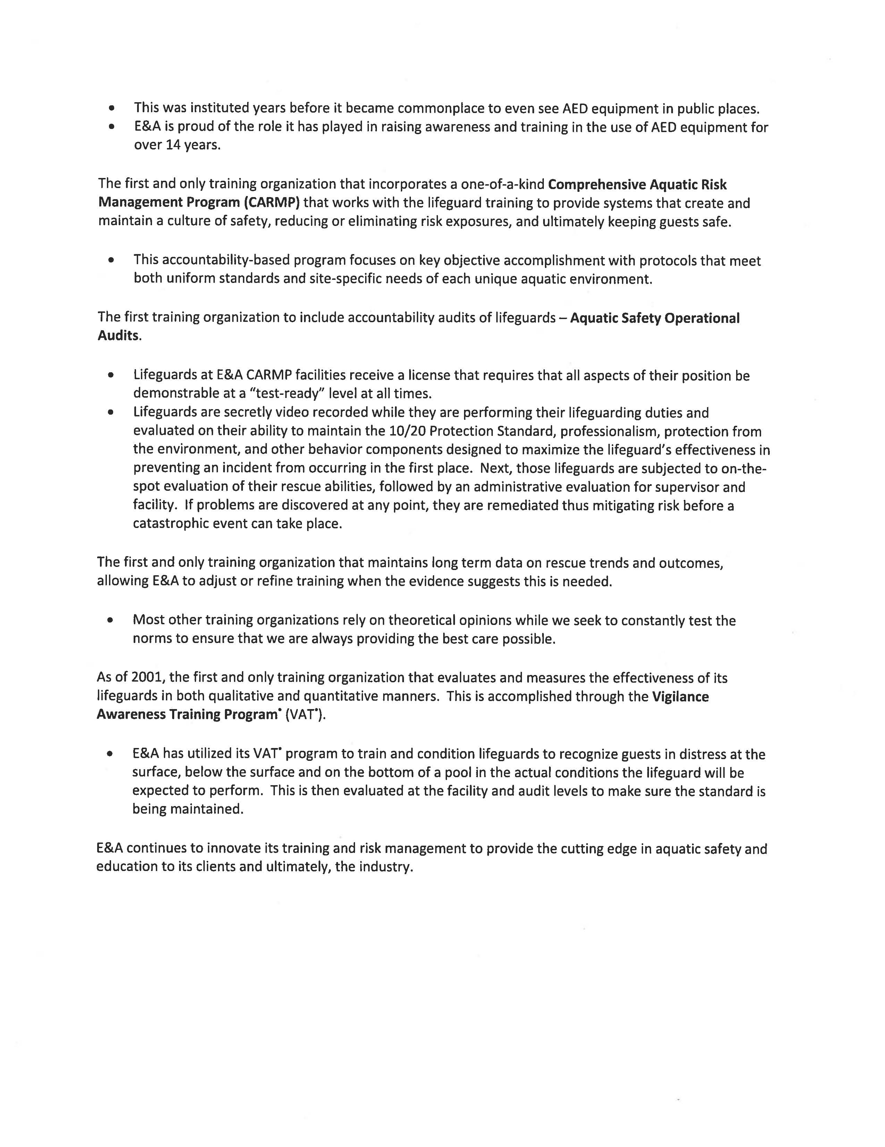
Exhibit C
Exhibit C cont.
Exhibit C cont.
Bylaws of the Orchard Mesa Pool Advisory Board
City of Grand Junction
Mesa County
Mesa County Valley School District 51

Article 1 – Purpose, Board, Place of Business

- The Orchard Mesa Pool Advisory Board (“Pool Board”) has been jointly established to provide policy direction relating to the operation of the Orchard Mesa Pool (“Pool” or “the Pool”.) The Board shall make recommendations to the Board of County Commissioners, the City Council and the School Board principally concerning the budget for the operation and maintenance of the Pool; however, the Pool Board may hear complaints from citizens and/or address service and policy matters. No budget or policy shall be effective until formally adopted by the City Council and the Board of County Commissioners. The Pool Board duties shall include but not necessarily be limited to setting goals and objectives; reviewing and recommending capital improvement plans and annual operating budgets; and, reviewing and recommending rates, fees and charges; adopting and/or amending rules and regulations.

- The Pool Board, in accordance with the intergovernmental agreement by and between the District, the City and the County shall give written and oral recommendations and serve in an advisory capacity to the City, County and District.

Article 2 – Appointment of Members

- The Pool Board shall be three members, with the City Council, the Board of County Commissioners and the District each appointing one member of each to serve. Service on the Pool Board shall be consistent with these bylaws and the intergovernmental agreement.

- The City Manager shall designate staff to serve the Board.

- The Pool Board shall meet on the first Friday of each month at 8:00 A.M. at a designated location.

- The terms of service will coincident with each members term which he/she was elected for with service on the Pool Board being for no longer than three (3) years. Board members are limited to two (2) consecutive terms so long as he/she is serving as an elected official for the entity that appointed him/her to the Pool Board.

- Members shall be selected without regard to race, color, religion, sex, age, sexual orientation, national origin, marital status or physical handicap.

Article 3 – Vacancies

Vacancies to the Pool Board shall be filled in the manner set forth herein for appointment and following the respective policies and procedures set forth by the City Council, the Board of County Commissioners and the School Board for appointment to a board or commission.

Article 4 – Officers

- At the first meeting of the Pool Board each calendar year, the Board members shall elect a chairperson.

- The chair shall serve as the informal head of the Pool Board and preside at meetings of the Pool Board. In the absence of the Board chairperson, the members in attendance shall designate a temporary chairperson who shall preside at the Board meeting and perform the duties of the chair and when so acting, shall have the authority and duties of the chair.

- The assigned City staff shall record the affairs of the Board and shall see to the correspondence and other communications of the Board.

Article 5 – Conflicts, Compensation, Expenses

- No compensation shall be paid to any member of the Pool Board for his/her services. The Pool Board shall not enter into any contract with any member or pay or authorize any remuneration to any member. The rules and requirements of the City Code and Charter and state law applicable to elected officials regarding conflicts of interest, disclosure, gifts and appearances of impropriety shall apply to each member of the Pool Board.

- A member may be reimbursed for his/her extraordinary expenses that are 1) allowed by motion of the Board and 2) the motion allowing the reimbursement of extraordinary expenses is approved prior to the expenses being incurred. Expenses so authorized must be incurred in the performance of the Board member’s duties. All such expenses shall be budgeted and paid with authorized funds.

Article 6 – Meetings, Notice, Open Meetings

- Regular meetings shall be held as provided herein or otherwise established in writing.

- Any member may call a special meeting and it shall then be the duty of the City staff to cause notice of such meeting to be properly given. Special meetings may be held at any place within the City of Grand Junction.

- Notice of any meeting of the Pool Board, including the purpose thereof, shall be made in writing to each member by mail, facsimile, e-mail at least 72 hours before the scheduled meeting. Attendance by a member at any meeting of the Pool Board shall be acceptance of notice by him/her of the time, place, and purpose thereof. Any lawful business of the Pool Board may be transacted at any meeting for which proper notice has been given.

- Any meeting may be held by telephone or video conference call upon approval of a majority of the Board.

- Affairs of the Pool Board shall be governed by the Open Meetings Law and the Open Records Act, as amended.

Article 7 – Quorum

A majority of the members of the Pool Board shall constitute a quorum. The act of a majority of the members present at a meeting in which a quorum is present shall be the act of the Board.

Article 8 – Authority

The Pool Board has no authority to bind the City, the County or the School District.

Article 9 – Notices

Any notice of claim, demand or other legal process served on or received by the Pool Board or any of its members for matters arising out of or under the members’ service on the Pool Board should be immediately delivered to the City Attorney.

Article 10 – Legal Advice and Insurance

The City Attorney shall serve as the legal advisor for the Pool Board. Each Pool Board member shall insure or cause him/herself to be insured by the council, board or commission that appointed him/her.

Adopted this 19th day of November, 2014 by the Grand Junction City Council.

