CITY OF GRAND JUNCTION, COLORADO

ORDINANCE NO. 4652

AN ORDINANCE REZONING APPROXIMATELY 3.763 ACRES FROM R-16 TO PD (PLANNED DEVELOPMENT) AND APPROVING
THE OUTLINE DEVELOPMENT PLAN (ODP)

GRAND JUNCTION HOUSING AUTHORITY SENIOR LIVING
PLANNED DEVELOPMENT – HIGHLANDS APARTMENTS
(AKA THE EPSTEIN PROPERTY)
LOCATED AT 805 BOOKCLIFF AVENUE

Recitals:

A request for a Rezone and Outline Development Plan approval has been submitted in accordance with the Grand Junction Municipal Code. The applicant has requested that approximately 3.763 acres, located at 805 Bookcliff Avenue, be rezoned from R-16 (Residential - 16 units per acre) to PD (Planned Development) with a default zoning of R-24 (Residential – 24 units per acre). The applicant proposes to develop the property into 128 units of multi-family residential units for seniors in two phases, with each phase consisting of 64 residential units, resulting in an ultimate proposed density of 30.9 units per acre. In addition, an area for indoor amenities such as offices for resident service provider visits (such as home health care and Veterans Administration) together with common fitness, wellness, and socializing areas is anticipated to be constructed as part of the first phase.

This PD zoning ordinance will establish the default zoning, including uses and deviations from the bulk standards.

In public hearings, the Planning Commission and City Council reviewed the request for the proposed Rezone and Outline Development Plan approval and determined that it satisfied the criteria as set forth and established in Section 21.02.140 of the Grand Junction Municipal Code and the proposed Rezone and Outline Development Plan is consistent with the purpose and intent of the Comprehensive Plan.

NOW, THEREFORE, BE IT ORDAINED BY THE CITY COUNCIL OF THE CITY OF GRAND JUNCTION THAT THE AREA DESCRIBED BELOW IS REZONED FROM R-16 TO PD with the following default zone and deviations from the default zoning:

Property to be Rezoned:

All that part of the N1/4 of the SW1/4NE1/4 of Section 11, Township 1 South, Range 1 West of the Ute Meridian, lying East of the center line of North Seventh Street; EXCEPT the West 450 feet of said tract; AND ALSO EXCEPTING THEREFROM all roads, easements and rights of way of record in Mesa County, Colorado.

Containing 3.763 acres, more or less. See Attached Exhibit A, Outline Development Plan.

- Deviation of Uses

The following uses shall also be allowed:

Management office with residential unit for on-site manager, including support offices for resident service providers such as home health care and Veterans Administration, together with fitness, wellness, and socializing areas. Other indoor amenities may include a coffee shop and/or sandwich shop.

In lieu of a solid fence the required fence buffer on the west side of the property can be open style fencing (to see through) or a landscaping berm.

- Deviations from Bulk Standards

A zoning density range of 24 to 32 dwelling units per acre.

Minimum front yard setback shall be 10 feet.

Minimum side yard setbacks shall be zero from any new lot line created by subdivision of the property.

INTRODUCED on first reading on the 17th day of December, 2014 and ordered published in pamphlet form.

ADOPTED on second reading this 7th day of January, 2015 and ordered published in pamphlet form.

ATTEST:

/s/: Phyllis Norris
President of Council

/s/: Stephanie Tuin
City Clerk

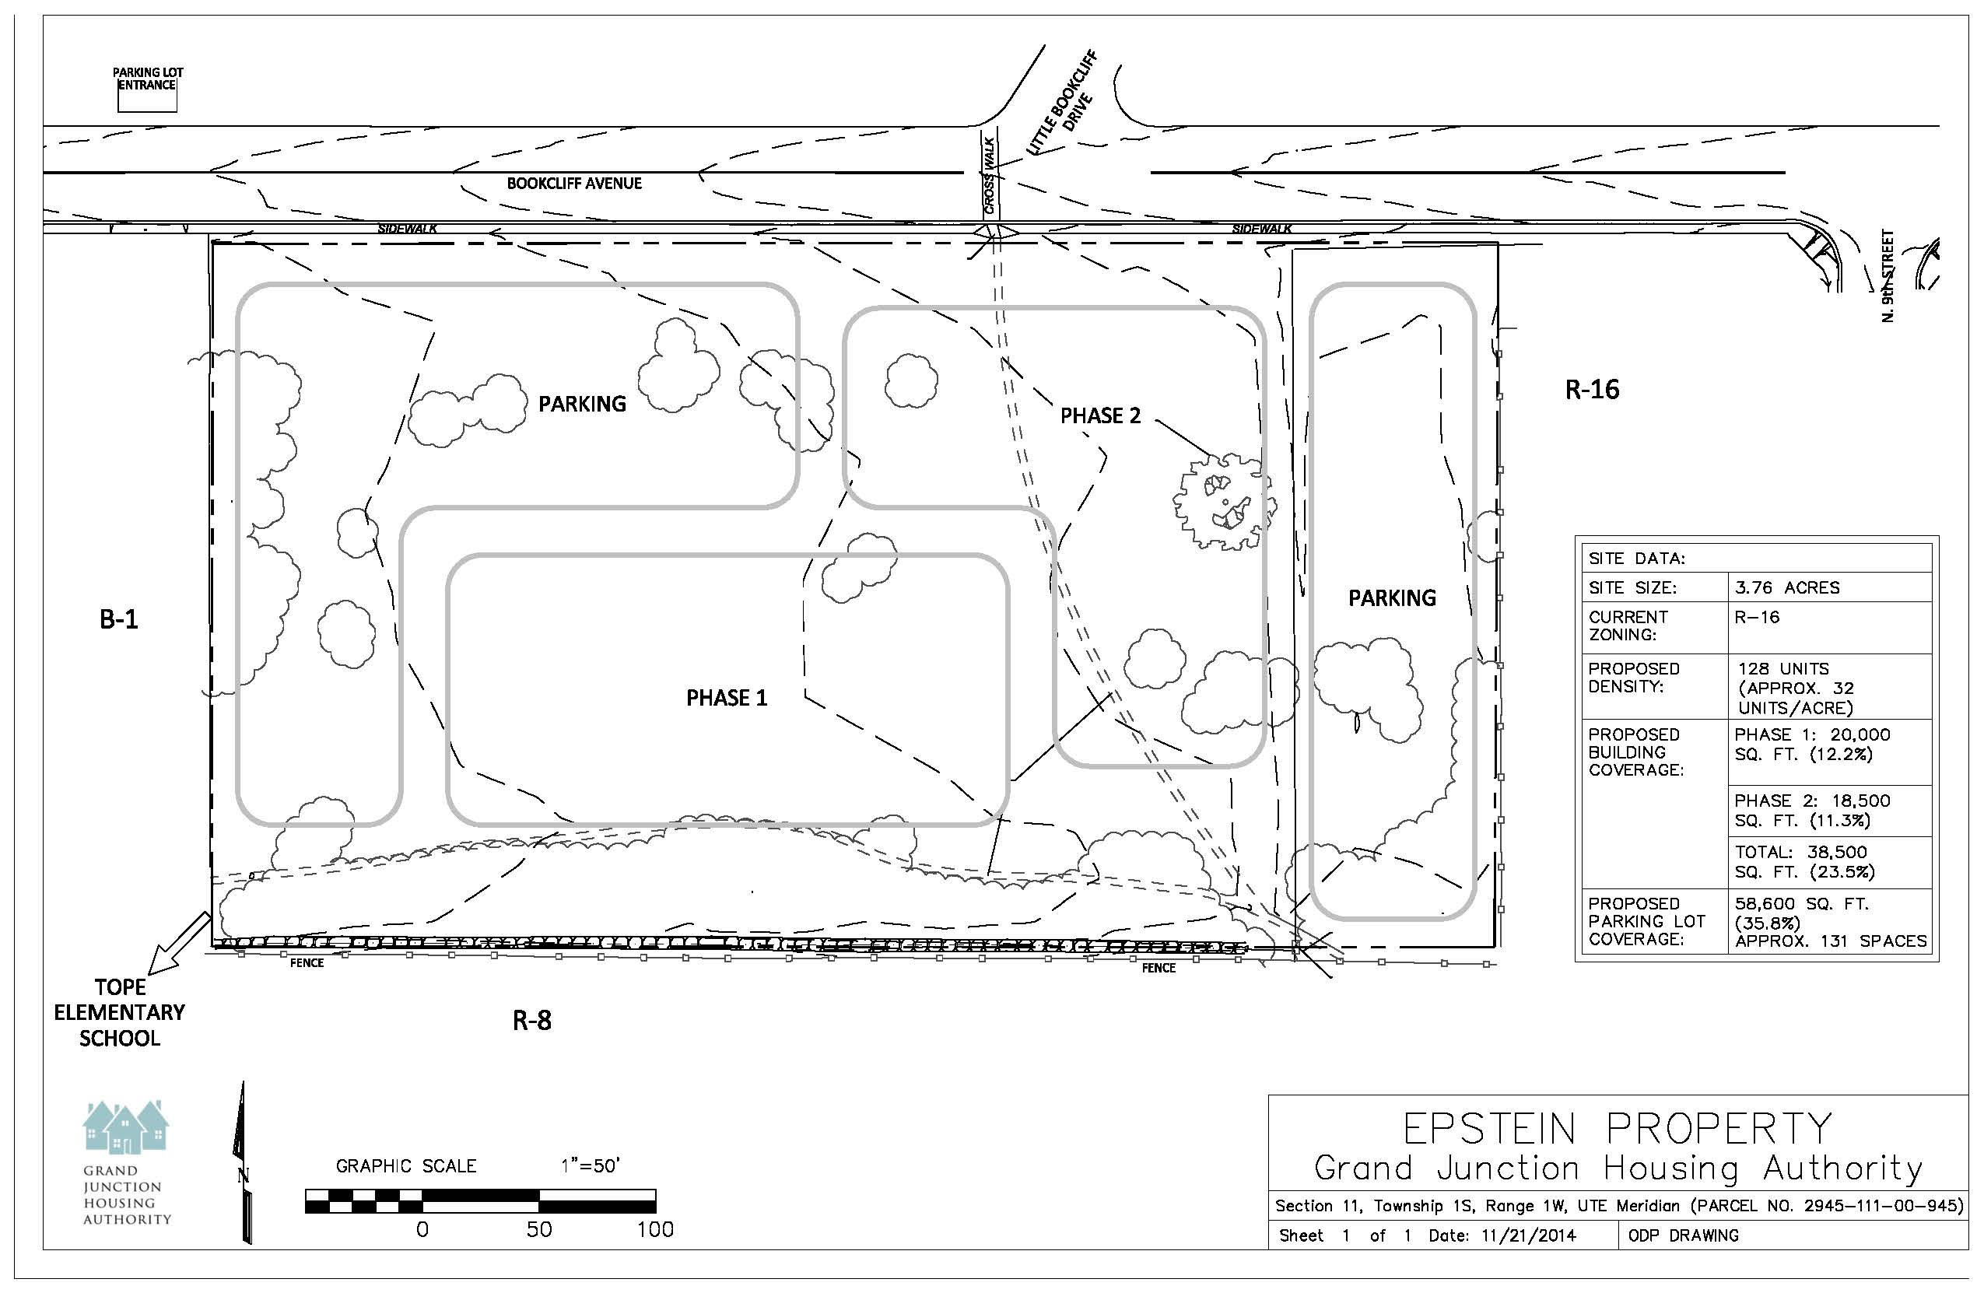
Exhibit A

