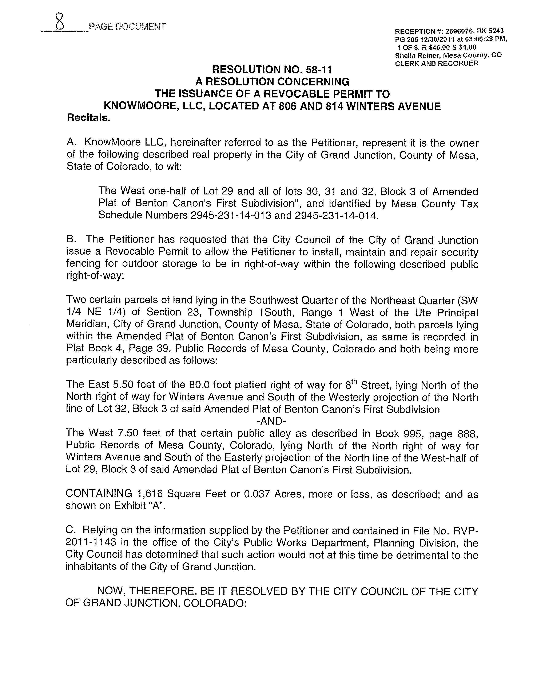
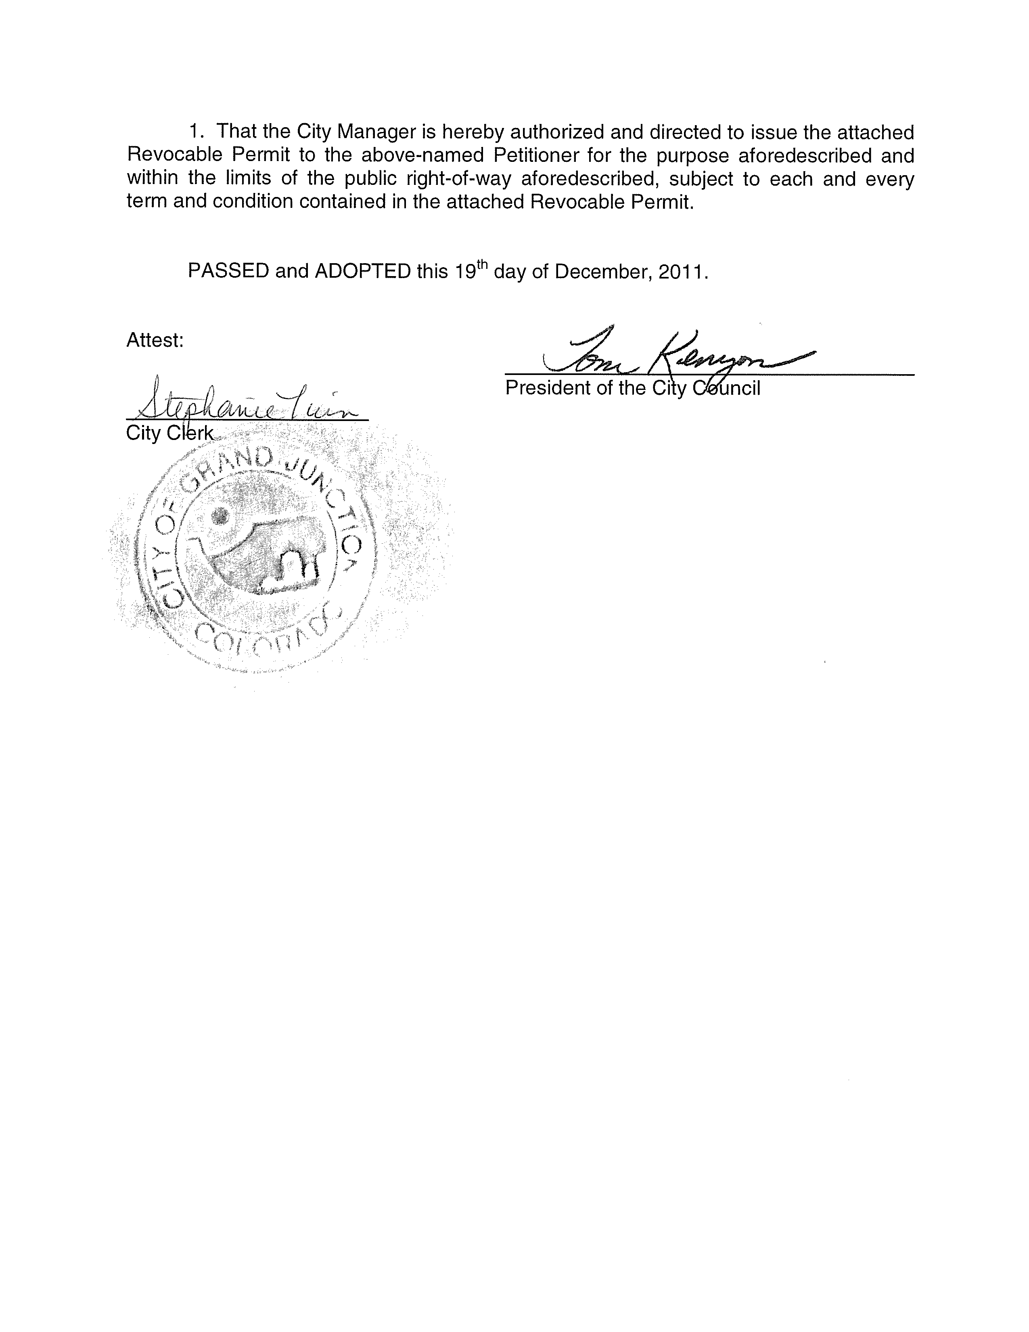
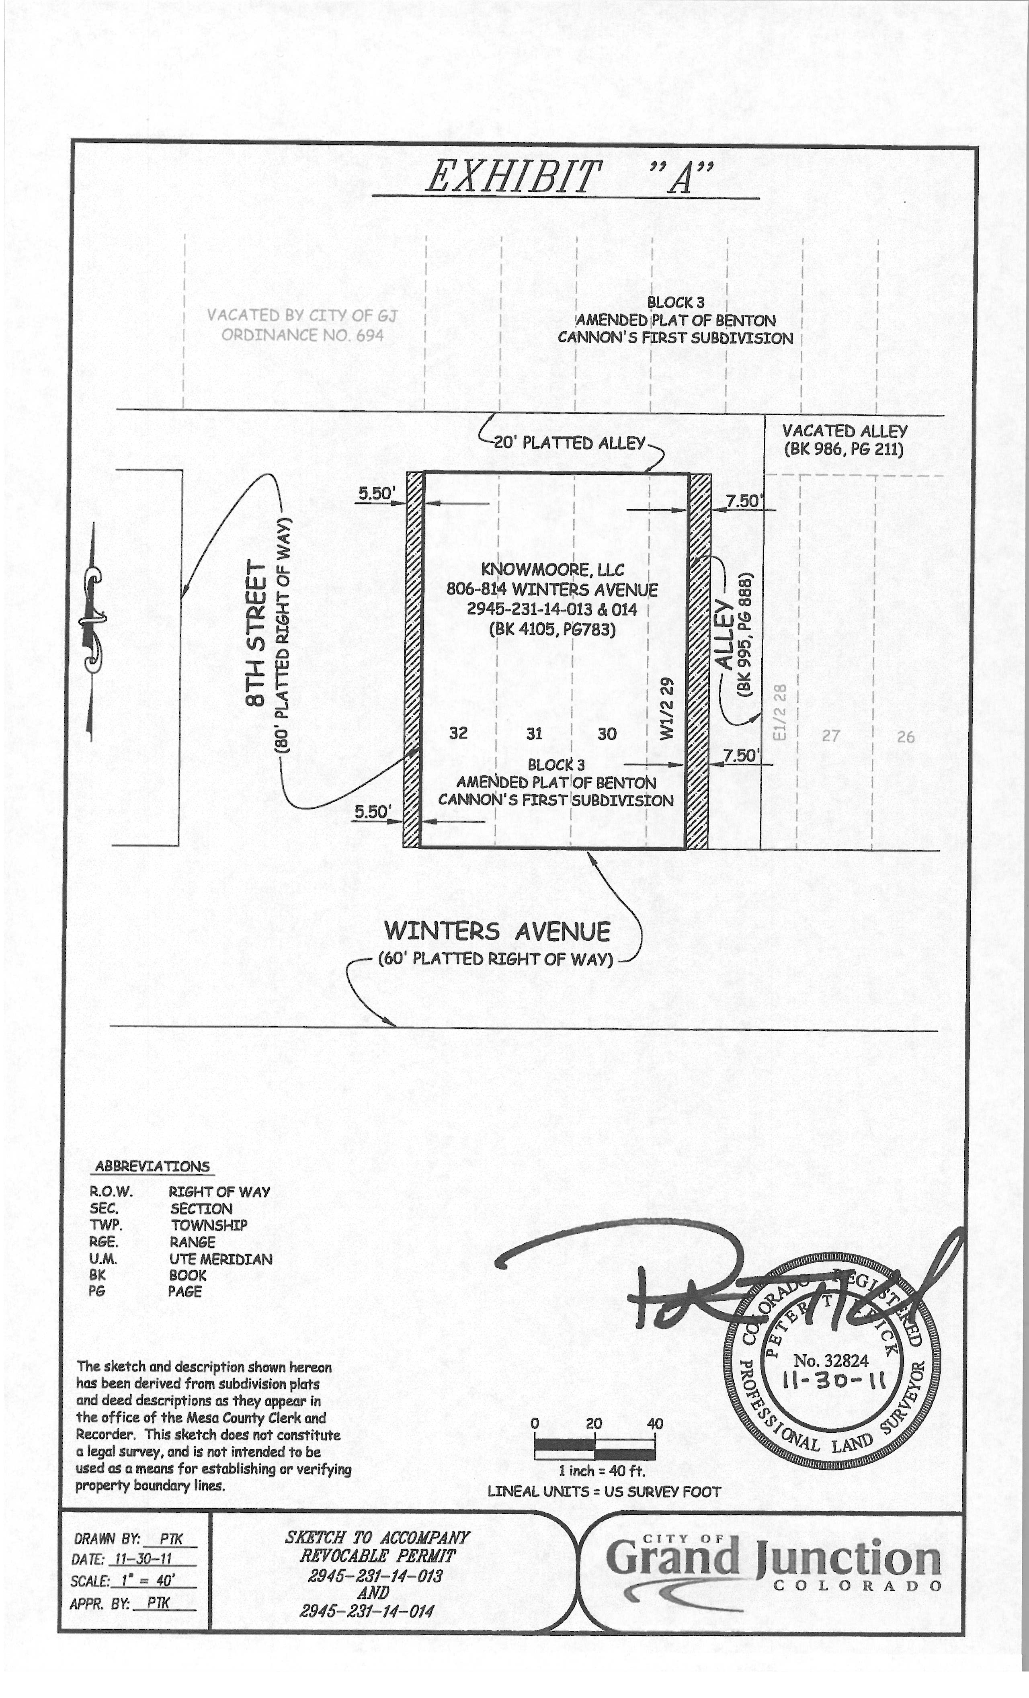
REVOCABLE PERMIT

Recitals.

A. KnowMoore LLC, hereinafter referred to as the Petitioner, represent it is the owner of the following described real property in the City of Grand Junction, County of Mesa, State of Colorado, to wit:

The West one-half of Lot 29 and all of lots 30, 31 and 32, Block 3 of Amended Plat of Benton Canon's First Subdivision", and identified by Mesa County Tax Schedule Numbers 2945-231-14-013 and 2945-231-14-014.

B. The Petitioner has requested that the City Council of the City of Grand Junction issue a Revocable Permit to allow the Petitioner to install, maintain and repair security fencing for outdoor storage within the following described public right-of-way:

Two certain parcels of land lying in the Southwest Quarter of the Northeast Quarter (SW 1/4 NE 1/4) of Section 23, Township 1South, Range 1 West of the Ute Principal Meridian, City of Grand Junction, County of Mesa, State of Colorado, both parcels lying within the Amended Plat of Benton Canon’s First Subdivision, as same is recorded in Plat Book 4, Page 39, Public Records of Mesa County, Colorado and both being more particularly described as follows:

The East 5.50 feet of the 80.0 foot platted right of way for 8th Street, lying North of the North right of way for Winters Avenue and South of the Westerly projection of the North line of Lot 32, Block 3 of said Amended Plat of Benton Canon’s First Subdivision

-AND-

The West 7.50 feet of that certain public alley as described in Book 995, page 888, Public Records of Mesa County, Colorado, lying North of the North right of way for Winters Avenue and South of the Easterly projection of the North line of the West-half of Lot 29, Block 3 of said Amended Plat of Benton Canon’s First Subdivision.

CONTAINING 1,616 Square Feet or 0.037 Acres, more or less, as described; and as shown on Exhibit “A”.

C. Relying on the information supplied by the Petitioner and contained in File No. RVP-2011-1143 in the office of the City’s Public Works and Planning Department, the City Council has determined that such action would not at this time be detrimental to the inhabitants of the City of Grand Junction.

NOW, THEREFORE, IN ACCORDANCE WITH THE ACTION OF THE CITY COUNCIL OF THE CITY OF GRAND JUNCTION, COLORADO:

There is hereby issued to the above-named Petitioner a Revocable Permit for the purpose aforedescribed and within the limits of the public right-of-way aforedescribed; provided, however, that the issuance of this Revocable Permit shall be conditioned upon the following terms and conditions:

1. The Petitioner’s use and occupancy of the public right-of-way as authorized pursuant to this Permit shall be performed with due care or any other higher standard of care as may be required to avoid creating hazardous or dangerous situations and to avoid damaging public improvements and public utilities or any other facilities presently existing or which may in the future exist in said right-of-way.

2. The City hereby reserves and retains a perpetual right to utilize all or any portion of the aforedescribed public right-of-way for any purpose whatsoever. The City further reserves and retains the right to revoke this Permit at any time and for any reason.

3. The Petitioner, for itself and for its successors, assigns and for all persons claiming through the Petitioner, agrees that it shall defend all efforts and claims to hold, or attempt to hold, the City of Grand Junction, its officers, employees and agents, liable for damages caused to any property of the Petitioner or any other party, as a result of the Petitioner’s occupancy, possession or use of said public right-of-way or as a result of any City activity or use thereof or as a result of the installation, operation, maintenance, repair and replacement of public improvements.

4. The Petitioner agrees that it shall at all times keep the above described public right-of-way in good condition and repair.

5. This Revocable Permit shall be issued only upon the concurrent execution by the
Petitioner of an agreement that the Petitioner and the Petitioner’s successors and assigns shall save and hold the City of Grand Junction, its officers, employees and agents harmless from, and indemnify the City, its officers, employees and agents, with respect to any claim or cause of action however stated arising out of, or in any way related to, the encroachment or use permitted, and that upon revocation of this Permit by the City the Petitioner shall, at the sole cost and expense of the Petitioner, within thirty (30) days of notice of revocation (which may occur by mailing a first class letter to the last known address), peaceably surrender said public right-of-way and, at its own expense, remove any encroachment so as to make the aforedescribed public right-of-
