**CITY OF GRAND JUNCTION**

**RESOLUTION NO. 17-15**

**A RESOLUTION VACATING A PUBLIC UTILITY EASEMENT**

**LOCATED AT 2693 ½ HIGHWAY 50 (COON HILL SUBDIVISION)**

RECITALS:

An application has been filed for the vacation of the 10’ - 15’ Utility Easement dedicated along the east side of Lot 2, Coon Hill Subdivision. The 10’ - 15’ Utility Easement contains no utilities.

The Planning Commission, having heard and considered the request, found the criteria of the Code to have been met, and recommends that the vacation.

The City Council having duly considered the applicant and the recommendation of the Planning Commission finds and determines that the request to vacta the Utility Easement is consistent with the Comprehensive Plan, the Grand Valley Circulation Plan and Section 21.02.100 (c) of the Grand Junction Municipal Code.

NOW, THEREFORE BE IT RESOLVED BY THE CITY COUNCIL OF THE CITY OF GRAND JUNCTION, COLORADO THAT:

The easement shown on “Exhibit A” as part of the application for vacation is described as follows and furthermore that the same is hereby vacated:

A certain parcel of land lying in the Southeast Quarter of the Northeast Quarter (SE 1/4 NE 1/4) of Section 26, Township 1 South, Range 1 West of the Ute Principal Meridian, County of Mesa, State of Colorado and lying entirely within Lot 2, Coon Hill II Subdivision, as same is recorded in Plat Book 19, Page 318, Public Records of Mesa County, Colorado, and being more particularly described as follows:

ALL of that certain 10 foot and 15 foot wide Utility Easement lying adjacent to the East line of said Lot 2, Coon Hill II Subdivision and lying North of that certain 14.0 foot wide Multipurpose Easement lying adjacent to the South line of said Lot 2, Coon Hill II Subdivision, said easement depicted and dedicated on the plat of Coon Hill Subdivision, as same is recorded in Plat Book 17, Page 366, Public Records of Mesa County, Colorado.

CONTAINING 5,238 Square Feet or 0.12 Acres, more or less, as described.

PASSED and ADOPTED this 18th day of March, 2015.

ATTEST:

/s/ Phyllis Norris

President of City Council

/s/ Stephanie Tuin

City Clerk

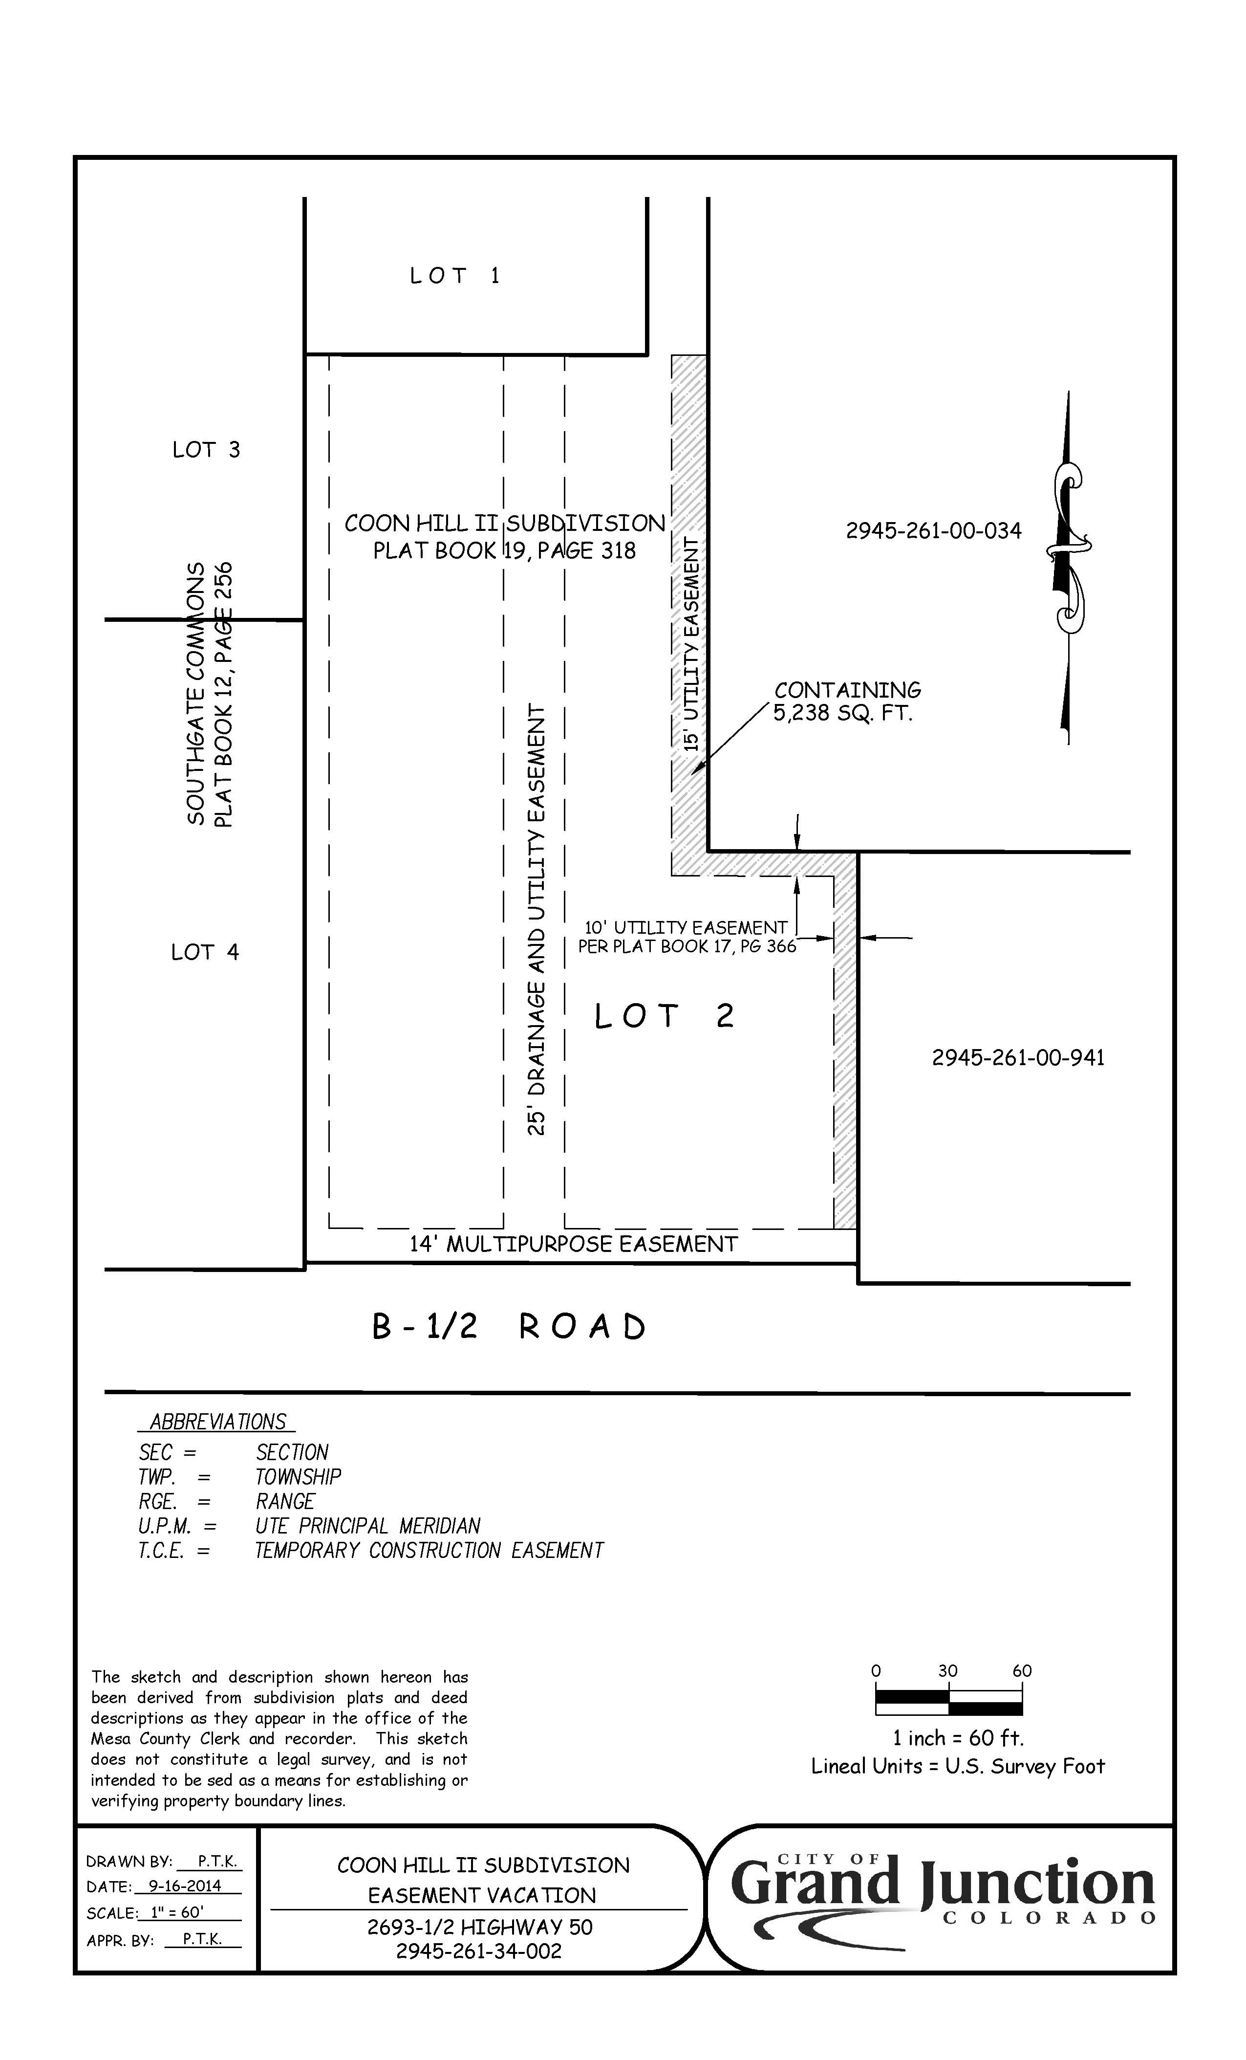

**Exhibit A**