RESOLUTION NO. 31-15
A Resolution authorizing the purchase of real property, LOCATED AT 743 HORIZON DRIVE, from GRand ConjunctioN, LLC DBA DOUBLETREE
Recitals:

- The City of Grand Junction has entered into a contract with Grand Conjunction, LLC for the purchase by the City of certain real property located within the proposed alignment of the I-70 Exit 31 Horizon Drive Roundabout project. The street address, Mesa County Assessor parcel number and project parcel numbers are as follows:

- The purchase contract provides that on or before July 1, 2015, the City Council must ratify the purchase and the allocation of funds for all expenses required to effectuate the purchase of said property.

- Based on the advice and information provided by the City staff, the City Council finds that it is necessary and proper that the City purchase said property.

NOW, THEREFORE, BE IT HEREBY RESOLVED BY THE CITY COUNCIL OF THE CITY OF GRAND JUNCTION THAT:

- The above described property shall be purchased for price of $197,000. All actions heretofore taken by the officers, employees and agents of the City relating to the purchase of said property which are consistent with the provisions of the negotiated Contract to Buy and Sell Real Estate and this Resolution are hereby ratified, approved and confirmed.

- Said $197,000 is authorized to be paid at closing, in exchange for conveyance of the fee simple title to the described property.

PASSED AND APPROVED this 1st day of July, 2015.

/s/ Phyllis Norris
President of the Council
ATTEST:

/s/ Stephanie Tuin
City Clerk

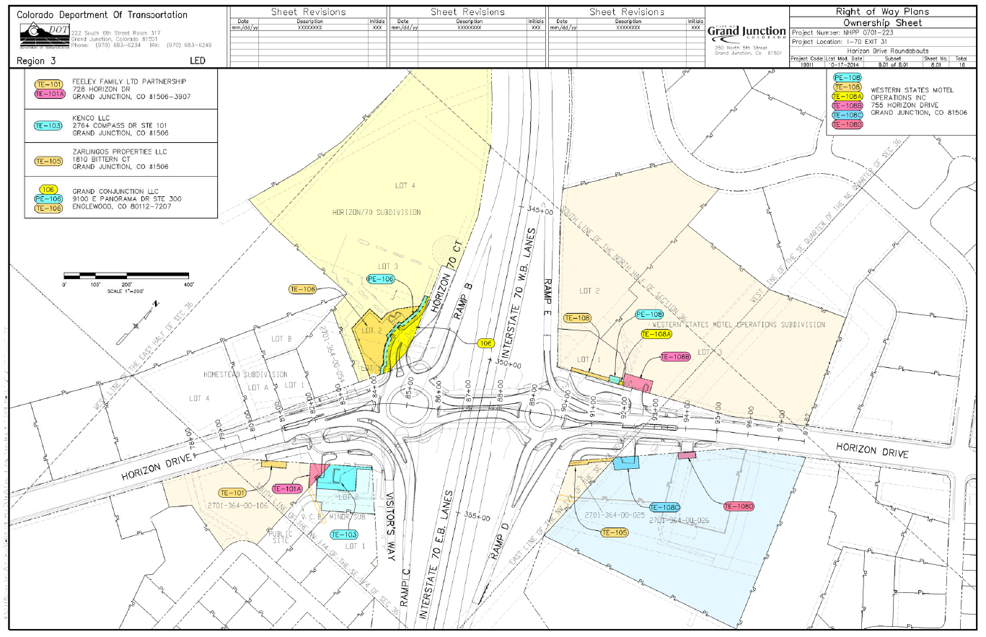
Right of Way being considered under this agenda item
(See next page for enlargement)
Double Tree
Hotel
Super 8 / Taco Bell
Clarion Inn
Zarlingos

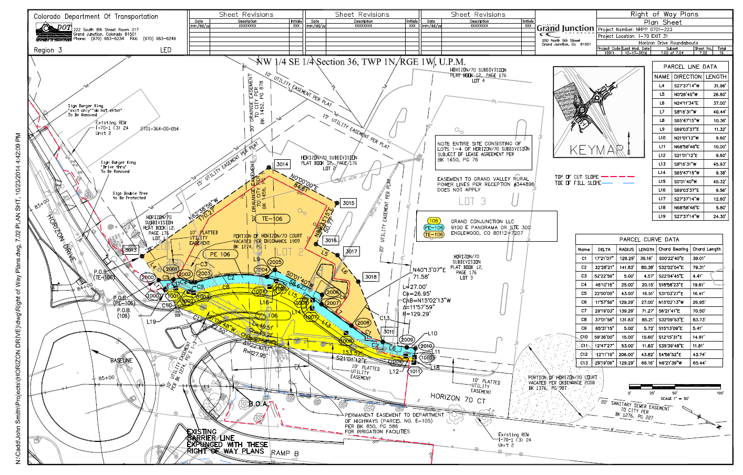
Double Tree
Hotel

