CITY OF GRAND JUNCTION, COLORADO

ORDINANCE NO. 4495

AN ORDINANCE AMENDING THE
OUTLINE DEVELOPMENT PLAN FOR REDLANDS MESA

Recitals
After public notice and public hearing as required by the Grand Junction Municipal Code, the Grand Junction Planning Commission recommended approval of the amendments to the Outline Development Plan for Redlands Mesa, finding that the ODP as amended conforms to the Future Land Use map, the Blended Map and the goals and policies of the City’s Comprehensive Plan. The ODP as amended meets the criteria found in Section 21.02.140 of the Grand Junction Municipal Code and the requirements of Section 21.02.150, regarding Planned Developments. The default zoning is R-4, Residential – 4 units per acre.

After public notice and public hearing before the Grand Junction City Council, City Council finds that the Redlands Mesa Amended Outline Development Plan, as shown on Exhibit “A” attached, is in conformance with the criteria of Section 21.02.150 of the Grand Junction Municipal Code.

BE IT ORDAINED BY THE CITY COUNCIL OF THE CITY OF GRAND JUNCTION THAT:

The Redlands Mesa Planned Development is zoned PD (Planned Development), and development pods shall not exceed the maximum of 8 dwelling units per acre; or the minimum of 1 dwelling unit per acre. Overall maximum density for the entire development does not change; it remains at 526 units.

This Ordinance is further conditioned:

1) If the planned development approval expires or becomes invalid for any reason, the property shall be fully subject to the default standards. The default standards of the R-4 zoning designation will apply.

2) All remaining parcels shall be platted by December 2021.

3) The bulk standards for the remaining undeveloped parcels, to wit parcels 1, 3, 4, 13A, 14, 15A and 15B, containing 60.281 acres, more or less, if not encumbered by Ridgeline Development Standards found in Section 21.00.07.020, shall be:

Minimum Front Yard Setback
20’ West Ridges Blvd. – from r-o-w (path side)
30’ West Ridges Blvd. – from r-o-w (non-path side)
Note: path side is that side 40’ from control line shown inside r-o-w.
20’ From r-o-w (all others unless otherwise depicted on plat)

Minimum Rear Yard Setback
20’ From property line (common rear yard lot lines)
20’ From property line (adjacent to golf or open space)
5’ Internal side setback
15’ Minimum between buildings
15’ Perimeter side setback
20’ Minimum Street Frontage
40’ Building Height
65% Maximum Lot coverage

4) Filings One through Seven setbacks are recorded on the respective plats. Filing 8, Lot 1, Block 1, setbacks are the same as those applied to Filing 7.

5) Due to topography constraints, transfer of density/intensity between the development pods/areas to be developed is allowed.

6) Dwelling units may be in the form of single-family attached, single-family detached, patio homes, townhomes or cluster development. Any given development pod may contain any one or more of these housing types.

INTRODUCED on first reading the 4th day of January, 2012 and ordered published in pamphlet form.

PASSED and ADOPTED on second reading the 16th day of January, 2012 and ordered published in pamphlet form.

ATTEST:

/s/ Stephanie Tuin /s/ Tom Kenyon
City Clerk President of the Council

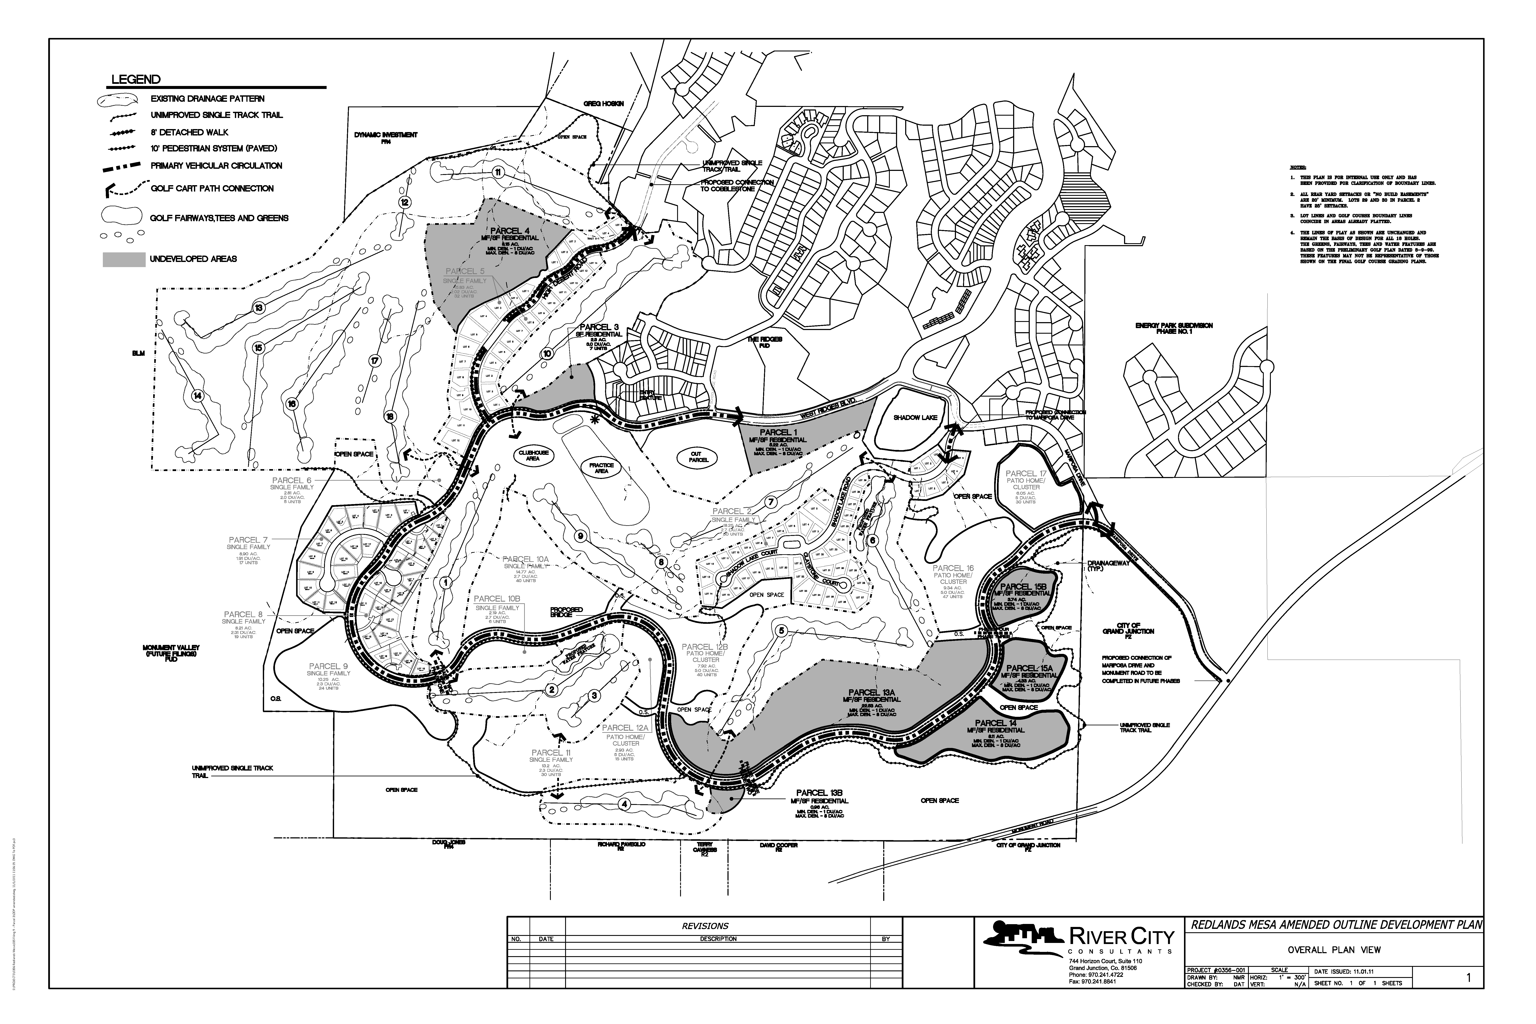
Exhibit “A”

