CITY OF GRAND JUNCTION

RESOLUTION NO. 39-15

A RESOLUTION VACATING A UTILITY EASEMENT

LOCATED AT 676 PEONY DRIVE

RECITALS:

Vacation of a dedicated public utility easement has been requested by the property owners.

The City Council finds that the request is consistent with the Comprehensive Plan, the Grand Valley Circulation Plan and Section 21.02.100 of the Grand Junction Municipal Code.

The Planning Commission, having heard and considered the vacation request, found the criteria of the Code to have been met and recommends that the vacation of the utility easement be approved.

NOW, THEREFORE BE IT RESOLVED BY THE CITY COUNCIL OF THE CITY OF GRAND JUNCTION THAT:

The following described dedicated easement is hereby vacated subject to the following conditions:

- Owner/applicants shall pay all recording/documentary fees to record this Resolution and any vacation document(s) and dedication document(s) all as necessary or required. The easement shown on “Exhibit A” and described below is a part of this Resolution and is incorporated by this reference as if fully set forth.

Dedicated easement to be vacated: 20 feet wide and approximately 238 feet long, across Lot 1, of the Hutto Subdivision Filing No.2.

- If a dedication of a new easement is required then the same shall be provided by the Owner/applicants at no cost.

PASSED and ADOPTED this 2nd day of September, 2015.

______________________________
Phyllis Norris
President of City Council
ATTEST:

_____________________________
Stephanie Tuin, City Clerk

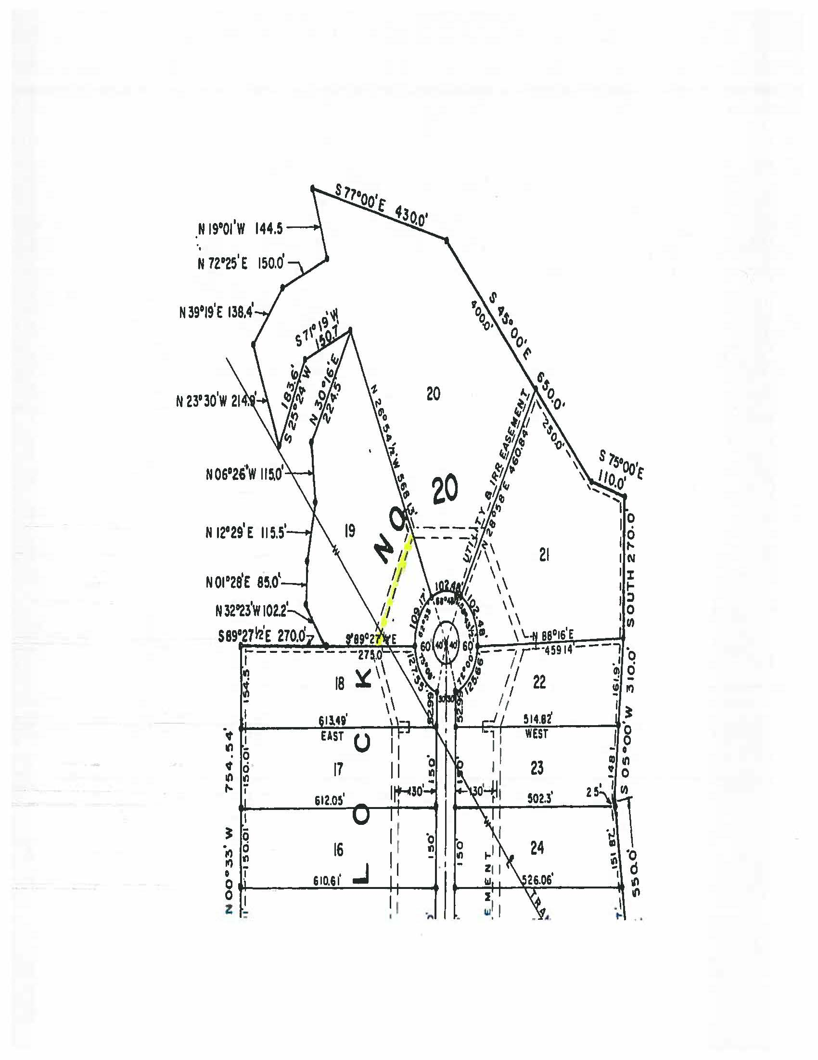
Subject Easement - Granted by Recorded Plat for Panorama Filing 7
Exhibit “A”

