CITY OF GRAND JUNCTION, COLORADO

ORDINANCE NO. 4510

AN ORDINANCE REZONING 632 AND 642 26 ½ ROAD AND A PARCEL LOCATED AT THE EASTERN END OF NORTHRIDGE DRIVE
TAX PARCEL NUMBER 2945-023-00-065,
FROM R-1 TO R-4;
REZONING 2628, 2630, 2632, 2634 PATTERSON ROAD AND AN UNADDRESSED LOT LOCATED BETWEEN 2634 AND 490 PATTERSON ROAD
TAX PARCEL 2945-023-00-041,
FROM R-5 TO B-1; AND REZONING 2634 ½ PATTERSON ROAD
FROM R-5 TO R-8

Recitals.

On February 17, 2010 the Grand Junction City Council adopted the Grand Junction Comprehensive Plan which includes the Future Land Use Map, also known as Title 31 of the Grand Junction Municipal Code of Ordinances.

The Comprehensive Plan established or assigned new land use designations to implement the vision of the Plan and guide how development should occur. In many cases the new land use designation encouraged higher density or more intense development in some urban areas of the City.

When the City adopted the Comprehensive Plan, it did not rezone property to be consistent with the new land use designations. As a result, certain urban areas now carry a land use designation that calls for a different type of development than the current zoning of the property. Staff analyzed these areas to consider whether the land use designation was appropriate, or if the zoning was more appropriate, to implement the vision, goals and policies of the Comprehensive Plan.
Upon analysis of each area, Staff has determined that the current Comprehensive Plan Future Land Use Map designation is appropriate, and that a proposed rezone would be justified in order to create consistency between the Comprehensive Plan’s Future Land Use Map and the zoning of these properties.

The proposed zone district meets the recommended land use category as shown on the Future Land Use Map of the Comprehensive Plan, Commercial and the Comprehensive Plan’s goals and policies and/or is generally compatible with appropriate land uses located in the surrounding area.

An Open House was held on November 16, 2011 to allow property owners and interested citizens an opportunity to review the proposed zoning map amendments, to make comments and to meet with staff to discuss any concerns that they might have. A display ad noticing the Open House was run in the Daily Sentinel newspaper to encourage public review and comment. The proposed amendments were also posted on the City website with information about how to submit comments or concerns.
After public notice and a public hearing as required by the Charter and Ordinances of the City, the Grand Junction Planning Commission recommended approval of the proposed zoning map amendment for the following reasons:

- The requested zones are consistent with the goals and policies of the Comprehensive Plan.

- The review criteria in Section 21.02.140 of the Grand Junction Zoning and Development Code have all been met.

After public notice and a public hearing before the Grand Junction City Council, the City Council hereby finds and determines that the proposed zoning map amendment will implement the vision, goals and policies of the Comprehensive Plan and should be adopted.

After public notice and public hearing as required by the Grand Junction Zoning and Development Code, the Grand Junction Planning Commission recommended approval of rezoning Area 13 properties from R-1 (Residential – 1 unit per acre) to the R-4 (Residential – 4 units per acre) zone district; R-5 (Residential – 5 units per acre) to R-8 (Residential – 8 units per acre) zone district and from R-5 (Residential – 5 units per acre) to B-1 (Neighborhood business) zone district for the following reasons:

The zone district meets the recommended land use category as shown on the future land use map of the Comprehensive Plan, and the Comprehensive Plan’s goals and policies and/or is generally compatible with appropriate land uses located in the surrounding area.

After the public notice and public hearing before the Grand Junction City Council, City Council finds that the R-4, R-8 and B-1 zone districts are established.

The Planning Commission and City Council find that the R-4, R-8 and B-1 zoning is in conformance with the stated criteria of Section 21.02.140 of the Grand Junction Municipal Code.

BE IT ORDAINED BY THE CITY COUNCIL OF THE CITY OF GRAND JUNCTION THAT:

The following properties shall be rezoned R-4 (Residential – 4 units per acre):
632 26 ½ Road
642 26 ½ Road
Tax parcel 2945-023-00-065, located at the Eastern end of Northridge Drive.

The following properties shall be rezoned B-1 (Neighborhood Business):
2628 Patterson Road
2630 Patterson Road
2632 Patterson Road
2634 Patterson Road
Tax parcel 2945-023-00-041, located between 2634 and 490 Patterson Road.

The following property shall be rezoned R-8 (Residential – 8 units per acre):
2634 ½ Patterson Road.

As shown on Exhibit “A” attached.

INTRODUCED on first reading the 13th day of February, 2012 and ordered published in pamphlet form.

PASSED and ADOPTED on second reading the 21st day of March, 2012 and ordered published in pamphlet form.

ATTEST:

/s/ Stephanie Tuin /s/ Tom Kenyon

City Clerk Mayor

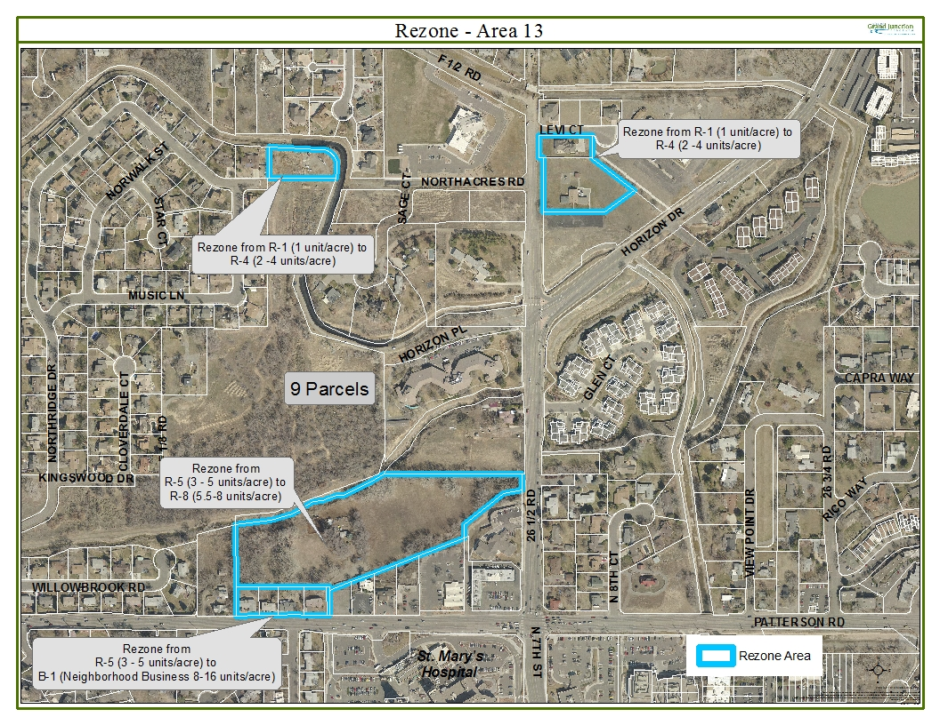
Exhibit “A”

