CITY OF GRAND JUNCTION, COLORADO

ORDINANCE NO. 4518

AN ORDINANCE REZONING 8 PARCELS
FROM R-2 (RESIDENTIAL – 2 UNITS PER ACRE) TO
R-4 (RESIDENTIAL – 4 UNITS PER ACRE)

LOCATED AT 2608 AND 2612 G ROAD; 719, 720, 721, 725, 726 26 ROAD;
AND AN UNADDRESSED PARCEL NUMBER 2701-344-00-022
(DIRECTLY NORTH OF 725 26 ROAD) FROM R-2 (RESIDENTIAL – 2 UNITS PER ACRE) TO R-4 (RESIDENTIAL – 4 UNITS PER ACRE) ZONE DISTRICT

Recitals.
On February 17, 2010 the Grand Junction City Council adopted the Grand Junction Comprehensive Plan which includes the Future Land Use Map, also known as Title 31 of the Grand Junction Municipal Code of Ordinances.

The Comprehensive Plan established or assigned new land use designations to implement the vision of the Plan and guide how development should occur. In many cases the new land use designation encouraged higher density or more intense development in some urban areas of the City.

When the City adopted the Comprehensive Plan, it did not rezone property to be consistent with the new land use designations. As a result, certain urban areas now carry a land use designation that calls for a different type of development than the current zoning of the property. Staff analyzed these areas to consider whether the land use designation was appropriate, or if the zoning was more appropriate, to implement the vision, goals and policies of the Comprehensive Plan.
Upon analysis of each area, Staff has determined that the current Comprehensive Plan Future Land Use Map designation is appropriate, and that a proposed rezone would be justified in order to create consistency between the Comprehensive Plan’s Future Land Use Map and the zoning of these properties(y).

The proposed zone district meets the recommended land use category as shown on the Future Land Use Map of the Comprehensive Plan, Commercial and the Comprehensive Plan’s goals and policies and/or is generally compatible with appropriate land uses located in the surrounding area.

An Open House was held on December 7, 2011, to allow property owners and interested citizens an opportunity to review the proposed zoning map amendments, to make comments and to meet with staff to discuss any concerns that they might have. A display ad noticing the Open House was run in the Daily Sentinel newspaper to encourage public review and comment. The proposed amendments were also posted on the City website with information about how to submit comments or concerns.
After public notice and a public hearing as required by the Charter and Ordinances of the City, the Grand Junction Planning Commission recommended approval of the proposed zoning map amendment for the following reasons:

- The requested zone is consistent with the goals and policies of the Comprehensive Plan.

- The review criteria in Section 21.02.140 of the Grand Junction Zoning and Development Code have all been met.

After public notice and public hearing as required by the Grand Junction Zoning and Development Code, the Grand Junction Planning Commission recommended approval of rezoning the Area 4 properties from R-2 (Residential – 2 units per acre) to the R-4 (Residential – 4 units per acre) zone district for the following reasons:

The zone district meets the recommended land use category as shown on the future land use map of the Comprehensive Plan, Residential Medium and the Comprehensive Plan’s goals and policies and/or is generally compatible with appropriate land uses located in the surrounding area.

After the public notice and public hearing before the Grand Junction City Council, City Council finds that the R-4 zone district to be established.

The Planning Commission and City Council find that the R-4 zoning is in conformance with the stated criteria of Section 21.02.140 of the Grand Junction Municipal Code.

BE IT ORDAINED BY THE CITY COUNCIL OF THE CITY OF GRAND JUNCTION THAT:

The following properties shall be rezoned R-4 (Residential – 4 units per acre) and as shown on Exhibit “A” attached.

2608 G Road
2612 G Road
719 26 Road
720 26 Road
721 26 Road
725 26 Road
726 26 Road
Parcel Number 2701-344-00-022 (Directly North of 725 26 Road)

Introduced on first reading the 7th day of March, 2012 and ordered published in pamphlet form.

Adopted on second reading this 4th day of April, 2012 and ordered published in pamphlet form.

ATTEST:

/s/ Stephanie Tuin /s/ Tom Kenyon
City Clerk Mayor
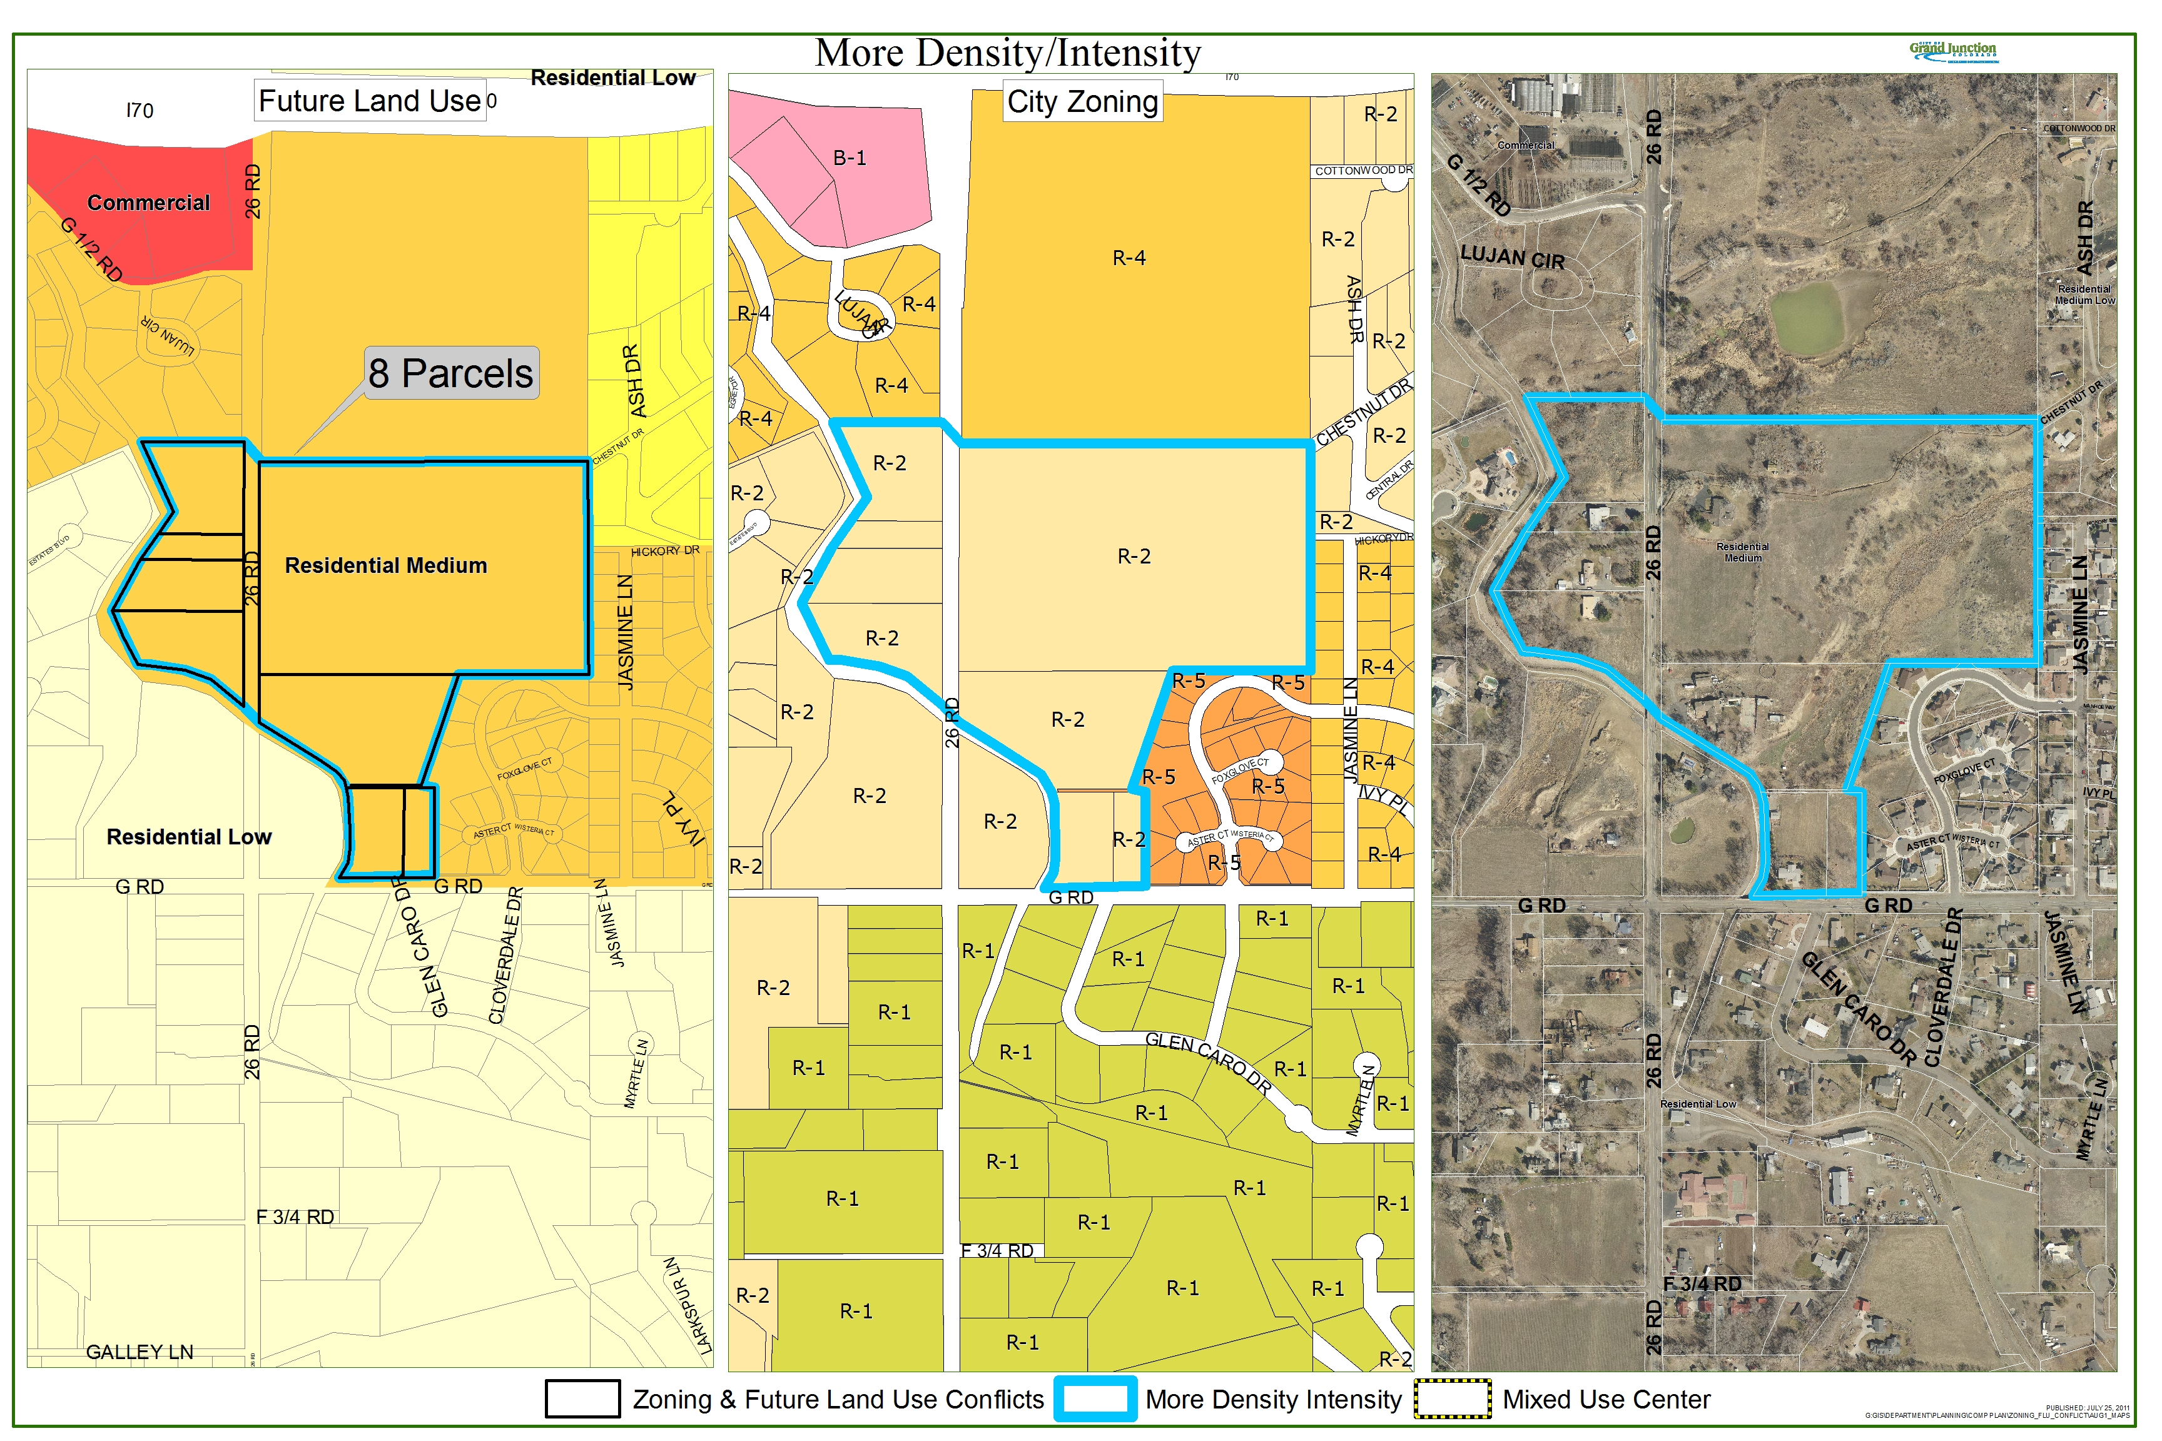
Exhibit “A”

