**CITY OF GRAND JUNCTION, COLORADO**

**ORDINANCE NO. 4690**

**AN ORDINANCE AMENDING THE COMPREHENSIVE PLAN,**

**SPECIFICALLY THE PEAR PARK NEIGHBORHOOD PLAN,**

**MORE SPECIFICALLY THE TRANSPORTATION ACCESS MANAGEMENT PLAN,**

**A PART OF THE GRAND VALLEY CIRCULATION PLAN,**

**TO REVISE THE ACCESS POINT ON D ½ ROAD**

**TO ALLOW DIRECT ACCESS INTO PROPERTY KNOWN AS FOX MEADOWS**

**LOCATED AT 3175 D ½ ROAD**

Recitals:

After public notice and public hearing as required by the Grand Junction Zoning and Development Code, the Grand Junction Planning Commission recommended approval of a request to amend the Pear Park Neighborhood Plan, an element of the Comprehensive Plan, to revise the access point to D 1/2 Road from property known as Fox Meadows, finding that it conforms with the goals and policies of the Comprehensive Plan and that the review criteria (ii) through (vi) in Section 21.02.130(c)(2) of the Grand Junction Municipal Code have been met.

After public notice and public hearing, the Grand Junction City Council finds that the requested amendment conforms with the goals and policies of the Comprehensive Plan and that the review criteria (ii) through (vi) in Section 21.02.130(c)(2) of the Grand Junction Municipal Code have been met.

**BE IT ORDAINED BY THE CITY COUNCIL OF THE CITY OF GRAND JUNCTION THAT:**

The 2004 Pear Park Transportation and Access Management Plan (TAMP) be revised move the access point onto D ½ Road from property at 3169 D ½ Road to property known as Fox Meadows, located at 3175 D ½ Road, as shown on the attached exhibit.

Introduced on first reading this 3rd day of February, 2016 and ordered published in pamphlet form.

Adopted on second reading this 17th day of February, 2016 and ordered published in pamphlet form.

ATTEST:

/s/ Stephanie Tuin /s/ Phyllis Norris

City Clerk President of the Council

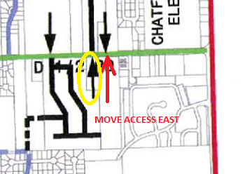

EXHIBIT

AMENDING THE PEAR PARK TRANSPORTATION ACCESS MANAGEMENT PLAN

AS SHOWN

Yellow = remove access. Red = new access