**CITY OF GRAND JUNCTION, COLORADO**

**ORDINANCE NO. 4693**

**AN ORDINANCE TO ZONE THE CHRISTIAN LIVING SERVICES DEVELOPMENT**

**TO A PD (PLANNED DEVELOPMENT) ZONE,**

**BY APPROVING AN OUTLINE DEVELOPMENT PLAN WITH A DEFAULT ZONE OF R-O (RESIDENTIAL OFFICE)**

**LOCATED AT 628 26 ½ ROAD**

Recitals:

A request to rezone 2.37 acres from R-O (Residential Office) to PD (Planned Development) and of an Outline Development Plan to develop a 58,000 square foot Assisted Living Facility has been submitted in accordance with the Zoning and Development Code (Code).

This Planned Development zoning ordinance will establish the standards, default zoning, and adopt the Outline Development Plan for the Christian Living Services Development. If this approval expires or becomes invalid for any reason, the property shall be fully subject to the default standards specified herein.

In public hearings, the Planning Commission and City Council reviewed the request for Outline Development Plan approval and determined that the Plan satisfied the criteria of the Code and is consistent with the purpose and intent of the Comprehensive Plan. Furthermore, it was determined that the proposed Plan has achieved “long-term community benefits” through more effective infrastructure, reduced traffic demands compared with other potential uses, filling a need for assisted living housing types, and an innovative design for a uniquely shaped site.

NOW, THEREFORE, BE IT ORDAINED BY THE CITY COUNCIL OF THE CITY OF GRAND JUNCTION THAT THE AREA DESCRIBED BELOW IS ZONED TO PLANNED DEVELOPMENT WITH THE FOLLOWING DEFAULT ZONE AND STANDARDS:

1. ALL of Lot 2, St. Paul Evangelical Lutheran Church Subdivision, City of Grand Junction, Mesa County, Colorado.
2. Christian Living Services (CLS) Outline Development Plan is approved with the Findings of Fact/Conclusions, and Conditions listed in the Staff Report including attachments and Exhibits.
3. Default Zone

The default land use zone is R-O (Residential Office), with the following deviations:

Reference Table 1 for Lot, Setback, and Bulk Standards.

Reference Table 2 for Architectural Considerations.

1. Authorized Uses

Uses include those typically associated with Assisted Living, predominately residential with internal support uses; no retail.

Table 1: Lot, Setback, and Bulk Standards:

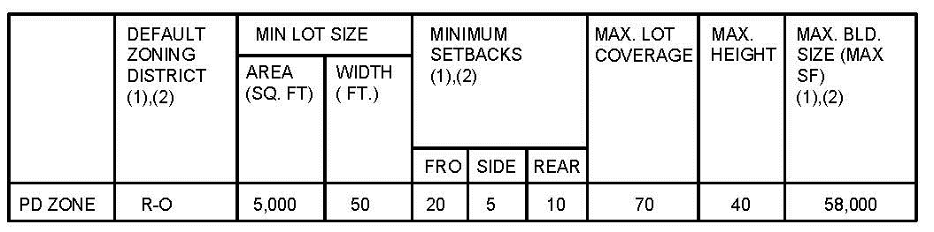

Footnotes:

1. Principal / Accessory Building
2. Deviations from R-O Default Standards

* Only one building shall be allowed, up to a maximum of 58,000 square feet.

Table 2: Architectural Considerations:

1. Architectural Standards shall be per the Default Zone of R-O (Residential Office) Unless Modified Herein.
2. Deviations from R-O Architectural Standards:

* The proposed building will not be required to align with existing neighboring buildings.
* The proposed building will not be required to provide a main entrance which opens onto a street.

Introduced for first reading on this 16th day of March, 2016 and ordered published in pamphlet form.

PASSED and ADOPTED this 6th day of April, 2016 and ordered published in pamphlet form.

/s/ Martin Chazen

President of City Council Pro Tem

ATTEST:

/s/ Stephanie Tuin

City Clerk

