**CITY OF GRAND JUNCTION**

## ORDINANCE NO. 4702

#### AN ORDINANCE VACATING RIGHT-OF-WAY FOR

#### HOESCH STREET

#### LOCATED WEST OF 723 W. WHITE AVENUE

RECITALS:

A vacation of the dedicated right-of-way has been requested by the adjoining property owners.

The City Council finds that the request is consistent with the Comprehensive Plan, the Grand Valley Circulation Plan and Section 21.02.100 of the Grand Junction Municipal Code.

The Planning Commission, having heard and considered the request, found the criteria of the Code to have been met, and recommends that the vacation be approved.

NOW, THEREFORE BE IT ORDAINED BY THE CITY COUNCIL OF THE CITY OF GRAND JUNCTION THAT:

The following described dedicated right-of-way for is hereby vacated subject to the listed conditions:

1. Applicants shall pay all recording/documentary fees for the Vacation Ordinance, any easement documents and dedication documents.

The following right-of-way is shown on “Exhibit A” as part of this vacation of description.

Dedicated right-of-way to be vacated:

A portion of the Hoesch Street Right-of-Way within the Northwest 1/4.; of the

Southeast 1/4.; of Section 15, Township 1 South, Range 1 West, U.M., City of Grand

Junction, Mesa County, State of Colorado;

COMMENCING at the Center 1/4.; Corner of Section 15, thence S 53°09'00" E a distance of 627.09 feet to the Northeast Corner of Lot I, Block 5 of The Grand River Subdivision, Deposit No. 2461-01, said point being the POINT OF BEGINNING;

THENCE S 89°48'18" E along a projection of the southerly Right-of-Way of West

White Avenue, a distance of 17.93 feet;

THENCE N 00°08'58" E a distance of 2.06 feet;

THENCE N 89°36'35" E a distance of 11.20 feet to a point on the easterly Right-of-

Way of Hoesch Street as dedicated in the WDD Subdivision, RN 2329913;

THENCE S 00°23'25" E along said Right-of-Way a distance of 32.89 feet;

THENCE N 89°57'36" W a distance of 29.51 feet to a point on the easterly line of the aforementioned Lot I, Block 5 of The Grand River Subdivision;

THENCE N 00°16'56" E, along said easterly line, a distance of 30.79 feet; to the

POINT OF BEGINNING;

CONTAINING 926 square feet, more or less.

BASIS OF BEARING: The Basis of Bearing for this description is the quarter line between the center 1/4.; corner and the center east 1/16 corner of section 15, Township

1 South, Range 1 West, U.M., having a bearing of N 89°39'16" E.

Per the attached agreement marked as Exhibit “B” and incorporated herein, all of the right-of-way vacated shall be treated as a part of Lot 2, Block 1 WDD Subdivision in the City of Grand Junction, County of Mesa, State of Colorado (“Lot 2”), and shall not be transferred separately from Lot 2 and shall be incorporated into the land area of Lot 2 with any future subdivision of Lot 2.

Introduced for first reading on this 18th day of May, 2016and ordered published in pamphlet form.

PASSED and ADOPTED this 1st day of June, 2016and ordered published in pamphlet form.

/s/ Phyllis Norris

President of City Council

ATTEST:

/s/ Stephanie Tuin

City Clerk

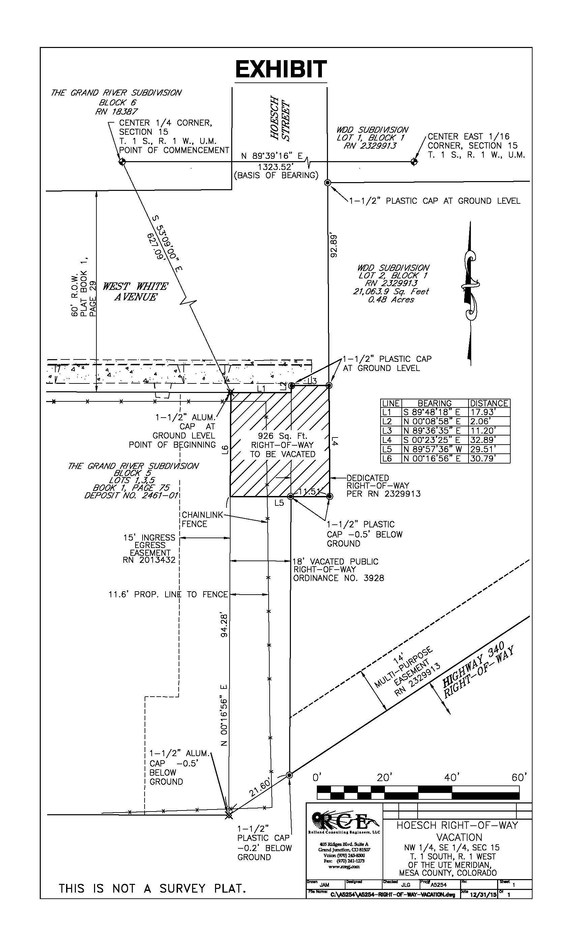

**A**

EXHIBIT “B”

Sixbey Investments, LLC, a Colorado Limited Liability Company, (“Sixbey”) is the owner of the property in the City of Grand Junction, County of Mesa, State of Colorado described as Lot 1 in Block 5 of Grand River Subdivision (“Lot 1”).

Gearty Properties LLC, a Colorado Limited Liability Company, (“Gearty”) is the owner of the property in the City of Grand Junction, County of Mesa, State of Colorado described as Lot 2, Block 1 WDD Subdivision (“Lot 2”).

The Plat of Grand River Subdivision dedicated 18’ of right-of-way for a street abutting the east side of Lot 1. A portion of that right-of-way has been previously vacated with City of Grand Junction (“City”) Ordinance No. 3928 recorded July 27, 2004 at Reception No. 2329914 in Book 4212 at Page 241 and corrected by an instrument recorded July 23, 2007 at Reception No. 2392262 in Book 4475 at Page 619. This vacated right-of-way was incorporated into Lot 2.

In Community Development File No. VAC-2016-68, Sixbey has requested that the City vacate the remainder of that right-of-way south of White Avenue abutting Lot 1 north of the previously vacated right-of-way described in the paragraph above along with the 10’ of right-of-way abutting the west side of Lot 2 dedicated on the WDD Subdivision plat.

Sixbey intends for all interest that it may have in the vacated right-of-way be granted to Gearty as part of Lot 2 and by signature below requests the City direct that all of the vacated right-of-way be transferred to and go with and be treated as a part of Lot 2.

Gearty understands and accepts all of the vacated right-of-way to belong to Gearty which shall run with and be treated as a part of Lot 2 and may not be transferred separately from Lot 2 and agrees that any subdivision completed in the future involving Lot 2 shall include all of the vacated right-of-way.

Sixbey hereby quitclaims any and all right, title and interest that Sixbey may have in any of the right-of-way referenced herein to Gearty Properties LLC.

Sixbey Investments, LLC Gearty Properties LLC

By:__________________________ By:________________________

Merritt L. Sixbey, Jr. John Ambrose Gearty,

Manager Member

State of Colorado )

)ss.

County of Mesa )

The foregoing instrument was acknowledged before me this __________ day of _________________, 2016, by Merritt L. Sixbey, Jr., as Manager of Sixbey Investments, LLC.

My commission expires ____________________.

Witness my hand and official seal. ____________________________________

Notary Public

State of Colorado )

)ss.

County of Mesa )

The foregoing instrument was acknowledged before me this __________ day of _________________, 2016, by John Ambrose Gearty as Member of Gearty Properties LLC.

My commission expires ____________________.

Witness my hand and official seal. ____________________________________

Notary Public