ORDINANCE NO. 4707

AN ORDINANCE APPROVING A LOAN FROM THE COLORADO WATER CONSERVATION BOARD TO FINANCE IMPROVEMENTS TO THE CITY’S WATER SYSTEM; AUTHORIZING THE FORM AND EXECUTION OF THE LOAN CONTRACT AND A PROMISSORY NOTE TO EVIDENCE SUCH LOAN; AUTHORIZING THE EXECUTION AND DELIVERY OF CERTAIN DOCUMENTS RELATED THERETO, INCLUDING A SECURITY AGREEMENT; AND PRESCRIBING OTHER DETAILS IN CONNECTION THEREWITH.

WHEREAS, the City of Grand Junction, Colorado (the “City”), is a home rule city duly existing under the Constitution and laws of the State of Colorado and its City Charter (the “Charter”); and

WHEREAS, the members of the City Council of the City (the “Council”) have been duly elected and qualified; and

WHEREAS, the Council has determined and does hereby determine that the City’s water system (the “System”) is an enterprise within the meaning of Article X, Section 20 of the Colorado Constitution (“TABOR”), and Section 37-45.1-103 of the Colorado Revised Statutes, as amended; and

WHEREAS, the Council has heretofore determined that the interest of the City and the public interest and necessity require certain improvements to the System, including, without limitation, certain repairs and improvements to the Hallenbeck Reservoir No. 1 Dam (collectively, the “Project”); and

WHEREAS, the Council has determined that in order to finance the Project it is necessary, advisable, and in the best interests of the City to enter into a loan contract (the “Loan Contract”) with the State of Colorado for the use and benefit of The Department of Natural Resources, Colorado Water Conservation Board (the “CWCB”), pursuant to which the CWCB will loan the City an amount not to exceed $1,010,000(the “Loan”) for such purposes; and

WHEREAS, the City’s repayment obligations under the Loan Contract shall be evidenced by a Promissory Note (the “Note”) to be issued by the City to the CWCB and further secured by a Security Agreement to be executed by the City, as borrower, to the CWCB, as secured party; and

WHEREAS, the Note and the Loan Contract shall collectively comprise a revenue obligation of the City payable from the Pledged Revenues (as defined herein), and pursuant to TABOR and Article XII, Section 93(f) of the Charter may be approved by the Council without an election; and

WHEREAS, forms of the Note, the Loan Contract, and the Security Agreement (collectively, the “Financing Documents”) have been filed with the City Clerk; and

WHEREAS, the Council desires to approve the forms of the Financing Documents and authorize the execution thereof.

NOW, THEREFORE, BE IT ORDAINED BY THE CITY COUNCIL OF THE CITY OF GRAND JUNCTION, COLORADO:

Approvals, Authorizations, and Amendments. The forms of the Financing Documents filed with the City Clerk are incorporated herein by reference and are hereby approved. The City shall enter into and perform its obligations under the Financing Documents in the forms of such documents, with such changes as are not inconsistent herewith and as are hereafter approved by the President of the Council (the “President”). The President and City Clerk are hereby authorized and directed to execute the Financing Documents and to affix the seal of the City thereto, and further to execute and authenticate such other documents or certificates as are deemed necessary or desirable in connection therewith. The Financing Documents shall be executed in substantially the forms approved at this meeting.

The execution by the President, the City Clerk, or other appropriate officers of the City of any instrument or certificate or other document in connection with the matters referred to herein shall be conclusive evidence of the approval by the City of such instrument or certificate or other document.

Election to Apply Supplemental Act. Section 11-57-204 of the Supplemental Public Securities Act, constituting Title 11, Article 57, Part 2, of the Colorado Revised Statutes, as amended (the “Supplemental Act”), provides that a public entity, including the City, may elect in an act of issuance to apply all or any of the provisions of the Supplemental Act. The Council hereby elects to apply all of the provisions of the Supplemental Act to the Financing Documents.

Certain Definitions. For all purposes of the Financing Documents and this Ordinance, the following terms shall have the following meanings:

“Capital Improvements” means the acquisition of land, easements, facilities and equipment (other than ordinary repairs and replacements), and the construction or reconstruction of improvements, betterments and extensions, for use by or in connection with the System.

“Gross Revenues” means all income and revenues directly or indirectly derived by the City from the operation and use of the System, or any part thereof, including without limitation, any rates, fees (including without limitation plant investment fees and availability fees) and charges for the services furnished by, or for the use of, the System, and all income attributable to any past or future dispositions of property or rights or related contracts, settlements, or judgments held or obtained in connection with the System or its operations, and including investment income accruing from such moneys; provided however, that there shall be excluded from Gross Revenues: ad valorem property taxes; any moneys borrowed and used for providing Capital Improvements; any money and securities and investment income therefrom in any refunding fund, escrow account, or similar account pledged to the payment of any bonds or other obligations; and any moneys received as grants or appropriations from the United States, the State of Colorado, or other sources, the use of which is limited or restricted by the grantor or donor to the provision of Capital Improvements or for other purposes resulting in the general unavailability thereof, except to the extent any such moneys shall be received as payments for the use of the System, services rendered thereby, the availability of any such service, or the disposal of any commodities therefrom. Notwithstanding anything contained above, amounts deposited in a rate stabilization account shall not be deemed Gross Revenues in the calendar year deposited and amounts withdrawn from the rate stabilization account shall be deemed Gross Revenues in the year withdrawn.

“Operation and Maintenance Expenses” means all reasonable and necessary current expenses of the City (referred to as the Borrower in the Financing Documents), paid or accrued, for operating, maintaining, and repairing the System, including without limitation legal and overhead expenses of the City (referred to as the Borrower in the Financing Documents) directly related to the administration of the System, insurance premiums, audits, professional services, salaries and administrative expenses, labor and the cost of materials and supplies for current operation; provided however, that there shall be excluded from Operation and Maintenance Expenses any allowance for depreciation, payments in lieu of taxes or franchise fees, expenses incurred in connection with Capital Improvements, payments due in connection with any bonds or other obligations, and expenses that are otherwise paid from ad valorem property taxes.

“Pledged Revenues” for any period means the Gross Revenues during such period less Operation and Maintenance Expenses.

“System” means all of the City’s water facilities and properties, now owned or hereafter acquired, whether situated within or without the City’s boundaries, including all present or future improvements, extensions, enlargements, betterments, replacements, or additions thereof or thereto, which facilities and properties are used exclusively for the City’s water activity enterprise.

Delegation and Parameters.

Pursuant to Section 11-57-205 of the Supplemental Act, the Council hereby delegates to the President, the Financial Operations Director, or any member of the Council the authority to make the following determinations relating to and contained in the Financing Documents, subject to the restrictions contained in paragraph (b) of this Section 3:

The interest rate on the Loan;

The principal amount of the Loan;

The amount of principal of the Loan maturing in any given year and the final maturity of the Loan;

The conditions on which and the prices at which the Loan may be paid prior to maturity;

The dates on which the principal of and interest on the Loan are paid; and

The existence and amount of capitalized interest or reserve funds for the Loan, if any.

The delegation in paragraph (a) of this Section 3 shall be subject to the following parameters and restrictions: (i) the interest rate on the Loan shall not exceed 3.00%; (ii) the principal amount of the Loan shall not exceed $1,010,000; and (iii) the final maturity of the Loan shall be the date established by the Loan documents and in any event no later than December 31, 2037.

Conclusive Recital. Pursuant to Section 11-57-210 of the Supplemental Act, the Financing Documents shall contain a recital that they are issued pursuant to the Supplemental Act. Such recital shall be conclusive evidence of the validity and the regularity of the issuance of the Financing Documents after their delivery for value.

Pledge of Revenues. The creation, perfection, enforcement, and priority of the pledge of revenues to secure or pay the Financing Documents provided herein shall be governed by Section 11-57-208 of the Supplemental Act and this Ordinance. The revenues pledged to the payment of the Financing Documents shall immediately be subject to the lien of such pledge without any physical delivery, filing, or further act. The lien of such pledge shall have the priority described in the Loan Contract. The lien of such pledge shall be valid, binding, and enforceable as against all persons having claims of any kind in tort, contract, or otherwise against the City irrespective of whether such persons have notice of such liens.

Limitation of Actions. Pursuant to Section 11-57-212 of the Supplemental Act, no legal or equitable action brought with respect to any legislative acts or proceedings in connection with the Financing Documents shall be commenced more than thirty days after the date of adoption of this Ordinance.

Limited Obligation; Special Obligation. The Financing Documents are payable solely from the Pledged Revenues and the Financing Documents do not constitute a debt within the meaning of any constitutional or statutory limitation or provision.

No Recourse against Officers and Agents. Pursuant to Section 11-57-209 of the Supplemental Act, if a member of the Council, or any officer or agent of the City acts in good faith, no civil recourse shall be available against such member, officer, or agent for payment of the principal of or interest on the Note. Such recourse shall not be available either directly or indirectly through the Council or the City, or otherwise, whether by virtue of any constitution, statute, rule of law, enforcement of penalty, or otherwise. By the acceptance of the Note and as a part of the consideration of its sale or purchase, the CWCB specifically waives any such recourse.

Disposition and Investment of Loan Proceeds. The proceeds of the Loan shall be applied only to pay the costs and expenses of acquiring, constructing and equipping the Project, including costs related thereto and, to the extent permitted under federal tax laws, reimbursement to the City for capital expenditures heretofore incurred and paid from City funds in anticipation of the incurrence of long-term financing therefor, and all other costs and expenses incident thereto, including without limitation, the costs of obtaining the Loan.

Neither the CWCB nor any subsequent owner(s) of the Financing Documents shall be responsible for the application or disposal by the City or any of its officers of the funds derived from the Loan. In the event that all of the proceeds of the Loan are not required to pay such costs and expenses, any remaining amount shall be used for the purpose of paying the principal amount of the Loan and the interest thereon.

Direction to Take Authorizing Action. The appropriate officers of the City and members of the Council are hereby authorized and directed to take all other actions necessary or appropriate to effectuate the provisions of this Ordinance, including but not limited to the execution and delivery of such certificates and affidavits as may reasonably be required by the CWCB.

Ratification and Approval of Prior Actions. All actions heretofore taken by the officers of the City and members of the Council, not inconsistent with the provisions of this Ordinance, relating to the Financing Documents, or actions to be taken in respect thereof, are hereby authorized, ratified, approved, and confirmed.

Repealer. All acts, orders, ordinances, or resolutions, or parts thereof, in conflict herewith are hereby repealed to the extent of such conflict.

Severability. Should any one or more sections or provisions of this Ordinance be judicially determined invalid or unenforceable, such determination shall not affect, impair, or invalidate the remaining provisions hereof, the intention being that the various provisions hereof are severable.

Ordinance Irrepealable. After the Note is issued, this Ordinance shall constitute an irrevocable contract between the City and the CWCB, and shall be and remain irrepealable until the Note and the interest thereon shall have been fully paid, satisfied, and discharged. No provisions of any constitution, statute, charter, ordinance, resolution, or other measure enacted after the issuance of the Note shall in any way be construed as impairing the obligations of the City to keep and perform its covenants contained in this Ordinance.

Effective Date. This Ordinance shall be in full force and effect 30 days after publication following final passage.

INTRODUCED, PASSED ON FIRST READING, APPROVED AND ORDERED PUBLISHED IN PAMPHLET FORM this 1st day of June, 2016.

CITY OF GRAND JUNCTION, COLORADO

[ S E A L ] _______________________________________

President of the City Council

Attest:

City Clerk

INTRODUCED, PASSED ON SECOND READING, APPROVED AND ORDERED PUBLISHED IN PAMPHLET FORM this 15th day of June, 2016.

CITY OF GRAND JUNCTION, COLORADO

[ S E A L ]

_______________________________________

President of the City Council

Attest:

City Clerk

STATE OF COLORADO )

)

COUNTY OF MESA ) SS.

)

CITY OF GRAND JUNCTION )

I, Stephanie Tuin, the City Clerk of the City of Grand Junction, Colorado (the “City”) and Clerk to the City Council of the City (the “Council”), do hereby certify as follows:

The foregoing pages are a true, correct and complete copy of an ordinance (the “Ordinance”) that was introduced, passed on first reading and ordered published in pamphlet form by the Council at a regular meeting thereof held on June 1, 2016 and was duly adopted and ordered published in pamphlet form by the Council at a regular meeting thereof held on June 15, 2016, which Ordinance has not been revoked, rescinded or repealed and is in full force and effect on the date hereof.

The Ordinance was duly moved and seconded and the Ordinance was passed on first reading at the meeting of June 1, 2016, by an affirmative vote of a majority of the members of the Council as follows:

|  |  |  |  |  |
| --- | --- | --- | --- | --- |
| Councilmember | Voting “Aye” | Voting “Nay” | Absent | Abstaining |
| Bennett Boeschenstein | X |  |  |  |
| Marty Chazen | X |  |  |  |
| Chris Kennedy | X |  |  |  |
| Duncan McArthur | X |  |  |  |
| Phyllis Norris | X |  |  |  |
| Barbara Traylor Smith |  |  | X |  |
| Rick Taggart |  |  | X |  |

The Ordinance was duly moved and seconded and the Ordinance was finally passed on second reading at the meeting of June 15, 2016, by an affirmative vote of a majority of the members of the Council as follows:

|  |  |  |  |  |
| --- | --- | --- | --- | --- |
| Councilmember | Voting “Aye” | Voting “Nay” | Absent | Abstaining |
| Bennett Boeschenstein | X |  |  |  |
| Marty Chazen | X |  |  |  |
| Chris Kennedy | X |  |  |  |
| Duncan McArthur | X |  |  |  |
| Phyllis Norris | X |  |  |  |
| Barbara Traylor Smith |  |  | X |  |
| Rick Taggart |  |  | X |  |

The members of the Council were present at such meetings and voted on the passage of the Ordinance as set forth above.

The Ordinance was approved and authenticated by the signature of the President of the Council, sealed with the City seal, attested by the City Clerk, and recorded in the minutes of the Council.

There are no bylaws, rules, or regulations of the Council that might prohibit the adoption of the Ordinance.

Notices of the meetings of June 1, 2016 and June 15, 2016 in the forms attached hereto as Exhibit A were posted at City Hall in accordance with law.

The Ordinance was published in pamphlet form in The Daily Sentinel, a daily newspaper of general circulation in the City, on June 3, 2016 and June 17, 2016, as required by the City Charter. True and correct copies of the affidavits of publication are attached hereto as Exhibit B.

WITNESS my hand and the seal of the City affixed this ____ day of June, 2016.

City Clerk and Clerk to the Council

[ S E A L ]

EXHIBIT A

(Attach Notices of Meetings of June 1, 2016 and June 15, 2016)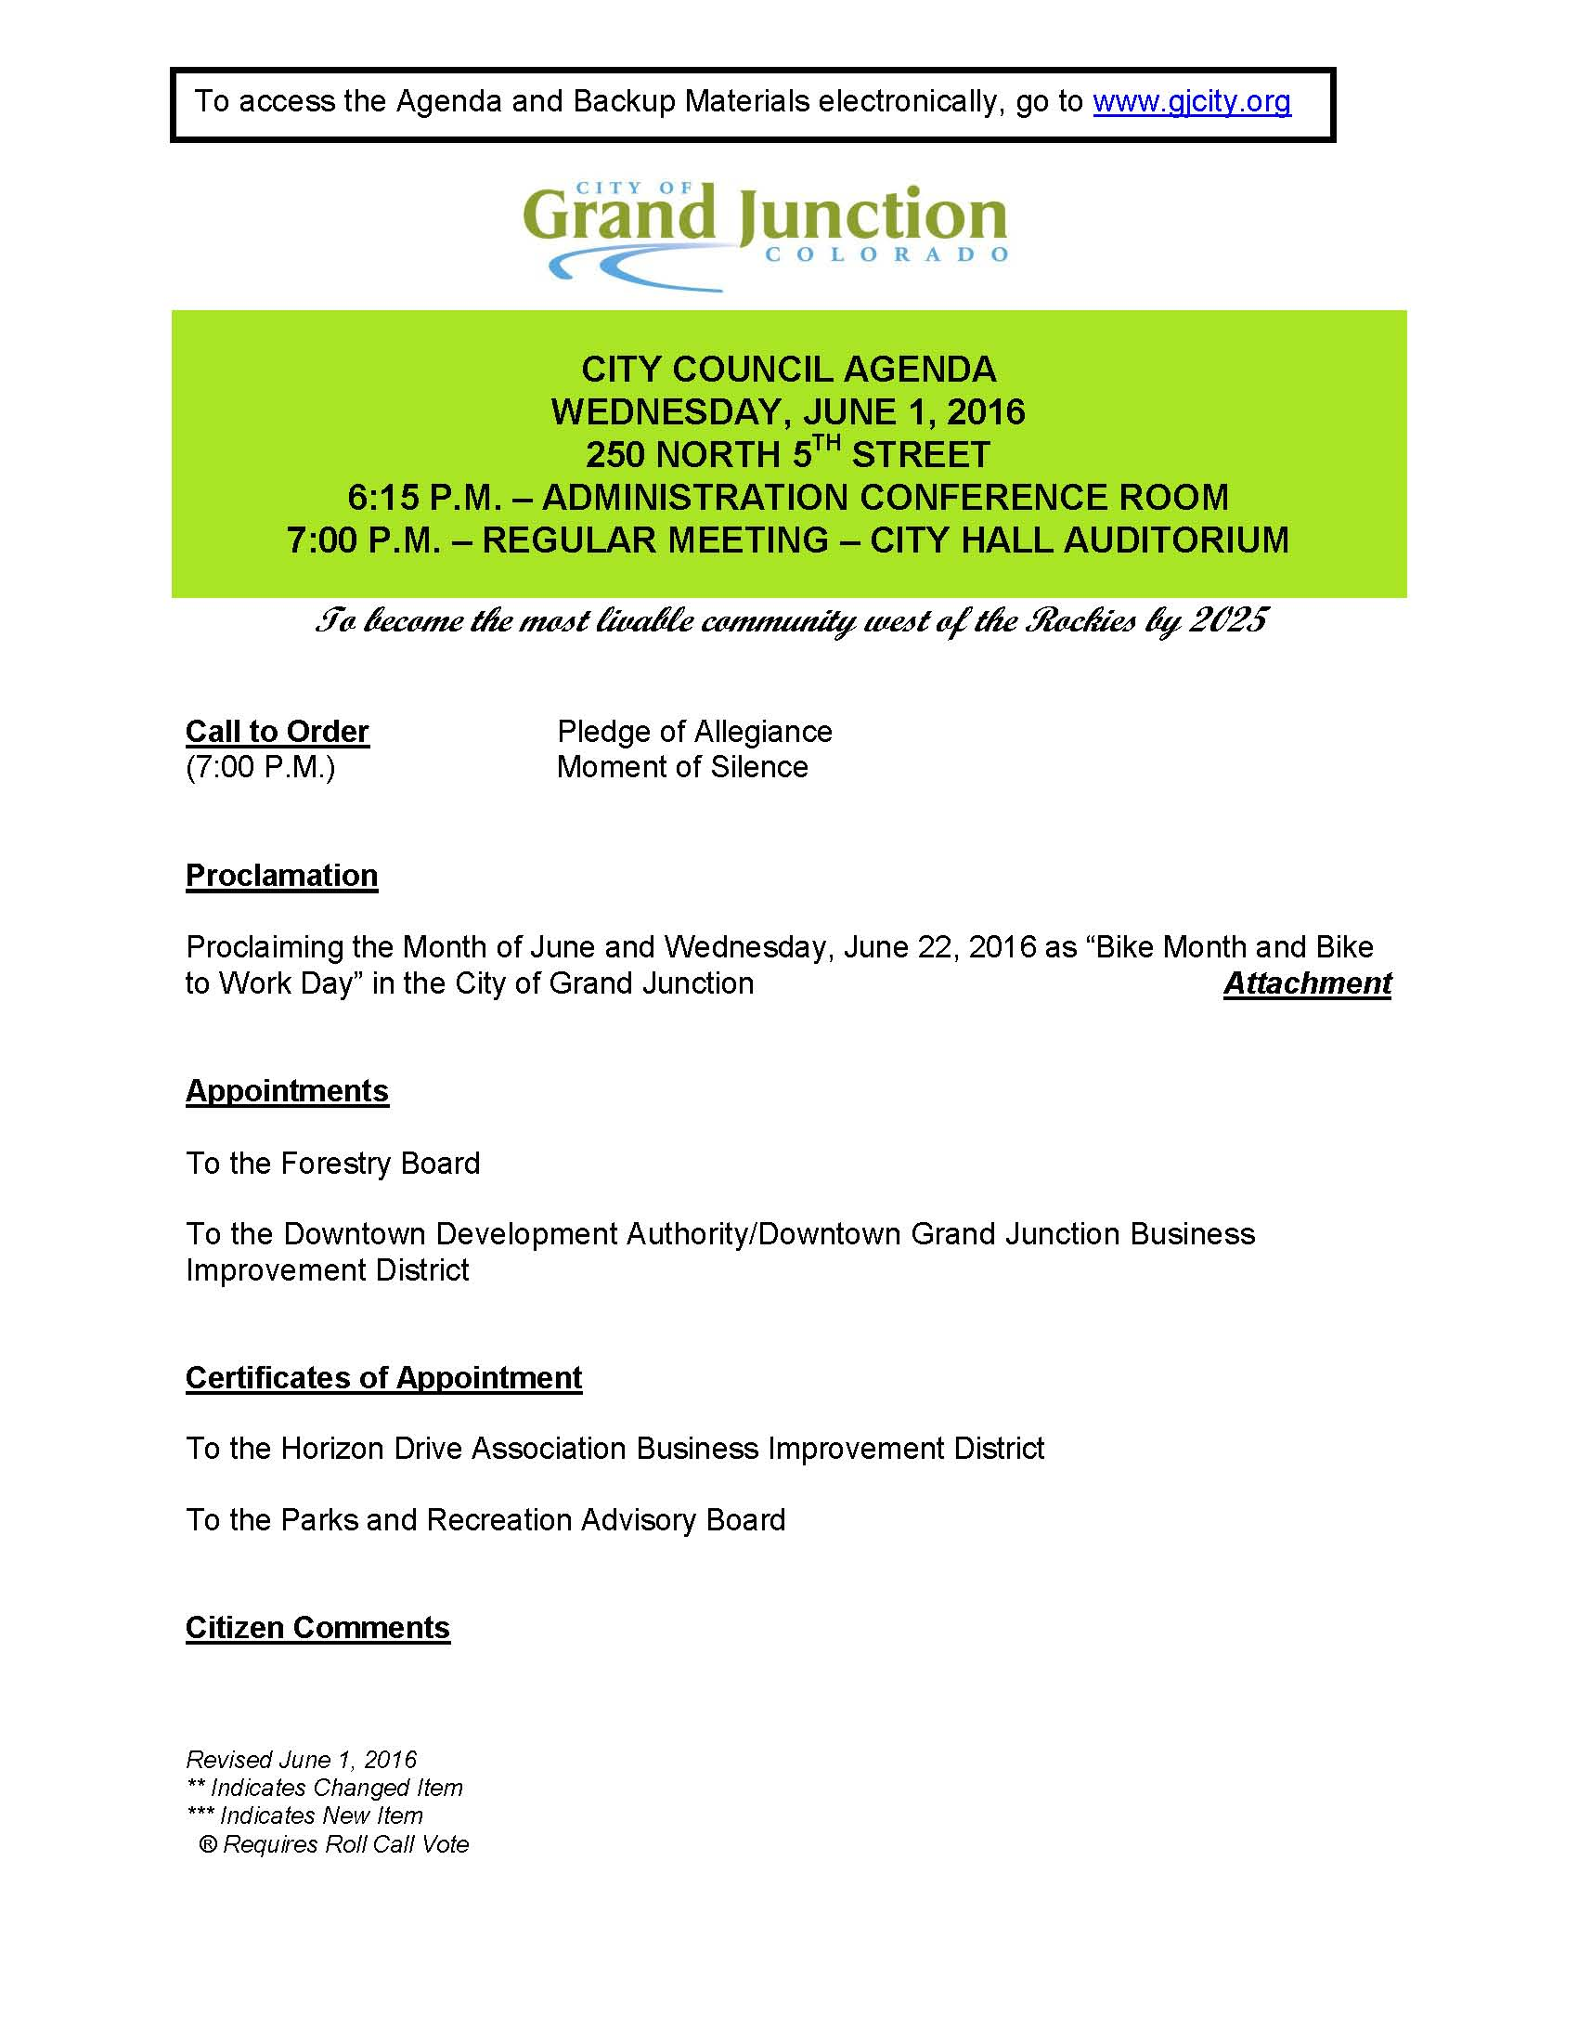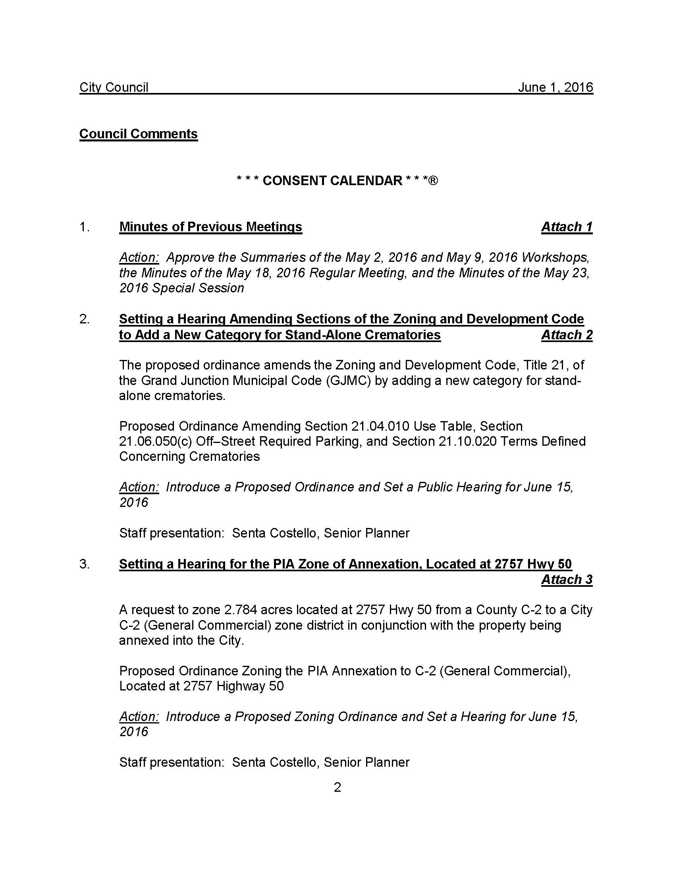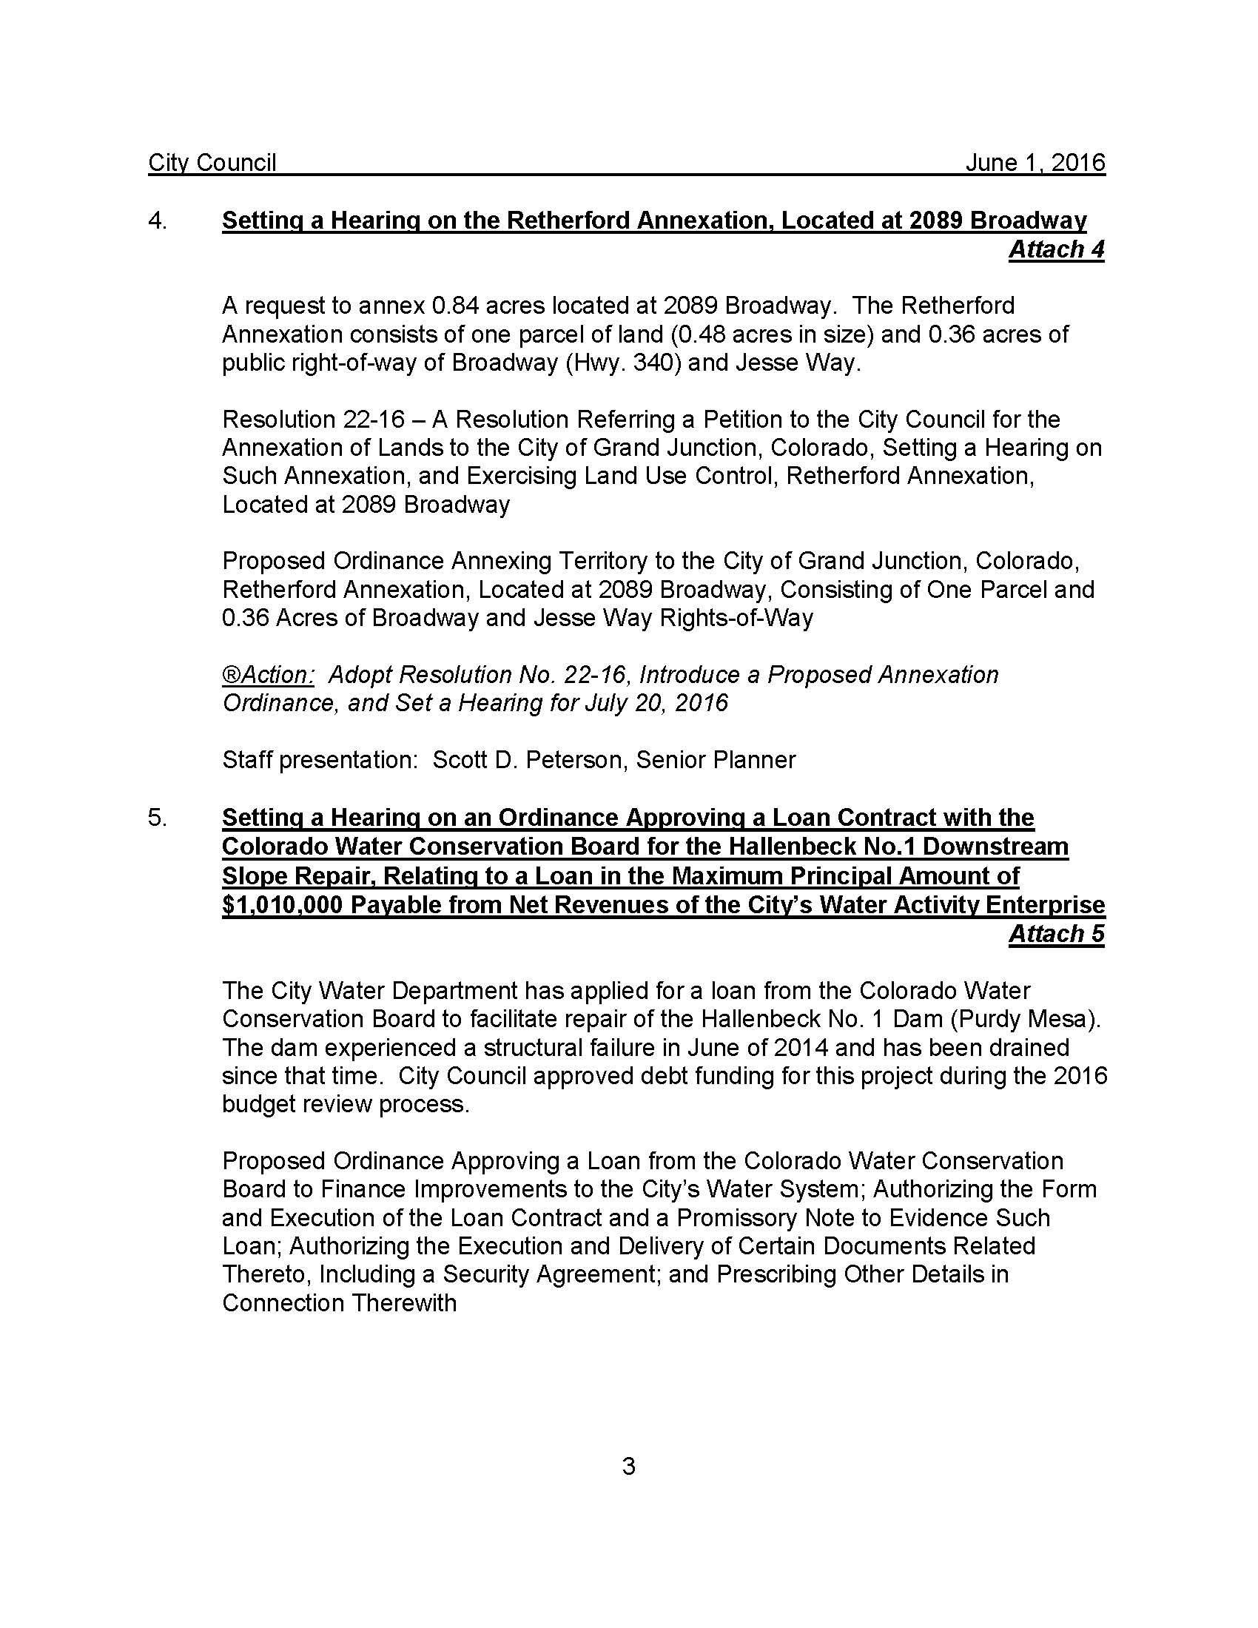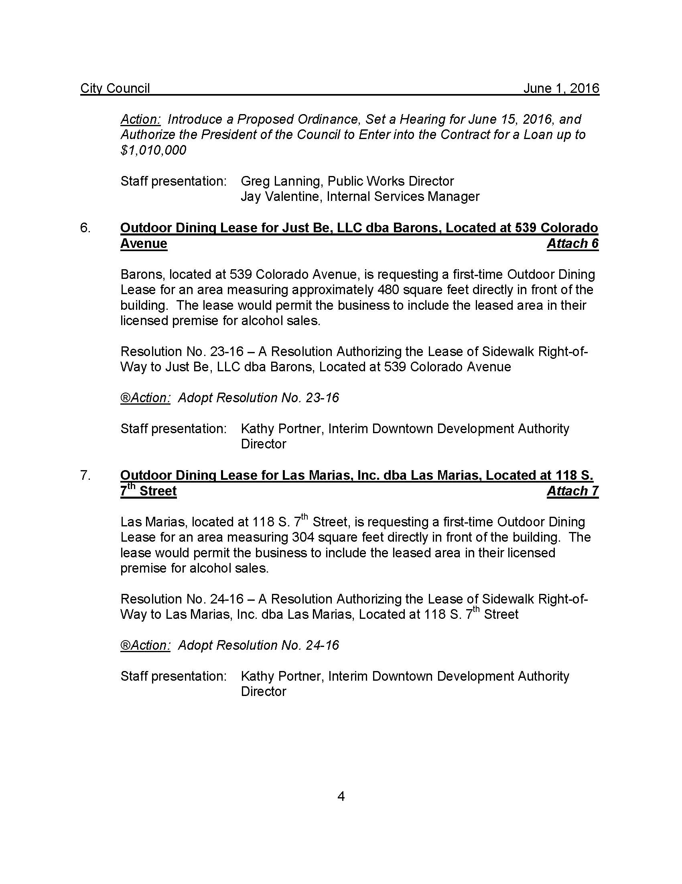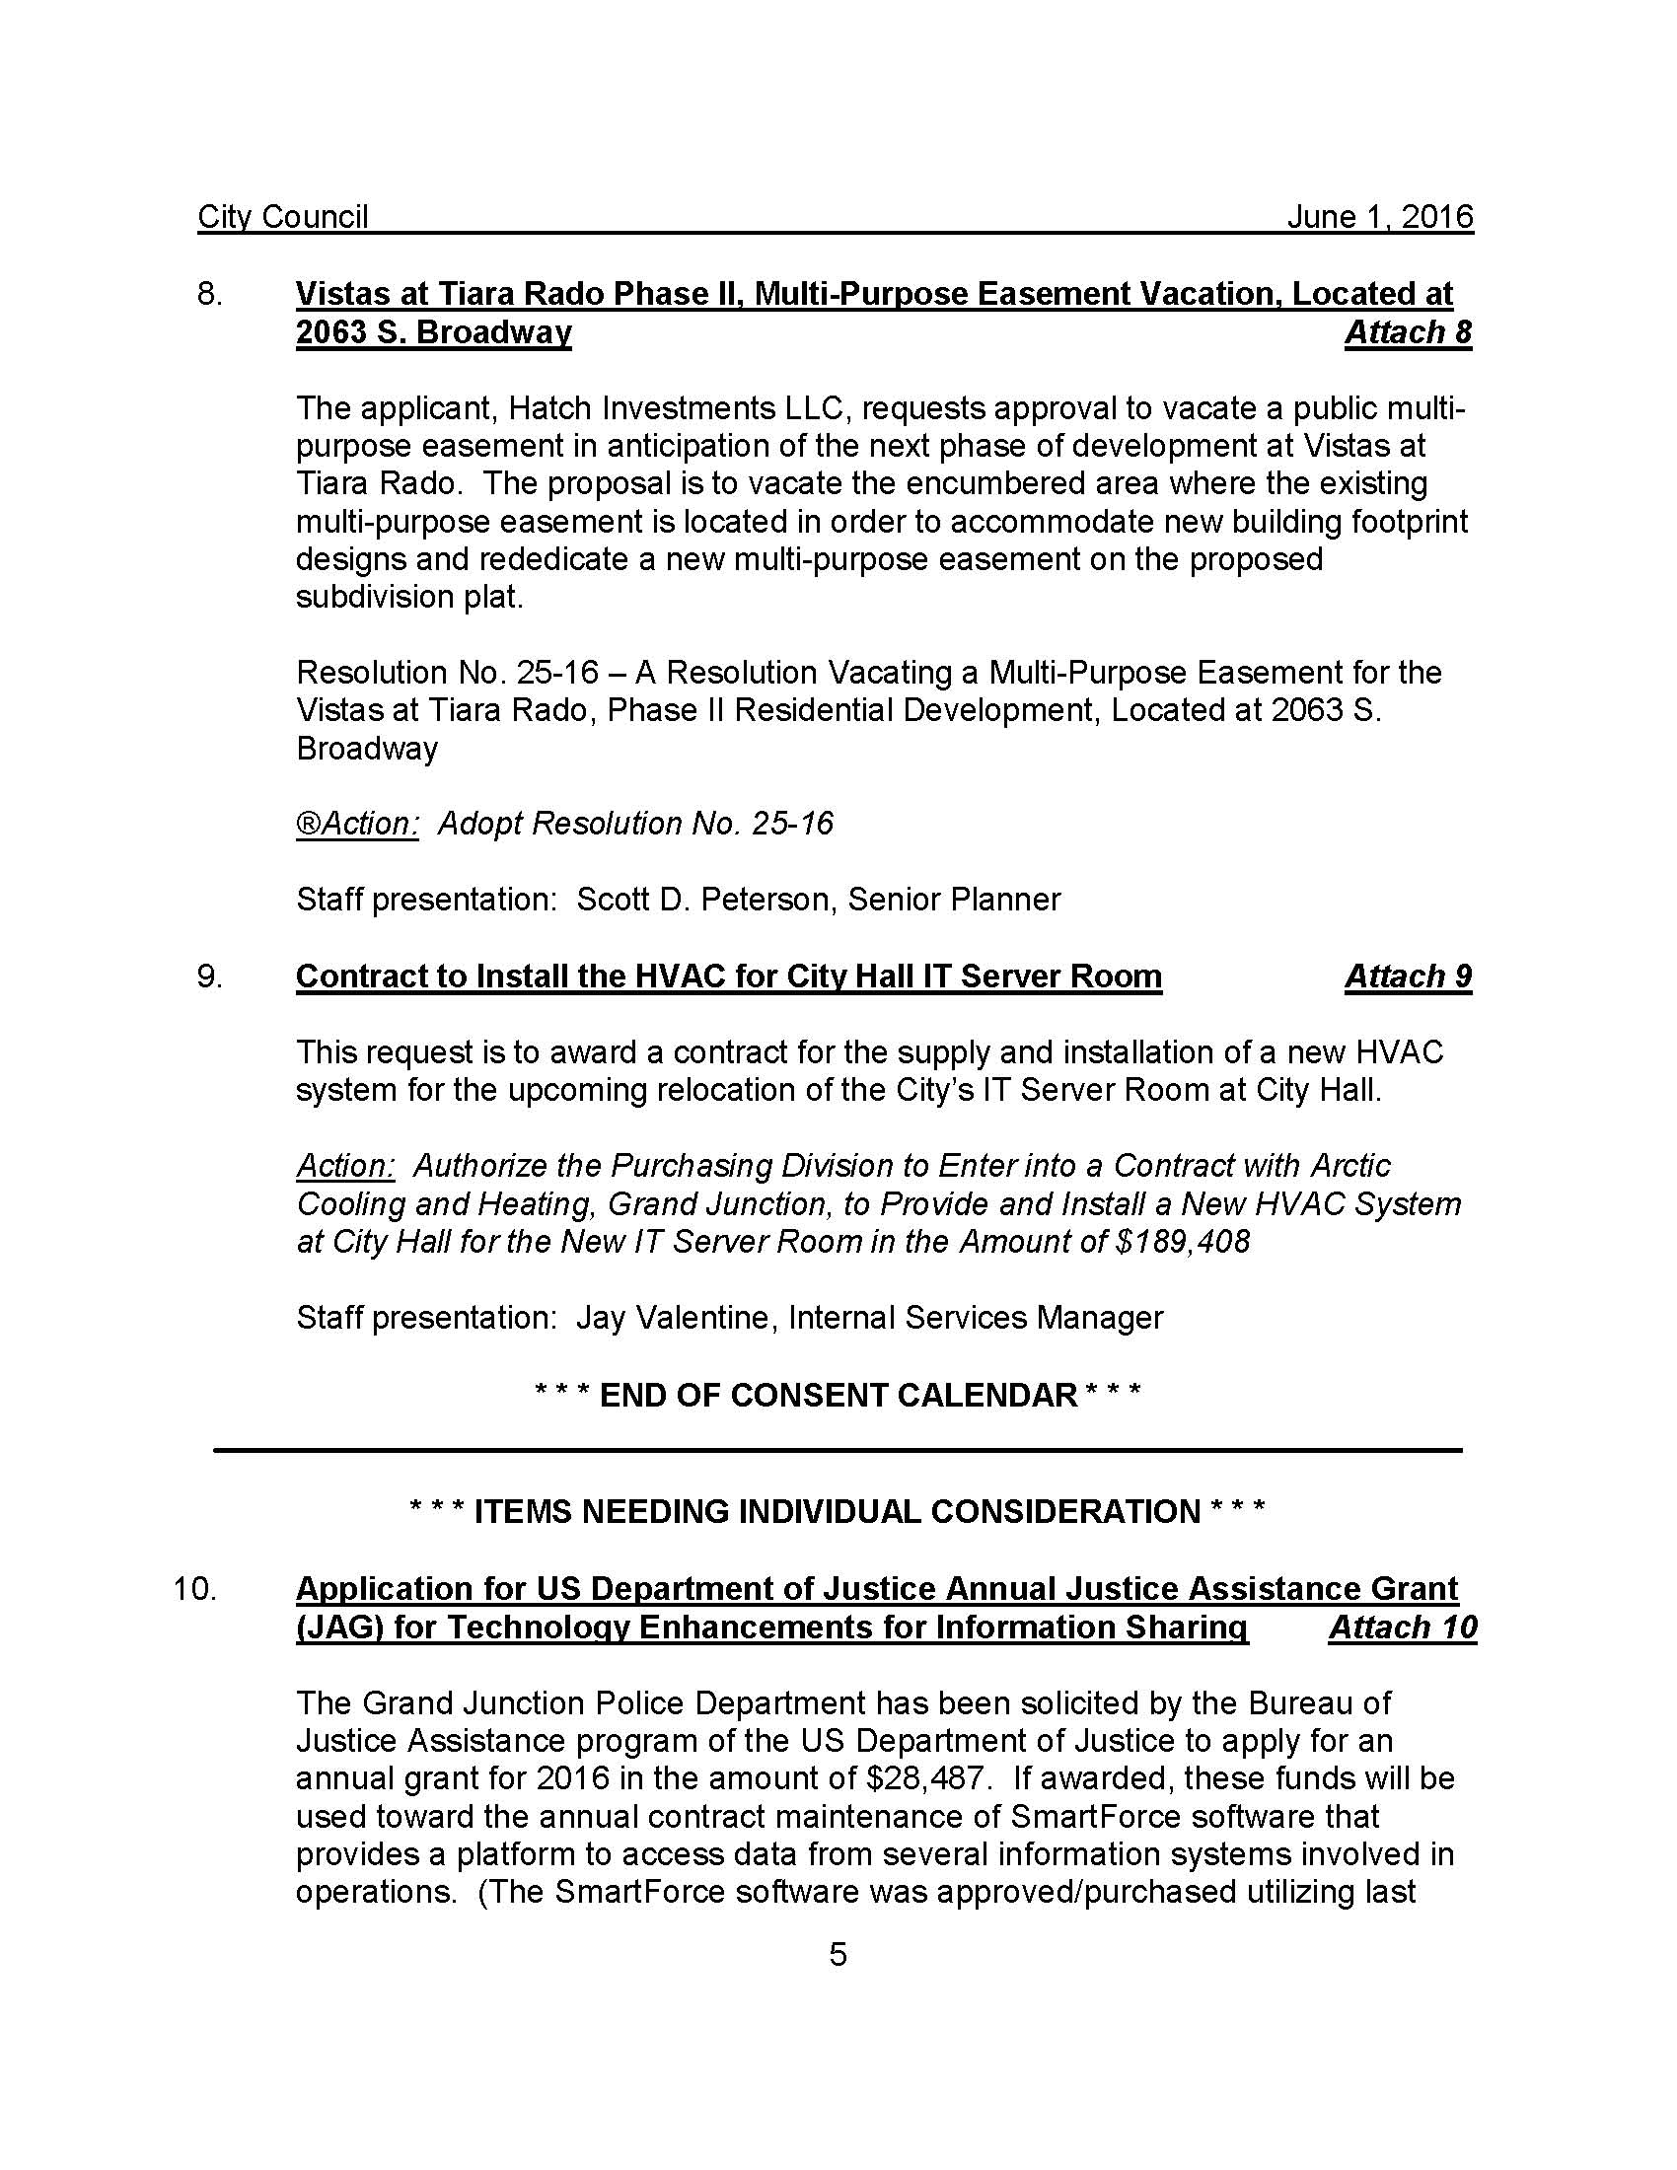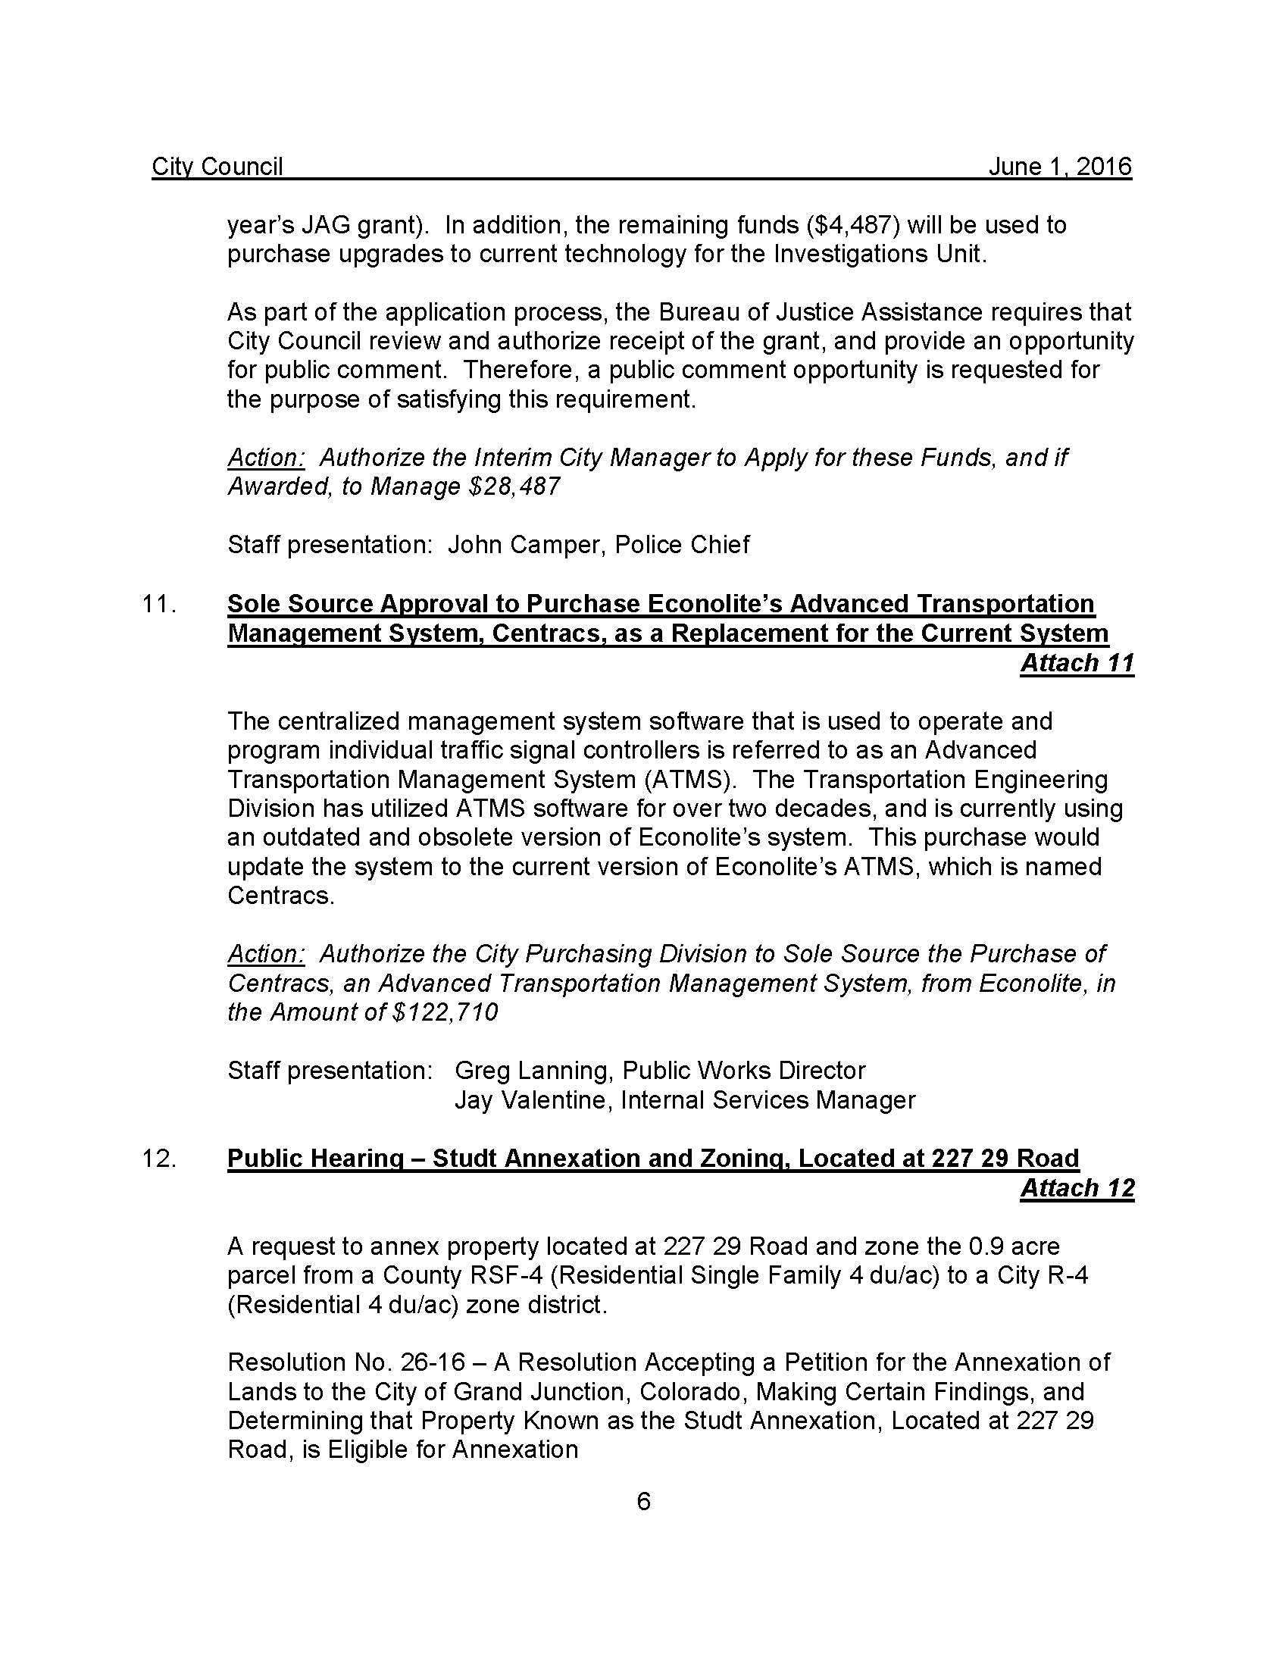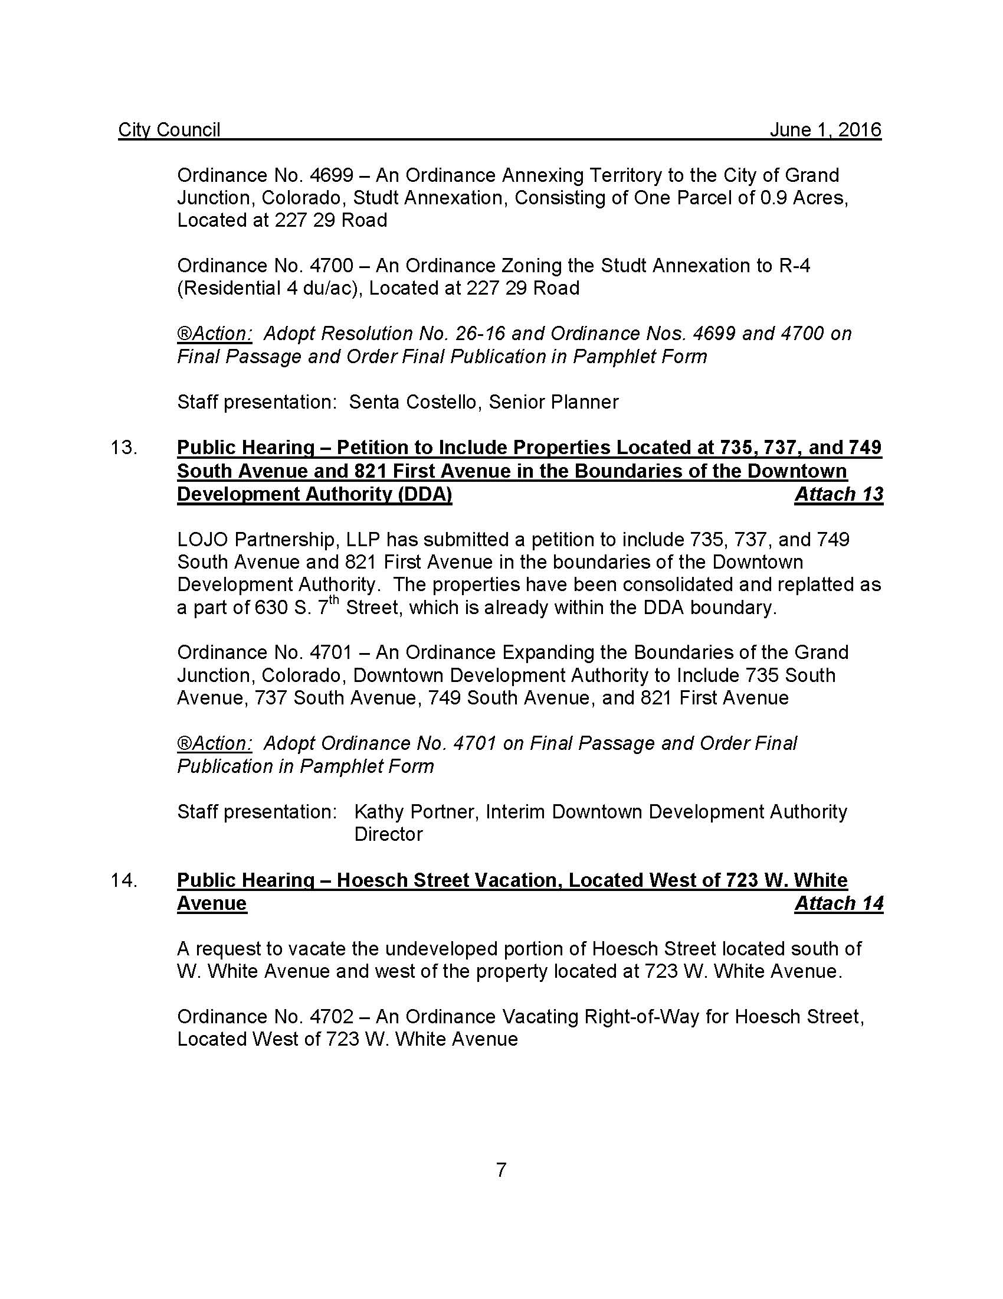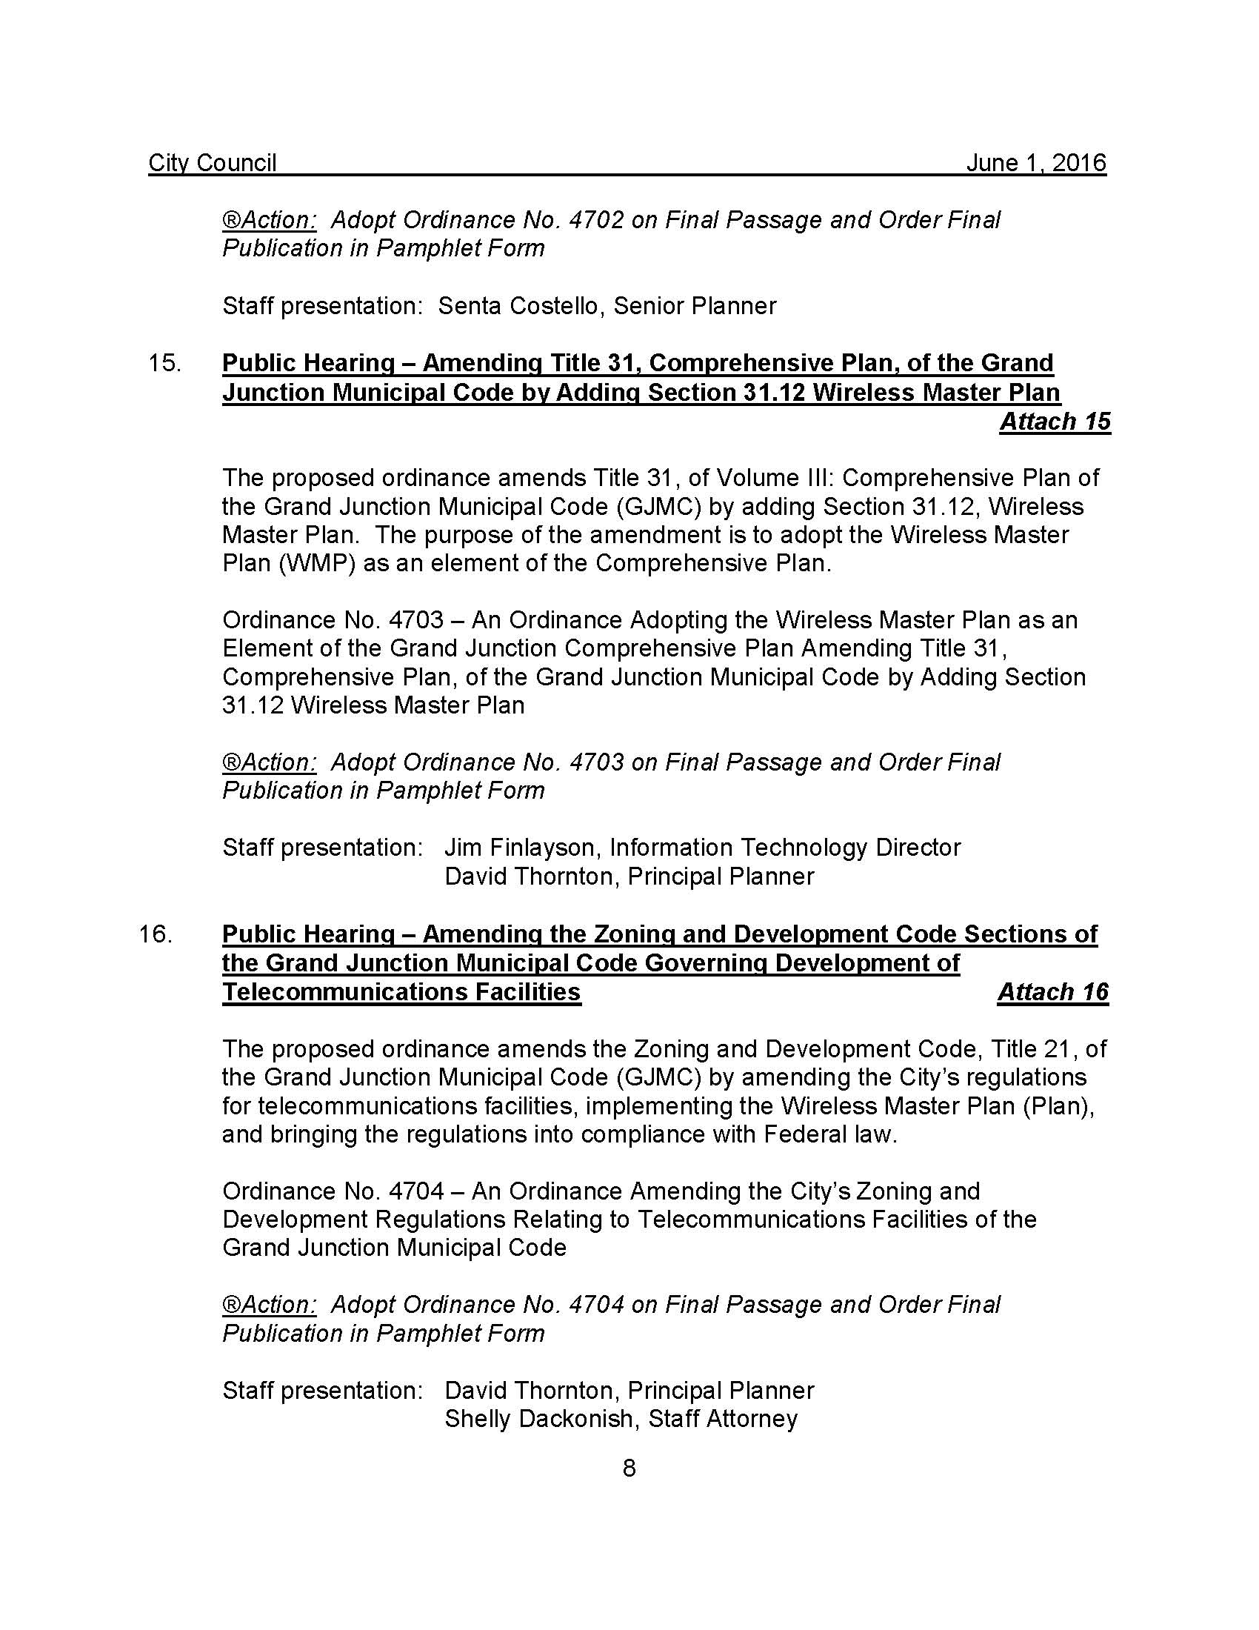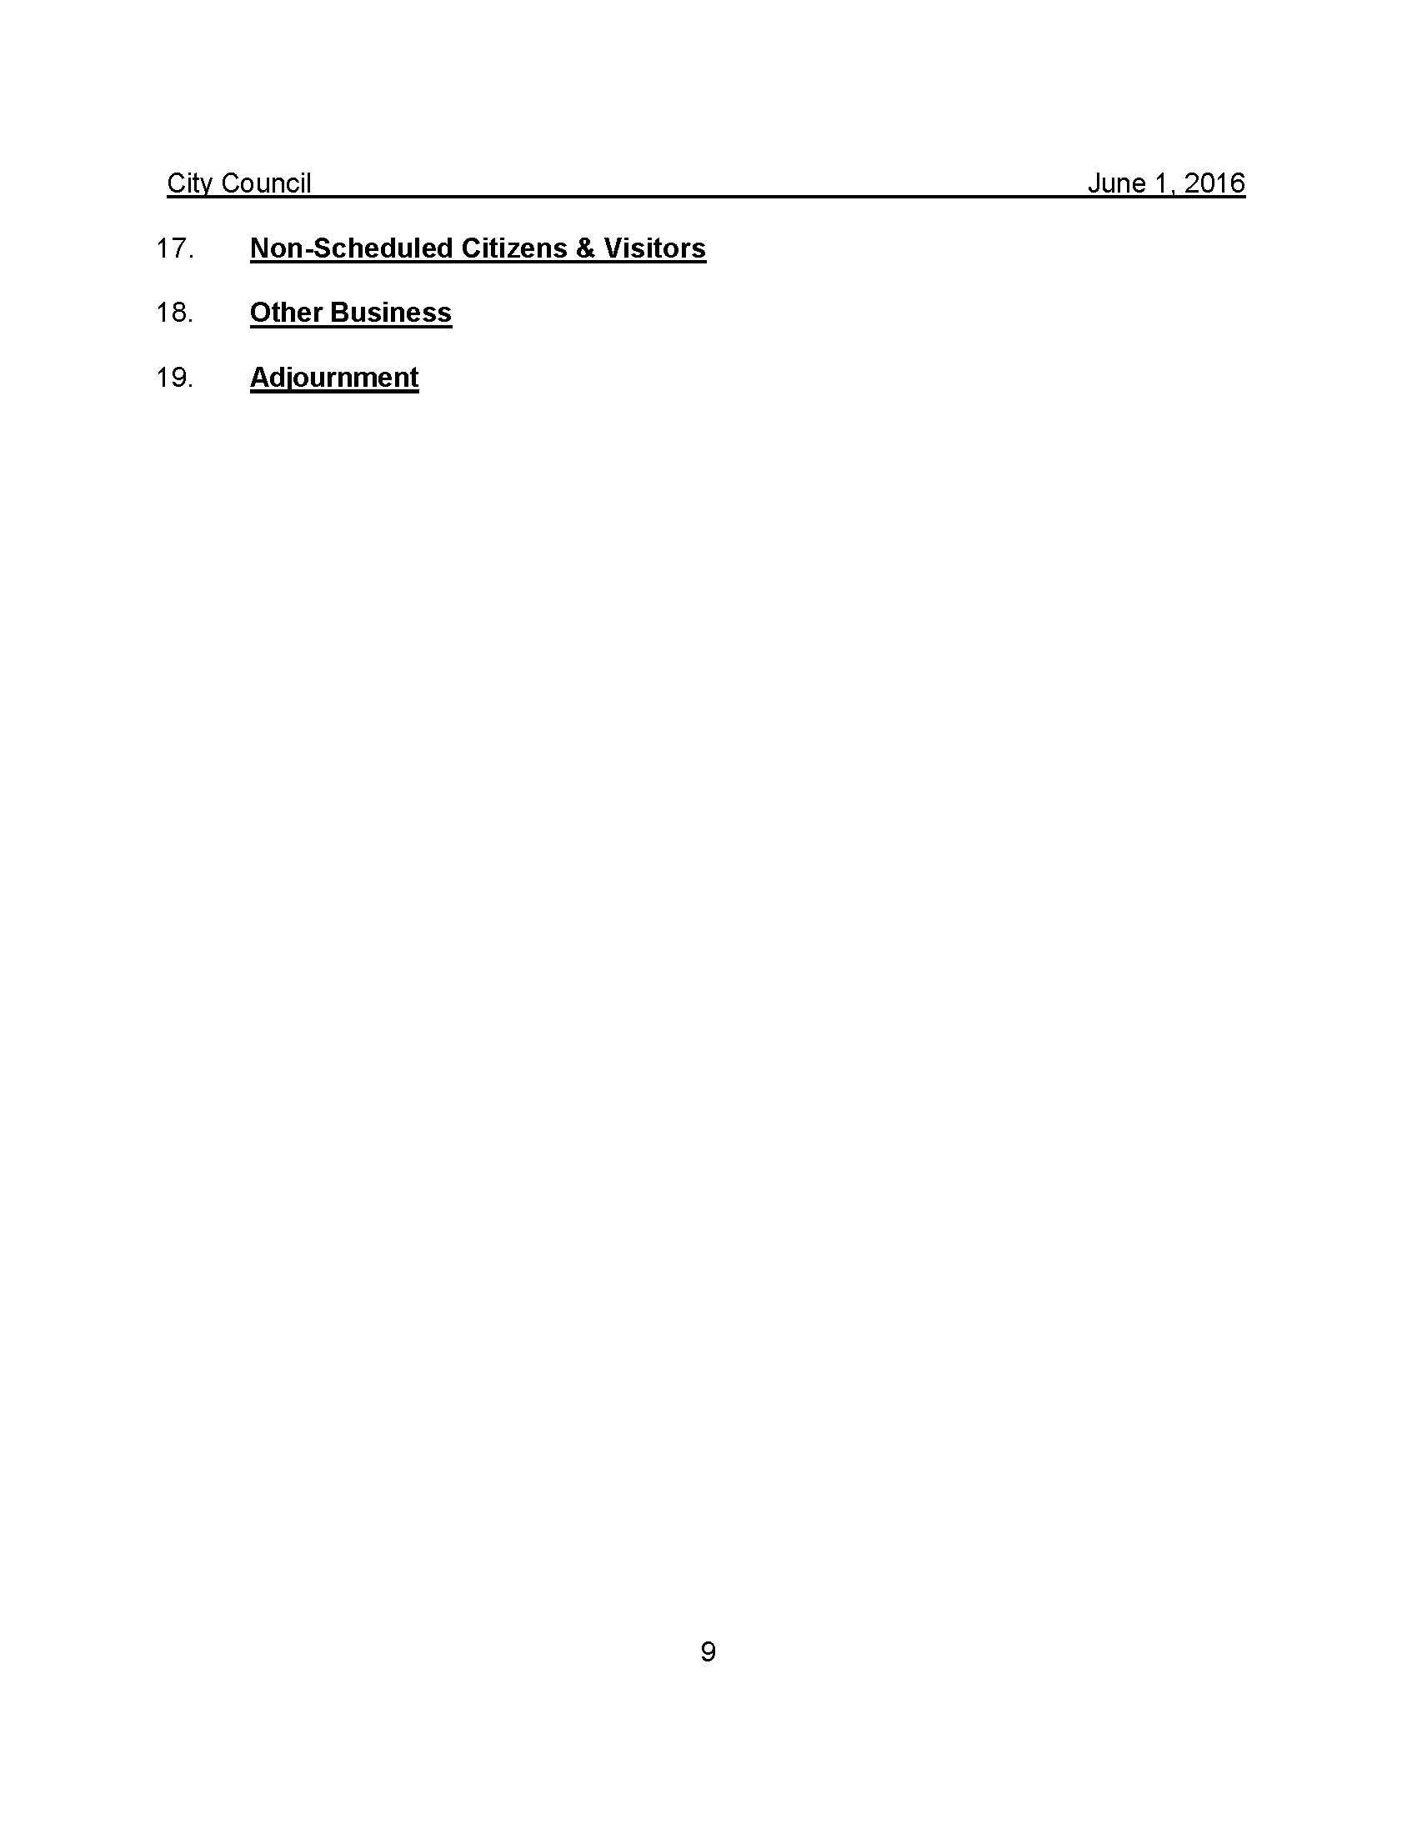

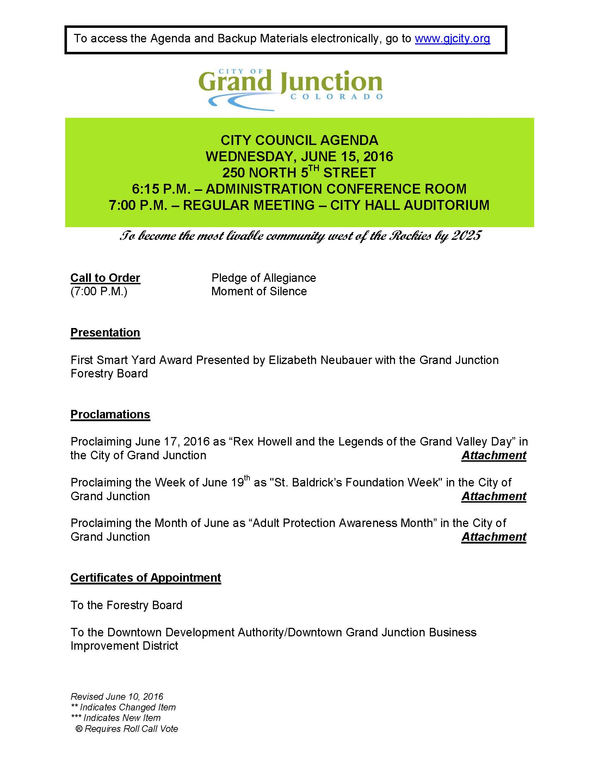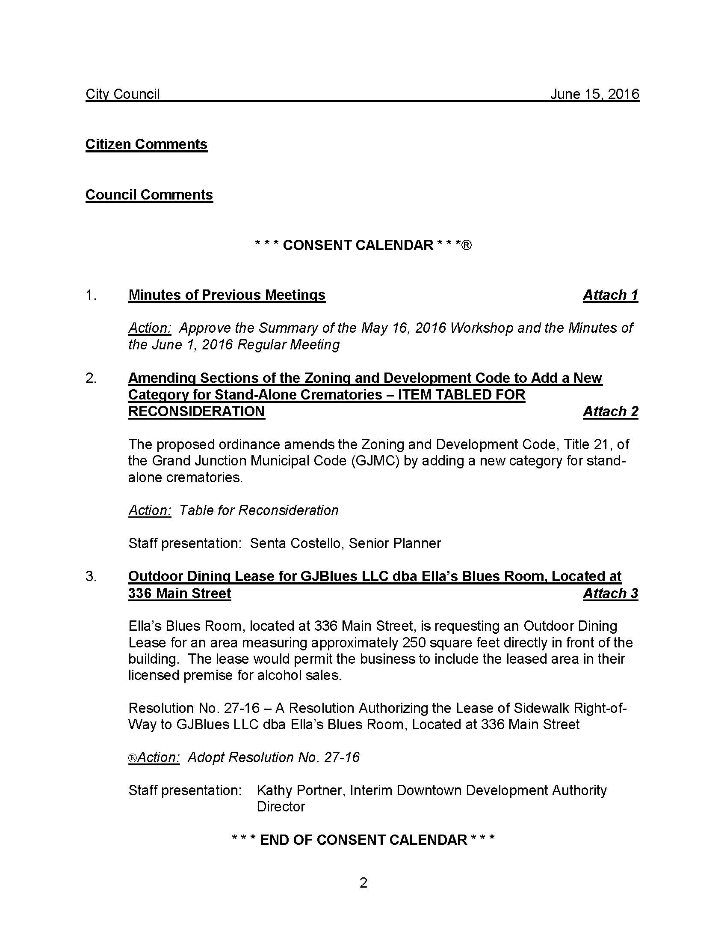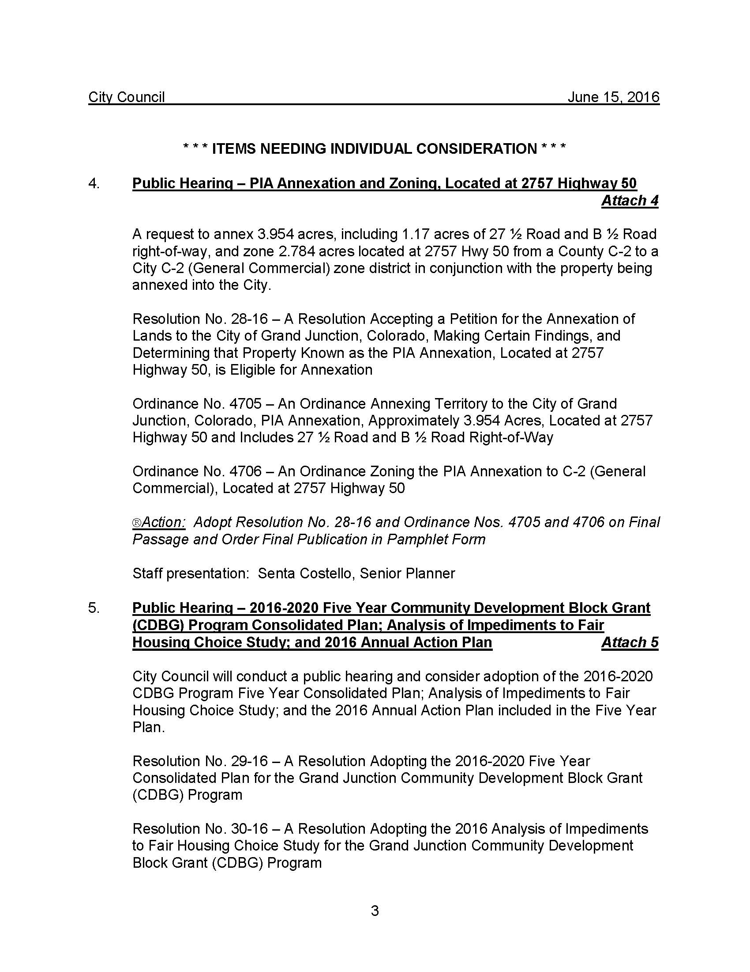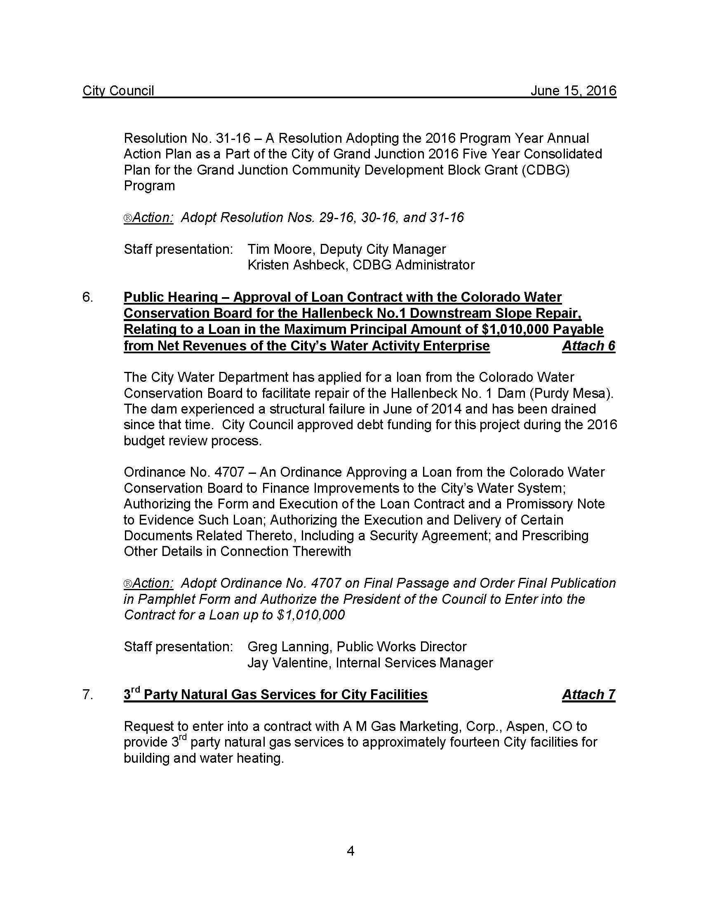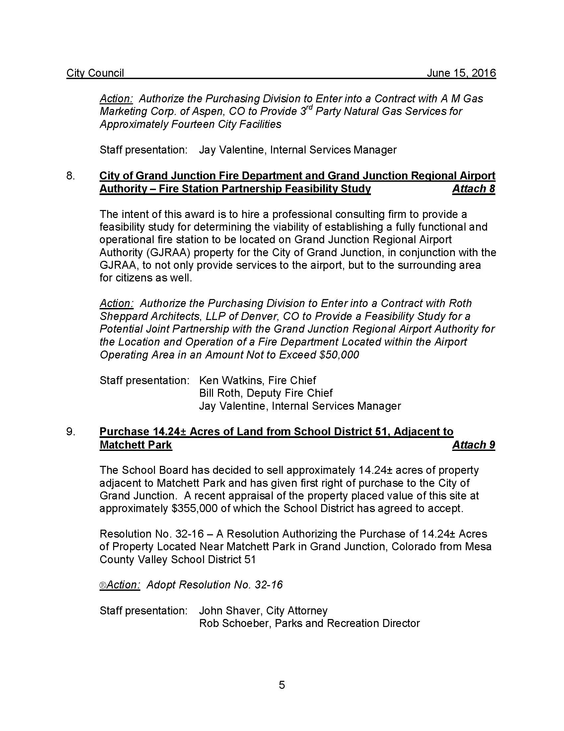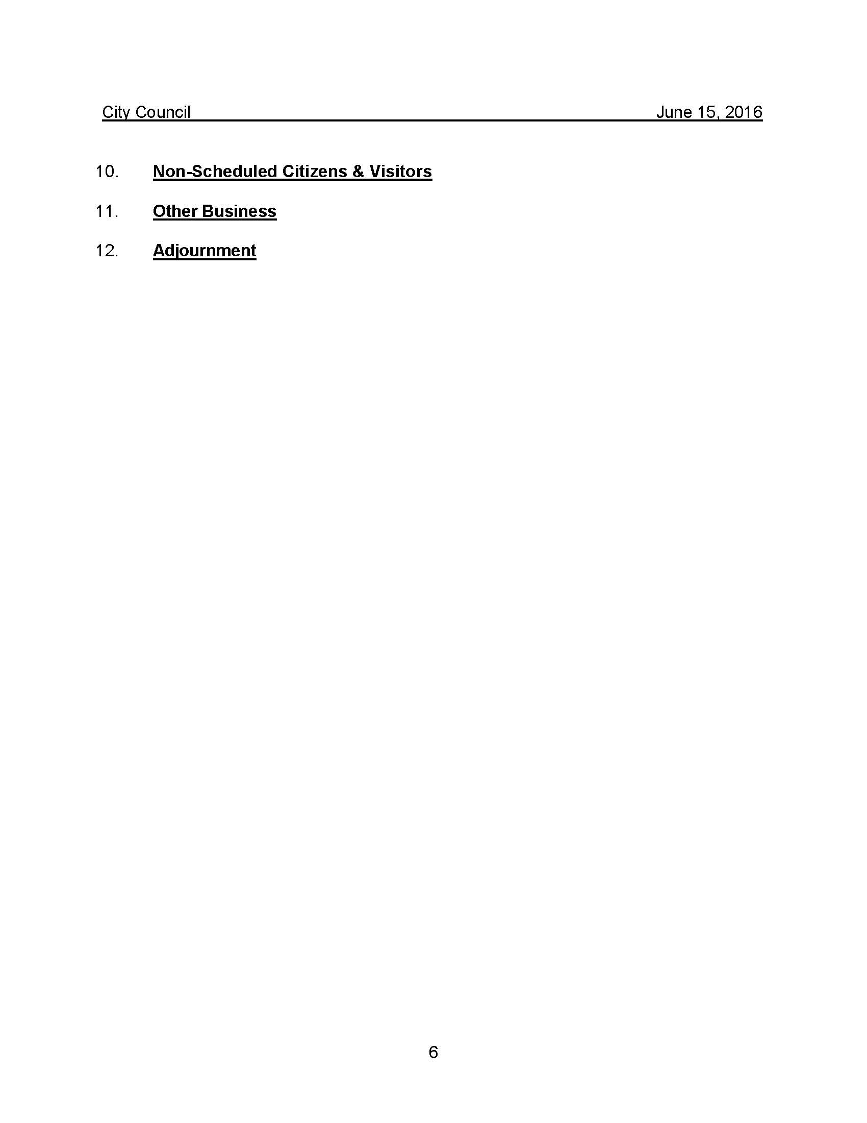

EXHIBIT B

(Affidavits of Publications)

