**CITY OF GRAND JUNCTION, COLORADO**

**ORDINANCE NO. 4719**

**AN ORDINANCE AMENDING THE**

**24 ROAD CORRIDOR DESIGN STANDARDS**

**Recitals:**

The City Council desires that the City’s zoning and development regulations be amended as needed so that they will be dynamic and responsive to the demands of the community and development trends, without compromising health, safety and welfare, and to streamline processes and regulations that may have become, over time, unnecessarily complex or difficult to apply.

The City Council adopted the 24 Road Corridor Sub-area Plan and the 24 Road Corridor Design Standards on November 1, 2000, in order to:

* Achieve high-quality development in the corridor in terms of land use, site planning and architectural design;
* Provide market uses that complement existing and desired uses and benefit the Grand Junction community;
* Take advantage of and expand upon existing public facilities in the corridor to create a “civic” presence;

**24 Road Gateway cityArchitecture**

* Achieve a distinctive “parkway” character along the roadway that can serve as a gateway to the Grand Junction community;
* Allow for flexibility in land uses (type, intensity, and density) while recognizing inherent differences between development on small parcels compared with larger parcels;
* Establish a transportation network that interconnects to create a logical urban pattern;
* Establish a high-quality image through zoning, design standards, and public improvements.

In the past 15 years there have been City-wide updates to development standards for site development, building architecture, site lighting, landscaping, and road, access and circulation, which meet or in some cases exceed the existing 24 Road Corridor Design Standards; the proposed amendments will eliminate confusion as to which standards are applicable and eliminate redundancies in development regulations.

**NOW THEREFORE BE IT ORDAINED BY THE CITY COUNCIL OF THE CITY OF GRAND JUNCTION THAT:**

**Title 25 of the Grand Junction Municipal Code (24 Road Corridor Design Standards) is amended as follows:**

**Title 25**

**24 ROAD CORRIDOR DESIGN STANDARDS**

**Chapters:**

**25.01 Introduction**

**25.02 Site Development**

**25.03 Architectural Design**

**25.04 Site Lighting**

**25.05 Signs**

**Chapter 25.01**

**INTRODUCTION**

**25.01.010 Background and intent.**

The 24 Road Corridor Design Standards provide development standards for public and private improvements in the 24 Road Corridor in order to implement the goals and objectives of the 24 Road Corridor Subarea Plan and to:

(a)    establish a practical, interconnected system of streets, parks, and parkways that allows easy orientation and convenient access for all modes of transportation;

(b)    utilize natural open spaces, such as creeks, and developed public spaces, streets, parks and parkways, to organize and coordinate development;

(c)    accommodate a broad mix of development types that encourage alternative transportation, especially walking, and transit use;

(d)    provide common usable open space that is of mutual benefit to surrounding property owners, businesses, and residents; and

(e)    establish a pattern and character for the long-term evolution of the corridor.

Adherence to these standards and guidelines will ensure that public and private improvements in the 24 Road Corridor will be well planned and executed in a high quality manner, which were important goals established through the 24 Road Corridor Subarea Plan.

These standards supplement other development regulations in the Grand Junction Municipal Code. Where there is a conflict between this Title 25 and the Zoning and Development Code (Title 21), the more restrictive standard shall apply.

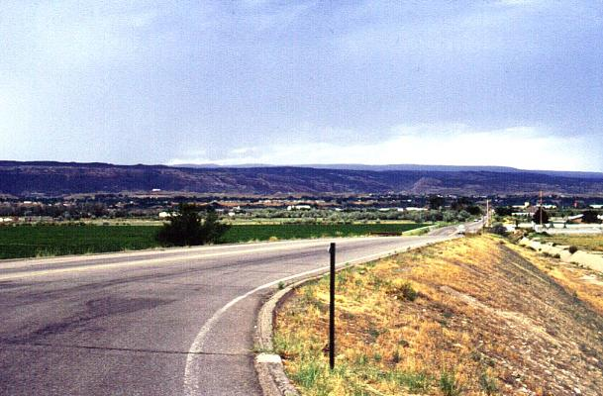

*View corridor along 24 Road highlights natural features*

**Chapter 25.02**

**SITE DEVELOPMENT**

Sections:

[25.02.010](http://www.codepublishing.com/co/grandjunction/html2/GrandJunction25/GrandJunction2512.html#25.12.010)    Purpose

25.02.020 Community Framework

25.02.030   On-site open space

25.02.040   Organizing features.

25.02.050   Site grading and drainage.

25.02.060   Building and parking setbacks.

25.02.070   Building location and orientation.

25.02.080   Parking, access, and circulation.

25.02.090   Auto-oriented uses.

25.02.100   Pedestrian and bicycle circulation.

25.02.110   Sidewalks.

25.02.120   Bicycle circulation.

**25.02.010 Purpose**

The location and design of buildings and site improvements are key to establishing the overall character and function of the 24 Road Corridor. Important site development considerations include large area development planning and coordination, the placement of buildings on the lot, relative amounts of area devoted to open space, buildings and parking areas, and vehicular and pedestrian circulation. With large undeveloped parcels such as those in the 24 Road Corridor, there is an opportunity to implement a “big picture” vision. The vision for the Corridor is to increase pedestrian movement and encourage a mixture of development types integrating housing, commercial uses, neighborhood centers, shared parking, and other appropriate land uses within neighborhoods and within buildings in a flexible pattern of lots and blocks to allow site planning flexibility and consistency of development patterns.

**25.02.020 Community Framework**

The overall planning concept for the 24 Road Corridor includes a community framework (Figure 2.1) that provides a distinctive image and organizing element for public and private development. The community framework includes public streets, parks, open spaces, natural drainages and future stormwater management facilities that serve and connect part or all of the corridor.

**Figure 2.1: Community Framework Plan**

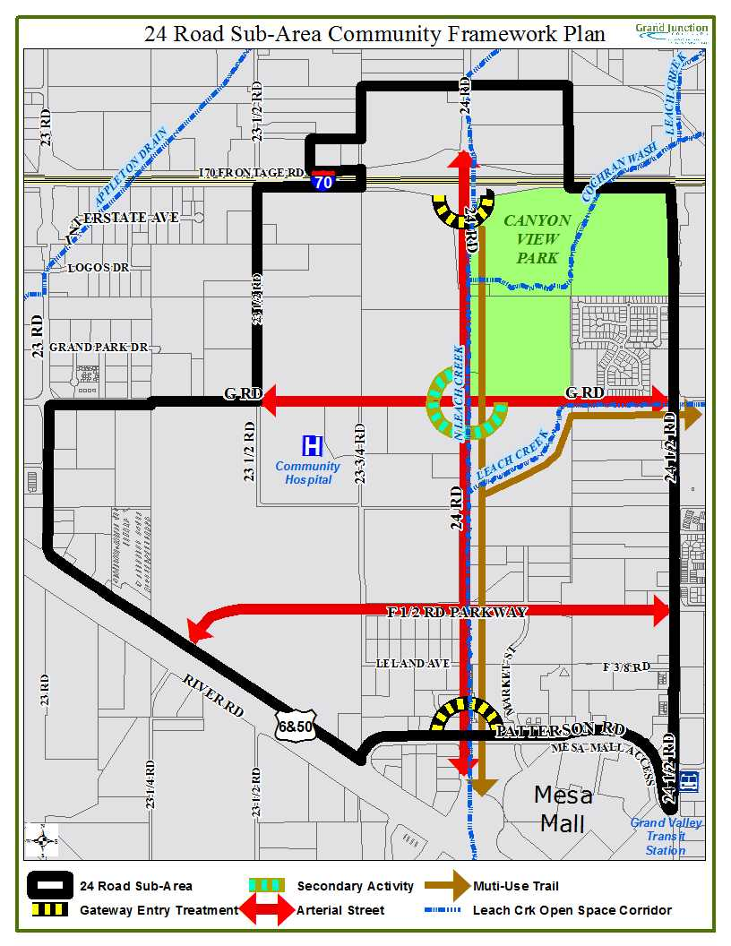

**25.02.030 On-site open space.**

On-site open space could be provided within areas that are also set aside for stormwater drainage, landscaped setbacks and other landscape areas associated with on-site buffer landscaping and amenities. Open space shall be provided on-site so as to implement and comply with the following:

(a)    Utilize well-defined natural and developed open spaces as features to serve as the focus of block, lot, and circulation patterns.

(b)    Supplement public open space such as parks and drainage corridors with privately developed open space that helps complete linkages and organize development. (Refer to open space requirements of zoning and development code.)

(c)    Open space, such as Leach Creek and developed parks and plazas, shall be used as a positive planning tool to organize and focus lot, block, and circulation patterns. Public access shall be provided to all public open space, natural and developed, directly from the public street/sidewalk system or through a public facility. Natural open space corridors and naturalized drainage ways (with trails) shall be publicly accessible at not less than 800-foot intervals.

(d)    Buildings with frontage on open space shall provide windows, doors, plazas, or other amenities that encourage pedestrian activity and provide views onto and/or are oriented toward the open space.

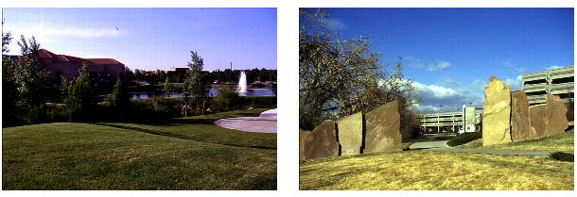

*Examples of privately developed and publicly developed open space amenities*

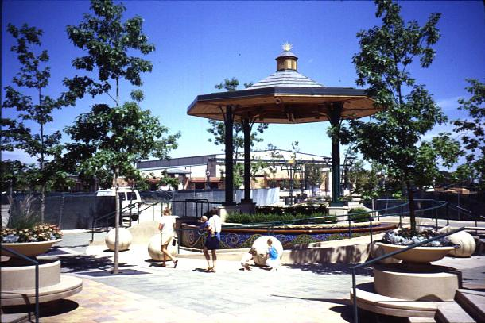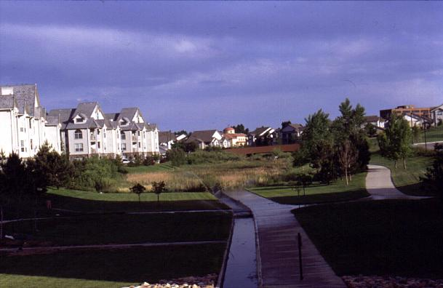

*Example of development oriented to open space Organizing features provide a focus for development*

**25.02.040 Organizing features.**

(a) **Purpose.** An organizing feature is a public open space around which development is focused. Organizing features can utilize natural open space, creeks, formal public spaces, streets, parks, and parkways to organize and coordinate development patterns. Organizing features should reinforce the pattern and orientation of streets and buildings through orderly arrangements of landscaping, pedestrian circulation and amenities, such as might be typical of a town square or campus quadrangle. Prominent amenities could be developed within open space to link building groups.

(b)    **Standards.**

(1)    At least one central feature or gathering place shall be located within a geographically distinct neighborhood, e.g., a convenient outdoor open space or plaza with amenities such as benches, monuments, kiosks, or public art. These places may be located on “civic blocks,” and may include buildings such as libraries, government offices, or public meeting places.

(2)    Buildings shall not orient rear, blank, or service dominated facades toward an organizing feature and shall include an entry that is visible, convenient to use, and connected to a public sidewalk by a direct route. Facades facing an organizing feature shall be of at least comparable architectural quality to other primary building facades.

(3)    Parking lots and parking spaces shall not be permitted within organizing features.

(4)    Multi-building developments shall use an organizing feature to create an internal campus-like arrangement of buildings and open space; provided, that the organizing feature is bounded along at least one side by a public street.

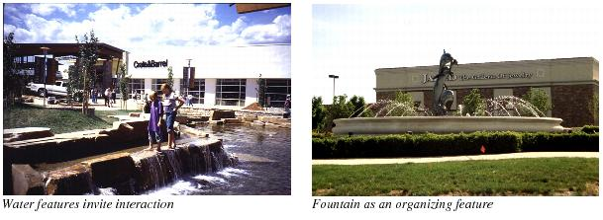(5) Organizing features shall utilize natural open space, creeks, formal public spaces, streets, parks, and parkways, where such are available on or adjacent to the site, to organize and coordinate development patterns.

*Open space incorporates drainage facility and amenities*

**25.02.050 Site grading and drainage.**

The site grading and drainage standards ensure that development fits within existing topography, reinforces the community open space framework, and effectively diverts and retains stormwater. In addition to other site grading and drainage requirements of the Municipal Code, the following standards shall apply in the 24 Road Corridor:

1. Unless precluded by soil conditions, graded slopes shall not be steeper than 3:1 slope. Where space limitations demand, terracing with retaining walls is the preferred solution.
2. Existing riparian areas and drainages, such as Leach Creek and its tributaries, shall be developed and maintained as natural open space corridors that provide surface drainage and developed pedestrian trails. The treatment of surface drainages shall be an open channel with gently sloping sides and naturalized landscape, except for the west bank of Leach Creek which is constrained by the 24 Road improvements. (See Figures 2.2 & 2.3.)

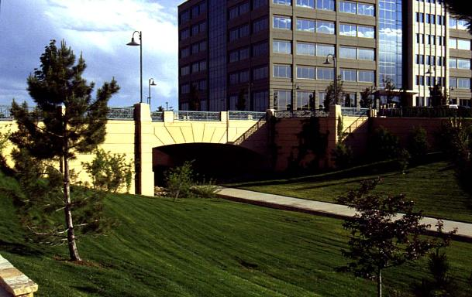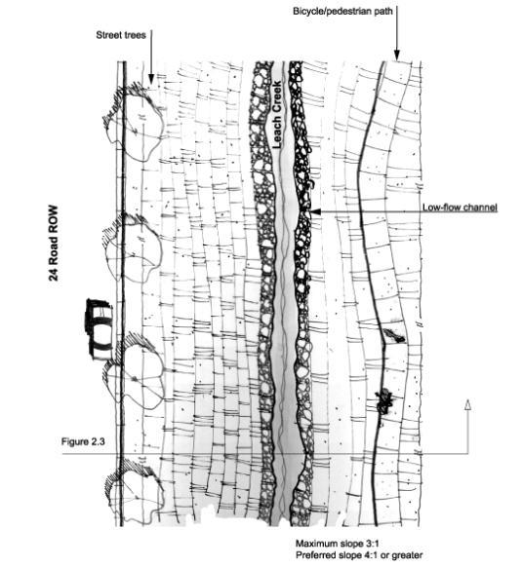**Figure 2.2: Natural Corridor Plan**

*Open space incorporates drainage facility and amenities*

**Figure 2.3: Natural Corridor Section**

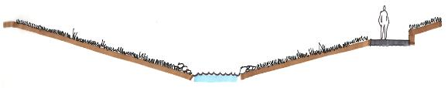

**25.02.060 Building and parking setbacks.**

Building and parking setback standards establish a coordinated streetscape image and provide sufficient space between buildings, roads and parking areas for adequate light, privacy, views, sound control and landscaping. In order to establish additional open space and maintain views, building and parking setbacks shall be provided as specified in Table 3.1.

**Table 3.1: Supplemental Building and Parking Setbacks**

| **Frontage** | **Building Setback** | **Parking Setback** |
| --- | --- | --- |
| 24 Road – west ROW | 50′ | 25′ |
| 24 Road – east ROW | 35′ from edge of Leach Creek corridor | 10′ from edge of Leach Creek corridor |
| Patterson Road (F Road) | Per zoning | 10′ |
| F 1/2 Road | Per zoning | 10′ |
| G Road | Per zoning | 10′ |

Notes:

(a)    Width of Leach Creek drainage corridor to be determined and will include multi-use trail. (See Figure 2.3.)

(b)    All measurements are from the right-of-way.

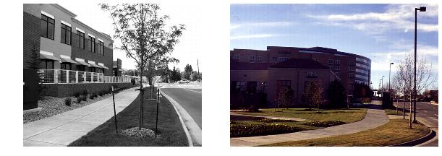

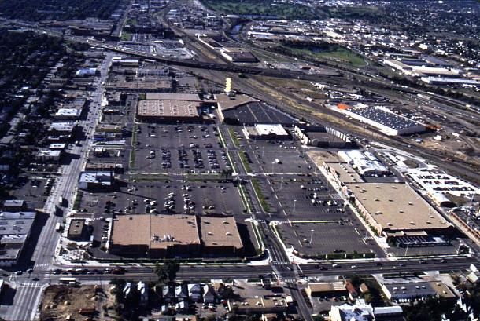*Coordinated landscaping in the building setback*

*complements ROW landscaping*

*Buildings at the edges of project site with pedestrian connections through parking areas*

**25.02.070 Building location and orientation.**

To encourage the orientation of buildings toward the street, reinforce the character and quality of public streets and sidewalks, maximize useful interconnections, and enhance the appearance of properties from the street, the following standards shall apply:

(a)    No development shall be permitted to place or orient buildings, parking, circulation, or service facilities on a lot in such a way as to treat primary street frontage(s) as a rear lot line. “Rear” shall be defined to mean a portion of the property lacking public access and containing a predominance of service functions and/or service facilities that significantly diminish the architectural or landscape quality of the development.

(b)    All sides of a building that are visible from a street, residential area, public park or organizing feature shall have the equivalent architectural treatment of the primary building façade.

(c) All service and loading facilities that are visible from a street, public park, residential area or organizing feature shall be completely screened from view.

(d)    Nonresidential uses located in the same block with residential uses shall be located on higher traffic streets and at the periphery or the end of each block having both uses and be effectively screened of light, noise, and pollution from service area or other incompatible activities.

(e)    Large retail buildings (over 20,000 gross square feet) shall be located to minimize the impact of windowless walls and service areas on public streets. On sites that include large retail buildings, smaller buildings in-line or on pads shall be located to form edges that frame and reinforce the space and appearance of public streets. Pad buildings shall locate at least one facade including windows and similar architectural features within 35 feet of the public right-of-way. Pad buildings shall be located at site corners and entries.

(f)    All sites abutting 24 Road shall treat 24 Road as a primary frontage with regard to the quality and orientation of buildings, site design, architectural features, and parking area design. This shall be in addition to any other required access and orientation. Primary frontage is intended to include landscape and building design that conveys the project identity and character and is of equal or superior quality to any other frontage of the project. No truck docks or service areas shall be permitted to face 24 Road.

**25.02.080 Parking, access, and circulation.**

In order to provide for safe and convenient movement of pedestrians and motor vehicles, limit vehicular/pedestrian conflicts, reduce paved areas, provide screening for paved areas and soften the visual impact of parking lots by providing interior planting, the following standards shall apply:

1. No more than two double-loaded bays of parking, with a maximum length of 125 feet, shall be allowed in front of buildings smaller than 20,000 square feet in size.
2. 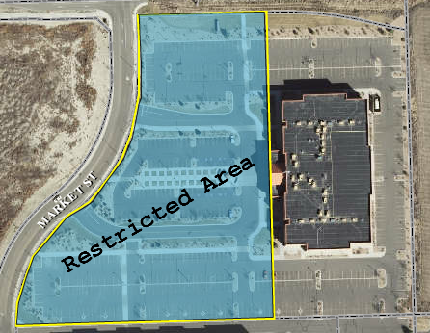For retail buildings 20,000 to 30,000 square feet in size, no more than 50 percent of the total surface parking area shall be located in the *restricted area* between the street and a building. For retail buildings larger than 30,000 square feet, no more than 60 percent of the total surface parking area shall be located in the *restricted area.* The restricted area is located between the front facade of the principal structure and the primary abutting street. The restricted area shall be determined by drawing a line from the front corners of the building to the nearest property line as shown in the example.

*Example of Restricted Area*

1. Service entrances, service yards and loading areas shall not be located on a side of any building that faces 24 Road, any arterial street, I-70, or residential uses.
2. Opportunities for future auto, pedestrian, and bicycle connections to adjoining sites shall be considered in all site design. Such connections shall be provided where reasonably practicable.

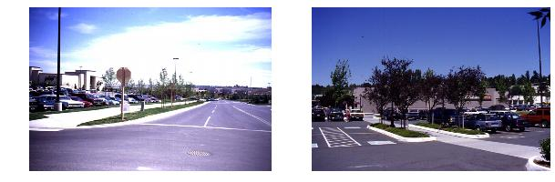

*Examples of pedestrian circulation systems within parking lots*

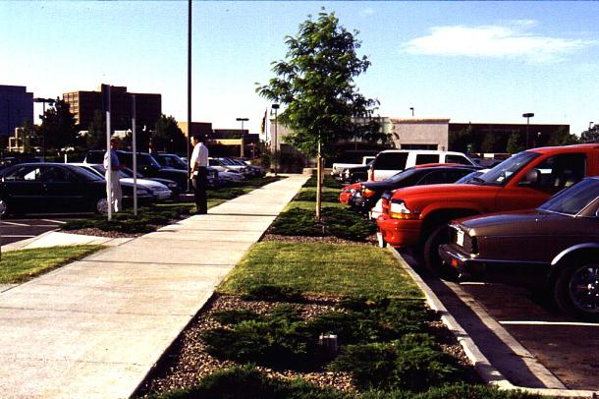

*Sidewalks and landscaping break up and soften the visual impact of large parking lots*

**25.02.090 Auto-oriented uses.**

To minimize impacts of auto circulation, queuing, drive-up facilities (including speaker systems and similar activities) and to promote street-oriented building design and pedestrian amenities, the following standards shall apply:

1. Drive-up and drive-through facilities (order stations, pick-up windows, bank teller windows, money machines, car drop-off areas for auto service or rental, etc.) shall be located on the side or rear of a building and away from residential uses.
2. For buildings greater than 100 feet from the street and with no intervening buildings, drive-through windows may be allowed to face a perimeter street, and drive-through lanes may be allowed with adequate landscaping buffer from the right-of-way line.

**25.02.100 Pedestrian and bicycle circulation**

To promote efficient and safe movement of pedestrians and bicyclists through the 24 Road Corridor, sidewalk and/or multi-use trail links shall be provided between development sites and open space including but not limited to an off-street multi-use trail connecting Canyon View Park and the Colorado River Trail.

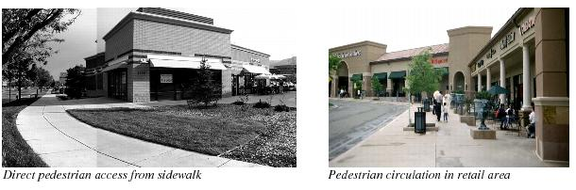

**25.02.110 Sidewalks**

To provide opportunity for continuous pedestrian movement through the 24 Road Corridor, the following standards shall apply:

1. A direct pedestrian connection to the building entry shall be provided from the public sidewalk.
2. Development shall provide pedestrian circulation from public walks to parking areas, building entries, plazas, and open spaces. Walkways shall be provided to separate pedestrians and vehicles, and shall link ground level uses. Primary walks shall be a minimum of five feet wide.
3. Clear and safe pedestrian routes shall be defined through parking areas to provide pedestrian access between buildings with minimum conflicts with vehicles. Walkways crossing drive aisles shall be clearly marked with signage, special paving, landscaping or other similar means of demarcation.
4. Sidewalks at least eight feet wide shall be provided along all building facades that abut public parking areas and feature a public entrance.
5. Pedestrian walks incorporating bicycle lanes shall be not less than 10 feet in width.
6. All parking areas located between a street and building shall include a landscaped pedestrian walk linking the building with a public sidewalk.
7. Physical barriers between contiguous development shall be prohibited unless necessary for safety or the mitigation of adverse impacts.
8. Development shall provide pedestrian linkages between the Leach Creek trail corridor and other public ways and open space areas.

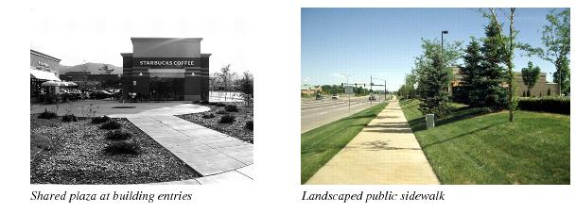**25.02.120 Bicycle circulation.**

To provide a safe, direct, and attractive system of interconnected public bikeways and bike routes throughout the corridor and defined routes to primary building entries, the following standards shall apply:

1. Bicycle parking shall be located in visible, active, and well-lit areas, near building entries, convenient to primary bicycling access, and not encroaching on pedestrian walkways. If possible, bike parking shall be located so it is visible from the inside of adjacent buildings.
2. Bicycle circulation shall connect and align with pre-existing and planned off-site bicycle routes. Crossings at intervening streets shall be located where safe means for crossing can be provided.

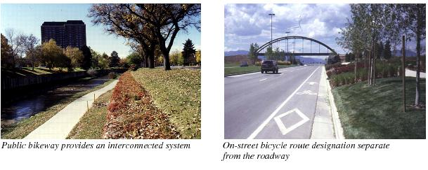

**Chapter 25.03**

**ARCHITECTURAL DESIGN**

Sections:

25.03.010 Purpose

25.03.020 Building form and scale

25.03.030 Building materials

25.03.040 Multi-unit residential development

25.03.050 Fencing and walls

25.03.060 Service and storage areas

**25.03.010 Purpose**

These architectural design standards are intended to:

1. Encourage a consistent level of architectural quality throughout the 24 Road Corridor;
2. Create a unified architectural character at the project level, addressing building form, scale and materials, including for walls, fencing and service and storage areas;
3. Reinforce the urban character of streets and open spaces;
4. Provide human scale and orientation;
5. Define the base, body and top of building elevations through the use of color, materials and details;
6. Ensure that the highest level of architectural detail occurs adjacent to areas of pedestrian activity;
7. Ensure that service and storage areas are functional yet do not visually impact views from adjacent uses and public areas;
8. Provide flexibility to allow for a number of design alternatives for different building types and to encourage design creativity.

Note: Additional standards for architectural design are included in Title 21, Grand Junction Zoning and Development Code.

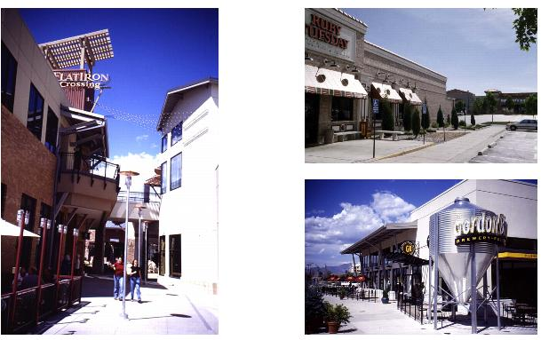

*Buildings in a variety of forms reinforce the pedestrian scale*

**25.03.020 Building form and scale. (Nonresidential and Multifamily Structures)**

The following standards shall apply to all building facades and exterior walls that are visible from adjacent public streets and other public spaces. These standards are intended to reduce the massive scale of large buildings, which, without application of these standards, may be incompatible with the 24 Road Corridor Overlay desired character.

(a)    Facades greater than 150 feet in length, measured horizontally, shall incorporate wall plane projections or recesses having a depth of at least three percent of the length of the facade and extending at least 20 percent of the length of the facade. No uninterrupted length of any facade shall exceed 150 horizontal feet.

(b)    Ground floor facades that face public streets shall have display windows, entry areas, awnings, or other such features along no less than 60 percent of their horizontal length. If the facade of the building facing the street is not the front, it shall provide the same features and/or landscaping in scale with the facade.

(c)    Variation in roof lines/roof materials, in order to add interest to and reduce the massive scale of large buildings, is required. Roofs shall have no less than two of the following features:

(1)    Parapets concealing flat roofs and rooftop equipment, such as HVAC units, from public view. Parapets shall not exceed one-third of the height of the supporting wall and shall not be of a constant height for a distance of greater than 150 feet;

(2)    Overhanging eaves, extending no less than three feet past the supporting walls, for no less than 30 percent of the building perimeter;

(3)    Sloping roofs that do not exceed an average slope greater than or equal to one foot of vertical rise for every three feet of horizontal run and less than or equal to one foot of vertical rise for every one foot of horizontal run; and

(4)   Three or more roof slope planes.

(d)     Primary building entries shall be connected to the public street sidewalk by the most direct route practical. Corner buildings need only provide public entry on one street-oriented facade.

(e)   Ground floor retail shall have direct pedestrian entries onto public streets, parks, or plazas. Primary building entries must be easily and directly accessible from a street and shall be either oriented to or easily visible from the street.

(f)    Entryway design elements and variations should give orientation and aesthetically pleasing character to the building. The following standards identify desirable entryway design features. Each principal building on a site shall have clearly defined, highly visible main entrances featuring no less than three of the following:

(1)    Canopies or porticos;

(2)    Overhangs;

(3)    Recesses/projections;

(4)    Arcades;

(5)    Raised corniced parapets over the door;

(6)    Peaked roof forms;

(7)    Arches;

(8)    Outdoor patios;

(9)    Display windows;

(10)    Architectural details such as tile work and moldings which are integrated into the building structure and design; and

(11)    Integral planters or wing walls that incorporate landscaped areas and/or places for sitting.

(g)    To the greatest extent possible, mechanical appurtenances shall be located within the structure. External mechanical appurtenances such as heating and air conditioning equipment shall be screened and finished to match the colors and materials of the building.

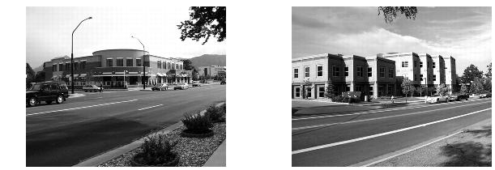

*Primary building entrances present inviting facades along arterial streets*

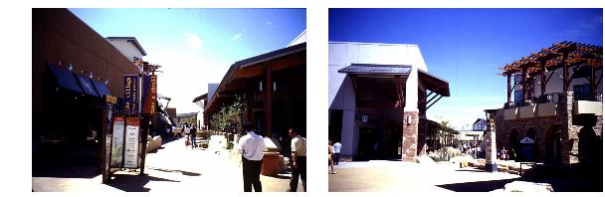

*Retail development includes pedestrian-scale open space*

**25.03.030 Building materials. (Nonresidential Structures)**

The following standards shall apply to nonresidential structures:

(a) All primary buildings shall use materials that are durable, economically maintained, and of a quality that will retain their appearance over time including but not limited to stone, brick, stucco, pre-cast concrete, and architectural metals.

(b)    Facade colors shall be nonspecular, neutral or earth tone colors. Use of high intensity, metallic, black or fluorescent color is prohibited.

(c)    Building trim and accent areas may feature brighter colors, including primary colors.

(d)    Predominant exterior building materials shall not include smooth-faced concrete block, smooth-faced tilt-up concrete panels, or prefabricated steel panels.

(e) Ancillary buildings, enclosures and projected building elements shall be designed as an integral part of their primary facility. Where detached buildings are necessary, they shall be compatible to the main building in design, form, use of materials, and color.

(f)    Building materials should be used in a manner that achieves a coordinated design on all building facades (“360-degree design”).

(g)   High quality, durable materials (brick and concrete masonry, pre-cast concrete, stone) should be the dominant treatment on all building facades facing 24 Road, Patterson Road/F Road, F 1/2 Road, and G Road.

**25.03.040 Multi-unit residential development. (Multifamily Structures)**

To ensure that multifamily residential architecture provides human scale and orientation and reinforces the urban character of streets and open spaces, the following standards shall apply to multifamily residential development in the 24 Road Corridor:

(a)   Buildings shall be designed to provide human scale, interest, and variety. The following techniques may be used to meet this objective:

(1)    Variation in the building form related to the scale of individual dwelling units or rooms such as recessed or projecting bays, shifts in massing, or distinct roof shapes.

(2)    Diversity of window size, shape, or patterns that relates to interior functions.

(3)    Emphasis of building entries through projecting or recessed forms, detail, color, or materials.

(4)    Variations of material, material modules, expressed joints and details, surface relief, color, and texture to break up large building forms and wall surfaces. Such detailing could include sills, headers, belt courses, reveals, pilasters, window bays, or similar features. Changes in materials should generally occur at inside corners or where the transition is accommodated through an architectural detail such as a cap or belt course.

(b)    Portions of buildings that are functionally limited from including significant window areas shall either be oriented away from public streets or shall make extensive use of the scaling methods defined above.

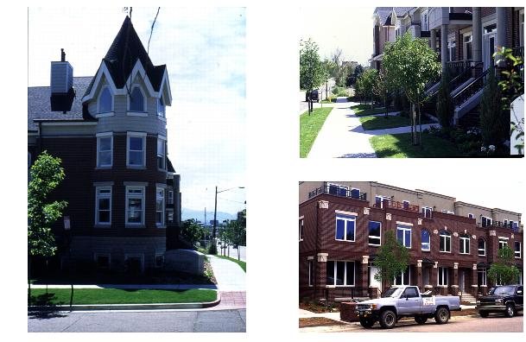(c)    Garages and carports shall either be integrated into the primary building form or shall be constructed of the same materials as the primary buildings.

*Examples of multifamily housing that provides variety and human scale*

**25.03.050 Fencing and walls. (Nonresidential and Multifamily Structures)**

To provide for security, to screen unsightly areas, and to provide visual relief and buffers, the following standards shall apply to multifamily and non-residential structures in the 24 Road Corridor:

(a)   The design and materials for walls and fences shall be coordinated with the design and materials of the principal buildings in terms of color, quality, scale and detail. This is not intended to require identical materials and design.

(b) The combined height of walls and fences on top of an earth berm shall not exceed the maximum permitted height for the wall or fence alone.

(c) Fence and wall design shall not include long, unarticulated street fences facing walks and shall prevent “fence canyons.”

(d)    Chain link fencing in areas visible from nonindustrial properties, parking areas, public streets and pedestrian walkways shall be of a type and color that is aesthetically pleasing and complementary to the building and its surroundings.

(e) Chain link fencing shall be landscaped.

**25.03.060 Service and storage areas. (Nonresidential and Multifamily Structures)**

To ensure that service and storage areas are functional while minimizing their visual impact on adjacent properties, parking and open space areas, public streets, walkways and trails, the following standards shall apply to nonresidential and multifamily structures in the 24 Road Corridor:

(a)    Outdoor storage, loading and operations areas shall be attractively screened from adjacent parcels and streets.

(1)    Outdoor storage, trash collection and/or compaction, loading or other such uses shall be located in the rear of the lot.  If because of lot configuration the Director determines that such placement is not feasible, then the side yard may be used, but in no case shall such area be located within 20 feet of any public street, public sidewalk or on-site pedestrian way.

(2)    Outdoor storage, HVAC equipment, trash collection, trash compaction and other service functions shall be designed so as to be visually incorporated into the overall site design and architecture of the building(s).

(3) Views of outdoor storage, trash collection and/or compaction, HVAC equipment, loading and other service facilities and functions shall be screened from visibility from all property lines and screened and separated from sidewalks and on-site pedestrian ways. Screening structures shall be made of the same materials as the principal structure.

(b)   Rooftop mechanical equipment, including satellite dishes and antennas over 30 inches in diameter, shall be screened from the view of public streets and open space. Alternate structures housing such equipment or wall-mounted painted-to-match units in unobtrusive locations in lieu of traditional screening will be considered. In the discretion of the Director, visual simulation may be required to demonstrate visual impacts on surrounding properties, open spaces, trails, parks, streets or walkways.

(c)   Utility connections to buildings, including but not limited to switch boxes, wires and electrical, gas and other meters, shall be screened or located out of view from public streets. All utilities and their connections shall be underground where permitted by the utility provider and other regulations.

(d) Loading doors shall be recessed from the building face to minimize their visual prominence.

(e) In non-industrial areas, screen fences or walls shall be at least one foot higher than the materials or equipment being screened, and at least six feet tall.

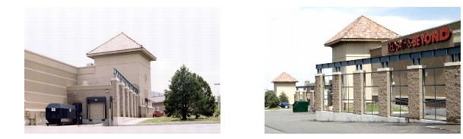

*Screening blocks views of loading and storage areas*

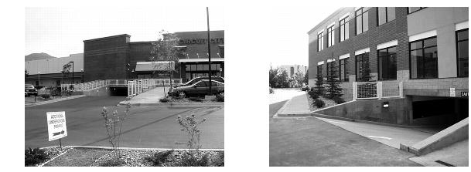

*Service areas incorporated into the architecture of the building*

**Chapter 25.04**

**SITE LIGHTING**

**25.04.010 Pedestrian, accent and security lighting.**

In order to enhance vehicular and pedestrian visibility while minimizing lighting glare and contrast, prevent undesired off-site glare, emphasize attractive features, illuminate sites and attract visitors to destinations using the minimum amount of light needed to do so, the following standards in addition to the lighting regulations in the City of Grand Junction Zoning and Development Code (Title 21) shall apply to lighting within the 24 Road Corridor:

(a)    All new development shall provide pedestrian lighting along public streets and pedestrian/bicycle trails.

(b) Lighting shall be designed to provide even and uniform light distribution without hot spots, dark spots, or glare.

(c) Lighting shall be designed to minimize dark areas that could pose a security concern near pedestrian areas.

(d) Pedestrian circulation systems shall be highlighted by visible light sources that clearly indicate the path of travel ahead.

(e) Accent fixtures providing direct illumination shall be in character with the architectural and landscape design character of the development.

(f) Architectural lighting shall not be used to draw attention to or advertise buildings or properties. Architectural lighting may be used to highlight specific architectural, artistic or pedestrian features with the intent of providing accent and interest or to help identify entryways.

(g) Accent lighting of landscape and/or pedestrian areas shall be mounted close to the ground and use a low level of illumination, such as bollard lighting or similar low mount fixtures used for illuminating landscaping and pedestrian areas.

(h) All accent and security lighting shall be shielded and downcast.

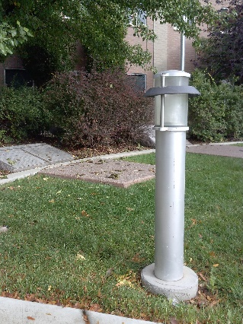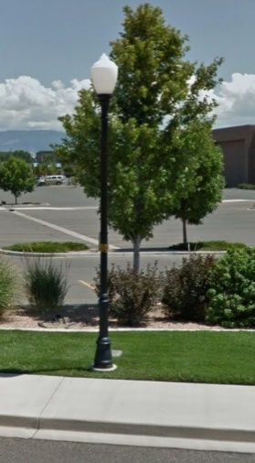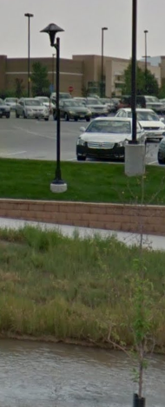

*Examples of appropriate pedestrian lighting Example of low level accent lighting.*

**Chapter 25.05**

**SIGNS**

**25.05.010** **Sign standards**

In order to ensure that signs in the 24 Road Corridor communicate information for property owners, tenants and users without adding unnecessary visual pollution to the Corridor, to encourage signage that is on a pedestrian scale, and to preserve and accentuate the views of the natural beauty of the Colorado National Monument and Colorado River corridor, and to ensure continuity of signs within a given project, the following standards, which include restrictions on sign size, height of freestanding signs and prohibition of billboards, shall apply to signage in the 24 Road Corridor, in addition to the sign regulations in the City of Grand Junction Zoning and Development Code (Title 21):

1. Only the following sign types are permitted: freestanding signs, flush wall signs, exempt signs, and temporary signs as allowed/regulated by the Section 21.06.070, Zoning and Development Code, except as further restricted in this Chapter 25.05.
2. Freestanding signs shall not exceed 12 feet in height from finished grade.
3. Sign face for freestanding and flush wall signs shall not exceed 100 square feet per sign.
4. Temporary signs and exempt signs shall be permitted in accordance with Section 21.06.070 of the Zoning and Development Code.
5. No billboards shall be permitted in the 24 Road Corridor. Billboards that were installed in accordance with a permit or planning clearance from the City prior to November 1, 2000 may remain, except that they may not be expanded, enlarged, converted to illuminated or changeable copy signage, or replaced once removed.
6. Freestanding signage shall be placed perpendicular to approaching traffic.
7. Signs within a development project shall be designed and installed with continuity by use of a coordinating scheme of color, typeface, materials, and construction details throughout the project area.
8. On freestanding signs, only graphics and typography are to be illuminated.
9. Freestanding signs shall be single- or double-faced and constructed of a metal panel with stone or veneer base. If the sign is single-faced, the backside shall be painted the same color as the cabinet and poles.
10. Flush wall signs shall not be illuminated externally; they may be either non-illuminated or internally illuminated.
11. 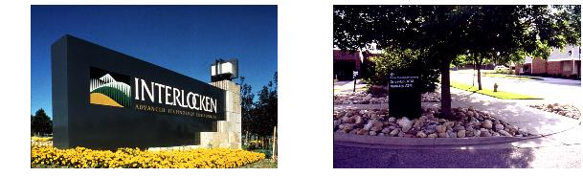Trail route identification signs shall be placed at critical locations which shall be determined by the Director during site plan review.

*Signs should communicate information and not add to visual pollution*