**CITY OF GRAND JUNCTION, COLORADO**

**ORDINANCE NO. 4740**

**AN ORDINANCE AMENDING ORDINANCE No. 4019 ZONING THE COMMONS PLANNED DEVELOPMENT TO UPDATE THE PD (PLANNED DEVELOPMENT) ZONING FOR AN EXISTING PD (PLANNED DEVELOPMENT) ZONE,**

**BY APPROVING AN OUTLINE DEVELOPMENT PLAN WITH DEFAULT ZONES OF R-8 (RESIDENTIAL 8 UNITS/ACRE), R-12 (RESIDENTIAL 12 UNITS/ACRE) AND MXOC (MIXED USE OPPORTUNITY CORRIDOR)**

**LOCATED AT 625 27-1/2 ROAD**

**(ADDRESS OF EXISTING ASSISTED LIVING FACILITY)**

Recitals:

A request to update the PD (Planned Development) zoning for an existing PD zone district on 19.9 acres with an ODP (Outline Development Plan – Attached Exhibit A) to continue to develop a senior living complex has been submitted in accordance with the Zoning and Development Code (Code).

This Planned Development zoning ordinance will establish the standards, default zoning, and adopt the Outline Development Plan for The Commons Senior Living Complex. If this approval expires or becomes invalid for any reason, the property shall be fully subject to the default standards specified herein.

In public hearings, the Planning Commission and City Council reviewed the request for Outline Development Plan approval and determined that the Plan satisfied the criteria of the Code and is consistent with the purpose and intent of the Comprehensive Plan. Furthermore, it was determined that the proposed Plan has achieved “long-term community benefits” through more effective infrastructure, reduced traffic demands compared with other potential uses, filling a need for assisted living housing types, and sustainable design for a mixed use complex.

NOW, THEREFORE, BE IT ORDAINED BY THE CITY COUNCIL OF THE CITY OF GRAND JUNCTION THAT THE AREA DESCRIBED BELOW IS ZONED PLANNED DEVELOPMENT WITH THE FOLLOWING DEFAULT ZONES AND STANDARDS:

1. Lots 1 and 3 of The Commons, a Subdivision of a part of the City of Grand Junction, County of Mesa, Colorado; Lot 4a of Cottages at The Commons, a Subdivision of a part of the City of Grand Junction, County of Mesa, Colorado; and Lots 1, 2 and 3, Block 1 of the Hilltop Commons Subdivision, a Subdivision of a part of the City of Grand Junction, County of Mesa, Colorado, encompassing a total of 19.9 acres.
2. The Commons Outline Development Plan is approved with the Findings of Fact/Conclusions and Conditions listed in the Staff Report including attachments and Exhibits.
3. Default Zones and Authorized Uses

The default zone district for Pod 1 (Lot 1, The Commons) is R-12 (Residential 12 units/acre);

The default zone district for Pod 2 (Lots 3 The Commons, Lot 4A Cottages at the Commons, and Lots 1 and 2, Block 1 Hilltop Commons) is R-8 (Residential 8 units/acre);

And the default zone district for Pod 3 (Lot 3, Block 1 Hilltop Commons) is MXOC (Mixed Use Opportunity Corridor)

Reference GJMC Section 21.03 for Lot, Setback and Bulk Standards; and Section 21.04 for Allowed Uses

1. Sign Plan:

Three (3) Existing Freestanding Identification Signs at east and west ends of Hermosa Avenue and on 27-1/2 Road in front of Assisted Living facility. Maximum Size: 12-feet wide x 5-feet high, with the maximum height of 6 feet. Signs shall be non-illuminated.

One (1) Existing Freestanding sign along the north side of Hermosa Avenue

Maximum Size: 4-feet wide x 5-feet high, with the maximum height of 5 feet. Sign shall be non-illuminated.

One (1) Freestanding Monument Sign along the north side of Hermosa Avenue near Commons Circle to identify potential new facility.

Maximum Size: 12-feet wide x 5-feet high, with the maximum height of 6 feet. Sign shall be non-illuminated.

Signs within the MXOC default zoning area (Pod 3) shall meet requirements of the zone district and GJMC Section 21.06.070 and will be reviewed with Final Development Plan(s). The MXOC zone district requires that all freestanding signs be monument style with a maximum height of 15 feet.

1. Development Schedule – All phases of project completed by 2027 (10 years)

Introduced for first reading on this 1st day of March, 2017 and ordered published in pamphlet form.

PASSED and ADOPTED this 15th day of March, 2017 and ordered published in pamphlet form.

ATTEST:

/s/: Phyllis Norris

President of City Council

/s/: Stephanie Tuin

City Clerk

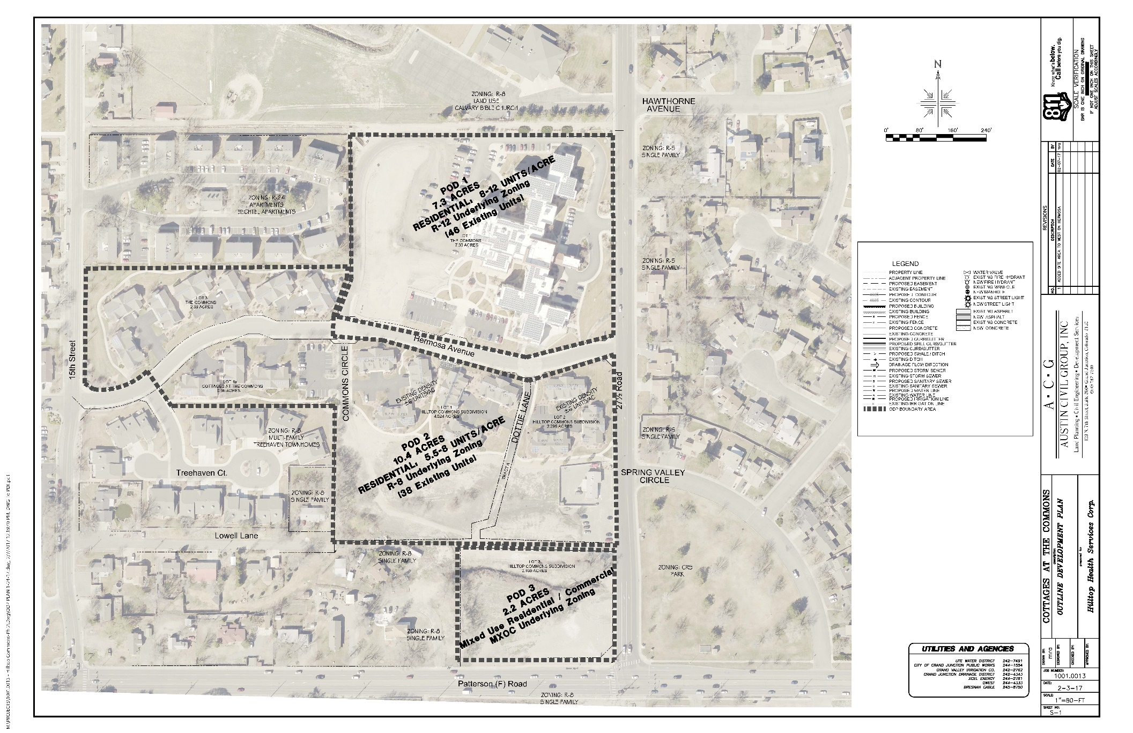

**EXHIBIT A – OUTLINE DEVELOPMENT PLAN (ODP)**