CITY OF GRAND JUNCTION, COLORADO

**ORDINANCE NO. 4746**

**AN ORDINANCE APPROVING A REZONE TO PD (PLANNED DEVELOPMENT) AND AN OUTLINE DEVELOPMENT PLAN FOR LAS COLONIAS PARK**

**LOCATED ON THE NORTH BANK OF THE COLORADO RIVER BETWEEN HIGHWAY 50 AND 27 ½ ROAD**

Recitals:

The requested Planned Development (PD) zoning and Outline Development Plan will establish the uses, standards and general configuration of the proposed Business Park to be integrated into the existing and proposed Recreational Park land uses and amenities on the 147 acre Las Colonias Park property, located on the north bank of the Colorado River between Highway 50 and 27 ½ Road.

The request for the rezone and Outline Development Plan have been submitted in accordance with the Zoning and Development Code (Code).

This Planned Development zoning ordinance will establish the standards, default zoning (CSR), land uses and conditions of approval for the Outline Development Plan for the Las Colonias property.

In public hearings, the Planning Commission and City Council reviewed the request for the proposed Outline Development Plan and determined that the Plan satisfied the criteria of the Code and is consistent with the purpose and intent of the Comprehensive Plan. Furthermore, it was determined that the proposed Plan has achieved “long-term community benefits” by effective infrastructure design; providing greater quality and quantity of private open space; protection and/or preservation of natural resources, habitat areas and natural features; and innovative design by incorporating the business park in with the public amenities.

NOW, THEREFORE, BE IT ORDAINED BY THE CITY COUNCIL OF THE CITY OF GRAND JUNCTION THAT THE AREA DESCRIBED BELOW IS ZONED TO PLANNED DEVELOPMENT WITH THE FOLLOWING DEFAULT ZONE AND STANDARDS:

1. This Ordinance applies to the following described properties:

A certain parcel of land lying in the East three-quarters (E 3/4) of Section 23, Township 1 South, Range 1 West of the Ute Principal Meridian and lying in the West-half (W 1/2) of Section 24, Township 1 South, Range 1 West of the Ute Principal Meridian, County of Mesa, State of Colorado and being more particularly described as follows:

BEGINNING at the intersection of the North line of the Southeast Quarter of the Northwest Quarter (SE 1/4 NW 1/4) of said Section 24 and the East right of way for Riverside Parkway; thence Easterly along said North line to the Northwest corner of the Replat of Pleasant View Subdivision, as same is recorded in Plat Book 8, Page 63, Public Records of Mesa County, Colorado; thence Southerly along the West line of said subdivision to the Southwest corner of said subdivision; thence Easterly along the South line of said subdivision to a point on the West right of way for 27-1/2 Road; thence Southerly along said West right of way to a point on the South line of the SE 1/4 NW 1/4 of said Section 24; thence Westerly along said South line to a point being the Northwest corner of the Northeast Quarter of the Northeast Quarter of the Southwest Quarter (NE 1/4 NE 1/4 SW 1/4) of said Section 24; thence Southerly along the West line of the NE 1/4 NE 1/4 SW 1/4 of said Section 24 to a point on the centerline (thalweg) of the Colorado River; thence Westerly along the centerline of the Colorado River to a point on the East right of way for Highway 50; thence traversing Northeasterly along the East right of way for Highway 50 to a point being the Southwest corner of that certain parcel of land currently assigned Mesa County Parcel Number 2945-233-00-022; thence Southeasterly along the South line of said parcel to a point being the Southeast corner of said parcel; thence Northerly along the East line of said parcel to a point on the South right of way for Struthers Avenue; thence Easterly along said South right of way to a point on the Northerly extension of the West line of Arcieri Subdivision, as same is recorded in Plat Book 12, Page 260, Public Records of Mesa County, Colorado; thence traversing the entire exterior boundary of said Arcieri Subdivision, Southerly, Easterly and Northerly to a point being the intersection of the Northerly extension of the East line of said Arcieri Subdivision with the South right of way for said Struthers Avenue; thence Easterly along said South right of way to a point being the Northwest corner of the certain parcel of land currently assigned Mesa County Parcel Number 2945-234-00-029; thence Southerly along the West line of said parcel to a point being the Southwest corner of said parcel; thence Easterly along the South line of said parcel to a point being the Southeast corner of said parcel and lying on the West line of Edgewater Subdivision, as same is recorded in Book 4986, Page 257, Public Records of Mesa County, Colorado; thence Southerly along said West line to a point being the Southwest corner of said Edgewater Subdivision; thence Easterly along the South line of said Edgewater Subdivision and the Easterly extension of the South line of Jeffryes Simple Subdivision, as same is recorded in Plat Book 18, Page 393, Public Records of Mesa County, Colorado to a point on the East line of the Northwest Quarter of the Southeast Quarter (NW 1/4 SE 1/4) of said Section 23; thence Northerly along said East line to a point on the South right of way for Riverside Parkway; thence Easterly, Northeasterly and Northerly traversing the South and East right of way of said Riverside Parkway to the Point of Beginning.

CONTAINING 160 Acres, more or less, as described.

1. The Las Colonias Outline Development Plan (Attachment A) is approved with the Findings of Fact/Conclusions and Conditions listed in the Staff Report, including attachments and exhibits.
2. If the Planned Development approval expires or becomes invalid for any reason, the properties shall be fully subject to the default standards of the CSR (Community Services and Recreation) Zoning District.
3. The default zone shall be CSR (Community Services and Recreation) with no deviations to the dimensional standards. All other applicable requirements shall apply with the following additions:
   1. Shared parking and landscaping will be provided throughout the site.
   2. A 30-inch tall decorative screen wall may be substituted for the required parking lot screening/landscaping between parking lots and the street.
4. The authorized “allowed” uses shall be:

|  |  |  |  |
| --- | --- | --- | --- |
| **Use Category** | **Principal Use** | **PD** | **Std.** |
| **Community Service** – uses providing a local service to the community | Community Activity Building | A | 21.04.020(e) |
| Community Service | A | 21.04.020(e) |
| **Cultural** – establishments that document the social and religious structures and intellectual and artistic manifestations that characterize a society | Museums, Art Galleries, Opera Houses, Libraries | A |  |
| **Hospital/Clinic** – uses providing medical treatment care to patients | Physical Rehabilitation | A | 21.04.020(g) |
| **Parks and Open Space** – natural areas consisting mostly of vegetative landscaping or outdoor recreation, community gardens, etc. | Parks, Lakes, Reservoirs, Other Open Space | A | 21.04.020(h) |
| **Safety Services** – public safety and emergency response services | All | A | 21.04.020(j) |
| **Utility, Basic** – Infrastructure services that need to be located in or near the area where the service is provided | Utility Service Facilities (Underground) | A | 21.04.020(l) |
| All Other Utility, Basic | A | 21.04.020(l) |
| **Utility, Corridors** – passageways for bulk transmitting or transporting of electricity, gas, oil, communication signals, or other similar services | Transmission Lines (Above Ground) | A | 21.04.020(m) |
| Transmission Lines (Underground) | A | 21.04.020(m) |
| **Entertainment Event, Major** – activities and structures that draw large numbers of people to specific events or shows | Indoor Facilities | A | 21.04.020(n) |
| Outdoor Facilities | A | 21.04.020(n) |
| **Lodging** | Hotels/Motels | A | 21.04.030(h) |
| **Office** – activities conducted in an office setting and generally focusing on business, government, professional, or financial services | General Offices | A | 21.04.020(o) |
| **Parking, Commercial** – parking that is not necessary to serve a specific use and for which fees may be charged | All | A | 21.06.050(b) & 21.04.020(p) |
| **Recreation and Entertainment, Outdoor** – large, generally commercial uses that provide continuous recreation or entertainment-oriented activities | Amusement Park | A | 21.04.020(q) |
| All Other Outdoor Recreation per definition | A |  |
| **Recreation and Entertainment, Indoor** – large, generally commercial uses that provide indoor recreation or entertainment-oriented activities including skating rinks, arcades | Health Club | A |  |
| Skating Rink, Arcade | A |  |
| All Other Indoor Recreation per definition | A |  |
| **Retail Sales and Service\*** – firms involved in the sale, lease or rental of new or used products to the general public. They may also provide personal services or entertainment, or provide product repair or services for consumer and business goods. | Bar/Nightclub | A | 21.04.020(r) |
| Food Service, Catering | A | 21.04.020(r) |
| Food Service, Restaurant (Including Alcohol Sales) | A | 21.04.020(r) |
| Farmers’ Market | A | 21.04.020(r) |
| General Retail Sales, Indoor Operations, Display and Storage | A | 21.04.030(l) & 21.04.020(r) |
| General Retail Sales, Outdoor Operations, Display or Storage | A | 21.04.040(h) & 21.04.020(r) |
| Rental Service, Indoor Display/Storage | A | 21.04.020(r) |
| Rental Service, Outdoor Display | A | 21.04.040(h) & 21.04.020(r) |
| **Manufacturing and Production** – firms involved in the manufacturing, processing, fabrication, packaging, or assembly of goods | Assembly – Indoor operations and storage | A | 21.04.020(w) |
| Food Products – Indoor operations and storage | A | 21.04.020(w) |
| Manufacturing/Processing – Indoor operations and storage | A | 21.04.020(w) |
| Assembly – Indoor operations with outdoor storage | A | 21.04.040(h) & 21.04.020(w) |
| Food Products – Indoor operations with outdoor storage | A | 21.04.040(h) & 21.04.020(w) |
| Manufacturing/Processing – Indoor operations with outdoor storage | A | 21.04.040(h) & 21.04.020(w) |
| **Warehouse and Freight** – firms involved in the storage or movement of freight | Indoor Operations, Storage and Loading with or without Outdoor Loading Docks | A | 21.04.020(x) |
| **Surface Passenger Terminal** – stations for ground-based vehicles, including loading and unloading areas | Bus/Commuter Stops | A | 21.04.020(bb) |
| **Telecommunications Facilities** – devices and supporting elements necessary to produce nonionizing electromagnetic radiation operating to produce a signal | Facilities on Wireless Master Plan Priority Site When Developed in Accordance with Wireless Master Plan Site-Specific Requirements | A | 21.04.030(q) & 21.04.020(ee) |
| Temporary PWSF (e.g., COW) | A | 21.04.030(q) |
| Co-Location | A | 21.04.030(q) |
| Tower Replacement | A | 21.04.030(q) |
| Dual Purpose Facility | A | 21.04.030(q) |
| DAS and Small Cell Facilities | A | 21.04.030(q) |
| Base Station with Concealed Attached Antennas | A | 21.04.030(q) |

1. Phase I of the development shall begin within one year of approval and completion of all phases shall occur within five years of approval.

Introduced for first reading on this 19th day of April, 2017 and ordered published in pamphlet form.

PASSED and ADOPTED this 3rd day of May, 2017 and ordered published in pamphlet form.

ATTEST:

/s/: J. Merrick Taggart

President of City Council

/s/: Stephanie Tuin

City Clerk

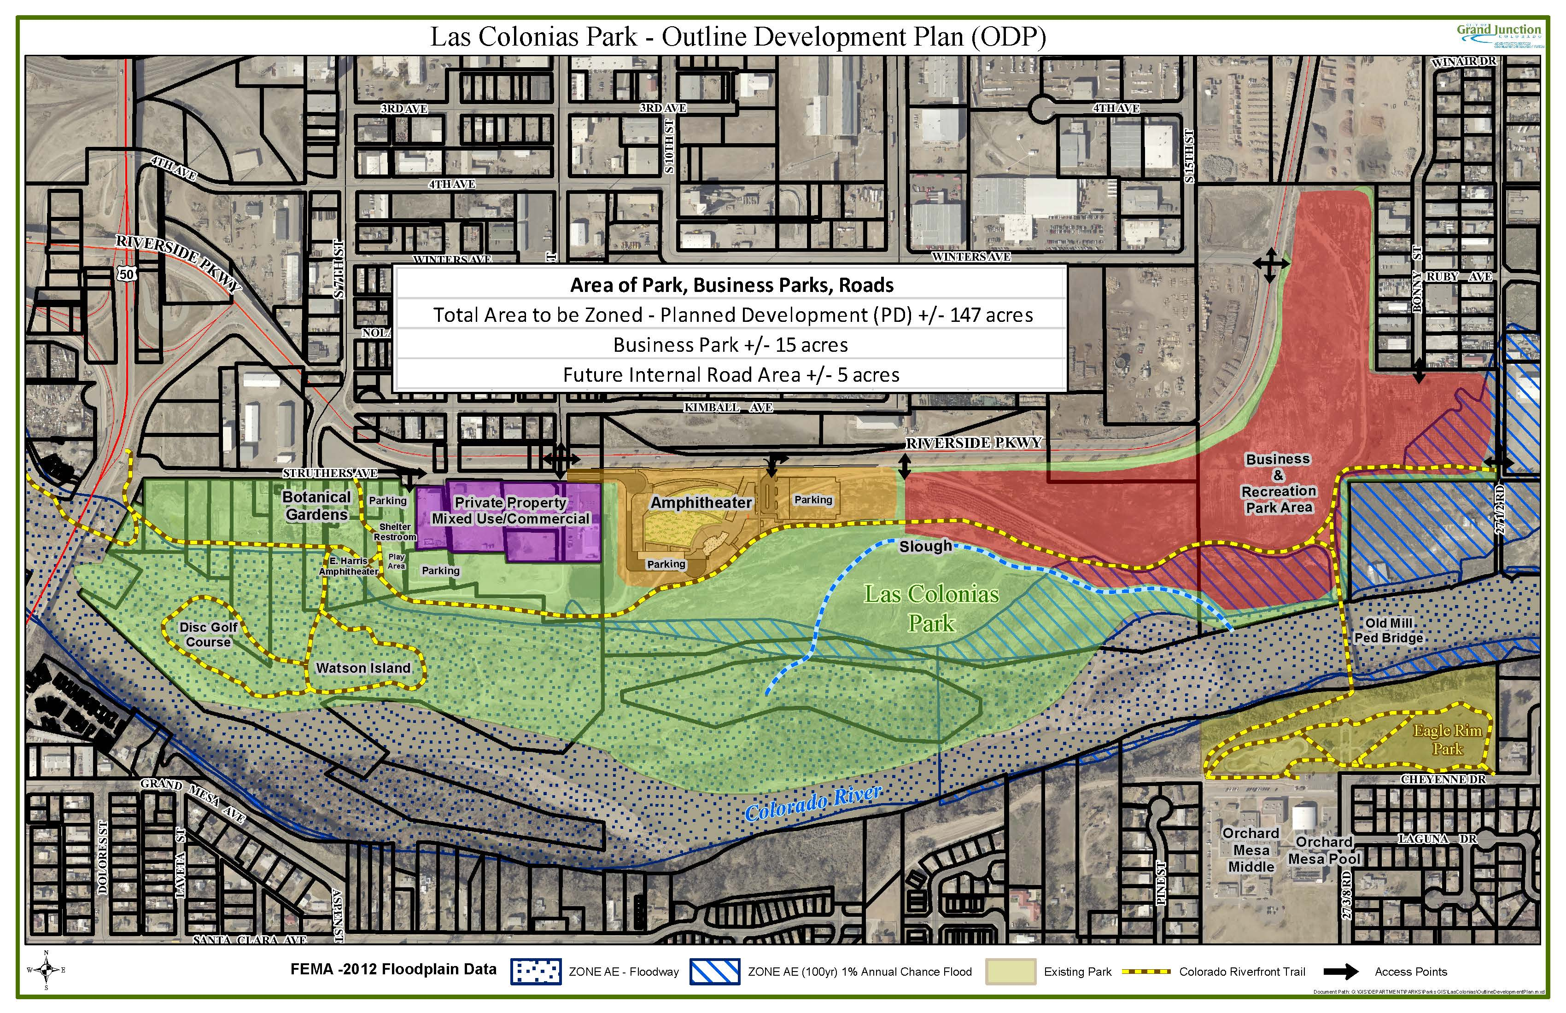

**Exhibit A**