RESOLUTION NO. 28-17

A RESOLUTION CONCERNING
THE ISSUANCE OF A REVOCABLE PERMIT TO
GRAND JUNCTION DOWNTOWN DEVELOPMENT AUTHORITY

Recitals.

A. The Grand Junction Downtown Development Authority (DDA), hereinafter referred to as the Petitioner, represents that it is an authority established by the City of Grand Junction City Council pursuant to the provisions of part 8 of Article 25 of Title 31 of the Colorado Revised Statutes to promote the public health, safety, prosperity, security and welfare, whose district (the area in which the DDA exercises its powers) is shown in the attached Exhibit 1.

B. The Petitioner requests that the City Council of the City of Grand Junction issue a Revocable Permit to allow the Petitioner to install, maintain and repair a “parklet” consisting of single benches, planter boxes, perforated metal panels, bench-steps, deck, and tables and chairs, substantially as shown in the attached Exhibit 2 (consisting of 4 pages) (“the Parklet”), within that certain part of the 5th Street public right-of-way shown in Exhibit 3.

C. Relying on the information supplied by the Petitioner and contained in File No. RVP-2017-213 in the office of the City’s Community Development Department, the City Council has determined that such action would not be detrimental to the inhabitants of the City of Grand Junction at this time.

NOW, THEREFORE, BE IT RESOLVED BY THE CITY COUNCIL OF THE CITY OF GRAND JUNCTION, COLORADO:

1. That the City Manager is hereby authorized and directed to issue the attached Revocable Permit to the above-named Petitioner for the foregoing described purposes and within the limits of the public right-of-way described above, subject to each and every term and condition contained in the attached Revocable Permit.

PASSED and ADOPTED this 17th day of May, 2017.

Attest:

President of the City Council

City Clerk
REVOCABLE PERMIT
Recitals.

A. The Grand Junction Downtown Development Authority (DDA), hereinafter referred to as the Petitioner, represents that it is an authority established by the City of Grand Junction City Council pursuant to the provisions of part 8 of Article 25 of Title 31 of the Colorado Revised Statutes to promote the public health, safety, prosperity, security and welfare, whose district (the area in which the DDA exercises its powers) is shown in the attached Exhibit 1.

B. The Petitioner requests that the City Council of the City of Grand Junction issue a Revocable Permit to allow the Petitioner to install, maintain and repair a “parklet” consisting of single benches, planter boxes, perforated metal panels, bench-steps, deck, and tables and chairs, substantially as shown in the attached Exhibit 2 (consisting of 4 pages) (the “Parklet”), within that certain part of the 5th Street public right-of-way shown in the attached Exhibit 3.

C. Relying on the information supplied by the Petitioner and contained in File No. RVP-2017-213 in the office of the City’s Community Development Department, the City Council has determined that such action would not be detrimental to the inhabitants of the City of Grand Junction at this time.

NOW, THEREFORE, IN ACCORDANCE WITH THE ACTION OF THE CITY COUNCIL OF THE CITY OF GRAND JUNCTION, COLORADO:

There is hereby issued to the above-named Petitioner a Revocable Permit for the Parklet within the limits of the public right-of-way shown on the attached Exhibit 3, subject to the following conditions:

1. The Petitioner’s use and occupancy of the public right-of-way and installation of features described above as authorized pursuant to this Permit shall be performed with due care or any other higher standard of care as may be required to avoid creating hazardous or dangerous situations and to avoid damaging public improvements and public utilities or any other facilities presently existing or which may in the future exist in said right-of-way.

2. The City hereby reserves and retains a perpetual right to utilize all or any portion of the aforedescribed public right-of-way for any purpose whatsoever. The City further reserves and retains the right to revoke this Permit at any time and for any reason.

3. The City hereby reserves and retains the right to charge, after one year from the date of issuance of this Permit, a fee in lieu of the revenue that the City may have received if the public right-of-way had been available for public parking. The Petitioner and the City agree that the City may impose a fee, in its sole discretion, not to exceed $2300.00 per year (“Fee”.) If the Fee is imposed the City shall notify the Petitioner in writing no less than 30 days in advance of the Fee first becoming due. The Fee may be prorated and paid monthly or in a lump sum. Nonpayment of the Fee, when imposed, shall be cause for revocation of this Permit.
4. The Petitioner, for itself and for its successors, assigns and for all persons claiming through the Petitioner, agrees that it shall defend all efforts and claims to hold, or attempt to hold, the City of Grand Junction, its officers, employees and agents, liable for damages caused to any property of the Petitioner or any other party, as a result of the Petitioner’s occupancy, possession or use of said public right-of-way or as a result of any City activity or use thereof or as a result of the installation, operation, maintenance, repair and replacement of public improvements.

5. The Petitioner agrees that it shall at all times keep the above described public right-of-way in good condition and repair.

6. This Revocable Permit shall be issued only upon the concurrent execution by the Petitioner of an agreement that the Petitioner and the Petitioner’s successors and assigns shall save and hold the City of Grand Junction, its officers, employees and agents harmless from, and indemnify the City, its officers, employees and agents, with respect to any claim or cause of action however stated arising out of, or in any way related to, the encroachment or use permitted, and that upon revocation of this Permit by the City the Petitioner shall, at the sole cost and expense of the Petitioner, within thirty (30) days of notice of revocation (which may occur by mailing a first class letter to the last known address), peaceably surrender said public right-of-way and, at its own expense, remove any encroachment so as to make the aforedescribed public right-of-way available for use by the City or the general public. The provisions concerning holding harmless and indemnity shall survive the expiration, revocation, termination or other ending of this Permit.

7. This Revocable Permit, the foregoing Resolution and the following Agreement shall be recorded by the Petitioner, at the Petitioner’s expense, in the office of the Mesa County Clerk and Recorder.

Dated this day of , 2017.

The City of Grand Junction, a Colorado home rule municipality

Attest:

City Clerk City Manager

Acceptance by the Petitioner:

_____________________________ _____________________________
Brandon Stam, Executive Director Kirk Granum, Chairman of the Board
Grand Junction Downtown Development Grand Junction Downtown Development
Authority Authority

AGREEMENT

Grand Junction Downtown Development Authority, for itself and for its successors and assigns, does hereby agree to:

(a) Abide by each and every term and condition contained in the foregoing Revocable Permit;

(b) Indemnify and hold harmless the City of Grand Junction, its officers, employees and agents with respect to all claims and causes of action, as provided for in the approving Resolution and Revocable Permit;

(c) Within thirty (30) days of revocation of said Permit by the City Council, peaceably surrender said public right-of-way to the City of Grand Junction;

(d) At the sole cost and expense of the Petitioner, remove any encroachment(s) so as to make said public right-of-way fully available for use by the City of Grand Junction or the general public.

Dated this day of , 2017.

Grand Junction Downtown Development Authority

______________________________ ___________________________
By: Brandon Stam, Executive Director By: Kirk Granum, Chairman of the Board

State of Colorado )
)ss.
County of Mesa )

The foregoing Agreement was acknowledged before me this___ day of ________________, 2017, by Brandon Stam, Executive Director of the Grand Junction Downtown Development Authority.

My Commission expires:
Witness my hand and official seal.

Notary Public
State of Colorado )
)ss.
County of Mesa )

The foregoing Agreement was acknowledged before me this___ day of ________________, 2017, by Kirk Granum, Chairman of the Board of the Grand Junction Downtown Development Authority Board of Directors.

My Commission expires:
Witness my hand and official seal.

Notary Public
Exhibit 1—Grand Junction Downtown Development Authority District Boundaries

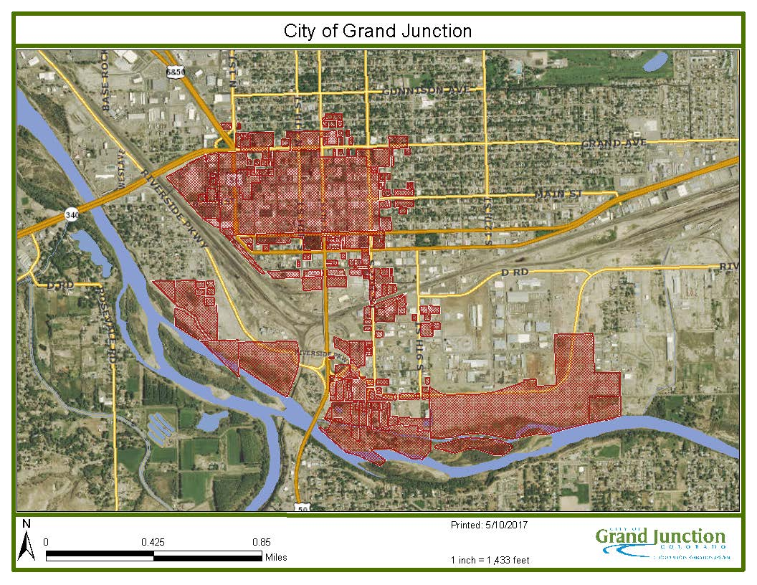

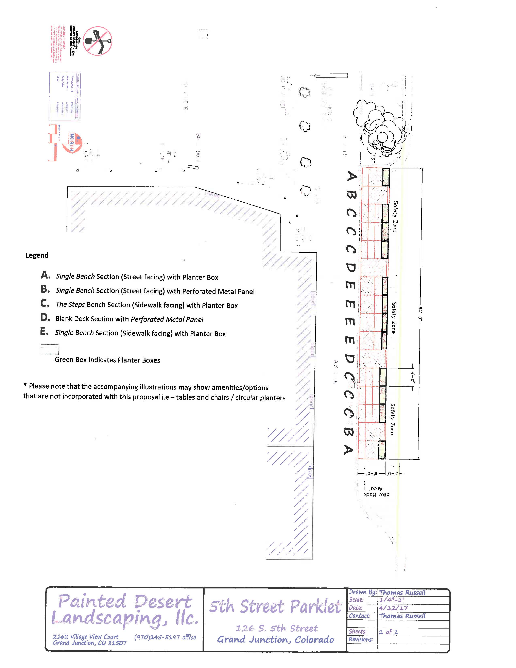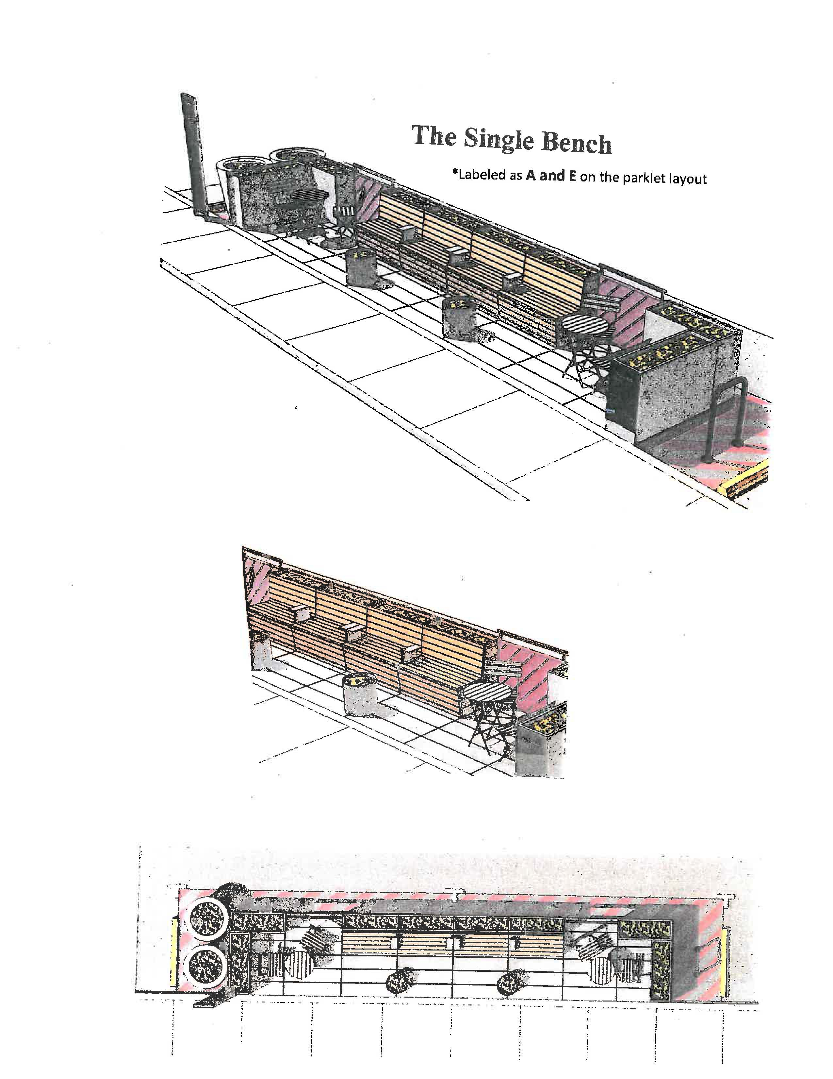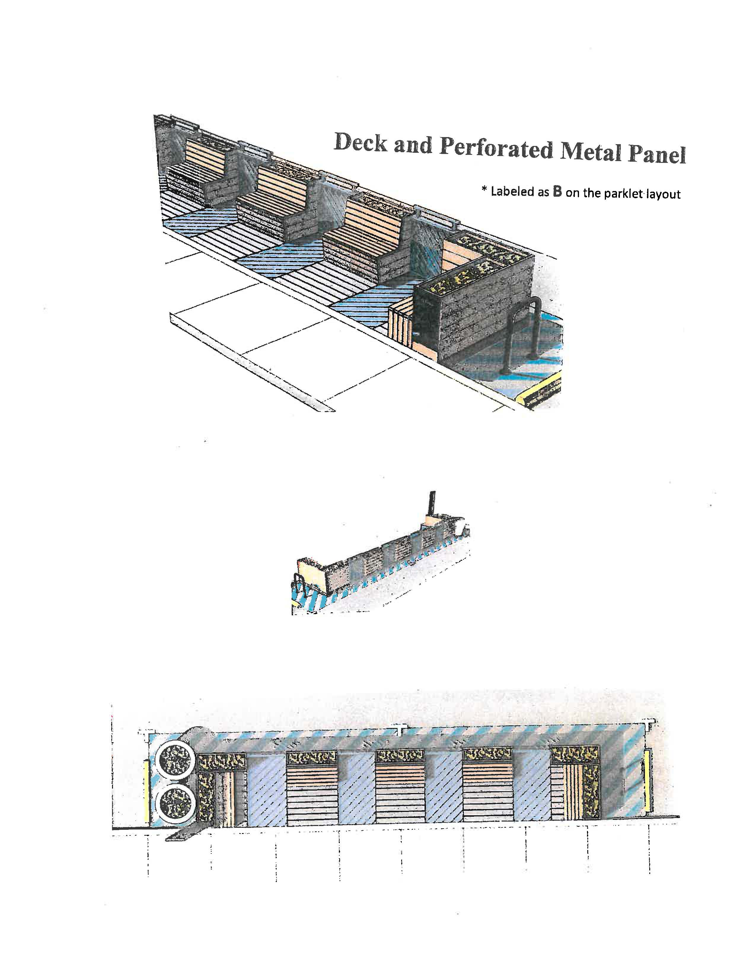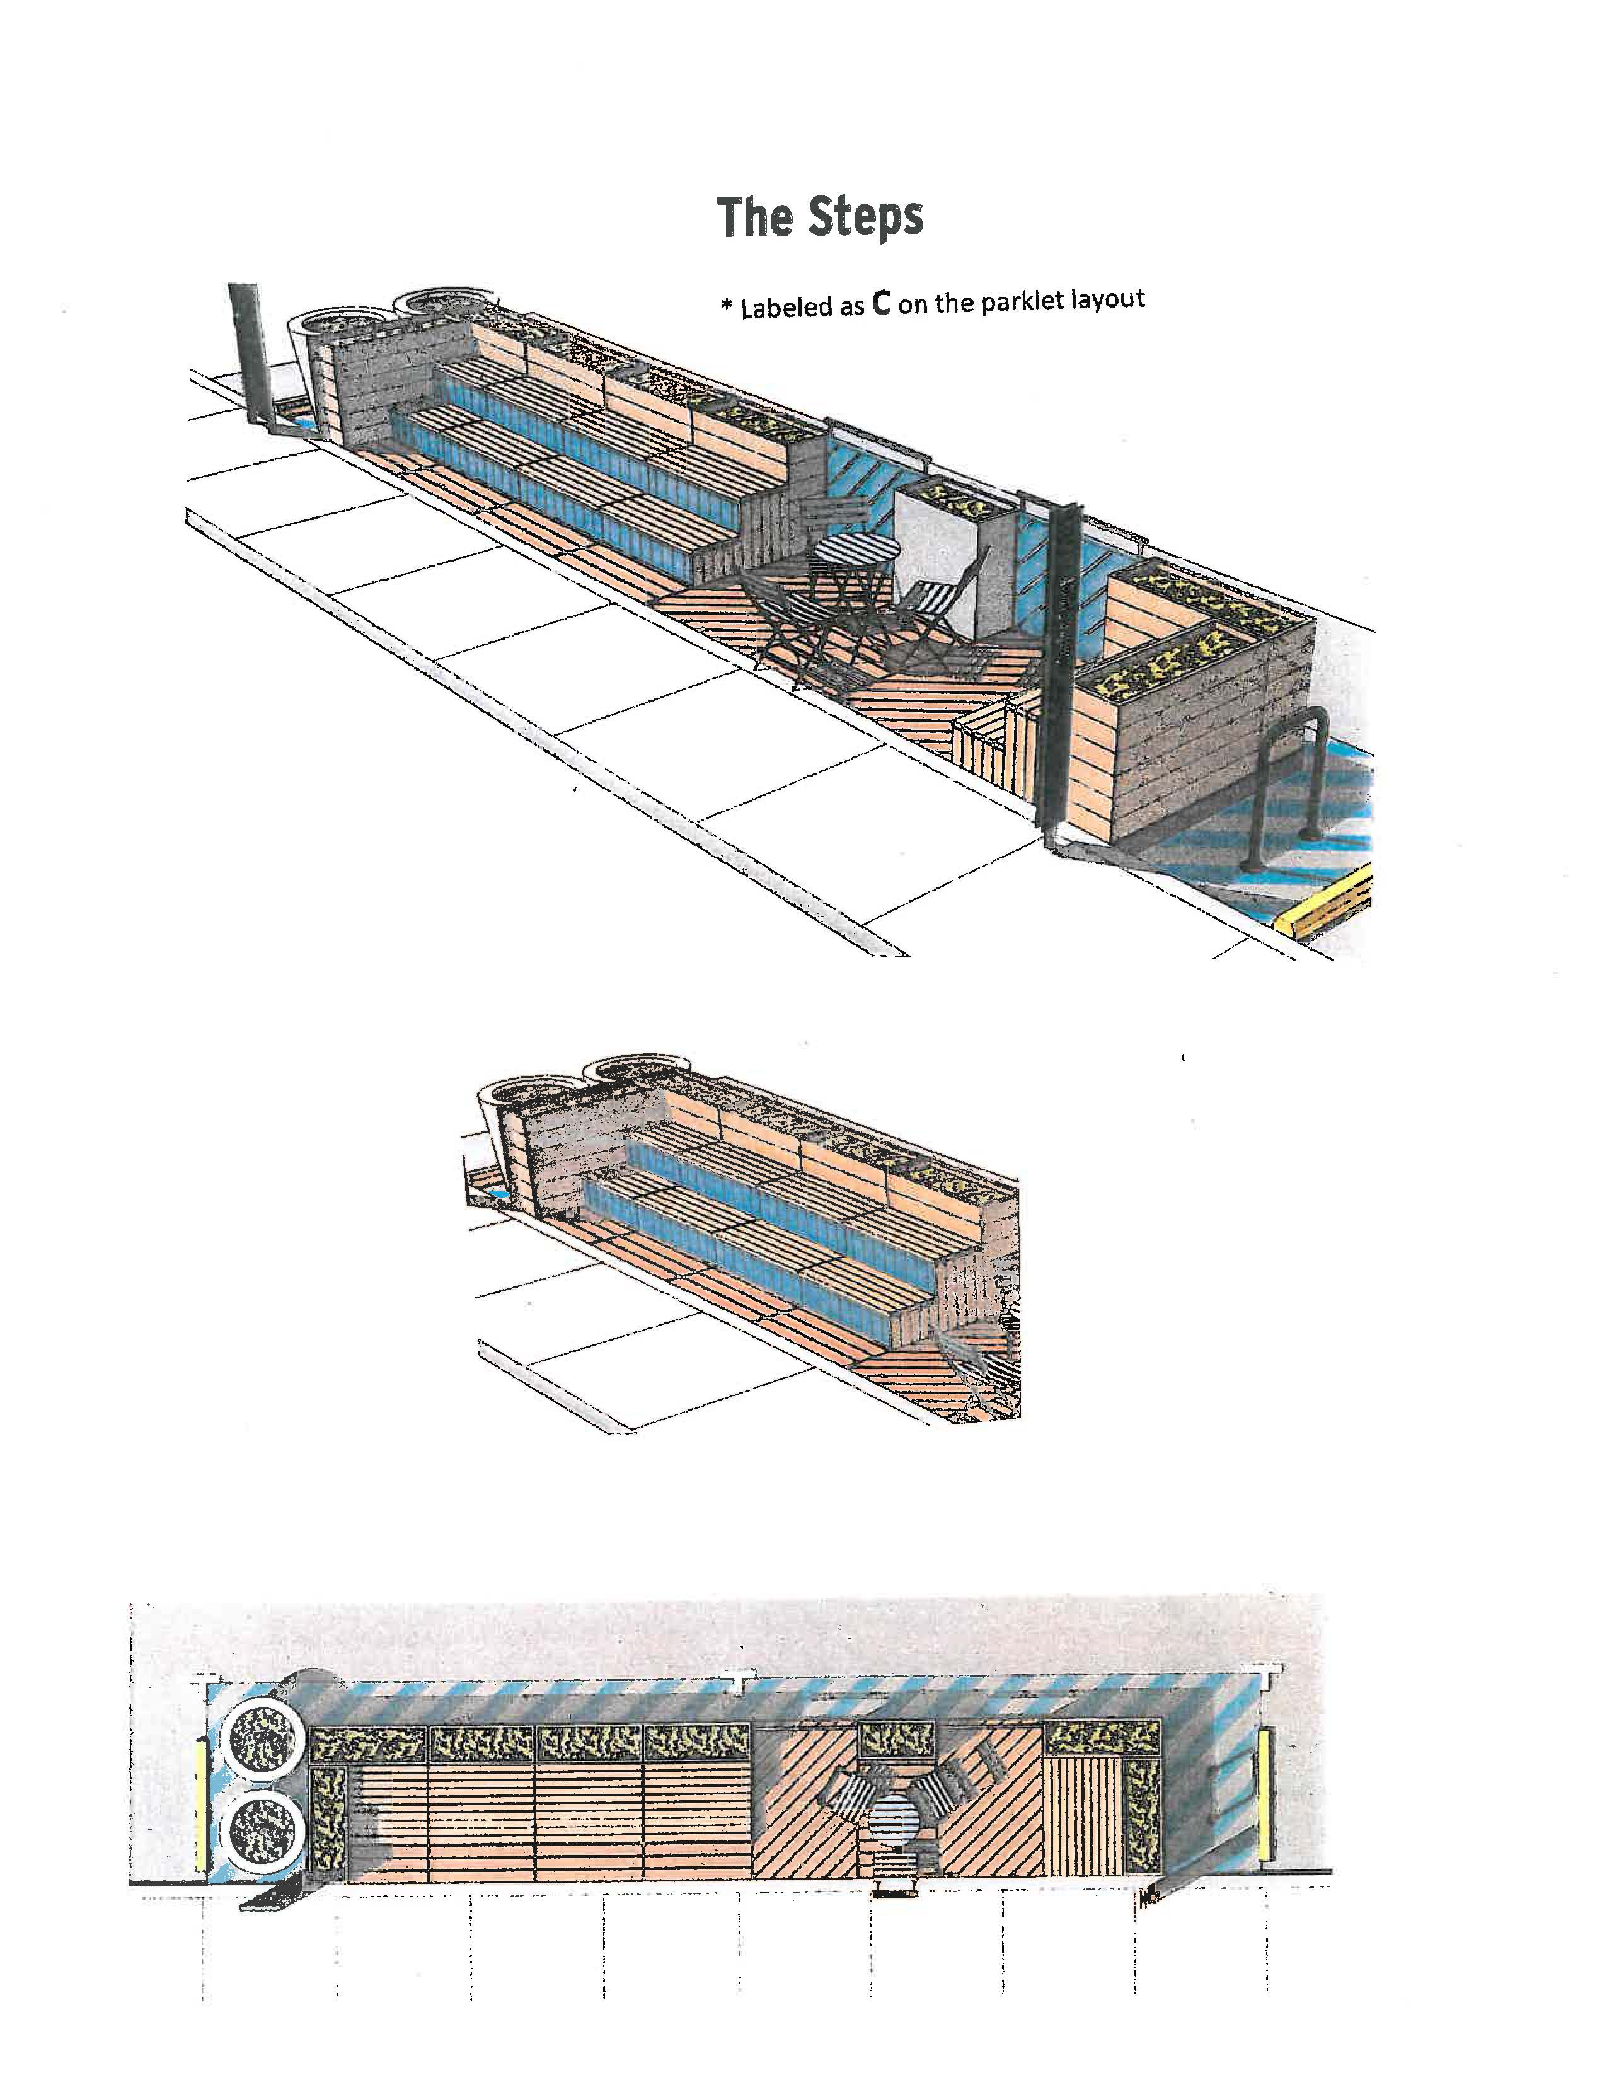
Exhibit 2
Exhibit 3

REVOCABLE DESCRIPTION

A certain parcel of land lying in the Southwest Quarter (SW 1/4) of Section 14, Township 1 South, Range 1 West of the Ute Principal Meridian, County of Mesa, State of Colorado, lying entirely within the right of way for South 5th Street, as same is depicted and recorded by the Plat of First Division Resurvey, Town of Grand Grand Junction, as same is recorded in Plat Book 1, Page 9, Public Records of Mesa County, Colorado and being more particularly described as follows:

A 6.0 foot wide East-West by 82.0 foot North-South parcel lying entirely within the paving of South 5th Street and bounded on the East by the West face of a concrete curb and bounded on the South by the Northerly edge of an existing concrete planter directly opposite 502 Colorado Avenue.

CONTAINING 492 Square Feet, more or less, as described.
