**CITY OF GRAND JUNCTION, COLORADO**

**ORDINANCE NO. 4754**

**AN ORDINANCE ADOPTING A Civic and Institutional Master Plan FOR COLORADO MESA UNIVERSITY and CONDITIONAL Right-of-Way Vacation IN ACCORDANCE WITH THE MASTER PLAN**

**LOCATED IN THE COLORADO MESA UNIVERSITY AREA**

**(Generally 7th to Cannell Streets and North to Orchard Avenue)**

RECITALS:

Section 21.02.190 of the Zoning and Development Code (Code) sets forth a process to consider Master Plans for major institutional and civic facilities that provide service to the community. The Colorado Mesa University (CMU) Campus Facilities Master Plan (attached) provides an overview of CMU’s future long term objective to expand the existing main campus westward toward N. 7th Street.

In conjunction with the Master Plan, CMU is requesting approval of an administrative review process for future vacations of right-of-way interior to the campus, (shown within the red outlined area on Exhibit A to CMU Master Plan) upon satisfaction of the conditions established in the Master Plan and this ordinance.

In accordance with the development of the campus anticipated in the Master Plan, CMU requests the vacation of alley and street right-of-ways in order to aid in the continued westward expansion planned for the campus. Currently, right of way vacations requests occur in a piecemeal fashion, generally as CMU acquires properties on both sides of any given right-of-way. That process is unwieldy and tends to be confusing because the vacations may not be understood in the context of the overall plan of development. Presently CMU owns the majority of the property shown within the “2017 Master Plan” boundary, outlined in red on Exhibit A, and sections of right-of-way have already been vacated. Consistent with the terms or all prior vacations all vacations pursuant to this ordinance shall require that CMU own the property on both sides of the right-of-way, provide for general circulation, emergency access, private access easements, if necessary, and compliance with Xcel Energy easement requirements. City utilities will be addressed pursuant to the terms and conditions of the *Colorado Mesa University and City of Grand Junction Utility Easement and Maintenance Agreement-CMU Main Campus*. Upon application by CMU for a vacation(s) that is supported by the Master Plan and if the conditions provided in the Ordinance are met or are not met, as reasonably determined by the Community Development Director, in her sole discretion, the Director shall provide written notice to CMU of her findings; if no protest is made to the findings then the vacation will be approved (or denied) after the 20th business day after notice. As further provided in the Ordinance, CMU shall provide written notice of the Director’s findings of satisfaction of the conditions to the property owners 500 feet of the area of the petitioned vacation within 10 days of the date of the Director’s notice to CMU finding satisfaction of the conditions.

If any owner takes exception to the Director’s findings of satisfaction of the conditions, he/she may request in writing, stating with particularity the finding(s) to which exception is taken, that the Director’s decision be considered by City Council.

If CMU takes exception to the Director’s findings that conditions are not satisfied, it may request in writing, stating with particularity the finding(s) to which exception is taken, that the Director’s decision be considered by City Council. The City Council shall schedule a review of the Director’s decision, on the record, within 20 days of the property owner’s request.

Upon finding of full and complete satisfaction of the conditions, whether by the Director or the City Council, the Director shall affect the vacation(s) by recording her findings, which shall include reference to the authority granted her by this Ordinance.

The City Council finds that the request to allow conditional approval of vacations of rights of way consistent with the CMU Master Plan is appropriate to and supported by the Comprehensive Plan, the Grand Valley Circulation Plan and Sections 21.02.190 (c) and 21.02.100 of the Grand Junction Zoning and Development Code.

The Planning Commission, having heard and considered the requests, found the criteria of the Code to have been met, and recommends approval of the Institutional and Civic Master Plan and conditional right-of-way vacation subject to full and complete satisfaction of the conditions set forth.

NOW, THEREFORE BE IT ORDAINED BY THE CITY COUNCIL OF THE CITY OF GRAND JUNCTION THAT:

The Colorado Mesa University Institutional and Civic Facility Master Plan is approved subject to the following findings and conditions:

1. The requested Institutional and Civic Facility Master Plan, including the vacation of right-of-way, is consistent with the goals and policies of the Comprehensive Plan, specifically Goals 4 and 12.
2. The applicable review criteria in Section 21.02.190 (c) and 21.02.100 of the Grand Junction Zoning and Development Code have been met or addressed.
3. The foregoing Recitals are incorporated herein and made a part hereof.
4. Right-of-way vacation in the identified planning area (Exhibit A) is presumed and conditionally approved on condition that CMU petitions for vacation(s), which shall be reviewed and approved administratively subject to the Director finding that CMU has met all of the following conditions:
   1. CMU must own properties on both sides of the right-of-way (streets and/or alleys) to be vacated; and,
   2. Private easement agreements must be provided to benefit any remaining privately owned property(ies) where access to the property(ies) is or may be claimed by the owner(s) to be compromised by the vacation; and,
   3. CMU shall plan for and propose circulation and emergency access to standards mutually acceptable and agreed to by the City and CMU, to establish and preserve public safety and legal access for both public and private users; and,
   4. All City utilities shall be subject to the terms and conditions of the *Colorado Mesa University and City of Grand Junction Utility Easement and Maintenance Agreement-CMU Main Campus; and,*
   5. CMU shall dedicate as applicable necessary utility easements to Xcel Energy and/or other utility providers.
5. Notice shall be given of all vacation petition decisions right-of-way vacations in the designated Master Plan area and exceptions to the Director’s decision shall be forwarded to the City Council for record review as provided in this Ordinance and the Recitals thereto.

Introduced for first reading on this 17th day of May, 2017 and ordered published in pamphlet form.

PASSED and ADOPTED this 7th day of June, 2017 and ordered published in pamphlet form.

______________________________

President of City Council

ATTEST:

______________________________

City Clerk

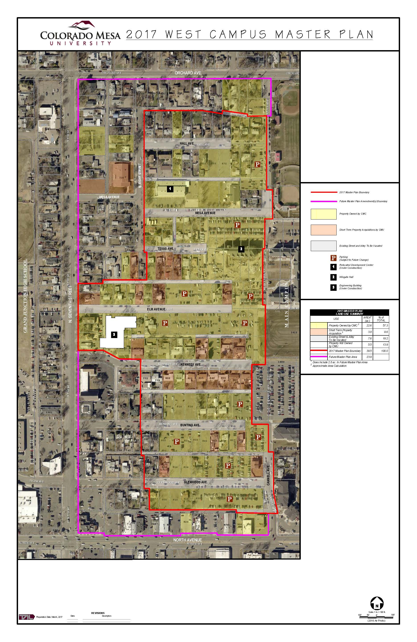

Exhibit A