CITY OF GRAND JUNCTION, COLORADO

ORDINANCE NO. 4532

AN ORDINANCE REZONING ONE PROPERTY
FROM C-2 (GENERAL COMMERCIAL) TO C-1 (LIGHT COMMERCIAL)

LOCATED AT 510 29 ½ ROAD

Recitals.

On February 17, 2010 the Grand Junction City Council adopted the Grand Junction Comprehensive Plan which includes the Future Land Use Map, also known as Title 31 of the Grand Junction Municipal Code of Ordinances.

The Comprehensive Plan established or assigned new land use designations to implement the vision of the Plan and guide how development should occur. In many cases the new land use designation encouraged higher density or more intense development in some urban areas of the City.

When the City adopted the Comprehensive Plan, it did not rezone property to be consistent with the new land use designations. As a result, certain urban areas now carry a land use designation that calls for a different type of development than the current zoning of the property. City Staff analyzed these areas to consider how best to implement the vision, goals and policies of the Comprehensive Plan.

Upon analysis of this area, City Staff determined that the current Comprehensive Plan Future Land Use Map designation is appropriate, and that a proposed rezone is the most appropriate way to create consistency between the Comprehensive Plan’s Future Land Use Map and the zoning of this property and to allow for maximum use of the property consistent with the Comprehensive Plan.

Consistency between the Comprehensive Plan’s future land use designation and the zone district of a given area is crucial to maximizing opportunity for landowners to make use of their property, because the Zoning and Development Code, in Sections 21.02.070 (a)(6)(i) and 21.02.080(d)(1), requires that all development projects comply with the Comprehensive Plan.

The C-1 zone district implements the Future Land Use Designation of Village Center Mixed use, is consistent with the Comprehensive Plan’s goals and policies and is generally compatible with land uses in the surrounding area.

An Open House was held on January 25, 2012 to allow property owners and interested citizens an opportunity to review the proposed zoning map amendments, to make comments and to meet with staff to discuss any concerns that they might have. A display ad noticing the Open House ran in the Daily Sentinel newspaper to encourage public review and comment. The proposed amendments were also posted on the City website with information about how to submit comments or concerns.

After public notice and a public hearing as required by the Charter and Ordinances of the City, the Grand Junction Planning Commission recommended approval of the proposed zoning map amendment for the following reasons:

- The requested zone(s) are consistent with the goals and policies of the Comprehensive Plan.

- The applicable review criteria in Section 21.02.140 of the Grand Junction Zoning and Development Code are met.

After public notice and a public hearing, the City Council hereby finds and determines that the proposed zoning map amendment will implement the vision, goals and policies of the Comprehensive Plan and should be adopted.

BE IT ORDAINED BY THE CITY COUNCIL OF THE CITY OF GRAND JUNCTION THAT:

The following property shall be rezoned C-1 (Light Commercial).

See attached map, Exhibit A.

510 29 ½ Road (Parcel # 2943-084-21-931)

Introduced on first reading this 18th day of April, 2012 and ordered published in pamphlet form.

Adopted on second reading this 16th day of May, 2012 and ordered published in pamphlet form.

ATTEST:

/s/ Stephanie Tuin /s/ Bill Pitts
City Clerk Mayor

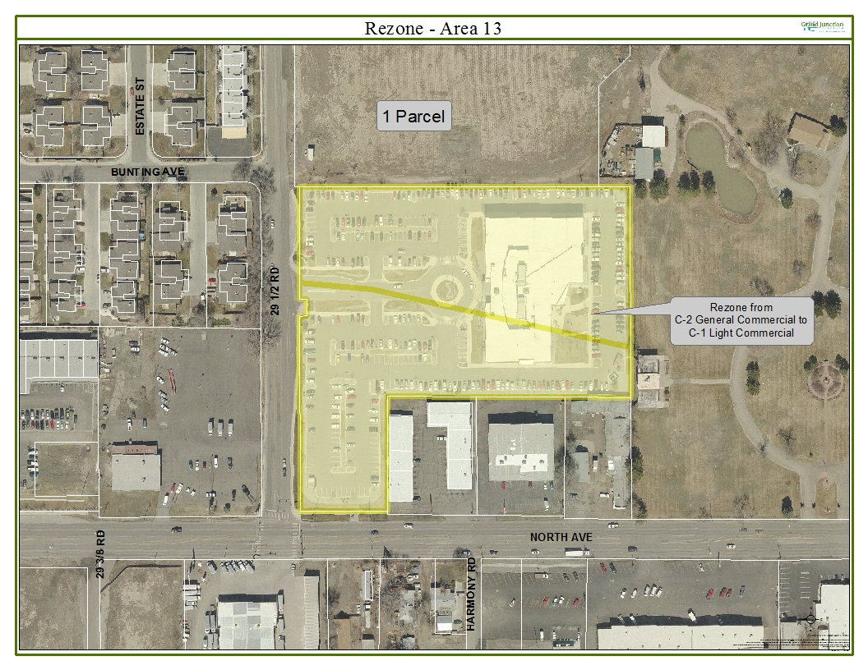
Exhibit A

