RESOLUTION NO. 17-12

A RESOLUTION AUTHORIZING THE LEASE OF SIDEWALK
RIGHT-OF-WAY TO WESIDE DELICATESSEN, INC., DBA THE WINERY RESTAURANT

Recitals:

The City has negotiated an agreement for Weside Delicatessen, Inc., dba The Winery Restaurant, to lease a portion of the pedestrian breezeway right-of-way located immediately west of 642 Main Street from the City for use as outdoor dining; and

The City Council deems it necessary and appropriate that the City lease said property to Weside Delicatessen, Inc.,

NOW, THEREFORE, BE IT RESOLVED BY THE CITY COUNCIL OF THE CITY OF GRAND JUNCTION, COLORADO:

The City Manager is hereby authorized and directed to sign the Lease Agreement leasing the city-owned right-of-way for an initial term of May 1, 2012 to September 7, 2013, at the rate of $434.00 for the initial term, to Weside Delicatessen, Inc.

PASSED and ADOPTED this 16th day of May, 2012.

/s/ Bill Pitts President of the Council
Attest:

/s/ Stephanie Tuin
City Clerk
DOWNTOWN OUTDOOR DINING LEASE AGREEMENT
THIS LEASE AGREEMENT (“Agreement”) is made and entered into as of this ____ day of _________20___, by and between THE CITY OF GRAND JUNCTION, COLORADO, a municipal corporation, as Lessor, (hereinafter “City”) and, Weside Delicatessen, Inc., dba The Winery Restaurant, as Lessee, (hereinafter “Lessee”), and the Grand Junction Downtown Development Authority as Lessor’s Administrative Agent, (hereinafter “DDA”).
RECITALS:
The City by Ordinance No. 3650 and subsequently amended by Ordinance No. 4120 established a Sidewalk Restaurant commercial activity permit for restaurants in the Downtown Shopping Park (DSP) on Main Street, Seventh Street and Colorado Avenue.
In accordance with that authority, the City Council and the DDA desire to make certain areas of the sidewalk in the DSP and at other locations as authorized available by lease to proximate land owners and/or lessees that want to make use of a portion of the public way for outdoor dining with or without alcohol service.
NOW THEREFORE, in consideration of the mutual covenants, terms and conditions contained herein, it is agreed as follows:
1. Demise of Premises.
Option A: The City does hereby lease to Lessee the Premises (hereinafter “Premises”) comprising approximately ________ square feet of the public way located in front of and immediately across the sidewalk from _________________________________________ . The City does hereby grant an easement across the sidewalk situated between the Lessee’s business and the Premises for the purpose of transporting alcohol beverages and food to and from the Premises. Said easement runs concurrently with this Agreement. The Premises, the easement area, and the location of Lessee’s primary business facility are more particularly described in the attached Exhibit A.
Option B: The City does hereby lease to Lessee the Premises (hereinafter “Premises”) comprising approximately 320 square feet of the public way located in front of and immediately abutting the Lessee’s business. The Premises and the location of Lessee’s primary business facility are more particularly described in the attached Exhibit A.
A brief description of the Lessee’s business is attached as Exhibit B.
2. Term.
The term of this Agreement shall be for a period to commence on May 15, 2012. Upon signature by all parties this Agreement supersedes all prior leases, and terminates on September 7, 2013.
3. Rental.
Lessee shall pay rent to Lessor at the rate of $1.00 per square foot per year and in the total sum of $ 434.00 , which sum shall be payable in advance at the offices of the City Clerk, Grand Junction City Hall, 250 North 5th Street, Grand Junction, Colorado 81501. If the rent payment is not paid in full when due, a Lease shall not issue.
4. Permitted Uses and Hours or Operation.
Lessee agrees to use the Premises for the purpose of selling and dispensing food and/or beverages to the public. The Premises may be open to the public during Lessee’s normal business hours, but in no event shall food and/or beverage service extend beyond 1:00 A.M. Service of alcoholic beverages shall be permitted provided Lessee holds a valid State and City liquor license. Tableside preparation of food shall be permitted pursuant to applicable health and safety regulations; however, fuel-based cooking or food preparation is expressly prohibited in the Premises. Live acoustic music performance is permitted on the Premises, provided any amplification utilized shall not result in a sound level exceeding 55 decibels measured at a distance of 20 feet from any of the Premises boundaries.
5. Assignment or Subletting Prohibited.
Lessee shall not have the right to assign the lease or to sublet the Premises in whole or in part without the prior written consent of the City.
6. Compliance with Legal Requirements.
Lessee shall comply with all applicable requirements of any governmental or quasi-governmental body including City, County, State or Federal agencies, boards, councils and commissions having jurisdiction respecting any operation conducted on the Premises by Lessee or any equipment, installations or other property placed upon, in or about the Premises by Lessee.
Lessee further agrees to comply with all rules of the DDA relating to the use of the Premises. Prior to commencing alcohol service in the Premises, Lessee shall include the Premises in the licensed service area as required by the liquor laws of the State and City.
Lessee shall not discriminate against any worker, employee or job applicant, or any member of the public because of race, color, creed, religion, ancestry, national origin, sex, age, marital status, physical handicap, status or sexual orientation, family responsibility or political affiliation, or otherwise commit an unfair employment practice.
7. Taxes.
Lessee shall timely list for taxes and pay all tax assessments of whatever kind or nature assessed against or on Lessee's possessory interest, improvements, furnishings, fixtures, inventory, equipment and other property situated or placed upon, in or about the Premises. All such amounts shall be paid prior to delinquency.
8. Utilities.
Lessee shall make arrangements for all utilities, if any, needed at the Premises and is responsible for payment of the fees and charges arising out of the provision and/or use of the utility service(s).
9. Improvements and Personal Property.
All construction, improvements, installations, furniture, fixtures and/or equipment on the Premises shall comply with the following:
a. Lessee may place furniture, fixtures and equipment in the Premises so long as the same do not endanger any passersby or patrons, and are secured to resist wind. No portion of the Lessee’s furniture, fixtures or equipment shall extend beyond the boundaries of the Premises nor impede pedestrian traffic on the sidewalk adjoining the Premises. The terms of this paragraph shall be construed to include but not be limited to perimeter enclosures, planters, signs, tables, chairs, shade structures, umbrellas while closed or open and any other fixtures, furniture or equipment placed or utilized by the Lessee. The Lessee may store its fixtures on the Premises at its own discretion and shall accept and retain full responsibility and liability for any damage to or theft of such fixtures. Required perimeter fencing shall be continuously maintained during the term of this Agreement.
b. Lessee shall provide a physical demarcation of the perimeter of the Premises, such as planters or stanchions, subject to DDA approval of the form and location of the same, to facilitate monitoring of potential encroachments beyond the Premises. If alcohol service is permitted in the Premises, the perimeter of the Premises shall be enclosed by a fixed perimeter enclosure no less than thirty (30) inches in height, the material, design and installation of which shall be approved by the DDA. Openings in the enclosure shall not be less than 44 inches wide. If there is a gate it must swing inward to prevent obstruction of the sidewalk.
c. No gas lighting shall be permitted in the Premises. Battery powered lights, candles in wind-protected enclosures, and low wattage electric lights, such as Christmas lights, shall be allowed. Under no circumstances shall electrical wires, extension cords or similar wiring, cables or conduit extend beyond the Premises into the public way, (easement area or otherwise) nor cross pedestrian paths, nor be placed so as to create a tripping hazard. Any suspended lighting must be securely installed to prevent dislodgement, sagging, or other hazard.
d. Signs are expressly prohibited on the Premises, except for the following: i) menu signs in compliance with the City sign code, and ii) umbrellas that display the Lessees business logo, and/or the logo of only one business product that is featured and representative of the theme of the business. Signs shall be subject to approval by the DDA and City. Third party business signs and/or identification are expressly prohibited on the Premises.

e. Lessee shall not utilize sidewalk trash and/or recycling receptacles for refuse generated within the Premises. Lessee may provide a private trash and/or recycling receptacle within the Premises provided that it is emptied and maintained on a regular basis.

f. Lessee shall remove any personal property, including but not limited to improvements, enclosures, furniture, fixtures, equipment or structures installed by it or at its direction on the Premises promptly upon expiration without renewal of this Agreement. Failure to remove said property within ten (10) days of expiration shall be deemed an abandonment of said property, and result in ownership thereof transferring to the DDA which shall have the right to dispose of said property as its own.
10. Safe and Sanitary Condition.
Lessee shall at all time keep the Premises in good repair and free from all litter, dirt, debris, snow, and ice, and in a clean and sanitary condition. Lessee shall not permit nor suffer any disorderly conduct or nuisance whatsoever, which would annoy or damage other persons or property by any alteration to the Premises or by any injury or accident occurring thereon. Lessee shall be responsible, subject to applicable law regulating the discharge of contaminants to the sewer for power-washing or steam cleaning the sidewalk surface of the Premises twice yearly.
11. Lessor and Agent not Liable for Damages or Injuries.
Lessor and its Administrative Agent shall not be responsible to Lessee or to any other person or entity for damages or injuries arising out of the Lessee’s use of the Premises. Lessor and/or its Administrative Agent are not an insurer for Lessee’s activities and Lessee shall obtain appropriate insurance against potential damages, injury, lost profit or advantage and any and all other claims as determined in the Lessees sole and absolute discretion. Lessee shall indemnify and hold harmless the City of Grand Junction and the DDA and its employees, elected and appointed officials, against any and all claims for damages or personal injuries arising from the use of the Premises.
12. Insurance.
Lessee agrees to furnish Certificates(s) of Insurance at least fifteen (15) days prior to the commencement of the term of this Agreement as proof that it has secured and paid for a policy of public liability insurance covering all public risks related to the leasing, use, occupancy, maintenance and operation of the Premises. Insurance shall be procured from a company authorized to do business in the State of Colorado and be satisfactory to the City. The amount of insurance, without co-insurance clauses, shall not be less than the maximum liability that can be imposed upon the City under the laws of the State, as amended. Lessee shall name the City and the DDA as named insureds on all insurance policies and such policies shall include a provision that written notice of any non-renewal, cancellation or material change in a policy by the insurer shall be delivered to the City no less than ten (10) days in advance of the effective date.
13. Inspection, Access and Improvements by City and/or DDA.
Lessee agrees to permit the City, its designated representatives, and/or the DDA to enter upon the Premises at any time to inspect the same and make any necessary repairs or alterations to the sidewalks, utilities, meters or other public facilities as the City may deem necessary or proper for the safety, improvement, maintenance or preservation thereof. Lessee further agrees that if the City shall determine to make changes or improvements affecting the Premises which may affect any improvements placed by the Lessee, that the Lessee, by execution of this Agreement, hereby waives any and all right to make any claim for damages to the improvements (or to its leasehold interest) and agrees to promptly remove any furniture, fixtures, equipment and structures as necessary during such construction periods. The City agrees to rebate all rents in the event it undertakes major structural changes that continue for a period in excess of 14 continuous days during a lease period.
14. Delivery and Condition of Premises upon Expiration or Termination.
Lessee agrees to surrender and deliver up the possession of the Premises in substantially the same condition as received, ordinary wear and tear and approved improvements excepted, promptly upon the expiration of this Lease or upon five (5) days’ written notice in the case of the termination of this Lease by City by reason of a breach in any provisions hereof.
15. Limitation of Rights Demised.
The City by this demise hereby conveys no rights or interest in the public way except the right to the uses on such terms and conditions as are described herein and retains all title thereto.
16. Sale or Transfer of Lessee’s Business Interest
Lessee hereby affirms that Lessee is the owner and/or lessee of the abutting or approximate property and agrees that on sale or other transfer of such interest, Lessee will so notify the City of the transfer in interest and all right and interest under this Lease shall terminate.
17. Attorney’s Fees.
If legal action is taken by either party hereto to enforce any of the provisions of this Agreement, the prevailing party shall be entitled to recover from the other party all of its cost, including reasonable attorney’s fees. If the City and/or DDA uses in-house counsel to prosecute or defend any action arising out of or under this Agreement the City and/or DDA shall be entitled to recover the value of those services at the prevailing rate of private litigation counsel in Grand Junction.
18. Waiver.
No failure by Lessor to exercise any rights hereunder to which Lessor may be entitled shall be deemed a waiver of Lessor's right to subsequently exercise same. Lessee shall gain no rights nor become vested with any power to remain in default under the terms hereof by virtue of Lessor's failure to timely assert his rights. It is further agreed that no assent, expressed or implied, to any breach of any one or more of the covenants or agreements herein shall be deemed or taken to be a waiver of any succeeding or any other breach.
19. Default.
a. Each and every one and all of the following events shall constitute an Event of Default:
i) If Lessee files a petition in bankruptcy or insolvency or for reorganization under any bankruptcy act or voluntarily takes advantage of any such act or makes an assignment for the benefit of creditors;
ii) if involuntary proceedings under any bankruptcy law, insolvency or receivership action shall be instituted against Lessee, or if a receiver or trustee shall be appointed for all or substantially all of the property of Lessee and such proceedings are not dismissed, or the receivership or trusteeship vacated, within ten (10) days after the institution or appointment;
iii) if Lessee fails to pay any sum due from it in strict accordance with the provisions of this Lease, and/or fails to pay any tax or assessment of the State, City or DDA and does not make the payment within ten (10) days after written notice thereof. For the purposes hereof, all sums due from Lessee shall constitute rentals whether denominated as rentals or otherwise elsewhere herein and Lessee has absolutely no right of offset;
iv) if Lessee fails to fully perform and comply with each and every condition and covenant of this Lease Agreement, and such failure or performance continues for a period of thirty (30) days after notice thereof;
v) if Lessee vacates or abandons the Premises;
vi) if the interest of Lessee is transferred, levied upon or assigned to any other person, firm or corporation whether voluntarily or involuntarily except as herein permitted;
vii) if Lessor, in any four month period during the Term, or spanning consecutive Terms, gives any notice to Lessee pursuant to subparagraphs iii) or iv) above, notwithstanding Lessee's cure of default within the allowable period or periods.
b. Upon the occurrence of any Event of Default as set forth above, Lessor shall have the right, at its option, to utilize any one or more of the following rights:
i) to cancel and terminate this Lease Agreement and all interests of the Lessee hereunder by giving notice of such cancellation and termination not less than ten (10) days prior to the effective date of such termination. Upon the expiration of said ten (10) day period, the Lessee shall have no further rights under this Lease Agreement (but such cancellation shall not serve to release or discharge the damages Lessee owes to Lessor); and/or
ii) to make any payment required of Lessee herein or correct any condition required to be corrected by Lessee, and Lessor shall have the right to enter the Premises for the purpose of correcting any such condition and to remain on the Premises until the complete correction of such condition. However, no expenditure by Lessor on behalf of Lessee shall be deemed to waive or release Lessee's breach hereof and Lessor shall retain all rights to proceed against Lessee as set forth herein; and/or
iii) to reenter the Premises immediately with or without order of court and without claim of trespass, remove the property of Lessee and store such property in a public warehouse or such other location selected by Lessor, all at the expense of Lessee. After such reentry, Lessor shall have the right to terminate this Lease Agreement by giving ten (10) days notice of termination to Lessee, but without such notice, the reentry by Lessor shall not terminate this Lease Agreement. On termination, Lessor may recover from Lessee all damages resulting from Lessee's breach, including the cost of recovery of the Premises and placing them in satisfactory condition; and/or
vi) all other rights and remedies provided by law to a Lessor with a defaulting Lessee including all such money damages as Lessor shall be entitled pursuant to the law of damages.
c. In the event of any conflict between any of the provisions hereof regarding the amount of time that must elapse without cure after notice of breach before the same constitutes an Event of Default, then the provisions establishing the least amount of time to cure after notice shall prevail.
d. Upon any breach hereof, regardless of whether such breach is, or becomes, an Event of Default; Lessor shall be reimbursed by Lessee for any reasonable attorney's fees incurred by Lessor in connection with such breach.
20. Notices and Written Consents.
All notices and written consents required under this Agreement shall be in writing and either hand delivered or mailed by first class certified mail to the following parties:
To Lessor: City of Grand Junction c/o City Attorney
250 North 5th Street
Grand Junction, Colorado 81501
To Lessee: Weside Delicatessen, Inc.
642 Main Street
Grand Junction, CO 81501
To Agent: Downtown Development Authority, c/o Executive Director
248 South 4th Street
Grand Junction, CO 81501
Notices shall be deemed served upon posting the same s addressed above and sent as First Class United States mail.
21. Binding Effect and Complete Terms.
The terms, covenants, conditions and agreements herein contained shall be binding upon and inure to the benefit of and shall be enforceable by Lessor and Lessee and by their respective heirs, successors and assigns. All negotiations and agreements of Lessor and Lessee are merged herein. No modification hereof or other purported agreement of the parties shall be enforceable unless the same is in writing and signed by the Lessor and Lessee. This Lease supersedes all prior leases between Lessor and Lessee.
22. Construction of Lease.
This Lease shall not be construed more strictly against either party regardless of which party is responsible for the preparation of the same.
23. Performance Standards.
It is the intention of all parties hereto that the obligations hereunder and actions related hereto will be performed in accordance with the highest standards of commercial reasonableness, common sense and good faith.
24. Authorization of Parties.
Each individual executing this Lease as director, officer, partner, member, or agent of a corporation, limited liability company, or partnership represents and warrants that he or she is duly authorized to execute and deliver this Lease on behalf of such corporation, limited liability company, or partnership and that reasonable evidence of such authorization will be provided to the other party upon request.
25. Administrative Agent.
In conformance with the City’s delegation of management responsibilities and authority concerning the Downtown Shopping Park and others areas of the public way in downtown Grand Junction, the City designates the DDA to serve as its Agent for the administration and enforcement of this Agreement.
IN WITNESS WHEREOF, the parties have signed and sealed this Lease Agreement, this day and year first above written.

Lessor: City of Grand Junction Lessee:

By: Richard Englehart, Acting City Manager Weside Delicatessen, Inc.
By: Stephen F. Thoms, President

Agent: Downtown Development Authority

By: Harry M. Weiss, Executive Director
Exhibit A: Proposed Lease Area (include dimensions and a sketch)
The area of the pedestrian alleyway immediately west of and abutting
642 Main Street, Grand Junction, CO (Mesa County Parcel Number 2945-144-18-006)
more particularly described in the dimensioned sketch below:
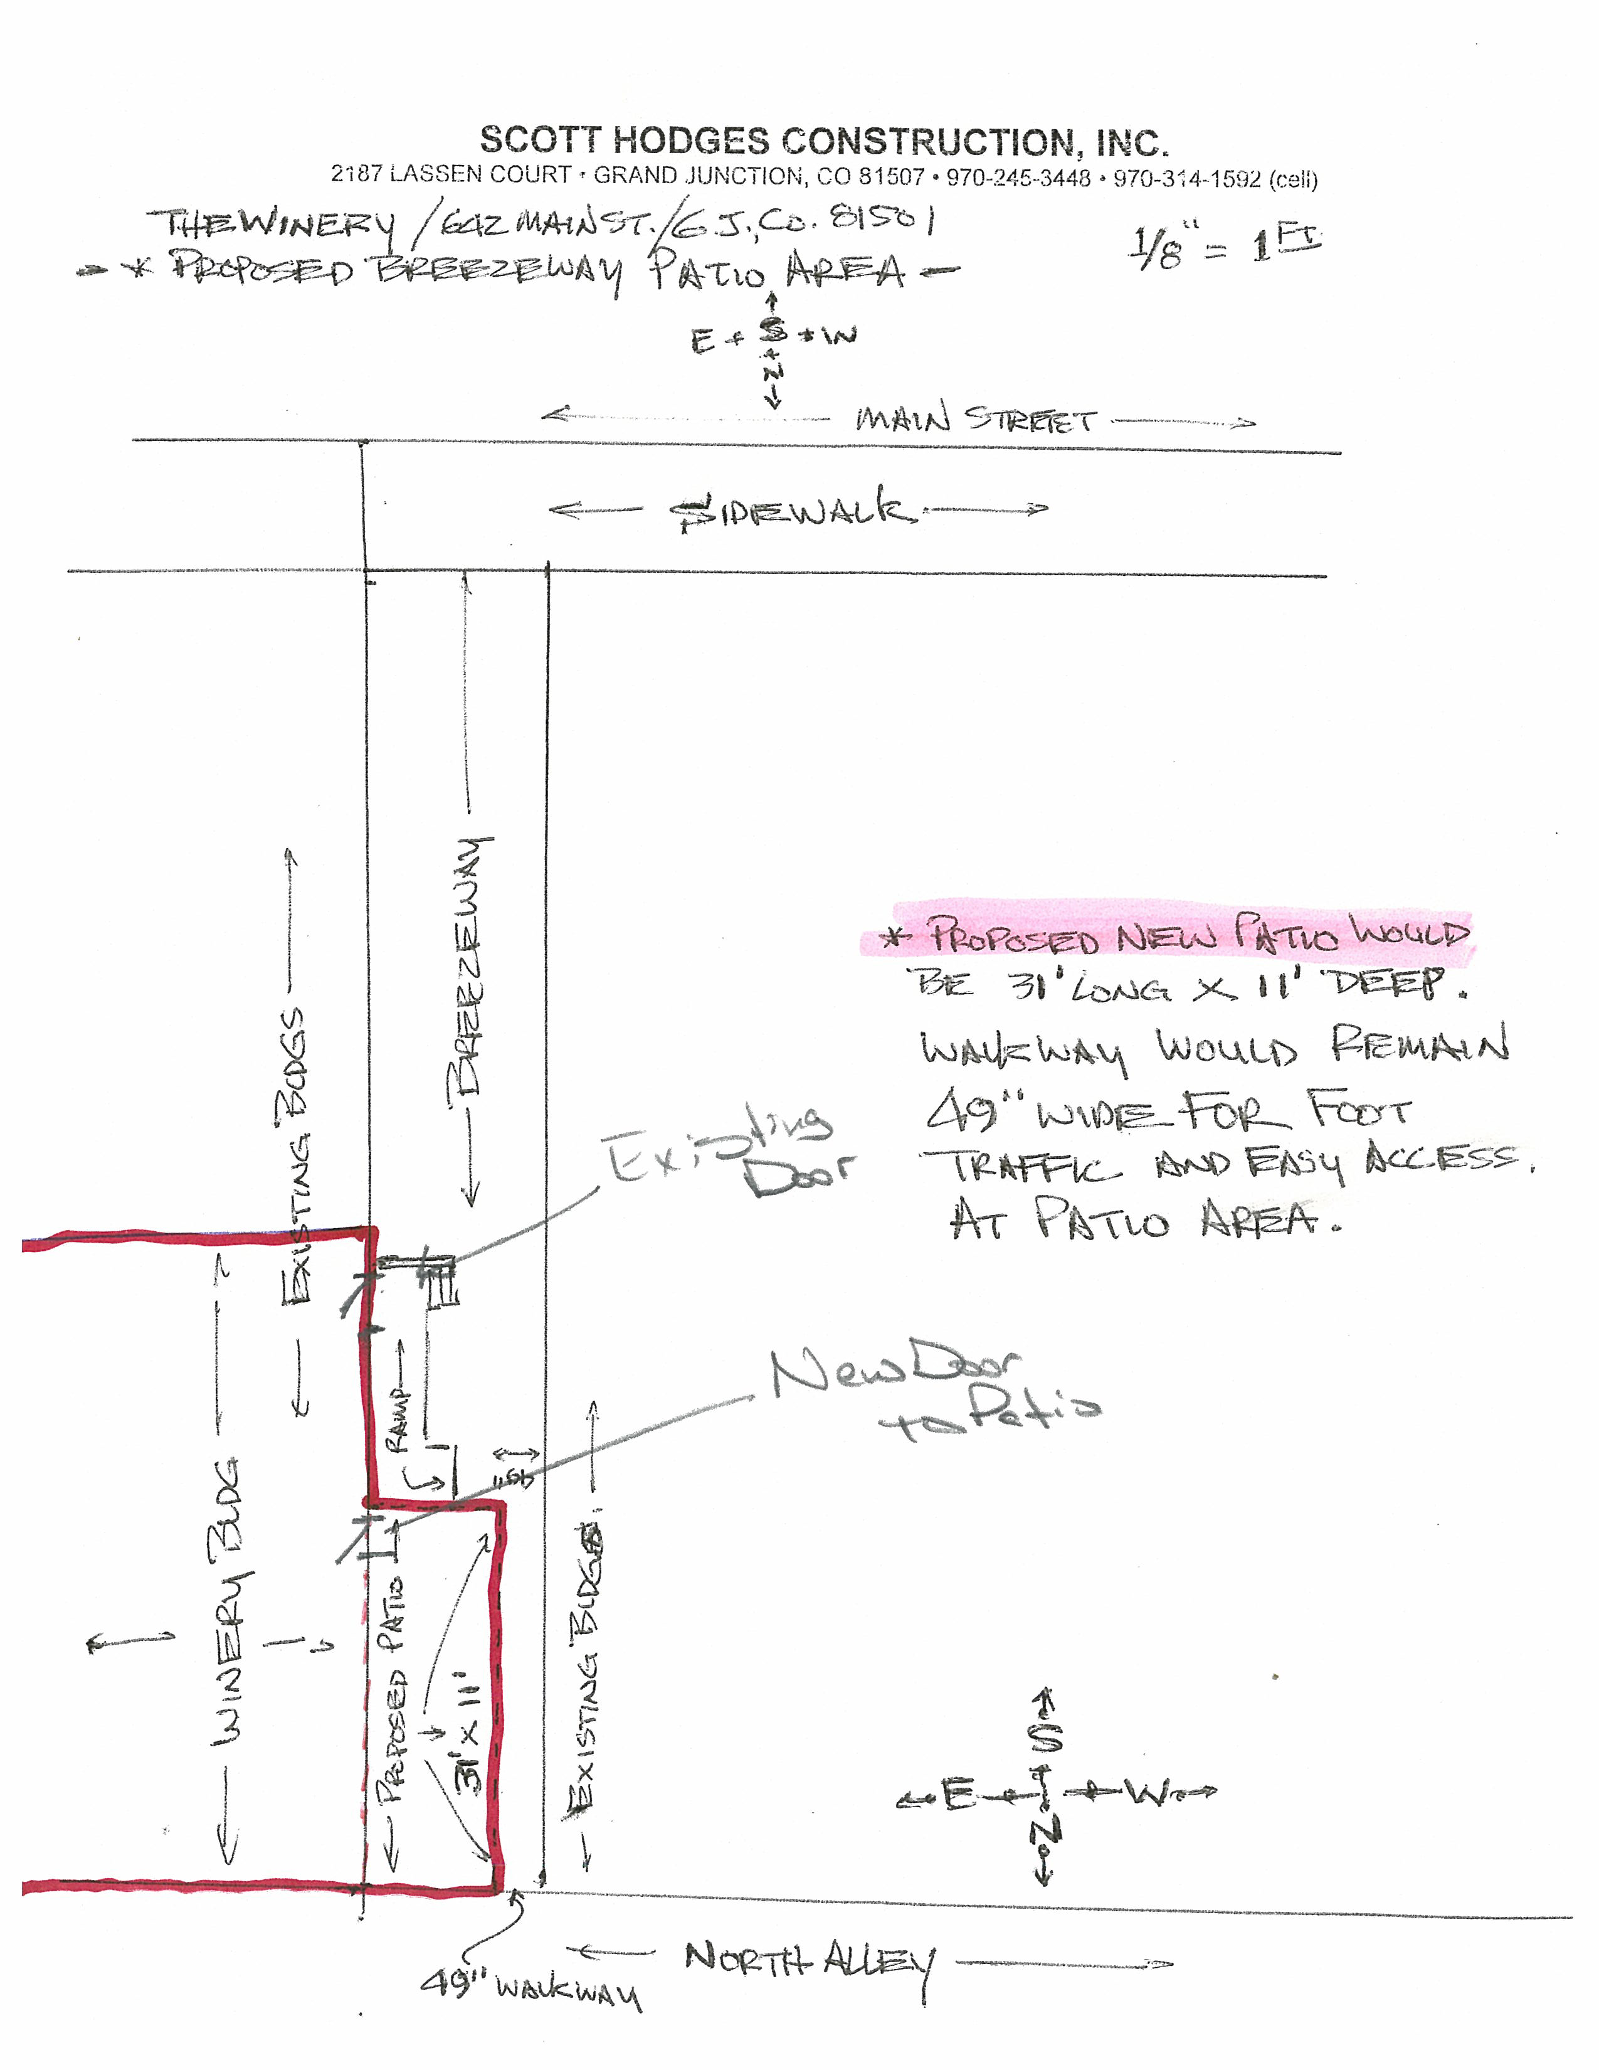

Exhibit B: Brief Description of Business / DDA Certification: include date, who prepared and lessee signature or initials
Business Name (name of insured): Weside Delicatessen, Inc.
DBA (if needed): The Winery Restaurant
Applicant / Relationship to Business: Steve Thoms, President/Owner
Contact Phone and Email: 242-4100 thewinery@qwestoffice.et
Type of Food/Beverage to be served in leased area: Food and Alcohol
Days of Operation / Operating Hours: Tuesday-Saturday, 11 am – 2 am
How this operation will benefit Downtown Grand Junction:
Additional outdoor dining opportunity for downtown patrons
Number of tables to be used in the leased area: 8-10
Number of chairs to be used in the leased area: 24-30
Semi-permanent or movable structures including carts, stands, signs, etc: NA
Describe any musical or vocal presentations or effects to be used in the leased area:
NA
Copies of Current
Permits & Licenses Obtained: State Sales Tax
City Sales Tax
Liquor License
Restaurant/Food Service
Proof of Liability Insurance Coverage Provided?
DDA Certification: The Downtown Development Authority hereby finds that this application is proper, that all applicable permits have been obtained or will be obtained, that it is in compliance and will further the goals and objectives of the Plan of Development for Downtown Grand Junction, and that no current application exists for this location.
Signed: __________________________ Date: ____________

If denied, state reason: _________________________________________________________________

Exhibit C: Assurances, Hold Harmless and Indemnity Agreement
The Applicant assures the Downtown Development Authority and the City of Grand Junction that if a lease is issued, s/he will comply with all of the requirements and provisions of Grand Junction City Ordinance 3609, all other applicable ordinances and laws, and the Plan of Development for Downtown Grand Junction. The applicant further assures that s/he has obtained or will obtain all of the necessary and required permits or licenses to engage in the business or activity proposed.
I, Stephen F. Thoms , applicant for a Lease to conduct activities in the Downtown Shopping Park area, agree that I shall:
(a) Hold harmless the City of Grand Junction, its officers and employees, and the Downtown Development Authority of Grand Junction, its officers and employees, from any claims for damage to property or injury to persons which may arise from or be occasioned by any activity carried on by me within the Downtown Shopping Park, and
(b) Indemnify the City of Grand Junction, its officers and employees, and the Downtown Development Authority, its officers and employees, against any claim, loss, judgment, or action, or any nature whatsoever, including reasonable attorney fees, that may arise from or be occasioned by any activity carried on by me within the Downtown Shopping Park.
I realize that consideration for this release is the granting of a lease to me by the City of Grand Junction, and I realize and agree that this Hold Harmless/ Indemnity Agreement shall take effect whenever I begin to conduct the type of activities for which the lease has been applied or when the permit is issued, whichever is earlier. I also understand and agree that this agreement shall apply to any activities which I carry on which are done in violation of the terms of this lease.

Executed this ____day of _____________________, 20___.

Signed: _________________________

