CITY OF GRAND JUNCTION, COLORADO

ORDINANCE NO. 4540

AN ORDINANCE REZONING THREE PARCELS
FROM C-1 (LIGHT COMMERCIAL) TO
R-5 (RESIDENTIAL – 5 UNITS PER ACRE)

LOCATED AT 1801 AND 1815 Bass Street AND 1810 Minnow Drive

Recitals.

On February 17, 2010 the Grand Junction City Council adopted the Grand Junction Comprehensive Plan which includes the Future Land Use Map, also known as Title 31 of the Grand Junction Municipal Code of Ordinances.

The Comprehensive Plan established or assigned new land use designations to implement the vision of the Plan and guide how development should occur. In many cases the new land use designation encouraged higher density or more intense development in some urban areas of the City.

When the City adopted the Comprehensive Plan, it did not rezone property to be consistent with the new land use designations. As a result, certain urban areas now carry a land use designation that calls for a different type of development than the current zoning of the property. City Staff analyzed these areas to consider how best to implement the vision, goals and policies of the Comprehensive Plan.

Upon analysis of this area, City Staff determined that the current Comprehensive Plan Future Land Use Map designation is appropriate, and that a proposed rezone is the most appropriate way to create consistency between the Comprehensive Plan’s Future Land Use Map and the zoning of this property and to allow for maximum use of the property consistent with the Comprehensive Plan.

Consistency between the Comprehensive Plan’s future land use designation and the zone district of a given area is crucial to maximizing opportunity for landowners to make use of their property, because the Zoning and Development Code, in Sections 21.02.070 (a)(6)(i) and 21.02.080(d)(1), requires that all development projects comply with the Comprehensive Plan.

The R-5 zone district implements the Future Land Use designation of Residential Medium, is consistent with the Comprehensive Plan’s goals and policies, and is generally compatible with land uses in the surrounding area.

An Open House was held on January 25, 2012 to allow property owners and interested citizens an opportunity to review the proposed zoning map amendments, to make comments and to meet with staff to discuss any concerns that they might have. A display ad noticing the Open House ran in the Daily Sentinel newspaper to encourage public review and comment. The proposed amendments were also posted on the City website with information about how to submit comments or concerns.

After public notice and public hearing as required by the Grand Junction Zoning and Development Code, the Grand Junction Planning Commission recommended approval of rezoning the three properties shown as Area 7 from C-1 (Light Commercial) to the R-5 (Residential – 5 du/ac) zone district for the following reasons:

The zone district meets the recommended land use category as shown on the future land use map of the Comprehensive Plan, Residential Medium and the Comprehensive Plan’s goals and policies and/or is generally compatible with appropriate land uses located in the surrounding area.

After the public notice and public hearing before the Grand Junction City Council, City Council finds that the R-5 zone district to be established.

The Planning Commission and City Council find that the R-5 zoning is in conformance with the stated criteria of Section 21.02.140 of the Grand Junction Municipal Code.

BE IT ORDAINED BY THE CITY COUNCIL OF THE CITY OF GRAND JUNCTION THAT:

The following properties shall be rezoned R-5 (Residential – 5 units per acre) and as shown on the attached Exhibit “A”.

1801 Bass Street
1815 Bass Street
1810 Minnow Drive

Introduced on first reading this 18th day of April, 2012 and ordered published in pamphlet form.

Passed and Adopted on second reading this 20th day of June, 2012 and ordered published in pamphlet form.

ATTEST:

/s/: Stephanie Tuin /s/: Bill Pitts
City Clerk Mayor

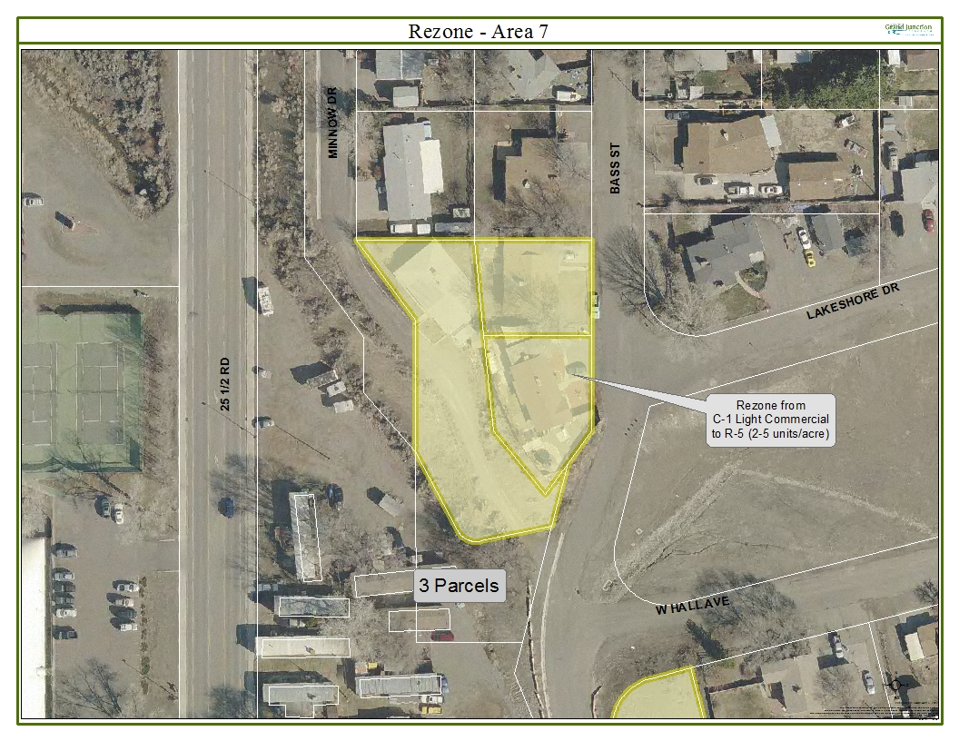
Exhibit “A”

