RESOLUTION NO. 36-12

A RESOLUTION AUTHORIZING AN AGREEMENT BETWEEN POWDERHORN SKI COMPANY, LLC AND THE CITY OF GRAND JUNCTION FOR THE LEASE OF CERTAIN CITY WATER FOR SNOWMAKING

RECITALS:

On July 30, 2012 the City Council considered a proposed agreement by and between the Powderhorn Ski Company, LLC and the City for the lease of certain City water to Powderhorn for snowmaking.

Councilmember Susuras, City Manager Englehart, City Utility Director Trainor and City Attorney Shaver and staff from the water and engineering departments have negotiated with Powderhorn and have informally come to terms.

The negotiating team recommends approval of the agreement.

NOW, THEREFORE, BE IT RESOLVED THAT:

The City, by and through the City Council and the signature of its President, does hereby approve, authorize and ratify the terms, covenants, conditions, duties and obligations to be performed by the City and Powderhorn in accordance with the contract and does direct that the City perform under and according to the agreement.

DATED this 15th day of August 2012.

/s/ Laura Luke
President of the Council Pro Tem

Attest:

/s/ Stephanie Tuin
City Clerk
AGREEMENT BETWEEN THE CITY OF GRAND JUNCTION
AND POWDERHORN SKI COMPANY, LLC

This AGREEMENT is made and entered into by and between the City of Grand Junction, hereinafter referred to as the “City” and Powderhorn Ski Company, LLC, hereinafter referred to as “Powderhorn.” Collectively the City and Powderhorn may be referred to as the Parties. Powderhorn may be referred to as Lessee.

- PURPOSE:

Formalize the collaboration and agreement between the City and Lessee for the use by Lessee of a maximum of 140, non-interruptible as that concept is defined herein, acre feet of the City’s municipal water supply for snowmaking, which may be referred to as the Project.

Develop and implement a mechanism for continued communication and consultation between the Parties in the processes and practices of drawing and using the water for the Project for the purposes of and in accordance with this Agreement; and

The parties desire to ensure an appropriate level of continued involvement by each party in Project planning and development and compensation to the City.

- STATEMENT OF MUTUAL BENEFIT AND INTERESTS:

The Parties are committed to working together, not as legal partners or joint venturers but as collaborators, to develop the Project that will serve to draw, transport and apply the water, as established by agreement between the Parties, to beneficial use.

The Parties recognize and agree that use/development decisions made by one party affect decisions by the other and that in order to accomplish the Purposes of this Agreement each Party will be presumed and reasonably required to act to benefit the other.

The Parties further recognize and agree that communication from one party to the other is key to the success of the Project.

- LESSEE SHALL:

- Use the water supplied pursuant to this Agreement for snowmaking at the Powderhorn ski area. When the approximate locations of the snowmaking equipment are identified, provide a map thereof to the City.

- Design and construct a pump station, pipeline and other means of drawing and conveying the water from the Somerville Reservoir. The approximate location of the pump station and pipeline are shown on attachment A.

- Pay the cost of construction, installation, operation and maintenance of the necessary pump station, pipeline, electrical service, meter(s) and other means of drawing, conveying, consuming and as applicable storing the water.

- Powderhorn shall design, construct and install, or cause at its own expense the design, construction and installation of those on-site and off-site improvements necessary or required for the Project. A list thereof is attached and incorporated by this reference (“Improvements” or “the Improvements”). The Parties stipulate and agree that the improvements list is not complete or exhaustive and shall be amended upon completion of final design.

- The scope of this project is such that the City may have to engage independent consultants(s) to adequately provide inspection services; Powderhorn agrees to pay such costs, in addition to all others for which Powderhorn is responsible hereunder. Inspection service(s) fees shall be reviewed and approved by Powderhorn prior to engagement of consultants. Consultant service(s) shall not start until agreement has been reached on the cost(s) of the consultants. The City agrees that it will use consultant services only as reasonably necessary.

- Powderhorn shall commence work on the Phase I Improvements within 72 months from the signing of this Agreement by the parties; that date is known as the “Commencement Date.” Powderhorn shall demonstrate to the City that it has the financial resources to start and finish the Improvements.

Phase I Description

- Pump station at Somerville Reservoir including the connection and valving at the outlet pipe at the base of the dam.

- Supply line from Somerville Reservoir to the top of chair #2, approximately 13,000 lineal feet of pipe, and then continuing to the top of Chair #1 including distribution hydrants on Upper Tenderfoot and Upper Maverick.

- Electrical service from the Grand Valley underground power line running through the Foster property, in the same trench as the water line, to the Powderhorn Somerville reservoir pump house.

- Electrical operating power service along the Upper Tenderfoot line from the top of Chair #2 including connection pedestals.

- Snowmaking distribution line with hydrants from the top of chair #1 down Bill's Run to a connection on the lower mountain to the existing snowmaking system servicing Lower Maverick, Lower Peacemaker and the Easy Rider beginner area.

- Electrical operating power service along the Bill's Run distribution line including the Easy Rider trails in the beginner area.

- Powderhorn shall complete Phase I of the Improvements by the end of eighteen months from the Commencement Date; that date is known as the “Completion Date.” This time period should account for adverse weather warning of an early winter and still allow enough time the next summer to complete the project.

Should Powderhorn fail to complete construction on or before the Completion Date, except as the result of “Acts of God”, Powderhorn shall have the option to extend the term of this Agreement for 3 years by making a one-time payment of $50,000. Furthermore, and as an express condition of the one-time 3 year extension “Extension Term” Powderhorn understands and agree that the Project shall be completed on or before the expiration of the Extension Term. If the one-time payment of $50,000 is not paid to the City and/or if the Extension Term is exercised and the Project is not complete, then this Agreement shall terminate.

- Reclaim/re-vegetate the City-provided temporary construction easement/material storage area upon completion of construction. The City, in consultation with Powderhorn, shall prepare the reclamation/revegetation plan for the Lessee’s use.

- At all times use good land stewardship practices, including dust mitigation, erosion control and noxious weed control, on City property that is used by the Lessee.

- Pay a per acre foot charge of $156.00 from 2013 -2053, for each and every acre foot consumed from the Reservoir(s), including transportation loses from evaporation when transferring water from the Anderson Reservoirs to the Somerville Reservoir.

The charges to be paid by Powderhorn (water storage and water consumption) shall be adjusted each year by 50% of the Denver Boulder CPI/U.

Flow meter(s) shall track consumption to the nearest gallon.

A 17.5% evaporation rate for water transferred from the Anderson Reservoirs to Somerville shall be applied. For example at that rate (17.5%) if Powderhorn bought 100 acre feet for the 2013/14 ski season, the City would transfer 117.5 acre feet to the Somerville Reservoir in order to account for evaporative loss from the ditch transfer from one reservoir to the other. The evaporation rate will be reviewed and may be adjusted by the City after four years of transfers for the Project. The evaporation rate shall be set as closely as possible to reflect actual losses.
- All payments to the City (consumption and storage if Powderhorn elects to request storage as provided in paragraph C-14) will be made November first of each year for the amount of water designated by Powderhorn for the following year. The first year’s payment shall be made in the year the pipeline and pump house are substantially complete and operational.

- Powderhorn shall notify the City by April 30th of each year, in writing to the person and at the address shown herein, of the number of acre feet of water it intends to purchase and/or store for the Project.

- In order to ensure availability of water for the Project Powderhorn may at its option request that the City annually hold up to 140 acre feet of additional water for Powderhorn’s use and benefit. Powderhorn shall annually designate in writing by April 30th of each year the amount of what that it desires to be stored.

The City will store the amount of water designated by Powderhorn for a fee of $60.00 per acre foot. Stored water, if any, shall be made available for Powderhorn’s use from year to year as otherwise provided by this Agreement. The storage fee shall be in addition to the $156.00 per acre foot consumption fee. Powderhorn’s failure to notify and/or pay the City shall relieve the City from any obligations to store water for the Project as described in this paragraph.

- CITY SHALL:

- Provide a use easement for the term of the lease for the pipe and a temporary construction easement/material storage area for construction staging/construction management. City will also provide a lay down area for construction of the pump house and pipeline which area which be returned to the city in a clean and seeded condition.

- The water for the Project shall be first made available by the City by October 15 and end on or before April 15 of each year.

- Volume and dates of availability of water for the Project are assumed and agreed as follows: a) up to 140 acre feet at build out of the snowmaking system; b) build-out is not anticipated for ten years; and c) at completion of the first phase of the snowmaking system on or about November 2013, Powderhorn will require approximately 60 acre feet.

- BOTH PARTIES SHALL:

- Cooperate in Project construction decision making especially when the decision(s) has or may have an impact on water quality. That cooperation shall be made and/or given in a manner consistent with the responsibilities and authorities assigned by this agreement or other applicable law or policy.

- Work together to achieve maximum benefits from available resources while safeguarding the City’s water quantity and quality. Efficiency and effectiveness toward attaining that goal can be made by a reduction in the duplication of effort and working to attain better overall coordination of land and ecosystem management.

- Make available, upon request, survey and topography documentation.

- During the non-snowmaking months, April 15 through October 15, the parties would contemplate that they may employ a “pumpback” to have the opportunity to pump water from Powderhorn back to the Somerville reservoir, for storage for snowmaking purposes. Any such pumpback would be credited against Powderhorn’s non-interruptible reserve. The parties have not had the opportunity to fully study the pumpback but believe it could benefit them by reducing the amount of water that would need to be reserved for Powderhorn during drought years. The City and Powderhorn agree that the pump back concept will be studied further and if it is of economic benefit to both entities then this agreement may be modified to provide a credit against the annual water consumption fee or other mutually agreeable consideration.

- IT IS MUTUALLY UNDERSTOOD AND AGREED BY AND BETWEEN THE PARTIES TO:

- COLORADO OPEN RECORDS ACT (CORA). Any information furnished to the City under or pursuant to this agreement is subject to disclosure to others under or in accordance with the Open Records Act.

- NON-EXCLUSIVE USE. This Agreement in no way limits or restricts the City from participating in similar water use projects or activities with other public or private agencies, organizations or persons.

- COMMENCEMENT/EXPIRATION/TERMINATION. This Agreement takes effect upon the signature of the Lessee and City and shall remain in effect for forty (40) years from the date of execution. This Agreement may be extended or amended in writing with assent to the extension or amendment requiring the same approval/formality as was required at the inception of the agreement.

Either the Lessee or the City may terminate this Agreement with a 60 month written notice to the other(s). Termination shall occur only for and in the advent of a breach of a material term of this agreement as the same is defined herein. Each and every term and condition of sections C, D and E(1), (2) and (3) hereof shall be deemed to be a material terms. In the event either party should fail or refuse to perform according to the terms of this Agreement, such party may be declared in default. If a default is declared, notice shall be given by the non-defaulting party to the defaulting party as provided in section 5. After a notice of default is given the defaulting party shall have a reasonable period of time to cure the default. The parties stipulate and agree for a claimed default that does not credibly present an imminent life, health or safety hazard a reasonable cure period shall be not more than 6 months. In the event the default does credibly present an imminent life, health or safety hazard the cure period shall be as agreed upon by the parties but in any event not more than 72 hours.

In the event of termination the Lessee shall be allowed to remove its pump, pump house, pipeline and other improvements and upon removal shall restore the City property to the condition it existed prior to installation.

- RESPONSIBILITIES OF PARTIES. The Lessee and the City and their respective officers, employees and agents shall be responsible for the administration of their activities and the utilization of their resources dedicated to the completion of the Project by and with the expenditure of their own funds. Each party shall carry out its separate activities in a coordinated and mutually beneficial manner.

- PRINCIPAL CONTACTS. The principal contacts for this instrument are:

City of Grand Junction Powderhorn
City Manager Andy Daly
City of Grand Junction Powderhorn Ski Co., LLC
250 N. 5th Street P.O. Box 250
Grand Junction, Colorado 81501 Mesa, Colorado 81643
970-244-1508 970-331-8245

These shall be the persons contacted for purposes of any notice provided for in this Agreement.

- NON-FUND OBLIGATING DOCUMENT. Nothing in this Agreement shall obligate the City to obligate, appropriate or transfer any funds. Specific work projects or activities that involve the transfer or expenditure of funds will require separate budget approval and be contingent upon the appropriation of funds.

- AUTHORIZED REPRESENTATIVES. By signature below, the Parties certify that the signatories to the document are authorized to act in all matters related to, arising out of or under this agreement.

- ASSIGNABILITY. Powderhorn may assign the rights provided in this Agreement to any successor as owner and/or operator of Powderhorn with the understanding that the new owner or operator must abide by all terms and conditions of this Agreement. Powderhorn shall notify the City in writing of any assignment.

THE PARTIES HERETO have executed this instrument this day of , 2012.
CITY OF GRAND JUNCTION |  | POWDERHORN SKI COMPANY, LLC

Attachment A

Powderhorn Water Agreement
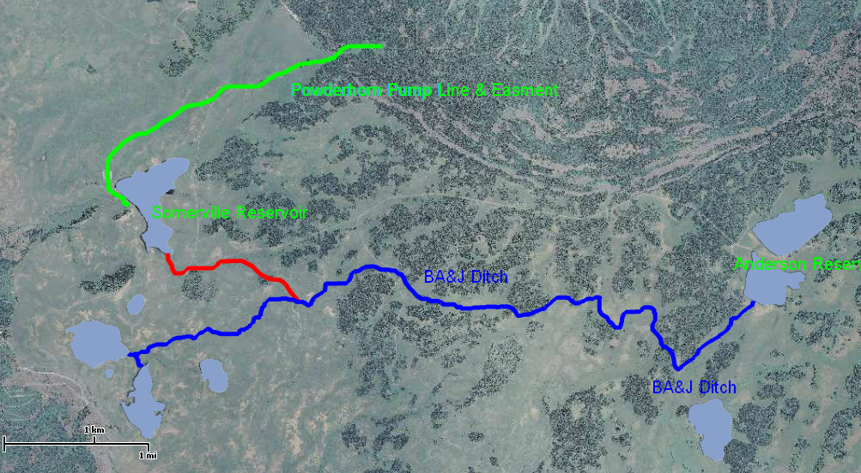
Pump Station
Powderhorn
Ski Area

